MENDOv3: AN IMPROVED AI-ENABLED MEDICINE RECOMMENDER FOR AN OVER THE COUNTER (OTC) DRUG DISPENSER
Kristine Mae Adlaon¹, Jayrald Basan², Earl Cedric M. Coronado³ , Geoffrey J. Diapana³ , and John Paul J. Estano³
1. Faculty Researcher, College of Computer Studies
2. Faculty Researcher, College of Pharmacy and Chemistry
3. Student Researcher, College of Computer Studies

- INTRODUCTION
Self-medication using over-the-counter (OTC) drugs is a widespread practice across many parts of the world, particularly in communities where healthcare access is limited or where individuals seek faster and more affordable treatment for minor illnesses [12, 13]. Studies have shown that people frequently rely on their interpretation of symptoms when selecting medications, which can lead to inappropriate drug use when symptoms are misunderstood or inaccurately described. In the Philippines, self-medication is also commonly practiced due to factors such as limited healthcare accessibility, long waiting times in medical facilities, and the affordability and availability of OTC medicines in local pharmacies [14, 15,16]. This trend is reflected in national findings showing that only 7.4% of Filipinos report not self-medicating, meaning roughly 92.6% engage in some form of self-treatment [15]. In Davao City, despite the Botika ng Bayan program providing free medicines to over a million residents annually, individuals often continue to rely on prior experience, advice from family members, or information obtained online when deciding which medication to take [17]. These behaviors highlight the need for accessible tools that can assist users in interpreting symptoms and identifying appropriate OTC medications.
To support this need, previous research introduced Mendo v1.0 and Mendo v2.0, systems designed to detect symptoms from user-described inputs and recommend suitable OTC medicines. These systems utilized a retrieval-based architecture grounded in information retrieval techniques, particularly TF-IDF, to match user symptom descriptions with predefined symptom categories and medication recommendations. The approach demonstrated promising performance in retrieving relevant symptom matches from user inputs.
Despite the need for tools that assist with symptom interpretation, one of the key challenges in supporting self-medication lies in how individuals describe their symptoms. Symptoms are subjective experiences expressed through natural language, which can vary widely across individuals and contexts. Studies have shown that ambiguity in natural language makes automated detection difficult, as patients often combine multiple symptoms or use negations in their descriptions [18, 19]. In the Philippines, AI-based symptom checker systems have reported similar challenges, where informal phrasing and mixed-language expressions reduce system accuracy [19, 20]. Locally, in Davao City, patients frequently describe symptoms using Bisaya–English expressions, further complicating automated interpretation and highlighting the need for localized NLP models tailored to regional language use.
However, the earlier version of the system (v1.0) was significantly limited by its single-token symptom processing, English-only interface, low storage capacity, and bulky hardware configuration. Version 2.0 addressed several of these constraints through multilingual dictionary-based translation, improved dispensing capacity, and the use of TF-IDF with cosine similarity for text matching. Despite these improvements, evaluation revealed a critical precision–safety gap: the system achieved high recall (97.63%) but considerably lower precision (78.08%), indicating that roughly one out of five recommendations could be clinically inappropriate. Further analysis showed that the dataset used to train the recommendation engine was limited and manually augmented, while the multilingual component relied heavily on synonym-based dictionary lookups. In addition, the system treated symptoms as isolated keywords rather than clinically distinct concepts. For example, cough symptoms may be classified as dry (non-productive) or wet (productive), which require different therapeutic approaches despite sharing the same base symptom. These limitations highlight a broader semantic and clinical context gap in the v2.0 architecture, ultimately reducing the reliability and safety of its medication recommendations.
To examine the limitations of the baseline system, an adversarial challenge set of 110 scenarios was constructed. The scenarios were designed to target common failure conditions in symptom interpretation and medication recommendation, including negation handling, contraindication awareness, multi symptom interpretation, and pediatric constraints. These cases reflect situations in which simple keyword retrieval methods often struggle to produce appropriate recommendations.
Table 1 presents the performance of the baseline system across these categories. The baseline model, which relies on TF IDF vectorization and cosine similarity for symptom matching, demonstrates moderate performance on straightforward retrieval tasks but performs poorly when the input requires compositional interpretation or safety awareness. Accuracy declines notably in multi symptom and pediatric scenarios, and the system frequently fails to prevent contraindicated medication suggestions when relevant conditions are present.
Category | Total | Correct | Failed | Accuracy
Baseline | 20 | 9 | 11 | 45.0%
Contraindication | 22 | 8 | 14 | 36.4%
Multi-symptom | 16 | 5 | 11 | 31.2%
Negation | 11 | 6 | 5 | 54.5%
Pediatric | 7 | 2 | 5 | 28.6%
Table 1: Performance by category
These quantitative results are further illustrated by several qualitative failures. In one example, the system recommended a fever tablet for the input “I only have sore throat, NO fever,” rather than suggesting throat specific treatments such as lozenges or sprays. In another case, the system returned an adult tablet brand for a four year old child with cough and fever who was allergic to aspirin, instead of recommending pediatric syrup formulations. Similarly, a Bisaya input that explicitly negated phlegm still resulted in a recommendation for a product intended for productive cough. Representative examples of these failures are summarized in Table 2.
Category | Language | Input Text | Expected | Predicted
Negation | English | I only have sore throat, NO fever | lozenges or throat spray | Biogesic
Pediatric | English | Child 4 yrs with cough and fever, allergic to aspirin | acetaminophen_syrup; guaifenesin_syrup or dextromethorphan_syrup | Solmux
Multi-Symptom Decomposition | Tagalog | May ubo na may plema at may lagnat | Guaifenesin; acetaminophen | Solmux
Contraindication | English | Toothache, has high blood pressure | Acetaminophen; avoid decongestants | Neozep
Table 2: Selected failure examples
These findings underscore a well-documented limitation of retrieval-based architectures: systems that lean on keyword matching cannot reason about what a patient is actually saying, cannot enforce safety constraints like age restrictions or contraindications, and struggle with anything beyond single-symptom, single-language queries [21, 22, 23]. In multilingual environments such as the Philippines, these challenges are further amplified by informal language use and mixed-language inputs [24, 25, 26]. Therefore, there is a need for improved architectures that can better capture the semantic relationships between symptoms, incorporate safety-aware reasoning, and provide more reliable medication guidance in real-world scenarios.
Findings from the systematic literature review indicate that recent studies have proposed several architectural strategies to address the limitations of retrieval-based symptom recommendation systems. While traditional TF-IDF–based approaches provide strong lexical matching for symptom terms, researchers have noted that such systems often struggle with semantic interpretation, complex symptom descriptions, and safety-aware reasoning in clinical recommendation tasks.
Several studies have explored enhanced symptom understanding techniques by integrating contextual semantic representations with rule-based linguistic processing. For example, Tan et al. (2024) and Kalva and Padakanti (2024) demonstrate that contextual embeddings can improve semantic similarity detection in patient narratives, while rule-based negation and scope handling remain useful for accurately interpreting patient-generated inputs, particularly in multilingual settings [2, 27]. This hybrid approach allows systems to capture deeper semantic relationships while maintaining interpretability and computational efficiency.
Other researchers have proposed multi-symptom decomposition and ranking strategies to address the limitations of single-label symptom matching. Studies by Sohail et al. (2025) and Bodele et al. (2024) suggest decomposing complex symptom descriptions into independent clinical components before generating recommendations [28, 29]. Rather than forcing a single best match, these approaches enable systems to produce complementary recommendations that correspond to multiple co-occurring symptoms, improving the clinical relevance of treatment suggestions.
Another important direction in the literature involves incorporating structured medical knowledge into recommendation pipelines. Systems such as RECOMED, described by Zomorodi et al. (2024), integrate knowledge graphs that encode relationships between active ingredients, contraindications, and patient-specific constraints such as age or pre-existing conditions [30]. These structured representations allow systems to enforce deterministic safety checks, including the prevention of contraindicated drug combinations and age-inappropriate formulations.
Collectively, these approaches highlight a growing shift toward hybrid architectures that combine lexical retrieval, semantic interpretation, and structured medical knowledge to improve both accuracy and safety in clinical recommendation systems.
It is also worth noting that commercial symptom checker applications like Ada Health, Babylon Health, and Isabel Healthcare have shown strong diagnostic accuracy in controlled evaluations, often using proprietary datasets with millions of clinical cases and large-scale model training. However, these systems are designed for broad diagnostic triage rather than OTC medication recommendation, they require constant internet connectivity, they operate mostly in English, and they rely on proprietary cloud-based architectures that raise data privacy concerns under Philippine law (Republic Act No. 10173). Mendo v3.0 is different from these systems in several important ways: it targets a narrowly scoped OTC recommendation task (13 symptoms, 24 medicines), runs entirely offline on constrained hardware, supports Filipino multilingual input including Bisaya and Tagalog, and prioritizes deterministic safety guarantees over broad diagnostic coverage.
Building on the approaches identified in the systematic literature review and addressing the limitations observed in the previous Mendo versions, this study introduces MendoVendo v3.0, an improved OTC medication recommendation system designed to enhance symptom interpretation and safety-aware decision support. While earlier versions relied primarily on TF-IDF vectorization and cosine similarity for symptom matching, the proposed system adopts a hybrid architecture that integrates lexical retrieval with complementary mechanisms for semantic interpretation, multi-symptom handling, and safety validation.
Specifically, the proposed architecture incorporates three key components. First, an enhanced symptom understanding module integrates contextual semantic representations with rule-based negation and scope detection to improve the interpretation of user-described symptoms, particularly in mixed-language inputs commonly observed in the Philippine context. To further improve the clinical interpretation of symptoms and enhance recommendation safety, the system incorporates elements of the OLDCARTS symptom assessment framework — specifically the Character, Onset, Aggravating, Timing, and Duration components — to guide targeted clarification questions for ambiguous symptoms and enforce time-based safety limits [31, 32]. This structured representation allows the system to capture additional contextual information about symptoms that may influence appropriate medication selection, while also screening for cases that have persisted long enough to warrant professional medical evaluation rather than OTC self-treatment.
Second, a multi-label symptom decomposition and ranking pipeline separates complex symptom descriptions into independent symptom clusters, enabling the system to generate complementary medication recommendations when multiple conditions are present. Third, a clinical constraint engine encodes structured relationships between OTC medications — including active ingredients, contraindications, and age-based formulation rules — through a curated JSON dataset, enabling deterministic safety checks during the recommendation process.
Objectives of the Study
This study aims to develop MendoVendo v3.0, an AI-enabled multilingual symptom detection and over-the-counter (OTC) medicine recommendation system designed to support safe and accessible self-medication. Specifically, the study aims to:
- Design and implement a multilingual natural language processing framework capable of detecting and interpreting user-described symptoms, including linguistic challenges such as negation, abbreviations, multi-symptom expressions, and mixed-language inputs, while incorporating structured symptom assessment through the OLDCARTS framework, including a duration-based safety check that screens for symptoms persisting beyond clinically safe thresholds for OTC self-medication.
- Develop a recommendation mechanism that suggests appropriate OTC medicines based on identified symptoms while incorporating safety-aware filtering mechanisms to reduce inappropriate medication recommendations.
- Release the annotated dataset as a publicly accessible CSV file hosted on a recognized academic data repository (such as Zenodo or Kaggle Datasets), along with documentation describing the annotation schema, symptom label definitions, and intended use cases to support reproducibility.
- Develop an accessible automated platform that enables users to receive safe OTC medicine recommendations based on their reported symptoms.
- METHODS
This chapter explains the methods used to design, build, and evaluate Mendo v3.0, a multilingual symptom detection and over-the-counter medicine recommendation system intended for pharmacy-kiosk use. The software was developed in Python using Flask and was designed for offline setting or low-connectivity operation on modest hardware. The central goal of the study was to improve the safety and precision of symptom-based OTC recommendations while preserving support for the kinds of multilingual, code-switched, and informal inputs commonly used by Filipino pharmacy customers. The system will only cover common OTC-manageable symptoms, specifically fever, cold, cough, allergy, headache, stomachache, and body pain. Any symptoms or conditions that are outside within the predefined symptoms, as well as emergency or high-risk cases, will not be covered by the recommendation module and instead trigger appropriate safety measures or referral responses.
Mendo v3.0 was developed as a clear departure from the earlier Mendo approach, which relied on direct text-to-drug matching. In the present version, the task is separated into two more transparent steps: symptom identification first, then recommendation scoring based on those symptoms. This design makes it easier to handle multi-symptom input, negated statements, clarification prompts, and safety checks in a way that can be traced and explained.
The study is organized as a three-iteration design process. Iteration 1 corresponds to the completed baseline system currently implemented in the codebase, including the OLDCARTS-inspired clarification logic, safety filtering, consultation logging, and internal benchmark evaluation. Iteration 2 is planned as a controlled real-user validation phase in selected pharmacy settings, where users will interact with the Iteration 1 system and their consultation inputs will be saved as logs for expert review. Iteration 3 is planned for expert-guided refinement of the system using the annotated consultation corpus, followed by re-evaluation and final deployment of the improved version. Because this chapter documents both the completed baseline artifact and the intended later research phases, the sections below distinguish clearly between implemented Iteration 1 components and proposed Iteration 2 and Iteration 3 activities.

Research Design
The study follows an iterative design science research approach. This was a natural fit because the project does not simply test an existing technique; it involves defining, building, evaluating, and refining a working artifact through multiple cycles until it meets functional and safety standards. The outcome of the research is therefore both a working system and a documented set of design decisions that justify the architecture [1,3].

The research design is structured into three iterations.

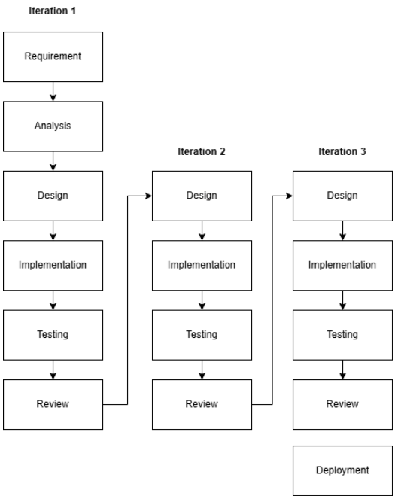
Figure 1: Iterative Research Approach

Iteration 1: System Design, Development, and Internal Evaluation
The first iteration focuses on completing the baseline version of the proposed system and preparing it for real-world deployment in participating community pharmacies. Instead of collecting a standalone symptom dataset, the deployed system will record anonymized consultation logs from consenting users. These logs, together with pharmacist validation, will serve as the basis for evaluating the system's recommendation performance and identifying areas for improvement in subsequent iterations.
Requirement. The objective of this iteration is to deliver a functional baseline system capable of assisting pharmacy customers seeking over-the-counter (OTC) medicines. The system must accept natural-language symptom descriptions in English, Filipino, Bisaya, and code-switched combinations; identify symptoms that fall within the study's OTC scope; screen for emergency or high-risk cases; ask clarification questions when symptom information is incomplete or ambiguous; recommend appropriate OTC medicines from the structured medicine database; and securely record each consultation for later evaluation. In addition, the deployed system must generate sufficient consultation records to support the measurement of recommendation performance using pharmacist-validated outcomes.
Analysis. The researchers analyzed the consultation workflow in community pharmacies to determine how the system should support both users and pharmacists. Since pharmacy customers often describe symptoms using mixed languages and incomplete information, the consultation process requires clarification before a recommendation can be made safely. Furthermore, evaluating recommendation quality requires more than storing user inputs; each consultation must be comparable with the pharmacist's assessment to determine whether the system's recommendation is correct. These observations established the need for a symptom-first recommendation approach, structured consultation logging, and expert validation as the basis for performance evaluation.
Design. Based on the analysis, the researchers designed a modular consultation pipeline that separates safety screening, symptom recognition, clarification, recommendation generation, and consultation logging into independent components. The architecture begins with red-flag screening, followed by multilingual symptom detection using a hybrid dictionary and semantic matching approach. A clarification module then gathers any missing symptom details before the recommendation engine retrieves suitable OTC medicines from the structured medicine database. Finally, a logging module records the consultation, including the user's symptoms, clarification responses, detected conditions, safety decisions, and recommended medicines, allowing each consultation to be reviewed alongside the pharmacist's assessment.
Implementation. During this iteration, the researchers implemented the baseline system as a Flask-based web application. The implementation integrated the multilingual symptom dictionary, semantic matching component (pre-trained multilingual sentence embeddings with cosine-anchor matching and a fine-tuned 13-label classification head), red-flag screening, OLDCARTS-inspired clarification module, duration-based safety checks, and the structured OTC medicine database into a single consultation workflow. The consultation logging mechanism was also implemented to automatically record anonymized consultation data after user consent. Once deployed in participating pharmacies, customers will use the system before consulting the pharmacist, allowing both the system-generated recommendation and the pharmacist's recommendation to be recorded for evaluation.

Testing. The baseline system will undergo two levels of evaluation. First, internal testing will verify that each module performs correctly, including symptom detection, clarification, safety screening, recommendation generation, and consultation logging. Second, field validation will be conducted in participating pharmacies, where consenting customers will use the system during actual consultations. The recommendations generated by the system will be compared with the recommendations provided by licensed pharmacists. These comparisons will be used to compute performance metrics such as precision, recall, and F1-score, while consultation logs will also be reviewed to identify common errors, missed symptoms, and inappropriate recommendations.
Review. At the end of the first iteration, the researchers will review both the technical performance of the baseline system and its real-world consultation results. The findings will determine whether the system can reliably identify symptoms, ask appropriate clarification questions, recommend suitable OTC medicines, and correctly suppress recommendations for unsafe cases. Performance metrics, pharmacist validation, and consultation log analysis will be used to identify areas requiring refinement before proceeding to the next iteration.

Iteration 2: Expert Annotation, Hardware Development, and Real-User Validation
Iteration 2 has two major tracks running concurrently. The first track focuses on expert annotation of the datasets collected in Iteration 1 and real-user validation of the software system. The second track involves the design and development of the hardware vending (vendo) dispenser that will eventually house the software system for autonomous OTC medicine dispensing.
Because this phase involves real participants in an actual pharmacy setting, ethical clearance is built into the iteration itself. Before any live consultation is recorded, the study must secure approval from the appropriate institutional ethics review body and obtain permission from participating Botika ng Bayan branches. Field activities begin only after the approved protocol, participant information materials, and data-handling procedures are in place [10, 11].
Design. The software track is designed around controlled field deployment of the Iteration 1 system in selected pharmacy settings. Real users interact with the consultation interface while the system records their inputs, clarification responses, detected symptoms, red-flag triggers, and recommendation outputs. These consultation logs constitute the primary real-world dataset for this iteration. Participation is voluntary, and each participant is informed about the study's purpose, what data is recorded, how logs are stored, and how they will be used. Consent materials are prepared in languages relevant to the study setting. The hardware track involves designing the vendo machine—a physical kiosk that integrates the Mendo software system, a touchscreen interface, a medicine dispensing mechanism, and inventory management. The hardware design must support the system's offline operation requirements and be suitable for placement in pharmacy settings.
Implementation. On the software side, the completed Iteration 1 system is deployed under supervised conditions. Participants who consent enter their symptom descriptions through the system, and logs are stored as the primary evaluation dataset. Privacy measures are observed: consultations are conducted to minimize bystander exposure, and access to logs is limited to authorized research team members and the designated expert reviewer. On the hardware side, the researchers begin fabricating the vending machine prototype—designing the dispensing mechanism, integrating the Raspberry Pi 5 computing unit, wiring the touchscreen interface, and assembling the physical enclosure. The hardware must pass basic functional tests (reliable dispensing, correct inventory tracking, power management) before integration with the software system.
Testing. The consultation logs are reviewed by a licensed pharmacist who annotates the correct symptoms, appropriate safety actions, and expected medicine recommendations for each logged interaction. This expert-annotated corpus allows direct comparison between the system's actual outputs and expert judgment, revealing which case types the baseline handles well and which still need improvement. Concurrently, the hardware prototype undergoes mechanical and electrical testing to ensure reliable medicine dispensing and inventory accuracy.
Review. The main outputs of Iteration 2 are (1) an expert-annotated consultation corpus from real user interactions and (2) a functional hardware vendo prototype. The review assesses whether the software system remained reliable under authentic pharmacy language, whether the annotated data is sufficient for system refinement, and whether the hardware prototype meets the physical requirements for deployment.
Iteration 3: System Refinement, Hardware Integration, and Final Deployment
Iteration 3 brings together the improved software and the completed hardware into a single integrated system.
Design. This iteration draws on findings from the expert-annotated logs and hardware testing results from Iteration 2. The researchers identify which symptom expressions were frequently missed, which clarification rules need strengthening, and which recommendation cases require tighter safety handling. If the annotated dataset proves large and reliable enough, the semantic symptom-matching component may be adapted using the Iteration 2 consultation corpus, though the recommendation core remains grounded in a structured medicine dataset rather than a black-box model.
Implementation. Software refinements may include expanding the multilingual dictionary, adjusting semantic thresholds, improving clarification prompts, refining duration thresholds based on pharmacist feedback and observed referral patterns, strengthening rule-based safety checks, and updating the medicine dataset based on expert feedback. On the hardware side, the refined software is integrated into the vendo machine. This includes connecting the recommendation output to the dispensing mechanism, so that once a user accepts a recommendation, the system triggers the correct medicine slot. Inventory management, payment handling, and user interface refinements are finalized during this phase.
Testing. The integrated system undergoes a comprehensive evaluation: the existing structured benchmark and regression tests are re-run, the system is evaluated against held-out annotated consultation data from Iteration 2, and end-to-end dispensing tests verify that the correct medicine is physically dispensed for each recommendation. The aim is to confirm that both software accuracy and hardware reliability meet deployment standards.
Review. The final review assesses whether symptom recognition has improved, whether safety behavior remains stable, whether the hardware performs reliably, and whether the integrated system is mature enough for operational use.
Deployment. If the refined system meets the required performance, safety, and usability standards, final deployment proceeds at the end of Iteration 3. In this study, deployment means releasing the validated MendoVendo system—software and hardware together—for its intended pharmacy-kiosk setting.

Research Philosophy

This study is grounded in a pragmatic research philosophy. The project sits at the intersection of language processing, software engineering, and clinical safety, which means the value of the artifact cannot be judged by algorithmic accuracy alone—it must also behave safely and sensibly when real people use it in a real pharmacy [1,3].

The pragmatic stance is reflected throughout the evaluation strategy. Quantitative testing measures symptom detection performance on structured benchmarks, while design decisions are guided by whether they improve traceability, multilingual robustness, and safe recommendation behavior. The system is judged not only by whether it classifies text correctly, but by whether its outputs are appropriate for an OTC self-medication context.

Theoretical Framework

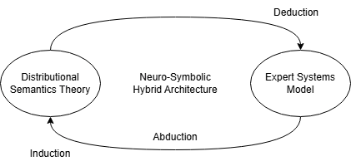
Figure 2: Theoretical Framework

Mendo v3.0 is built on a hybrid architectural approach that deliberately combines connectionist AI with symbolic reasoning. This design addresses the precision–safety gap observed in previous retrieval-based iterations by keeping probabilistic linguistic interpretation separate from deterministic clinical decision-making. The system's five-stage pipeline rests on two complementary theoretical foundations: Distributional Semantics Theory and the Knowledge-Based Expert Systems model [1, 5, 6]. These operate in a cascaded arrangement, the first ensures the system can understand what users are saying despite linguistic diversity, while the second ensures the system's medical reasoning stays within safe, verifiable bounds.

Distributional Semantics Theory

The system's ability to make sense of unstructured, multilingual, and informally phrased symptom descriptions draws from Distributional Semantics Theory. In plain terms, this theory holds that the meaning of a word emerges from the company it keeps — words appearing in similar contexts tend to carry similar meanings [5, 7]. This matters because pharmacy-kiosk users in Davao City do not type clinical terminology; they describe symptoms using paraphrases, regional dialects, or code-switched language that no finite dictionary can fully anticipate.

Within the Mendo v3.0 architecture, this theory underwrites the semantic embedding fallback layer. Driven by inductive learning from large textual corpora, a pre-trained multilingual transformer model maps user input into a high-dimensional vector space. When evaluating live user input, this layer employs abductive reasoning to infer the most probable underlying concept from informal text, thereby enabling the system to identify meaning equivalence between different surface expressions. Consequently, phrases such as "sakit ng ulo" and "my head is pounding" both map near the HEADACHE concept. This maintains broad recall for diverse patient language without requiring exact dictionary matches. Critically, however, the system treats these probabilistic outputs as supporting evidence rather than as authoritative detections. Every semantic suggestion must still pass through lexical guards that prevent the model from hallucinating symptoms not actually present in the user's text [7, 8].

Knowledge-Based Expert Systems Theory

While distributional semantics handles the variability of human language, the system's core safety and reasoning mechanisms are grounded in the Expert Systems model. An expert system mimics the decision-making of a human specialist by applying structured knowledge through a deterministic inference engine [1, 6, 9]. By executing strict deductive reasoning, the Expert Systems model governs both the symbolic processing of natural language, including negation rules, scope detection, and contrastive boundary logic, as well as the clinical reasoning required for safe medication dispensing, such as contraindication checks, age-based formulation selection, and paracetamol overlap detection.

This deterministic foundation is necessary for a safety-critical, domain-specific application. Rather than operating as an open-ended conversational agent, the system functions as a strictly constrained decision-support tool, mapping validated symptoms to a predefined over-the-counter catalog using absolute clinical rules [1, 6].

Conceptual Framework

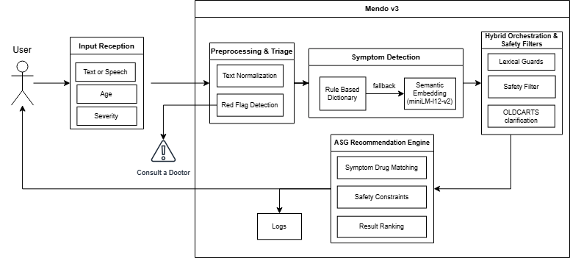
Figure 3: Conceptual Framework
Mendo v3.0 is designed as a multilingual OTC medicine recommendation kiosk that accepts free-text symptom descriptions and produces age-appropriate, safety-screened medication suggestions. The system follows a five-stage conceptual process.
In the first stage, the user enters their symptom description through the kiosk interface using Bisaya, Tagalog, English, or any combination. Age and symptom severity can be optionally provided.
Proxy-Purchase Screening. Because pharmacy customers often buy medicine for someone else — a child, an elderly parent, or a sick relative at home — the consultation opens with a short screening step that asks whether the medicine is for the user or for another person. When it is for someone else, the age the system collects is explicitly the intended patient’s age rather than the buyer’s, so that the age-based safety filter (which removes medicines below a product’s minimum-age requirement) is applied to the person who will actually take the medicine. The selection is stored with the consultation log for auditability. This complements the existing pregnancy red-flag, which already lets a proxy purchaser buy on behalf of a pregnant relative without the system mistaking the buyer for the patient.
In the second stage, the system preprocesses and normalizes the input while simultaneously screening for red-flag conditions—potential emergencies that warrant professional medical attention rather than OTC treatment. If a serious condition is flagged, the system suppresses all OTC recommendations and advises the user to seek immediate medical help. Only inputs that pass this screening proceed further.
In the third stage, the system performs symptom detection using a hybrid NLP approach that combines rule-based dictionary matching with semantic analysis. This enables recognition of both direct symptom mentions and varied, informal, or multilingual expressions of the same complaint.
In the fourth stage, detected symptoms pass through additional validation: negation checks, context-sensitive screening, and clarification prompts for symptoms that require more information (such as whether a cough is dry or productive). The output is a validated symptom set.
In the fifth stage, validated symptoms first pass through a duration screening step where the user is asked, for each detected symptom, how long the complaint has persisted. If the reported duration exceeds a clinically defined threshold specific to that symptom, the system blocks OTC recommendations and refers the user to a healthcare professional. Only symptoms that fall within safe self-medication timeframes proceed to the recommendation engine, which matches them against the OTC medicine database using symptom relevance, age restrictions, contraindications, and safety rules. The system presents appropriate recommendations with dosage guidance and safety reminders—or, if the case exceeds the safe scope of OTC use, advises the user to consult a healthcare professional.
The key conceptual shift from earlier Mendo versions is this: rather than predicting a medicine directly from raw text, v3.0 first identifies what the user's symptoms are, then evaluates possible medicines under defined safety constraints. This two-step approach provides a clearer and safer foundation for handling multi-symptom cases, negation, multilingual input, and context-sensitive recommendations.

System Architecture

Mendo v3.0 is implemented as a Flask application running on Python 3.12.3. The system comprises a customer-facing consultation layer, a hybrid NLP and recommendation layer, a data and knowledge layer, an inventory integration layer, and a logging layer. The consultation interface accepts typed symptom descriptions and can also process transcribed speech through an optional server-side endpoint. Results are filtered by age and cross-referenced against available inventory before recommendations are shown.

The architecture deliberately favors deterministic, rule-based processing for the first pass of symptom detection and safety screening. Semantic embeddings serve as a fallback only when dictionary matching finds nothing. This arrangement prioritizes traceability and safety in a pharmacy context where the system must explain and constrain its outputs rather than generate open-ended medical advice.
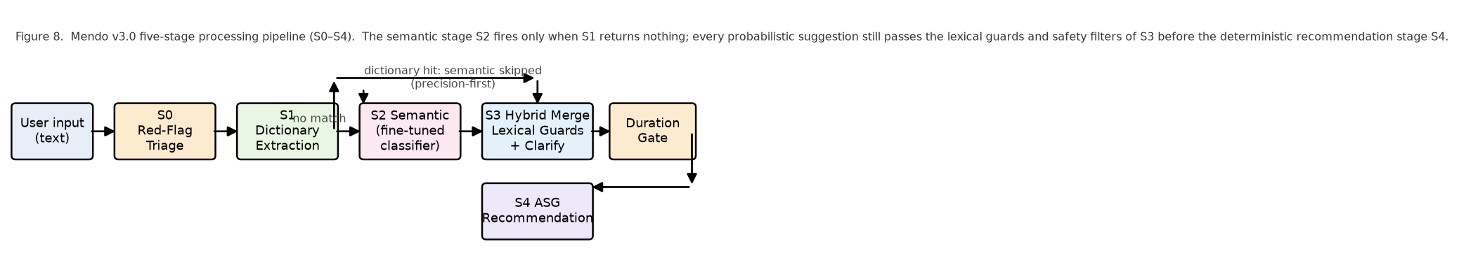
Figure 8: Mendo v3.0 five-stage processing pipeline (S0–S4). The semantic stage fires only when the dictionary returns nothing; every probabilistic suggestion still passes the lexical guards and safety filters of Stage 3 before the deterministic recommendation stage.

Stage 0: Triage / Red-Flag Safety Layer
The initial processing stage functions as a critical safety mechanism, screening user input for medical emergencies that require professional medical intervention rather than OTC self-medication. To balance precision and recall, the triage layer avoids brittle exact-phrase matching and overly broad keyword matching. Instead, it utilizes Proximity-Based Co-occurrence and Exclusion Rules.
The system detects critical red-flag conditions by searching for specific combinations of clinical entities occurring within a defined lexical window. Crucially, this stage incorporates "Exclusion Tokens" (negative constraints) to prevent over-triage. This ensures that severe keywords (e.g., "blood" or "numb") do not trigger false alarms when used in non-emergency, treatable contexts (e.g., "high blood pressure" or "numb tooth"), allowing those cases to safely proceed to the OTC recommendation stage.

Category | Clinical Rationale | Trigger Pattern (Co-occurrence) | Lexical Exceptions (Ignore if present)
Gastrointestinal Hemorrhage | Lower/Upper GI bleed | [blood / dugo] + [stool / dumi / vomit / suka] | None
Cardiac Emergency | Possible myocardial infarction | [pain / masakit] + [chest / dibdib / dughan] | halak, plema, ubo, cough (Allows treatment for chest muscle pain caused by severe coughing/congestion)
Respiratory Emergency | Impaired airway / Anaphylaxis | [difficulty / hirap / lisod] + [breathing / hinga] | None
Suspected Dengue / Viral | High risk of hemorrhage | [fever / lagnat] + [rashes / pantal / spots] | kagat, bite, allergy (Allows OTC antihistamines for insect bites/mild allergies)
Neurological Event (Stroke) | Requires immediate ER evaluation | [numb / manhid] + [face / mukha / half / kalahati] | ngipin, tooth (Allows OTC analgesics for radiating dental pain)
Severe Dehydration | Acute kidney injury risk | [diarrhea / nagtatae] + [walang ihi / no urine] | None
Pregnancy Contraindication | High risk of fetal harm from OTCs | [buntis / pregnant / naglilihi] (Single Keyword) | asawa, misis, kapatid, sister (Allows proxy purchasing for a pregnant relative)
Dangerous Hyperthermia | High risk of convulsions | [fever / lagnat / temp] + [40, 41, 42] | kilo, kg, edad, years old (Prevents numbers from being misclassified as temperature)
Direct Emergencies | Immediate intervention required | [seizure / kombulsyon] OR [nahimatay / fainted] | None

Table 4: Common Red Flag Key Words with Clinical Rationale

Stage 1: Dictionary-Based Symptom Extraction
The primary extraction stage uses a curated multilingual symptom dictionary containing 587 phrases across 14 clinical labels — the 13 semantic detection labels plus TOOTHACHE — covering five language variants. Each phrase was manually verified for linguistic accuracy and clinical relevance through iterative expansion during Iteration 1.
On using a curated dictionary instead of an existing dataset. A fair question is why this symptom dictionary was hand-curated rather than taken from an existing dataset. The practical answer is that no public dataset covers the specific intersection this system targets: lay, code-switched Tagalog–Bisaya–English symptom expressions (including Jejemon and leetspeak) mapped onto a small, fixed set of OTC-relevant symptom labels. General medical vocabularies and symptom corpora are overwhelmingly English and clinician-facing, and they do not capture how Davao pharmacy customers actually describe what they feel. We therefore built the dictionary from authoritative and field sources — package inserts and MIMS Philippines for the clinical terminology, and pharmacy fieldwork plus local language resources for the colloquial and dialectal variants — and we treat dataset reuse as complementary rather than a replacement. For Iteration 2, we plan to expand the dictionary’s surface forms more systematically by mining structured drug references such as MIMS for additional brand, generic, and indication terms, and by harvesting real spelling and phrasing variants from the consultation logs, so that coverage grows from observed usage rather than from the team’s imagination alone.

Symptom Label | Phrase Count | Languages | Key Examples
HEADACHE | 46 | Tag/Bis/Eng | "masakit ang ulo", "labad akong ulo", "headache"
FEVER | 105 | Tag/Bis/Eng | "lagnat", "nilalagnat", "hilanat", "init akong lawas"
BODY_ACHES | 64 | Tag/Bis/Eng | "masakit katawan", "binugbog", "bug at akong lawas"
RASHES | 32 | Tag/Bis/Eng | "pantal", "rash", "makati ang balat"
STOMACH_ACHE | 74 | Tag/Bis/Eng | "sakit tiyan", "kabag", "hyperacidity"
SORE_THROAT | 37 | Tag/Bis/Eng | "masakit lalamunan", "sore throat", "garas"
COUGH_PRODUCTIVE | 20 | Tag/Bis/Eng | "may plema", "basang ubo", "halak"
ALLERGIC_RHINITIS | 29 | Tag/Bis/Eng | "allergy", "bahing", "alerdyi", "makati ilong"
COUGH_GENERAL | 32 | Tag/Bis/Eng | "ubo", "cough", "inuubo", "gi-ubo"
COUGH_DRY | 15 | Tag/Bis/Eng | "walang plema", "tuyong ubo", "dry cough"
DIARRHEA | 44 | Tag/Bis/Eng | "pagtatae", "diarrhea", "lbm", "loose bowel"
NASAL_CONGESTION | 11 | Tag/Bis/Eng | "barado ilong", "stuffy nose", "blocked nose"
RUNNY_NOSE | 25 | Tag/Bis/Eng | "sipon", "runny nose", "tumutulo ilong"
TOOTHACHE | 53 | Tag/Bis/Eng | “sakit ngipin”, “ngilo”, “toothache”
Table 5: Symptom Dictionary — 587 phrases across 14 labels
Dictionary expansion (August 2026 revision). The dictionary grew from 570 to 587 phrases. Twelve of the new entries target common colloquial surface forms that previously fell through to the semantic stage or were missed outright: the Visayan fever family kalintura (kalintura, may kalintura, naa koy kalintura), the body-heat term panuhot (panuhot, panuhoton, napanuhot, ga panuhot), the runny-nose variant sip un, and stomach-complaint expressions built on guol (guol akong tiyan, guol ang akong tiyan, guol ang tiyan ko, guol sa tiyan). The common Tagalog fever word sinat is pinned deterministically in the FEVER dictionary with matching negation and lexical-guard keywords, so it is no longer subject to semantic scoring.

Text Normalization. All input text undergoes deterministic normalization before phrase matching: (1) lowercase conversion, (2) leetspeak/Jejemon character substitution (@ → a, 0 → o, 1 → i, 3 → e, 4 → a, 5 → s, 7 → t, 8 → b, $ → s, ! → i, | → i), (3) removal of non-alphanumeric characters (preserving ñ for Filipino words), and (4) whitespace collapsing. This handles informal digital communication styles common among Filipino youth (e.g., "s@k1t ul0" normalizes to "sakit ulo" and matches HEADACHE).

Phrase Matching Strategy. After the text normalization layer resolves deterministic character-level substitutions and canonical case alignments, the extraction pipeline passes the string to a dual-tiered exact dictionary matching layer. This layer treats single-word keywords and multi-word phrases differently to balance matching precision and operational speed. For single-word keywords, the system applies word-boundary constraints to prevent false positives caused by partial substring containment within unrelated tokens. This filter ensures a symptom term is recognized only when it stands alone as an independent lexical unit. For example, the keyword "ubo" will exclusively trigger a match if it is an isolated token, preventing erroneous extractions within distinct, unrelated words containing the same character sequence, such as "tubo" (pipe) or "subo" (to swallow). Conversely, multi-word dictionary entries, such as "masakit ang ulo" or "dry cough," are evaluated using sequential substring matching. Because multi-token phrases contain interior whitespace delimiters, they are structurally insulated from accidental containment inside individual unrelated words. Utilizing standard substring verification for these exact multi-word entries eliminates unnecessary regular expression compilation overhead, optimizing runtime efficiency. While this rigid string matching layer requires precise token sequencing and exact character alignment, its purpose is to serve as a high-velocity filter for clear-cut structural matches; any complex syntactic variations, inverted phrasing, severe typos, or unrecognized vocabularies that bypass this dictionary layer are subsequently routed to the downstream semantic embedding model for contextual resolution.

Negation Handling. Patients frequently mention symptoms they do not have alongside those they do (e.g., “masakit ang ulo ko pero walang lagnat” — “my head hurts but I don't have a fever”). Negation is processed by a scope-aware token walker instead of a fixed word window: a negation marker opens a scope that accumulates across coordinate connectors (ug, og, at, and, or, kay, tsaka, sabay) so that one marker can negate a whole joined list (“wala koy ubo ug sipon” negates both), and the scope closes at a contrastive or reason boundary (pero, but, apan, dahil, may, naa, meron). Every symptom keyword consumed inside the open scope is negated, with three conservative exceptions: a closer symptom keyword interrupts the chain (the nearer mention absorbs the negation); a trap verb (mawala, hunong, tigil) turns the mention positive, so “dili mawala akong ubo” still detects the cough; and a wellness predicate (normal, okay, walay problema) appearing before any symptom absorbs the negation, so “dili normal akong pagkalibang” still detects the diarrhea. Fused negative assertions such as “wala may mogawas” are parsed as a single negative construction and never open a positive clause. Every label negated here is recorded so that the fuzzy rescue pass can never resurrect it.
$neg(w_{k})⟺∃m<k:w_{m}∈N∧B(m,k)=∅∧\left(S(m,k)=∅∨S(m,k)\text{ joined by }C\right)$ (11)
where N is the set of negation markers, B the scope-end boundaries, S the symptom keywords, and C the coordinate joiners. Two vetoes keep the rule conservative: a trap verb (mawala, hunong, tigil) inside the scope turns the mention positive (“dili mawala akong ubo” still detects the cough), and a wellness predicate (normal, okay ra, walay problema) appearing before the first symptom keyword absorbs the negation (“dili normal akong pagkalibang” still detects the diarrhea). Fused negative assertions such as “wala may mogawas” are parsed as a single negative construction and never open a positive clause. Worked example: “wala koy gibati na sakit akong tiyan kay okay ra ug sakit sa ulo, pero gi ubo ko” — the scope opened by wala accumulates over ug and kay (negating both tiyan and ulo), closes at pero, and the cough is the only positive detection.
Formally, with tokens w₁…wₙ, a symptom keyword wₖ is negated if a negation marker m < k opens a scope that reaches wₖ without a contrastive boundary, and every intervening symptom keyword is linked to wₖ by a coordinate joiner:

Contrastive Boundary Splitting. Input is split on contrastive conjunctions (pero, but, kaso, however, though) into independent segments. Each segment is evaluated independently for negation, with positive mentions after a contrastive boundary overriding prior negation.

Cough-Type Qualification. A seven-step decision tree distinguishes COUGH_DRY, COUGH_PRODUCTIVE, and COUGH_GENERAL before the general dictionary scan runs. The tree incorporates itchy/scratchy throat indicators, chest-rattle/congestion indicators, cough-word verification, cough negation with plema-filler exemption, dry qualifier detection, wet qualifier detection, and a COUGH_GENERAL default.

Fuzzy Rescue Mechanism. After dictionary matching and negation processing, a generic fuzzy rescue pass recovers misspelled symptom mentions: each input token is compared against a table of 18 canonical English anchors using bounded Levenshtein distance with per-anchor edit caps (Table 6). The rescue is deliberately conservative. Anchors are English-only spellings because common Filipino and Bisaya words sit within 1–2 edits of the native anchors (“isang” ~ “ilong”, “simula” ~ “sikmura”) and would destroy precision; exact-match local synonyms live in the dictionary instead. Candidate tokens must be alphabetic, at least four characters long, and within two characters of the anchor's length. Tokens that are real dictionary words, negation markers, scope words, or genuine near-miss non-symptom words (ever, never, that, though, tough, couch, enough, …) are never candidates. A misspelled token inside a negation window is recorded as negated rather than detected — “wala koy hedache” fires nothing, while “hedache” alone rescues HEADACHE. Representative rescues include hedache→HEADACHE, totache→TOOTHACHE, couhg→COUGH_GENERAL, diahrea→DIARRHEA, and stomakache→STOMACH_ACHE.
$d(i,j)=min\left\{d(i−1,j)+1,d(i,j−1)+1,d(i−1,j−1)+1\left[t_{i} ≠ a_{j}\right]\right\},d(i,0)=i, d(0,j)=j$ (12)
$t↦L(a)⟺∃(a,L,δ_{a})∈𝒜:lev(t,a)≤δ_{a}∧||t|−|a||≤2∧|t|≥4∧t∉D∪E∪N∪B$ (13)
where δₐ is the per-anchor edit cap, D the set of dictionary tokens, E the near-miss exclusion set, N the negation markers, and B the scope words.
A token t is mapped to the label of anchor a iff:
The rescue relies on two formal rules. The Levenshtein distance recursion:

Table 6: Fuzzy Typo Rescue — Canonical English Anchor Table
Anchor | Symptom Label | Max Edits (δ)
headache | HEADACHE | 2
toothache | TOOTHACHE | 2
stomachache | STOMACH_ACHE | 2
stomach | STOMACH_ACHE | 2
tummy | STOMACH_ACHE | 1
diarrhea | DIARRHEA | 2
fever | FEVER | 1
cough | COUGH_GENERAL | 2
throat | SORE_THROAT | 2
sorethroat | SORE_THROAT | 2
nose | RUNNY_NOSE | 1
rash | RASHES | 1
itchy | RASHES | 2
sneeze | ALLERGIC_RHINITIS | 2
allergy | ALLERGIC_RHINITIS | 2
allergic | ALLERGIC_RHINITIS | 2
body | BODY_ACHES | 1
runny | RUNNY_NOSE | 2

Proximity-Based Heuristics. Several symptom labels use co-occurrence detection for compositional descriptions: headache heuristics (head word + pain word within ≤5 tokens), sore throat proximity (throat word + pain word within ≤5 tokens with dual negation checking), per-cue-group nasal inference, and an allergen-trigger heuristic.

Free-Text Headache-Type Intake.
Beyond the interactive head-map, the headache module also accepts the fourteen clinical headache types through typed free text, so the same clinical routing is available without extra UI steps. A deterministic multilingual tag matcher (no ML) scores the typed description against 202 strong and 67 weak cue tags organised per clinical type (migraine, tension, sinus, cluster, thunderclap, hypertension, spinal, post-traumatic, exertion, and the remaining types). Strong-tag evidence dominates; the five red-zone types — thunderclap, hypertension, spinal, post-traumatic, and exertion — dominate all other evidence and route the user directly to Emergency Triage. For the remaining types, the matched type's prefer/avoid medicine lists feed the recommendation engine, and every outcome is logged with the matched tags for auditability. When the user has clicked the head-map, the explicit click takes precedence over typed text.

Stage 2: Semantic Embedding Fallback
The semantic stage covers symptom descriptions that fall outside the dictionary's 587 curated phrases. It uses the pre-trained paraphrase-multilingual-MiniLM-L12-v2 model from the Sentence-Transformers library (Reimers & Gurevych, 2019), a compact transformer (~33 million parameters) producing 384-dimensional sentence embeddings. For an input sentence s of n tokens, the sentence vector is computed by mean-pooling the encoder's final hidden states: e(s) = (1/n) Σₖ₌₁ⁿ hₖ, where each hₖ ∈ ℝ³⁸⁴ and n is the number of tokens. The same encoder and pooling serve both semantic pathways described below.
$$e(s) = \frac{1}{n}\sum_{k = 1}^{n}{h_{k}}$$ (1)At initialization, 145 anchor sentences (5–23 per symptom label) are pre-encoded into 384-dimensional vectors, one vector e(a) per anchor. At runtime the user's input is encoded to e(u) and compared against all anchors using the cosine similarity of their embedding vectors,
$$cos(e(u), e(a)) = \frac{(e(u) · e(a))}{(‖e(u)‖ · ‖e(a)‖)}$$ (2)
where · denotes the dot product, ‖·‖ the Euclidean norm, and uᵢ, aᵢ the i-th components of the two 384-dimensional vectors. For each of the 13 labels L with anchor set Aₗ, the label score is the best-anchor maximum,
$$s_{L} = \max_{a ∈ A_L} cos(e(u), e(a))$$ (3)
and L is returned as a candidate when sₗ ≥ τ, with the similarity threshold τ = 0.65. Candidates are then ranked by sₗ and capped at two labels per utterance.
The encoder weights remain the fixed, publicly available pre-trained artifact; the semantic stage is complemented by a lightweight classification head fine-tuned on the project's internal evaluation corpora (see the Fine-Tuned Symptom Classification Head subsection). Freezing the encoder while training only the 13-label head is a deliberate choice: (1) safety — a small trained head does not disturb the encoder's multilingual competence and limits overfitting on a small corpus; (2) reproducibility — the pre-trained weights are a fixed artifact and the head is retrained deterministically from saved corpora; and (3) multilingual coverage — the model's pre-trained knowledge spans 50+ languages including Filipino and Cebuano, which would be difficult to replicate with limited domain-specific fine-tuning. Because the head is trained on the project's own corpora, its benchmark runs are reported only as regression checks; its honest generalization evidence comes from the held-out paraphrase and negative sets in the Evaluation chapter.
To give more context on how we landed on 0.65: we started by testing a low threshold of 0.40, which produced way too many false positives since a lot of unrelated inputs were clearing that bar. Bumping it up to 0.50 helped, but still let through phrases that were not really symptom-related. At 0.60, most valid paraphrases were being captured with fewer false positives, but we noticed that some legitimate matches for figurative or idiomatic expressions were getting dropped. At 0.65, the system kept coverage for meaningful paraphrases while filtering out adversarial cases like gibberish input and non-symptom text. Going higher to 0.70 and above caused the system to reject valid multilingual paraphrases that fell just barely below the cutoff. So 0.65 ended up being the best middle ground between catching real symptoms and not making things up. We do plan to run a more formal sensitivity analysis during Iteration 3 once we have real consultation data to work with.
A key design decision is the precision-first switching logic: the semantic layer activates only when Stage 1 finds zero symptoms. When the dictionary returns results, those results stand as-is, with no semantic augmentation. Deterministic, auditable results take priority over probabilistic detections wherever dictionary coverage is sufficient.
One trade-off of this design is that if the dictionary catches the primary symptom but misses a secondary one expressed idiomatically or figuratively, the semantic layer will not activate for that case. We accepted this trade-off because in an OTC recommendation context, a false positive (detecting a symptom that is not there) is more dangerous than a false negative (missing a secondary symptom): a missed secondary symptom yields an incomplete but not wrong recommendation, whereas a false positive could trigger an unnecessary or even contraindicated medicine. This precision-first behaviour — the primary symptom caught while an idiomatically expressed secondary one is missed — is exactly what the planned Iteration-2 real-user simulation is designed to measure. Relaxing this logic so the semantic layer runs as an augmentation rather than a fallback is something we plan to explore in Iteration 3, once we have enough real-user data to evaluate whether it increases false positive rates.
The model loads as a lazy singleton instantiated only on the first query requiring semantic processing to minimize startup time and memory on the Raspberry Pi 5 target hardware.

Fine-Tuned Symptom Classification Head.
Alongside cosine-anchor matching, the semantic stage includes a supervised counterpart: the same MiniLM encoder with a 13-output classification head fine-tuned on the project's internal symptom corpora. For an input sentence, the mean-pooled vector e(s) ∈ ℝ³⁸⁴ is projected by a weight matrix W ∈ ℝ³⁸⁴×¹³ with bias b, and each of the 13 labels L receives the logit
where W_L is the L-th column of W. The label probability is obtained with the sigmoid function applied independently per label (multi-label formulation, since several symptoms may be present simultaneously):
$$p_{L} = σ(z_{L}) = \frac{1}{(1 + e^{{−z}_{L}})}$$ (5)
$$z_{L} = W_{L}^{⊤} e(s) + b_{L}$$ (4)
Training. The head is trained on 801 labeled utterances assembled from the project's internal evaluation corpora — the 520-case multilingual symptom suite, the 288-case detection benchmark, and the 2026-08-14 idiom-enrichment corpus — after de-duplication. Because false positives are the more dangerous failure mode, each label contributes to the binary cross-entropy loss with a label-specific positive weight w_L (range 1–20) that up-weights the rare labels:
where y_L ∈ {0, 1} is the ground-truth indicator. The head is optimized with AdamW (learning rate 2×10⁻⁵, batch size 16, 6 epochs) while the encoder weights remain frozen. Five-fold cross-validation over the same corpus selects the operating threshold:
$$L_{BCE} = −\frac{1}{13}\sum_{L = 1}^{13}{\left[w_{L} y_{L} ln p_{L} + (1 − y_{L}) ln(1 − p_{L})\right]}$$ (6)
$θ^{*}=\underset{θ∈Θ}{\backslash argmax} {EM}_{CV}(θ),Θ=\{0.30,0.35,…,0.70\}$ (7)
Labels with p_L below the tuned cutoff τ′ = 0.70 are suppressed (out-of-fold exact-match 43.6% under the strict multi-label metric, which requires every label of a multi-symptom row to match). The final head is retrained on all 801 rows, and its weights (~20K parameters on top of the frozen 33M-parameter encoder) are stored beside the model directory for offline loading.
Deployment. Both semantic pathways expose the same analyze() interface and are selected at startup; the fine-tuned head is the deployed default (engine id mendo-expert-minilm-finetuned-v1), while the cosine-anchor path (mendo-expert-minilm-v3.2) remains selectable for comparison, and both honour the identical precision-first gating, lexical guards, and safety filters described under Stage 3. On the held-out paraphrase set (16 dictionary-miss utterances never seen during training) the fine-tuned head resolves 9/16 exactly versus 8/16 for cosine-anchor matching; on 20 fresh chit-chat negatives, both implementations emit zero symptoms (20/20). The head also makes the semantic stage fast: ≈11 ms mean per query when the stage fires, versus ≈59 ms for the cosine path, both on CPU. Because its training data include the internal benchmark corpora, detection-benchmark runs for this implementation are reported only as regression checks; the held-out sets above are its honest generalization evidence.

Stage 3: Hybrid Merge, Lexical Guards, and Safety Filters
This stage orchestrates results from Stages 0–2 and applies multi-layered filtering before anything reaches the recommendation engine. The processing flow:
1. Run triage detection (Stage 0) → red_flags list
2. Run dictionary extraction (Stage 1) → dict_symptoms
3. Apply explicit cough negation override
4. If dict_symptoms is non-empty → return dict_symptoms (skip semantic)
5. If dict_symptoms is empty → load semantic model (lazy singleton)
6. Run semantic extraction → raw semantic detections
7. Apply lexical guard: 11 keyword-gate groups covering all 13 symptom labels — each semantic detection must be grounded in at least one relevant keyword from the original input text
8. Apply centralized safety filter: seven explicit negation functions plus red-flag suppression rules
9. Score-rank and select top-N (default: 2) semantic symptoms
10. Return final symptom set with source attribution

Lexical Guard Mechanism. This prevents the embedding model from "hallucinating" symptoms not lexically present in the input. Each of 13 symptom labels has a dedicated keyword gate. For example, a semantic detection of COUGH requires at least one cough-related keyword in the input. COUGH_PRODUCTIVE has a compound gate requiring both a cough keyword AND a phlegm keyword. Detections failing their keyword gate are silently dropped.

Centralized Safety Filter. Seven explicit negation functions (fever, headache, cough, diarrhea, sore throat, nasal symptoms, allergy) are applied using word-boundary-safe regex. Two red-flag suppression rules prevent dangerous false positives: blood_in_stool → suppress DIARRHEA; severe_allergic_reaction → suppress SORE_THROAT. Three contextual gates further keep the semantic stage from misreading triage-level or non-nasal text as congestion: a bare breathing-difficulty phrase (“hirap huminga”, “shortness of breath”) is treated as a respiratory red flag rather than a nasal-congestion detection unless a nasal anchor (ilong/nose) is present; a throat mention without any nasal anchor vetoes NASAL_CONGESTION (a “blocked throat” routes to throat care, not cold syrup); and explicit allergy verbs (react, reacts, reaction) join the allergy lexicon triggers.
OLDCARTS Clarification Layer and Duration Screening Layer. The system uses targeted clarification logic, interactive visual mapping, and multi-modal input elements to collect critical context for symptoms where the label alone is insufficient for a safe over-the-counter (OTC) recommendation. The clarification layer is treated as a practical assessment heuristic within the recommendation design, not as a core theoretical pillar [31, 32].
To maximize accessibility and data fidelity across all symptom modules, the user interface completely replaces abstract, generic 1–10 numerical input scales with symptom-specific, highly visual iconographic scales tailored for conditions like coughs, colds (sipon), and stomachaches. Furthermore, the system embeds immediate emergency triage protocols directly into this layer to intercept high-acuity conditions before duration checking begins. For neurological complaints, the interface integrates an interactive, clickable visual head-map graphic; selecting high-risk anatomical regions (e.g., occipital zones) or indicating a sudden, severe "thunderclap" onset routes the user directly to Emergency Triage. Similarly, the dermatological sub-form incorporates a critical screening checkbox for rashes asking: "Are you experiencing difficulty breathing?". If this is flagged as true, the system identifies a potential systemic anaphylactic reaction and triggers an immediate Emergency Red Flag routing, completely bypassing standard processing. For gastrointestinal assessments, the system refines its evaluation by embedding a mandatory contextual menu, requiring the user to specify whether the pain occurs before eating, after eating, or is unrelated to food intake to better map aggravating and alleviating factors. Additionally, the cold (sipon) module incorporates specific clarification logic to distinguish allergic reactions from viral presentations; minor runny-nose cases accompanied by distinct allergy indicators such as sneezing, itchy eyes or nose, exposure to environmental triggers (dust, pollen, or pets), or symptoms recurring 'every morning' are automatically matched to OTC antihistamines (Cetirizine), whereas standard cases without these indicators are routed to receive general viral sipon relief.
Beyond these context-specific clarifications and emergency gates, the system implements the Duration component of the OLDCARTS framework as a universal safety measure applied across all symptom categories. After any applicable clarification questions are resolved and emergency flags are cleared, the system presents bilingual multiple-choice options to capture symptom persistence. If the reported duration exceeds the clinically defined threshold for that particular symptom, the system blocks all OTC recommendations and displays a referral notice advising the user to consult a licensed healthcare professional, along with the clinical basis for the referral.
The duration thresholds were derived from clinical guidelines published by the World Health Organization [33, 36, 38, 42], the United States Centers for Disease Control and Prevention [34, 39], the Mayo Clinic clinical reference database [35, 37, 40, 41], and standard OTC package insert warnings used in Philippine pharmacies. The 14-day cough threshold aligns with the DOH community-level TB screening protocol, given that the Philippines ranks among the top three countries in global TB burden [38]. The 3-day fever threshold accounts for the dengue-endemic status of the country, where dengue warning signs typically emerge within 24–48 hours after fever resolution [33, 34]. The 2-day diarrhea threshold follows established clinical advice that adult diarrhea lasting beyond 48 hours warrants medical evaluation due to dehydration risk and the possibility of bacterial or parasitic infection [35, 36]. Notably, the cold (sipon) sub-form enforces a strict 7-day threshold across all related nasal symptoms to proactively screen for secondary bacterial sinusitis or underlying complications before standard OTC options are permitted.

Symptom | Threshold | Action if Exceeded | Clinical Rationale / System Action
Fever | > 3 days | Block OTC, refer | Dengue, typhoid, malaria indicator (endemic PH) [33, 34]
Diarrhea | > 2 days | Block OTC, refer | Dehydration risk; bacterial or parasitic infection [35, 36]
Sore Throat | > 5 days | Block OTC, refer | Streptococcal infection; rheumatic fever risk [37]
Stomach Ache | > 7 days | Block OTC, refer | Peptic ulcer, gallstones, appendicitis (Evaluated via food-intake dropdown)
Headache | > 7 days | Block OTC, refer | Hypertension, neurological issues [41, 42] (Bypassed if occipital/sudden via visual head-map)
Body Aches | > 7 days | Block OTC, refer | Inflammatory arthritis, nerve damage, post-viral sequelae
Rashes | > 7 days | Block OTC, refer | Fungal infection, scabies, chronic immune condition (Bypassed if dyspnea checkbox is True)
Allergic Rhinitis | > 7 days | Block OTC, refer | Chronic immune issue requiring prescription treatment
Nasal Congestion | > 7 days | Block OTC, refer | Colds/Sipon duration validation rule; screens for bacterial sinusitis [40]
Runny Nose | > 7 days | Block OTC, refer | Colds/Sipon duration validation rule; screens for bacterial sinus infection [40]
Cough (all types) | > 14 days | Block OTC, refer | TB screening protocol (DOH, endemic PH) [38, 39]
Table 7: Duration Safeguard Matrix — Symptom-Specific Thresholds for OTC Self-Medication

The duration check is performed per symptom. When the system detects multiple symptoms, it asks about each one sequentially, displaying a progress indicator (for example, "Symptom 1 of 3") so the user knows how many questions remain. If even one symptom exceeds its threshold, that symptom's recommendations are blocked and a referral is shown, while symptoms within safe timeframes proceed to the recommendation engine. This design ensures that cases where OTC treatment is still appropriate for some symptoms are not unnecessarily blocked entirely.
OLDCARTS Sample Implementation. To further illustrate the pipeline's multilingual processing, multi-step OLDCARTS flow, and multi-tiered safety-gating mechanisms, consider how the system handles distinct user scenarios. In a primary scenario, a Cebuano-speaking user approaches the kiosk and inputs: "gi ubo ko" (I'm coughing). The hybrid extraction pipeline processes this Bisaya input through three sequential stages. First, the dictionary scanner matches "ubo" against Cebuano cough entries to generate the symptom label COUGH_GENERAL. Because a cough is the sole detected symptom and lacks contextual modifiers regarding type, the system triggers a Character clarification prompt: "Please specify: Is your cough dry (walay/walang plema) or with phlegm (naay/may plema)?".
If the user selects "Dry cough," the system maps this input to the OLDCARTS Character component and reclassifies the symptom as COUGH_DRY. This reclassification dynamically shifts the recommendation strategy, selecting cough suppressants such as Tuseran Forte (Dextromethorphan + Paracetamol + Phenylephrine + Chlorphenamine) or Sinecod Forte (Butamirate citrate) while explicitly excluding expectorants like Solmux (Carbocisteine), as administering an expectorant for a non-productive cough serves no therapeutic purpose and risks unnecessary side effects. Conversely, selecting "With phlegm" reclassifies the condition as COUGH_PRODUCTIVE, directing the system to recommend expectorants like Ascof Forte (Lagundi leaf extract), Solmux, and Robitussin (Guaifenesin) while excluding suppressants.
Before displaying these recommendations, the system enforces the Timing element of the OLDCARTS framework through the Duration safeguard. For cough symptoms, the user is presented with four bilingual multiple-choice selections tailored to clinical thresholds: less than a day, 1–7 days, 8–14 days, or more than two weeks. Instead of abstract 1–10 numerical inputs, the interface utilizes highly visual, symptom-specific iconographic scales to determine severity and progression. If the user indicates a duration of "More than 2 weeks," the system blocks the over-the-counter (OTC) recommendation and displays a formal referral notice, as a cough persisting beyond 14 days may indicate chronic bronchitis, undiagnosed asthma, or tuberculosis, which require professional medical evaluation. If the duration falls within the safe thresholds of less than 14 days, the system proceeds to display the appropriate medicine recommendations normally.
The system applies analogous cross-symptom validation rules and emergency bypasses when users navigate other sub-forms:
Colds (Sipon) Pathway: If a user reports nasal symptoms via the iconographic scale but selects a duration exceeding 7 days, the system automatically bypasses standard OTC options and routes the user directly to a Doctor Consultation to screen for secondary bacterial sinusitis.
Stomachache Pathway: When a user presents with gastrointestinal complaints, the system refines its evaluation by generating a mandatory contextual dropdown menu asking: "Does the pain occur before eating, after eating, or is it unrelated to food intake?". This allows the pipeline to map the exact Timing and aggravating factors to differentiate between acid-related dyspepsia and acute abdominal pathologies.
High-Acuity Emergency Pathways: To mitigate risks associated with critical conditions, certain user selections trigger immediate triage routing that completely bypasses the standard duration questions. For example, if a user interacting with the neurological interface clicks a high-risk anatomical region (such as the occipital zone) on the interactive visual head-map graphic, or if a user in the dermatological sub-form checks the critical screening box confirming "difficulty breathing" alongside a rash, the system immediately suspends normal processing and routes the session directly to Emergency Triage.
Collectively, these operational scenarios demonstrate the system's multi-layered capabilities, seamlessly merging multilingual symptom extraction, interactive visual triage, contextual character clarification, and strict duration safeguards to optimize patient routing and prevent unsafe self-medication.

Stage 4: ASG Recommendation Engine
The final stage maps detected symptoms to OTC medicine recommendations using a structured JSON dataset built under the Authoritative-Source-Grounded (ASG) framework.

ASG Framework and Medicine Dataset. The ASG framework was adopted after the originally planned pharmacist annotation process could not be completed within the project timeline. Under this framework, all medicine data is sourced exclusively from authoritative pharmaceutical references: package inserts, MIMS Philippines, and DOH Philippines guidelines. The present version therefore represents a constrained, authoritative-source-grounded baseline; pharmacist review and expert annotation remain part of the Iteration 2 validation cycle, and final integrated validation is planned for Iteration 3. Each of the 24 medicine entries contains 15 fields:

Field | Type | Source
Brand | String | Product label
Generic/Main Use | String | Package insert
Drug Category | String | MIMS classification
Primary Symptom | String | Clinical mapping
Typical Symptoms Treated | String (comma-sep) | Package insert
Dosage Form | String | Product label
Minimum Age | String | Package insert
Notes | String | Clinical notes
Approved_Indications | Tuple[str] | Package Insert / MIMS
Indication_Source | String | ASG attribution
Contraindications | Tuple[str] | Package Insert / MIMS
Warnings | Tuple[str] | Package Insert
Drug_Interactions | Tuple[str] | Package Insert / MIMS
Max_Duration_Days | Integer | Package Insert
Contraindication_Source | String | ASG attribution
Table 8: Summary of ASG Framework and Medicine Datasets

The dataset contains 24 medicine entries covering 19 unique brands, representing common OTC medications available in Philippine pharmacies. Multiple entries exist for medicines available in different dosage forms (e.g., Biogesic Tablet and Biogesic Syrup) to enable age-appropriate form selection.

Recommendation Logic. The algorithm follows a deterministic, rule-based process:

1. Triage Gate: If red flags were detected, suppress all OTC recommendations and return "CONSULT A LICENSED MEDICAL EXPERT" with the specific emergency category.

2. COUGH_GENERAL Handling: If COUGH_GENERAL is the sole detected symptom, request cough-type clarification rather than recommending a generic medicine.

3. Symptom-to-Medicine Matching: Each detected symptom is matched against the dataset using rule-based scoring, and candidates are ranked by match score.

4. Brand Merging: Multiple entries of the same brand are merged, keeping the highest score and combining match reasons.

5. Safety Checks: (a) Paracetamol overlap detection warns when multiple paracetamol-containing medicines are recommended; (b) opposing mechanism warnings flag simultaneous expectorant and suppressant recommendations; (c) age filtering removes medicines below the user's minimum age requirement; (d) duration screening blocks OTC recommendations when the user reports symptom persistence beyond the clinically defined safe threshold for that symptom category (see Table 6: Duration Safeguard Matrix).

Medicine Coverage. The 24 entries cover: Cold & Flu (Bioflu), Cold/Decongestant (Neozep, Decolgen, Decolgen Forte, Symdex-D), Cough Suppressant (Tuseran Forte, Sinecod Forte), Expectorant (Ascof Forte, Solmux, Robitussin), Pain & Fever (Biogesic, Advil), Allergy (Cetirizine), Anti-Diarrheal (Loperamide/Diatabs), Probiotic (Erceflora), Rehydration (Hydrite ORS), Antacid (Kremil-S), and Antispasmodic (Buscopan).

Multilingual Language Support
Mendo v3.0 processes patient symptom descriptions in five language variants reflecting the linguistic diversity of Philippine pharmacy interactions.

Language Variant | Coverage Level | Example Input
Tagalog | Primary | "masakit ang ulo ko at nilalagnat"
Bisaya/Cebuano | Primary | "labad akong ulo, garas akong tilaok"
English | Full | "I have a headache and fever"
Taglish/Conyo (code-switch) | Full | "masakit head ko, may cough ako"
Jejemon/Leetspeak | Full | "s@k1t ul0", "lgnat ako"
Table 9: Coverage of the Multilingual Language Support for Mendo v3.0

Tagalog and Bisaya/Cebuano receive primary support with extensive phrase coverage in the dictionary, dedicated negation words, and anchor sentences in the semantic layer. English is fully supported through both dictionary phrases and the embedding model's native capability. Taglish/Conyo code-switching is handled through combined dictionary coverage and cross-lingual embedding similarity. Jejemon/leetspeak is handled through normalization-layer character substitution rules.

Evaluation Methodology
The proposed system is evaluated in two complementary phases: a technical evaluation that the research team conducts in-house, and a clinical validation carried out with a licensed pharmacy professional. The two phases answer different questions — the first asks whether the system behaves as designed, the second asks whether that design is actually correct in real pharmacy use.
Who conducts it. The technical evaluation is performed by the three student researchers, who run the structured benchmark against the deployed pipeline and record the results. Because correctness here is ultimately a clinical question, the expected medicine recommendations and safety decisions encoded in the benchmark were reviewed and signed off by the study’s adviser from the College of Pharmacy and Chemistry — a licensed pharmacist — so that the “correct answer” for each case is clinically grounded rather than decided by the developers alone. The Iteration 2 field validation is then conducted by licensed pharmacist(s) at the participating Botika ng Bayan branches.
The technical benchmark consists of 319 predefined test cases (see Benchmark Design below), each paired with a clinically reviewed expected output. For the field phase, the target is to collect at least 100 consenting, anonymized consultations across the participating branches — enough to support meaningful precision, recall, and F1 estimates against pharmacist judgment.
How it is conducted. In the technical phase, each benchmark case is submitted to the system and the generated output (detected symptoms, clarification prompts, red-flag decisions, duration referrals, and recommendations) is compared against the clinically reviewed expected output; a case passes only when every applicable component matches. In the clinical-validation phase, consenting users interact with the kiosk in a real pharmacy while anonymized logs are recorded; a licensed pharmacist then independently states, for each logged consultation, what the appropriate symptoms, safety action, and recommendation should have been. The agreement between the system’s output and this expert judgment — reported as precision, recall, and F1 — becomes the system’s externally validated accuracy.

Benchmark Design
The technical evaluation uses a structured CSV-based benchmark of 319 predefined test cases organized into five tiers of increasing difficulty. Each case pairs a predefined user input with its expected outputs — detected symptoms, clarification prompts, safety decisions, and recommendation outcomes — and a case is counted as successful only when the system produces the expected output for every applicable component.
Multilingual Evaluation Suite (520 cases). In addition to the five-tier CSV benchmark, the system is exercised against a multilingual utterance sheet of 520 rows: 13 symptom labels × 5 varied utterances × 2 forms (plain statement and negated statement) × 4 language variants (English, Filipino, Cebuano, and mixed code-switch). Each row's expected labels were reviewed by the licensed-pharmacist adviser, and the sheet doubles as the labeled corpus for the fine-tuned classification head (de-duplicated together with the 288-case benchmark into the 767 training rows described under the semantic stage). Accordingly, for the fine-tuned head these 520 rows are regression evidence, while for the cosine-anchor and dictionary paths they are fully held out. Results are reported under Evaluation Results below; of the two rows the deployed system does not resolve exactly, one is a typo in the sheet's own text and the other is a labeling-scheme clash in which the sheet maps a pure-throat utterance to Cough while the product taxonomy defines SORE_THROAT as a first-class label.
How the cases were created (an honest disclosure). The benchmark inputs were authored by the research team with the help of a large language model (LLM), which was prompted to generate realistic, varied, and deliberately adversarial Tagalog/Bisaya/English symptom descriptions for each target category and failure mode. The team then curated, corrected, and labeled every case, and the expected outputs were reviewed by the College of Pharmacy and Chemistry adviser. We state this plainly because it bounds what the benchmark can claim: since the same team that built the dictionary also shaped the test set, these 319 cases are best understood as a coverage and regression measure — evidence that the system behaves consistently across a wide, difficult range of inputs — not as an independent, third-party accuracy estimate. Independent accuracy is the job of the pharmacist-validated field study in Iteration 2. To limit the test set simply mirroring the rule base, no benchmark case was copied from the phrase dictionary, and the full set was frozen only after the rule inventory and semantic anchors were finalized.
Basis for the tier design. The five-tier structure follows the standard progression used in software and NLP system testing — from core functionality, to robustness under realistic noise, to adversarial stress, and finally to safety-critical behavior [1, 3]. Tiers 1–4 adapt this progression to symptom detection, while Tier 5 operationalizes the Duration component of the OLDCARTS clinical-assessment framework [31, 32], with each threshold grounded in the clinical references cited in Table 6 (WHO, U.S. CDC, Mayo Clinic, and Philippine DOH guidance) [33–42]. The tier sizes reflect where the design risk is concentrated: broad functional and robustness coverage, a dedicated adversarial tier to probe false positives, and focused safety tiers for triage and duration.
The benchmark is organized into the following tiers: Formal definitions. For a single case, let P be the set of predicted labels and E the expected set. Exact match is set equality, P = E. Per-label micro-averaging pools decisions across the whole corpus:
where TP, FP, and FN count labels across all (case, label) pairs, and
is the average fraction of the 13 labels that are wrong per case over M cases. Macro-F1 averages the per-class F1 equally, giving rare labels the same weight as common ones.
$$Hamming loss = \frac{1}{M}\sum_{m = 1}^{M}{\frac{\left|P_{m} Δ E_{m}\right|}{13}}$$ (10)
$$Precision = \frac{TP}{(TP + FP)}, Recall = \frac{TP}{(TP + FN)}$$ (8)
$$F1 = \frac{2 · Precision · Recall}{(Precision + Recall)}$$ (9)
Tier 1: Core Functional (106 test cases) – Evaluates the system's fundamental capabilities, including symptom recognition, multilingual input processing, negation handling, clarification generation, and recommendation accuracy.
Tier 2: Extended Robustness (94 test cases) – Assesses the system's ability to process realistic user inputs, such as code-switched language, Bisaya-heavy descriptions, informal expressions, misspellings, and complex symptom combinations.
Tier 3: Adversarial (64 test cases) – Tests the system's resilience against ambiguous, misleading, incomplete, or invalid inputs that may otherwise produce false symptom detection or inappropriate recommendations.
Tier 4: Triage Safety (24 test cases) – Verifies that emergency symptoms and other high-risk conditions are correctly identified and that the system suppresses OTC recommendations by directing users to seek immediate medical attention.
Tier 5: Duration Safeguard (31 test cases) – Evaluates the duration-based safety mechanism to ensure that symptoms persisting beyond clinically defined thresholds trigger appropriate referral recommendations instead of OTC medicine suggestions.
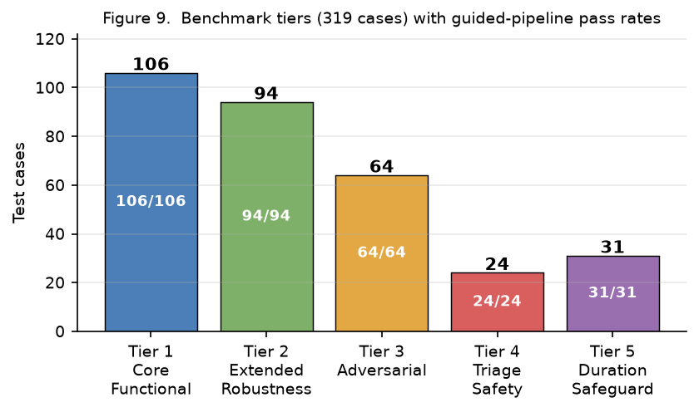
Figure 9: Benchmark tiers (319 cases) with guided-pipeline pass rates. All five tiers pass exactly under the deployed flow.

Evaluation Metrics
Exact Match. Detected symptoms exactly equal expected symptoms (set equality). This is the primary success metric.
Partial Match. At least one correct symptom detected with no false positives, but incomplete capture.
Failed. Wrong symptoms detected or empty result when non-empty output was expected.
F1 Score. Harmonic mean of per-test precision and recall, averaged across all cases.

Additional Validation Sets
outside the dictionary's 587 curated phrases
Fresh Negative Set (20 cases, implemented). Twenty kiosk-style distractor utterances (chit-chat, price inquiries, gibberish — e.g., “magkano ang biogesic”, “salamat”, “asdfghjkl”) test the honesty requirement that nothing fires when no symptom is present; they were never used to build any rule, anchor, or training row. Both the fine-tuned head and the cosine path score 20/20 (nothing emitted). The Real-User Simulation set remains the planned Iteration-2 deliverable.

Evaluation Results

The structured benchmark was run against the deployed pipeline on the current codebase with the fine-tuned semantic head active. On the 288 detection cases (Tiers 1–4), the system reaches 288/288 (100.0%) exact match once the cough clarification step is simulated, and 234/288 (81.2%, micro-F1 0.851) on the raw output before clarification — the same count as the standalone dictionary stage (234/288, 81.2%): the precision-first gate lets the semantic stage decide only the dictionary-miss cases, and on this synthetic set none of its suggestions changes a raw outcome (see Table 11). The precision-first gate guarantees the pipeline never drops below the deterministic stage's raw result. The Tier 5 Duration Safeguard passes 31/31 (100%). Two further implemented suites round out the picture: the multilingual 520-row sheet resolves 518/520 (99.6%), with only the two documented annotation anomalies unresolved, and the free-text headache-type intake passes 60/60 (100%). The regression suite (pytest) reports 90 tests and 93 subtests passing — including the negation-scope, wellness-predicate, and typo-rescue cases introduced with this revision — and the six pure-negation traps in the 288-case set are all handled (6/6). Table 10 summarizes these results.

Benchmark | Cases | Partial | Failed
Detection (Tiers 1–4, with cough clarification) | 288 | 288/288 (100.0%) | 0 misses
Detection (Tiers 1–4, raw output) | 288 | 234/288 (81.2%); micro-F1 0.851 | cough type unresolved without clarification
Duration Safeguard (Tier 5) | 31 | 31/31 (100%) | -
Multilingual Evaluation Suite (520) | 520 | 518/520 (99.6%) | 2 annotation anomalies
Semantic Generalization (16 held-out) | 16 | 9/16 direct; 10/16 guarded | deep-figurative, guard-vetoed misses
Fresh Negatives (20 held-out) | 20 | 20/20 (100%) | —
Headache-Type Intake | 60 | 60/60 (100%) | —
Table 10: Summary of Evaluation Results for Each Match

Table 10 (per-stage detection) and Table 12 (comparative models) report different numbers on the same 288 cases because they evaluate different points in the pipeline. When a case involves cough, Table 10's “with clarification” row simulates the user answering the cough-type question (“Is your cough dry or with phlegm?”), resolving COUGH_GENERAL into a specific type; under that condition the system reaches 288/288 (100.0%). The “raw output” row removes that step, so 54 cough cases score as mismatches because the system returns COUGH_GENERAL instead of the specific type, yielding 234/288 (81.2%) and micro-F1 0.851. The raw figure is the fairer number to compare against models that have no clarification mechanism.
A note on how we read these numbers. Because we are the same team that wrote the system's rules and also put together the benchmark ourselves, a high score here is something we frankly expected — and we want to be upfront that it is not the same thing as independent accuracy. We treat the benchmark as a coverage and regression check: it tells us the system behaves consistently across a wide and deliberately adversarial range of inputs, and it lets us catch the moment a rule change breaks something that used to work. The figure we actually care about — how often our system agrees with a licensed pharmacist on real, unscripted consultations — is exactly what we designed the Iteration 2 field validation to produce, and until we have that data in hand, we are deliberately not claiming it.
The 54 raw-output mismatches are all cough-type cases and are resolved by the clarification step in the deployed flow. Early Iteration-1 runs reported five open detection errors; these were closed during the refinement cycle by (1) making bare breathing-difficulty phrases a respiratory red flag rather than a nasal-congestion detection, (2) extending negation to plural word forms and phrase-initial negation idioms, and (3) tightening the fuzzy rescue so a misspelling repair cannot resurrect an explicitly negated or already-exact symptom. In the final codebase the guided flow is exact on all 288 detection cases. An evaluation that conceals its own failure history is not a useful evaluation, which is why the five pre-existing recommendation-stage mismatches (edge-case dosing-rule combinations among the 225 recommendation checks) are reported in the benchmark log next to the 220 passing checks rather than hidden.
Overall, the structured benchmark should be read as evidence of consistent, regression-checked behavior on a hard, multilingual test set — not as a deployment-accuracy claim. The deployment-accuracy claim is deferred to the pharmacist-validated field study in Iteration 2.
Semantic backend comparison. Because the semantic stage fires only on dictionary misses, its quality is measured on held-out paraphrases rather than on the synthetic benchmark. Table 11 compares the two semantic implementations run live through the full pipeline: the shipped fine-tuned classifier (engine mendo-expert-minilm-finetuned-v1) and the zero-shot cosine-anchor path (mendo-expert-minilm-v3.2). Both are exact on the 288-case benchmark (for the classifier this is in-sample regression only — its honest evidence is the held-out sets), and both emit zero symptoms on all 20 fresh chit-chat negatives. On the 16 held-out paraphrases the classifier resolves 9/16 with direct scoring (10/16 when the sheet's BODY_ACHE→BODY_ACHES annotation is canonicalized and the pipeline's lexical guards are active), versus 8/16 for the cosine path; the classifier is also about 5× faster per semantic query (~11 ms versus ~59 ms on CPU). The remaining misses are deep-figurative phrases that the guards veto — safe-by-design misses, never false positives.
Table 11: Semantic Backend Comparison (live, full-pipeline)
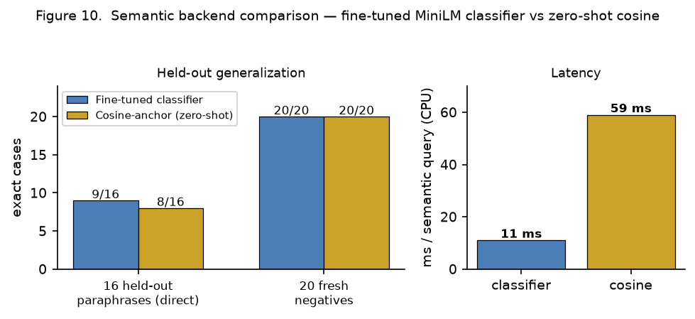
Figure 10: Semantic backend comparison — held-out paraphrases (direct), fresh negatives, and per-query latency on CPU.
Metric | Fine-tuned classifier | Cosine-anchor (zero-shot)
Mendo Dictionary (Stage 1) | 234/288 (81.2%) | 0.854
Mendo Hybrid Pipeline (deployed) | 234/288 (81.2%) | 0.854
0.849 | 0.851 | 0.028
4.4 | 9/16 (56.2%) | 8/16 (50.0%)
16 held-out paraphrases (guarded) | 10/16 (62.5%) | —
20 fresh negatives | 20/20 (100%) | 20/20 (100%)
Semantic latency (CPU) | ≈ 11 ms/query | ≈ 59 ms/query
Weights | 33M frozen + ~20K head | 33M frozen (zero-shot)
Comparative Benchmarking Against Retrieval and Embedding Baselines
A recurring question during development — and one the panel raised at the defense — was whether the hand-built pipeline was unnecessarily complex: would a fine-tuned transformer or a standard machine-learning classifier simply outperform it given the same data? To answer it directly, we benchmarked the deployed pipeline against five trained baselines on the same 288-case detection benchmark. The full comparison is committed and reproducible at experiments/classifier_benchmark/run_classifier_benchmark.py.

Models compared. Seven configurations were evaluated on the 288 cases: the Mendo dictionary (Stage 1) and the deployed Mendo hybrid, both evaluated cold (no training) on all 288; three TF-IDF classifiers — Linear SVM, Logistic Regression, and Random Forest (character n-grams 2–5, OneVsRest multilabel); and two fine-tuned multilingual transformers — mBERT (bert-base-multilingual-cased, ~178M) and XLM-RoBERTa (xlm-roberta-base, ~278M), each with a multilabel classification head trained using AdamW (learning rate 5×10⁻⁵, weight decay 0.01).

Evaluation protocol. The Mendo pipeline is evaluated cold on all 288 cases because it does not learn from the benchmark. The five trainable baselines use 5-fold stratified cross-validation (seed 42), giving roughly 230 training and 58 test cases per fold; predictions are collected out-of-fold and scored over the full 288. Exact match — set equality over the 13 symptom labels, with the empty set representing NONE — is the primary metric, reported alongside micro-F1 and Hamming loss.

The Mendo rows of Table 12

Model | Exact Match | Micro Precision | Micro Recall | Micro F1 | Hamming Loss | Latency (ms)
Mendo Dictionary (Stage 1) | 234/288 (81.2%) 231/288 (80.2%) | 0.863 0.856 | 0.849 0.846 | 0.856 0.851 | 0.027 0.028 | 2.1 2.1
Mendo Hybrid Pipeline (deployed) | 234/288 (81.2%) 234/288 (81.2%) | 0.863 0.863 | 0.849 0.849 | 0.856 0.856 | 0.027 0.027 | 4.4 4.4
Random Forest (TF-IDF) | 144/288 (50.0%) | 0.837 | 0.605 | 0.702 | 0.049 | 23.77
mBERT (fine-tuned) | 110/288 (38.2%) | 0.839 | 0.409 | 0.550 | 0.064 | 35.45
Logistic Regression (TF-IDF) | 95/288 (33.0%) | 0.902 | 0.154 | 0.263 | 0.082 | 0.06
XLM-RoBERTa (fine-tuned) | 65/288 (22.6%) | 1.000 | 0.017 | 0.033 | 0.094 | 24.14
Table 12: Comparative Benchmark Results

Analysis. In the raw (no-clarification) setting, the deployed hybrid reaches 234/288 (81.2%) — the same count as the standalone dictionary stage (234/288, 81.2%): the precision-first gate lets the semantic fallback decide only the dictionary-miss cases, and on this synthetic set none of its suggestions changes a raw outcome. The semantic stage's measurable contribution appears on the held-out paraphrase set instead (9/16 direct, 10/16 guarded — see Table 11). Both Mendo rows outperform every trained baseline by a wide margin. Among the baselines, SVM with character n-grams is strongest (55.9%) because subword features tolerate Filipino spelling variation, but it still cannot model negation, code-switching, or several symptoms in one sentence. The fine-tuned transformers do worse, not better: mBERT reaches 38.2% and XLM-RoBERTa only 22.6%. That looks surprising for 178–278M-parameter models, but it is exactly what severe data scarcity produces — with roughly 230 training examples per fold spread over 13 labels (a 2¹³ = 8,192-way label space), the transformers cannot learn stable decision boundaries and collapse toward predicting almost nothing; XLM-RoBERTa's high precision but near-zero recall (1.00 / 0.02) is the classic symptom. The low scores reflect data insufficiency, not a flaw in transformer architectures — with a larger annotated corpus and a usable GPU the picture would likely change. Within the same comparison, the fine-tuned 13-label head demonstrates that the constraint that limits the general baselines — data scarcity — is exactly what the curated dictionary-plus-semantic architecture was designed to absorb.

Scope and honesty of this comparison. This is deliberately a low-resource baseline comparison, and we present it as such. It shows that, given the data and hardware actually available for this project (288 labeled cases, offline Raspberry Pi 5, no GPU), hand-encoded domain knowledge beats supervised learning from a small labeled corpus; it does not claim transformers are universally inferior. The full benchmark — data splits, training, and metrics — is committed and reproducible at experiments/classifier_benchmark/run_classifier_benchmark.py. The classical-ML baselines (SVM, Random Forest, Logistic Regression) and the Mendo rows were regenerated by this script and reproduced the original figures exactly; the two fine-tuned-transformer rows (marked *) carry the original run’s figures and are being regenerated with the same committed script (CPU fine-tuning is slow on the dev machine; a GPU completes it in minutes). As a supplementary check, modern sentence-embedding models (BGE-M3, Qwen3-0.6B, Jina-v3) used in retrieval mode also scored only 34–47% on the same cases (experiments/retrieval_benchmark), reinforcing that general-purpose neural similarity is too blunt for this narrow, safety-critical task.

Among the trained baselines, SVM with character-level TF-IDF is the strongest (55.9%), because subword n-grams capture Filipino morphology and tolerate misspellings. But it hits a hard ceiling: it cannot detect negation, handle Bisaya–English code-switching mid-sentence, or reason about multiple co-occurring symptoms — precisely the cases that account for the hybrid’s large lead.

Taken together, given Mendo’s actual constraints — a small label set, multilingual code-switched input, safety-critical negation handling, and offline deployment on a Raspberry Pi 5 with no GPU — the hand-engineered hybrid was the most suitable architecture among those tested. This benchmark does not claim rule-based systems are universally better than neural ones; it answers a practical engineering question for this specific project, and the answer here is yes. If larger annotated datasets become available through the Iteration 2 data collection, revisiting fine-tuned and few-shot neural approaches with proper hardware would be a worthwhile next step.

Benchmark Integrity. No benchmark case was copied from or derived from the handcrafted phrase inventory, and the 288-case benchmark set was finalized only after the rule inventory and semantic anchor set had been frozen. The benchmark includes adversarial categories (negation, code-switching, misspellings, gibberish) specifically designed to test failure modes the dictionary cannot cover, further reducing the risk of indirect overfitting between the rule base and the evaluation set.

Why Not a Large Language Model for Drug Recommendation?

After seeing how well transformers perform in other medical NLP tasks, a reviewer might reasonably ask: why not go all the way and use a full generative LLM like GPT-4, LLaMA, or Gemini to handle both symptom detection and drug recommendation? We considered this early in the project and ultimately decided against it, for reasons that go beyond benchmark scores.

- Safety and determinism. When a system recommends medicine, a wrong answer can cause real harm. LLMs produce text probabilistically. Run the same prompt twice and you might get different advice. They can hallucinate drug names, miss a negation in the input, or suggest a medicine that is contraindicated for a child. Our pipeline avoids this by design: paracetamol overlap checks, opposing-mechanism warnings, age-based formulation filters, red-flag triage suppression, and duration-based referral thresholds are all hard-coded rules that fire on every single consultation without exception. An LLM does not natively provide those deterministic guarantees unless you wrap it in an external rule layer on top, and at that point you are essentially rebuilding what we already have [1, 6, 21, 22].

- Explainability and traceability. If a pharmacist or a panel reviewer asks "why did the system recommend this drug?", we need a clear answer. Our pipeline logs exactly which dictionary phrases matched, which semantic anchors activated, which negation rules blocked a detection, and which safety filters altered the final output. Every recommendation has a paper trail. An LLM generates a text response, but there is no straightforward way to trace back which internal weights or attention patterns produced that specific recommendation. You could bolt on an explanation layer, but that adds complexity without matching the native traceability the rule-based pipeline already provides [3, 6].

- returns results in about 11 milliseconds per query on CPU when the fine-tuned head fires (≈59 ms for the zero-shot cosine path)

- Cost and sustainability. Cloud LLM APIs charge per token, and a busy pharmacy kiosk could easily handle hundreds of consultations a day. Paying an API provider to recommend Biogesic or cetirizine, which cost only a few pesos each, does not make economic sense. Once deployed, the Mendo pipeline has zero per-query cost. No API keys, no monthly bills, no external service dependencies.

- Regulatory and data privacy. Sending patient symptom descriptions to an external API (whether Google's, OpenAI's, or anyone else's) raises immediate privacy concerns under Philippine data privacy law (Republic Act No. 10173). Health information routed through third-party servers creates compliance risks that we would rather not take. A fully offline system sidesteps the issue entirely: patient data never leaves the kiosk [10, 11].

- The problem is bounded, not open-ended. LLMs shine when a task needs flexible reasoning across broad knowledge. That is not what Mendo does: it detects symptoms from 13 fixed labels, looks them up against 24 medicines, and applies age and safety rules. It is a narrow, well-defined problem, and narrow problems benefit more from purpose-built engineering than from general-purpose generation. The comparative benchmark bears this out — general-purpose embedding models with hundreds of millions of parameters still could not match a pipeline built specifically for this scope, which suggests that simply adding parameters is not the answer when the domain is small and the safety rules must be exact.

For all these reasons, we chose a hybrid architecture: a compact 33-million-parameter embedding model handles the linguistic understanding, while hard-coded rules handle every safety-critical decision. It is a deliberate division of labor—we trust the model to understand language, but we do not trust any model to decide what medicine someone should take.

On User Verification and Anonymity. During the defense it was asked whether the kiosk should verify each user with a fingerprint on the first screen — both to limit repeated attempts and to support user profiling. We considered biometric verification and deliberately chose not to require it, for three reasons. First, privacy and data minimization: under the Philippine Data Privacy Act (RA 10173), a fingerprint is sensitive personal information, and collecting it would turn an otherwise anonymous OTC consultation into an identifiable health record stored on the device — a far larger privacy and consent burden than the system needs. A walk-up pharmacy kiosk works best when a customer can use it without enrolling biometric data. Second, accessibility: requiring fingerprint enrollment adds friction and excludes users who cannot or prefer not to enroll, which runs against the goal of broad, low-barrier access. Third, the brute-force concern it was meant to address applies to the administrative dashboard, not the public consultation flow; we handle that at the right layer — hashed credentials (PBKDF2), session hardening, and server-side request validation — rather than by fingerprinting customers. If a future deployment requires loyalty or repeat-purchase features, our recommendation is an explicit, opt-in mechanism with informed consent, never a mandatory biometric gate on a health consultation.

Error-Driven Iterative Refinement

During Iteration 1, the system was tested by deliberately feeding it tricky and unusual inputs to find weaknesses. This process revealed 19 issues spread across common problem areas like the system misunderstanding negation (e.g., "wala nako'y ubo" being read as a cough instead of "no cough"), mixing up similar symptom types, incorrectly identifying symptoms from unrelated words, and missing certain safety-critical patterns. Each issue was fixed one at a time, and after every fix the full 288-case benchmark was re-run to make sure nothing that was already working got broken.

As a supplementary probe—not a substitute for structured testing—the researchers also used Gemini 2.5 Pro to scan for potential blind spots the team might have overlooked. Out of seven areas it flagged, six had already been addressed through the testing process. This supplementary check gave additional confidence that the iterative approach had caught most of the important edge cases, though the benchmark and regression tests remain the primary basis for evaluating system correctness.

Hardware Section

This section documents the physical subsystem of MendoVendo v3.0: the dispensing mechanism, the cash-acceptance hardware, the microcontroller that drives both, and the boundary between that hardware and the recommendation software described in the preceding sections. The governing design value is the same one that governs the software layer. Every decision that affects patient safety or money is made by a deterministic rule, and no such decision is delegated to a component whose behaviour has not been measured on the bench.

That principle has a consequence the reader should note at the outset. The prototype is built so that it refuses to accept real currency or to drive real motion until the corresponding physical evidence has been captured and reviewed. Throughout this section, therefore, a clear distinction is maintained between three categories of claim: what has been measured on the physical hardware, what has been designed and verified in software or in CAD but not yet actuated, and what remains deliberately disabled. Presenting an untested subsystem as working would be the more flattering account; it would also be the one that fails first in the field.

System Architecture

The user interacts only with the front panel. The Raspberry Pi 5 runs the entire recommendation pipeline offline, so no patient utterance or symptom record leaves the device; this is the design response to the Data Privacy Act (RA 10173) discussed in Section 2. The Pi communicates with an Arduino Uno R3 over USB at 115200 baud. The Arduino owns all real-time work: counting interrupt-driven pulses from the cash acceptors and commanding servo motion through a PCA9685 driver.

The division of labour is deliberate. A general-purpose operating system cannot guarantee that it will service an interrupt within the 50 ms window of a credit pulse, and a missed or double-counted pulse is a money defect. Conversely, an 8-bit microcontroller is a poor place to hold financial state. The Arduino therefore captures and timestamps events; the Pi decides what they mean and records them durably.

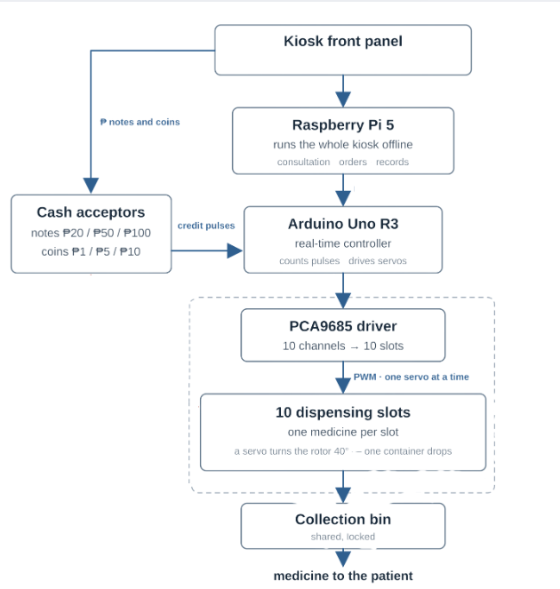

Figure 4: Hardware architecture of the kiosk. Cash and touch input enter at the top, the Pi and the Arduino divide the work, and one container leaves the bottom. Solid outlines mark hardware that is present and has been measured

3D Printed Model

Figure 5: One complete dispensing slot, assembled: deck plate, 9-pocket rotor, stationary magazine, and containers seated in the pockets.

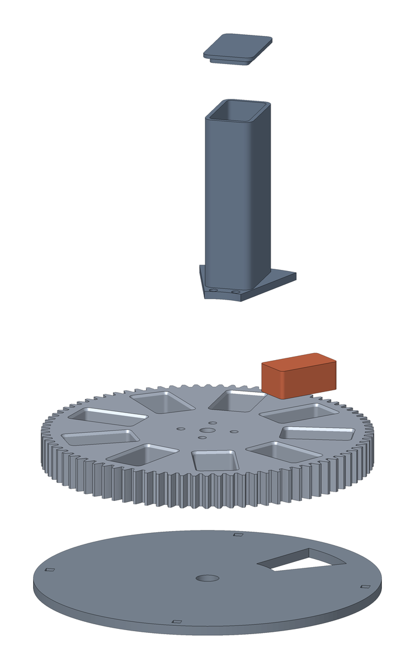
Figure 6: Exploded view of one slot, showing the assembly order and the drop aperture in the deck plate.

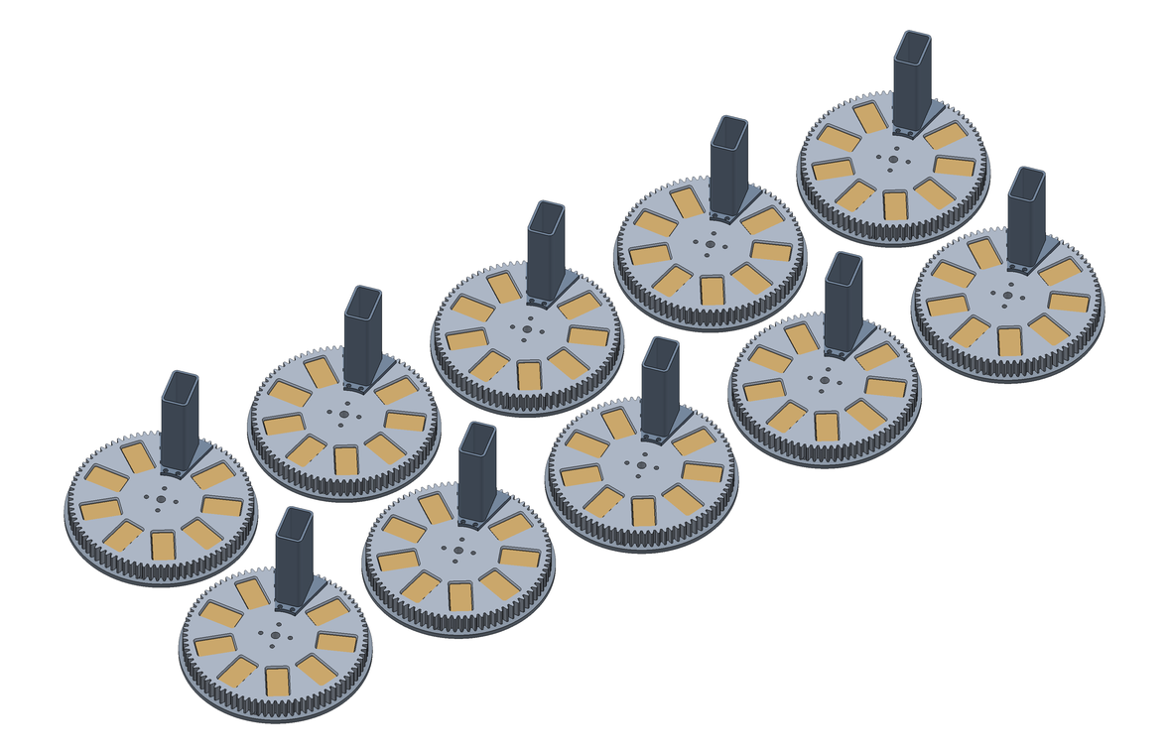
Figure 7: The ten-slot bank. Each slot is mechanically independent and holds a single OTC medicine.

Project Workplan

No. | Activity | 2026
 |  | Feb | Mar | Apr | May | Jun | Jul | Aug | Sep | Oct | Nov | Dec
1 | Research Planning & Proposal Development
1.1 | Literature review and protocol writing
1.2 | Topic Finalization & Adviser Consultation
1.3 | REC submission to obtain Ethical Clearance
2 | Iteration 1
2.1 | System Requirements Definition
2.2 | Hybrid Recommendation System Design
2.3 | Baseline System Development
2.4 | OTC Symptom Dataset Collection
2.5 | Internal System Testing and Validation
2.6 | Dataset Cleaning and Preparation
2.7 | Iteration 1 System and Dataset Review
3 | Iteration 2
3.1 | Expert Annotation of Consultation Data
3.2 | Vendo Machine Prototype Development
3.3 | Software and Hardware Functional Testing
3.4 | Iteration 2 Evaluation and Review
4 | Iteration 3
4.1 | System Refinement Based on Expert Feedback
4.2 | Hardware–Software Integration
4.3 | Integrated System Testing and Evaluation
4.4 | Final System Validation
4.5 | Deployment of the MendoVendo System
5 | Documentation & Thesis Defense
5.1 | Thesis Writing & Documentation
5.2 | Revision & Adviser Consultation
5.3 | Thesis Presentation Consultation
5.4 | Final Thesis Defense

Legend:
█ Phase 1: Protocol Development & Ethics Approval █ Phase 2: Iteration 1
█ Phase 3: Iteration 2 █ Phase 4: Iteration 3
█ Phase 5: Documentation & Defense

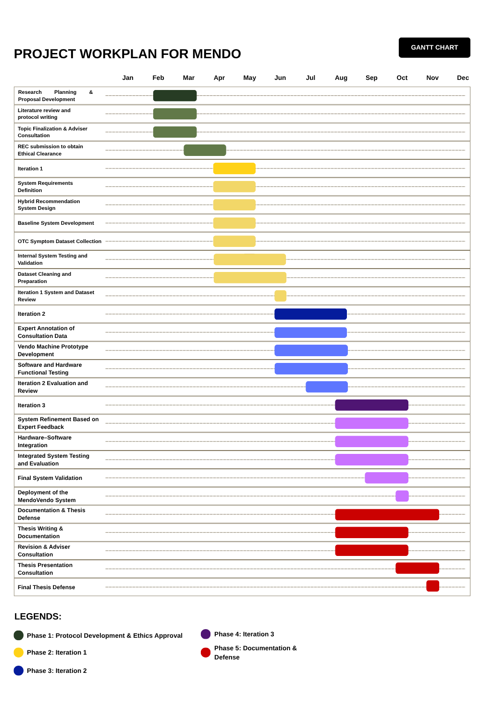
Project Workplan (Gantt Chart)

Proposed Budget
Item No. | xItem Description | Quantity | Unit Cost (₱) | Total Cost (₱)
A. Core Processing Components
1 | Raspberry Pi 5 (8GB) | 1 | 10,000 | 10,000
2 | 64GB Authentic MicroSD | 1 | 600 | 600
3 | Official 5V PSU | 1 | 800 | 800
B. Microcontroller Layer
4 | Arduino Mega 2560 | 1 | 900 | 900
5 | Servo Driver PCA9685 | 1 | 350 | 350
C. Dispensing Mechanism (Servo-Driven Modular Wheels)
6 | MG996R High Torque Servo | 12 | 250 | 3,000
7 | PLA Filament (1.5kg total) | 2 rolls | 900 | 1,800
D. Structural Materials (Acrylic Enclosure)
8 | 3mm Clear Acrylic Panels | set | 3,500 | 3,500
9 | Laser cutting / fabrication allowance | set | 1,200 | 1,200
E. Power System
10 | 5V 10A Switching Power Supply | 1 | 900 | 900
11 | Buck Converter Modules | 2 | 120 | 240
F. Supporting Electronics
12 | Relay Modules | 1 | 250 | 250
13 | Limit Switch Sensors | 6 | 40 | 240
G. Medicine Containers
14 | Plastic Capsule Containers | 500 minimum | .80 | 400
TOTAL ESTIMATED BUDGET: |  |  |  | ₱24,180

References:

[1] Eguia, H., Sánchez-Bocanegra, C. L., Vinciarelli, F., Alvarez-Lopez, F., & Saigí-Rubió, F. (2024). Clinical decision support and natural language processing in medicine: Systematic literature review. *Journal of Medical Internet Research*, 26, Article e55315. https://doi.org/10.2196/55315
[2] Tan, J., Rong, Y., Zhao, K., Bian, T., Xu, T., Huang, J., Cheng, H., & Meng, H. (2024). Natural language-assisted multi-modal medication recommendation. *Proceedings of the 33rd ACM International Conference on Information and Knowledge Management*, 2200–2209. https://doi.org/10.1145/3627673.3679529
[3] Bayor, A. A., Li, J., Yang, I. A., & Varnfield, M. (2025). Designing clinical decision support systems (CDSS)—A user-centered lens of the design characteristics, challenges, and implications: Systematic review. *Journal of Medical Internet Research*, 27, e63733. https://doi.org/10.2196/63733
[4] Wohlgemut, J. M., Erhan Pisirir, Stoner, R. S., Perkins, Z. B., Marsh, W., Tai, N. R. M., & Kyrimi, E. (2024). A scoping review, novel taxonomy and catalogue of implementation frameworks for clinical decision support systems. *BMC Medical Informatics and Decision Making*, 24(1). https://doi.org/10.1186/s12911-024-02739-1
[5] Elvas, L. B., Almeida, A., & Ferreira, J. C. (2025). Natural language processing in medical text processing: A scoping literature review. *International Journal of Medical Informatics*, 204, 106049. https://doi.org/10.1016/j.ijmedinf.2025.106049
[6] Newton, N., Bamgboje-Ayodele, A., Forsyth, R., Tariq, A., & Baysari, M. T. (2025). A systematic review of clinicians' acceptance and use of clinical decision support systems over time. *npj Digital Medicine*, 8(1). https://doi.org/10.1038/s41746-025-01662-7
[7] Haemmerl, K., Fastowski, A., Libovický, J., & Fraser, A. (2023). Exploring anisotropy and outliers in multilingual language models for cross-lingual semantic sentence similarity. *Findings of the Association for Computational Linguistics: ACL 2023*, 7023–7037. https://doi.org/10.18653/v1/2023.findings-acl.439
[8] Mahajan, Y., Bansal, N., Blanco, E., & Karmaker, S. (2024). ALIGN-SIM: A task-free test bed for evaluating and interpreting sentence embeddings through semantic similarity alignment. *Findings of the Association for Computational Linguistics: EMNLP 2024*, 7393–7428. https://doi.org/10.18653/v1/2024.findings-emnlp.436
[9] Lin, X., Liang, C., Liu, J., Lyu, T., Ghumman, N., & Campbell, B. (2024). Artificial intelligence–augmented clinical decision support systems for pregnancy care: Systematic review. *Journal of Medical Internet Research*, 26, e54737. https://doi.org/10.2196/54737
[10] Rose, S. L., & Shapiro, D. (2024). An ethically supported framework for determining patient notification and informed consent practices when using artificial intelligence in health care. *CHEST*, 166(3), 572–578. https://doi.org/10.1016/j.chest.2024.04.014
[11] Bouderhem, R. (2024). Shaping the future of AI in healthcare through ethics and governance. *Humanities and Social Sciences Communications*, 11(1), 1–12. https://doi.org/10.1057/s41599-024-02894-w
[12] Limaye, D., Limaye, V., Krause, G., & Fortwengel, G. (2017). A systematic review of the literature to assess self-medication practices. *Annals of Medical and Health Sciences Research*. https://www.amhsr.org/articles/a-systematic-review-of-the-literature-to-assess-selfmedication-practices-3711.html
[13] Ma, C., & Zhang, H. (2025). A cross-sectional study on self-medication with over-the-counter drugs among adolescents: An analysis of current practices. *Frontiers in Public Health*, 13. https://doi.org/10.3389/fpubh.2025.1560299
[14] Maever, A., Filipino, C., & Dayrit, M. M. (2023). Self-care practices for common acute conditions in the Philippines: A scoping review. *International Journal of Health Governance*, 28(4). https://doi.org/10.1108/ijhg-01-2023-0008
[15] Manila Standard. (2022, January 29). Internet research among reasons why most Filipinos self-medicate. *Manila Standard*. https://manilastandard.net/?p=314203452
[16] Decoding OTC medicines in the Philippines. (2023, October 20). NIQ. https://nielseniq.com/global/en/insights/analysis/2023/decoding-otc-medicines-in-the-philippines/
[17] Star, S. (2025, January 6). Over 1M Dabawenyos receive free meds from city's Botika ng Bayan. *SunStar Publishing Inc*. https://www.sunstar.com.ph/davao/over-1m-dabawenyos-receive-free-meds-from-citys-botika-ng-bayan
[18] Saad, S., & Algarni, A. (2025). Disease prediction from symptom descriptions using deep learning and NLP technique. *International Journal of Advanced Computer Science and Applications*, 16(5). https://thesai.org/Downloads/Volume16No5/Paper_41-Disease_Prediction_from_Symptom_Descriptions.pdf
[19] Hulke, R., & Gudhade, M. (2025). AI-based symptom checker and preliminary diagnosis system. *IOSR Journal of Computer Engineering*, 27(2), 35–42. https://www.iosrjournals.org/manuscript_paper/116690.pdf
[20] Exploring the functionality of AI symptom checkers: How natural language processing transforms patient symptom assessment. (2025, June 7). *Simbo AI Blog*. https://www.simbo.ai/blog/exploring-the-functionality-of-ai-symptom-checkers-how-natural-language-processing-transforms-patient-symptom-assessment-965754/
[21] Khaledian, N., & Falahati, S. (2026). Safe and personalized drug recommendation via heterogeneous graph learning: Integrating graphSAGE representations with DDI-aware cross-attention. *Progress in Artificial Intelligence*. https://doi.org/10.1007/s13748-026-00437-9
[22] Li, S., Wang, H., He, J., & Chen, X. (2025). AMGNet: An attention-guided multi-graph collaborative decision network for safe medication recommendation. *Electronics*, 14(4), 760. https://doi.org/10.3390/electronics14040760
[23] Chen, Q., Li, X., Geng, K., & Wang, M. (2023). Context-aware safe medication recommendations with molecular graph and DDI graph embedding. *Proceedings of the AAAI Conference on Artificial Intelligence*, 37(6), 7053–7060. https://doi.org/10.1609/aaai.v37i6.25861
[24] Gallego, F., & Veredas, F. J. (2024). Recognition and normalization of multilingual symptom entities using in-domain-adapted BERT models and classification layers. *Database: The Journal of Biological Databases and Curation*, 2024, baae087. https://doi.org/10.1093/database/baae087
[25] Multilingual health symptom checker. (2025). *Computer Science, Engineering and Technology*, 3(2), 77–81. https://doi.org/10.46632/cset/3/2/9
[26] VerbalCare: A multilingual AI-based healthcare communication system. (2025). *International Journal of Scientific Development and Research*. https://www.ijsdr.org/papers/IJSDR2508203.pdf
[27] Kalva, P., & Padakanti, S. (2024). AI-driven personal healthcare: An integrated system for symptom-based OTC medication selection and local availability tracking. *International Journal of Research in Computer Applications and Information Technology*, 7(2), 464–476. https://ijrcait.com/index.php/home/article/view/IJRCAIT_07_02_036
[28] Sohail, M., et al. (2026). Enhancing medical prescriptions with machine learning: A symptoms-based drug recommendation system. *International Journal of Scientific Research in Engineering and Management*. https://ijsrem.com/download/enhancing-medical-prescriptions-with-machine-learning-a-symptoms-based-drug-recommendation-system/
[29] Bodele, H., Tagde, M., Rangari, S., Jadhao, Y., Bawankar, V., & Kumre, T. (2024). Medicine recommendation system using ML. *International Journal for Research in Applied Science and Engineering Technology*, 12(12), 836–844. https://doi.org/10.22214/ijraset.2024.65843
[30] Zomorodi, M., Ghodsollahee, I., Martin, J. H., Talley, N. J., Salari, V., Plawiak, P., Rahimi, K., & Acharya, U. R. (2023). RECOMED: A comprehensive pharmaceutical recommendation system. *arXiv*. https://doi.org/10.48550/arXiv.2301.00280
[31] Elmes, G. (2025, June 10). OLDCARTS: A framework for clinical excellence. *NursEd*. https://nursed.ca/virtual-care/oldcarts-patient-assessment-tool/
[32] Ummu, M. N. (2023, December 28). OLD CARTS acronym (explained w/ questions). *NurseShip*. https://www.nurseship.com
[33] World Health Organization. (2025, August 21). Dengue and severe dengue. World Health Organization. https://www.who.int/news-room/fact-sheets/detail/dengue-and-severe-dengue
[34] Centers for Disease Control and Prevention. (2024, May 16). Symptoms of Dengue and Testing. Dengue. https://www.cdc.gov/dengue/signs-symptoms/index.html
[35] Mayo Clinic. (2025). Diarrhea - Symptoms and causes. Mayo Clinic. https://www.mayoclinic.org/diseases-conditions/diarrhea/symptoms-causes/syc-20352241
[36] WHO. (2024, March 7). Diarrhoeal Disease. Who.int; World Health Organization: WHO. https://www.who.int/news-room/fact-sheets/detail/diarrhoeal-disease
[37] Mayo Clinic. (2021, June 10). Sore throat - Symptoms and causes. Mayo Clinic. https://www.mayoclinic.org/diseases-conditions/sore-throat/symptoms-causes/syc-20351635
[38] World Health Organization. (2025, March 14). Tuberculosis. World Health Organization. https://www.who.int/news-room/fact-sheets/detail/tuberculosis
[39] Centers for Disease Control and Prevention. (2024, May 3). Signs and Symptoms of Tuberculosis. Tuberculosis (TB). https://www.cdc.gov/tb/signs-symptoms/index.html
[40] Mayo Clinic. (2023, August 29). Acute sinusitis - Symptoms and causes. Mayo Clinic. https://www.mayoclinic.org/diseases-conditions/acute-sinusitis/symptoms-causes/syc-20351671
[41] Mayo Clinic. (2019). Chronic daily headaches - Symptoms and causes. Mayo Clinic. https://www.mayoclinic.org/diseases-conditions/chronic-daily-headaches/symptoms-causes/syc-20370891
[42] World Health Organization. (2024, March 6). Headache disorders. Who.int; World Health Organization: WHO. https://www.who.int/news-room/fact-sheets/detail/headache-disorders

‌

