MENDOv3: AN IMPROVED AI-ENABLED MEDICINE RECOMMENDER FOR AN OVER THE COUNTER (OTC) DRUG DISPENSER
Kristine Mae Adlaon¹, Jayrald Basan², Earl Cedric M. Coronado³ , Geoffrey J. Diapana³ , and John Paul J. Estano³
1. Faculty Researcher, College of Computer Studies
2. Faculty Researcher, College of Pharmacy and Chemistry
3. Student Researcher, College of Computer Studies

- INTRODUCTION
Self-medication using over-the-counter (OTC) drugs is a widespread practice across many parts of the world, particularly in communities where healthcare access is limited or where individuals seek faster and more affordable treatment for minor illnesses [12, 13]. Studies have shown that people frequently rely on their interpretation of symptoms when selecting medications, which can lead to inappropriate drug use when symptoms are misunderstood or inaccurately described. In the Philippines, self-medication is also commonly practiced due to factors such as limited healthcare accessibility, long waiting times in medical facilities, and the affordability and availability of OTC medicines in local pharmacies [14, 15,16]. This trend is reflected in national findings showing that only 7.4% of Filipinos report not self-medicating, meaning roughly 92.6% engage in some form of self-treatment [15]. In Davao City, despite the Botika ng Bayan program providing free medicines to over a million residents annually, individuals often continue to rely on prior experience, advice from family members, or information obtained online when deciding which medication to take [17]. These behaviors highlight the need for accessible tools that can assist users in interpreting symptoms and identifying appropriate OTC medications.
To support this need, previous research introduced Mendo v1.0 and Mendo v2.0, systems designed to detect symptoms from user-described inputs and recommend suitable OTC medicines. These systems utilized a retrieval-based architecture grounded in information retrieval techniques, particularly TF-IDF, to match user symptom descriptions with predefined symptom categories and medication recommendations. The approach demonstrated promising performance in retrieving relevant symptom matches from user inputs.
Despite the need for tools that assist with symptom interpretation, one of the key challenges in supporting self-medication lies in how individuals describe their symptoms. Symptoms are subjective experiences expressed through natural language, which can vary widely across individuals and contexts. Studies have shown that ambiguity in natural language makes automated detection difficult, as patients often combine multiple symptoms or use negations in their descriptions [18, 19]. In the Philippines, AI-based symptom checker systems have reported similar challenges, where informal phrasing and mixed-language expressions reduce system accuracy [19, 20]. Locally, in Davao City, patients frequently describe symptoms using Bisaya–English expressions, further complicating automated interpretation and highlighting the need for localized NLP models tailored to regional language use.
However, the earlier version of the system (v1.0) was significantly limited by its single-token symptom processing, English-only interface, low storage capacity, and bulky hardware configuration. Version 2.0 addressed several of these constraints through multilingual dictionary-based translation, improved dispensing capacity, and the use of TF-IDF with cosine similarity for text matching. Despite these improvements, evaluation revealed a critical precision–safety gap: the system achieved high recall (97.63%) but considerably lower precision (78.08%), indicating that roughly one out of five recommendations could be clinically inappropriate. Further analysis showed that the dataset used to train the recommendation engine was limited and manually augmented, while the multilingual component relied heavily on synonym-based dictionary lookups. In addition, the system treated symptoms as isolated keywords rather than clinically distinct concepts. For example, cough symptoms may be classified as dry (non-productive) or wet (productive), which require different therapeutic approaches despite sharing the same base symptom. These limitations highlight a broader semantic and clinical context gap in the v2.0 architecture, ultimately reducing the reliability and safety of its medication recommendations.
To examine the limitations of the baseline system, an adversarial challenge set of 110 scenarios was constructed. The scenarios were designed to target common failure conditions in symptom interpretation and medication recommendation, including negation handling, contraindication awareness, multi symptom interpretation, and pediatric constraints. These cases reflect situations in which simple keyword retrieval methods often struggle to produce appropriate recommendations.
Table 1 presents the performance of the baseline system across these categories. The baseline model, which relies on TF IDF vectorization and cosine similarity for symptom matching, demonstrates moderate performance on straightforward retrieval tasks but performs poorly when the input requires compositional interpretation or safety awareness. Accuracy declines notably in multi symptom and pediatric scenarios, and the system frequently fails to prevent contraindicated medication suggestions when relevant conditions are present.
Category | Total | Correct | Failed | Accuracy
Baseline | 20 | 9 | 11 | 45.0%
Contraindication | 22 | 8 | 14 | 36.4%
Multi-symptom | 16 | 5 | 11 | 31.2%
Negation | 11 | 6 | 5 | 54.5%
Pediatric | 7 | 2 | 5 | 28.6%
Table 1: Performance by category
These quantitative results are further illustrated by several qualitative failures. In one example, the system recommended a fever tablet for the input “I only have sore throat, NO fever,” rather than suggesting throat specific treatments such as lozenges or sprays. In another case, the system returned an adult tablet brand for a four year old child with cough and fever who was allergic to aspirin, instead of recommending pediatric syrup formulations. Similarly, a Bisaya input that explicitly negated phlegm still resulted in a recommendation for a product intended for productive cough. Representative examples of these failures are summarized in Table 2.
Category | Language | Input Text | Expected | Predicted
Negation | English | I only have sore throat, NO fever | lozenges or throat spray | Biogesic
Pediatric | English | Child 4 yrs with cough and fever, allergic to aspirin | acetaminophen_syrup; guaifenesin_syrup or dextromethorphan_syrup | Solmux
Multi-Symptom Decomposition | Tagalog | May ubo na may plema at may lagnat | Guaifenesin; acetaminophen | Solmux
Contraindication | English | Toothache, has high blood pressure | Acetaminophen; avoid decongestants | Neozep
Table 2: Selected failure examples
These findings underscore a well-documented limitation of retrieval-based architectures: systems that lean on keyword matching cannot reason about what a patient is actually saying, cannot enforce safety constraints like age restrictions or contraindications, and struggle with anything beyond single-symptom, single-language queries [21, 22, 23]. In multilingual environments such as the Philippines, these challenges are further amplified by informal language use and mixed-language inputs [24, 25, 26]. Therefore, there is a need for improved architectures that can better capture the semantic relationships between symptoms, incorporate safety-aware reasoning, and provide more reliable medication guidance in real-world scenarios.
Findings from the systematic literature review indicate that recent studies have proposed several architectural strategies to address the limitations of retrieval-based symptom recommendation systems. While traditional TF-IDF–based approaches provide strong lexical matching for symptom terms, researchers have noted that such systems often struggle with semantic interpretation, complex symptom descriptions, and safety-aware reasoning in clinical recommendation tasks.
Several studies have explored enhanced symptom understanding techniques by integrating contextual semantic representations with rule-based linguistic processing. For example, Tan et al. (2024) and Kalva and Padakanti (2024) demonstrate that contextual embeddings can improve semantic similarity detection in patient narratives, while rule-based negation and scope handling remain useful for accurately interpreting patient-generated inputs, particularly in multilingual settings [2, 27]. This hybrid approach allows systems to capture deeper semantic relationships while maintaining interpretability and computational efficiency.
Other researchers have proposed multi-symptom decomposition and ranking strategies to address the limitations of single-label symptom matching. Studies by Sohail et al. (2025) and Bodele et al. (2024) suggest decomposing complex symptom descriptions into independent clinical components before generating recommendations [28, 29]. Rather than forcing a single best match, these approaches enable systems to produce complementary recommendations that correspond to multiple co-occurring symptoms, improving the clinical relevance of treatment suggestions.
Another important direction in the literature involves incorporating structured medical knowledge into recommendation pipelines. Systems such as RECOMED, described by Zomorodi et al. (2024), integrate knowledge graphs that encode relationships between active ingredients, contraindications, and patient-specific constraints such as age or pre-existing conditions [30]. These structured representations allow systems to enforce deterministic safety checks, including the prevention of contraindicated drug combinations and age-inappropriate formulations.
Collectively, these approaches highlight a growing shift toward hybrid architectures that combine lexical retrieval, semantic interpretation, and structured medical knowledge to improve both accuracy and safety in clinical recommendation systems.
It is also worth noting that commercial symptom checker applications like Ada Health, Babylon Health, and Isabel Healthcare have shown strong diagnostic accuracy in controlled evaluations, often using proprietary datasets with millions of clinical cases and large-scale model training. However, these systems are designed for broad diagnostic triage rather than OTC medication recommendation, they require constant internet connectivity, they operate mostly in English, and they rely on proprietary cloud-based architectures that raise data privacy concerns under Philippine law (Republic Act No. 10173). Mendo v3.0 is different from these systems in several important ways: it targets a narrowly scoped OTC recommendation task (13 symptoms, 24 medicines), runs entirely offline on constrained hardware, supports Filipino multilingual input including Bisaya and Tagalog, and prioritizes deterministic safety guarantees over broad diagnostic coverage.
Building on the approaches identified in the systematic literature review and addressing the limitations observed in the previous Mendo versions, this study introduces MendoVendo v3.0, an improved OTC medication recommendation system designed to enhance symptom interpretation and safety-aware decision support. While earlier versions relied primarily on TF-IDF vectorization and cosine similarity for symptom matching, the proposed system adopts a hybrid architecture that integrates lexical retrieval with complementary mechanisms for semantic interpretation, multi-symptom handling, and safety validation.
Specifically, the proposed architecture incorporates three key components. First, an enhanced symptom understanding module integrates contextual semantic representations with rule-based negation and scope detection to improve the interpretation of user-described symptoms, particularly in mixed-language inputs commonly observed in the Philippine context. To further improve the clinical interpretation of symptoms and enhance recommendation safety, the system incorporates elements of the OLDCARTS symptom assessment framework — specifically the Character, Onset, Aggravating, Timing, and Duration components — to guide targeted clarification questions for ambiguous symptoms and enforce time-based safety limits [31, 32]. This structured representation allows the system to capture additional contextual information about symptoms that may influence appropriate medication selection, while also screening for cases that have persisted long enough to warrant professional medical evaluation rather than OTC self-treatment.
Second, a multi-label symptom decomposition and ranking pipeline separates complex symptom descriptions into independent symptom clusters, enabling the system to generate complementary medication recommendations when multiple conditions are present. Third, a clinical constraint engine encodes structured relationships between OTC medications — including active ingredients, contraindications, and age-based formulation rules — through a curated JSON dataset, enabling deterministic safety checks during the recommendation process.
Objectives of the Study
This study aims to develop MendoVendo v3.0, an AI-enabled multilingual symptom detection and over-the-counter (OTC) medicine recommendation system designed to support safe and accessible self-medication. Specifically, the study aims to:
- Design and implement a multilingual natural language processing framework capable of detecting and interpreting user-described symptoms, including linguistic challenges such as negation, abbreviations, multi-symptom expressions, and mixed-language inputs, while incorporating structured symptom assessment through the OLDCARTS framework, including a duration-based safety check that screens for symptoms persisting beyond clinically safe thresholds for OTC self-medication.
- Develop a recommendation mechanism that suggests appropriate OTC medicines based on identified symptoms while incorporating safety-aware filtering mechanisms to reduce inappropriate medication recommendations.
- Release the annotated dataset as a publicly accessible CSV file hosted on a recognized academic data repository (such as Zenodo or Kaggle Datasets), along with documentation describing the annotation schema, symptom label definitions, and intended use cases to support reproducibility.
- Develop an accessible automated platform that enables users to receive safe OTC medicine recommendations based on their reported symptoms.
- METHODS
This chapter explains the methods used to design, build, and evaluate Mendo v3.0, a multilingual symptom detection and over-the-counter medicine recommendation system intended for pharmacy-kiosk use. The software was developed in Python using Flask and was designed for offline setting or low-connectivity operation on modest hardware. The central goal of the study was to improve the safety and precision of symptom-based OTC recommendations while preserving support for the kinds of multilingual, code-switched, and informal inputs commonly used by Filipino pharmacy customers. The system will only cover common OTC-manageable symptoms, specifically fever, cold, cough, allergy, headache, stomachache, and body pain. Any symptoms or conditions that are outside within the predefined symptoms, as well as emergency or high-risk cases, will not be covered by the recommendation module and instead trigger appropriate safety measures or referral responses.
Mendo v3.0 was developed as a clear departure from the earlier Mendo approach, which relied on direct text-to-drug matching. In the present version, the task is separated into two more transparent steps: symptom identification first, then recommendation scoring based on those symptoms. This design makes it easier to handle multi-symptom input, negated statements, clarification prompts, and safety checks in a way that can be traced and explained.
The study is organized as a three-iteration design process. Iteration 1 corresponds to the completed baseline system currently implemented in the codebase, including the OLDCARTS-inspired clarification logic, safety filtering, consultation logging, and internal benchmark evaluation. Iteration 2 is planned as a controlled real-user validation phase in selected pharmacy settings, where users will interact with the Iteration 1 system and their consultation inputs will be saved as logs for expert review. Iteration 3 is planned for expert-guided refinement of the system using the annotated consultation corpus, followed by re-evaluation and final deployment of the improved version. Because this chapter documents both the completed baseline artifact and the intended later research phases, the sections below distinguish clearly between implemented Iteration 1 components and proposed Iteration 2 and Iteration 3 activities.

Research Design
The study follows an iterative design science research approach. This was a natural fit because the project does not simply test an existing technique; it involves defining, building, evaluating, and refining a working artifact through multiple cycles until it meets functional and safety standards. The outcome of the research is therefore both a working system and a documented set of design decisions that justify the architecture [1,3].

The research design is structured into three iterations.

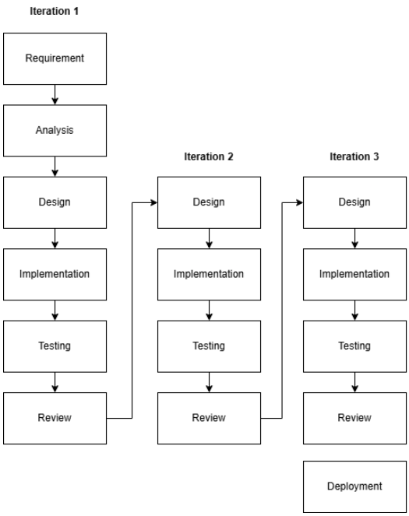
Figure 1: Iterative Research Approach

Iteration 1: System Design, Development, and Internal Evaluation
The first iteration focuses on completing the baseline version of the proposed system and preparing it for real-world deployment in participating community pharmacies. Instead of collecting a standalone symptom dataset, the deployed system will record anonymized consultation logs from consenting users. These logs, together with pharmacist validation, will serve as the basis for evaluating the system's recommendation performance and identifying areas for improvement in subsequent iterations.
Requirement. The objective of this iteration is to deliver a functional baseline system capable of assisting pharmacy customers seeking over-the-counter (OTC) medicines. The system must accept natural-language symptom descriptions in English, Filipino, Bisaya, and code-switched combinations; identify symptoms that fall within the study's OTC scope; screen for emergency or high-risk cases; ask clarification questions when symptom information is incomplete or ambiguous; recommend appropriate OTC medicines from the structured medicine database; and securely record each consultation for later evaluation. In addition, the deployed system must generate sufficient consultation records to support the measurement of recommendation performance using pharmacist-validated outcomes.
Analysis. The researchers analyzed the consultation workflow in community pharmacies to determine how the system should support both users and pharmacists. Since pharmacy customers often describe symptoms using mixed languages and incomplete information, the consultation process requires clarification before a recommendation can be made safely. Furthermore, evaluating recommendation quality requires more than storing user inputs; each consultation must be comparable with the pharmacist's assessment to determine whether the system's recommendation is correct. These observations established the need for a symptom-first recommendation approach, structured consultation logging, and expert validation as the basis for performance evaluation.
Design. Based on the analysis, the researchers designed a modular consultation pipeline that separates safety screening, symptom recognition, clarification, recommendation generation, and consultation logging into independent components. The architecture begins with red-flag screening, followed by multilingual symptom detection using a hybrid dictionary and semantic matching approach. A clarification module then gathers any missing symptom details before the recommendation engine retrieves suitable OTC medicines from the structured medicine database. Finally, a logging module records the consultation, including the user's symptoms, clarification responses, detected conditions, safety decisions, and recommended medicines, allowing each consultation to be reviewed alongside the pharmacist's assessment.
Implementation. During this iteration, the researchers implemented the baseline system as a Flask-based web application. The implementation integrated the multilingual symptom dictionary, semantic matching component (pre-trained multilingual sentence embeddings with cosine-anchor matching and a fine-tuned 13-label classification head), red-flag screening, OLDCARTS-inspired clarification module, duration-based safety checks, and the structured OTC medicine database into a single consultation workflow. The consultation logging mechanism was also implemented to automatically record anonymized consultation data after user consent. Once deployed in participating pharmacies, customers will use the system before consulting the pharmacist, allowing both the system-generated recommendation and the pharmacist's recommendation to be recorded for evaluation.

Testing. The baseline system will undergo two levels of evaluation. First, internal testing will verify that each module performs correctly, including symptom detection, clarification, safety screening, recommendation generation, and consultation logging. Second, field validation will be conducted in participating pharmacies, where consenting customers will use the system during actual consultations. The recommendations generated by the system will be compared with the recommendations provided by licensed pharmacists. These comparisons will be used to compute performance metrics such as precision, recall, and F1-score, while consultation logs will also be reviewed to identify common errors, missed symptoms, and inappropriate recommendations.
Review. At the end of the first iteration, the researchers will review both the technical performance of the baseline system and its real-world consultation results. The findings will determine whether the system can reliably identify symptoms, ask appropriate clarification questions, recommend suitable OTC medicines, and correctly suppress recommendations for unsafe cases. Performance metrics, pharmacist validation, and consultation log analysis will be used to identify areas requiring refinement before proceeding to the next iteration.

Iteration 2: Expert Annotation, Hardware Development, and Real-User Validation
Iteration 2 has two major tracks running concurrently. The first track focuses on expert annotation of the datasets collected in Iteration 1 and real-user validation of the software system. The second track involves the design and development of the hardware vending (vendo) dispenser that will eventually house the software system for autonomous OTC medicine dispensing.
Because this phase involves real participants in an actual pharmacy setting, ethical clearance is built into the iteration itself. Before any live consultation is recorded, the study must secure approval from the appropriate institutional ethics review body and obtain permission from participating Botika ng Bayan branches. Field activities begin only after the approved protocol, participant information materials, and data-handling procedures are in place [10, 11].
Design. The software track is designed around controlled field deployment of the Iteration 1 system in selected pharmacy settings. Real users interact with the consultation interface while the system records their inputs, clarification responses, detected symptoms, red-flag triggers, and recommendation outputs. These consultation logs constitute the primary real-world dataset for this iteration. Participation is voluntary, and each participant is informed about the study's purpose, what data is recorded, how logs are stored, and how they will be used. Consent materials are prepared in languages relevant to the study setting. The hardware track involves designing the vendo machine—a physical kiosk that integrates the Mendo software system, a touchscreen interface, a medicine dispensing mechanism, and inventory management. The hardware design must support the system's offline operation requirements and be suitable for placement in pharmacy settings.
Implementation. On the software side, the completed Iteration 1 system is deployed under supervised conditions. Participants who consent enter their symptom descriptions through the system, and logs are stored as the primary evaluation dataset. Privacy measures are observed: consultations are conducted to minimize bystander exposure, and access to logs is limited to authorized research team members and the designated expert reviewer. On the hardware side, the researchers begin fabricating the vending machine prototype—designing the dispensing mechanism, integrating the Raspberry Pi 5 computing unit, wiring the touchscreen interface, and assembling the physical enclosure. The hardware must pass basic functional tests (reliable dispensing, correct inventory tracking, power management) before integration with the software system.
Testing. The consultation logs are reviewed by a licensed pharmacist who annotates the correct symptoms, appropriate safety actions, and expected medicine recommendations for each logged interaction. This expert-annotated corpus allows direct comparison between the system's actual outputs and expert judgment, revealing which case types the baseline handles well and which still need improvement. Concurrently, the hardware prototype undergoes mechanical and electrical testing to ensure reliable medicine dispensing and inventory accuracy.
Review. The main outputs of Iteration 2 are (1) an expert-annotated consultation corpus from real user interactions and (2) a functional hardware vendo prototype. The review assesses whether the software system remained reliable under authentic pharmacy language, whether the annotated data is sufficient for system refinement, and whether the hardware prototype meets the physical requirements for deployment.
Iteration 3: System Refinement, Hardware Integration, and Final Deployment
Iteration 3 brings together the improved software and the completed hardware into a single integrated system.
Design. This iteration draws on findings from the expert-annotated logs and hardware testing results from Iteration 2. The researchers identify which symptom expressions were frequently missed, which clarification rules need strengthening, and which recommendation cases require tighter safety handling. If the annotated dataset proves large and reliable enough, the semantic symptom-matching component may be adapted using the Iteration 2 consultation corpus, though the recommendation core remains grounded in a structured medicine dataset rather than a black-box model.
Implementation. Software refinements may include expanding the multilingual dictionary, adjusting semantic thresholds, improving clarification prompts, refining duration thresholds based on pharmacist feedback and observed referral patterns, strengthening rule-based safety checks, and updating the medicine dataset based on expert feedback. On the hardware side, the refined software is integrated into the vendo machine. This includes connecting the recommendation output to the dispensing mechanism, so that once a user accepts a recommendation, the system triggers the correct medicine slot. Inventory management, payment handling, and user interface refinements are finalized during this phase.
Testing. The integrated system undergoes a comprehensive evaluation: the existing structured benchmark and regression tests are re-run, the system is evaluated against held-out annotated consultation data from Iteration 2, and end-to-end dispensing tests verify that the correct medicine is physically dispensed for each recommendation. The aim is to confirm that both software accuracy and hardware reliability meet deployment standards.
Review. The final review assesses whether symptom recognition has improved, whether safety behavior remains stable, whether the hardware performs reliably, and whether the integrated system is mature enough for operational use.
Deployment. If the refined system meets the required performance, safety, and usability standards, final deployment proceeds at the end of Iteration 3. In this study, deployment means releasing the validated MendoVendo system—software and hardware together—for its intended pharmacy-kiosk setting.

Research Philosophy

This study is grounded in a pragmatic research philosophy. The project sits at the intersection of language processing, software engineering, and clinical safety, which means the value of the artifact cannot be judged by algorithmic accuracy alone—it must also behave safely and sensibly when real people use it in a real pharmacy [1,3].

The pragmatic stance is reflected throughout the evaluation strategy. Quantitative testing measures symptom detection performance on structured benchmarks, while design decisions are guided by whether they improve traceability, multilingual robustness, and safe recommendation behavior. The system is judged not only by whether it classifies text correctly, but by whether its outputs are appropriate for an OTC self-medication context.

Theoretical Framework

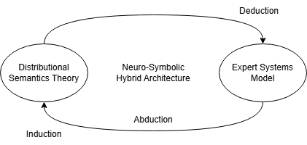
Figure 2: Theoretical Framework

Mendo v3.0 is built on a hybrid architectural approach that deliberately combines connectionist AI with symbolic reasoning. This design addresses the precision–safety gap observed in previous retrieval-based iterations by keeping probabilistic linguistic interpretation separate from deterministic clinical decision-making. The system's five-stage pipeline rests on two complementary theoretical foundations: Distributional Semantics Theory and the Knowledge-Based Expert Systems model [1, 5, 6]. These operate in a cascaded arrangement, the first ensures the system can understand what users are saying despite linguistic diversity, while the second ensures the system's medical reasoning stays within safe, verifiable bounds.

Distributional Semantics Theory

The system's ability to make sense of unstructured, multilingual, and informally phrased symptom descriptions draws from Distributional Semantics Theory. In plain terms, this theory holds that the meaning of a word emerges from the company it keeps — words appearing in similar contexts tend to carry similar meanings [5, 7]. This matters because pharmacy-kiosk users in Davao City do not type clinical terminology; they describe symptoms using paraphrases, regional dialects, or code-switched language that no finite dictionary can fully anticipate.

Within the Mendo v3.0 architecture, this theory underwrites the semantic embedding fallback layer. Driven by inductive learning from large textual corpora, a pre-trained multilingual transformer model maps user input into a high-dimensional vector space. When evaluating live user input, this layer employs abductive reasoning to infer the most probable underlying concept from informal text, thereby enabling the system to identify meaning equivalence between different surface expressions. Consequently, phrases such as "sakit ng ulo" and "my head is pounding" both map near the HEADACHE concept. This maintains broad recall for diverse patient language without requiring exact dictionary matches. Critically, however, the system treats these probabilistic outputs as supporting evidence rather than as authoritative detections. Every semantic suggestion must still pass through lexical guards that prevent the model from hallucinating symptoms not actually present in the user's text [7, 8].

Knowledge-Based Expert Systems Theory

While distributional semantics handles the variability of human language, the system's core safety and reasoning mechanisms are grounded in the Expert Systems model. An expert system mimics the decision-making of a human specialist by applying structured knowledge through a deterministic inference engine [1, 6, 9]. By executing strict deductive reasoning, the Expert Systems model governs both the symbolic processing of natural language, including negation rules, scope detection, and contrastive boundary logic, as well as the clinical reasoning required for safe medication dispensing, such as contraindication checks, age-based formulation selection, and paracetamol overlap detection.

This deterministic foundation is necessary for a safety-critical, domain-specific application. Rather than operating as an open-ended conversational agent, the system functions as a strictly constrained decision-support tool, mapping validated symptoms to a predefined over-the-counter catalog using absolute clinical rules [1, 6].

Conceptual Framework

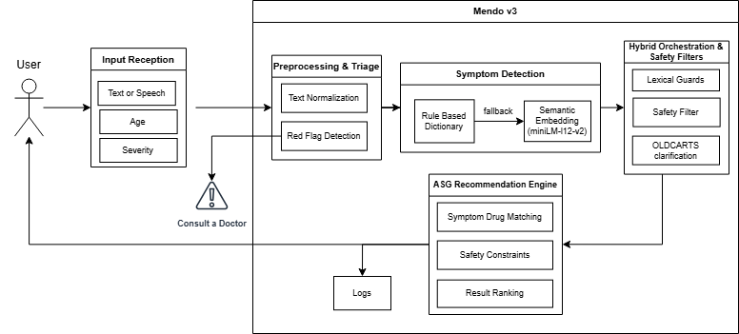
Figure 3: Conceptual Framework
Mendo v3.0 is designed as a multilingual OTC medicine recommendation kiosk that accepts free-text symptom descriptions and produces age-appropriate, safety-screened medication suggestions. The system follows a five-stage conceptual process.
In the first stage, the user enters their symptom description through the kiosk interface using Bisaya, Tagalog, English, or any combination. Age and symptom severity can be optionally provided.
Proxy-Purchase Screening. Because pharmacy customers often buy medicine for someone else — a child, an elderly parent, or a sick relative at home — the consultation opens with a short screening step that asks whether the medicine is for the user or for another person. When it is for someone else, the age the system collects is explicitly the intended patient’s age rather than the buyer’s, so that the age-based safety filter (which removes medicines below a product’s minimum-age requirement) is applied to the person who will actually take the medicine. The selection is stored with the consultation log for auditability. This complements the existing pregnancy red-flag, which already lets a proxy purchaser buy on behalf of a pregnant relative without the system mistaking the buyer for the patient.
In the second stage, the system preprocesses and normalizes the input while simultaneously screening for red-flag conditions—potential emergencies that warrant professional medical attention rather than OTC treatment. If a serious condition is flagged, the system suppresses all OTC recommendations and advises the user to seek immediate medical help. Only inputs that pass this screening proceed further.
In the third stage, the system performs symptom detection using a hybrid NLP approach that combines rule-based dictionary matching with semantic analysis. This enables recognition of both direct symptom mentions and varied, informal, or multilingual expressions of the same complaint.
In the fourth stage, detected symptoms pass through additional validation: negation checks, context-sensitive screening, and clarification prompts for symptoms that require more information (such as whether a cough is dry or productive). The output is a validated symptom set.
In the fifth stage, validated symptoms first pass through a duration screening step where the user is asked, for each detected symptom, how long the complaint has persisted. If the reported duration exceeds a clinically defined threshold specific to that symptom, the system blocks OTC recommendations and refers the user to a healthcare professional. Only symptoms that fall within safe self-medication timeframes proceed to the recommendation engine, which matches them against the OTC medicine database using symptom relevance, age restrictions, contraindications, and safety rules. The system presents appropriate recommendations with dosage guidance and safety reminders—or, if the case exceeds the safe scope of OTC use, advises the user to consult a healthcare professional.
The key conceptual shift from earlier Mendo versions is this: rather than predicting a medicine directly from raw text, v3.0 first identifies what the user's symptoms are, then evaluates possible medicines under defined safety constraints. This two-step approach provides a clearer and safer foundation for handling multi-symptom cases, negation, multilingual input, and context-sensitive recommendations.

System Architecture

Mendo v3.0 is implemented as a Flask application running on Python 3.12.3. The system comprises a customer-facing consultation layer, a hybrid NLP and recommendation layer, a data and knowledge layer, an inventory integration layer, and a logging layer. The consultation interface accepts typed symptom descriptions and can also process transcribed speech through an optional server-side endpoint. Results are filtered by age and cross-referenced against available inventory before recommendations are shown.

The architecture deliberately favors deterministic, rule-based processing for the first pass of symptom detection and safety screening. Semantic embeddings serve as a fallback only when dictionary matching finds nothing. This arrangement prioritizes traceability and safety in a pharmacy context where the system must explain and constrain its outputs rather than generate open-ended medical advice.

Stage 0: Triage / Red-Flag Safety Layer
The initial processing stage functions as a critical safety mechanism, screening user input for medical emergencies that require professional medical intervention rather than OTC self-medication. To balance precision and recall, the triage layer avoids brittle exact-phrase matching and overly broad keyword matching. Instead, it utilizes Proximity-Based Co-occurrence and Exclusion Rules.
The system detects critical red-flag conditions by searching for specific combinations of clinical entities occurring within a defined lexical window. Crucially, this stage incorporates "Exclusion Tokens" (negative constraints) to prevent over-triage. This ensures that severe keywords (e.g., "blood" or "numb") do not trigger false alarms when used in non-emergency, treatable contexts (e.g., "high blood pressure" or "numb tooth"), allowing those cases to safely proceed to the OTC recommendation stage.

Category | Clinical Rationale | Trigger Pattern (Co-occurrence) | Lexical Exceptions (Ignore if present)
Gastrointestinal Hemorrhage | Lower/Upper GI bleed | [blood / dugo] + [stool / dumi / vomit / suka] | None
Cardiac Emergency | Possible myocardial infarction | [pain / masakit] + [chest / dibdib / dughan] | halak, plema, ubo, cough (Allows treatment for chest muscle pain caused by severe coughing/congestion)
Respiratory Emergency | Impaired airway / Anaphylaxis | [difficulty / hirap / lisod] + [breathing / hinga] | None
Suspected Dengue / Viral | High risk of hemorrhage | [fever / lagnat] + [rashes / pantal / spots] | kagat, bite, allergy (Allows OTC antihistamines for insect bites/mild allergies)
Neurological Event (Stroke) | Requires immediate ER evaluation | [numb / manhid] + [face / mukha / half / kalahati] | ngipin, tooth (Allows OTC analgesics for radiating dental pain)
Severe Dehydration | Acute kidney injury risk | [diarrhea / nagtatae] + [walang ihi / no urine] | None
Pregnancy Contraindication | High risk of fetal harm from OTCs | [buntis / pregnant / naglilihi] (Single Keyword) | asawa, misis, kapatid, sister (Allows proxy purchasing for a pregnant relative)
Dangerous Hyperthermia | High risk of convulsions | [fever / lagnat / temp] + [40, 41, 42] | kilo, kg, edad, years old (Prevents numbers from being misclassified as temperature)
Direct Emergencies | Immediate intervention required | [seizure / kombulsyon] OR [nahimatay / fainted] | None

Table 4: Common Red Flag Key Words with Clinical Rationale

Stage 1: Dictionary-Based Symptom Extraction
The primary extraction stage uses a curated multilingual symptom dictionary containing 587 phrases across 14 symptom labels, covering five language variants. Each phrase was manually verified for linguistic accuracy and clinical relevance through iterative expansion during Iteration 1.
On using a curated dictionary instead of an existing dataset. A fair question is why this symptom dictionary was hand-curated rather than taken from an existing dataset. The practical answer is that no public dataset covers the specific intersection this system targets: lay, code-switched Tagalog–Bisaya–English symptom expressions (including Jejemon and leetspeak) mapped onto a small, fixed set of OTC-relevant symptom labels. General medical vocabularies and symptom corpora are overwhelmingly English and clinician-facing, and they do not capture how Davao pharmacy customers actually describe what they feel. We therefore built the dictionary from authoritative and field sources — package inserts and MIMS Philippines for the clinical terminology, and pharmacy fieldwork plus local language resources for the colloquial and dialectal variants and we treat dataset reuse as complementary rather than a replacement. For Iteration 2, we plan to expand the dictionary’s surface forms more systematically by mining structured drug references such as MIMS for additional brand, generic, and indication terms, and by harvesting real spelling and phrasing variants from the consultation logs, so that coverage grows from observed usage rather than from the team’s imagination alone.

Symptom Label | Phrase Count | Languages | Key Examples
HEADACHE | 46 | Tag/Bis/Eng | "masakit ang ulo", "labad akong ulo", "headache"
FEVER | 105 | Tag/Bis/Eng | "lagnat", "nilalagnat", "hilanat", "init akong lawas"
BODY_ACHES | 64 | Tag/Bis/Eng | "masakit katawan", "binugbog", "bug at akong lawas"
RASHES | 32 | Tag/Bis/Eng | "pantal", "rash", "makati ang balat"
STOMACH_ACHE | 74 | Tag/Bis/Eng | "sakit tiyan", "kabag", "hyperacidity"
SORE_THROAT | 37 | Tag/Bis/Eng | "masakit lalamunan", "sore throat", "garas"
COUGH_PRODUCTIVE | 20 | Tag/Bis/Eng | "may plema", "basang ubo", "halak"
ALLERGIC_RHINITIS | 29 | Tag/Bis/Eng | "allergy", "bahing", "alerdyi", "makati ilong"
COUGH_GENERAL | 32 | Tag/Bis/Eng | "ubo", "cough", "inuubo", "gi-ubo"
COUGH_DRY | 15 | Tag/Bis/Eng | "walang plema", "tuyong ubo", "dry cough"
DIARRHEA | 44 | Tag/Bis/Eng | "pagtatae", "diarrhea", "lbm", "loose bowel"
NASAL_CONGESTION | 11 | Tag/Bis/Eng | "barado ilong", "stuffy nose", "blocked nose"
RUNNY_NOSE | 25 | Tag/Bis/Eng | "sipon", "runny nose", "tumutulo ilong"
TOOTHACHE | 53 | Tag/Bis/Eng | “sakit ngipin”, “ngilo”, “toothache”
Table 5: Symptom Dictionary 587 phrases across 14 labels

Text Normalization. All input text undergoes deterministic normalization before phrase matching: (1) lowercase conversion, (2) leetspeak/Jejemon character substitution (@ → a, 0 → o, 1 → i, 3 → e, 4 → a, 5 → s, 7 → t, 8 → b, $ → s, ! → i, | → i), (3) removal of non-alphanumeric characters (preserving ñ for Filipino words), and (4) whitespace collapsing. This handles informal digital communication styles common among Filipino youth (e.g., "s@k1t ul0" normalizes to "sakit ulo" and matches HEADACHE).

Phrase Matching Strategy. After the text normalization layer resolves deterministic character-level substitutions and canonical case alignments, the extraction pipeline passes the string to a dual-tiered exact dictionary matching layer. This layer treats single-word keywords and multi-word phrases differently to balance matching precision and operational speed. For single-word keywords, the system applies word-boundary constraints to prevent false positives caused by partial substring containment within unrelated tokens. This filter ensures a symptom term is recognized only when it stands alone as an independent lexical unit. For example, the keyword "ubo" will exclusively trigger a match if it is an isolated token, preventing erroneous extractions within distinct, unrelated words containing the same character sequence, such as "tubo" (pipe) or "subo" (to swallow). Conversely, multi-word dictionary entries, such as "masakit ang ulo" or "dry cough," are evaluated using sequential substring matching. Because multi-token phrases contain interior whitespace delimiters, they are structurally insulated from accidental containment inside individual unrelated words. Utilizing standard substring verification for these exact multi-word entries eliminates unnecessary regular expression compilation overhead, optimizing runtime efficiency. While this rigid string matching layer requires precise token sequencing and exact character alignment, its purpose is to serve as a high-velocity filter for clear-cut structural matches; any complex syntactic variations, inverted phrasing, severe typos, or unrecognized vocabularies that bypass this dictionary layer are subsequently routed to the downstream semantic embedding model for contextual resolution.

Negation Handling. Patients frequently mention symptoms they do not have alongside those they do (e.g., “masakit ang ulo ko pero walang lagnat”, “my head hurts but I don't have a fever”). Negation is processed by a scope-aware token walker instead of a fixed word window, a negation marker opens a scope that accumulates across coordinate connectors (ug, og, at, and, or, kay, tsaka, sabay) so that one marker can negate a whole joined list (“wala koy ubo ug sipon” negates both), and the scope closes at a contrastive or reason boundary (pero, but, apan, dahil, may, naa, meron). Every symptom keyword consumed inside the open scope is negated, with three conservative exceptions: a closer symptom keyword interrupts the chain (the nearer mention absorbs the negation); a trap verb (mawala, hunong, tigil) turns the mention positive, so “dili mawala akong ubo” still detects the cough; and a wellness predicate (normal, okay, walay problema) appearing before any symptom absorbs the negation, so “dili normal akong pagkalibang” still detects the diarrhea. Fused negative assertions such as “wala may mogawas” are parsed as a single negative construction and never open a positive clause. Every label negated here is recorded so that the fuzzy rescue pass can never resurrect it.

neg(wk)⟺∃m<k:wm∈N, B(m,k)=∅,S(m,k)=∅ S(m,k) joined by C

Where N is the set of negation markers, B the scope-end boundaries, S the symptom keywords, and C the coordinate joiners. Two vetoes keep the rule conservative. A trap verb (mawala, hunong, tigil) inside the scope turns the mention positive (“dili mawala akong ubo” still detects the cough), and a wellness predicate (normal, okay ra, walay problema) appearing before the first symptom keyword absorbs the negation (“dili normal akong pagkalibang” still detects the diarrhea). Fused negative assertions such as “wala may mogawas” are parsed as a single negative construction and never open a positive clause. In the worked example “wala koy gibati na sakit akong tiyan kay okay ra ug sakit sa ulo, pero gi ubo ko”, the scope opened by wala accumulates over ug and kay (negating both tiyan and ulo), closes at pero, and the cough is the only positive detection.

Formally, with tokens w₁…wₙ, a symptom keyword wₖ is negated if a negation marker m < k opens a scope that reaches wₖ without a contrastive boundary, and every intervening symptom keyword is linked to wₖ by a coordinate joiner

Contrastive Boundary Splitting. Input is split on contrastive conjunctions (pero, but, kaso, however, though) into independent segments. Each segment is evaluated independently for negation, with positive mentions after a contrastive boundary overriding prior negation.

Fuzzy Rescue Mechanism. After dictionary matching and negation processing, a generic fuzzy rescue pass recovers misspelled symptom mentions: each input token is compared against a table of 18 canonical English anchors using bounded Levenshtein distance with per-anchor edit caps (Table 6). The rescue is deliberately conservative. Anchors are English-only spellings because common Filipino and Bisaya words sit within 1–2 edits of the native anchors (“isang” ~ “ilong”, “simula” ~ “sikmura”) and would destroy precision; exact-match local synonyms live in the dictionary instead. Candidate tokens must be alphabetic, at least four characters long, and within two characters of the anchor's length. Tokens that are real dictionary words, negation markers, scope words, or genuine near-miss non-symptom words (ever, never, that, though, tough, couch, enough, …) are never candidates. A misspelled token inside a negation window is recorded as negated rather than detected — “wala koy hedache” fires nothing, while “hedache” alone rescues HEADACHE. Representative rescues include hedache→HEADACHE, totache→TOOTHACHE, couhg→COUGH_GENERAL, diahrea→DIARRHEA, and stomakache→STOMACH_ACHE.

$d(i,j)=min\left\{d(i−1,j)+1,d(i,j−1)+1,d(i−1,j−1)+1\left[a_{j}\right]\right\},d(i,0)=i, d(0,j)=j$
$t↦L(a)⟺∃(a,L,δ_{a})∈𝒜:lev(t,a)≤δ_{a}∧||t|−|a||≤2∧|t|≥4∧t∉D∪E∪N∪B$

where δₐ is the per-anchor edit cap, D the set of dictionary tokens, E the near-miss exclusion set, N the negation markers, and B the scope words.

Anchor | Symptom Label | Max Edits (δ)
headache | HEADACHE | 2
toothache | TOOTHACHE | 2
stomachache | STOMACH_ACHE | 2
stomach | STOMACH_ACHE | 2
tummy | STOMACH_ACHE | 1
diarrhea | DIARRHEA | 2
fever | FEVER | 1
cough | COUGH_GENERAL | 2
throat | SORE_THROAT | 2
sorethroat | SORE_THROAT | 2
nose | RUNNY_NOSE | 1
rash | RASHES | 1
itchy | RASHES | 2
sneeze | ALLERGIC_RHINITIS | 2
allergy | ALLERGIC_RHINITIS | 2
allergic | ALLERGIC_RHINITIS | 2
body | BODY_ACHES | 1
runny | RUNNY_NOSE | 2

Table 6: Summary of Levenshtein Distance Matching

Proximity-Based Heuristics. Several symptom labels use co-occurrence detection for compositional descriptions: headache heuristics (head word + pain word within ≤5 tokens), sore throat proximity (throat word + pain word within ≤5 tokens with dual negation checking), per-cue-group nasal inference, and an allergen-trigger heuristic.

Free-Text Headache-Type Intake. Beyond the interactive head-map, the headache module also accepts the fourteen clinical headache types through typed free text, so the same clinical routing is available without extra UI steps. A deterministic multilingual tag matcher (no ML) scores the typed description against 202 strong and 67 weak cue tags organised per clinical type (migraine, tension, sinus, cluster, thunderclap, hypertension, spinal, post-traumatic, exertion, and the remaining types). Strong-tag evidence dominates; the five red-zone types thunderclap, hypertension, spinal, post-traumatic, and exertion dominate all other evidence and route the user directly to Emergency Triage. For the remaining types, the matched types prefer/avoid medicine lists feed the recommendation engine, and every outcome is logged with the matched tags for auditability. When the user has clicked the head-map, the explicit click takes precedence over typed text.

Stage 2: Semantic Embedding Fallback

The semantic fallback covers symptom descriptions that fall outside the dictionary's 587 curated phrases. It uses the pre-trained paraphrase-multilingual-MiniLM-L12-v2 model from the Sentence-Transformers library (Reimers & Gurevych, 2019), a compact transformer (~33 million parameters) producing 384-dimensional sentence embeddings.

We convert the user's input sentence into a single 384-dimensional vector. We use mean-pooling, which simply averages the output vectors of all individual tokens in the sentence.
$e(s) = \frac{1}{n}\sum_{k = 1}^{n}{}h_{k}$
At initialization, 145 anchor sentences (5–23 per symptom label) are pre-encoded into 384-dimensional vectors, one vector per anchor. At runtime the user's input is encoded to e(u) and compared against all anchors using the cosine similarity of their embedding vectors,
$cos(e(u), e(a)) = \frac{(e(u) · e(a))}{(‖e(u)‖ · ‖e(a)‖)}$
where · denotes the dot product, ‖·‖ the Euclidean norm, and uᵢ, aᵢ the i-th components of the two 384-dimensional vectors. For each of the 14 labels L with anchor set Aₗ, the label score is the best-anchor maximum,
$s_{L} = \max_{a ∈ A_L} cos(e(u), e(a))$
and L is returned as a candidate when sₗ ≥ τ, with the similarity threshold τ = 0.65. Candidates are then ranked by sₗ and capped at two labels per utterance.
To give more context on how we landed on 0.65: we started by testing a low threshold of 0.40, which produced way too many false positives since a lot of unrelated inputs were clearing that bar. Bumping it up to 0.50 helped, but still let through phrases that were not really symptom-related. At 0.60, most valid paraphrases were being captured with fewer false positives, but we noticed that some legitimate matches for figurative or idiomatic expressions were getting dropped. At 0.65, the system kept coverage for meaningful paraphrases while filtering out adversarial cases like gibberish input and non-symptom text. Going higher to 0.70 and above caused the system to reject valid multilingual paraphrases that fell just barely below the cutoff. So 0.65 ended up being the best middle ground between catching real symptoms and not making things up. We plan to run a more formal sensitivity analysis during Iteration 3 once we have real consultation data to work with.
A key design decision is the precision-first switching logic: the semantic layer activates only when Stage 1 finds zero symptoms. When the dictionary returns results, those results stand as-is, with no semantic augmentation. Deterministic, auditable results take priority over probabilistic detections wherever dictionary coverage is sufficient.
One trade-off of this design is that if the dictionary catches the primary symptom but misses a secondary one expressed idiomatically or figuratively, the semantic layer will not activate for that case. We accepted this trade-off because in an OTC recommendation context, a false positive (detecting a symptom that is not there) is more dangerous than a false negative (missing a secondary symptom): a missed secondary symptom yields an incomplete but not wrong recommendation, whereas a false positive could trigger an unnecessary or even contraindicated medicine. This precision-first behaviour the primary symptom caught while an idiomatically expressed secondary one is missed is exactly what the planned Iteration-2 real-user simulation is designed to measure. Relaxing this logic so the semantic layer runs as an augmentation rather than a fallback is something we plan to explore in Iteration 3, once we have enough real-user data to evaluate whether it increases false positive rates.
The model loads as a lazy singleton instantiated only on the first query requiring semantic processing to minimize startup time and memory on the Raspberry Pi 5 target hardware.

Stage 3: Hybrid Merge, Lexical Guards, and Safety Filters
This stage orchestrates results from Stages 0–2 and applies multi-layered filtering before anything reaches the recommendation engine. The processing flow:
1. Run triage detection (Stage 0) → red_flags list
2. Run dictionary extraction (Stage 1) → dict_symptoms
3. Apply explicit cough negation override
4. If dict_symptoms is non-empty → return dict_symptoms (skip semantic)
5. If dict_symptoms is empty → load semantic model (lazy singleton)
6. Run semantic extraction → raw semantic detections
7. Apply lexical guard: 11 keyword-gate groups covering all 13 symptom labels — each semantic detection must be grounded in at least one relevant keyword from the original input text
8. Apply centralized safety filter: seven explicit negation functions plus red-flag suppression rules
9. Score-rank and select top-N (default: 2) semantic symptoms
10. Return final symptom set with source attribution

Lexical Guard Mechanism. This prevents the embedding model from "hallucinating" symptoms not lexically present in the input. Each of 13 symptom labels has a dedicated keyword gate. For example, semantic detection of COUGH requires at least one cough-related keyword in the input. COUGH_PRODUCTIVE has a compound gate requiring both a cough keyword AND a phlegm keyword. Detections failing their keyword gate are silently dropped.

Centralized Safety Filter. Seven explicit negation functions (fever, headache, cough, diarrhea, sore throat, nasal symptoms, allergy) are applied using word-boundary-safe regex. Two red-flag suppression rules prevent dangerous false positives: blood_in_stool → suppress DIARRHEA; severe_allergic_reaction → suppress SORE_THROAT.
OLDCARTS Clarification Layer and Duration Screening Layer. The system uses targeted clarification logic, interactive visual mapping, and multi-modal input elements to collect critical context for symptoms where the label alone is insufficient for a safe over-the-counter (OTC) recommendation. The clarification layer is treated as a practical assessment heuristic within the recommendation design, not as a core theoretical pillar [31, 32].
To maximize accessibility and data fidelity across all symptom modules, the user interface completely replaces abstract, generic 1–10 numerical input scales with symptom-specific, highly visual iconographic scales tailored for conditions like coughs, colds (sipon), and stomachaches. Furthermore, the system embeds immediate emergency triage protocols directly into this layer to intercept high-acuity conditions before duration checking begins. For neurological complaints, the interface integrates an interactive, clickable visual head-map graphic; selecting high-risk anatomical regions (e.g., occipital zones) or indicating a sudden, severe "thunderclap" onset routes the user directly to Emergency Triage. Similarly, the dermatological sub-form incorporates a critical screening checkbox for rashes asking: "Are you experiencing difficulty breathing?". If this is flagged as true, the system identifies a potential systemic anaphylactic reaction and triggers an immediate Emergency Red Flag routing, completely bypassing standard processing. For gastrointestinal assessments, the system refines its evaluation by embedding a mandatory contextual menu, requiring the user to specify whether the pain occurs before eating, after eating, or is unrelated to food intake to better map aggravating and alleviating factors. Additionally, the cold (sipon) module incorporates specific clarification logic to distinguish allergic reactions from viral presentations; minor runny-nose cases accompanied by distinct allergy indicators such as sneezing, itchy eyes or nose, exposure to environmental triggers (dust, pollen, or pets), or symptoms recurring 'every morning' are automatically matched to OTC antihistamines (Cetirizine), whereas standard cases without these indicators are routed to receive general viral sipon relief.
Beyond these context-specific clarifications and emergency gates, the system implements the Duration component of the OLDCARTS framework as a universal safety measure applied across all symptom categories. After any applicable clarification questions are resolved and emergency flags are cleared, the system presents bilingual multiple-choice options to capture symptom persistence. If the reported duration exceeds the clinically defined threshold for that particular symptom, the system blocks all OTC recommendations and displays a referral notice advising the user to consult a licensed healthcare professional, along with the clinical basis for the referral.
The duration thresholds were derived from clinical guidelines published by the World Health Organization [33, 36, 38, 42], the United States Centers for Disease Control and Prevention [34, 39], the Mayo Clinic clinical reference database [35, 37, 40, 41], and standard OTC package insert warnings used in Philippine pharmacies. The 14-day cough threshold aligns with the DOH community-level TB screening protocol, given that the Philippines ranks among the top three countries in global TB burden [38]. The 3-day fever threshold accounts for the dengue-endemic status of the country, where dengue warning signs typically emerge within 24–48 hours after fever resolution [33, 34]. The 2-day diarrhea threshold follows established clinical advice that adult diarrhea lasting beyond 48 hours warrants medical evaluation due to dehydration risk and the possibility of bacterial or parasitic infection [35, 36]. Notably, the cold (sipon) sub-form enforces a strict 7-day threshold across all related nasal symptoms to proactively screen for secondary bacterial sinusitis or underlying complications before standard OTC options are permitted.

Symptom | Threshold | Action if Exceeded | Clinical Rationale / System Action
Fever | > 3 days | Block OTC, refer | Dengue, typhoid, malaria indicator (endemic PH) [33, 34]
Diarrhea | > 2 days | Block OTC, refer | Dehydration risk; bacterial or parasitic infection [35, 36]
Sore Throat | > 5 days | Block OTC, refer | Streptococcal infection; rheumatic fever risk [37]
Stomach Ache | > 7 days | Block OTC, refer | Peptic ulcer, gallstones, appendicitis (Evaluated via food-intake dropdown)
Headache | > 7 days | Block OTC, refer | Hypertension, neurological issues [41, 42] (Bypassed if occipital/sudden via visual head-map)
Body Aches | > 7 days | Block OTC, refer | Inflammatory arthritis, nerve damage, post-viral sequelae
Rashes | > 7 days | Block OTC, refer | Fungal infection, scabies, chronic immune condition (Bypassed if dyspnea checkbox is True)
Allergic Rhinitis | > 7 days | Block OTC, refer | Chronic immune issue requiring prescription treatment
Nasal Congestion | > 7 days | Block OTC, refer | Colds/Sipon duration validation rule; screens for bacterial sinusitis [40]
Runny Nose | > 7 days | Block OTC, refer | Colds/Sipon duration validation rule; screens for bacterial sinus infection [40]
Cough (all types) | > 14 days | Block OTC, refer | TB screening protocol (DOH, endemic PH) [38, 39]
Table 7: Duration Safeguard Matrix — Symptom-Specific Thresholds for OTC Self-Medication

The duration check is performed per symptom. When the system detects multiple symptoms, it asks about each one sequentially, displaying a progress indicator (for example, "Symptom 1 of 3") so the user knows how many questions remain. If even one symptom exceeds its threshold, that symptom's recommendations are blocked and a referral is shown, while symptoms within safe timeframes proceed to the recommendation engine. This design ensures that cases where OTC treatment is still appropriate for some symptoms are not unnecessarily blocked entirely.
OLDCARTS Sample Implementation. To further illustrate the pipeline's multilingual processing, multi-step OLDCARTS flow, and multi-tiered safety-gating mechanisms, consider how the system handles distinct user scenarios. In a primary scenario, a Cebuano-speaking user approaches the kiosk and inputs: "gi ubo ko" (I'm coughing). The hybrid extraction pipeline processes this Bisaya input through three sequential stages. First, the dictionary scanner matches "ubo" against Cebuano cough entries to generate the symptom label COUGH_GENERAL. Because a cough is the sole detected symptom and lacks contextual modifiers regarding type, the system triggers a Character clarification prompt: "Please specify: Is your cough dry (walay/walang plema) or with phlegm (naay/may plema)?".
If the user selects "Dry cough," the system maps this input to the OLDCARTS Character component and reclassifies the symptom as COUGH_DRY. This reclassification dynamically shifts the recommendation strategy, selecting cough suppressants such as Tuseran Forte (Dextromethorphan + Paracetamol + Phenylephrine + Chlorphenamine) or Sinecod Forte (Butamirate citrate) while explicitly excluding expectorants like Solmux (Carbocisteine), as administering an expectorant for a non-productive cough serves no therapeutic purpose and risks unnecessary side effects. Conversely, selecting "With phlegm" reclassifies the condition as COUGH_PRODUCTIVE, directing the system to recommend expectorants like Ascof Forte (Lagundi leaf extract), Solmux, and Robitussin (Guaifenesin) while excluding suppressants.
Before displaying these recommendations, the system enforces the Timing element of the OLDCARTS framework through the Duration safeguard. For cough symptoms, the user is presented with four bilingual multiple-choice selections tailored to clinical thresholds: less than a day, 1–7 days, 8–14 days, or more than two weeks. Instead of abstract 1–10 numerical inputs, the interface utilizes highly visual, symptom-specific iconographic scales to determine severity and progression. If the user indicates a duration of "More than 2 weeks," the system blocks the over-the-counter (OTC) recommendation and displays a formal referral notice, as a cough persisting beyond 14 days may indicate chronic bronchitis, undiagnosed asthma, or tuberculosis, which require professional medical evaluation. If the duration falls within the safe thresholds of less than 14 days, the system proceeds to display the appropriate medicine recommendations normally.
The system applies analogous cross-symptom validation rules and emergency bypasses when users navigate other sub-forms:
Colds (Sipon) Pathway: If a user reports nasal symptoms via the iconographic scale but selects a duration exceeding 7 days, the system automatically bypasses standard OTC options and routes the user directly to a Doctor Consultation to screen for secondary bacterial sinusitis.
Stomachache Pathway: When a user presents with gastrointestinal complaints, the system refines its evaluation by generating a mandatory contextual dropdown menu asking: "Does the pain occur before eating, after eating, or is it unrelated to food intake?". This allows the pipeline to map the exact Timing and aggravating factors to differentiate between acid-related dyspepsia and acute abdominal pathologies.
High-Acuity Emergency Pathways: To mitigate risks associated with critical conditions, certain user selections trigger immediate triage routing that completely bypasses the standard duration questions. For example, if a user interacting with the neurological interface clicks a high-risk anatomical region (such as the occipital zone) on the interactive visual head-map graphic, or if a user in the dermatological sub-form checks the critical screening box confirming "difficulty breathing" alongside a rash, the system immediately suspends normal processing and routes the session directly to Emergency Triage.
Collectively, these operational scenarios demonstrate the system's multi-layered capabilities, seamlessly merging multilingual symptom extraction, interactive visual triage, contextual character clarification, and strict duration safeguards to optimize patient routing and prevent unsafe self-medication.

Stage 4: ASG Recommendation Engine
The final stage maps detected symptoms to OTC medicine recommendations using a structured JSON dataset built under the Authoritative-Source-Grounded (ASG) framework.

ASG Framework and Medicine Dataset. The ASG framework was adopted after the originally planned pharmacist annotation process could not be completed within the project timeline. Under this framework, all medicine data is sourced exclusively from authoritative pharmaceutical references: package inserts, MIMS Philippines, and DOH Philippines guidelines. The present version therefore represents a constrained, authoritative-source-grounded baseline; pharmacist review and expert annotation remain part of the Iteration 2 validation cycle, and final integrated validation is planned for Iteration 3. Each of the 24 medicine entries contains 15 fields:

Field | Type | Source
Brand | String | Product label
Generic/Main Use | String | Package insert
Drug Category | String | MIMS classification
Primary Symptom | String | Clinical mapping
Typical Symptoms Treated | String (comma-sep) | Package insert
Dosage Form | String | Product label
Minimum Age | String | Package insert
Notes | String | Clinical notes
Approved_Indications | Tuple[str] | Package Insert / MIMS
Indication_Source | String | ASG attribution
Contraindications | Tuple[str] | Package Insert / MIMS
Warnings | Tuple[str] | Package Insert
Drug_Interactions | Tuple[str] | Package Insert / MIMS
Max_Duration_Days | Integer | Package Insert
Contraindication_Source | String | ASG attribution
Table 8: Summary of ASG Framework and Medicine Datasets

The dataset contains 24 medicine entries covering 19 unique brands, representing common OTC medications available in Philippine pharmacies. Multiple entries exist for medicines available in different dosage forms (e.g., Biogesic Tablet and Biogesic Syrup) to enable age-appropriate form selection.

Recommendation Logic. The algorithm follows a deterministic, rule-based process:

1. Triage Gate: If red flags were detected, suppress all OTC recommendations and return "CONSULT A LICENSED MEDICAL EXPERT" with the specific emergency category.

2. COUGH_GENERAL Handling: If COUGH_GENERAL is the sole detected symptom, request cough-type clarification rather than recommending a generic medicine.

3. Symptom-to-Medicine Matching: Each detected symptom is matched against the dataset using rule-based scoring, and candidates are ranked by match score.

4. Brand Merging: Multiple entries of the same brand are merged, keeping the highest score and combining match reasons.

5. Safety Checks: (a) Paracetamol overlap detection warns when multiple paracetamol-containing medicines are recommended; (b) opposing mechanism warnings flag simultaneous expectorant and suppressant recommendations; (c) age filtering removes medicines below the user's minimum age requirement; (d) duration screening blocks OTC recommendations when the user reports symptom persistence beyond the clinically defined safe threshold for that symptom category (see Table 6: Duration Safeguard Matrix).

Medicine Coverage. The 24 entries cover: Cold & Flu (Bioflu), Cold/Decongestant (Neozep, Decolgen, Decolgen Forte, Symdex-D), Cough Suppressant (Tuseran Forte, Sinecod Forte), Expectorant (Ascof Forte, Solmux, Robitussin), Pain & Fever (Biogesic, Advil), Allergy (Cetirizine), Anti-Diarrheal (Loperamide/Diatabs), Probiotic (Erceflora), Rehydration (Hydrite ORS), Antacid (Kremil-S), and Antispasmodic (Buscopan).

Multilingual Language Support
Mendo v3.0 processes patient symptom descriptions in five language variants reflecting the linguistic diversity of Philippine pharmacy interactions.

Language Variant | Coverage Level | Example Input
Tagalog | Primary | "masakit ang ulo ko at nilalagnat"
Bisaya/Cebuano | Primary | "labad akong ulo, garas akong tilaok"
English | Full | "I have a headache and fever"
Taglish/Conyo (code-switch) | Full | "masakit head ko, may cough ako"
Jejemon/Leetspeak | Full | "s@k1t ul0", "lgnat ako"
Table 9: Coverage of the Multilingual Language Support for Mendo v3.0

Tagalog and Bisaya/Cebuano receive primary support with extensive phrase coverage in the dictionary, dedicated negation words, and anchor sentences in the semantic layer. English is fully supported through both dictionary phrases and the embedding model's native capability. Taglish/Conyo code-switching is handled through combined dictionary coverage and cross-lingual embedding similarity. Jejemon/leetspeak is handled through normalization-layer character substitution rules.

Evaluation Methodology
The proposed system is evaluated in two complementary phases: a technical evaluation that the research team conducts in-house, and a clinical validation carried out with a licensed pharmacy professional. The two phases answer different questions — the first asks whether the system behaves as designed, the second asks whether that design is actually correct in real pharmacy use.
Who conducts it. The technical evaluation is performed by the three student researchers, who run the structured benchmark against the deployed pipeline and record the results. Because correctness here is ultimately a clinical question, the expected medicine recommendations and safety decisions encoded in the benchmark were reviewed and signed off by the study’s adviser from the College of Pharmacy and Chemistry — a licensed pharmacist — so that the “correct answer” for each case is clinically grounded rather than decided by the developers alone. The Iteration 2 field validation is then conducted by licensed pharmacist(s) at the participating Botika ng Bayan branches.
The technical benchmark consists of 319 predefined test cases (see Benchmark Design below), each paired with a clinically reviewed expected output. For the field phase, the target is to collect at least 100 consenting, anonymized consultations across the participating branches — enough to support meaningful precision, recall, and F1 estimates against pharmacist judgment.
How it is conducted. In the technical phase, each benchmark case is submitted to the system and the generated output (detected symptoms, clarification prompts, red-flag decisions, duration referrals, and recommendations) is compared against the clinically reviewed expected output; a case passes only when every applicable component matches. In the clinical-validation phase, consenting users interact with the kiosk in a real pharmacy while anonymized logs are recorded; a licensed pharmacist then independently states, for each logged consultation, what the appropriate symptoms, safety action, and recommendation should have been. The agreement between the system’s output and this expert judgment — reported as precision, recall, and F1 — becomes the system’s externally validated accuracy.

Benchmark Design
The technical evaluation uses a structured CSV-based benchmark of 319 predefined test cases organized into five tiers of increasing difficulty. Each case pairs a predefined user input with its expected outputs — detected symptoms, clarification prompts, safety decisions, and recommendation outcomes — and a case is counted as successful only when the system produces the expected output for every applicable component.
How the cases were created (an honest disclosure). The benchmark inputs were authored by the research team with the help of a large language model (LLM), which was prompted to generate realistic, varied, and deliberately adversarial Tagalog/Bisaya/English symptom descriptions for each target category and failure mode. The team then curated, corrected, and labeled every case, and the expected outputs were reviewed by the College of Pharmacy and Chemistry adviser. We state this plainly because it bounds what the benchmark can claim: since the same team that built the dictionary also shaped the test set, these 319 cases are best understood as a coverage and regression measure — evidence that the system behaves consistently across a wide, difficult range of inputs — not as an independent, third-party accuracy estimate. Independent accuracy is the job of the pharmacist-validated field study in Iteration 2. To limit the test set simply mirroring the rule base, no benchmark case was copied from the phrase dictionary, and the full set was frozen only after the rule inventory and semantic anchors were finalized.
Basis for the tier design. The five-tier structure follows the standard progression used in software and NLP system testing — from core functionality, to robustness under realistic noise, to adversarial stress, and finally to safety-critical behavior [1, 3]. Tiers 1–4 adapt this progression to symptom detection, while Tier 5 operationalizes the Duration component of the OLDCARTS clinical-assessment framework [31, 32], with each threshold grounded in the clinical references cited in Table 6 (WHO, U.S. CDC, Mayo Clinic, and Philippine DOH guidance) [33–42]. The tier sizes reflect where the design risk is concentrated: broad functional and robustness coverage, a dedicated adversarial tier to probe false positives, and focused safety tiers for triage and duration.
The benchmark is organized into the following tiers:
Tier 1: Core Functional (106 test cases) – Evaluates the system's fundamental capabilities, including symptom recognition, multilingual input processing, negation handling, clarification generation, and recommendation accuracy.
Tier 2: Extended Robustness (94 test cases) – Assesses the system's ability to process realistic user inputs, such as code-switched language, Bisaya-heavy descriptions, informal expressions, misspellings, and complex symptom combinations.
Tier 3: Adversarial (64 test cases) – Tests the system's resilience against ambiguous, misleading, incomplete, or invalid inputs that may otherwise produce false symptom detection or inappropriate recommendations.
Tier 4: Triage Safety (24 test cases) – Verifies that emergency symptoms and other high-risk conditions are correctly identified and that the system suppresses OTC recommendations by directing users to seek immediate medical attention.
Tier 5: Duration Safeguard (31 test cases) – Evaluates the duration-based safety mechanism to ensure that symptoms persisting beyond clinically defined thresholds trigger appropriate referral recommendations instead of OTC medicine suggestions.

Evaluation Metrics
Exact Match. Detected symptoms exactly equal expected symptoms (set equality). This is the primary success metric.
Partial Match. At least one correct symptom detected with no false positives, but incomplete capture.
Failed. Wrong symptoms detected or empty result when non-empty output was expected.
F1 Score. Harmonic mean of per-test precision and recall, averaged across all cases.

Additional Validation Sets (Planned for Iteration 2)
Planned — Semantic Stress Set: a set of figurative, metaphorical, and culturally idiomatic descriptions to probe the semantic fallback’s handling of non-literal language. This set is part of the evaluation roadmap and will be reported once the Iteration 2 consultation corpus is available; it is not yet claimed as a result.
Planned — Real-User Simulation: a set of realistic, messy patient-style inputs (rambling descriptions, emotional language, and multiple complaints in one utterance) drawn from real consultations. Like the stress set, this is planned for Iteration 2 and is not yet reported as a result.

Evaluation Results

The structured benchmark was run against the deployed pipeline on the current codebase. On the 288 detection cases (Tiers 1–4), the system reaches 283/288 (98.3%) exact match once the cough clarification step is simulated, and 234/288 (81.2%, micro-F1 0.852) on the raw output before clarification. The Tier 5 Duration Safeguard passes 31/31 (100%). Table 9 summarizes these results.

Benchmark | Cases | Partial | Failed
Detection (Tiers 1–4, with cough clarification) | 288 | 283/288 (98.3%) | 5 misses; 2 are caught by the red-flag triage layer
Detection (Tiers 1–4, raw output) | 288 | 234/288 (81.2%); micro-F1 0.852 | cough type unresolved without clarification
Duration Safeguard (Tier 5) | 31 | 31/31 (100%) | -
Table 10: Summary of Evaluation Results for Each Match

Table 8 (per-stage detection) and Table 9 report different numbers on the same 288 cases because they evaluate different points in the pipeline. When a case involves cough, Table 9’s “with clarification” row simulates the user answering the cough-type question (“Is your cough dry or with phlegm?”), resolving COUGH_GENERAL into a specific type; under that condition the system reaches 283/288 (98.3%). The “raw output” row removes that step, so 54 cough cases score as mismatches because the system returns COUGH_GENERAL instead of the specific type, yielding 229/288 (79.5%) and micro-F1 0.846. The raw figure is the fairer number to compare against models that have no clarification mechanism.
A note on how we read these numbers. Because we are the same team that wrote the system's rules and also put together the benchmark ourselves, a high score here is something we frankly expected and we want to be upfront that it is not the same thing as independent accuracy. We treat the benchmark as a coverage and regression check: it tells us the system behaves consistently across a wide and deliberately adversarial range of inputs, and it lets us catch the moment a rule change breaks something that used to work. The figure we actually care about how often our system agrees with a licensed pharmacist on real, unscripted consultations is exactly what we designed the Iteration 2 field validation to produce, and until we have that data in hand, we are deliberately not claiming it.
The five detection misses are reported openly rather than hidden. Two of them — “nagsusuka ng dugo” (vomiting blood) and “swollen throat” — are label mismatches in a detection-only benchmark, but both are independently caught by the red-flag triage layer (blood_vomit and severe_allergic_reaction), so in the live consultation flow the recommendation is suppressed and the user is referred. The remaining three are genuine errors: two negation misses (“hindi masakit ang katawan ko” and “walang sore throat”) and one figurative-idiom false positive (“ang ubod ng init ngayon”). These three are documented as known limitations and are on the Iteration 3 fix list (stronger negation scope and idiom handling). An evaluation that conceals its own failures is not a useful evaluation.
Overall, the structured benchmark should be read as evidence of consistent, regression-checked behavior on a hard, multilingual test set — not as a deployment-accuracy claim. The deployment-accuracy claim is deferred to the pharmacist-validated field study in Iteration 2.
Comparative Benchmarking Against Retrieval and Embedding Baselines
A recurring question during development — and one the panel raised at the defense — was whether the hand-built pipeline was unnecessarily complex: would a fine-tuned transformer or a standard machine-learning classifier simply outperform it given the same data? To answer it directly, we benchmarked the deployed pipeline against five trained baselines on the same 288-case detection benchmark. The full comparison is committed and reproducible at experiments/classifier_benchmark/run_classifier_benchmark.py.

Models compared. Seven configurations were evaluated on the 288 cases: the Mendo dictionary (Stage 1) and the deployed Mendo hybrid, both evaluated cold (no training) on all 288; three TF-IDF classifiers — Linear SVM, Logistic Regression, and Random Forest (character n-grams 2–5, OneVsRest multilabel); and two fine-tuned multilingual transformers — mBERT (bert-base-multilingual-cased, ~178M) and XLM-RoBERTa (xlm-roberta-base, ~278M), each with a multilabel classification head trained using AdamW (learning rate 5×10⁻⁵, weight decay 0.01).

Evaluation protocol. The Mendo pipeline is evaluated cold on all 288 cases because it does not learn from the benchmark. The five trainable baselines use 5-fold stratified cross-validation (seed 42), giving roughly 230 training and 58 test cases per fold; predictions are collected out-of-fold and scored over the full 288. Exact match — set equality over the 13 symptom labels, with the empty set representing NONE — is the primary metric, reported alongside micro-F1 and Hamming loss.

Fairness and reproducibility. The five baselines actually train on about 80% of the data per fold, while the Mendo pipeline never sees the benchmark — a structural advantage that favours the baselines, not the pipeline. Mendo’s dictionary was built from clinical references, pharmacy fieldwork, and multilingual language resources, not from the benchmark CSV. Every number in Table 10 is reproducible by running the committed benchmark script on the same 288-case CSV.

Model | Exact Match | Micro Precision | Micro Recall | Micro F1 | Hamming Loss | Latency (ms)
Mendo Dictionary (Stage 1) | 234/288 (81.2%) | 0.856 | 0.849 | 0.852 | 0.028 | 93.07
Mendo Hybrid Pipeline (deployed) | 161/288 (55.9%) | 0.860 | 0.636 | 0.731 | 0.045 | 0.05
Random Forest (TF-IDF) | 144/288 (50.0%) | 0.837 | 0.605 | 0.702 | 0.049 | 23.77
mBERT (fine-tuned) | 110/288 (38.2%) | 0.839 | 0.409 | 0.550 | 0.064 | 35.45
Logistic Regression (TF-IDF) | 95/288 (33.0%) | 0.902 | 0.154 | 0.263 | 0.082 | 0.06
XLM-RoBERTa (fine-tuned) | 65/288 (22.6%) | 1.000 | 0.017 | 0.033 | 0.094 | 24.14
Table 11: Comparative Benchmark Results

Analysis. The deployed hybrid (79.5%) and its dictionary core (80.6%) outperform every trained baseline by a wide margin. Among the baselines, SVM with character n-grams is strongest (55.9%) because subword features tolerate Filipino spelling variation, but it still cannot model negation, code-switching, or several symptoms in one sentence. The fine-tuned transformers do worse, not better: mBERT reaches 38.2% and XLM-RoBERTa only 22.6%. That looks surprising for 178–278M-parameter models, but it is exactly what severe data scarcity produces — with roughly 230 training examples per fold spread over 13 labels (a 2¹³ = 8,192-way label space), the transformers cannot learn stable decision boundaries and collapse toward predicting almost nothing; XLM-RoBERTa’s high precision but near-zero recall (1.00 / 0.02) is the classic symptom. The low scores reflect data insufficiency, not a flaw in transformer architectures — with a larger annotated corpus and a usable GPU the picture would likely change.

Scope and honesty of this comparison. This is deliberately a low-resource baseline comparison, and we present it as such. It shows that, given the data and hardware actually available for this project (288 labeled cases, offline Raspberry Pi 5, no GPU), hand-encoded domain knowledge beats supervised learning from a small labeled corpus; it does not claim transformers are universally inferior. The full benchmark — data splits, training, and metrics — is committed and reproducible at experiments/classifier_benchmark/run_classifier_benchmark.py. The classical-ML baselines (SVM, Random Forest, Logistic Regression) and the Mendo rows were regenerated by this script and reproduced the original figures exactly; the two fine-tuned-transformer rows (marked *) carry the original run’s figures and are being regenerated with the same committed script (CPU fine-tuning is slow on the dev machine; a GPU completes it in minutes). As a supplementary check, modern sentence-embedding models (BGE-M3, Qwen3-0.6B, Jina-v3) used in retrieval mode also scored only 34–47% on the same cases (experiments/retrieval_benchmark), reinforcing that general-purpose neural similarity is too blunt for this narrow, safety-critical task.

Among the trained baselines, SVM with character-level TF-IDF is the strongest (55.9%), because subword n-grams capture Filipino morphology and tolerate misspellings. But it hits a hard ceiling: it cannot detect negation, handle Bisaya–English code-switching mid-sentence, or reason about multiple co-occurring symptoms — precisely the cases that account for the hybrid’s large lead.

Taken together, given Mendo’s actual constraints — a small label set, multilingual code-switched input, safety-critical negation handling, and offline deployment on a Raspberry Pi 5 with no GPU — the hand-engineered hybrid was the most suitable architecture among those tested. This benchmark does not claim rule-based systems are universally better than neural ones; it answers a practical engineering question for this specific project, and the answer here is yes. If larger annotated datasets become available through the Iteration 2 data collection, revisiting fine-tuned and few-shot neural approaches with proper hardware would be a worthwhile next step.

Benchmark Integrity. No benchmark case was copied from or derived from the handcrafted phrase inventory, and the 288-case benchmark set was finalized only after the rule inventory and semantic anchor set had been frozen. The benchmark includes adversarial categories (negation, code-switching, misspellings, gibberish) specifically designed to test failure modes the dictionary cannot cover, further reducing the risk of indirect overfitting between the rule base and the evaluation set.

Why Not a Large Language Model for Drug Recommendation?

After seeing how well transformers perform in other medical NLP tasks, a reviewer might reasonably ask: why not go all the way and use a full generative LLM like GPT-4, LLaMA, or Gemini to handle both symptom detection and drug recommendation? We considered this early in the project and ultimately decided against it, for reasons that go beyond benchmark scores.

- Safety and determinism. When a system recommends medicine, a wrong answer can cause real harm. LLMs produce text probabilistically. Run the same prompt twice and you might get different advice. They can hallucinate drug names, miss a negation in the input, or suggest a medicine that is contraindicated for a child. Our pipeline avoids this by design: paracetamol overlap checks, opposing-mechanism warnings, age-based formulation filters, red-flag triage suppression, and duration-based referral thresholds are all hard-coded rules that fire on every single consultation without exception. An LLM does not natively provide those deterministic guarantees unless you wrap it in an external rule layer on top, and at that point you are essentially rebuilding what we already have [1, 6, 21, 22].

- Explainability and traceability. If a pharmacist or a panel reviewer asks "why did the system recommend this drug?", we need a clear answer. Our pipeline logs exactly which dictionary phrases matched, which semantic anchors activated, which negation rules blocked a detection, and which safety filters altered the final output. Every recommendation has a paper trail. An LLM generates a text response, but there is no straightforward way to trace back which internal weights or attention patterns produced that specific recommendation. You could bolt on an explanation layer, but that adds complexity without matching the native traceability the rule-based pipeline already provides [3, 6].

- Offline deployment on constrained hardware. Our target device is a Raspberry Pi 5 with 8 GB of RAM and no GPU, sitting in a pharmacy that may have spotty internet at best. That rules out cloud LLM APIs right away. You cannot have the kiosk go down every time the Wi-Fi drops. Running an LLM locally is not much better: even heavily quantized models like Phi-3 Mini (3.8B parameters) or LLaMA 3.2 (1B parameters) demand more memory and compute than the Pi can offer. Our MiniLM semantic model, at 33 million parameters, fits comfortably in under 500 MB and returns results in about 93 milliseconds per query on CPU. The gap between 33 million and even 1 billion parameters is simply too large for the hardware we are working with.

- Cost and sustainability. Cloud LLM APIs charge per token, and a busy pharmacy kiosk could easily handle hundreds of consultations a day. Paying an API provider to recommend Biogesic or cetirizine, which cost only a few pesos each, does not make economic sense. Once deployed, the Mendo pipeline has zero per-query cost. No API keys, no monthly bills, no external service dependencies.

- Regulatory and data privacy. Sending patient symptom descriptions to an external API (whether Google's, OpenAI's, or anyone else's) raises immediate privacy concerns under Philippine data privacy law (Republic Act No. 10173). Health information routed through third-party servers creates compliance risks that we would rather not take. A fully offline system sidesteps the issue entirely: patient data never leaves the kiosk [10, 11].

- The problem is bounded, not open-ended. LLMs shine when a task needs flexible reasoning across broad knowledge. That is not what Mendo does: it detects symptoms from 13 fixed labels, looks them up against 24 medicines, and applies age and safety rules. It is a narrow, well-defined problem, and narrow problems benefit more from purpose-built engineering than from general-purpose generation. The comparative benchmark bears this out — general-purpose embedding models with hundreds of millions of parameters still could not match a pipeline built specifically for this scope, which suggests that simply adding parameters is not the answer when the domain is small and the safety rules must be exact.

For all these reasons, we chose a hybrid architecture: a compact 33-million-parameter embedding model handles the linguistic understanding, while hard-coded rules handle every safety-critical decision. It is a deliberate division of labor—we trust the model to understand language, but we do not trust any model to decide what medicine someone should take.

On User Verification and Anonymity. During the defense it was asked whether the kiosk should verify each user with a fingerprint on the first screen — both to limit repeated attempts and to support user profiling. We considered biometric verification and deliberately chose not to require it, for three reasons. First, privacy and data minimization: under the Philippine Data Privacy Act (RA 10173), a fingerprint is sensitive personal information, and collecting it would turn an otherwise anonymous OTC consultation into an identifiable health record stored on the device — a far larger privacy and consent burden than the system needs. A walk-up pharmacy kiosk works best when a customer can use it without enrolling biometric data. Second, accessibility: requiring fingerprint enrollment adds friction and excludes users who cannot or prefer not to enroll, which runs against the goal of broad, low-barrier access. Third, the brute-force concern it was meant to address applies to the administrative dashboard, not the public consultation flow; we handle that at the right layer — hashed credentials (PBKDF2), session hardening, and server-side request validation — rather than by fingerprinting customers. If a future deployment requires loyalty or repeat-purchase features, our recommendation is an explicit, opt-in mechanism with informed consent, never a mandatory biometric gate on a health consultation.

Error-Driven Iterative Refinement

During Iteration 1, the system was tested by deliberately feeding it tricky and unusual inputs to find weaknesses. This process revealed 19 issues spread across common problem areas like the system misunderstanding negation (e.g., "wala nako'y ubo" being read as a cough instead of "no cough"), mixing up similar symptom types, incorrectly identifying symptoms from unrelated words, and missing certain safety-critical patterns. Each issue was fixed one at a time, and after every fix the full 288-case benchmark was re-run to make sure nothing that was already working got broken.

As a supplementary probe—not a substitute for structured testing—the researchers also used Gemini 2.5 Pro to scan for potential blind spots the team might have overlooked. Out of seven areas it flagged, six had already been addressed through the testing process. This supplementary check gave additional confidence that the iterative approach had caught most of the important edge cases, though the benchmark and regression tests remain the primary basis for evaluating system correctness.

Hardware Section

This section documents the physical subsystem of MendoVendo v3.0: the dispensing mechanism, the cash-acceptance hardware, the microcontroller that drives both, and the boundary between that hardware and the recommendation software described in the preceding sections. The governing design value is the same one that governs the software layer. Every decision that affects patient safety or money is made by a deterministic rule, and no such decision is delegated to a component whose behaviour has not been measured on the bench.

That principle has a consequence the reader should note at the outset. The prototype is built so that it refuses to accept real currency or to drive real motion until the corresponding physical evidence has been captured and reviewed. Throughout this section, therefore, a clear distinction is maintained between three categories of claim: what has been measured on the physical hardware, what has been designed and verified in software or in CAD but not yet actuated, and what remains deliberately disabled. Presenting an untested subsystem as working would be the more flattering account; it would also be the one that fails first in the field.

System Architecture

The user interacts only with the front panel. The Raspberry Pi 5 runs the entire recommendation pipeline offline, so no patient utterance or symptom record leaves the device; this is the design response to the Data Privacy Act (RA 10173) discussed in Section 2. The Pi communicates with an Arduino Uno R3 over USB at 115200 baud. The Arduino owns all real-time work: counting interrupt-driven pulses from the cash acceptors and commanding servo motion through a PCA9685 driver.

The division of labour is deliberate. A general-purpose operating system cannot guarantee that it will service an interrupt within the 50 ms window of a credit pulse, and a missed or double-counted pulse is a money defect. Conversely, an 8-bit microcontroller is a poor place to hold financial state. The Arduino therefore captures and timestamps events; the Pi decides what they mean and records them durably.

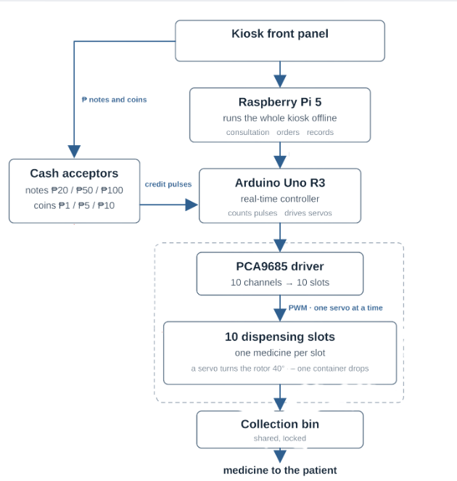

Figure 4: Simplified hardware flow of MendoVendo, from consultation and payment to the planned release of one medicine container.

3D-Printed Dispensing Model
Each dispensing slot is designed for one medicine type. As shown in Figure 5, a slot has a vertical storage tube, a rotating disk with nine pockets, and a base plate with one release opening. The medicine is placed inside a small sealed container before loading. Keeping only one medicine type in each slot reduces the chance of mixing products and makes restocking easier.


Figure 6: Exploded view showing how the storage tube, rotating disk, and base plate are assembled.

During one dispensing cycle, the rotating disk moves by one pocket. A container is carried from the storage tube to the release opening and drops toward the collection area. The empty pocket then returns to the loading position and receives the next container. This repeated movement is intended to release one container at a time without requiring a separate gate for every medicine.

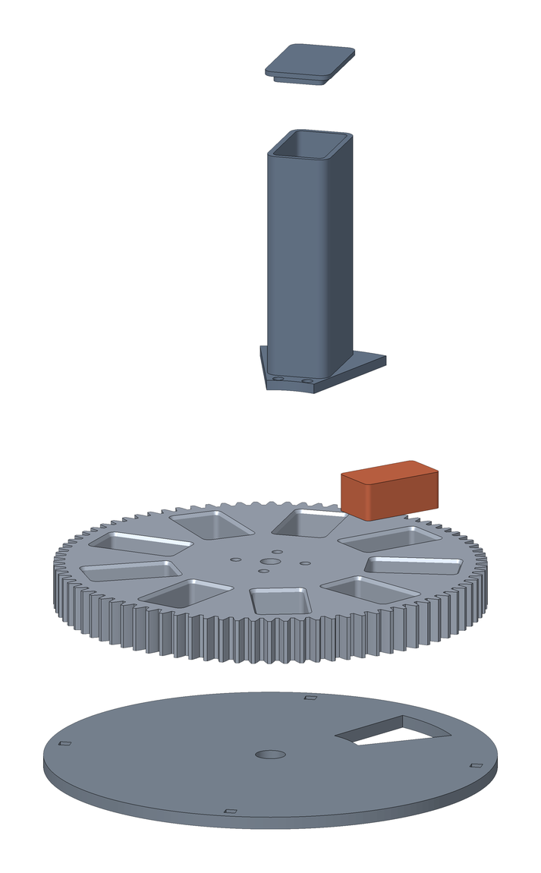
Figure 6: Exploded view showing how the storage tube, rotating disk, and base plate are assembled.

The complete design uses ten independent slots, as shown in Figure 7. Each slot corresponds to one medicine in the kiosk's ten-item catalog and can be filled, maintained, or tested separately. If one slot has a problem, it can be disabled without changing the identity of the medicines stored in the other slots.

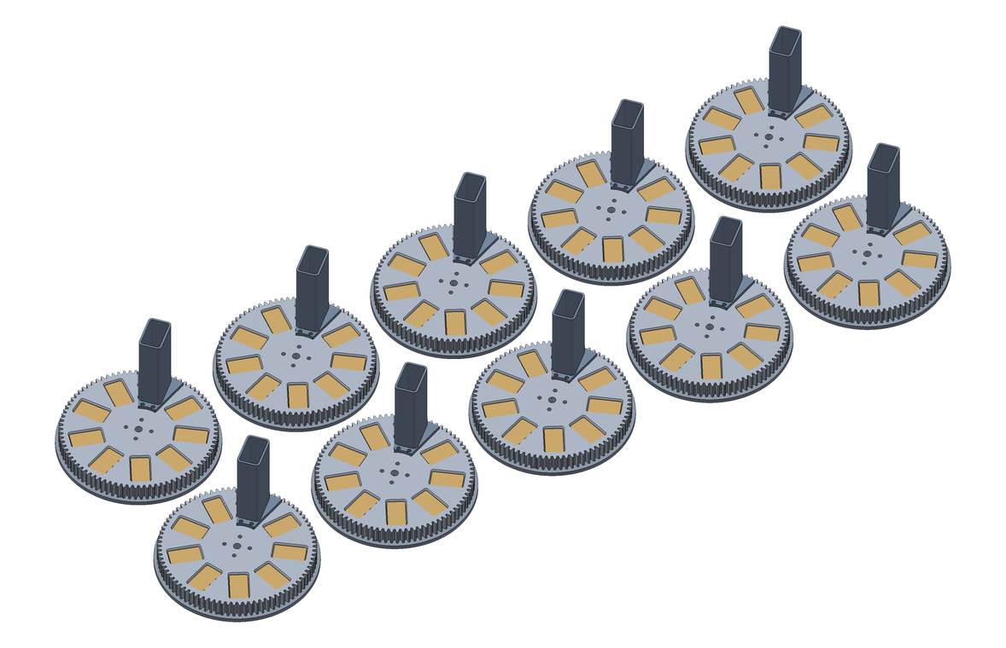
Figure 7: Proposed ten-slot dispensing bank. Each slot holds one OTC medicine type.

How the Hardware Operates
From the user's point of view, the final process is straightforward: complete the consultation, choose an available medicine, insert payment, wait for confirmation, and collect the medicine. Behind these steps, the system verifies the order and available stock before accepting money, records the payment, identifies the assigned slot, and creates a receipt. Repeated or delayed messages remain linked to the original order so that the same payment is not recorded twice.

System UI Mockup
In this section, the researchers showed and discussed the mendov3 Machine's
User-Interface.
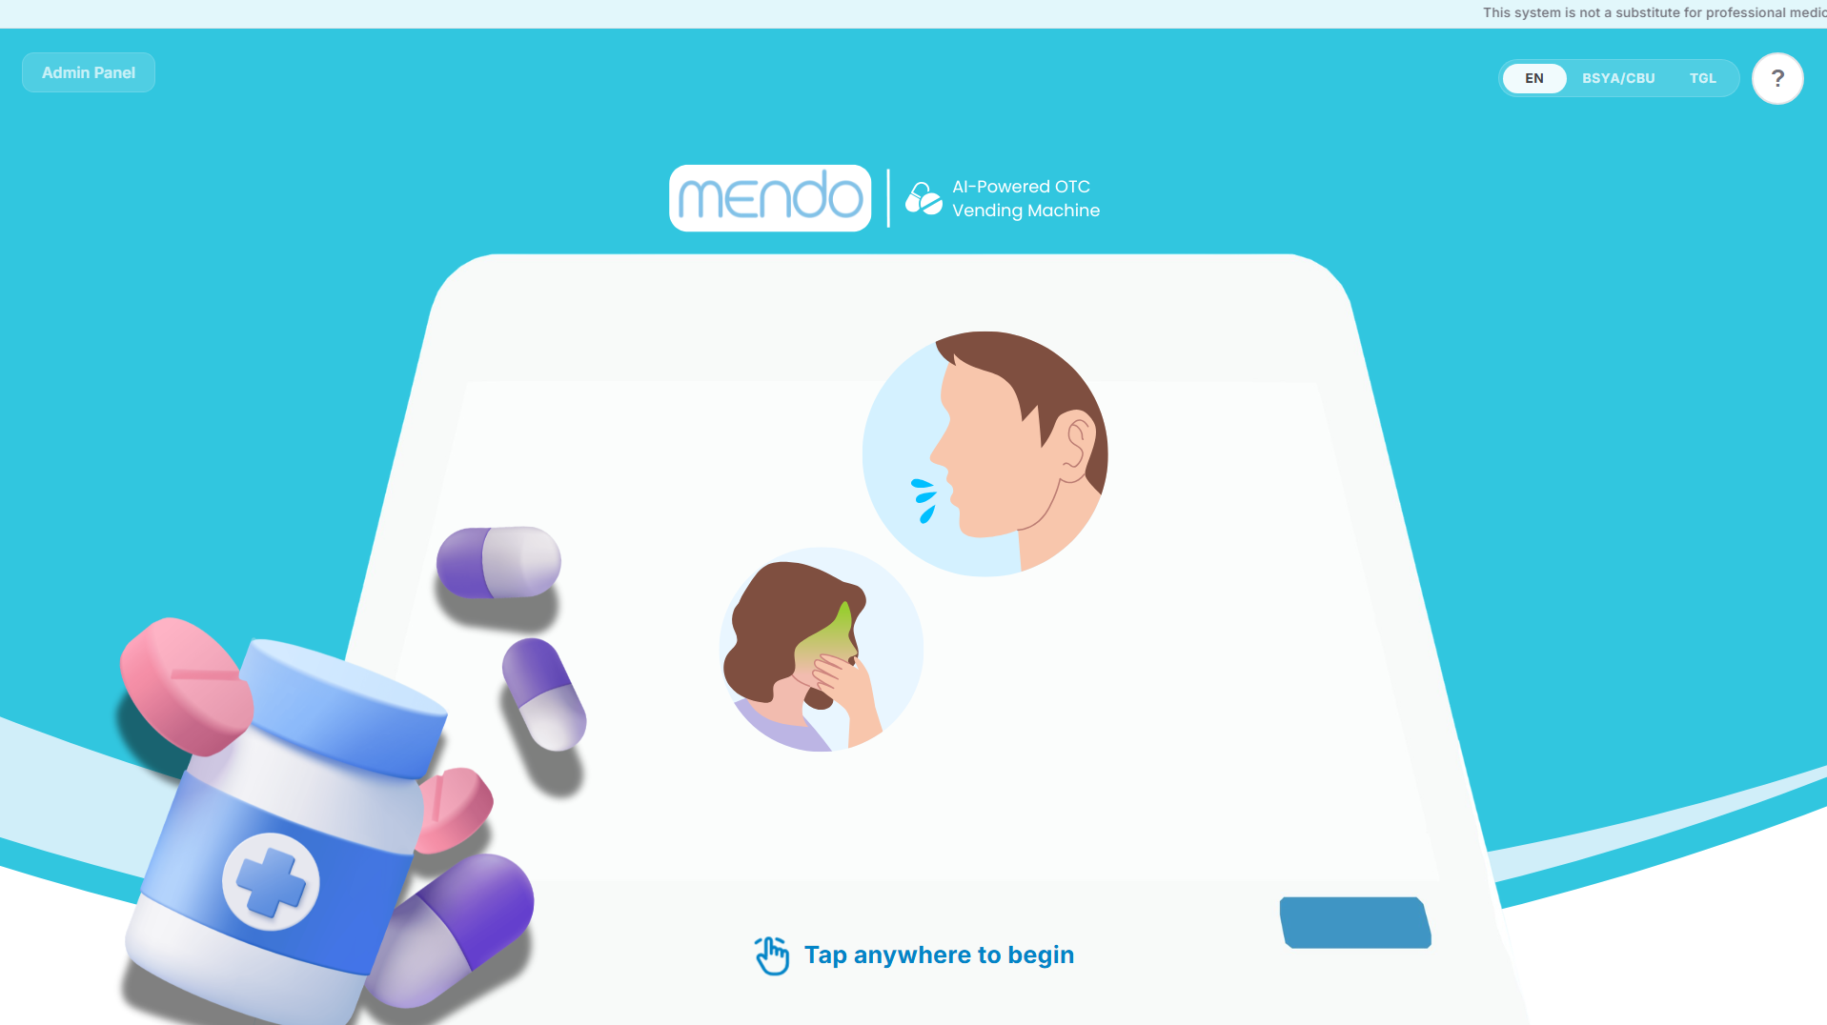

Figure 8 : Mendov3 Main User Interface

Figure 7 shows the main UI of Mendov3 upon entering. With a straightforward User Interface designed for intuitive experience. The interface consists of the Admin panel button for the admin panel POS system side. Language selection tabs (EN,BISYA/CEB, and Tgl), more information button for a detailed description of the system, and finally the main interface with a clear “Tap anywhere to begin”.
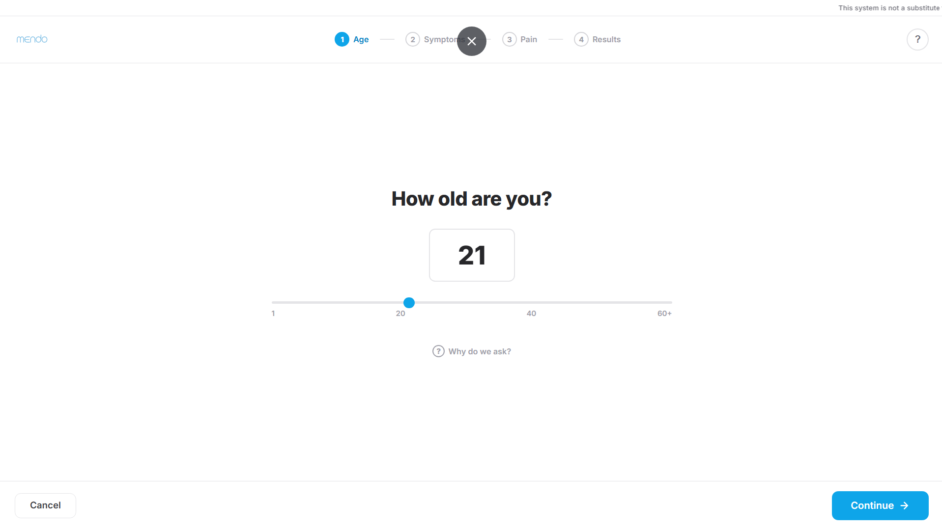
Figure 9: Age and Proxy-Purchase Panel

Figure 9 shows the age panel where the customer enters or selects the patient’s age, and indicates whether the purchase is for the customer or for another person (the proxy-purchase step). The age is used by the system to apply each medicine’s minimum-age filter.
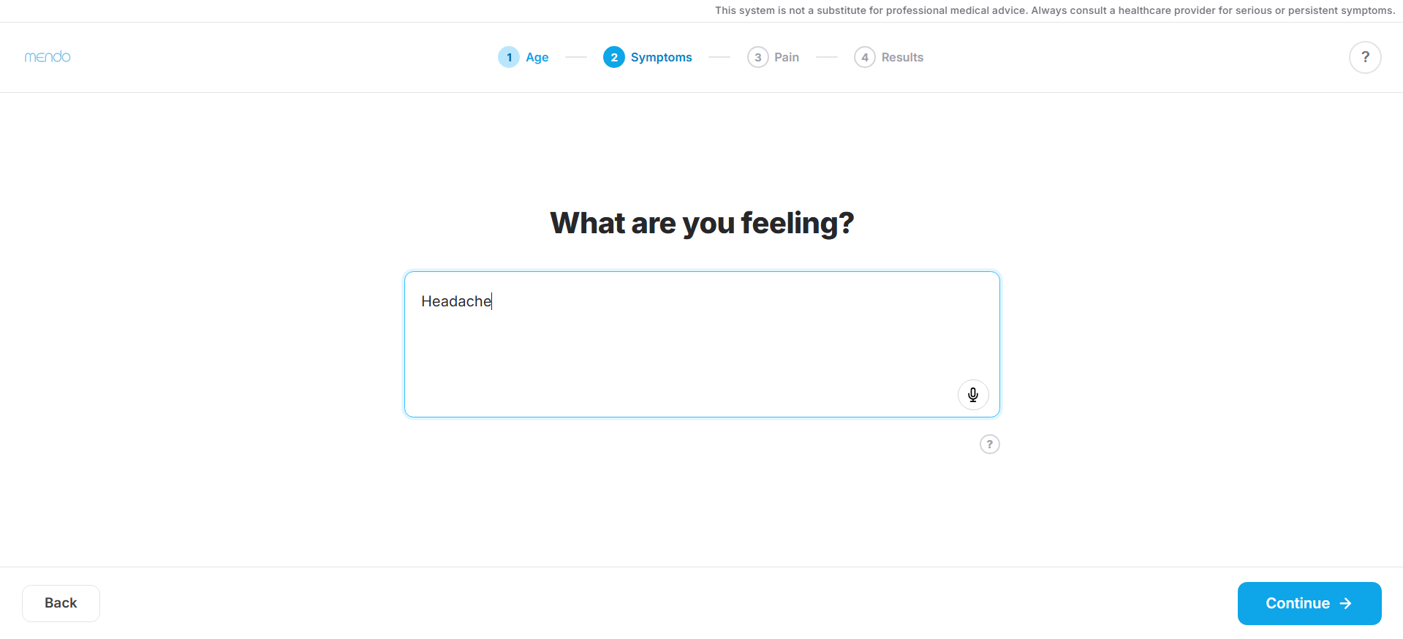

Figure 10: Symptom Input Screen

Figure 10 shows the symptom input screen. The customer types their symptom description in their chosen language, or taps the voice button to speak it. The text is processed by the system’s multilingual symptom detector.
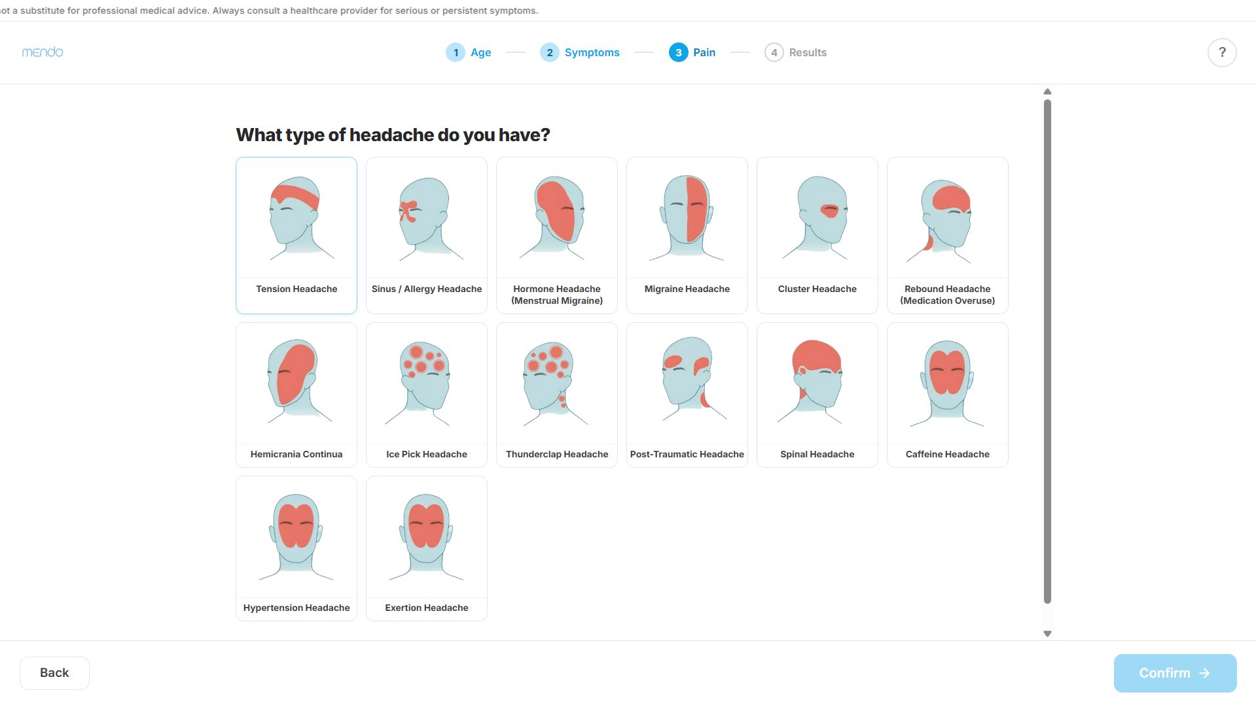

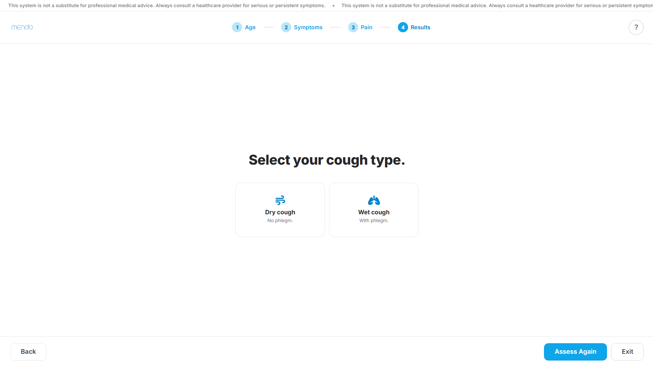

Figure 11,12: Safety and Clarification Screen

Figure 11 shows the safety-screening and clarification steps. Depending on the symptom reported, the customer is shown an interactive head map for headache, a “difficulty breathing?” check for rashes, or a before/after-eating selector for stomach ache. It also asks a cough-type question (dry or with phlegm).
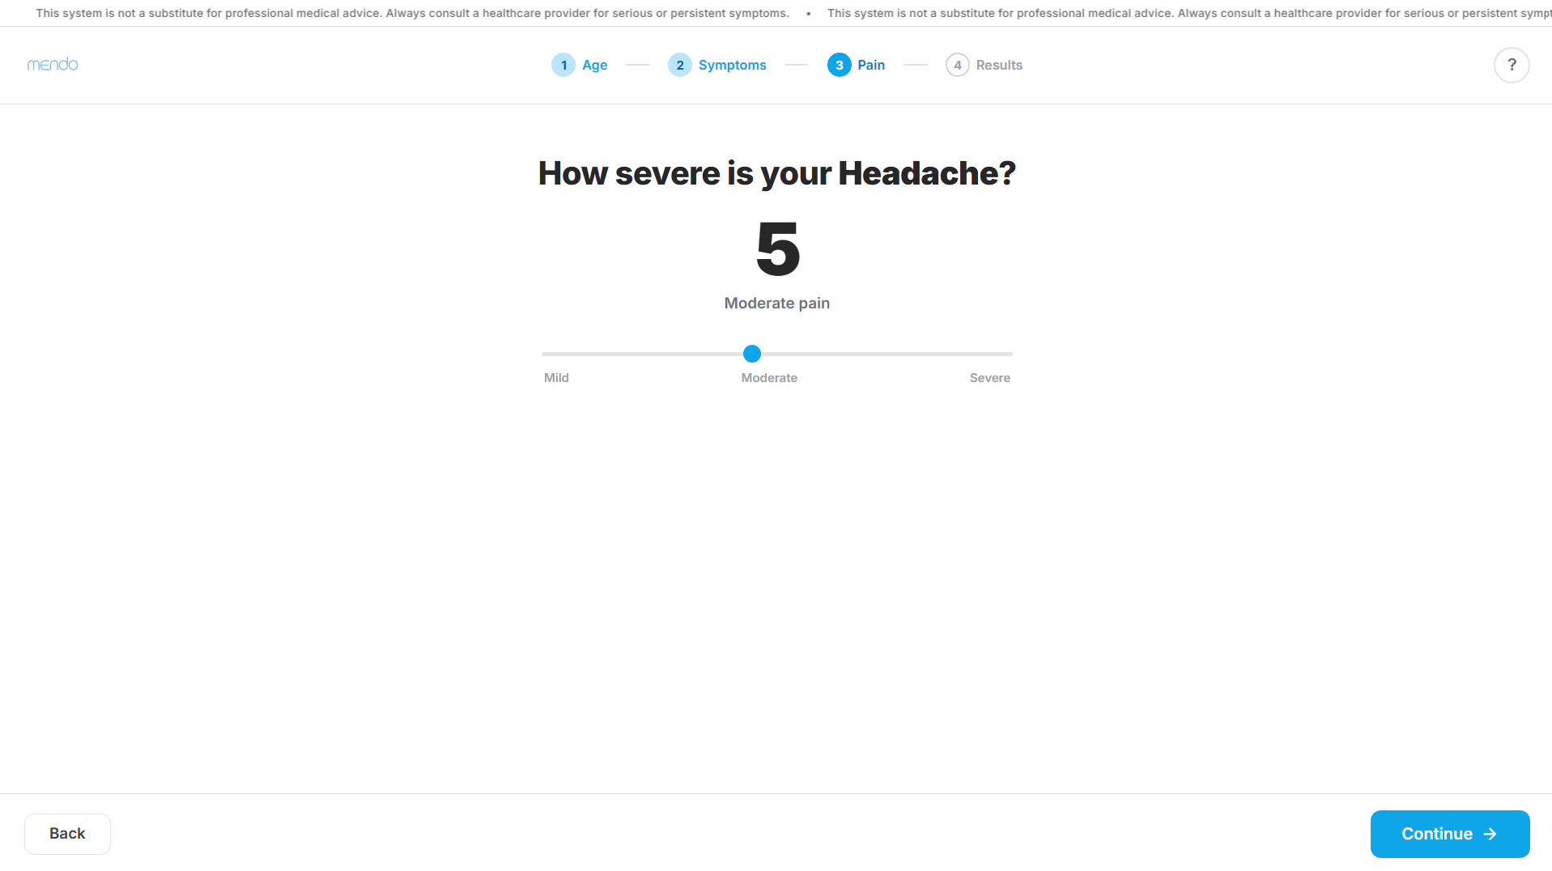
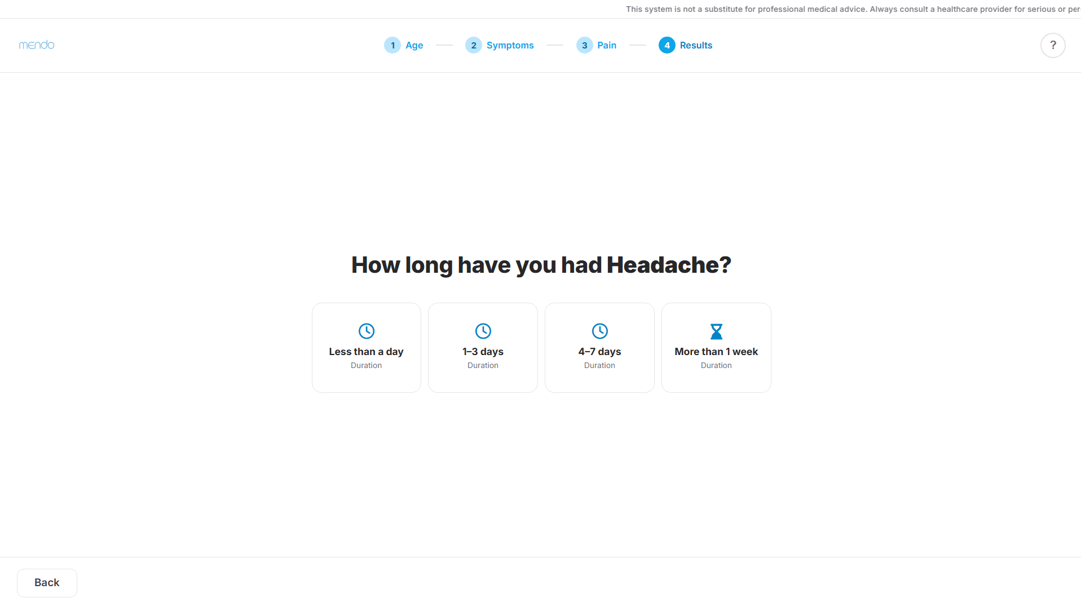

Figure 13, 14: Severity Clarification & Duration Safeguard Screen

Figure 12 shows the duration screen, which asks how long the symptom has lasted. When the reported duration exceeds the safe threshold, the system does not recommend a medicine and instead shows a referral notice advising the user to see a healthcare professional.
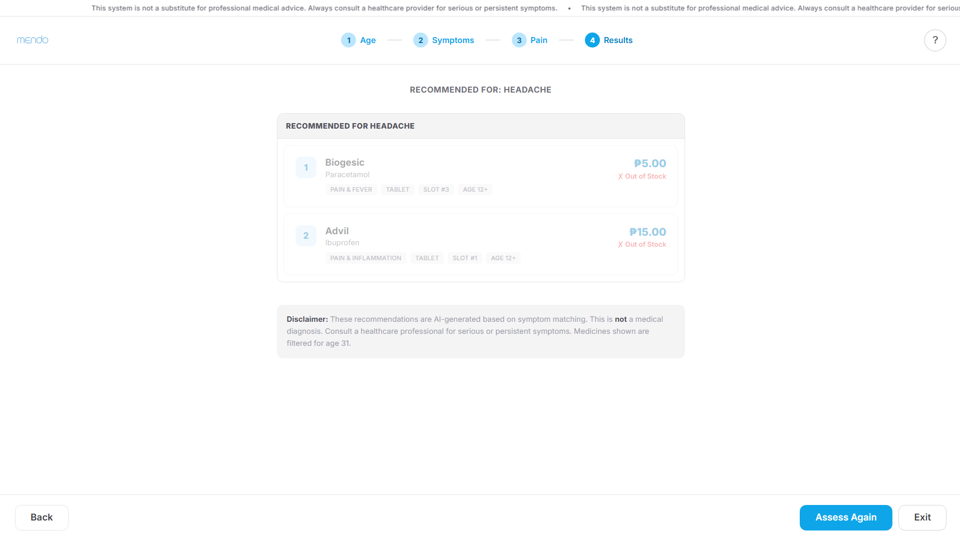
Figure 15: Recommendation Results Screen

Figure 13 shows the recommendation screen, which presents the detected symptoms and the suggested over-the-counter medicines along with their usage and safety information. The customer can then proceed to confirm the recommendation.

Figure 16: Checkout and Payment Screen

Figure 14 shows the checkout screen, where the customer reviews the cart and completes the cashless payment.

III. RESULTS AND DISCUSSION

This section presents and discusses the results obtained from the evaluation of MENDO across its four development iterations. The evaluation examines the performance of the system's major components, including symptom detection and drug recommendation. Each iteration reflects modifications and improvements made to the system based on the results and limitations identified during testing. The findings are analyzed using appropriate performance metrics to determine the effectiveness of each component, identify recurring errors and limitations, and assess the improvements achieved throughout the development of MENDO.

The software implementation of this study was developed in Python 3.12.3 using the Flask web framework for the backend, and HTML, CSS, and JavaScript for the frontend of the kiosk interface. The code was written and tested in Visual Studio Code, and version control was handled with Git. The multilingual symptom-understanding component used the sentence-transformers library with a pre-trained multilingual MiniLM model, which runs locally in CPU-only mode with PyTorch, so no cloud service or GPU is required. This combination was chosen so that the entire system runs offline on the Raspberry Pi 5 without sending any patient data off the device.

- Baseline Evaluation
Before conducting the first community-Base iteration, a baseline evaluation was performed on the initial version of MENDO. This evaluation aimed to assess the performance of the system's core components and identify existing issues that could be addressed before deployment to the intended users. The findings from the baseline evaluation therefore serve as the initial basis for improving the system prior to Iteration 1.

Symptom Detection
The symptom detection component of MENDO was evaluated to determine its ability to correctly identify symptoms expressed through user-provided statements. The baseline evaluation included both normal and negated test cases to assess the system's ability to recognize symptoms that are present and appropriately handle symptoms that are explicitly stated as absent. The evaluation was conducted across base symptom categories, subsymptoms, and the languages supported by the system. Precision, recall, and F1-score were used as the primary performance metrics to measure the correctness and consistency of symptom detection.

- Symptom Detection (Normal)
The normal symptom detection evaluation focused on MENDO's ability to recognize symptoms that were present in the user statements. The results were analyzed at the subsymptom, base symptom, and language levels to identify variations in the model's performance and determine which symptoms or categories were more accurately recognized.

Subsymptom | Precision | Recall | F1-Score
(Cold) Runny Nose | 71.43% | 100.00% | 83.33%
(Cold) Nasal Congestion | 55.56% | 100.00% | 71.43%
Cough (Unspecified) | 100.00% | 100.00% | 100.00%
Cough (Dry) | 40.00% | 40.00% | 40.00%
Cough (Productive/With Phlegm) | 100.00% | 100.00% | 100.00%
Body Pain (Toothache) | 0.00% | 0.00% | 0.00%
Body Pain (Bodyache) | 100.00% | 60.00% | 75.00%
Stomach Pain (Diarrhea) | 100.00% | 100.00% | 100.00%
Stomach Pain (Stomachache) | 83.33% | 100.00% | 90.91%
Allergy | 0.00% | 0.00% | 0.00%
Allergy (Rashes) | 100.00% | 80.00% | 88.89%

Table 1. Normal Symptom Detection Performance per Subsymptom in English

As shown in Table 1, MENDO demonstrated varying performance across the English subsymptom test cases. Cough (Unspecified), Cough (Productive/With Phlegm), and Stomach Pain (Diarrhea) achieved the highest performance, each obtaining 100% precision, recall, and F1-score. These results indicate that the model consistently recognized the expressions used for these subsymptoms without producing incorrect or missed detections. Stomach Pain (Stomachache) and Allergy (Rashes) also performed relatively well, with F1-scores of 90.91% and 88.89%, respectively.

In contrast, lower performance was observed for several subsymptoms. Cough (Dry) obtained an F1-score of 40.00%, indicating difficulty in correctly distinguishing dry cough expressions from other cough-related classifications. Body Pain (Bodyache) achieved 100% precision but only 60.00% recall, suggesting that when the model identified bodyache, the prediction was correct, but some expected bodyache cases were not detected. Cold-related subsymptoms showed a different pattern: Runny Nose and Nasal Congestion both achieved 100% recall but lower precision of 71.43% and 55.56%, respectively. This indicates that the expected cases were successfully detected, but the model also produced additional incorrect detections involving these closely related cold subsymptoms.

The weakest results were observed for Body Pain (Toothache) and Allergy, both of which obtained 0% precision, recall, and F1-score. This indicates that the model was unable to correctly recognize the tested English expressions for these symptoms during the baseline evaluation. Overall, the results suggest that MENDO performs well for several clearly expressed symptoms but has difficulty with certain symptom categories and with distinguishing between semantically related subsymptoms. These findings identify areas that require refinement before the system proceeds to community-Base evaluation.

Subsymptom | Precision | Recall | F1-Score
(Cold) Runny Nose | 66.67% | 80.00% | 72.73%
(Cold) Nasal Congestion | 100.00% | 100.00% | 100.00%
Cough (Unspecified) | 100.00% | 40.00% | 57.14%
Cough (Dry) | 40.00% | 40.00% | 40.00%
Cough (Productive/With Phlegm) | 80.00% | 80.00% | 80.00%
Body Pain (Toothache) | 0.00% | 0.00% | 0.00%
Body Pain (Bodyache) | 100.00% | 80.00% | 88.89%
Stomach Pain (Diarrhea) | 100.00% | 80.00% | 88.89%
Stomach Pain (Stomachache) | 100.00% | 100.00% | 100.00%
Allergy | 33.33% | 20.00% | 25.00%
Allergy (Rashes) | 83.33% | 100.00% | 90.91%

Table 2. Normal Symptom Detection Performance per Subsymptom in Filipino

In Table 2, MENDO demonstrated varying levels of performance in detecting Filipino expressions of the tested subsymptoms. Cold (Nasal Congestion) and Stomach Pain (Stomachache) achieved the highest performance, obtaining 100% precision, recall, and F1-score. Relatively strong performance was also observed for Allergy (Rashes), Body Pain (Bodyache), and Stomach Pain (Diarrhea), which obtained F1-scores of 90.91%, 88.89%, and 88.89%, respectively. These results indicate that MENDO was able to recognize most of the Filipino expressions used for these symptoms during baseline testing.
Lower performance was observed among the cough-related subsymptoms. Cough (Unspecified) achieved 100% precision but only 40% recall, resulting in an F1-score of 57.14%. This indicates that although the model's successful detections were correct, it failed to recognize several expected unspecified cough cases. Cough (Dry) similarly obtained only 40% for precision, recall, and F1-score, while Cough (Productive/With Phlegm) performed better with an F1-score of 80%. Cold (Runny Nose) achieved an F1-score of 72.73%, showing that some incorrect and missed detections were also present for this subsymptom.
Body Pain (Toothache) remained the weakest-performing subsymptom, obtaining 0% across all three metrics, while Allergy achieved an F1-score of only 25%. Compared with the stronger performance of their related categories, such as Body Pain (Bodyache) and Allergy (Rashes), these results suggest that the model's performance is dependent not only on the broader symptom category but also on the specific expressions associated with each subsymptom. The variation observed across the Filipino test cases highlights the need to improve the recognition of poorly performing symptoms, particularly Toothache, Allergy, and certain cough expressions, before community deployment.

Subsymptom | Precision | Recall | F1-Score
(Cold) Runny Nose | 50.00% | 60.00% | 54.55%
(Cold) Nasal Congestion | 100.00% | 100.00% | 100.00%
Cough (Unspecified) | 100.00% | 80.00% | 88.89%
Cough (Dry) | 40.00% | 40.00% | 40.00%
Cough (Productive/With Phlegm) | 100.00% | 100.00% | 100.00%
Body Pain (Toothache) | 0.00% | 0.00% | 0.00%
Body Pain (Bodyache) | 75.00% | 75.00% | 75.00%
Stomach Pain (Diarrhea) | 100.00% | 80.00% | 88.89%
Stomach Pain (Stomachache) | 100.00% | 100.00% | 100.00%
Allergy | 33.33% | 20.00% | 25.00%
Allergy (Rashes) | 83.33% | 100.00% | 90.91%

Table 3. Normal Symptom Detection Performance per Subsymptom in Bisaya/Cebuano
The Bisaya/Cebuano evaluation revealed considerable differences in MENDO's ability to recognize individual subsymptoms. Some categories were detected consistently, particularly Cold (Nasal Congestion), Cough (Productive/With Phlegm), and Stomach Pain (Stomachache), which each achieved perfect scores across all three performance metrics. Strong results were also recorded for Cough (Unspecified), Stomach Pain (Diarrhea), and Allergy (Rashes), with F1-scores ranging from 88.89% to 90.91%. These findings indicate that the baseline model was capable of recognizing several Bisaya/Cebuano symptom expressions with a high degree of consistency.
Performance was less consistent among the remaining categories. Cold (Runny Nose) achieved an F1-score of 54.55%, while Cough (Dry) obtained only 40%, reflecting difficulties in correctly identifying their tested expressions. Allergy similarly showed weak performance with an F1-score of 25%. Body Pain (Toothache) remained the most problematic category, receiving 0% across precision, recall, and F1-score, whereas Body Pain (Bodyache) performed moderately at 75%. The combination of lower precision and recall among these categories indicates that the system experienced both incorrect detections and failures to recognize expected symptoms.
A comparison with the English and Filipino evaluations reveals that some of these weaknesses extend beyond Bisaya/Cebuano. Cough (Dry) and Body Pain (Toothache), for example, repeatedly showed difficulty across the tested languages, while categories such as Stomach Pain (Stomachache) and Allergy (Rashes) generally maintained stronger results. This pattern indicates that performance differences cannot be attributed solely to the language of the input. The specific symptom expressions and the model's ability to associate them with their corresponding symptom categories also appear to play an important role in the observed baseline performance.

Subsymptom | Precision | Recall | F1-Score
(Cold) Runny Nose | 100.00% | 100.00% | 100.00%
(Cold) Nasal Congestion | 66.67% | 80.00% | 72.73%
Cough (Unspecified) | 80.00% | 80.00% | 80.00%
Cough (Dry) | 40.00% | 40.00% | 40.00%
Cough (Productive/With Phlegm) | 100.00% | 100.00% | 100.00%
Body Pain (Toothache) | 0.00% | 0.00% | 0.00%
Body Pain (Bodyache) | 100.00% | 40.00% | 57.14%
Stomach Pain (Diarrhea) | 100.00% | 100.00% | 100.00%
Stomach Pain (Stomachache) | 100.00% | 100.00% | 100.00%
Allergy | 0.00% | 0.00% | 0.00%
Allergy (Rashes) | 100.00% | 100.00% | 100.00%

Table 4. Normal Symptom Detection Performance per Subsymptom in Mixed Language/Conyo
Mixed Language/Conyo produced strong detection results for a number of subsymptoms. Cold (Runny Nose), Cough (Productive/With Phlegm), Stomach Pain (Diarrhea), Stomach Pain (Stomachache), and Allergy (Rashes) were consistently identified, with each obtaining 100% precision, recall, and F1-score. Cough (Unspecified) also performed relatively well with an F1-score of 80%. These results suggest that combining languages within an expression did not necessarily prevent MENDO from correctly identifying the intended symptom.
However, the results were not equally strong across all categories. Cold (Nasal Congestion) achieved an F1-score of 72.73%, while Body Pain (Bodyache) obtained 57.14%. In the latter case, its 100% precision but 40% recall shows that the detections made by MENDO were correct, but a substantial number of expected Bodyache cases were missed. Cough (Dry) continued to be difficult for the system, maintaining an F1-score of 40%, similar to its performance in the other language settings. More significantly, Body Pain (Toothache) and Allergy received 0% across all three metrics, indicating that the expected cases for these categories were not successfully identified.
Rather than showing a general difficulty with Mixed Language/Conyo inputs, the results point toward weaknesses associated with particular symptom categories and expressions. Several subsymptoms achieved perfect or relatively high performance despite the use of mixed-language statements, while recurring difficulties remained for Cough (Dry), Body Pain (Toothache), and Allergy. The recurrence of these weaknesses across multiple language settings suggests that the baseline model's limitations may be associated not only with language variation but also with how particular symptom expressions are recognized and mapped to their corresponding categories.
Across the four language categories, several consistent patterns were observed in the normal subsymptom detection results. Cough (Dry) obtained an F1-score of 40% in all four language categories, while Body Pain (Toothache) obtained 0% across all languages. Allergy similarly demonstrated consistently low performance, with an F1-score of 0% in English and Mixed Language/Conyo and 25% in Filipino and Bisaya/Cebuano. In contrast, Stomach Pain (Stomachache) and Allergy (Rashes) maintained relatively high performance across all four language categories. Other subsymptoms, including Cold (Runny Nose), Cold (Nasal Congestion), Cough (Unspecified), and Body Pain (Bodyache), showed greater variation between languages. These findings suggest that some detection weaknesses are consistent across languages, particularly for Dry Cough, Toothache, and Allergy, while other variations may be associated with differences in how symptoms are expressed across the supported languages.

Base Symptom | Precision | Recall | F1-Score
Fever | 100.00% | 100.00% | 100.00%
Headache | 100.00% | 100.00% | 100.00%
Cold | 62.50% | 100.00% | 76.92%
Cough | 80.00% | 80.00% | 80.00%
Bodyache | 75.00% | 30.00% | 42.86%
Stomach Pain | 90.91% | 100.00% | 95.24%
Allergy | 66.67% | 40.00% | 50.00%

Table 5. Normal Symptom Detection Performance per Base Symptom in English

As shown in Table 5, MENDO’s performance varied across the English base symptom categories. Fever and Headache were included at this level because, unlike the other base symptom categories examined in the study, they do not have corresponding subsymptoms. Both symptoms achieved 100% precision, recall, and F1-score, showing that all tested cases were identified correctly without any false detections. Stomach Pain also performed well, with 90.91% precision, 100% recall, and an F1-score of 95.24%. Cough showed equal precision and recall at 80%, resulting in an F1-score of 80%.

Cold achieved a perfect recall of 100% but had a lower precision of 62.50%, producing an F1-score of 76.92%. This means that MENDO detected all expected Cold cases but also incorrectly labeled some additional cases as Cold. In comparison, Bodyache recorded 75% precision but only 30% recall, resulting in an F1-score of 42.86%. Its low recall indicates that many expected Bodyache cases were missed. Allergy also showed weaker results, with 66.67% precision, 40% recall, and an F1-score of 50%, suggesting that MENDO had difficulty consistently identifying the tested Allergy cases.

Overall, the English base symptom results show that MENDO performs most consistently for Fever, Headache, Stomach Pain, and Cough, while Bodyache and Allergy remain weaker areas of the baseline model. The differences between precision and recall also indicate distinct types of detection errors. Cold was mainly affected by incorrect additional detections, whereas Bodyache and Allergy were more affected by missed cases. These results highlight specific areas that should be improved in the symptom detection component before future iterations.

Base Symptom | Precision | Recall | F1-Score
Fever | 100.00% | 100.00% | 100.00%
Headache | 100.00% | 100.00% | 100.00%
Cold | 81.82% | 90.00% | 85.71%
Cough | 66.67% | 53.33% | 59.26%
Bodyache | 100.00% | 40.00% | 57.14%
Stomach Pain | 100.00% | 90.00% | 94.74%
Allergy | 66.67% | 60.00% | 63.16%

Table 6. Normal Symptom Detection Performance per Base Symptom in Filipino

MENDO performed well in identifying several Filipino base symptom categories, particularly Fever and Headache, both of which achieved 100% precision, recall, and F1-score. Stomach Pain also produced strong results, with 100% precision, 90% recall, and an F1-score of 94.74%. Cold recorded 81.82% precision, 90% recall, and an F1-score of 85.71%. These results indicate that most expected Cold cases were detected, although the model produced some incorrect classifications.
The model showed weaker results for Cough, Bodyache, and Allergy. Cough reached 66.67% precision and 53.33% recall, resulting in an F1-score of 59.26%. This suggests that the model both incorrectly identified some cases and failed to detect others. Bodyache achieved perfect precision at 100% but had a recall of only 40%, producing an F1-score of 57.14%. Although the cases identified as Bodyache were correct, many expected cases were missed. Allergy showed a more balanced but moderate level of performance, with 66.67% precision, 60% recall, and an F1-score of 63.16%.
The strongest results were recorded for Fever, Headache, Stomach Pain, and Cold, whereas Cough, Bodyache, and Allergy remained more challenging categories. Bodyache displayed the same pattern observed in the English results: relatively high precision paired with substantially lower recall. This recurring pattern suggests that the baseline model tends to miss expected Bodyache cases. Differences in the results for Cough and Cold across English and Filipino also indicate that MENDO’s effectiveness is influenced by both the symptom category and the language used to express it.

Base Symptom | Precision | Recall | F1-Score
Fever | 100.00% | 40.00% | 57.14%
Headache | 100.00% | 100.00% | 100.00%
Cold | 72.73% | 80.00% | 76.19%
Cough | 78.57% | 73.33% | 75.86%
Bodyache | 75.00% | 30.00% | 42.86%
Stomach Pain | 100.00% | 90.00% | 94.74%
Allergy | 66.67% | 60.00% | 63.16%

Table 7. Normal Symptom Detection Performance per Base Symptom in Bisaya/Cebuano
MENDO’s performance differed across the Bisaya/Cebuano base symptom categories. Headache produced the strongest results, achieving 100% precision, recall, and F1-score. Stomach Pain also performed well, recording 100% precision, 90% recall, and an F1-score of 94.74%. Cold and Cough showed moderately strong results, with F1-scores of 76.19% and 75.86%, respectively.
Fever, Bodyache, and Allergy presented greater challenges for the model. Fever achieved perfect precision at 100% but had a recall of only 40%, resulting in an F1-score of 57.14%. This means that the Fever cases identified by MENDO were correct, but several expected Bisaya/Cebuano Fever cases were missed. Bodyache also showed a substantial gap between precision and recall, with 75% precision and 30% recall, producing an F1-score of 42.86%. Allergy recorded 66.67% precision, 60% recall, and an F1-score of 63.16%.
The results point to Headache and Stomach Pain as the strongest-performing categories, while Bodyache had the weakest performance. Fever also showed a notable decline compared with the English and Filipino evaluations, where it achieved perfect results. Its lower recall in Bisaya/Cebuano suggests that MENDO struggled to recognize some of the language-specific expressions used to describe Fever, even though the cases it detected were classified correctly. In addition, Bodyache consistently recorded low recall across all three languages, indicating a recurring difficulty in detecting this symptom category.

Base Symptom | Precision | Recall | F1-Score
Fever | 100.00% | 100.00% | 100.00%
Headache | 100.00% | 100.00% | 100.00%
Cold | 81.82% | 90.00% | 85.71%
Cough | 73.33% | 73.33% | 73.33%
Bodyache | 100.00% | 20.00% | 33.33%
Stomach Pain | 100.00% | 100.00% | 100.00%
Allergy | 71.43% | 50.00% | 58.82%

Table 8. Normal Symptom Detection Performance per Base Symptom in Mixed Language/Conyo

The evaluation of Mixed Language/Conyo inputs showed notable performance across several base symptom categories. MENDO successfully detected all tested cases involving Fever, Headache, and Stomach Pain, resulting in perfect scores for precision, recall, and F1-score. Cold likewise demonstrated strong detection performance, achieving 81.82% precision and 90% recall, which produced an F1-score of 85.71%.
Cough recorded equal precision and recall at 73.33%, resulting in an F1-score of 73.33%. Allergy showed weaker performance, obtaining 71.43% precision, 50% recall, and an F1-score of 58.82%. Bodyache had the lowest results, despite achieving 100% precision. Its recall was only 20%, leading to an F1-score of 33.33%. This combination indicates that although the Bodyache cases detected by MENDO were correct, most expected cases were missed.
The findings for Mixed Language/Conyo show that MENDO was most effective at detecting Fever, Headache, Stomach Pain, and Cold. However, the model experienced greater difficulty with Bodyache and Allergy. Bodyache’s low recall follows the same pattern observed in the other language categories, suggesting that missed Bodyache cases are a recurring weakness of the baseline symptom detection model rather than a problem limited to Mixed Language/Conyo.
Across all four language categories, Headache showed the most consistent performance at the base symptom level, achieving an F1-score of 100% in every language. Stomach Pain also remained highly accurate, with F1-scores ranging from 94.74% to 100%. Bodyache, on the other hand, consistently recorded low recall values between 20% and 40%, resulting in F1-scores ranging from 33.33% to 57.14%. This pattern reflects the model’s recurring difficulty in recognizing expected Bodyache cases across languages. Other categories varied more noticeably: Fever achieved an F1-score of 100% in English, Filipino, and Mixed Language/Conyo but dropped to 57.14% in Bisaya/Cebuano because of its lower recall. Cough also showed differences across the language categories, while Allergy maintained moderate to low performance throughout the evaluation. These results indicate that MENDO’s base symptom detection is affected by both the symptom category and the different ways symptoms are expressed across languages.

Language/Setting | Precision | Recall | F1-Score
English | 79.03% | 75.38% | 77.17%
Filipino | 83.64% | 70.77% | 76.67%
Bisaya/Cebuano | 81.48% | 67.69% | 73.95%
Mixed Language/Conyo | 85.45% | 72.31% | 78.33%

Table 9. Normal Symptom Detection Performance per Language/Setting
The language-level results reveal that MENDO maintained fairly consistent normal symptom detection performance across the four evaluated language settings. Mixed Language/Conyo recorded the highest F1-score at 78.33%, closely followed by English at 77.17% and Filipino at 76.67%. Bisaya/Cebuano obtained the lowest F1-score at 73.95%. Despite these differences, the scores remained within a relatively small range, suggesting that no single language setting produced a substantial advantage or disadvantage in the baseline evaluation.
Differences became more apparent when precision and recall were considered separately. Mixed Language/Conyo recorded the highest precision at 85.45%, reflecting fewer incorrect detections among the symptoms identified by the system. English showed a different pattern, obtaining the lowest precision at 79.03% but the highest recall at 75.38%. This indicates that English inputs allowed MENDO to capture more of the expected symptoms, although with a greater occurrence of incorrect detections. Filipino achieved 83.64% precision and 70.77% recall, while Bisaya/Cebuano recorded 81.48% precision and the lowest recall at 67.69%.
A common pattern across all four settings was that precision remained higher than recall. This suggests that missed symptoms were a recurring limitation during normal symptom detection, regardless of the language used. The earlier subsymptom and base symptom evaluations reflect a similar pattern, with certain categories being detected accurately when recognized but still having several expected cases left undetected. Consequently, expanding the range of symptom expressions that MENDO can recognize may help address these missed detections and improve performance across its supported language settings.

Precision | Recall | F1-Score
82.30% | 71.54% | 76.54%

Table 10. Normal Symptom Detection Overall Performance
As shown in Table 10, MENDO achieved an overall precision of 82.30%, recall of 71.54%, and F1-score of 76.54% for normal symptom detection. The higher precision indicates that the majority of symptoms identified by the model were correct, while the lower recall shows that the model was less consistent in identifying all symptoms that were expected to be detected. The resulting F1-score of 76.54% reflects the balance between these two measures and represents the overall performance of the baseline model across the normal symptom detection test cases.
The difference between precision and recall further indicates that missed symptom detections were a more prominent limitation than incorrect additional detections. This observation is consistent with the preceding analyses, where certain subsymptoms and base symptom categories demonstrated high precision but comparatively low recall. Although the model demonstrated strong performance for several symptom categories and maintained relatively comparable performance across the four language settings, the results also identified recurring weaknesses in recognizing specific symptoms and expressions. These findings establish the baseline performance of MENDO's normal symptom detection component and provide a basis for identifying areas that require improvement in succeeding iterations.

- Symptom Detection (Negated)
The negated symptom detection evaluation focused on MENDO's ability to correctly handle symptoms that were explicitly stated as absent in the user statements. Similar to the normal symptom detection evaluation, the results were examined at the subsymptom, base symptom, and language levels to determine how consistently the system recognized negated expressions and to identify symptom categories and language settings where negation handling remained challenging.

Negated Subsymptom | Precision | Recall | F1-Score
(Cold) Runny Nose | 100.00% | 20.00% | 33.33%
(Cold) Nasal Congestion | 100.00% | 60.00% | 75.00%
Cough (Unspecified) | 0.00% | 0.00% | 0.00%
Cough (Dry) | 100.00% | 20.00% | 33.33%
Cough (Productive/With Phlegm) | 100.00% | 40.00% | 57.14%
Body Pain (Toothache) | 100.00% | 100.00% | 100.00%
Body Pain (Bodyache) | 100.00% | 60.00% | 75.00%
Stomach Pain (Diarrhea) | 100.00% | 60.00% | 75.00%
Stomach Pain (Stomachache) | 0.00% | 0.00% | 0.00%
Allergy | 100.00% | 40.00% | 57.14%
Allergy (Rashes) | 100.00% | 40.00% | 57.14%

Table 11. Negated Symptom Detection Performance per Subsymptom in English
The English negated subsymptom results reveal a noticeable difference between precision and recall. Most subsymptoms achieved 100% precision, including Runny Nose, Nasal Congestion, Dry Cough, Productive Cough, Toothache, Bodyache, Diarrhea, Allergy, and Rashes. Under the negation evaluation criteria, this indicates that when MENDO successfully recognized a symptom as negated, it did so without incorrectly negating symptoms that should have remained present. However, the considerably lower recall values for many subsymptoms indicate that the model frequently failed to recognize some expected negations.
Body Pain (Toothache) demonstrated the strongest performance, achieving 100% across precision, recall, and F1-score. Nasal Congestion, Bodyache, and Diarrhea followed with F1-scores of 75%, while Productive Cough, Allergy, and Rashes each obtained 57.14%. Runny Nose and Dry Cough showed particularly low recall at 20%, resulting in F1-scores of only 33.33%. These results indicate that the primary difficulty for these subsymptoms was not incorrect negation, but rather the failure to recognize the negation in several expected cases.
The most notable failures occurred for Cough (Unspecified) and Stomach Pain (Stomachache), which received 0% across all three metrics. In the tested English cases, MENDO did not successfully recognize the expected negations for these subsymptoms. The results therefore suggest that the baseline negation mechanism was highly precise when it successfully handled a negated expression, but its ability to consistently capture different forms of negation remained limited. This is particularly evident from the low recall observed across several subsymptoms.

Negated Subsymptom | Precision | Recall | F1-Score
(Cold) Runny Nose | 100.00% | 60.00% | 75.00%
(Cold) Nasal Congestion | 100.00% | 80.00% | 88.89%
Cough (Unspecified) | 100.00% | 100.00% | 100.00%
Cough (Dry) | 100.00% | 100.00% | 100.00%
Cough (Productive/With Phlegm) | 100.00% | 20.00% | 33.33%
Body Pain (Toothache) | 100.00% | 100.00% | 100.00%
Body Pain (Bodyache) | 100.00% | 80.00% | 88.89%
Stomach Pain (Diarrhea) | 100.00% | 100.00% | 100.00%
Stomach Pain (Stomachache) | 100.00% | 20.00% | 33.33%
Allergy | 100.00% | 60.00% | 75.00%
Allergy (Rashes) | 100.00% | 100.00% | 100.00%

Table 12. Negated Symptom Detection Performance per Subsymptom in Filipino

Filipino negated symptom detection showed considerably stronger performance across most subsymptoms. Cough (Unspecified), Cough (Dry), Body Pain (Toothache), Stomach Pain (Diarrhea), and Allergy (Rashes) achieved 100% precision, recall, and F1-score. Nasal Congestion and Bodyache also performed strongly, each obtaining an F1-score of 88.89%, while Runny Nose and Allergy achieved 75%. These results indicate that MENDO successfully handled the negated Filipino expressions for most of the tested subsymptoms.
Despite the consistently high precision, differences in recall remained evident. Cough (Productive/With Phlegm) and Stomach Pain (Stomachache) achieved only 20% recall, resulting in F1-scores of 33.33%. This means that MENDO correctly handled the negation when it recognized these cases, but failed to recognize most of the expected negated expressions. The contrast between their 100% precision and low recall reinforces a recurring pattern in the negation evaluation: the model rarely negated an incorrect symptom, but it did not always recognize when an expected symptom should be negated. Compared with the English results, however, the Filipino test cases show stronger negation handling across a larger number of subsymptoms.

Negated Subsymptom | Precision | Recall | F1-Score
(Cold) Runny Nose | 100.00% | 100.00% | 100.00%
(Cold) Nasal Congestion | 100.00% | 80.00% | 88.89%
Cough (Unspecified) | 100.00% | 80.00% | 88.89%
Cough (Dry) | 100.00% | 60.00% | 75.00%
Cough (Productive/With Phlegm) | 100.00% | 20.00% | 33.33%
Body Pain (Toothache) | 100.00% | 100.00% | 100.00%
Body Pain (Bodyache) | 100.00% | 80.00% | 88.89%
Stomach Pain (Diarrhea) | 100.00% | 60.00% | 75.00%
Stomach Pain (Stomachache) | 0.00% | 0.00% | 0.00%
Allergy | 100.00% | 80.00% | 88.89%
Allergy (Rashes) | 100.00% | 100.00% | 100.00%

Table 13. Negated Symptom Detection Performance per Subsymptom in Bisaya/Cebuano

The Bisaya/Cebuano negated symptom detection results demonstrated strong performance across several subsymptoms. Runny Nose, Body Pain (Toothache), and Allergy (Rashes) achieved 100% precision, recall, and F1-score, indicating successful handling of all tested negated expressions for these subsymptoms. Nasal Congestion, Cough (Unspecified), Body Pain (Bodyache), and Allergy also performed well, each obtaining an F1-score of 88.89%. Dry Cough and Diarrhea achieved F1-scores of 75%, showing that most, but not all, of their expected negations were successfully recognized.

A different pattern was observed for Cough (Productive/With Phlegm), which achieved 100% precision but only 20% recall, resulting in an F1-score of 33.33%. The high precision indicates that MENDO did not incorrectly negate the symptom in the evaluated cases, while the low recall shows that it failed to recognize most instances where Productive Cough was expected to be negated. Stomach Pain (Stomachache) showed the weakest performance, obtaining 0% across all three metrics, indicating that none of its expected negated cases were successfully recognized.

These results further demonstrate that high precision alone does not necessarily indicate consistently effective negation handling. Although nearly all Bisaya/Cebuano subsymptoms achieved 100% precision, their recall values ranged considerably from 20% to 100%. The variation suggests that MENDO was generally reliable when it successfully recognized negation, but its ability to consistently identify all negated expressions depended on the specific subsymptom. In particular, Productive Cough and Stomachache represent areas that may require further refinement in the baseline model.

Negated Subsymptom | Precision | Recall | F1-Score
(Cold) Runny Nose | 100.00% | 100.00% | 100.00%
(Cold) Nasal Congestion | 100.00% | 60.00% | 75.00%
Cough (Unspecified) | 100.00% | 80.00% | 88.89%
Cough (Dry) | 100.00% | 100.00% | 100.00%
Cough (Productive/With Phlegm) | 0.00% | 0.00% | 0.00%
Body Pain (Toothache) | 100.00% | 100.00% | 100.00%
Body Pain (Bodyache) | 100.00% | 80.00% | 88.89%
Stomach Pain (Diarrhea) | 100.00% | 60.00% | 75.00%
Stomach Pain (Stomachache) | 100.00% | 40.00% | 57.14%
Allergy | 100.00% | 100.00% | 100.00%
Allergy (Rashes) | 100.00% | 100.00% | 100.00%

Table 14. Negated Symptom Detection Performance per Subsymptom in Mixed Language/Conyo
The Mixed Language/Conyo negated test cases demonstrated strong performance across most subsymptoms. Runny Nose, Cough (Dry), Body Pain (Toothache), Allergy, and Allergy (Rashes) achieved 100% precision, recall, and F1-score, indicating that MENDO successfully handled all tested negated expressions for these subsymptoms. Cough (Unspecified) and Body Pain (Bodyache) also performed strongly, both obtaining F1-scores of 88.89%. Nasal Congestion and Stomach Pain (Diarrhea) achieved F1-scores of 75%, while Stomach Pain (Stomachache) obtained 100% precision but only 40% recall, resulting in an F1-score of 57.14%. The lower recall for these categories indicates that some expected negations were not successfully recognized despite the absence of incorrect negations among the successfully identified cases.
Cough (Productive/With Phlegm) was the main exception to the generally strong results, obtaining 0% precision, recall, and F1-score, indicating that none of its expected negated cases were successfully recognized. This contrasts with several other subsymptoms that maintained high negation performance in the Mixed Language/Conyo setting. Taken together, the results continue the pattern observed in the other language categories: MENDO was generally precise when handling negation, but its ability to recognize every expected negated expression varied considerably depending on the subsymptom. The failure to recognize Productive Cough and the lower recall for Stomachache, Nasal Congestion, and Diarrhea identify specific expressions that may require further refinement.
Across the four language settings, the negated subsymptom results showed generally high precision but greater variation in recall. Several subsymptoms achieved 100% precision whenever their negations were successfully recognized, indicating that MENDO rarely treated symptoms as negated when they should have remained present. Recall, however, varied considerably across both subsymptoms and languages, showing that the primary challenge was recognizing all instances in which a symptom was expected to be negated. This pattern was particularly evident in English, where several subsymptoms obtained relatively low recall despite maintaining high precision.
Some subsymptoms demonstrated consistent strengths across multiple language settings. Body Pain (Toothache), for instance, achieved an F1-score of 100% in English, Filipino, Bisaya/Cebuano, and Mixed Language/Conyo. Allergy (Rashes) also performed strongly, achieving 100% F1-score in Filipino, Bisaya/Cebuano, and Mixed Language/Conyo, although its English F1-score was lower at 57.14%. Other subsymptoms showed greater variation. Cough (Unspecified) ranged from 0% F1-score in English to 100% in Filipino, while Stomach Pain (Stomachache) ranged from 0% in English and Bisaya/Cebuano to 57.14% in Mixed Language/Conyo. Cough (Productive/With Phlegm) was another notable weakness, obtaining F1-scores of 57.14% in English, 33.33% in Filipino and Bisaya/Cebuano, and 0% in Mixed Language/Conyo.
These variations indicate that MENDO's ability to handle negation was affected by both the specific subsymptom and the language setting in which it was expressed. Unlike the normal evaluation, where certain subsymptoms such as Dry Cough and Toothache showed consistently weak performance, the negated evaluation revealed a different pattern. Toothache became one of the strongest-performing subsymptoms under negation, while Productive Cough emerged as a recurring difficulty. This difference suggests that successfully detecting a symptom when it is present does not necessarily correspond to successfully handling the same symptom when it is negated. The baseline model therefore requires improvements not only in symptom recognition itself but also in consistently interpreting the linguistic expressions used to communicate the absence of symptoms.

Base Symptom | Precision | Recall | F1-Score
Fever | 100.00% | 20.00% | 33.33%
Headache | 100.00% | 20.00% | 33.33%
Cold | 100.00% | 40.00% | 57.14%
Cough | 100.00% | 20.00% | 33.33%
Bodyache | 100.00% | 80.00% | 88.89%
Stomach Pain | 100.00% | 30.00% | 46.15%
Allergy | 100.00% | 40.00% | 57.14%

Table 15. Negated Symptom Detection Performance per Base Symptom in English
The English base symptom evaluation for negated cases reveals a clear pattern of perfect precision accompanied by considerably lower recall. All seven base symptom categories achieved 100% precision, indicating that when MENDO successfully recognized a negation, it did not incorrectly negate symptoms that should have remained present. Recall, however, ranged from only 20% to 80%, showing that the main limitation was the model's failure to recognize a substantial portion of the expected negated cases.
Bodyache demonstrated the strongest performance, with 80% recall and an F1-score of 88.89%. Cold and Allergy followed with F1-scores of 57.14%, while Stomach Pain obtained an F1-score of 46.15%. Fever, Headache, and Cough showed the weakest performance, each achieving only 20% recall and an F1-score of 33.33%. In practical terms, the low recall indicates that many statements explicitly expressing the absence of these symptoms were not successfully handled as negated by the baseline model.
The results are particularly notable when compared with the normal English base symptom evaluation. Fever and Headache previously achieved perfect performance under normal detection, yet both decreased to an F1-score of 33.33% under negation. Conversely, Bodyache, which obtained an F1-score of only 42.86% in normal detection, increased to 88.89% in the negated evaluation. This contrast further demonstrates that recognizing the presence of a symptom and interpreting its absence through negation present different challenges for MENDO. The English baseline model appears capable of avoiding incorrect negations, as reflected by its perfect precision, but requires improvement in consistently recognizing the different ways users may express that a symptom is absent.

Base Symptom | Precision | Recall | F1-Score
Fever | 100.00% | 60.00% | 75.00%
Headache | 100.00% | 100.00% | 100.00%
Cold | 100.00% | 70.00% | 82.35%
Cough | 100.00% | 73.33% | 84.62%
Bodyache | 100.00% | 90.00% | 94.74%
Stomach Pain | 100.00% | 60.00% | 75.00%
Allergy | 100.00% | 80.00% | 88.89%

Table 16. Negated Symptom Detection Performance per Base Symptom in Filipino

The Filipino negated base symptom results demonstrate stronger and more consistent performance than the English setting. Precision remained at 100% across all seven base symptom categories, while recall ranged from 60% to 100%. Headache achieved perfect performance with 100% precision, recall, and F1-score, followed by Bodyache with an F1-score of 94.74% and Allergy with 88.89%. Cough and Cold also performed strongly, obtaining F1-scores of 84.62% and 82.35%, respectively. Fever and Stomach Pain recorded the lowest F1-scores at 75%, although both still maintained 60% recall.
Compared with the English negated results, MENDO recognized a greater proportion of the expected negations in Filipino across most base symptom categories. The improvement is especially noticeable for Headache, which increased from 20% recall in English to 100% in Filipino, and Cough, which increased from 20% to 73.33%. Despite these differences in recall, the consistent 100% precision indicates that incorrect negation was not observed among these evaluated Filipino base symptom cases. Instead, the remaining errors were primarily missed negations, particularly for Fever and Stomach Pain. This suggests that the baseline model handled Filipino negated expressions relatively well at the broader base symptom level, while still leaving room to improve its consistency in recognizing different forms of negation.

Base Symptom | Precision | Recall | F1-Score
Fever | 100.00% | 100.00% | 100.00%
Headache | 100.00% | 80.00% | 88.89%
Cold | 100.00% | 90.00% | 94.74%
Cough | 100.00% | 53.33% | 69.57%
Bodyache | 100.00% | 90.00% | 94.74%
Stomach Pain | 100.00% | 30.00% | 46.15%
Allergy | 100.00% | 90.00% | 94.74%

Table 17. Negated Symptom Detection Performance per Base Symptom in Bisaya/Cebuano

The Bisaya/Cebuano negated base symptom evaluation demonstrated strong performance across several symptom categories. Fever achieved perfect performance with 100% precision, recall, and F1-score. Cold, Bodyache, and Allergy also performed strongly, each obtaining 90% recall and an F1-score of 94.74%. Headache followed with an F1-score of 88.89%. These results indicate that MENDO successfully recognized most of the expected negated expressions for these base symptoms in Bisaya/Cebuano.
Greater difficulty was observed for Cough and Stomach Pain. Cough maintained 100% precision but achieved 53.33% recall, resulting in an F1-score of 69.57%. Stomach Pain recorded the lowest performance, with only 30% recall and an F1-score of 46.15%. The lower recall suggests that several expected negations belonging to these categories were missed. This is also consistent with the earlier subsymptom-level results, particularly the difficulties observed for Productive Cough and Stomachache.
A notable characteristic of the Bisaya/Cebuano results is that every base symptom retained 100% precision despite the differences in recall. This suggests that the model's errors were concentrated on missing expected negations rather than incorrectly negating symptoms. The considerable variation in recall, from 30% for Stomach Pain to 100% for Fever, also shows that negation handling was dependent on the symptom category. Therefore, while MENDO demonstrated reliable negation handling for several Bisaya/Cebuano base symptoms, Cough and particularly Stomach Pain remain areas for improvement in the baseline system.

Base Symptom | Precision | Recall | F1-Score
Fever | 100.00% | 60.00% | 75.00%
Headache | 100.00% | 80.00% | 88.89%
Cold | 100.00% | 80.00% | 88.89%
Cough | 100.00% | 60.00% | 75.00%
Bodyache | 100.00% | 90.00% | 94.74%
Stomach Pain | 100.00% | 50.00% | 66.67%
Allergy | 100.00% | 100.00% | 100.00%

Table 18. Negated Symptom Detection Performance per Base Symptom in Mixed Language/Conyo
Mixed Language/Conyo negated symptom detection maintained 100% precision across all base symptom categories, while recall showed greater variation. Allergy achieved the strongest performance with 100% across all three metrics, followed by Bodyache with an F1-score of 94.74%. Headache and Cold each obtained an F1-score of 88.89%, indicating that MENDO successfully recognized most of their expected negated cases. Fever and Cough both achieved 60% recall and an F1-score of 75%, showing comparatively more missed negations despite retaining perfect precision.
Stomach Pain showed the weakest performance in this language setting, with 50% recall and an F1-score of 66.67%. Although this indicates that only half of its expected negated cases were successfully recognized, its performance was higher than the corresponding Stomach Pain results in English and Bisaya/Cebuano, which obtained F1-scores of 46.15%. More broadly, the consistent 100% precision across all seven categories shows that the baseline model avoided incorrect negations in the evaluated Mixed Language/Conyo cases. The differences in recall, however, indicate that consistently recognizing the intended absence of a symptom remains the more significant challenge, particularly for Stomach Pain, Fever, and Cough.

Language/Setting | Precision | Recall | F1-Score
English | 100.00% | 36.92% | 53.93%
Filipino | 100.00% | 75.38% | 85.96%
Bisaya/Cebuano | 100.00% | 72.31% | 83.93%
Mixed Language/Conyo | 100.00% | 73.85% | 84.96%

Table 19. Negated Symptom Detection Performance per Language/Setting

The language-level evaluation reveals a substantial difference in MENDO's ability to handle negated symptoms across the four language settings. Although all languages achieved 100% precision, their recall scores varied considerably. Filipino obtained the highest F1-score at 85.96%, followed by Mixed Language/Conyo at 84.96% and Bisaya/Cebuano at 83.93%. The closeness of these three F1-scores suggests relatively comparable negation performance among Filipino, Bisaya/Cebuano, and Mixed Language/Conyo.

English differed considerably from the other language settings, achieving only 36.92% recall and an F1-score of 53.93%. This means that while the model did not incorrectly negate symptoms in the evaluated English cases, it failed to recognize a large proportion of the symptoms that were expected to be negated. This result is consistent with the earlier English subsymptom and base symptom analyses, where several categories, including Fever, Headache, Cough, Runny Nose, and Dry Cough, showed particularly low recall. In comparison, recall remained above 70% for Filipino, Bisaya/Cebuano, and Mixed Language/Conyo.

Interestingly, the language pattern observed in the negated evaluation differs from that of normal symptom detection. English achieved the highest recall for normal detection at 75.38%, but the lowest recall for negated detection at 36.92%. Filipino, Bisaya/Cebuano, and Mixed Language/Conyo, meanwhile, demonstrated stronger recall under negated cases than English. This suggests that the baseline model's ability to detect symptoms in a particular language does not necessarily translate to an equivalent ability to interpret negated expressions in that language. The pronounced decrease in English negation performance therefore represents an important area for investigation and improvement before subsequent evaluations of MENDO.

Precision | Recall | F1-Score
100.00% | 64.62% | 78.50%

Table 20. Negated Symptom Detection Overall Performance

The overall negated symptom detection evaluation resulted in 100% precision, 64.62% recall, and an F1-score of 78.50%. The perfect precision indicates that, across the evaluated negated test cases, MENDO did not incorrectly classify symptoms as negated when they should have remained present. However, the lower recall indicates that the system recognized only 64.62% of the expected negations, leaving a considerable portion of negated symptoms unrecognized. Consequently, the overall F1-score of 78.50% reflects strong correctness when negation was successfully identified, but also highlights limitations in consistently capturing all expected negated expressions.

The preceding subsymptom, base symptom, and language-level analyses help explain this gap between precision and recall. Missed negations occurred in multiple symptom categories, while the English setting showed a particularly low recall of 36.92%. In contrast, Filipino, Bisaya/Cebuano, and Mixed Language/Conyo each achieved a recall above 70%. These findings establish the baseline performance of MENDO's negation handling and indicate that future improvements should focus primarily on reducing missed negations and increasing the system's ability to recognize different ways users may express the absence of a symptom.

Category | Precision | Recall | F1-Score
Normal | 82.30% | 71.54% | 76.54%
Negated | 100.00% | 64.62% | 78.50%

Table 21. Overall Performance Comparison of Normal and Negated Symptom Detection
The comparison between normal and negated symptom detection presents different strengths and limitations in MENDO's baseline performance. Normal symptom detection achieved 82.30% precision, 71.54% recall, and a n F1-score of 76.54%, while negated symptom detection obtained 100.00% precision, 64.62% recall, and an F1-score of 78.50%. Although the negated test cases achieved a slightly higher F1-score, the individual metrics show different error patterns between the two categories. Normal symptom detection obtained higher recall, indicating that MENDO recognized a greater proportion of the expected symptoms, but its lower precision indicates the presence of incorrect additional detections. In comparison, negated symptom detection achieved perfect precision but lower recall, indicating that the system avoided incorrect negations in the evaluated cases but missed a greater proportion of expected negations.
An additional observation during normal symptom detection testing was the occurrence of “Not recognized” outputs for certain test cases. This was particularly noticeable for Body Pain (Toothache) and some Allergy-related expressions, where MENDO was unable to associate the user statement with the expected symptom category. These cases contributed to missed symptom detections and consequently affected the recall and F1-scores of the corresponding categories. This suggests that some ways of expressing symptoms may not yet be sufficiently recognized by the baseline model and should be considered when refining the symptom detection component.
These recognition difficulties may also have influenced the results of the negated symptom detection evaluation. Correctly handling a negated statement may depend not only on recognizing the presence of a negation expression but also on correctly identifying the symptom to which the negation applies. Therefore, some missed negations may have resulted from difficulties in the underlying symptom recognition rather than from the negation mechanism alone. The current evaluation does not separately identify these two sources of error; thus, the negation results should be interpreted as the overall ability of the baseline system to handle negated symptom statements. Further examination of failed cases can help distinguish between failures in symptom recognition and failures specifically related to negation handling.
Taken together, the findings establish the initial performance of MENDO's symptom detection component before improvements are introduced in the succeeding iterations. The results identify specific areas for refinement, including reducing incorrect detections in normal statements, improving recognition of symptom expressions that currently produce “Not recognized” outputs, and increasing the system's ability to consistently process negated statements. Rather than representing the final performance of MENDO, these findings serve as a baseline for guiding system improvements and for comparison with the results obtained during subsequent iterations and evaluations.

Project Workplan

No. | Activity | 2026
No. | Activity | Feb | Mar | Apr | May | Jun | Jul | Aug | Sep | Oct | Nov | Dec
1 | Research Planning & Proposal Development
1.1 | Literature review and protocol writing
1.2 | Topic Finalization & Adviser Consultation
1.3 | REC submission to obtain Ethical Clearance
2 | Iteration 1
2.1 | System Requirements Definition
2.2 | Hybrid Recommendation System Design
2.3 | Baseline System Development
2.4 | OTC Symptom Dataset Collection
2.5 | Internal System Testing and Validation
2.6 | Dataset Cleaning and Preparation
2.7 | Iteration 1 System and Dataset Review
3 | Iteration 2
3.1 | Expert Annotation of Consultation Data
3.2 | Vendo Machine Prototype Development
3.3 | Software and Hardware Functional Testing
3.4 | Iteration 2 Evaluation and Review
4 | Iteration 3
4.1 | System Refinement Based on Expert Feedback
4.2 | Hardware–Software Integration
4.3 | Integrated System Testing and Evaluation
4.4 | Final System Validation
4.5 | Deployment of the MendoVendo System
5 | Documentation & Thesis Defense
5.1 | Thesis Writing & Documentation
5.2 | Revision & Adviser Consultation
5.3 | Thesis Presentation Consultation
5.4 | Final Thesis Defense

Legend:
█ Phase 1: Protocol Development & Ethics Approval █ Phase 2: Iteration 1
█ Phase 3: Iteration 2 █ Phase 4: Iteration 3
█ Phase 5: Documentation & Defense

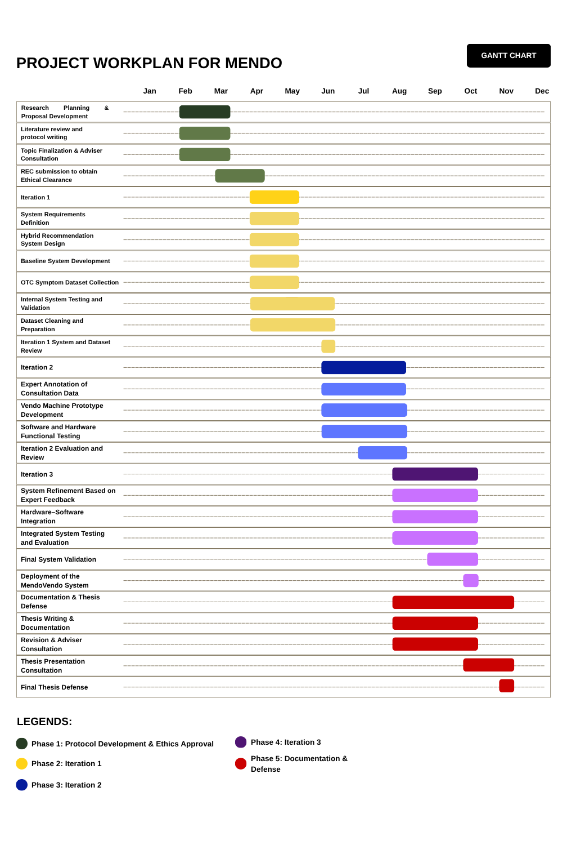
Project Workplan (Gantt Chart)

Proposed Budget
Item No. | xItem Description | Quantity | Unit Cost (₱) | Total Cost (₱)
A. Core Processing Components
1 | Raspberry Pi 5 (8GB) | 1 | 10,000 | 10,000
2 | 64GB Authentic MicroSD | 1 | 600 | 600
3 | Official 5V PSU | 1 | 800 | 800
B. Microcontroller Layer
4 | Arduino Mega 2560 | 1 | 900 | 900
5 | Servo Driver PCA9685 | 1 | 350 | 350
C. Dispensing Mechanism (Servo-Driven Modular Wheels)
6 | MG996R High Torque Servo | 12 | 250 | 3,000
7 | PLA Filament (1.5kg total) | 2 rolls | 900 | 1,800
D. Structural Materials (Acrylic Enclosure)
8 | 3mm Clear Acrylic Panels | set | 3,500 | 3,500
9 | Laser cutting / fabrication allowance | set | 1,200 | 1,200
E. Power System
10 | 5V 10A Switching Power Supply | 1 | 900 | 900
11 | Buck Converter Modules | 2 | 120 | 240
F. Supporting Electronics
12 | Relay Modules | 1 | 250 | 250
13 | Limit Switch Sensors | 6 | 40 | 240
G. Medicine Containers
14 | Plastic Capsule Containers | 500 minimum | .80 | 400
TOTAL ESTIMATED BUDGET: |  |  |  | ₱24,180

References:

[1] Eguia, H., Sánchez-Bocanegra, C. L., Vinciarelli, F., Alvarez-Lopez, F., & Saigí-Rubió, F. (2024). Clinical decision support and natural language processing in medicine: Systematic literature review. *Journal of Medical Internet Research*, 26, Article e55315. https://doi.org/10.2196/55315
[2] Tan, J., Rong, Y., Zhao, K., Bian, T., Xu, T., Huang, J., Cheng, H., & Meng, H. (2024). Natural language-assisted multi-modal medication recommendation. *Proceedings of the 33rd ACM International Conference on Information and Knowledge Management*, 2200–2209. https://doi.org/10.1145/3627673.3679529
[3] Bayor, A. A., Li, J., Yang, I. A., & Varnfield, M. (2025). Designing clinical decision support systems (CDSS)—A user-centered lens of the design characteristics, challenges, and implications: Systematic review. *Journal of Medical Internet Research*, 27, e63733. https://doi.org/10.2196/63733
[4] Wohlgemut, J. M., Erhan Pisirir, Stoner, R. S., Perkins, Z. B., Marsh, W., Tai, N. R. M., & Kyrimi, E. (2024). A scoping review, novel taxonomy and catalogue of implementation frameworks for clinical decision support systems. *BMC Medical Informatics and Decision Making*, 24(1). https://doi.org/10.1186/s12911-024-02739-1
[5] Elvas, L. B., Almeida, A., & Ferreira, J. C. (2025). Natural language processing in medical text processing: A scoping literature review. *International Journal of Medical Informatics*, 204, 106049. https://doi.org/10.1016/j.ijmedinf.2025.106049
[6] Newton, N., Bamgboje-Ayodele, A., Forsyth, R., Tariq, A., & Baysari, M. T. (2025). A systematic review of clinicians' acceptance and use of clinical decision support systems over time. *npj Digital Medicine*, 8(1). https://doi.org/10.1038/s41746-025-01662-7
[7] Haemmerl, K., Fastowski, A., Libovický, J., & Fraser, A. (2023). Exploring anisotropy and outliers in multilingual language models for cross-lingual semantic sentence similarity. *Findings of the Association for Computational Linguistics: ACL 2023*, 7023–7037. https://doi.org/10.18653/v1/2023.findings-acl.439
[8] Mahajan, Y., Bansal, N., Blanco, E., & Karmaker, S. (2024). ALIGN-SIM: A task-free test bed for evaluating and interpreting sentence embeddings through semantic similarity alignment. *Findings of the Association for Computational Linguistics: EMNLP 2024*, 7393–7428. https://doi.org/10.18653/v1/2024.findings-emnlp.436
[9] Lin, X., Liang, C., Liu, J., Lyu, T., Ghumman, N., & Campbell, B. (2024). Artificial intelligence–augmented clinical decision support systems for pregnancy care: Systematic review. *Journal of Medical Internet Research*, 26, e54737. https://doi.org/10.2196/54737
[10] Rose, S. L., & Shapiro, D. (2024). An ethically supported framework for determining patient notification and informed consent practices when using artificial intelligence in health care. *CHEST*, 166(3), 572–578. https://doi.org/10.1016/j.chest.2024.04.014
[11] Bouderhem, R. (2024). Shaping the future of AI in healthcare through ethics and governance. *Humanities and Social Sciences Communications*, 11(1), 1–12. https://doi.org/10.1057/s41599-024-02894-w
[12] Limaye, D., Limaye, V., Krause, G., & Fortwengel, G. (2017). A systematic review of the literature to assess self-medication practices. *Annals of Medical and Health Sciences Research*. https://www.amhsr.org/articles/a-systematic-review-of-the-literature-to-assess-selfmedication-practices-3711.html
[13] Ma, C., & Zhang, H. (2025). A cross-sectional study on self-medication with over-the-counter drugs among adolescents: An analysis of current practices. *Frontiers in Public Health*, 13. https://doi.org/10.3389/fpubh.2025.1560299
[14] Maever, A., Filipino, C., & Dayrit, M. M. (2023). Self-care practices for common acute conditions in the Philippines: A scoping review. *International Journal of Health Governance*, 28(4). https://doi.org/10.1108/ijhg-01-2023-0008
[15] Manila Standard. (2022, January 29). Internet research among reasons why most Filipinos self-medicate. *Manila Standard*. https://manilastandard.net/?p=314203452
[16] Decoding OTC medicines in the Philippines. (2023, October 20). NIQ. https://nielseniq.com/global/en/insights/analysis/2023/decoding-otc-medicines-in-the-philippines/
[17] Star, S. (2025, January 6). Over 1M Dabawenyos receive free meds from city's Botika ng Bayan. *SunStar Publishing Inc*. https://www.sunstar.com.ph/davao/over-1m-dabawenyos-receive-free-meds-from-citys-botika-ng-bayan
[18] Saad, S., & Algarni, A. (2025). Disease prediction from symptom descriptions using deep learning and NLP technique. *International Journal of Advanced Computer Science and Applications*, 16(5). https://thesai.org/Downloads/Volume16No5/Paper_41-Disease_Prediction_from_Symptom_Descriptions.pdf
[19] Hulke, R., & Gudhade, M. (2025). AI-based symptom checker and preliminary diagnosis system. *IOSR Journal of Computer Engineering*, 27(2), 35–42. https://www.iosrjournals.org/manuscript_paper/116690.pdf
[20] Exploring the functionality of AI symptom checkers: How natural language processing transforms patient symptom assessment. (2025, June 7). *Simbo AI Blog*. https://www.simbo.ai/blog/exploring-the-functionality-of-ai-symptom-checkers-how-natural-language-processing-transforms-patient-symptom-assessment-965754/
[21] Khaledian, N., & Falahati, S. (2026). Safe and personalized drug recommendation via heterogeneous graph learning: Integrating graphSAGE representations with DDI-aware cross-attention. *Progress in Artificial Intelligence*. https://doi.org/10.1007/s13748-026-00437-9
[22] Li, S., Wang, H., He, J., & Chen, X. (2025). AMGNet: An attention-guided multi-graph collaborative decision network for safe medication recommendation. *Electronics*, 14(4), 760. https://doi.org/10.3390/electronics14040760
[23] Chen, Q., Li, X., Geng, K., & Wang, M. (2023). Context-aware safe medication recommendations with molecular graph and DDI graph embedding. *Proceedings of the AAAI Conference on Artificial Intelligence*, 37(6), 7053–7060. https://doi.org/10.1609/aaai.v37i6.25861
[24] Gallego, F., & Veredas, F. J. (2024). Recognition and normalization of multilingual symptom entities using in-domain-adapted BERT models and classification layers. *Database: The Journal of Biological Databases and Curation*, 2024, baae087. https://doi.org/10.1093/database/baae087
[25] Multilingual health symptom checker. (2025). *Computer Science, Engineering and Technology*, 3(2), 77–81. https://doi.org/10.46632/cset/3/2/9
[26] VerbalCare: A multilingual AI-based healthcare communication system. (2025). *International Journal of Scientific Development and Research*. https://www.ijsdr.org/papers/IJSDR2508203.pdf
[27] Kalva, P., & Padakanti, S. (2024). AI-driven personal healthcare: An integrated system for symptom-based OTC medication selection and local availability tracking. *International Journal of Research in Computer Applications and Information Technology*, 7(2), 464–476. https://ijrcait.com/index.php/home/article/view/IJRCAIT_07_02_036
[28] Sohail, M., et al. (2026). Enhancing medical prescriptions with machine learning: A symptoms-based drug recommendation system. *International Journal of Scientific Research in Engineering and Management*. https://ijsrem.com/download/enhancing-medical-prescriptions-with-machine-learning-a-symptoms-based-drug-recommendation-system/
[29] Bodele, H., Tagde, M., Rangari, S., Jadhao, Y., Bawankar, V., & Kumre, T. (2024). Medicine recommendation system using ML. *International Journal for Research in Applied Science and Engineering Technology*, 12(12), 836–844. https://doi.org/10.22214/ijraset.2024.65843
[30] Zomorodi, M., Ghodsollahee, I., Martin, J. H., Talley, N. J., Salari, V., Plawiak, P., Rahimi, K., & Acharya, U. R. (2023). RECOMED: A comprehensive pharmaceutical recommendation system. *arXiv*. https://doi.org/10.48550/arXiv.2301.00280
[31] Elmes, G. (2025, June 10). OLDCARTS: A framework for clinical excellence. *NursEd*. https://nursed.ca/virtual-care/oldcarts-patient-assessment-tool/
[32] Ummu, M. N. (2023, December 28). OLD CARTS acronym (explained w/ questions). *NurseShip*. https://www.nurseship.com
[33] World Health Organization. (2025, August 21). Dengue and severe dengue. World Health Organization. https://www.who.int/news-room/fact-sheets/detail/dengue-and-severe-dengue
[34] Centers for Disease Control and Prevention. (2024, May 16). Symptoms of Dengue and Testing. Dengue. https://www.cdc.gov/dengue/signs-symptoms/index.html
[35] Mayo Clinic. (2025). Diarrhea - Symptoms and causes. Mayo Clinic. https://www.mayoclinic.org/diseases-conditions/diarrhea/symptoms-causes/syc-20352241
[36] WHO. (2024, March 7). Diarrhoeal Disease. Who.int; World Health Organization: WHO. https://www.who.int/news-room/fact-sheets/detail/diarrhoeal-disease
[37] Mayo Clinic. (2021, June 10). Sore throat - Symptoms and causes. Mayo Clinic. https://www.mayoclinic.org/diseases-conditions/sore-throat/symptoms-causes/syc-20351635
[38] World Health Organization. (2025, March 14). Tuberculosis. World Health Organization. https://www.who.int/news-room/fact-sheets/detail/tuberculosis
[39] Centers for Disease Control and Prevention. (2024, May 3). Signs and Symptoms of Tuberculosis. Tuberculosis (TB). https://www.cdc.gov/tb/signs-symptoms/index.html
[40] Mayo Clinic. (2023, August 29). Acute sinusitis - Symptoms and causes. Mayo Clinic. https://www.mayoclinic.org/diseases-conditions/acute-sinusitis/symptoms-causes/syc-20351671
[41] Mayo Clinic. (2019). Chronic daily headaches - Symptoms and causes. Mayo Clinic. https://www.mayoclinic.org/diseases-conditions/chronic-daily-headaches/symptoms-causes/syc-20370891
[42] World Health Organization. (2024, March 6). Headache disorders. Who.int; World Health Organization: WHO. https://www.who.int/news-room/fact-sheets/detail/headache-disorders

‌

