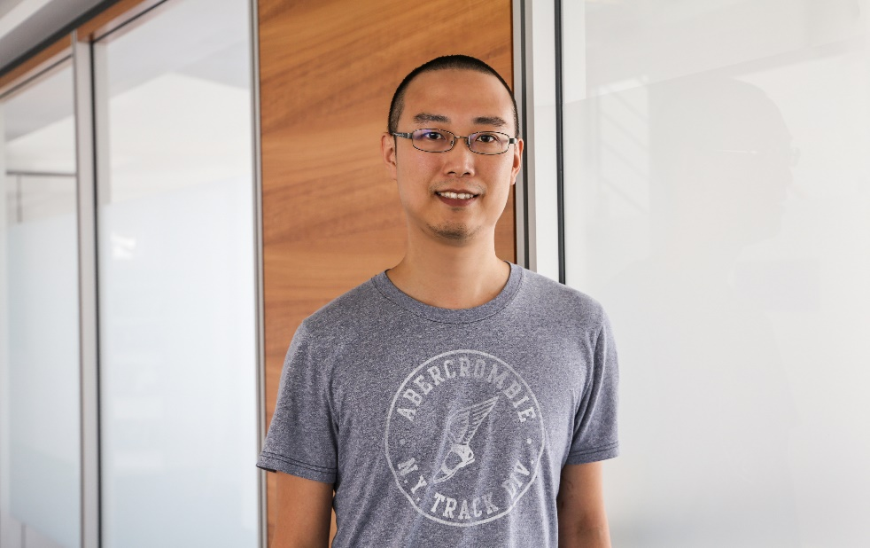Chung-Hao Huang

01.02.1985

+49 1701870577

yyergg@gmail.com

EDUCATION

* **PhD in Graduate Institute of Electronics Engineering**

National Taiwan University

2008.Sep - 2016.Jun

* **Bachelor in Electronics Engineering**

National Taiwan University

2003.Sep - 2007.Jun

KEY QUALIFICATIONS

* PhD in Graduate Institute of Electronics Engineering, National Taiwan University  
  (2017 QS World University Ranking #27)
* 1 year research experience in SW dependability(AI and Smart Contract)
* 2 years designing and implementing Android APP in an AR startup company

TECHNICAL SKILLS

* Test case generation framework for autonomous driving
* Adversarial attack of neural network
* X86 architecture and UEFI bios basic concept
* Experience in parser generator (lex, yacc, ply, ANTLR, pyparsing)
* Android APP
* LAMP or Django backend server
* Experience in NP-complete, PSPACE-complete, EXPTIME-complete algorithm implementation with C, C++ or python

WORK EXPERIENCE

**2017.Nov – now, fortiss GmbH, Scientist**

* fortiss GmbH is a research institute focusing on bridging industrial company and academical research. I am participating/leading following projects in fortiss.
  + Build a service broker and fleet management system to control UAVs
  + Build an NN-based perception component for adaptive cruise control (ACC) and design a testing framework for the component to meet the requirement of ISO 15622 and ISO 26262
  + Build a bounded model checking tool chain for EVM smart contracts

**2015.Mar – 2017.Jul, ChaseWind Co. Ltd, Co-founder & CTO**

* ChaseWind is a startup company which is building HUD smart glasses and corresponding cloud service for cyclist
  + Product Intro: <https://youtu.be/1CR__QuYoKE>
  + LinkedIn: <https://www.linkedin.com/company-beta/11061863/>
  + Crunchbase: https://www.crunchbase.com/organization/chasewind
* Defined the RESTful API of the server and the SW spec of the Android APP on the phone and glasses and implemented the Android APP
* Intellectual property and financial plan
* Recognitions during in ChaseWind:
  + 2017 Plug and Play, Sunnyvale - International program
  + 2017 MWC, Barcelona - Exhibitor
  + 2016 Bluetooth SIG Breakthrough Awards - Finalist
  + 2016 From Innovation to Innovation(FITI) - Champion, $90K
  + 2015 Mobile Heroes Communication - Champion, $10k

**2016.Mar – 2016.Sep, Jorjin Technologies Inc., SW Engineer**

* Survey the application requirements of AR glasses from different verticals such as medical, fire fighters, security guards, pipeline workers, etc.
* Once the SW spec had been finalized, implement demo APPs to demonstrate the capability of HW platform

**2014.Feb – 2016.Feb, Intel PC BIOS team, Intern**

* Implement tools in the BIOS building tool chain and integrate the tool into CI system to improve the quality of code. Most of the tools are parser-based python script which can fix the code formatting, verify memory alignment, check binary compatible between versions.
* Maintain BIOS code, debug issues and implement POC of new features

**2011.Jun – 2012.Jun, Intel Innovation center(embedded), Intern**

* Review the IP in the production code
* Maintain the server of remote testing platform
* Design automatic test cases for digital signage or POS printing system

**Contractor**

* Android APPs
* Hospital Information System (JAVA Hibernate): Registration/Admission/Payment/Case/Medicine management system

MAJOR GRADUATE SCHOOL RESEARCH

* SW Testing on Android APPs
  + Auto test case generating tool with GUI object identification
  + Tool to extract specific behavior which causes anomalies by applying data mining in test results
  + Black box memory leakage and code coverage detection with deassamble technique
* Temporal Logic and Game Theory

PUBLICATIONS

* Journal
  + [Acta Inf. 2017] Model-Checking Iterated Games
  + [IEEE Trans. SW 2016] A Game-Theoretic Foundation for the Maximum Software Resilience against Dense Errors
  + [ACM Toplas 2015] An Extension of ATL with Strategy Interaction
* Conference
  + [MEMOCODE 18] Towards Dependability Metrics for Neural Networks
  + [ATVA 18] Quantitative Projection Coverage for Testing ML-enabled Autonomous Systems
  + [VSTTE 18] Verification of Binarized Neural Networks via Inter-Neuron Factoring
  + [CAV 2014] G4LTL-ST: Automatic Generation of PLC Programs
  + [TACAS 2013] Model-Checking Iterated Games
  + [APLAS 2013] Temporal Specification Mining for Anomaly Analysis
  + [GandALF 2012] Rapid Recovery for Systems with Scarce Faults
  + [CONCUR 2011] A Temporal Logic for the Interaction of Strategies
  + [FASE 2011] Evolving a Test Oracle in Black-Box Testing