



Microsoft iSCSI Software Initiator Version 2.X Users Guide

Microsoft Corporation
Published: January 2007
Updated: November 2008

Abstract
iSCSI SANs are gaining in popularity as executives increasingly understand their advantages. These include leveraging of existing investments in Ethernet and TCP/IP deployments as well as expertise.
The initial portion of this document is focused upon the IT executive making procurement and deployment decisions. The document describes the advantages of iSCSI and also provides a brief architecture overview. Next, the document describes the availability of iSCSI for various different flavors of Windows and then provides an executive overview of scenarios that work as well as scenarios that are not supported by Microsoft.
The document then changes focus to address the needs of the storage administrator. After a brief technical overview of iSCSI architecture implementation in Windows, the document moves on to describe iSCSI installation, best practices and troubleshooting.
This document is an rtf (rich text format) document that can be viewed without requiring Microsoft Word or the Word Viewer to be installed. The document can be viewed on Windows with Wordpad or with typical rich text readers on non Windows systems.
.
The information contained in this document represents the current view of Microsoft Corporation on the issues discussed as of the date of publication. Because Microsoft must respond to changing market conditions, it should not be interpreted to be a commitment on the part of Microsoft, and Microsoft cannot guarantee the accuracy of any information presented after the date of publication.
This document is for informational purposes only. MICROSOFT MAKES NO WARRANTIES, EXPRESS OR IMPLIED, AS TO THE INFORMATION IN THIS DOCUMENT.
Complying with all applicable copyright laws is the responsibility of the user. Without limiting the rights under copyright, no part of this document may be reproduced, stored in or introduced into a retrieval system, or transmitted in any form or by any means (electronic, mechanical, photocopying, recording, or otherwise), or for any purpose, without the express written permission of Microsoft Corporation.
Microsoft may have patents, patent applications, trademarks, copyrights, or other intellectual property rights covering subject matter in this document. Except as expressly provided in any written license agreement from Microsoft, the furnishing of this document does not give you any license to these patents, trademarks, copyrights, or other intellectual property.
© 2008 Microsoft Corporation. All rights reserved.
Microsoft, Windows, Windows Server and Windows Vista are either registered trademarks or trademarks of Microsoft Corporation in the United States and/or other countries.
The names of actual companies and products mentioned herein may be the trademarks of their respective owners.

Contents

Introduction 7
iSCSI SAN Components 7
iSCSI Client/Host 7
iSCSI Target 8
Native and Heterogeneous IP SANs 8
iSCSI Availability with various different versions of Windows 12
Highlights of the Windows iSCSI implementation 13
What has been tested and determined to work 14
Microsoft Server Cluster (MSCS) 14
Microsoft Exchange 15
Microsoft SQL Server 16
Microsoft File Server shares/DFS 16
Not supported for use with the Microsoft iSCSI Software Initiator: 17
Dynamic disks on Windows Server 2003, Windows XP and Windows 2000 17
NIC Teaming 17
Architectural overview and features 18
Services that depend upon iSCSI devices 19
How the iSCSI Initiator Service Manages Targets 20
Node Names 20
Initiator Instance 21
Discovery mechanisms 21
How targets are organized 21
Installing the iSCSI Initiator 24
Installation on Windows Server 2008 and Windows Vista 24
Installation on Windows Server 2003, Windows XP and Windows 2000 24
Security 29
iSCSI Best Practices 30
Storage Array Performance Best Practices 30
Networking best practices 30
Firewall configuration for Windows 2008 Server Core 32
Using the Microsoft iSCSI Initiator Service on Windows Server 2008 33
Initiator IQN Name 34
Persistent Targets 34
Running automatic start services on iSCSI disks 35
Management applications/Interfaces 35
iSCSI Control Panel Configuration Utility 35
iSCSI Property Pages 35
iSCSICLI 36
WMI 36
Perfmon/Sysmon 38
Using Multipathing I/O 40
Configuring MCS (Multiple Connections) 42
Configuring Microsoft MPIO 54
iSCSI Boot Initiator Architectural Overview 66
iSCSI Boot Step by Step instructions for the Windows Administrator 68
Configure the iSCSI target to be accessible only to one particular client (Step 9 ) 77
Windows Server 2003 Host configuration 82
Configure the Windows Server 2003 host to access the target and check that the Windows Server can successfully access it (Step 10) 83
Configure client to boot from iSCSI target (Step 12) 88
Troubleshooting 89
Multifunction cards 89
Checked Builds 89
Terminal Services on Windows 2000 89
Eventlog 89
Debug Logging 89
Installation 91
Multipathing 93
Addressing Slow Performance with iSCSI clusters 94
Error Recovery 96
Other Areas 98
Appendix A - Event Tracing in MS iSCSI Drivers 100
Appendix B - iSCSI Eventlog messages 102
Microsoft iSCSI Initiator Service 102
Microsoft Software Initiator Kernel Mode Driver 105
Appendix C – iSCSICLI command reference 113
Boot Configuration Known Issues (Windows Server 2003 Boot Initiator) 116
MPIO Failover in an iSCSI boot configuration using the Microsoft iSCSI Software Initiator 116
Appendix D – Microsoft iSCSI Software Initiator Error Messages and Status Codes 139
Appendix E – Integrating iSCSI Support in Windows PE 145
Prerequisites 145
Section to add to Software registry hive (PE_Soft) 147
Section to add to System registry hive (PE_Sys) 147
To create a bootable CD-ROM 151
Test and Validate the completed WinPE2.0 image 152
Appendix F - iSCSI Initiator & MPIO tunable timers 154
The following MPIO timers and timeout values may be used to tune the configuration of MPIO. MPIO Timer Key Values 154
Microsoft iSCSI Initiator Service Timers 156
Microsoft iSNS Timers 159
Microsoft iSCSI Initiator Driver Timers 161
Other Timers 165
References and Resources 167

Microsoft iSCSI Software Initiator 2.x
Users Guide

Microsoft Corporation
Published: June 2005
Updated: July 2008

The information contained in this document represents the current view of Microsoft Corporation on the issues discussed as of the date of publication. Because Microsoft must respond to changing market conditions, it should not be interpreted to be a commitment on the part of Microsoft, and Microsoft cannot guarantee the accuracy of any information presented after the date of publication.
This document is for informational purposes only. MICROSOFT MAKES NO WARRANTIES, EXPRESS OR IMPLIED, AS TO THE INFORMATION IN THIS DOCUMENT.
Complying with all applicable copyright laws is the responsibility of the user. Without limiting the rights under copyright, no part of this document may be reproduced, stored in or introduced into a retrieval system, or transmitted in any form or by any means (electronic, mechanical, photocopying, recording, or otherwise), or for any purpose, without the express written permission of Microsoft Corporation.
Microsoft may have patents, patent applications, trademarks, copyrights, or other intellectual property rights covering subject matter in this document. Except as expressly provided in any written license agreement from Microsoft, the furnishing of this document does not give you any license to these patents, trademarks, copyrights, or other intellectual property.
© 2003 Microsoft Corporation. All rights reserved.
Microsoft, Windows, and Windows NT are either registered trademarks or trademarks of Microsoft Corporation in the United States and/or other countries.
The names of actual companies and products mentioned herein may be the trademarks of their respective owners.

Contents 3
Introduction 7
iSCSI SAN Components 7
iSCSI Client/Host 7
iSCSI Target 8
Native and Heterogeneous IP SANs 8
iSCSI Availability with various different versions of Windows 12
Highlights of the Windows iSCSI implementation 13
What has been tested and determined to work 14
Microsoft Server Cluster (MSCS) 14
Microsoft Exchange 15
Microsoft SQL Server 16
Microsoft File Server shares/DFS 16
Not supported for use with the Microsoft iSCSI Software Initiator: 17
Dynamic disks on Windows Server 2003, Windows XP and Windows 2000 17
NIC Teaming 17
Architectural overview and features 18
Services that depend upon iSCSI devices 19
How the iSCSI Initiator Service Manages Targets 20
Node Names 20
Initiator Instance 21
Discovery mechanisms 21
How targets are organized 21
Installing the iSCSI Initiator 24
Installation on Windows Server 2008 and Windows Vista 24
Installation on Windows Server 2003, Windows XP and Windows 2000 24
Security 29
iSCSI Best Practices 30
Storage Array Performance Best Practices 30
Networking best practices 30
Firewall configuration for Windows 2008 Server Core 32
Using the Microsoft iSCSI Initiator Service on Windows Server 2008 33
Initiator IQN Name 34
Persistent Targets 34
Running automatic start services on iSCSI disks 35
Management applications/Interfaces 35
iSCSI Control Panel Configuration Utility 35
iSCSI Property Pages 35
iSCSICLI 36
WMI 36
Perfmon/Sysmon 38
Using Multipathing I/O 40
Configuring MCS (Multiple Connections) 42
Configuring Microsoft MPIO 54
iSCSI Boot Initiator Architectural Overview 66
iSCSI Boot Step by Step instructions for the Windows Administrator 68
Configuring DHCP for iSCSI Boot (Step 7) 68
Create an iSCSI Target (volume) on a host (Step 8) 71
Configure the iSCSI target to be accessible only to one particular client (Step 9 ) 77
Windows Server 2003 Host configuration 82
Configure the Windows Server 2003 host to access the target and check that the Windows Server can successfully access it (Step 10) 83
Transfer the image from the client boot volume to the target (Step 11) 87
Configure client to boot from iSCSI target (Step 12) 88
Troubleshooting 89
Multifunction cards 89
Checked Builds 89
Terminal Services on Windows 2000 89
Eventlog 89
Debug Logging 89
Installation 91
Multipathing 93
Addressing Slow Performance with iSCSI clusters 94
Error Recovery 96
Other Areas 98
Appendix A - Event Tracing in MS iSCSI Drivers 100
Appendix B - iSCSI Eventlog messages 102
Microsoft iSCSI Initiator Service 102
Microsoft Software Initiator Kernel Mode Driver 105
Appendix C – iSCSICLI command reference 113
Boot Configuration Known Issues (Windows Server 2003 Boot Initiator) 116
MPIO Failover in an iSCSI boot configuration using the Microsoft iSCSI Software Initiator 116
Appendix D – Microsoft iSCSI Software Initiator Error Messages and Status Codes 139
Appendix E – Integrating iSCSI Support in Windows PE 145
Prerequisites 145
Section to add to Software registry hive (PE_Soft) 147
Section to add to System registry hive (PE_Sys) 147
To create a bootable CD-ROM 151
Test and Validate the completed WinPE2.0 image 152
Appendix F - iSCSI Initiator & MPIO tunable timers 154
The following MPIO timers and timeout values may be used to tune the configuration of MPIO. MPIO Timer Key Values 154
Microsoft iSCSI Initiator Service Timers 156
Microsoft iSNS Timers 159
Microsoft iSCSI Initiator Driver Timers 161
Other Timers 165
References and Resources 167

Introduction
iSCSI Storage Area Networks and iSCSI devices are gaining in popularity for a number of reasons. These reasons include:
- iSCSI leverages existing investments in Ethernet infrastructures and expertise
- iSCSI leverages existing investments in IP Protocol including the vast amount of industry investment in maturing the IP Protocol
- iSCSI offers Dynamic Capacity Expansion
- Simpler SAN Configuration and Management
- Centralized Management through consolidation of storage
- Scalable Performance
- Higher storage utilization
- iSCSI presents volumes as a block storage device which makes them ideal for use by enterprise applications such as Microsoft Exchange and Microsoft SQL Server. In particular, the Microsoft iSCSI Software Initiator is the component of the overall iSCSI environment that makes it possible to make the iSCSI SAN attached disks appear to be local attached disks.
The rest of this introductory section defines some often used terms in iSCSI lingo such as “host”, “target”, “initiator”, etc.

iSCSI SAN Components
iSCSI SANs components are largely analogous to FC SAN components. These components are as follows:

iSCSI Client/Host
The iSCSI client or host (also known as the iSCSI initiator) is a system, such as a server, which attaches to an IP network and initiates requests and receives responses from an iSCSI target. Each iSCSI host is identified by a unique iSCSI qualified name (IQN), analogous to a Fibre Channel world wide name (WWN).
To transport block (SCSI) commands over the IP network, an iSCSI driver must be installed on the iSCSI host. An iSCSI driver is included with the Microsoft iSCSI initiator.
A Gigabit Ethernet adapter (transmitting 1000 megabits per second--Mbps) is recommended for connection to the iSCSI target. Like the standard 10/100 adapters, most Gigabit adapters use Category 5 or Category 6E cabling that is already in place. Each port on the adapter is identified by a unique IP address.

iSCSI Target
An iSCSI target is any device that receives iSCSI commands. The device can be an end node, such as a storage device, or it can be an intermediate device, such as a bridge between IP and Fibre Channel devices.
Each iSCSI target is identified by a unique IQN, and each port on the storage array controller (or on a bridge) is identified by one or more IP addresses.

Native and Heterogeneous IP SANs
The relationship between the iSCSI initiator and the iSCSI target is shown in Figure 1. In this case, the iSCSI initiator (or client) is the host server and the iSCSI target is the storage array. This topology is considered a native iSCSI SAN, because it consists entirely of components that transmit the SCSI protocol over TCP/IP.
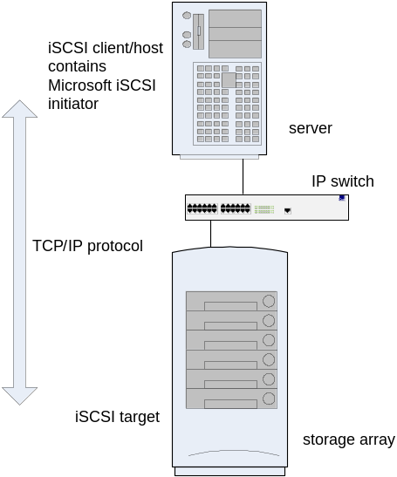
Figure 1. iSCSI in a Native SAN
In contrast, heterogeneous IP SANs, such as the one illustrated in Figure 2, consist of components that transmit SCSI both over TCP/IP and over Fibre Channel interconnects. To accomplish this, a bridge or gateway device is installed between the IP and the Fibre Channel components. The bridge serves to translate between the TCP/IP and Fibre Channel protocols, so that the iSCSI host sees the storage as an iSCSI target.
Note
Servers that directly access the Fibre Channel target must contain HBAs rather than the network adapter cards of iSCSI hosts. iSCSI hosts can use either a NIC or a HBA.
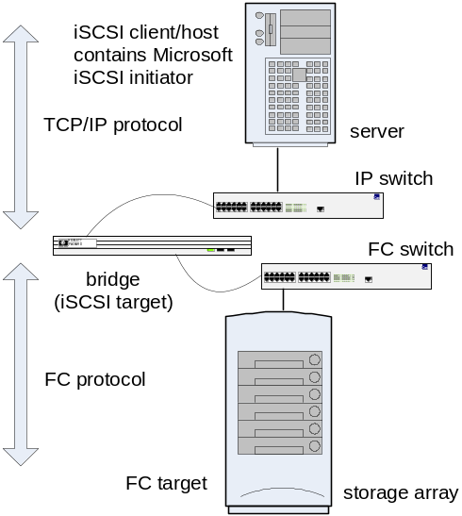
Figure 2. iSCSI in a Heterogeneous IP SAN

iSCSI Availability with various different versions of Windows
Microsoft supports iSCSI in general and the iSCSI Software Initiator in particular, in the Windows family of operating systems. This support takes the form of two different aspects, based upon the version of the Windows operating system being involved
- With Windows Server 2008 and Windows Vista, the iSCSI Software Initiator and other iSCSI components are built into the operating system.
- For Windows Server 2003, Windows XP and Windows 2000 family of operating systems, the iSCSI Software Initiator is available as a download package from the Microsoft website. Microsoft strongly recommends that customers use one of the following:
  - Windows Server 2003 SP1 or higher
  - Windows 2000 with the latest service pack/security pack
  - Windows XP SP2 or higher

Highlights of the Windows iSCSI implementation
The Windows iSCSI implementation is comprehensive and this section provides a quick highlight tour. Subsequent sections within this document discuss some of these features in more detail, explaining the various technical alternatives, how to choose between them and also how to enable them.. Some of the important features of the Microsoft iSCSI implementation include:

- Support for IPV6 addressing – in addition to IPv4, iSCSI devices can also use IPv6 addresses and protocol(s)
- IPsec support – to ensure data privacy, IPsec is supported
- Microsoft MPIO support – Microsoft Multipathing or MPIO is a feature to ensure high availability of data by utilizing multiple different paths between the CPU on which the application is executing and the iSCSI target where the data is physically stored
- Multiple Connections per session (MCS) – to ensure both speed and availability
- Error Recovery Level 2 – this feature helps recover from a disruption in a TCP/IP session
Windows Server 2008 advances the platform with additional enhancement including the following
- Enhanced performance – Windows Server 2008 iSCSI Initiator uses the new Winsock Kernel mode interface (WSK) first introduced in Windows Vista
- Support for the Intel Slicing by 8 Algorithm for iSCSI digest calculation.

What has been tested and determined to work
Microsoft has tested various different pieces of software and a representative list is discussed in this section. As already mentioned, this is *not* an all inclusive list; meaning that an application not mentioned here does not imply the application does not work with the Microsoft iSCSI Software Initiator.

Microsoft Server Cluster (MSCS)
Microsoft MPIO and the Microsoft iSCSI DSM can be used with MSCS. 3rd party DSMs based on Microsoft MPIO which are qualified under the Designed for Windows Logo Program are supported at the same level as the Microsoft iSCSI DSM is supported. This category maps to Raid System, bustype=iSCSI. On Windows 2000 only the failover load balance policy is supported. Although the Microsoft iSCSI Software Initiator works with MSCS on Windows 2000 Server, Customers requiring the support of iSCSI with Microsoft Cluster Server should use either Windows Server 2003 or Windows Server 2008. Please see this link for more information:
http://www.microsoft.com/windowsserver2003/technologies/storage/iscsi/iscsicluster.mspx Microsoft Cluster Server solutions using the Microsoft iSCSI Software Initiator do not required that the configuration be specifically Logo’d in order to be supported. Customers simply need to use components which are logo’d within their individual device and system categories including NICs, Servers, etc for cluster configurations. Enterprise class NICs should be used for iSCSI configurations (this applies to MSCS & non MSCS environments). It is recommended that customers use the Microsoft Cluster Configuration Validation Wizard to validate their iSCSI cluster configurations. This tool is available for download from http://www.microsoft.com/downloads
Search on the phrase “Microsoft Cluster Configuration Validation Wizard”
Microsoft Server Cluster (MSCS) shared storage when using only a single data path (including the quorum disk) can be implemented using iSCSI disk volumes as the shared storage so long as the iSCSI target supports the SCSI RESERVE and RELEASE commands. There is no special iSCSI, cluster or application configuration needed to support this scenario. Since the cluster service manages application dependencies, it is not needed to make any cluster managed service (or the cluster service itself) dependent upon the Microsoft iSCSI service.
On Windows 2003, all other load balance policies are supported if the iSCSI target supports SCSI PERSISTENT RESERVE and PERSISTENT RELEASE and the persistent reserve key is established on all nodes of the cluster. To configure the persistent reservation key for your cluster, you need to assign 8 byte keys to all nodes in the cluster. Pick a 6 byte value that is specific to that cluster and a different 2 byte values for each node in the cluster. The cluster specific value should be different for different clusters on your SAN to protect a cluster from using the wrong storage device.
To configure the persistent reservation key for your cluster:
- Select an 8-byte value that is unique to that cluster.
- Locate the following registry key:
HKLM\System\CurrentControlSet\Services\MSiSCDSM\PersistentReservation
- Add the following values:
  - UsePersistentReservation REG_DWORD 1
Setting this value to 1 enables Persistent Reservation.
  - PersistentReservationKey REG_BINARY <PR key>
This is a 8-byte binary value that is unique to the cluster. The same binary value must be used on all nodes in the cluster.
Note: These registry values must be added to all nodes in the cluster.
<PR Key> is an 8 byte binary value that is composed of a 6 byte part that is specific to the cluster and a 2 byte part that is specific to the node. For example if you have a three node cluster you could assign 0xaabbccccbbaa as the cluster specific part. The nodes could then have the following PR keys:

Node 1: 0xaabbccccbbaa0001
Node 2: 0xaabbccccbbaa0002
Node 3: 0xaabbccccbbaa0003

NOTE: In some configurations, failover and recovery of cluster disk resources may not function properly without the persistent reservation configuration mentioned above, even when used with the Fail Over Only load balance policy. In these instances, during disk arbitration, the surviving node of the cluster may be unable to gain access to the disks, and the following errors are listed in the Cluster.Log file.
To prevent this behavior the persistent reservation key will be required even with fail over only in these configurations:
00000928.00000958::2008/11/12-23:24:40.270 INFO Physical Disk <Disk Q:>: [DiskArb] Arbitrate for ownership of the disk by reading/writing various disk sectors.
00000928.00000958::2008/11/12-23:24:40.270 ERR Physical Disk <Disk Q:>: [DiskArb] Failed to read (sector 12), error 170.
00000928.00000958::2008/11/12-23:24:40.270 INFO Physical Disk <Disk Q:>: [DiskArb] We are about to break reserve.
00000928.00000958::2008/11/12-23:24:40.270 INFO Physical Disk <Disk Q:>: [DiskArb] Issuing BusReset on signature 30f21b55.
00000928.00000958::2008/11/12-23:24:40.270 ERR Physical Disk <Disk Q:>: [DiskArb] BusReset completed, status 1.
00000928.00000958::2008/11/12-23:24:40.270 ERR Physical Disk <Disk Q:>: [DiskArb] Failed to break reservation, error 1.

Microsoft Exchange
Microsoft Exchange Server can store its program files, mailboxes, public folders, logs and other data on iSCSI disk volumes in both cluster and non cluster configurations. Since Microsoft Exchange has a service component, in a non cluster configuration, the Exchange service needs to be configured with a dependency on the iSCSI initiator 2.x service on Windows 2000. When using the Microsoft iSCSI Software Initiator 2.x with Windows 2003, the dependency is not needed. In an MSCS configuration, the dependency does not need to be configured since the dependency on the disk is handled by the cluster service.

Microsoft SQL Server
Microsoft SQL Server can store its program files, logs and other data on iSCSI disk volumes in both cluster and non cluster configurations. Since Microsoft SQL Server has a service component, in a non cluster configuration, the SQL service needs to be configured with a dependency on the iSCSI initiator service on Windows 2000. When using the Microsoft iSCSI Software Initiator 2.0x with Windows 2003, the dependency is not needed. In an MSCS configuration the dependency does not need to be configured since the dependency on the disk is handled by the cluster service.

Microsoft File Server shares/DFS
To support file shares exposed as iSCSI Disk Volumes on Windows 2000, you will need to configure the lanmanserver service to have a dependency on the msiscsi (Microsoft iSCSI initiator) service. For example, if you have an iSCSI disk volume that is exposed as drive I: and have a file share point I:\Documents then on Windows 2000. When using the Microsoft iSCSI Software Initiator 2.0x with Windows Server 2003, the dependency is not needed.

Not supported for use with the Microsoft iSCSI Software Initiator:
(These are not supported by the Microsoft software iSCSI initiator; they may be supported by a hardware-based iSCSI initiator (HBA,), check with your HBA vendor for information on supported features with the HBA)

Dynamic disks on Windows Server 2003, Windows XP and Windows 2000
Configuring volumes on iSCSI disks as Dynamic disk volumes using the Microsoft software iSCSI initiator is not currently supported. It has been observed that timing issues may prevent dynamic disk volumes on iSCSI disks from being reactivated at system startup.
The use of dynamic disk volumes with Windows Vista and Windows Server 2008 is supported.

NIC Teaming
Microsoft does not support the use of NIC teaming on iSCSI interfaces. For iSCSI SAN interfaces, Microsoft recommends that customers use dual or quad ported NICs, or multiple single-port NICs and allow Microsoft Windows components to handle fail-over and redundancy to ensure consistent visibility into the data path. Fail-over and load balancing of multiple paths to an iSCSI target from within the same server is supported through MS MPIO and Multiple Connections per session (fail over and load balancing using multiple adapters in the same server. Please see details on configuring MS MPIO and MCS later in this guide. Microsoft Cluster Server can also be used for fail over and load balancing of shared storage resources between servers (fail over and load balancing between servers). NIC teaming can still be used on LAN interfaces only that are not used to connect to an iSCSI SAN.

Architectural overview and features
Figure 3 shows an architectural block diagram of the various Windows iSCSI components.

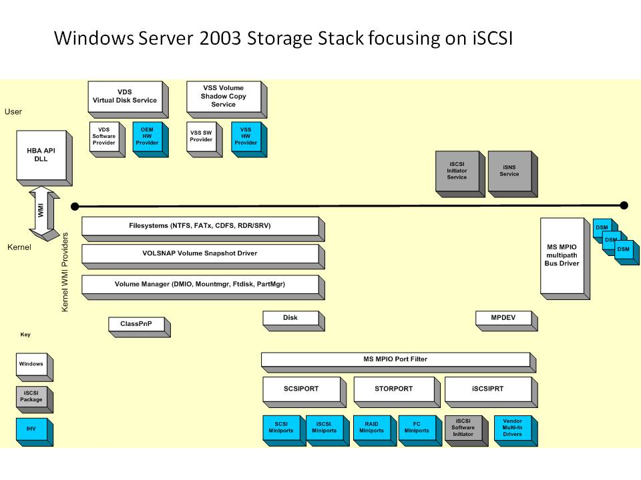

The shaded blocks in Figure 3 are included in the downloadable iSCSI package from the Microsoft web site. As mentioned elsewhere in this document, this download does not apply to Windows Vista and Windows Server 2008.
The Microsoft iSCSI Software Initiator package is composed of the following components
- Software initiator kernel mode driver (mini-port driver - msiscsi.sys)
- An optional iSCSI device driver component that is responsible for moving data from the storage stack over to the standard network stack. This initiator is only used when iSCSI traffic goes over standard network adapters, not when specialized iSCSI HBA adapters are used.
- iSCSI port driver (iscsiprt.sys)
- A port driver that implements Windows specific functionalities such as Plug and Play, Power Management, Command Queuing, etc. The software initiator driver (msiscsi.sys) and some multi-function HBA drivers (bus and mini-port) will use this port driver.
- Initiator service (iscsiexe.exe)
- A service that manages all iSCSI initiators (including network adapters and HBAs) on behalf of the OS. Its functions include aggregating discovery information and managing security. It includes an iSNS client, the code required for device discovery.
- Management applications
- The iSCSI command line interface (iSCSICLI), property pages for device management, Windows Management Instrumentation (WMI), and a control panel application.
- Microsoft MPIO Multipathing Support for iSCSI (MPIO and iSCSI DSM drivers)
MPIO provides high availability fail over and load balancing to external storage arrays.
Both the management API interfaces and the kernel mode initiator driver interfaces are very well defined and thus allow Independent Software Vendors (ISVs) and Independent Hardware Vendors (IHVs) to leverage these interfaces to produce value add components. The Microsoft iSCSI Software Initiator package includes a software based iSCSI kernel mode initiator driver that uses the Windows TCP/IP stack and one or more network interface cards (NICs) exposed to Windows. IHVs can build specialized iSCSI initiator hardware (iSCSI HBA) in conjunction with a SCSIport miniport or Storport miniport driver that can be used by the iSCSI initiator service. Microsoft recommends the use of Storport miniports on Windows Server 2003 and Windows XP, x64. Storport is not available on Windows 2000 or Windows XP, therefore SCSIport must be used on those platforms. These drivers must support the Microsoft iSCSI driver interfaces in order to work properly with the iSCSI Initiator service. These iSCSI HBA drivers can be used in place of the software initiator driver or in conjunction with the software initiator driver. Since the iSCSI initiator service aggregates all kernel mode initiator drivers to coordinate iSCSI management in Windows, a management application vendor can include iSCSI support in its management application by writing directly to the iSCSI management interfaces and thus be able to manage both hardware and software initiator drivers in a common way. Microsoft only supports the use of iSCSI HBAs that have been Logo’d under the Designed for Windows Logo Program. To be supported, configurations using iSCSI hardware HBAs must use the Microsoft iSCSI Initiator Service to handle login and logout from all iSCSI targets. iSCSI HBAs which don’t use the Microsoft iSCSI Initiator Service are not supported.
Note: Microsoft does not support 3rd party iSCSI software initiators on Windows.

Services that depend upon iSCSI devices
A special note should be made regarding the timing of the availability of devices that are connected to the system via the MS iSCSI software initiator. These iSCSI devices are presented to Windows later in the boot process than direct attached storage is presented. There are some applications and services that make assumptions about the timing of the availability of the devices at boot. The iSCSI initiator service and the Windows Service Control Manager include functionality for helping these services and applications synchronize with the arrival of devices and volumes hosted on iSCSI targets.
The basic mechanism works as follows. The iSCSI initiator service is configured to be automatically started by the service control manager during system startup. This service can be configured to delay completing its service startup sequence until a list of devices and disk volumes has completed initialization. If there is another service that is configured to be automatically started during system startup and this service has an assumption that all devices and disk volumes are available before it starts or a service whose code or data is installed on an iSCSI disk volume then that service must be configured to start after the iSCSI initiator service completes its initialization. On Windows 2000 this is accomplished by making the services dependent upon the iSCSI initiator service. On Windows XP and 2003 the iSCSI initiator service is configured to start in a load order group and thus will always be started before any services that are not in a load order group. So in this case there is no need to change any service dependencies.

How the iSCSI Initiator Service Manages Targets

Node Names
The MS iSCSI initiator service strictly follows the rules specified for iSCSI node names. The rules are applied for both the initiator’s node name and any target node names discovered. Rules for building iSCSI node names are described in the iSCSI specification and the “String Profile for iSCSI Names” internet draft. In summary the rules are as follows:

- Node names are encoded in the UTF8 character set. Note the initiator service does not support UCS-4 characters. RFC 2044 describes UTF8 encoding.
- Node names are 223 bytes or less
- Node names may contain alphabetic characters (a to z), numbers (0 to 9) and three special characters: ‘.’, ‘-‘, and ‘:’.
- Uppercase characters are always mapped to lowercase.

The MS iSCSI initiator service will return an error if there is an attempt to set the initiator’s node name to an invalid string. It will also return an error if there is an attempt to manually configure a target with an invalid target node name. The MS iSCSI initiator service will dynamically generate an initiator node name based upon the computer name if there is none set. If there are any invalid characters in the computer name then those invalid characters are mapped to ‘-‘. For example if the computer name is Computer1_Dept1 then the equivalent part of the node name is Computer1-Dept1.

If the MS iSCSI software initiator discovers a target that has a node name that is not valid then it will ignore that target and in some cases all targets discovered with it (for example all targets within a SendTargets text response). In this case an eventlog entry will be generated that contains the invalid target name.

Initiator Instance
The MS iSCSI software initiator service aggregates the software initiator and iSCSI HBAs into a common iSCSI node. In doing this the service must keep track of the individual iSCSI HBA and software initiators as a number of the APIs will allow operations to occur on only one of those HBAs. For example the LoginIScsiTarget API has a parameter that specifies which HBA or software initiator to use. The service and APIs refer to each HBA or software initiator as an Initiator Instance.

Discovery mechanisms
The iSCSI Initiator service supports four discovery mechanisms:
- SendTargets - The SendTarget portals are statically configured using the iscsicli AddTargetPortal command. The iSCSI initiator service will perform an iSCSI discovery login followed by a SendTargets operation at the time the target portal is added and whenever the service starts or whenever a management application requests a refresh.
- iSNS - The address of the iSNS servers that the MS iSCSI initiator service will use is statically configured using the iscsicli AddiSNSServer command. The MS iSCSI initiator service will obtain the list of targets from the iSNS servers whenever the service starts, whenever a management application requests a refresh and whenever the iSNS server sends a State Change Notification (SCN).
- HBA Discovery - iSCSI HBAs that conform to the MS iSCSI initiator service interfaces can participate in target discovery by means of an interface between the HBA and the MS iSCSI initiator service. The MS iSCSI initiator service will request the list of targets from the HBA whenever the service starts and whenever the HBA indicates that the target list has changed.
- Manually Configured Targets - iSCSI targets can be manually configured using the iscsicli AddTarget command or using the iSCSI control panel applet. It is possible for a manually configured target to be configured as “hidden” in which case the target is not reported unless it is discovered by another mechanism. Manually configured targets are persisted. Those targets that are not configured as “hidden” are available whenever the service restarts.

How targets are organized
The MS iSCSI initiator service maintains multiple instances of a target if it was discovered by multiple discovery mechanisms. For example, if a target was discovered via a query request to an iSNS server and also via a SendTargets request to a SendTargets portal then there would be two instances of that target maintained by the service. The MS iSCSI initiator service organizes the target instances by each discovery mechanism and orders those target instances in a particular way so that certain discovery mechanisms have priority over others when selecting a target instance to use for login. The priority is as follows:
- Targets discovered dynamically by HBA Discovery. By giving these targets highest priority it ensures that any hardware-based iSCSI HBA (presumably with acceleration) will be provided the chance to login first. These targets will have a specific initiator name associated with them to indicate which HBA discovered them. There should only be a single target instance of this type.
- Targets discovered dynamically by SendTargets. These will have a specific initiator name associated with them to indicate via which HBA they were discovered. Among target instances discovered by different initiator names, there is no particular order.
- Targets discovered dynamically by iSNS. These will not have an initiator name associated with them. There is no particular order among instances of targets discovered by different iSNS servers.
- Targets "discovered" by manual configuration (i.e. static targets). These will not have an initiator name associated with them. There should be only a single target instance of this type.
The parameters used for logging into a session are obtained by merging the parameters from up to three sources: Parameters passed in the LoginIScsiTarget API, parameters discovered by the discovery mechanism, and parameters specified when the target is manually configured via the AddIScsiStaticTarget API.
One of the parameters that gets merged from these sources is the LoginOptions. LoginOptions contain information about how the initiator should establish the session with the target. The rules for merging LoginOptions values are as follows:
A login operation to a target could potentially have up to 3 sets of login options that need to be merged into a single set.
A is the one passed in the login API.
B is one maintained by the target instance when the target was discovered.
C is one established when the target is manually configured via AddIScsiStaticTarget API.
To do the merge the following rules apply:
  - For LoginFlags, HeaderDigest, DataDigest, MaximumConnections, DefaultTime2Wait, DefaultTime2Retain, the values in A take precedence over B which take precedence over C.
  - AuthType, Username and Password are treated as a unit. That is, if A, B or C specify an AuthType that is not ISCSI_NO_AUTH_TYPE, then the values for AuthType, Username and Password for that specific set of login options are used. The same order of precedence as in 1 is used.
If IPSEC filters are already configured for the target portal being used to login to the target, then those filters will be reused and any IPSEC information passed will be ignored.
If the service has been configured with IPSEC information for the target portal before calling the LoginIScsiTarget API then the IPSEC information (SecurityFlags and preshared key) passed to the LoginIScsiTarget API will be ignored and superceded by the information already configured in the service.
If Mappings are specified in the LoginIScsiTarget API then those mappings are used. If they are not specified then any mappings specified in the manually configured (by AddIScsiStaticTarget) target instance are used. If neither have Mappings then the initiator selects the mappings to use.
If a target portal is specified in the LoginIScsiTarget API then that target portal is used. If one is not specified then the target portal maintained in the target instance that was discovered by a discovery mechanism (including possibly manual configuration discovery) is used.
iSNS Server

The Microsoft Internet Storage Name Service (iSNS) Server included in Windows Server “Longhorn” adds support to the Windows operating system for managing and controlling iSNS clients. More information on the IETF iSNS Standard is available from the IETF (www.ietf.org).
Microsoft iSNS Server is a Microsoft Windows service that processes iSNS registrations, de-registrations, and queries via TCP/IP from iSNS clients, and also maintains a database of these registrations. The Microsoft iSNS Server package consists of Wwindows service software, a control-panel configuration tool, a command-line interface tool, and WMI interfaces. Additionally, a cluster resource DLL enables a Microsoft Cluster Server to manage an Microsoft iSNS Server as a cluster resource.
A common use for Microsoft iSNS Server is to allows iSNS clients – such as the Microsoft iSCSI Initiator – to register themselves and to query for other registered iSNS clients. Registrations and queries are transacted remotely over TCP/IP. However some management functions such as discovery-domain management are restricted to being transacted via WMI.
Microsoft iSNS Server facilitates automated discovery, management, and configuration of iSCSI and Fibre Channel devices (using iFCP gateways) on a TCP/IP network and stores SAN network information in database records that describe currently active nodes and their associated portals and entities.
- Nodes may be initiators, targets, or management nodes. Management nodes can only connect to iSNS via WMI or the isnscli tool.
- Typically, initiators and targets register with the iSNS server and initiators query the iSNS server for a list of available targets.
- A dynamic database stores initiator and target information. The database aids in providing iSCSI target discovery functionality for the iSCSI initiators on the network. The database is kept dynamic via the Registration Period and Entity Status Inquiry features of iSNS. Registration Period allows the server to automatically deregister stale entries, and Entity Status Inquiry provides the server a “ping” like functionality to determine whether registered clients are still present on the network, and allows the server to automatically deregister those clients which are no longer present.
- The State Change Notification Service allows registered clients to be made aware of changes to the database in the iSNS server. It allows the clients to maintain a dynamic picture of the iSCSI devices available on the network.
- The Discovery Domain Service allows an administrator to assign iSCSI Nodes and Portals into one or more groups called Discovery Domains. Discovery Domains provide a “zoning” functionality where an iSCSI initiator can only discover those iSCSI targets who share at least one Discovery Domain in common with it.

Installing the iSCSI Initiator
This section is for the benefit of the system/storage administrator and explains how to install the iSCSI Software Initiator package on various different flavors of Windows.

Installation on Windows Server 2008 and Windows Vista
The iSCSI Initiator is already installed natively with Windows Server 2008 and Windows Vista. On these two platforms, no installation steps are required.

Installation on Windows Server 2003, Windows XP and Windows 2000
To install the iSCSI Initiator package, run the appropriate installer package for your computer by typing its name on the command line or double-clicking on the file icon from an Explorer window. Administrator privileges are required to install the Microsoft iSCSI Software Initiator package.
The installer package uses the Software Update Installation Wizard based on update.exe technology to install or upgrade the Microsoft iSCSI initiator. The installer can be run in interactive, passive, or quiet mode. The interactive mode allows the user to select the installation options from the wizard, while the passive and quiet modes allow installation options to be selected by environment variable settings.
Xxxx below refers to the build number of the specific 2.XX version
Initiator-2.xx-buildxxxx-ia64chk - Checked (Debug) version for computers based on the ia64 processor architecture. This will install only on a free (retail) build of Windows.
Initiator-2.xx-buildxxxx-ia64fre.exe - Free (Retail) version for computers based on the ia64 processor architecture. This will install only on a free (retail) build of Windows.
Initiator-2.xx-buildxxxx-x86chk.exe - Checked (Debug) version for computers based on the x86 processor architecture. This will install only on a free (retail) build of Windows.
Initiator-2.xx-buildxxxx-x86fre.exe - Free (Retail) version for computers based on the x86 processor architecture. This will install only on a free (retail) build of Windows.
Initiator-2.xx-buildxxxx-amd64chk.exe - Checked (Debug) version for computers based on the x64 processor architecture. This will install only on a free (retail) build of Windows.
Initiator-2.xx-buildxxxx-amd64fre.exe - Free (Retail) version for computers based on the x64 processor architecture. This will install only on a free (retail) build of Windows.
The installer package uses the Software Update Installation Wizard to effect the installation or upgrade of the Microsoft iSCSI Software Initiator. To use the wizard you click Next to advance to the next page, Back to revert to the previous page and Cancel to cancel the installation or upgrade. The installer can be run in an interactive mode, a passive mode and a quiet mode. The interactive mode allows the user to select the installation options from the wizard while the passive and quiet modes allow the installation options to be selected via an environment variable.
Four selections are presented in the wizard:
iSCSI Port Driver (iscsiprt)
This is always checked and cannot be unchecked. All configurations require the port driver and thus it is always installed.
Initiator Service (iscsiexe.exe)
This is the usermode iSCSI initiator service and is required for all iSCSI Software Initiator installations using iSCSI HBA or the iSCSI software Software Initiator.
Software Initiator (msiscsi.exe)
This is the kernel mode iSCSI software initiator driver and is used to connect to iSCSI devices via the Windows TCP/IP stack using NICs. If this option is selected then the Initiator Service option is also selected automatically.
Microsoft MPIO Multipathing Support for iSCSI.
Selecting this option installs the core MS MPIO files and the Microsoft iSCSI Device Specific Module (DSM). This will enable the MS iSCSI software initiator and HBA to perform session based multipathing to a target that supports multiple sessions to a target. If the version of MS MPIO core files is later than the version installed on the computer then the core MS MPIO files will be upgraded to the latest version that is part of the installation package. Microsoft MPIO is supported on Windows 2000 Server platforms, Windows Server 2003 platforms, and future Windows Server platforms. Microsoft MPIO is not supported on Windows XP or Windows 2000 Professional. When installing the Microsoft iSCSI Software Initiator package on either Windows XP or Windows 2000 Professional, the Microsoft MPIO check-box will be greyed out.
The following drivers are installed when you install the Microsoft MPIO component:
- Mpio.sys (multipath bus-driver) that
  - Acts as a ‘pseudo-bus’ driver and is responsible for creating and controlling the multipath physical disk device objects.
  - Communicates with the other drivers that are part of the multipath solution.
  - Co-ordinates PnP and Power operations that affect multiple multipath components.
  - Provides a method (via WMI) for vendors to monitor and manage their Storage Enclosures and the associated iSCSI DSM
- Mpspfltr.sys (port-driver filter)
  - Ensures that PnP and Power IRPs sent to te HBA’s miniport driver or ISCSI software initiator driver are properly handled by the rest of the multipath solution.
  - Provides notifications from the port driver to the multipath bus-driver for such events as enumeration of the bus, power operations, and various PnP events.
- Mpdev.sys (replacement disk driver)
  - Forwards PnP and Power events to the multipath bus-driver
  - Responds to directives from the multipath physical device object to which it is associated.
  - Forwards I/O requests from the multipath physical device object and disallows requests from other upper-layer software.
- Msiscdsm.sys (device specific module driver for iSCSI)
  - Responsible for implementing the load balance policies and maintaining the settings during a reboot.
  - Provides routing information to Mpio.sys such as which path to a device should be chosen to process a request.
  - Handles device-specific initialization.
  - Interprets or issues commands such as reserve or release.
  - Identifies conditions requiring a request to be retried or when a fail-over is warranted.
  - Handles failing over to another path.
  - Provides an optional interface via WMI to a user-mode administrative application.
Many 3rd party vendors have Microsoft MPIO based solutions distributed with their storage arrays which include the core Microsoft MPIO binaries and a 3rd party DSM. These solutions and use of 3rd party DSMs is supported by Microsoft as long as the multipathing solution is based on Microsoft MPIO and Logo’d through the Designed for Windows Logo Program. Supported solutions are listed in the equipment type = RAID system and will list "MPIO" in the testing matrix along with "Base Qualification Tested".
Note: The Microsoft iSCSI Software Initiator installation will upgrade the core MPIO binaries on the system to the current version within the package.
To add or remove specific MS iSCSI Software Initiator components run the setup package executable and configure the checkboxes to match the desired installation. The app should autocheck the boxes for components that are already installed. For example if you want to add the MS MPIO component then you’d leave the other checkboxes alone and just check the MS MPIO checkbox. Note that if the MS MPIO checkbox is not checked then the installer will attempt to uninstall the Microsoft iSCSI DSM and the core MS MPIO files. However if there is another DSM installed then the core MS MPIO files will not be uninstalled. The setup app determines if another DSM is installed by checking the MS MPIO supported device list.
To completely uninstall the MS iSCSI Software Initiator package go to the Add/Remove program applet in the control panel and click on the remove button for the MS iSCSI Software Initiator package. The uninstall will completely uninstall the iSCSI initiator package including the kernel mode driver, initiator service and MS MPIO support, although if there is another DSM then the core MS MPIO files will not be uninstalled.
If the MS iSCSI Initiator package version 1.06 is installed the installer package will upgrade it. Note that if you uninstall the 2.0x initiator package then both 1.06 and 2.0 versions of iSCSI initiator package are uninstalled. It is not possible to rollback to 1.06. When reporting problems to Microsoft Product Support Services, customers will be required to reproduce any problem using the most current version of the Microsoft iSCSI Software Initiator vs. older versions.
Note: Upgrades of versions prior to 1.06 are not supported. If a version prior to 1.06 is installed, it must first be uninstalled before installing a newer version.
If you have a multifunction iSCSI adapter that depends upon the iSCSI port driver then you should install the iSCSI initiator installation package first before plugging in the multifunction iSCSI adapter. If you did plug in the adapter first then you will need to update drivers for the adapter after installing the Microsoft iSCSI port driver.
The Microsoft iSCSI Software Initiator package installation program supports two types of unattended operations, passive mode and quiet mode. Passive mode will show UI but will not interact with the user but instead use default values for any user prompts. Quiet mode will not show any UI and will not interact with the user and will use default values for any user prompts. Note that in both passive and quiet modes that if the installer is instructed to reboot the PC then the PC will be reboot automatically when the installer completes.
In unattended installations, the installer uses command line switches defined in the below table and specified in the environment variable ISCSI_SETUP_OPTIONS to select components for installation.
Command Line Switches for Unattended Installation

Option | Function
/Service | Installs the iSCSI service.
/SoftwareInitiator | Installs the Software Initiator kernel-mode driver. If this switch is used, the iSCSI service is also installed
/MPIO | Installs the MPIO binaries and Microsoft DSM driver.

If switches are specified in the ISCSI_SETUP_OPTIONS environment variable, then the installer will cause the corresponding checkboxes to be selected. If switch are not specified in the environment variable, then the installer will cause the corresponding checkboxes to be unselected. For example, including the /Service and /SoftwareInitiator switches in the environment variable will check the Initiator Service and the Software Initiator Kernel Mode driver checkboxes and uncheck the MPIO checkbox. If the installer is then run in passive or quiet mode, the Initiator Service and Kernel Mode Software Initiator driver will be installed and iSCSI MPIO support will be uninstalled.
If the environment variable is not set, the installer will determine which components are already installed and set checkboxes for each installed component. If the installer is run in passive or quiet mode then previously installed components will be upgraded and components that were not previously installed will not be installed.
Running Quiet Mode Unattended Installation
To perform an unattended install using quiet mode and install all of the components included with iSCSI initiator package, enter the following commands:
set ISCSI_SETUP_OPTIONS=/Service /SoftwareInitiator /MPIO
%PATHTOPACKAGE%\2.00-initiator-x86fre.exe /quiet
If you upgrade the initiator, the server may automatically restart once the installation is complete. If you want to prevent the server from automatically restarting, add the /norestart switch:
%PATHTOPACKAGE%\2.00-initiator-x86fre.exe /quiet /norestart
If the installer needs a reboot to complete installation, but a reboot is not performed then the iSCSI initiator package will be in an undefined state and may not work properly.
If you receive an error during the installation, you should consult the installer log file %windir%\iscsiins.log. Additional information may be recorded in the update package log file %windir%\iscsi200.log and the setupapi log file %windir%\setupapi.log.
To perform an unattended uninstall, enter the following command:
%windir%\$NtUninstalliscsi200$\spuninst\spuninst.exe /passive or /quiet /forcerestart

The following Command Line Switches valid for installation of the iSCSI boot Initiator only :
/BootSupport :<Network Service> | Installs iSCSI boot support, where <Network Service> is the name of the service associated with the network driver.
/AllowPaging | By default, the iSCSI boot initiator will disable all kernel mode code paging. Use this option to allow kernel mode code paging.  WARNING : Use of this setting requires a local disk for paging. Additionally the pagefile must not be located on an iSCSI disk.

Security
The Microsoft iSCSI initiator service supports the usage and configuration of CHAP and IPSEC for both the MS iSCSI software initiator and iSCSI HBAs. All supported iSCSI HBAs do support CHAP while some may or may not support IPSEC.
CHAP is a protocol that is used to authenticate the peer of a connection and is based upon the peer sharing a password or secret. The Microsoft iSCSI initiator service supports both one-way and mutual CHAP. The usage model assumed by the Microsoft iSCSI initiator service is that each target can have its own unique CHAP secret for one-way CHAP and the initiator itself has a single secret for mutual CHAP with all targets. The Microsoft iSCSI initiator service can persist the target CHAP secret for each target by using the iscsicli command AddTarget. The secret is encrypted before persisting to restrict access to only the Microsoft iSCSI Initiator service. If the target secret is persisted then it does not need to be passed on every login attempt. Alternatively a management application such as the iSCSI initiator control panel applet can pass the target CHAP secret at each login attempt. For persistent targets, the target CHAP secret is persisted along with the other information used to login to the target. The target CHAP secret for each persistent targets assigned to the Microsoft iSCSI initiator kernel mode driver are also encrypted before being persisted.
CHAP requires the initiator to have both a username and secret in order to operate. The CHAP username is typically passed to the target and the target will lookup the secret for that username in its private table. By default the Microsoft iSCSI initiator service will use the initiator node name as the CHAP username. This can be overridden by passing a CHAP username to the login request. Note that the Microsoft iSCSI software initiator kernel mode driver has a limit of 223 characters for the CHAP username.
IPSEC is a protocol that provides authentication and data encryption at the IP packet layer. The IKE protocol is used between the peers to allow the peers to authenticate each other and negotiate the packet encryption and authentication mechanisms to be used for the connection. Since the Microsoft iSCSI software initiator uses the Windows TCP/IP stack it can use all of the functionality available in the Windows TCP/IP stack. For authentication this includes preshared keys, Kerberos, and certificates. Active Directory can be used to distribute the IPSEC filters to the iSCSI initiator computers. 3DES and HMAC-SHA1 are also supported as well as tunnel and transport modes.
Since iSCSI HBA have their own TCP/IP stack embedded in the adapter, the iSCSI HBA has its own implementation of IPSEC and IKE and so the functionality available on the iSCSI HBA may vary. At a minimum they support preshared keys and 3DES and HMAC-SHA1. The MS iSCSI Initiator service has a common API that is used for configuring IPSEC for both the Microsoft iSCSI software initiator and iSCSI HBA.

iSCSI Best Practices
- Deploy on fast networks – at least a GigE or better network
- Ensure physical security
- Use strong passwords for all accounts
- Use CHAP authentication because that ensures each host has its own password. Mutual CHAP authentication is even better.
- Use iSNS for discovery

Storage Array Performance Best Practices
Ensure that your storage array is optimized for the best performance for your workload. Customers should choose iSCSI arrays which include RAID functionality and cache. For Exchange configurations and other IO throughput applications which are sensitive to latency, it’s especially important to keep the Exchange disks in a separate pool on the array. More information and best practices using Exchange with iSCSI is available at the Microsoft Exchange Solution Review website which contains program for listings of http://www.microsoft.com/technet/prodtechnol/exchange/2003/esrp.mspx
For applications that don’t have low latency or high IOPS requirements, iSCSI storage networks can be implemented over MAN or WANs links as well, allowing global distribution. iSCSI eliminates the conventional boundaries of storage networking, enabling businesses to access data world-wide, and ensuring the most robust disaster protection possible.
Follow the storage array vendors best practice guides for configuring the Microsoft iSCSI initiator timeouts. ```Security Best Practices
The iSCSI protocol was implemented with security in mind. In addition to segregating iSCSI SANs from LAN traffic , the following security methods are available using the Microsoft iSCSI Software Initiator
- One Way and Mutual CHAP
- IPsec
- Access Control
Access Control to a specific LUN is configured on the iSCSI target prior to logon from the Windows host. The is also refered to as LUN masking.
The Microsoft iSCSI Software Initiator supports both one way and mutual CHAP as well as IPsec. In accordance with iSCSI standards, IPsec is used for encryption and CHAP for authentication. Key exchange for encrypted communication is provided with the Windows Internet Key Exchange Security features. The initiator service has a common API that can be used for configuring both the software initiator and the iSCSI HBAs.

Networking best practices
- Use non blocking switches and set the negotiated speed on the switches.
- Disable unicast storm control on iSCSI ports. Most switches have unicast storm control disabled by default. If your switch has this enabled, you should disable this on the ports connected to iSCSI hosts and targets to avoid packet loss.
- Enable Flow Control on network switches and adapters; flow control ensures a receiver can make the sender pace its speed and is important in avoiding data loss
- Ensure spanning tree algorithm for detecting loops is turned off; loop detection introduces a delay in making a port become usable for data transfer and may lead to application timeouts
- Segregate SAN and LAN traffic. iSCSI SAN interfaces should be separated from other corporate network traffic (LAN). Servers should use dedicated NICs for SAN traffic. Deploying iSCSI disks on a separate network helps to minimize network congestion and latency. Additionally, iSCSI volumes are more secure when… Segregate SAN & LAN traffic can be separated using port based VLANs or physically separate networks.
- Configure additional Paths for High Availability; use either Microsoft MPIO or MCS (multiple connections per session) with additional NICs in the server to create additional connections to the iSCSI storage array through redundant Ethernet switch fabrics.
- Unbind File and Print Sharing from the iSCSI NIC – on the NICs which connect only to the iSCSI SAN, unbind File and Print Sharing.
- Use Gigabit Ethernet connections for high speed access to storage. Congested or lower speed networks can cause latency issues that disrupt access to iSCSI storage and applications running on iSCSI devices. In many cases, a properly designed IP-SAN can deliver better performance than internal disk drives. iSCSI is suitable for WAN and lower speed implementations including replication where latency and bandwidth are not a concern.
- Use Server class NICs. It is recommended to use NICs which are designed for enterprise networking and storage applications.
- Use CAT6 rated cables for Gigabit Network Infrastructures. For 10Gigabit implementations, Cat-6a or Cat-7 cabling is usually required for use with distances over 55 meters.
- Use Jumbo Frames if supported in your network infrastructure. Jumbo Frames can be used to allow more data to be transferred with each Ethernet transaction and reduce the number of frames. This larger frame size reduces the overhead on both your servers and iSCSI targets. For end to end support, each device in the network needs to support Jumbo frames including the NIC and Ethernet switches.

Firewall configuration for Windows 2008 Server Core
The following section details commands for enabling incoming or outgoing traffic for iSCSI and iSNS through the firewall. These commands may also be used to script configuration on non-Server core installations.
Note: Changing enable=yes to enable=no for any of the following commands will prevent the given type of traffic through the Windows firewall.

Enabling Outgoing iSCSI Traffic for the initiator:

The following command enables iSCSI Initiator traffic outbound through the firewall on the machine running the iSCSI Software initiator:
netsh advfirewall firewall set rule "iSCSI Service (TCP-Out)" new enable=yes

The following command allows outbound traffic to use an iSNS server for target discovery

netsh advfirewall firewall>set rule "iSNS Server (TCP Out)" new enable=yes

Enabling inbound traffic on a server running iSNS Server:

netsh advfirewall firewall>set rule "iSNS Server (TCP In)" new enable=yes

Using the Microsoft iSCSI Initiator Service on Windows Server 2008
The Microsoft iSCSI Software initiator configuration utility can be accessed from control panel in classic mode.
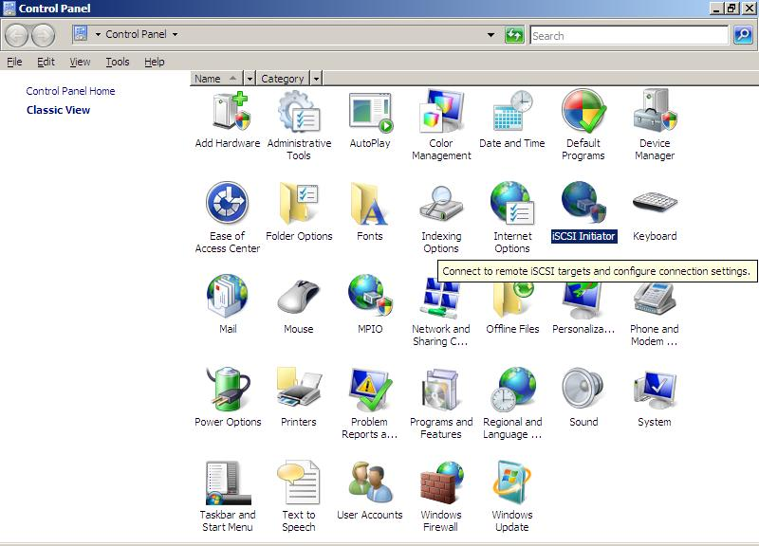

The Microsoft iSCSI Software initiator configuration utility can also be accessed from administrative tools in Windows Server 2008.
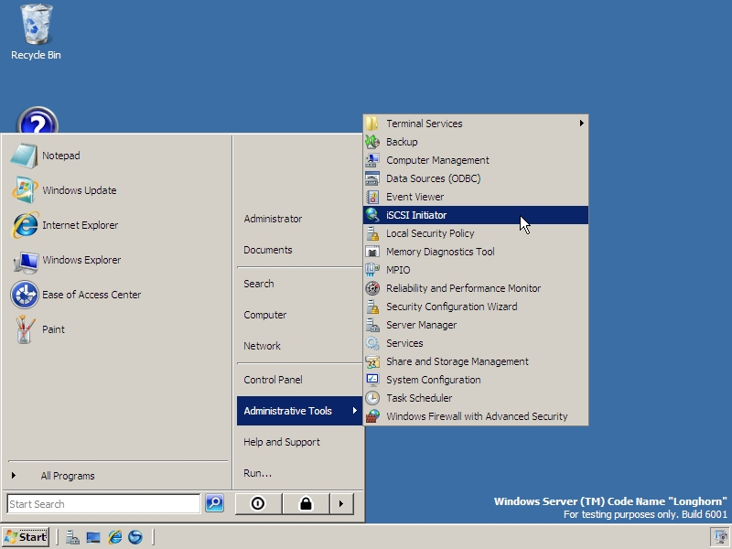

Initiator IQN Name
Each iSCSI initiator and target must have a world wide unique name. Typically this is an iqn name. The single Internet Qualified Name (iqn) name applies to all iSCSI HBAs and the Microsoft iSCSI Software initiator in the system. You should not configure an iSCSI HBA to have a different iqn name than the iqn name that is used by other iSCSI HBAs and the Microsoft iSCSI Software Initiator. They must all share the same iqn name. The Microsoft iSCSI initiator service will automatically choose an iqn name based on the Windows computer and domain name and the Microsoft .com domain name address. If the Windows computer or domain name is changed then the iqn name will also change. However an administrator can specifically configure the iqn name to a fixed value that is used instead of the generated iqn name. If the administrator specifies a fixed IQN name, that name must be maintained as world wide unique.

Persistent Targets
The Microsoft iSCSI initiator service supports the concept of persistent targets. By using common APIs and UI, the Microsoft iSCSI initiator service can configure software and hardware initiators to always reconnect to a target whenever the computer is rebooted. In this way the devices on the target should always be connected to the computer at all times. The login information needed to connect to the persistent targets (ie, CHAP secrets, portal, etc) are captured when the persistent login is done by the administrator and saved by the software and hardware initiators in non-volatile storage. Hardware initiators can initiate reconnection very early in the boot process while the Microsoft software initiator kernel mode driver will initiate reconnection as soon as the Windows TCP/IP stack and the Microsoft iSCSI initiator service loads.

Running automatic start services on iSCSI disks
The disk startup sequence in Windows when using the Microsoft iSCSI software initiator kernel mode driver is different from the startup sequence when using an iSCSI or other HBA. Disks exposed by the Microsoft iSCSI initiator kernel mode driver are available for applications and services much later in the boot process and in some cases might not be available until after the service control manager begins to start automatic start services. The Microsoft iSCSI initiator service includes functionality to synchronize automatic start services and the appearance of iSCSI disk. The iSCSI service can be configured with a list of disk volumes that are required to be present before the start of automatic start services.
In order to install automatic start services on volumes created from iSCSI disks you need to follow the following steps:
- Login to all of the targets your machine will be using. Ensure that these are the only targets that are logged in. Be sure that you have also made them persistent logins by using the iscsicli command PersistentLoginTarget or clicking on the appropriate option in the control panel applet.

- Configure all volumes on top of the disks using Disk Administrator

- Use the iscsicli commands BindPersistentVolumes, AddPersistentVolume, RemovePersistentVolume and ClearPersistentVolumes (or appropriate button in the control panel applet) to allow the iSCSI service to configure the list of persistent volumes

On Windows 2000 only, make the automatic service dependent upon the msiscsi service.
Note: If you have made any services dependent upon the Microsoft iSCSI initiator service, you will need to manually stop the service before upgrading or removing the Microsoft iSCSI Software initiator package.

Management applications/Interfaces

iSCSI Control Panel Configuration Utility
The Microsoft iSCSI initiator service includes a control panel configuration utility that allows an administrator to do the most common iSCSI operations via an easy to use GUI. The applet can be used with the Microsoft iSCSI software initiator kernel mode driver and all iSCSI HBA in a common way. Note that not all functionality of the Microsoft iSCSI initiator service is available via the applet. Full functionality is available using the command line tool iSCSICLI.

iSCSI Property Pages
The Microsoft iSCSI initiator service includes a device coinstaller that includes additional property pages for the Microsoft iSCSI initiator kernel mode driver and iSCSI HBA. The property pages offer a great deal of common information and common configuration options. For example TCP/IP properties such as IP address can be configured for any iSCSI HBA using the common property page implemented by the co-installer.

iSCSICLI
iSCSICLI is a command line tool suitable for scripting and completely exposes all functionality available by the Microsoft iSCSI initiator service. See appendix C for more information on specific iSCSICLI commands.

WMI
The Microsoft iSCSI Software Initiator package includes two sets of WMI interfaces that a management application can use to obtain information about and control the iSCSI initiator. The iSCSI WMI interfaces (as are all WMI interfaces) are available locally as well as remotely via DCOM, scripting and other methods. In fact, VBScript and/or JScript can easily be embedded in dynamic HTML pages to provide an easy to develop interface to the Microsoft iSCSI Software Initiator package.
The first set of interfaces contains those that are exposed directly by the MS iSCSI initiator kernel mode drivers. This set of interfaces includes the following classes:
MSiSCSI_HBAInformation – provides information about the capabilities of the iSCSI initiator kernel mode driver

MSiSCSI_HBASessionConfig – provides the default session configuration information

MSiSCSI_PortalInfoClass – exposes information about the initiator portals

MSiSCSI_InitiatorSessionInfo - exposes session and connection information on the initiator. This is the class to query if you are interested in the current list of sessions and connections.
MSiSCSI_InitiatorNodeFailureEvent - fires an event when a node failure occurs
MSiSCSI_InitiatorInstanceFailureEvent - fires an event when an initiator failure occurs
MSiSCSI_TCPIPConfig – HBA initiator only, TCP/IP configuration class. This describes and allows configuration of the TCP/IP parameters.
MSiSCSI_NICConfig - HBA initiator only, NIC configuration class.
MSiSCSI_BootConfiguration - HBA initiator only, Boot configuration class.
MSiSCSI_SecurityCapabilities – HBA initiator only, security capabilities
MSiSCSI_DiscoveryConfig - HBA initiator only, this class describes and allows configuration of the HBA discovery configuration.
MSiSCSI_RADIUSConfig - HBA initiator only, this class describes and allows configuration of the RADIUS configuration.
MSiSCSI_QueryLBPolicy – Query the load balance policy for connections within a session
MSiSCSI_Eventlog – HBA miniports can fire this class to create eventlog entries
MSiSCSI_Redirect_PortalInfoClass - Information about session that have encountered login redirection.
MSiSCSI_ManagementOperation – Supplies a method that allows user to ping via an iSCSI HBA.
The second set of interfaces controls and obtains information from the MS iSCSI initiator service. These classes provide the same functionality as the iSCSI Win32 APIs.

MSiSCSIInitiator_TargetClass - Used to enumerate the list of iSCSI targets known to the iSCSI discovery service
MSiSCSIInitiator_TargetClass::Login - Perform an iSCSI login to the target
MSiSCSIInitiator_PersistentLoginClass - Used to enumerate the list of persistent logins that have been configured in the iSCSI discovery service
MSiSCSIInitiator_iSNSServerClass - Used to enumerate the list of iSNS servers that have been configured in the iSCSI discovery service
MSiSCSIInitiator_iSNSServerClass::Refresh -Refresh the list of discovered targets from this iSNS server

MSiSCSIInitiator_SendTargetPortalClass - Used to enumerate the list of SendTargets portals that have been configured in the iSCSI discovery service
MSiSCSIInitiator_SendTargetPortalClass::Refresh - Refresh the list of discovered targets from this SendTargets portal
MSiSCSIInitiator_InitiatorClass - Used to enumerate the list of iSCSI Initiators that have been configured in the iSCSI discovery service
MSiSCSIInitiator_SessionClass - Used to enumerate the list of iSCSI sessions that are currently open
MSiSCSIInitiator_SessionClass::Logout - Perform an iSCSI logout of this session
MSiSCSIInitiator_SessionClass::SendScsiInquiry - Send a SCSI Inquiry command to the target for this session
MSiSCSIInitiator_SessionClass::SendScsiReadCapacity - Send a SCSI Read Capacity command to the target for this session
MSiSCSIInitiator_SessionClass::SendScsiReportLuns - Send a SCSI Report LUNs command to the target for this session
MSiSCSIInitiator_SessionClass::AddConnection – Add a connection to a session
MSiSCSIInitiator_SessionClass::RemoveConnection – Remove a connection from a session
MSiSCSIInitiator_MethodClass - Provides various methods that do not fit into the other defined classes
MSiSCSIInitiator_MethodClass::RefreshTargetList - Refresh the entire list of targets using all available discovery methods
MSiSCSIInitiator_MethodClass::SetIScsiTunnelModeOuterAddress - Set the IPSec outer address to be used to create a secure session between two iSCSI portals
MSiSCSIInitiator_MethodClass::SetIScsiIKEInfo - Set the IKE information to be used for authentication purposes by the specified iSCSI initiator
MSiSCSIInitiator_MethodClass::SetIScsiGroupPresharedKey - Set the group preshared key to be used when negotiating authentication for iSCSI login purposes
MSiSCSIInitiator_MethodClass::SetIScsiInitiatorCHAPSharedSecret - Set the shared secret to be used when negotiating CHAP authentication for iSCSI login purposes
MSiSCSIInitiator_MethodClass::SetIScsiInitiatorNodeName - Set the iSCSI initiator node name to be used by the MS iSCSI discovery service for iSCSI discovery and login purposes
MSiSCSIInitiator_MethodClass::SetupPersistentIScsiVolumes - Persist the current list of active iSCSI volumes to synchronize with the MS iSCSI discovery service start completion with on next MS iSCSI discovery service start

MSiSCSIInitiator_PersistentDevices – List of persistent devices bound. This is the list of devices that the initiator service will wait for before completing its service startup sequence.

Perfmon/Sysmon
On Windows XP and Windows Server 2003 the following classes are available as performance objects within the sysmon (perfmon) tool. Note that the counters will not be displayed in the Sysmon/Perfmon Add Counter dialog box unless there is an active iSCSI session.
The MS iSCSI initiator kernel mode drivers expose the following classes that provide performance information:
MSiSCSI_ConnectionStatistics – Connection level statistics such as bytes sent/received, and PDU sent/received
MSiSCSI_SessionStatistics – Session level statistics such as bytes sent/received, PDU sent/received, format errors, digest errors, and timeout errors.
MSiSCSI_InitiatorLoginStatistics – Initiator node level statistics with information about login success and various types of login failures.

MSiSCSI_InitiatorInstanceStatistics – Initiator node level statistics with information about session level errors.

MSiSCSI_RequestTimeStatistics – Information about the length of time the initiator takes to process requests.

iSCSI HBA initiator kernel mode drivers also expose the MSiSCSI_NICPerformance class which has performance information about the NIC in the iSCSI HBA.

Using Multipathing I/O
The release of iSCSI 2.x includes support for establishing redundant paths for sending I/O from the initiator to the target. Setting up redundant paths properly is important to ensure high availability of the target disk. Ideally the Windows Server host should use paths on separate NIC cards and/or iSCSI HBA, separate network infrastructure (cables, switches, routers, etc) and separate target ports. This can additionally be accomplished through the use of VLANs. There are two technologies supported with the MS iSCSI software initiator to enable redundancy and load balancing:
- Multiple connections per session (MCS)
- Microsoft MPIO support

Multiple connections per session (MCS) support is defined in the iSCSI RFC to allow multiple TCP/IP connections from the initiator to the target for the same iSCSI session. This is iSCSI Protocol specific. In this way I/O can be sent over either TCP/IP connection to the target. If one connection fails another connection can continue processing I/O without interruption to the application. Note that not all iSCSI targets support MCS. iSCSI targets which support MCS include but are not limited to EMC Celerra, iStor and Network Appliance.
The MS iSCSI initiator kernel mode driver supports a set of load balance policies that determine how I/O is allocated among the different connections.
Microsoft MPIO support allows the initiator to login multiple sessions to the same target and aggregate the duplicate devices into a single device exposed to Windows. Each session to the target can be established using different NICs, network infrastructure and target ports. If one session fails then another session can continue processing I/O without interruption to the application. Note that the iSCSI target must support multiple sessions to the same target. The Microsoft iSCSI MPIO DSM support supports a set of load balance policies that determine how I/O is allocated among the different sessions. Microsoft MPIO is supported on Windows 2000 Server platforms, Windows Server 2003 platforms, and future Windows Server platforms. Microsoft MPIO is not supported on Windows XP or Windows 2000 Professional.
Most iSCSI target arrays support multiple sessions through Microsoft MPIO including but not limited to EqualLogic (all product models), Network Appliance (all product models), EMC Celerra, EMC CX and AX product lines, EMC Symmetrix , iStor, , Dell MD3000i, Dell EMC AX and CX product lines Dell NX1950, LSI Logic, Hewlett Packard, SUN Microsystems 5320, Adaptec, and Lefthand Networks as well as many other iSCSI targets.
For MCS the load balance policies apply to connections in a session and apply to all LUNs exposed in the session. For Microsoft MPIO the load balance policies apply to each LUN individually. Depending upon the load balance policy that you select, the path will either have a status of Standby or Active. Failed paths are removed from the list of paths within the iSCSI device.
Although it is technically possible to layer Microsoft MPIO and MCS together since they function at different layers in the Windows stack, Microsoft does not support the layering of MPIO and MCS due to complexities this can introduce if troubleshooting is needed on a configuration.

The Microsoft iSCSI DSM assumes that all targets are active/active and can handle IO on any path at any time. There does not exist a mechanism within the iSCSI protocol to determine whether a target is active/active or active/passive, therefore, the UI will always show all load balance policies as available to be configured for a target even if the target does not support them or if the target is active/passive. In this case, you should contact your iSCSI target vendor for an appropriate DSM that works with their target. Future Windows Releases will include support for ALUA enabling the Microsoft provided DSM to work with non active/active arrays.
MCS supports all of the load balance policies detailed below on Windows 2000, XP and 2003. Microsoft MPIO is a protocol independent Windows Server only technology and supports all of the policies on Windows 2003 and failover only on Windows 2000 Server.

- Fail Over Only: No load balancing is performed. There is a single active path and the rest of the paths are standby paths. The active path is used for sending all I/O. If the active path fails then one of the standby paths is used. When the formally active path is reconnected it will become active and the standby path that was activated would return to standby.
- Round Robin: All paths are active paths and they will be used for sending I/O in a round robin fashion.
- Round Robin with a subset of paths: A set of paths are configured as active and a set of paths are configured as standby. I/O is sent in a round robin fashion over the active paths. If all of the active paths fail then one of the standby paths is used. If any of the formerly active paths become available again then the formerly active paths are used and the standby path that was activated becomes a standby path again.
- Weighted Path: Each path is assigned a weight and I/O will be sent on the path with the lowest weight. If the path with the lowest weight fails then the path with the next lowest weight will be used.
- Least Queue Depth: This is only supported by MCS. The path that has the fewest number of requests queued is the one where the I/O is sent.
There are a number of things to consider when choosing to use MCS or Microsoft MPIO for multipathing.
- If your configuration uses hardware iSCSI HBA then Microsoft MPIO should be used.
- If your target does not support MCS then Microsoft MPIO should be used. Most iSCSI target arrays support Microsoft MPIO. Targets which support MCS include but are not limited to Network Appliance, EMC Celerra, and iStor
- If your target does support MCS and you are using the Microsoft software initiator driver then MCS is the best option. There may be some exceptions where you desire a consistent management interface among multipathing solutions and already have other Microsoft MPIO solutions installed that may make Microsoft MPIO an alternate choice in this configuration.
- If you need to specify different load balance policies for different LUNs then Microsoft MPIO should be used.
- If you are using Windows XP or Windows Vista, MCS is the only option since Microsoft MPIO is only available with Windows Server SKUS.

Note that the MS iSCSI control panel applet shows two different pages to setup multipathing policies. The page reached by clicking on the connections button on the Target details page is used to configure the load balance policies for MCS. The page reached by clicking the Advanced button on the Device details page is used to configure the load balance policies for that device using Microsoft MPIO.

Configuring MCS (Multiple Connections)
The following example illustrates how to configure MCS using the Microsoft iSCSI Software Initiator with 4 MCS connections using Round Robin load balance policy. This example uses the Network Appliance iSCSI Target array, however, any iSCSI target that supports MCS can be used. Please see documentation from your iSCSI target array vendor on support for MCS.

- Launch the iSCSI Initiator Properties Control Panel applet as shown below.
Figure: iSCSI Properties Applet
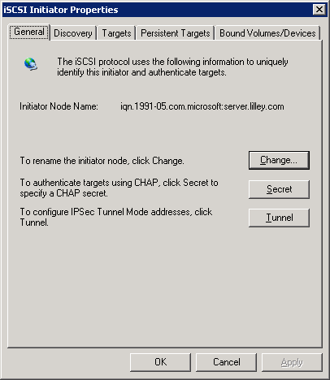
- If you are using an iSNS server or HBA discovery to discover target portals, skip to Step 6.
- Select the Discovery tab as shown below.
Figure: iSCSI Initiator - Discovery Tab
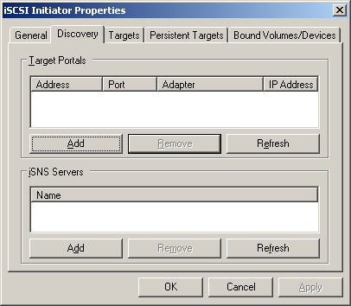
- Click Add and enter the IP address or DNS name and Port number for the Target Portal that you want to logon to as shown below.
Figure:Add Target Portal Dialog
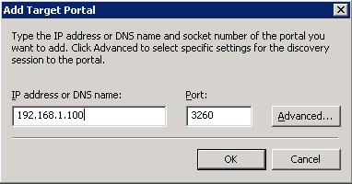
- If your Target Portal requires Chap for authentication, click Advanced, select the Chap logon information option, enter the Target secret, and then click OK twice to return to the iSCSI Initiator Properties dialog.
- Verify the Target Portals properties displayed on the Discovery tab as shown below.
Figure: Discovery Target Portal Properties
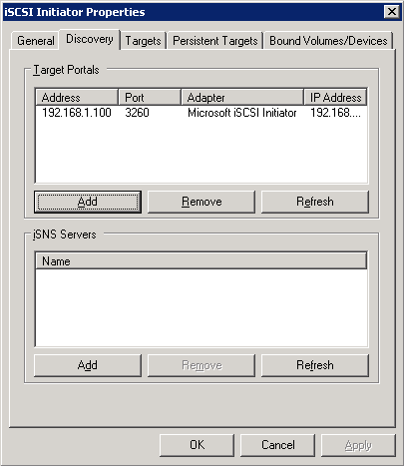
- Select the Targets tab as shown below to display a list of available targets that you can log on to. Note that the Status for these targets is shown as Inactive prior to logon.
Figure: iSCSI Initiator Properties - Targets Tab
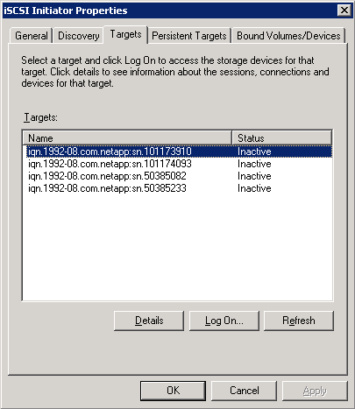
  - If your targets are not listed on the Targets tab, verify discovery and successful logon by repeating Steps 2 through 5.
  - If you successfully logged onto the Target portal but the target is still not listed, verify that the target has Logical Unit Numbers (LUNs) assigned to this server.
  - If the target is still not listed, check the System Event Log for errors, resolve any issues noted in the log, and repeat Steps 2 through 5 to log on to the Target Portal.
- Select the target that you want to log on to and click Log On to display the Log On to Target dialog shown below.
Figure: Log On to Target Dialog
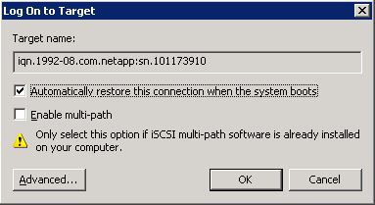
- In the Log On to Target dialog:
  - If you want this target to be persistent, select Automatically restore this connection when the system boots.
  - Click Advanced and select the Local Adapter, Source IP, and Target Portal as shown below
Figure: Log On to Portal - Advanced Settings
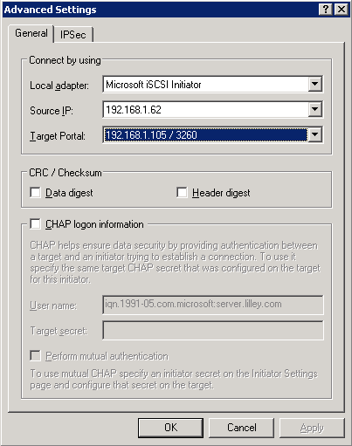
  - If your target requires CHAP authentication, select Chap logon information and enter the Target secret.
  - Click OK to return to the Log On to Portal dialog.
  - Click OK again to return to the iSCSI Initiator Properties dialog.
- In the iSCSI Initiator Properties dialog, verify that your target indicates Connected in the Status column as shown below.
Figure: Targets Tab - Connected Status
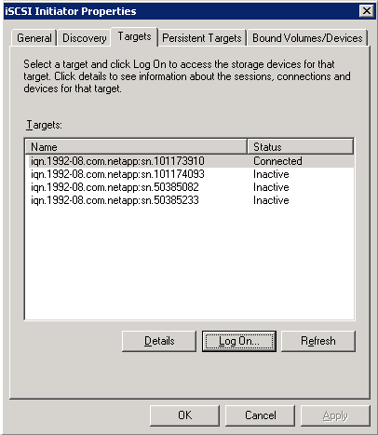
- Select the target that you logged on to and click Details to display the Target Properties dialog shown below. Note the Session Properties Status and Connection Count.
Figure: Target Properties
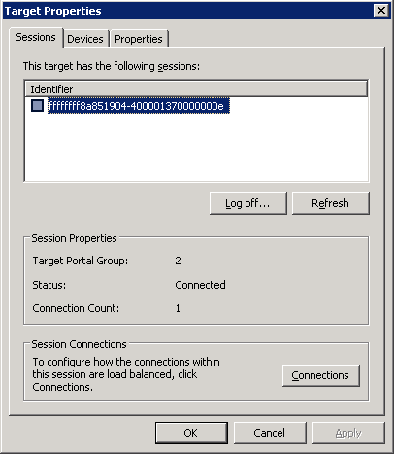
- In the Identifier box, select the session ID and click Connections to display the Session Connections dialog shown below. Note the Load Balance Policy setting and the list of connections for this session.
Figure: Session Connections
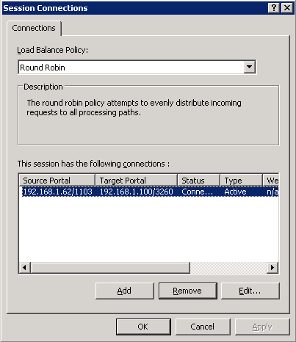
- To add another connection to this session:
  - Click Add to display the Add Connection dialog shown below.
Figure: Add Connection
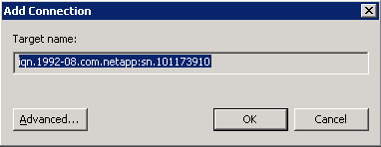
  - Click Advanced to display the Advanced Settings dialog for this session as shown below.
Figure: Add Connection - Advanced Settings
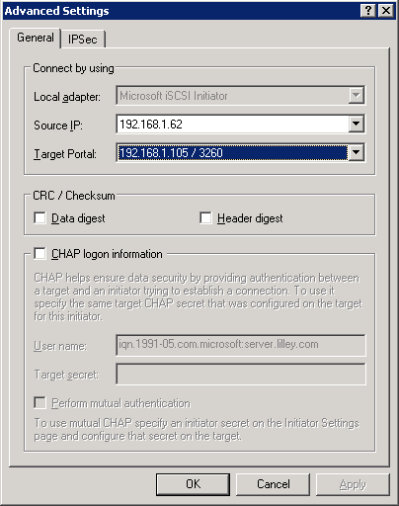
  - In the Advanced Settings dialog, select a different Source IP such as the Source IP for a different network interface card (NIC).
  - If the target has multiple portals, select a different Target Portal address.
  - If the new connection requires CHAP authentication, select Chap logon information and enter the Target secret.
  - Click OK to close the Advanced Settings dialog and return to the Add Connections dialog.
  - Click OK to close the Add Connections dialog and return to Session Connections dialog.
- In the Session Connections dialog, verify that both connections are listed as shown below.
Figure: Session Connections - Multiple Connections
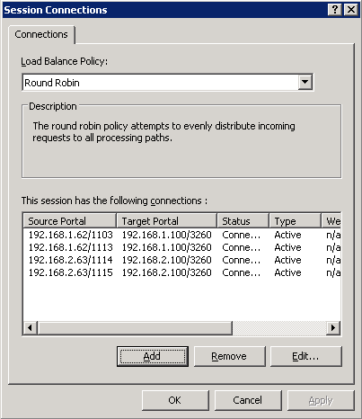
- To add additional connections, repeat Steps 13 and 14.
- After adding all required connections, optimize the load between connections by selecting the appropriate Load Balance Policy for your environment. In Figure:, the Load Balance Policy has been set to Round Robin to evenly distribute incoming requests through all connections.
Note In the Session Connections dialog, you can also change the type of connection from Active to Standby by selecting the connection and clicking Edit. If you set a connection to Inactive, you should also change the Load Balance Policy to Round Robin with Subset; this policy executes round robin load balance only on paths designated as active and tries standby paths only upon failure of active paths.

- Click OK to return to the Target Properties dialog.
- To view device Logical Unit Numbers (LUNs) presented within this session:
  - In the Target Properties dialog, select the Devices tab as shown below.
Figure: Target Properties - Devices Tab.
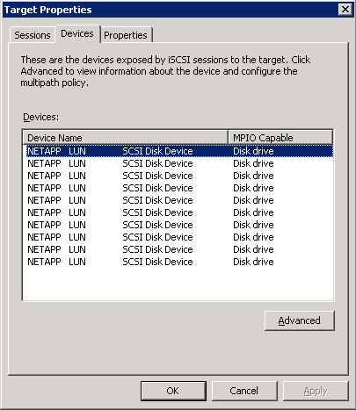
  - Select the device and click Advanced to view device details as shown below. Note the LUN number displayed in the SCSI Address.
Figure: Device Details Dialog.
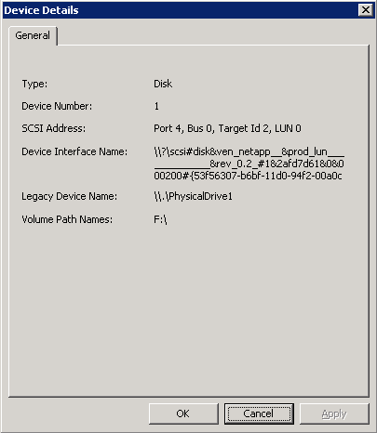
- Click OK to return to Target Properties, click OK to return to Session Connections, and then click OK to close the Session Connections dialog.

Configuring Microsoft MPIO

The following example illustrates how to configure MS MPIO using the Microsoft iSCSI Software Initiator with 4 sessions using the Round Robin load balance policy. This example uses the EqualLogic iSCSI target array, however, any iSCSI target that supports Microsoft MPIO (multiple sessions) can be used. Please see documentation from your iSCSI target array vendor on support for MPIO. The Microsoft iSCSI DSM included with the iSCSI initiator package is designed to work with storage arrays which follow the Active/Active controller model. For non active/active arrays, customers need to obtain a DSM from their storage array vendor.

- Launch the iSCSI Initiator Properties Control Panel applet as shown below.
Figure: iSCSI Properties Applet
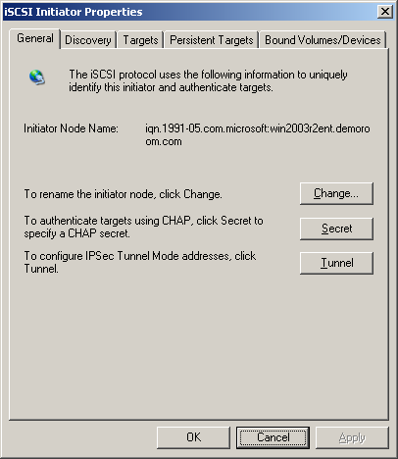
- If you are using an iSNS server or HBA discovery to discover target portals, skip to Step 6.
- Select the Discovery tab as shown below.
Figure: iSCSI Initiator - Discovery Tab
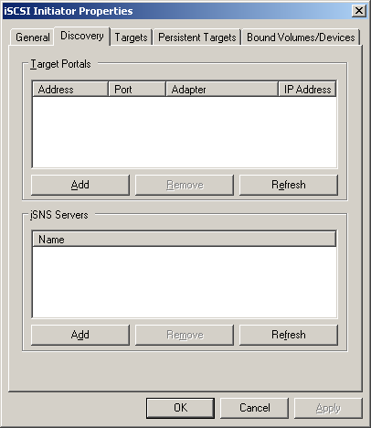
- Click Add and enter the IP address or DNS name and Port number for the Target Portal that you want to logon to as shown belolw.
Figure: Add Target Portal Dialog
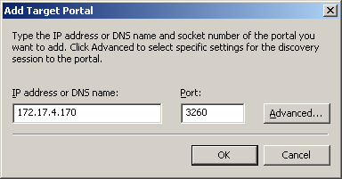
- If your Target Portal requires Chap for authentication, click Advanced, select the Chap logon information option, enter the Target secret, and then click OK twice to return to the iSCSI Initiator Properties dialog.
- Verify the Target Portals properties displayed on the Discovery tab as shown below.
Figure: Discovery Target Portal Properties
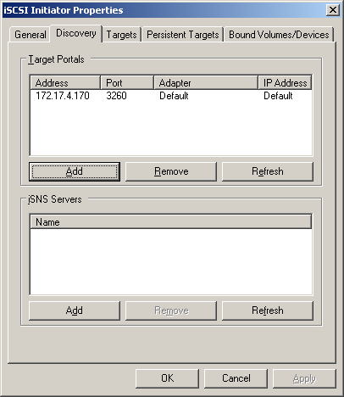
- Select the Targets tab as shown below to display a list of available targets that you can log on to. Note that the Status for the target is shown as Inactive prior to logon.
Figure: iSCSI Initiator Properties - Targets Tab
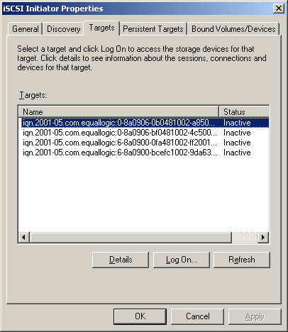
  - If your target is not listed on the Targets tab, verify that the target has Logical Unit Numbers (LUNs) assigned to this server and repeat Steps 3 through 5.
  - If the target is still not listed, check the System Event Log for errors, resolve any issues noted in the log, and repeat Steps 3 through 5 again.
- In the iSCSI Initiator Properties dialog, select the target that you want to log on to and click Log On to display the Log On to Target dialog shown below.
Figure: Log On to Target Dialog
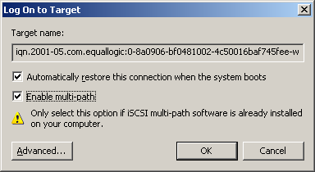
- In the Log On to Target dialog:
  - If you want this target to be persistent, select Automatically restore this connection when the system boots.
  - Select Enable multi-path.
Caution Make sure iSCSI multi-path software has been installed in the computer before enabling a multi-path connection.

  - Click Advanced and select the Local Adapter, Source IP, and Target Portal as shown below
Figure: Log On to Portal - Advanced Settings for First Multi-path Connection
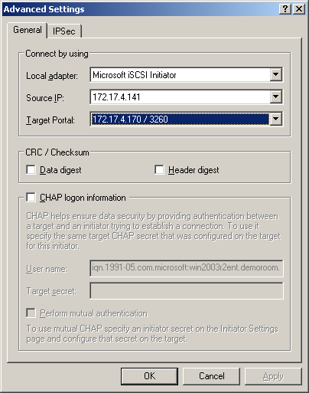
  - If your target requires CHAP authentication, select Chap logon information and enter the Target secret.
  - Click OK to return to the Log On to Portal dialog and then click OK again to return to the iSCSI Initiator Properties dialog.
- In the iSCSI Initiator Properties dialog, verify that your target indicates Connected in the Status column as shown below.
Figure: Targets Tab - Connected Status
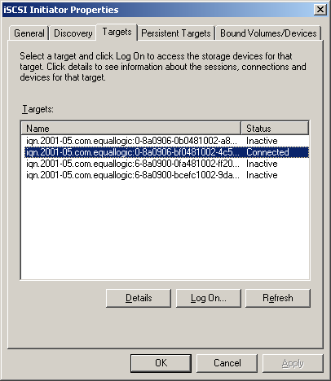
- To add a second session (another path) to the target, select the target that you want to add sessions to and click Log On to display the Log On to Target dialog shown below.
Figure: Log On to Target Dialog
- In the Log On to Target dialog:
  - Leave the previously selected target settings for Automatically restore this connection when the system boots and Enable multi-path unchanged.
  - Click Advanced and select a different Local Adapter NIC or HBA with a different Source IP. If the target has multiple portals, select a different portal address.
  - Click OK to return to the Log On to Portal dialog and then click OK again to return to the iSCSI Initiator Properties dialog.
- Repeat Steps 11 and 12 to add additional sessions (paths) to the target.
- After adding the desired sessions (paths), select the target and click Details to display the Target Properties dialog as shown below and note the multiple session Identifers. To cancel a session, check the box beside a session Identifier and click Log Off.
Figure: Target Properties for Multi-path Connection
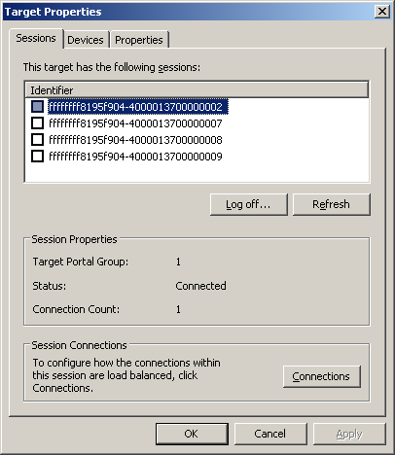

- To view information about Logical Unit Numbers (LUNs) assigned to devices presented within sessions, select the Devices tab as shown below.
Figure: Target Properties - Devices Tab
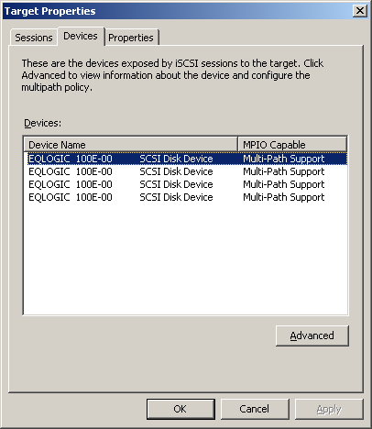
- To view and configure an individual LUN, select the LUN and click Advanced to display the Device Details dialog as shown below.
Figure: MPIO LUN Device Details
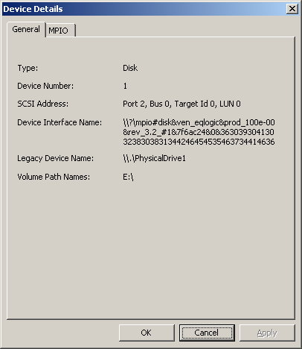
- To configure the MPIO settings for the LUN, select the MPIO tab as shown below. On this tab, you can select the appropriate Load Balance Policy settings for the individual LUN. You can also view the Active or Standby path type and change the path type by selecting the path and clicking Edit.
Figure: MPIO LUN Device Settings
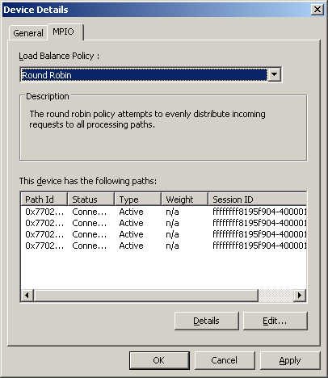
- To view additional information about a path, select the path and click Details to display the MPIO Path Details dialog as shown below.
Figure: MPIO Path Details
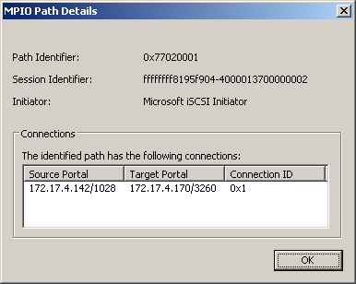
- After choosing the appropriate Load Balance Policy and configuring the Active or Standby path type for an individual LUN, click OK to return to the Target Properties dialog and repeat Steps 16 and 17 for each LUN.
- After configuring all LUNs, click OK to close the Target Properties dialog and then click OK to close the iSCSI Initiator Properties applet.

iSCSI Boot Initiator Architectural Overview
Windows Server 2003 can be booted from a SAN using either an FC HBA or an iSCSI HBA. In either case, the HBA, the HBA is responsible for reading blocks off the boot volume and loading the initial OS bits into memory.
Windows Server 2003 can also be booted from a SAN using the appropriate iSCSI Software Initiator and the same Interrupt 13 boot mechanism. Version 2.06 or higher versions of the Microsoft iSCSI Software Initiator support boot from SAN. Version 2.07 of the Microsoft iSCSI Software Initiator can be found at http://www.microsoft.com/downloads/details.aspx?FamilyID=12cb3c1a-15d6-4585-b385-befd1319f825&DisplayLang=en The network stack is loaded early in the boot sequence since the existence of the network stack is required to read blocks off the boot volume.

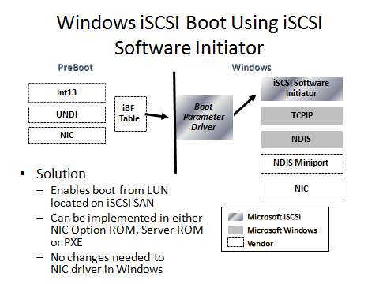

Figure X Boot Architecture for iSCSI SAN Boot using Microsoft iSCSI Software Initiator
NIC vendors and PXE Rom vendors who support iSCSI boot using the Microsoft software initiator implement an INT13 aware BIOS inside the HBA or NIC, or boot rom which includes implementation of the iSCSI Boot Firmware Table. As part of the ACPI 3.0b specification, Microsoft has defined the iSCSI Boot Firmware Table (iBTF) shown in the figure. . The (iBFT) is a block of information containing parameters needed to boot Microsoft Windows Server 2003 and Windows Server 2008 using the iSCSI protocol and the Microsoft iSCSI Software Initiator. Independent Hardware Vendors implementing iSCSI boot support in their firmware need to use the table headers defined in this specification to enable the passing of boot critical parameters to the Windows operating system.
The HBA/NIC establishes an iSCSI session to the target disk which includes the Windows image and loads the OS. Once the OS has bootstrapped enough to load the iSCSI Software Initiator, there is a handoff and the iSCSI Software Initiator establishes its own session to the target and continues loading the rest of the Windows operating system.

iSCSI Boot Step by Step instructions for the Windows Administrator
This section of the document provides detailed instructions for the Windows administrator on how to have Windows Server 2003 or Windows Server 2008 system remote boot from an iSCSI target using the Microsoft iSCSI Initiator.
The steps involve
- Prepare a Windows Server 2003 or Windows Server 2008 with a supported NIC or iSCSI HBA. Refer to the Windows Catalog to obtain a list of such hardware.
- Install Windows Server 2003 or Windows Server 2008 on the system and install all available hot fixes and Service Packs (these will be available mostly for Windows Server 2003 only)
- For Windows Server 2003, install the NDIS QFE described in KB902113. This provides a fix in NDIS to enable the NDIS stack to support paging I/O under certain situations.
- For Windows Server 2003, install the iSCSI Software Initiator from the Microsoft download center.
- Reboot the system
- Test and then "image" the new operating system installation. Please note that the only supported method of imaging Server 2003 is in conjunction with the System Preparation Utility (Sysprep), which is included with Windows
- If required, install a DHCP server. Reconfigure the DHCP Server to support reservations since this is required for iSCSI boot.
- Create a LUN on your iSCSI target.
- Make this newly created iSCSI target accessible only to the client. Configure this LUN to be accessible to the MAC address of the NIC card and the iqn name of the iSCSI Software Initiator Windows Server 2003 host being booted.
- Ensure that the Windows Server 2003 machine (the host) installed in step 1 can successfully access the iSCSI target volume created in setup 8.
- Transfer the image to the iSCSI LUN created in step 8
- Configure the host to boot from this image transferred in step 10
- Remove local hard drive or keep local hard drive for pagefile use
The following sections explain bullets 7 through 12 in more detail using screen shots as appropriate.

Configuring DHCP for iSCSI Boot (Step 7)
In order to boot separate machines to individually assigned iSCSI targets, DHCP reservations can be used. Using a reservation allows the target (root path) and host name options to be specified for each machine. Specifying these options at the scope or server level would cause all clients receiving leases from the scope or server respectively to use the same root path and host name. The current implementation does not support single image instancing which makes the use of scope and server options, primarily for the purpose of root path, invalid at this time.
Before configuring DHCP, be sure you are not attempting to host DHCP on a network that already has an active DHCP server. Doing so could result in disruption of service for users of the existing server.
Here are the steps to configure a Windows Server 2003 to properly run a DHCP service that can be used for iSCSI boot:

- Install the DHCP Server service on a suitable machine on the local network where the iSCSI client machine will be booting. Click
  - Control Panel - Add/Remove Programs – Add/Remove Windows Components
  - Networking Services – Details – Select Dynamic Host Configuration Protocol (DHCP)
  - If the server hosting DHCP is a member of a domain it will need to be authorized in Active Directory.
- Next, follow these steps to create a scope and activate it. Open the DHCP MMC snap-in and right-click on the server name.
  - Select Authorize.
  - The account used to authorize the server must be an enterprise administrator of the forest and domain administrator for the server’s domain. (315370)
  - Note: The red down arrow displayed to indicate that a server is not authorized may not update immediately. Wait at least 30 seconds and then attempt to refresh the view. (244638)
  - Refer to article KB303317 for other problems authorizing the DHCP server.
  - In the DHCP MMC snap-in, right-click the server name and select “New Scope”.
  - Follow the steps presented in the wizard to create the scope.
  - Activate the scope once it is created.
  - Expand the newly created scope, right-click Reservations then choose “New Reservation”.
  - Fill in at least the name, IP, and MAC address fields.
  - The supported types option can be set to either “Both” or “BOOTP only”.

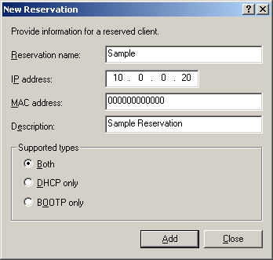

Select the reservation that was just created and right-click it. Select “Configure Options”.
Select option 12 and enter the hostname for the client.

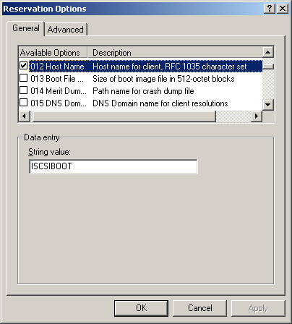

Select option 17 and enter the iSCSI target’s IQN.

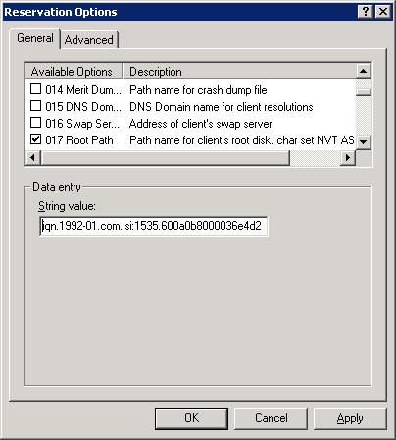

The server is now configured to provide an address and the appropriate options to this client.

Create an iSCSI Target (volume) on a host (Step 8)
This section refers to bullet item 8 and explains how to create a target volume on a suitable host. The exact steps are dependent upon the solution you prefer to use. The following example uses Engeno Simplicity to create a 30GB volume on a host called “iscsiboot”. You should refer to the directions provided by your iSCSI storage array (target) manufacturer for specific instructions on how to create an iSCSI disk to serve as your boot volume.
On the Engenio Simplicity “Configure” tab, click on “Create Volume”

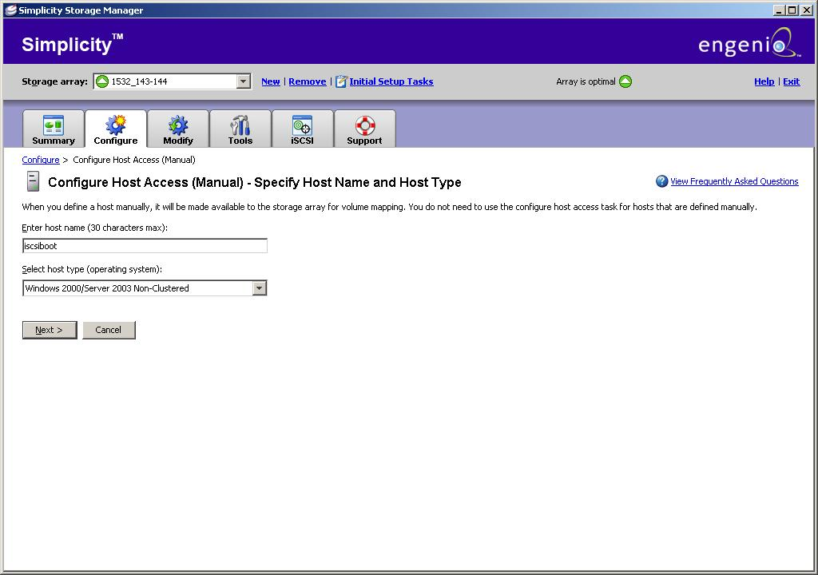

Since we are using host iscsiboot in this example, select the host “iscsiboot” and click next
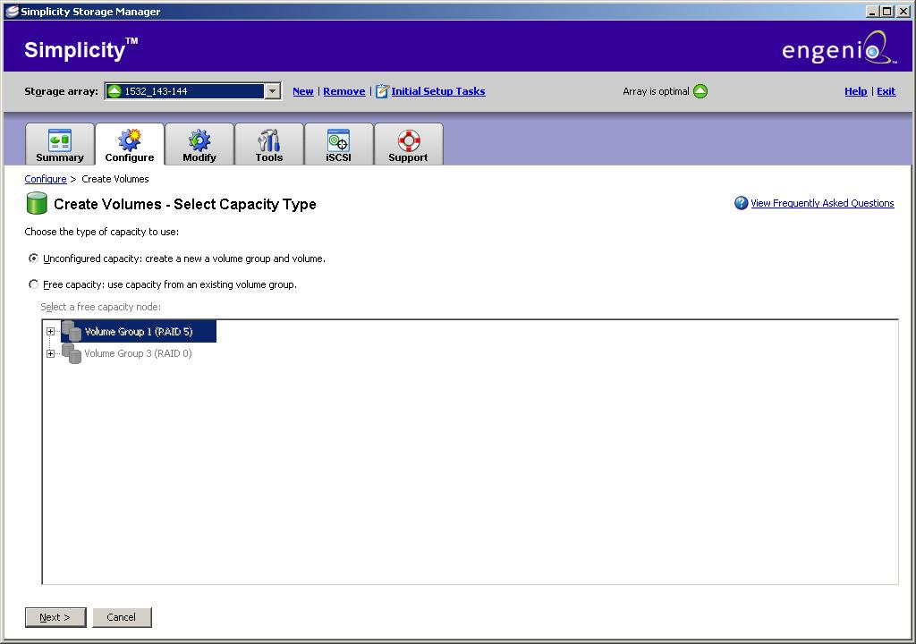
Select Automatic drive selection choices and click next
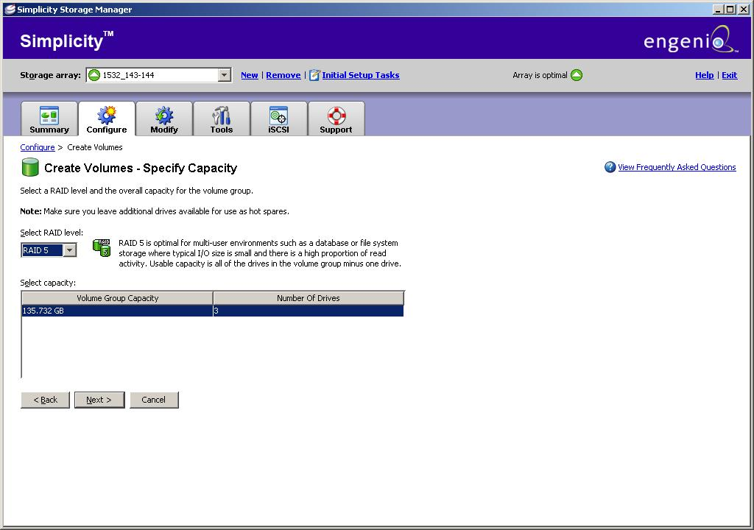
Select an appropriate RAID level. This example selects RAID level 5 and the click next
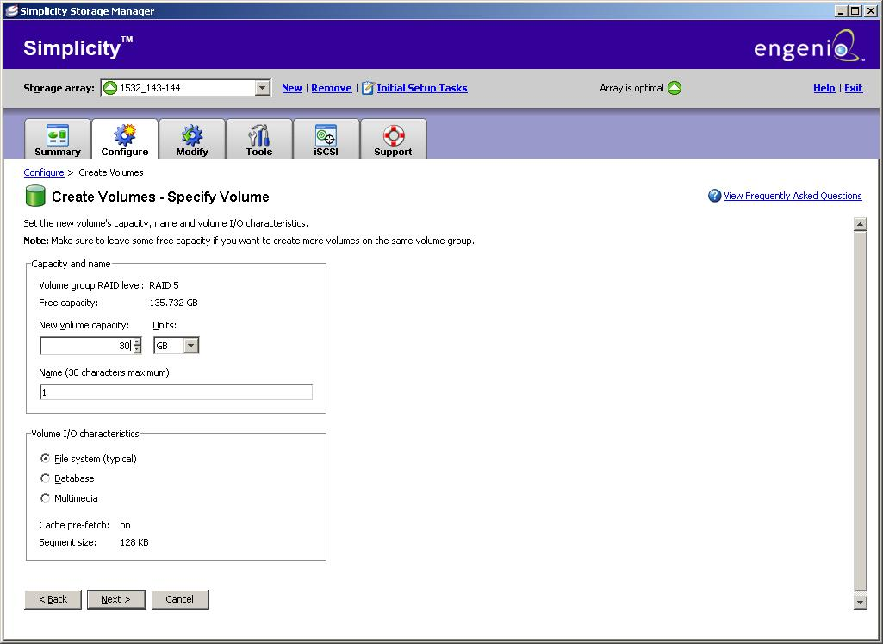
Configure an appropriate volume size – this example chooses a 30GB volume. Select “File System (Typical)” and click next

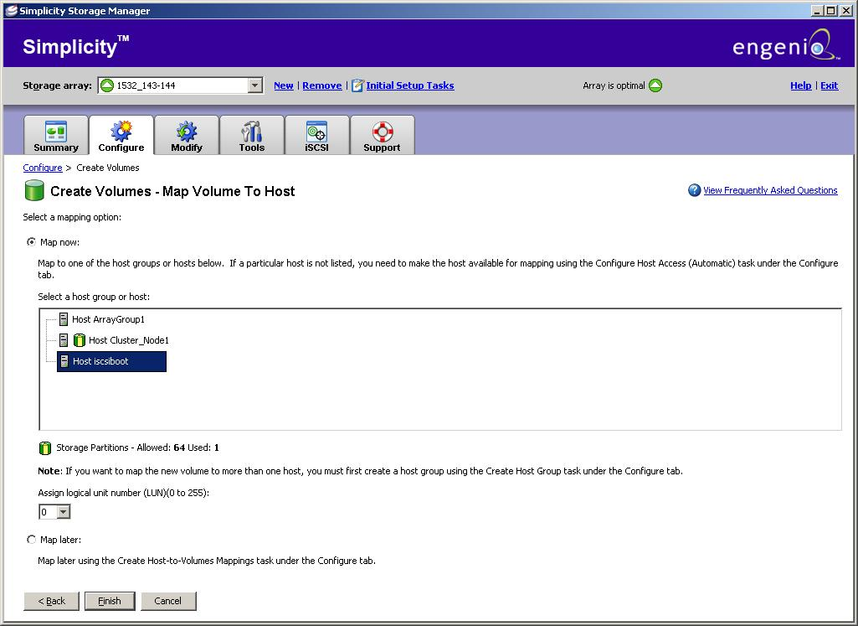
The volume has been created. Now it needs to be mapped to the host so that the host can make it available as a target. Select option “Map Now” and highlight the host “iscsiboot”. Click next.
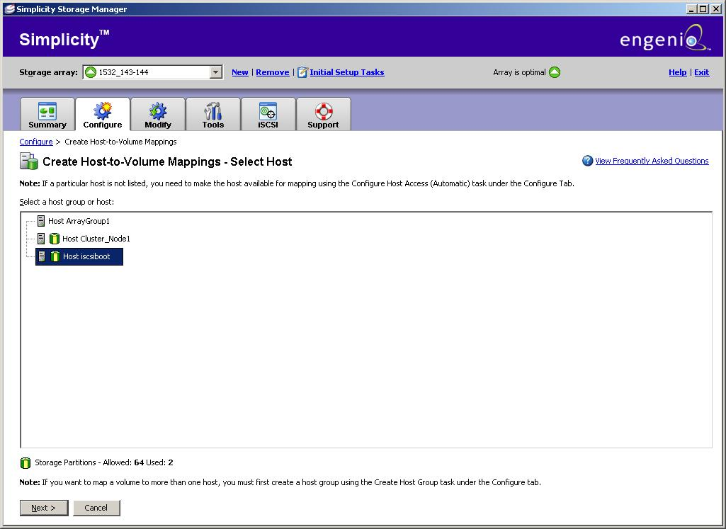
Select the host iscsiboot and click next.

Configure the iSCSI target to be accessible only to one particular client (Step 9 )
On the Engenio “Configure” tab, click “Configure Host Access”
Specifiy “iscsiboot” as the host, select the appropriate host type (Windows Server 2003 for this example) and click next
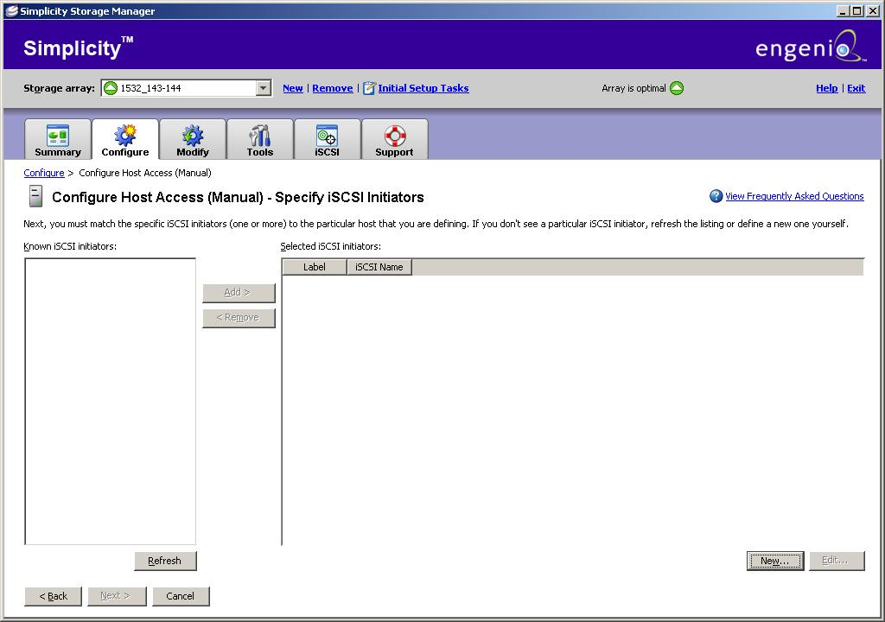
Click on “New”
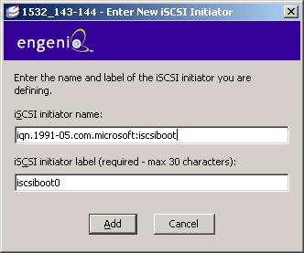
Fill out the iSCSI client name and its label (the client is also the initiator) and then click “Add”
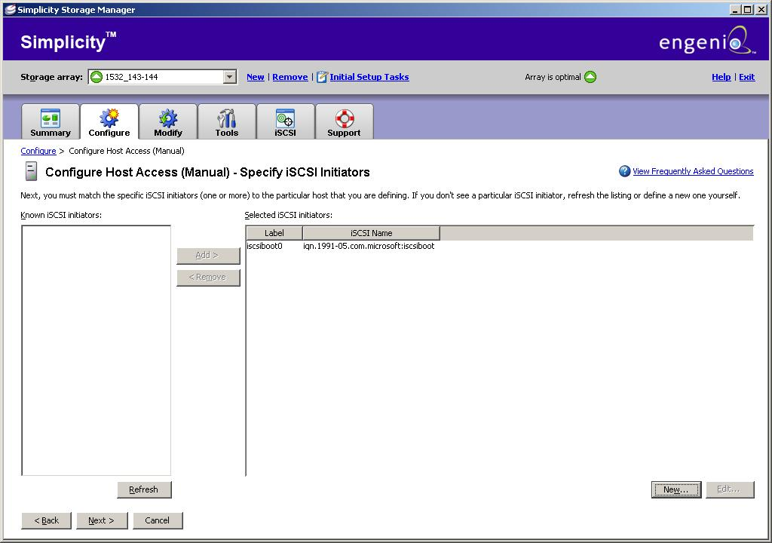
The newly added initiator should be shown in the dialog box. Highlight this entry and click “Next”
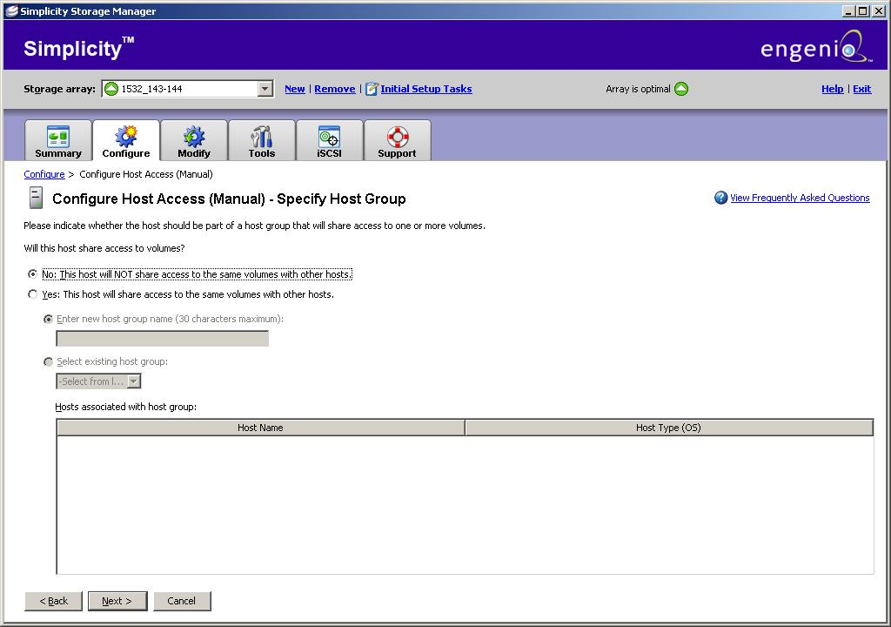

Remember that iSCSI boot requires exclusive access. Select the button “No, this host will NOT share access to the same volume with other hosts” and click “Next”
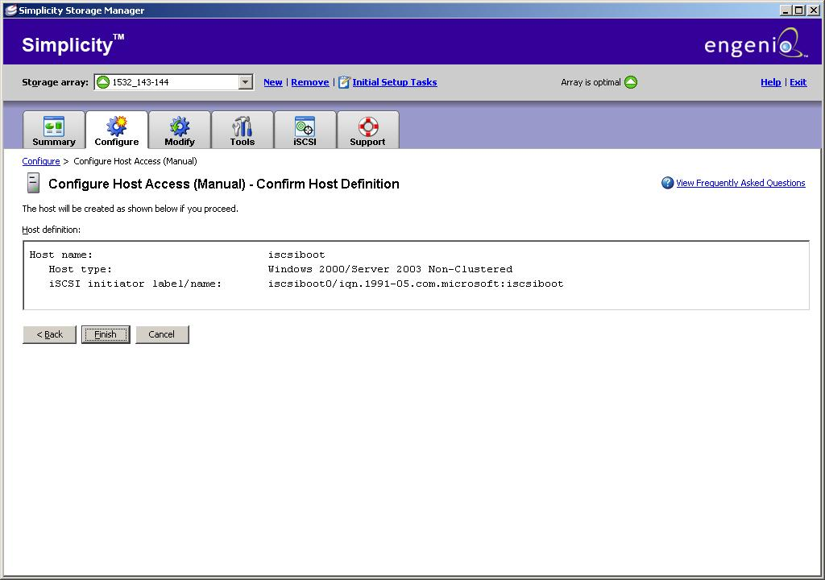
The dialog box should now show the host and initiator. Click “Finish”. The iSCSI target has now been created and configured for access by the initiator.

Windows Server 2003 Host configuration
Install Windows Server 2003 on a Server containing a local drive
Install the Microsoft iSCSI Software Initiator (boot version) available on www.microsoft.com/downloads
Link: http://www.microsoft.com/downloads/details.aspx?FamilyID=12cb3c1a-15d6-4585-b385-befd1319f825&DisplayLang=en

Configure the Windows Server 2003 host to access the target and check that the Windows Server can successfully access it (Step 10)

This section explains Step 10 in detail.
Open the iSCSI Initiator properties page

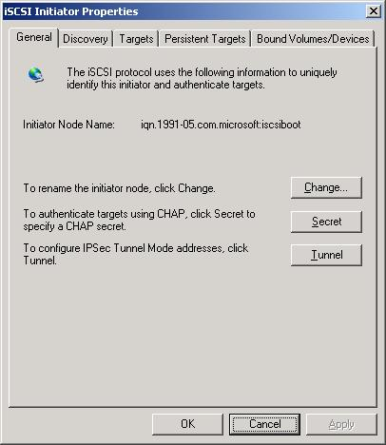
Select the “Discovery” tab.

Click “Add” under “Target Portals” and enter the IP address of the Host (Enginio) Server

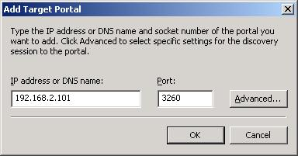

On the “Targets” tab, the target created earlier should now be listed
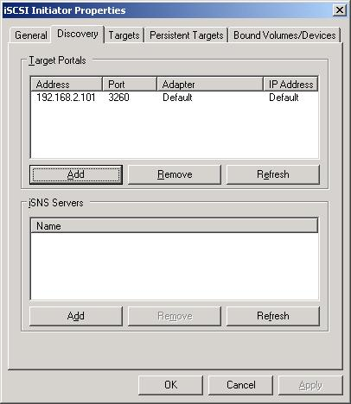

Highlight the target and select “Log On”.
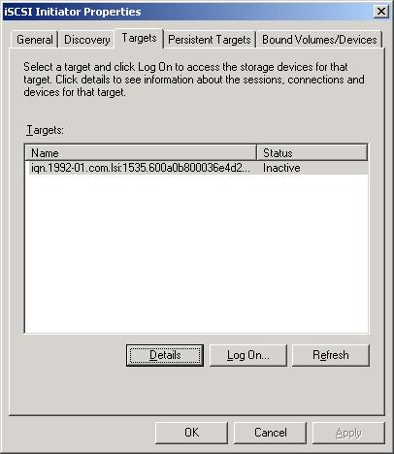

Select the checkbox to automatically restore the connection and click OK.
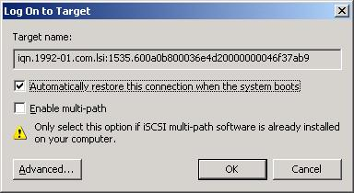
The status should change to “Connected”.
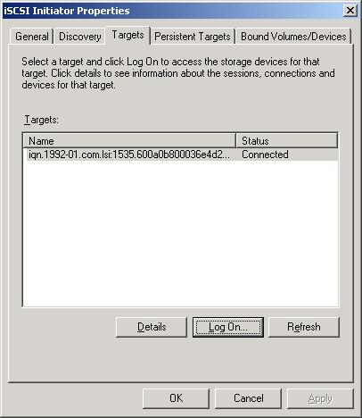
If the status changes to connected, the iSCSI target has been successfully accessed by the client.

Transfer the image from the client boot volume to the target (Step 11)
At this stage, the iSCSI host (which is a Windows Server machine) has access to the iSCSI target volume. The iSCSI target volume has no usable data yet. The task at hand is to transfer the Windows Server boot image to the iSCSI target volume that has just been created. To accomplish this, implement the following steps:
- Boot to WinPE with network access and map a drive to the temporary storage location.
- Use ImageX to create a .WIM file image of the OS drive. A sample command line would look like
  - Imagex /compress fast /capture c: z:\2k3image\2k3image.wim “iSCSI Boot Image – no Sysprep”
  - The path z:\2k3image represents the temporary storage location mapped in step “b”.
Note: If present, pagefile.sys may be deleted from the drive in order to save disk space and time creating and restoring the image.
- The image needs to be applied to the iSCSI target disk.
- Boot the system to the local disk.
- Note: If sysprep was used it may be easier to change the target assignment to another host temporarily in order to apply the image to the disk. Once the image is applied the settings can be reverted to the original system.
- Open disk management and identify the iSCSI target disk.
- If prompted, initialize, but do not convert the disk.
- Format the target disk and assign a drive letter.
- Map a drive to the image location.
- Use ximage to apply the image to the target disk.
- Sample command-line –
- Imagex /apply z:\2k3image\2k3image.wim f: 1

Configure client to boot from iSCSI target (Step 12)

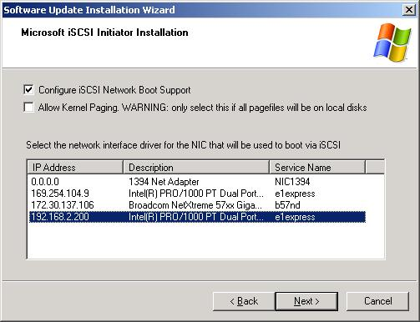
Rerun the Microsoft iSCSI Initiator installation
- Select the option to “Configure iSCSI Network boot support”
- Highlight the iSCSI target which has been configured for access by the client and which has the boot image
- Click Next

Troubleshooting
This section provides troubleshooting tips for the system/storage administrator.

Multifunction cards
Network Interface Cards implemented as LOMs (LAN on motherboard) or as add in cards which are qualified under the NIC category in the Designed for Windows Logo Program are supported with the iSCSI Software Initiator. These are standard NICs and do not require any iSCSI specific functionality. Please note that some multifunction adapters can be used as either layer 2 NICs or as iSCSI Host Bus Adapters. Layer 2 NICs rely on the Microsoft iSCSI Software Initiator to handle iSCSI protocol processing. iSCSI HBAs implement the iSCSI protocol directly in their hardware/firmware. If you are using a multifunction NIC as an iSCSI HBA (typically implanted as a storport or scsiport miniport) and you encounter interoperability issues connecting to industry standard iSCSI targets, it’s useful to try using the adapter as a layer 2 NIC instead with just the networking miniport (ndis miniport) supplied by the NIC vendor in conjunction with the Microsoft iSCSI Software Initiator. iSCSI Host Bus Adapters (HBAs) used with the Microsoft iSCSI initiator service must implement the required Microsoft iSCSI driver interfaces as outlined in the Microsoft iSCSI Driver Development Kit. The software initiator kernel mode driver supports version 1.0 of the iSCSI specification (RFC 3790) ratified by the Internet Engineering Task Force (IETF). An iSCSI target that also supports version 1.0 of the iSCSI specification is required.

Checked Builds
If needed for debugging purposes, links to the checked builds of Microsoft iSCSI Software Initiator 2.x are listed in the additional details section of the download page:
http://www.microsoft.com/downloads/details.aspx?familyid=12CB3C1A-15D6-4585-B385-BEFD1319F825&displaylang=en
You don’t need to use a checked build of Windows to use the checked build of the Microsoft iSCSI Software Initiator. Checked builds should not be run in production environments, but rather for debugging purposes only.

Terminal Services on Windows 2000
If you are connected to a Windows 2000 server via terminal services and login to an iSCSI target the disks exposed by the iSCSI session will not be shown in device manager until the terminal server session is logged out and logged back in. This is a known issue.

Eventlog
The MS iSCSI Initiator Service and the MS iSCSI Initiator kernel mode driver both log errors, warnings and informational messages to the system eventlog. If a problem occurs, consult the eventlog first.

Debug Logging

In some cases, detailed debug logging is needed in order to troubleshoot a problem. The checked build of the MS iSCSI initiator service can create a debug log file as well as send debug logging to the kernel debugger. You do not need to use a checked build of Windows to use a checked build of the Microsoft iSCSI Software Initiator. If a kernel debugger is not available, the service can be configured to append the debug logging to a file via a Registry value. Another Registry value can be used to adjust the level of debug output. The default value
is minimal debug output. To enable logging, first install a checked (debug) version of the MS iSCSI initiator package. Next change the following Registry values and then restart the computer.

HKLM\Software\Microsoft\Windows NT\Current Version\ISCSI\Discovery

Values
ServiceLogFileName
On checked builds, all debug spew will also be logged into
this file.

DebugSpewLevel
Bitmask that specifies the level of debug spew to the
debugger or log file.
#define SPEW_ALL 0xffffffff
#define SPEW_FATAL 0x00000001
#define SPEW_ERROR 0x00000002
#define SPEW_WARNING 0x00000004
#define SPEW_INFORMATION 0x00000008
#define SPEW_RECURRING 0x00000010

#define SPEW_DRIVER_PROBLEM 0x00010000
#define SPEW_WMI_API 0x00020000
#define SPEW_MEMORY 0x00040000
#define SPEW_TCP 0x00080000
#define SPEW_REFCOUNT 0x00100000
#define SPEW_PROCTHREADIDS 0x00200000
#define SPEW_TIMESTAMP 0x00400000

For most purposes a DebugSpewLevel of 0x006f0007 is appropriate for troubleshooting.

Installation
If you installed using a domain account then your computer either does not have connectivity to the domain controller or does not have access to the token-groups-global-and-universal (TGGAU) attribute. If you are using an HBA and want to enable advanced event logging support then run iSCSI setup using the local administrators account"
If you receive an error during installation you should consult the MS iSCSI initiator installer log file and the update log file. These log files are located in %windir% and are named iscsiins.log and iscsi200.log respectively. If there are errors installing the Microsoft iSCSI kernel mode driver or Microsoft MPIO then the file %windir%\setupapi.log may have useful information.
If you receive the message “Failed to install catalog files.” this typically means you have already installed the package. In order to reinstall the package go into the %windir%\system32\catroot\ {F750E6C3-38EE-11D1-85E5-00C04FC295EE} directory and delete the iscsi200.cat file. Note that this file may have the system attribute set on it.
If you receive the message “A driver is being upgraded with a version that is not compatible with the current version. Please check the system inf directory for the inf files that are incompatible with the driver being installed. See the iSCSI users guide for more information."”, then it is likely that you are attempting to install an older version of the MS iSCSI initiator kernel mode driver. Ensure that the version of the MS iSCSI Software Initiator that you are installing is newer than the version that was previously installed. If this is the case then there may be an error in the versioning of the iSCSI initiator files. To workaround this problem, look for all files matching the pattern oem*.inf the %windir%\inf directory. Examine each individual file to see if it is the INF file for the iSCSI software initiator kernel mode driver. If it is then delete that file and the corresponding .pnf file. For example, if oem1.inf is for the MS iSCSI Software Initiator then delete oem1.inf and oem1.pnf. Examine all oem*.inf files. When finished, restart the installation, choosing the repair option.
If you receive the message “An error occurred while setting security for the WMI interfaces. A required privilege is not held by the client”, then it is likely that the security descriptors assigned to the WMI interfaces for iSCSI are not valid or have SACLs assigned to them. A SACL is a data structure that is included in a security descriptor to indicate that auditing for the object should be done. WMI guids do not support auditing and will return this error in the case that a WMI guid is accessed when the security descriptor for the guid includes a SACL. To resolve this you should determine how the SACLs are assigned to security descriptors for the WMI guids and use that procedure to remove the SACL from the security descriptors for all of the WMI guids. Another way to resolve this is to obtain from a machine that does not have the SACLs assigned to the WMI guids and is running the same version of Windows as your target machine, the contents of the registry values listed below under the HKEY_LOCAL_MACHINE\System\Current Control Set\Control\WMI\Security key. You would then overwrite the registry values on your target machine with the registry values containing security descriptors without SACLs assigned. It is also possible to manually delete the following values from the registry key HKEY_LOCAL_MACHINE\System\Current Control Set\Control\WMI\Security. Note that if you do so then these guids will use the default security descriptor for WMI guids and this may allow unauthorized users access to the WMI guids.

7A2C6C2B-E5A5-49ad-AD68-133089ACD74D
C75258E9-BE79-4a48-A23D-EEB6F8FB940C
53EF8D5F-36F3-4124-8B76-C6AD521A1021
45755098-4291-43df-9720-B58642DD63DF
225B9D64-47A9-41c8-81CD-69BC02652D87
8EAEF9D8-C053-49d3-9205-65C703C2ECC1
556BC0B0-0FB5-40f2-9255-B7D9A669DAEC
B35694DE-D323-49d2-ABB2-8139209AD150
EA4D82BF-29DA-4e12-800A-E5437964462C
420512D9-0537-4c67-A779-84BA7B29CE9F
41646815-7524-4bc0-904A-CD7D510EAC02
391F3325-0BA3-4083-A861-CF4F6F97A527
46B122C0-3767-4069-916E-3A43702F05CE
7BB02370-B8AE-4d29-88DE-76951D3245BA
58515BF3-2F59-4f37-B74F-85AEEC652AD6
84CA6FD6-B152-4e6a-8869-FDE5E37B6157
D7931411-0376-4869-A491-8D679BFC004A
36B58EA2-C461-4bb0-AC8E-952F59D251ED
B4D1C606-8682-4b7a-AC6B-D883D91555FB
4AE27CD9-8DFA-4c37-A42C-B88A93E3E521
C827993C-6D1F-4194-9B5C-D7C0A5F1CFB7
F022F413-3BF5-47ec-A942-33B81CF8E7FF
FA30C290-68DB-430a-AF76-91A2E1C49154
5C59FD61-E919-4687-84E2-7200ABE2209B
1221948A-6332-4ac2-AA04-268AABCECE4F
E67E1BDB-D130-4143-9EB2-8BEE1899FD52

If the problem still exists after deleting these values check for the value 00000000-0000-0000-0000-000000000000. If it exists then delete it, however this will reset the security descriptor for all WMI guids that do not have an explicit security descriptor assigned.

If you receive the error, “iSCSI200 installation did not complete.
Windows has been partially updated and may not work properly.”
Try one of the following commands
- "mofcomp iscsihba.mof" (location of the file is in C:\WINDOWS\iSCSI\iscsihba.mof)
- OR "mofcomp iscsievt.mof"
After this, re-run the Microsoft iSCSI installation but deselect all checkbox options. You should get a message indicating that “the installation succeeded”.

Then, immediately attempt re-running the installer and check the first two options, (the Initiator Service and the Software Initiator).
You should get a message indicating that “the installation succeeded”. After this, you should be able to configure and run the iSCSI software initiator.

This error occurs very rarely, and is an issue with the generic Windows installer mechanism (update.exe).

Multipathing
This section lists multipathing errors that may be recorded in the Event Logs and discusses potential solutions for these error conditions:
- Note: When you view the MPIO Device Details, Source Portal shows 0.0.0.0 as the IP address. When viewing the details of the Targets on the connections page the Source Portal displays 0.0.0.0 as the Source IP.

- Error: “Too many Connections” when you attempt to add a second connection to an existing session.
This issue can occur if the Target does not support Multiple connections per session (MCS). Consult with the Target vendor to see if they plan on adding support for MCS.
- When you attempt to add a second connection to an existing session, you may notice that the Add button within the “Session Connections” window is greyed out.
This issue can occur if you logged onto the Target using an iSCSI HBA that doesn’t support MCS. Consult with the HBA vendor to see if they plan on releasing a driver that supports MCS. If you log onto the Target using the Software Initiator driver, this issue shouldn’t occur.
- A path (or connection) fails or a path (or connection) that previously had a status of active is now listed as standby.
This issue can occur for the following reasons:
  - Bad network cable or the network cable was disconnected from the HBA, NIC, Switch, or Target.
  - Issues with the ethernet switch or router.
  - Drivers (and Firmware) need to updated for the NIC or HBA.
  - The NIC or HBA card failed.
The following events may be logged if this issue occurs:
Event Type: Information
Event Source: Tcpip
Event Category: None
Event ID: 4202
Description:
The system detected that network adapter Intel 21140-Based PCI Fast Ethernet Adapter (Generic) was disconnected from the network, and the adapter's network configuration has been released. If the network adapter was not disconnected, this may indicate that it has malfunctioned. Please contact your vendor for updated drivers.

Event Type: Error
Event Source: iScsiPrt
Event Category: None
Event ID: 5
Description:
Failed to setup initiator portal. Error status is given in the dump data.
Data:
0000: 00 00 04 00 01 00 5e 00 ......^.
0008: 00 00 00 00 05 00 00 c0 .......À
05 00 00 c0 represents a status code C0000005 (STATUS_ACCESS_ VIOLATION)
0010: 00 00 00 00 00 00 00 00 ........
0018: 00 00 00 00 00 00 00 00 ........
0020: 00 00 00 00 00 00 00 00 ........
0028: 07 02 00 c0 ...À
07 02 00 c0 represents the status returned by TCP for the connect request. In this case, the status is c00000b5 (STATUS_INVALID_ADDRESS_COMPONENT).

If you are using an HBA, check to see if the HBA driver logged any events in the system log.
For an HBA to work properly with Microsoft MPIO, the bustype must be set to BusTypeiScsi in the inf in the HBA driver package. This will ensure that the bustype is set to BusTypeiScsi (0x09) in Parameters\BusType REG_DWORD under the services key, so that the Microsoft iSCSI DSM can claim the device.

Addressing Slow Performance with iSCSI clusters
Modifying TCPACK registry settings may address slow performance and failover issues with MSCS clusters using iSCSI. Specifically, this has been reported with EMC CLARiiON CX3-40c and CLARiiON CX3-20c in conjunction with PowerPath and may happen with other iSCSI arrays/multipathing solutions as well. Symptoms include unreliable Microsoft iSCSI cluster failover during period of network congestion and slow performance .

Slow performance may occur during network congestion when RFC 1122-delayed acknowledgements extend the error recovery process. In these situations, the default 200 millisecond delay on the acknowledgement can significantly impact read bandwidth. Use of multipathing solutions which load balancing read requests across multiple array ports, increases the likelihood that simultaneous read completions from multiple ports will result in network congestion. This increases the likelihood of experiencing the problem.
As specified in RFC 1122, Microsoft TCP uses delayed acknowledgments to reduce the number of packets that are sent on the media. Instead of sending an acknowledgment for each TCP segment received, TCP in Windows 2000 and later takes a common approach to implementing delayed acknowledgments. As data is received by TCP on a particular connection, it sends an acknowledgment back only if one of the following conditions is true:
- No acknowledgment was sent for the previous segment received.
- A segment is received, but no other segment arrives within 200 milliseconds for that connection.
Typically, an acknowledgment is sent for every other TCP segment that is received on a connection unless the delayed ACK timer (200 milliseconds) expires. You can adjust the delayed ACK timer by editing the registry as outlined in the workaround below.
Fix
Modify the TCP/IP settings for the network interfaces carrying iSCSI traffic to immediately acknowledge incoming TCP segments. This workaround solves the read performance issue. The procedure to modify the TCP/IP settings is different for Windows 2000 servers and Windows 2003 servers. Follow directions appropriate for the version you are running on your servers.
Customers should check with their array vendor to get the latest firmware in conjunction with the change to the host side configuration, specifically in the case for EMC CLARiiON, a firmware update is required
Note: These TCP/IP settings should not be modified for network interfaces not carrying iSCSI traffic as the increased acknowledgement traffic may negatively affect other applications.
Caution! This workaround contains information about modifying the registry. Before you modify the registry, make sure to back it up and make sure that you understand how to restore the registry if a problem occurs. For information about how to back up, restore, and edit the registry, click the following link to view the following article in the Microsoft Knowledge Base: http://support.microsoft.com/kb/256986/.
On a server that runs Windows 2000 SP3 or later, follow these steps:
- Start Registry Editor (Regedit.exe).
- Locate and then click the following registry subkey:
HKEY_LOCAL_MACHINE\SYSTEM\CurrentControlSet\Services\Tcpip\Parameters\Interfaces
the interfaces will be listed underneath by automatically generated GUIDs like {064A622F-850B-4C97-96B3-0F0E99162E56}
- Click each of the interface GUIDs and perform the following steps:
a. Check the IPAddress or DhcpIPAddress parameters to determine whether the interface is used for iSCSI traffic. If not, skip to the next interface.
b. On the Edit menu, point to New and then click DWORD value.
c. Name the new value TcpDelAckTicks and assign it a value of 0.
- Exit the Registry Editor.
- Restart Windows for this change to take effect.
On a server that runs Windows Server 2003 SP1 or later, follow these steps:
- Start Registry Editor (Regedit.exe).
- Locate and then click the following registry subkey:
HKEY_LOCAL_MACHINE\SYSTEM\CurrentControlSet\Services\Tcpip\Parameters\Interfaces
the interfaces will be listed underneath by automatically generated GUIDs like {064A622F-850B-4C97-96B3-0F0E99162E56}
- Click each of the interface GUIDs and perform the following steps:
a. Check the IPAddress or DhcpIPAddress parameters to determine whether the interface is used for iSCSI traffic. If not, skip to the next interface.
b. On the Edit menu, point to New, and then click DWORD value.
c. Name the new value TcpAckFrequency, and assign it a value of 1.
- Exit the Registry Editor.
- Restart Windows for this change to take effect.

Error Recovery

iSCSI uses 3 levels of error recovery as defined in the IETF iSCSI specification:
- ErrorRecoveryLevel=0 is recovery only by session restart
- ErrorRecoveryLevel=1 is recovery by reissuing commands, data, or status
- ErrorRecoveryLevel=2 is connection failure recoveryThe following information may be helpful if you are reviewing networking traces and see some form of error recovery.

The Microsoft iSCSI Software Initiator Package includes support for ERL 0, 1, and 2. In order to use ERL 1 or 2, the iSCSI target must also support them. The Microsoft iSCSI Software Initiator will negotiate the error recovery level with the iSCSI target, with 2 being the highest. If the target does not indicate support for an error recovery level supported by the initiator, they will negotiate down to use the lowest supported level, which would be 0, if the target supported neither levels 1 or 2.

ErrorRecoveryLevel 0
At ErrorRecoveryLevel 0, you will see logout PDUs when you would not expect them to be seen, such as before an exchange is complete. In extreme cases the initiator could just drop the session altogether. If the initiator drops a session it normally would not try to start a new session until the DefaultTime2Wait value expires. Dropped sessions and logout PDUs should contain a reason (status) code indicating why the session is being dropped.

ErrorRecoveryLevel 1
ErrorRecoveryLevel 1 implements features of ErrorRecoveryLevel 0 and adds the following:
- CRC error detection
- Header digest errors (may silently throw away the PDU)
- Initiator responding with selective negative acknowledgement (SNACK) PDU
- Data digest errors can be handled at the point of detection by:
- The initiator responding with a "selective negative acknowledgement" SNACK PDU.
- The target responding with a Reject PDU followed by a "ready to transmit" (R2T) PDU.
- Either the target or the initiator silently throwing the PDU away and handling it later as it had been a header digest error.
- If the target detects the data digest error it is required to issue a Reject PDU with a reason code of "Data (payload) Digest Error" and to discard the in-error PDU. Then it should either request that the data be resent via an R2T PDU or terminate the task with SCSI Response PDU with the reason "Protocol Service CRC Error" and perform the appropriate cleanup.
- Targets should not retransmit status or data except on a request made by the initiator via a status SNACK or a data SNACK.
- Targets can retransmit R2T's if they determine retransmission is necessary. These are called recovery R2Ts.
- The initiator uses CmdSN and ExpCmdSN to detect that the command is lost and then resend the command.
- The initiator uses StatSN and ExpStatSN to detect that status is lost and then request that status be resent via SNACK.
- The initiator uses DataSN and ExpStatSN to detect missing data and then request the data be resent via a SNACK.
- The initiator reflects the ExpStatSN back to the target to inform the target that the status up to that point was received along with all appropriate data.

ErrorRecoveryLevel 2
ErrorRecoveryLevel 2 iImplements ErrorRecoveryLevel 0 and 1 features and adds methods for recovering the connection and the session once a connection problem has been detected as follows:
- Once a session goes down, the initiator may attempt to login a new connection to recover the commands from the failed connection, or will use the existing connection to attempt to recover outstanding commands.
- The initiator may issue an implicit logout of the failed connection and a re-login of a new one. The initiator issue a login to the same portal group as the original connection, with the same initiator node name, the same ISID, and TSIH, and the same CID of the failed connection.
- Two of the values that can be set at login time are DefaultTime2Wait and DefaultTime2Retain. These key=value pairs, which each have a default of three seconds if not changed by negotiation at login, are used as follows:
- If the connection goes away unexpectedly the initiator has until the DefaultTime2Wait (in seconds) before it can attempt to reconnect. This gives the target a chance to notice that the link is gone, do whatever cleanup is needed, and prepare for a reconnection.
- After this period, the initiator has additional DefaultTime2Retain (in seconds) to reestablish connections (if desired) and the allegiance of tasks suspended by the loss of the original connection. If not accomplished by this time, the target may abort and clean up all tasks and state (except persistent reserves).

Portal Hopping
The Microsoft iSCSI Software Initiator implements a feature called Portal Hopping. This feature enables the initiator to attempt to recover an iSCSI session via different target portals when a TCP connection used by the iSCSI session get disrupted. The Microsoft Initiator will first attempt to recover the iSCSI session using the original target portal. If that is not successful, it will try other target portals advertised in the target's SendTargets response. If that is not successful, it will attempt to recover the iSCSI session via the original target portal again, and repeat the process again.
This feature can be enabled or disabled via the Advanced setting of the "Logon to the Target" page in the Microsoft iSCSI GUI. To enable this feature, choose "default" in "Target Portal" list. To disable this feature, specify a specific target portals instead. With Portal Hopping disabled, the Microsoft Initiator will only try to attempt to recover the iSCSI session via the target portal used in the original iSCSI login.
There may be a situation that disabling this feature may be desirable. For example, in a configuration that has multiple physical networks or multiple VLANs, it is possible that some of the target portals are not accessible to a given host. In this situation, SendTargets responses sent by the iSCSI target will advertise some addresses which may not be accessible by the host.
If the number of inaccessible target portals advertised in the SendTargets response is large, Portal Hopping may cause a long delay to recover the iSCSI session. After the initial attempt to connect to the original target portal fails, the Microsoft Initiator attempts to connect to other target portals which are not accessible. It may take a long time for the Microsoft Initiator to cycle through the list of inaccessible target portals before it makes another attempt to the original target portal.

Other Areas
If you encounter a situation where your computer takes a long time to display the login prompt after booting or takes a long time to login after entering your login credentials, then there may be an issue related to the Microsoft iSCSI initiator service starting. First see the “Running automatic start services on iSCSI disks” section for information about persistent volumes and the binding operation. Check the system eventlog to see if there is an event “Timeout waiting for iSCSI persistently bound volumes…”. If this is the case then one or more of the persistently bound volumes did not reappear after reboot which could be due to network or target error. To remove the list of persistently bound volumes use the command “iscsicli ClearPersistentDevices”.

Windows does not support disks that have been formatted to anything other than a 512byte block size. Block size refers to the low level formatting of the disk and not the cluster or allocation size used by NTFS. Be aware that using a disk with a block size larger than 512 bytes will cause applications not to function correctly. You should check with your iSCSI target manufacture to ensure that their default block size is set to 512 bytes or problems will likely occur.

The MS iSCSI initiator service will not allow a session to be logged out if there are any handles that are open to the device. In this case if the session is attempted to be logged out the error "The session cannot be logged out since a device on that session is currently being used." is reported. This means that there is an application or device which has an open handle to the physical disk on the target. If you look in the system eventlog you should see an event that has the name of the device with the open handle.
Also be sure to check that there are no applications that might be using files on that drive. There is a tool called handle.exe which is available on http://www.sysinternals.com that dumps the list of open handles and the processes that have opened the handle. If you look at the output of the tool you may be able to find the processes that have open handles to files and sections on the disk you are trying to logout. Please note that handle.exe is a 3rd party utility not specifically sanctioned or supported by Microsoft. Use this utility at your own risk.

Pagefiles should not be created on iSCSI disks exposed by the Microsoft iSCSI software initiator kernel mode driver due to timing issues in the startup sequence.

On machines that are slow to boot you may get an eventlog message “Initiator Service failed to respond in time to a request to encrypt or decrypt data” if you have persistent logins that are configured to use CHAP. Additionally the persistent login will fail to login. This is due to a timing issue in the service startup order. To workaround this issue increase the timeout value for the IPSecConfigTimeout value in the registry under:

HKLM\SYSTEM\CurrentControlSet\Control\Class\{4D36E97B-E325-11CE-BFC1-08002BE10318}\<Instance Number>\Parameters

Appendix A - Event Tracing in MS iSCSI Drivers

The following sections describe how to enable event tracing in MS iSCSI drivers. Event tracing can be very useful in diagnosing failures.

Creating the trguid.ctl file required for tracing
Before beginning tracing, you must first create a text file which contains the following information on the first line using notepad.exe:

Here, the trace GUID is given in the file by name trguid.ctl and is the filename used with the rest of the examples in this section. The GUID file should contain the following one line:

{1babefb4-59cb-49e5-9698-fd38ac830a91} 0x00000007 0

Start Trace

To start tracing, do the following from a CMD Prompt:
logman.exe create trace <Name> -ets -nb 16 256 -bs 64 -o <LogFile> -pf <GUID File>

logman.exe is present in %windir%\system32 directory. The above command starts a trace session. The name <Name> is assigned to that session. The trace level is controlled by the value of the flag in the GUID File. <Guid File> contains the trace GUID and trace flag. The trace messages are written to <Log File>.

For example, to start a trace session by name iScsiTrace with verbosity level iScsiDebugTrace, and log file iScsiTr.log, do the following:

logman.exe create trace iScsiTrace -ets -nb 16 256 -bs 64 -o iScsiTr.log -pf trguid.ctl

Stop Tracing

To stop tracing do the following from CMD prompt:

logman.exe stop <Name> -ets

For example, to stop the trace session with name iScsiTrace, do

logman stop iScsiTrace –ets

The log file is a binary file. If you are troubleshooting an iSCSI issue via Microsoft Product support services, please send the log file to them to assist in analyzing the failure.

Query Trace Status

To verify that tracing is running properly, do the following from a CMD prompt.
logman.exe query -ets

To return extended information about the tracing status, do the following from the CMD prompt:

logman query iscsitrace -ets

Appendix B - iSCSI Eventlog messages

Microsoft iSCSI Initiator Service
MessageID=63
SymbolicNAME=

MessageId=102
SymbolicName=ISCSIEXE_EVENTMSG_ERROR_FINDING_PERSISTENT_VOLUMES
Error %1 while searching for iSCSI persistently bound volumes.

MessageId=103
SymbolicName=ISCSIEXE_EVENTMSG_TIMEOUT_FINDING_PERSISTENT_VOLUMES
Timeout waiting for iSCSI persistently bound volumes. If there are any services or applications that use information stored on these volumes then they may not start or may report errors.

MessageId=104
SymbolicName=ISCSIEXE_EVENTMSG_ONLINE_DISK_FAILED
Error %1 trying to online dynamic disk %2.

MessageId=105
SymbolicName=ISCSIEXE_EVENTMSG_IPSEC_INITIALIZATION_FAILED
Error %1 trying to initialize access to Windows IPSEC services.

MessageId=106
SymbolicName=ISCSIEXE_EVENTMSG_SERVICE_INITIALIZATION_FAILED
Error %1 while initializing iSCSI initiator service at checkpoint %2.

MessageId=107
SymbolicName=ISCSIEXE_EVENTMSG_NO_INITIATOR_SECRET

Error %1 initializing initiator shared secret.
.

MessageId=108
SymbolicName=ISCSIEXE_EVENTMSG_DEVICE_NOT_ISCSI_INITIATOR

Status %1 determining that device interface %2 does not support iSCSI WMI interfaces. If this device is not an iSCSI HBA then this error can be ignored.

MessageId=109
SymbolicName=ISCSIEXE_EVENTMSG_INITIATOR_UPCALL_FORMAT_ERROR
The iSCSI Initiator passed an upcall, but it was not formatted properly.

MessageId=110
SymbolicName=ISCSIEXE_EVENTMSG_INITIATOR_IOCTL_ERROR
A request to the iSCSI initiator failed with error %1.

MessageId=111
SymbolicName=ISCSIEXE_EVENTMSG_STATIC_DISCOVERY_FAILED
iSCSI discovery of statically defined targets failed %1.

MessageId=112
SymbolicName=ISCSIEXE_EVENTMSG_ISNS_DISCOVERY_FAILED
iSCSI discovery via iSNS failed %1 to iSNS server %2.

MessageId=113
SymbolicName=ISCSIEXE_EVENTMSG_SENDTARGETS_DISCOVERY_FAILED
iSCSI discovery via SendTargets failed %1 to target portal %2.

MessageId=114
SymbolicName=ISCSIEXE_EVENTMSG_INVALID_SENDTARGETS_TEXT
iSCSI discovery via SendTargets failed %1 to target portal %2 due to an invalid SendTargets text response from the target.
.
MessageId=115
SymbolicName=ISCSIEXE_EVENTMSG_HBA_DISCOVERY_FAILED
iSCSI discovery via Host Bus Adapter failed %1 to Host Bus Adapter %2.

MessageId=116
SymbolicName=ISCSIEXE_EVENTMSG_DEVICE_NOT_REMOVED
Removal of device %1 on iSCSI session %2 was vetoed by %3.

MessageId=117
SymbolicName=ISCSIEXE_EVENTMSG_IPSEC_CONFIG_FAILURE
Configuration of IPSEC was required, but failed with error %1 for target address %2.

MessageId=118
SymbolicName=ISCSIEXE_EVENTMSG_TIMEBOMB
The evaluation period for the iSCSI initiator service has passed.

MessageId=119
SymbolicName=ISCSIEXE_EVENTMSG_ISNS_ADDRESS_ENUMERATION_FAILED
Error %1 when iSNS client tried to enumerate the local IP Addresses.

MessageId=120
SymbolicName=ISCSIEXE_EVENTMSG_SERVICE_NOT_ON_FIREWALL_AUTH_LIST
The iSCSI initiator service is not on the Windows Firewall List of Authorized Applications or its entry is not currently enabled. The iSCSI Initiator service may not be able to maintain its registration with an iSNS Server, or be notified of changes to the iSNS Server database.
.

MessageId=121
SymbolicName=ISCSIEXE_EVENTMSG_SERVICE_CANNOT_CHECK_FIREWALL_AUTH_LIST
Error %1 when the iSCSI Initiator service attempted to check whether it is on the Windows Firewall List of Authorized Applications.

Microsoft Software Initiator Kernel Mode Driver
The source for system events logged by Software Initiator will be iScsiPrt. The message in the log would convey the cause of that event. For instance, Event ID 1 will have the following message – Initiator failed to connect to the target. Target IP address and TCP Port number are given in dump data. This indicates that the initiator could not make a TCP connection to the given target portal. Some events will have more information in the dump data. In such cases the additional information will start at offset 0x28 in the dump data. For example, Event ID 1 has additional information in the dump data. The additional information in this case is Target IP Address and TCP Port number. The user can determine to which IP Address and TCP Port the initiator could not connect to from Event ID 1.

This section describes all the events that are logged by iScsiPrt. The first bullet gives the number corresponding to the event. The second bullet gives the message corresponding to the event. The sub-bullet under the second bullet contains additional information related to the event.

- Event ID 1
- Initiator failed to connect to the target. Target IP address and TCP Port number are given in dump data.
  - This event is logged when the initiator could not make a TCP connection to the given target portal. The dump data in this event will contain the Target IP address and TCP port to which initiator could not make a TCP connection.

- Event ID 2
- The initiator could not allocate resources for an iSCSI session.
  - This event is logged when the initiator could allocate resources such as memory for processing certain operation. This can typically happen in low memory conditions.

- Event ID 3
- Maximum command sequence number is not serially greater than expected command sequence number in login response.
  - This event is logged when the Maximum Command Sequence Number in the final login response PDU is not serially greater than the Expected Command Sequence Number. The dump data contains Expected Command Sequence number followed by Maximum Command Sequence number.

- Event ID 4
- MaxBurstLength is not serially greater than FirstBurstLength. Dump data contains FirstBurstLength followed by MaxBurstLength.
  - This event is logged when MaxBurstLength given by the target is not serially greater than FirstBurstLength. The dump data contains FirstBurstLength followed by MaxBurstLength.

- Event ID 5
- Failed to setup initiator portal. Error status is given in the dump data.
  - This event is logged when the initiator fails to create the network object for the initiator portal. This can typically happen if the network stack is not ready or has not assigned an IP address to the NIC that is being used when the initiator attempts to create the network object.

- Event ID 6
- The initiator could not allocate resources for an iSCSI connection
  - This event is logged when the initiator could not allocate resources such as memory, work item, etc for an iSCSI connection. This can typically happen in low memory conditions.

- Event ID 7
- The initiator could not send an iSCSI PDU. Error status is given in the dump data.
  - This event is logged when the initiator could not send an iSCSI PDU to the target. The dump data will contain the NT STATUS code returned by the network layer for the Send operation. User can refer to Windows documentation, such as MSDN, for getting more information about the NT STATUS code.

- Event ID 8
- Target or discovery service did not respond in time for an iSCSI request sent by the initiator. iSCSI Function code is given in the dump data. For details about iSCSI Function code please refer to iSCSI User's Guide.
  - This event is logged when an iSCSI operation times out.

- Event ID 9
- Target did not respond in time for a SCSI request. The CDB is given in the dump data
  - This event is logged when the target did not complete a SCSI command within the timeout period specified by SCSI layer. The dump data will contain the SCSI Opcode corresponding to the SCSI command. User can refer to SCSI specification for getting more information about the SCSI command.

- Event ID 10
- Login request failed. The login response packet is given in the dump data.
  - This event is logged when a login request times out. The entire login response PDU is given in the dump data.

- Event ID 11
- Target returned an invalid login response packet. The login response packet is given in the dump data.
  - This event is logged when the target sends an invalid login response PDU. The entire login response PDU is given in the dump data.

- Event ID 12
- Target provided invalid data for login redirect. Dump data contains the data returned by the target.
  - This event is logged when the data provided in login response PDU for login redirection is invalid. The dump data will contain the data given by the target in the login response PDU.

- Event ID 13
- Target offered an unknown AuthMethod. Dump data contains the data returned by the target.
  - This event is logged when the value given for AuthMethod key is invalid. The dump data will contain the value given by the target.

- Event ID 14
- Target offered an unknown digest algorithm for CHAP. Dump data contains the data returned by the target.
  - This event is logged when the algorithm specified for CHAP is unknown or invalid. The dump data will contain the value given by the target.

- Event ID 15
- CHAP challenge given by the target contains invalid characters. Dump data contains the challenge given
  - This event is logged when the CHAP challenge given by the target contains invalid characters. The dump data will contain the CHAP challenge given by the target.

- Event ID 16
- An invalid key was received during CHAP negotiation. The key=value pair is given in the dump data
  - This event is logged when the target sends an unknown or invalid key value pair in the login response PDU. The dump data will contain the key and value given by the target.

- Event ID 17
- CHAP Response given by the target did not match the expected one. Dump data contains the CHAP response.
  - This event is logged when the CHAP response given by the target does not match the value expected by the initiator. This can typically happen when the CHAP secret used is not correct or there is error in interpreting the CHAP values such as CHAP challenge, CHAP ID, etc.

- Event ID 18
- Header Digest is required by the initiator, but target did not offer it.
  - This event is logged when the initiator requires Header Digest for an iSCSI connection, but the target did not offer header digest in the login response.

- Event ID 19
- Data Digest is required by the initiator, but target did not offer it.
  - This event is logged when the initiator requires Data Digest for an iSCSI connection, but the target did not offer data digest in the login response.

- Event ID 20
- Connection to the target was lost. The initiator will attempt to retry the connection
  - This event is logged when the initiator loses connection to the target when the connection was in iSCSI Full Feature Phase. This event typically happens when there are network problems, network cable is removed, network switch is shutdown, or target resets the connection. In all cases initiator will attempt to reestablish the TCP connection.

- Event ID 21
- Data Segment Length given in the header exceeds MaxRecvDataSegmentLength declared by the target.
  - This event is logged when the size of the immediate data in an iSCSI PDU exceeds the value declared by the target in MaxRecvDataSegmentLength key during login phase.

- Event ID 22
- Header digest error was detected for the given PDU. Dump data contains the header and digest.
  - This event is logged when header digest is detected in an iSCSI PDU. The dump data will contain the entire iSCSI PDU and the digest given for that.

- Event ID 23
- Target sent an invalid iSCSI PDU. Dump data contains the entire iSCSI header.
  - This event is logged when an iSCSI PDU with invalid fields is received by the initiator. The dump data will contain the entire iSCSI PDU.

- Event ID 24
- Target sent an iSCSI PDU with an invalid opcode. Dump data contains the entire iSCSI header
  - This event is logged when the target sends an iSCSI PDU with invalid iSCSI Opcode. The dump data will contain the entire iSCSI PDU.

- Event ID 25
- Data digest error was detected. Dump data contains the calculated checksum followed by the given checksum.
  - This event is logged when the initiator detects data digest error in the iSCSI PDU. The dump data will contain the checksum computed by the initiator followed by the checksum given by the target in the PDU.

- Event ID 26
- Target trying to send more data than requested by the initiator.
  - This event is logged when the size of the data in an iSCSI PDU or a sequence of PDUs is greater than the maximum size expected by the initiator. For instance, if the Expected Transfer Length in a SCSI READ command is 4K and the target sends more than 4K in the response.

- Event ID 27
- Initiator could not find a match for the initiator task tag in the received PDU. Dump data contains the entire iSCSI header.
  - This event is logged when the initiator could not find a match for the initiator task tag that is given in an iSCSI PDU. This could typically happen when the initiator has timed out waiting for a response from the target for a command and cleared the entry for that command. The target sends a response after this cleanup has occurred. It could also happen if the target gave an unknown initiator task tag in an iSCSI PDU. The dump data will contain the entire PDU.

- Event ID 28
- Initiator received an invalid R2T packet. Dump data contains the entire iSCSI header.
  - This event is logged when one or more fields in an R2T packet is invalid. The dump data will contain the entire PDU.

- Event ID 29
- Target rejected an iSCSI PDU sent by the initiator. Dump data contains the rejected PDU.
  - This event is logged when the target rejects an iSCSI PDU sent by the initiator. The dump data will contain the rejected PDU.

- Event ID 30
- Initiator could not allocate a workitem for processing a request.
  - This event is logged when the initiator could not allocate a work item. This can typically happen in low memory conditions.

- Event ID 31
- Initiator could not allocate resource for processing a request.
  - This event is logged when the initiator could not allocate resources such as memory for processing a request. This can typically happen in low memory conditions.

- Event ID 32
- Initiator received an asynchronous logout message. The Target name is given in the dump data.
  - This event is logged by the initiator when the target sends an asynchronous logout message. The name of the target will be given in the dump data.

- Event ID 33
- Challenge size given by the target exceeds the maximum specified in iSCSI specification.
  - This event is logged when the size of the CHAP challenge given by the target exceeds the maximum size specified in the iSCSI specification.

- Event ID 34
- A connection to the target was lost, but Initiator successfully reconnected to the target. Dump data contains the target name.
  - This event is logged when the initiator successfully reestablishes a TCP connection to the target.

- Event ID 35
- Target CHAP secret is smaller than the minimum size (12 bytes) required by the spec. Dump data contains the given CHAP secret.
  - This event is logged when the CHAP secret for the target is smaller than the minimum size specified in the iSCSI specification. Dump data will contain the given CHAP secret.

- Event ID 36
- Initiator CHAP secret is smaller than the minimum size (12 bytes) required by the spec. Dump data contains the given CHAP secret.
  - This event is logged when the CHAP secret for the initiator is smaller than the minimum size specified in the iSCSI specification. Dump data will contain the given CHAP secret.

- Event ID 37
- FIPS service could not be initialized. Persistent logons will not be processed.
  - This event is logged when FIPS service could not be initialized. FIPS service is required for generating CHAP challenge. If the service is not available login using CHAP cannot be performed.

- Event ID 38
- Initiator requires CHAP for logon authentication, but target did not offer CHAP.
  - This event is logged when initiator requires CHAP for logon authentication, but the target did not offer CHAP in the login response.

- Event ID 39
- Initiator sent a task management command to reset the target. The target name is given in the dump data
  - This event is logged when the initiator sends a Task Management command to reset the target. This typically happens when the target did not respond to a SCSI command within the timeout period specified by the SCSI layer. The name of the target will be given in the dump data.

- Event ID 40
- Target requires logon authentication via CHAP, but Initiator is not configured to perform CHAP.
  - This event is logged when target requires CHAP for logon authentication, but the initiator is not configured to perform CHAP.

- Event ID 41
- Target did not send AuthMethod key during security negotiation phase.
  - This event is logged when the target did not send AuthMethod key in login response during security negotiation phase.

- Event ID 42
- Target sent an invalid status sequence number for a connection. Dump data contains Expected Status Sequence number followed by the given status sequence number.
  - This event is logged when the status sequence number given in an iSCSI PDU is incorrect. The dump data will contain the expected status sequence number followed by the status sequence number given in the iSCSI PDU.

- Event ID 43
- Target failed to respond in time for a login request
  - This event is logged when the target fails to respond to a login request.

- Event ID 44
- Target failed to respond in time for a logout request.
  - This event is logged when the target fails to respond to a logout request

- Event ID 45
- Target failed to respond in time for a login request. This login request was for adding a new connection to a session.
  - This event is logged when a login request for adding a connection to a session timed out.

- Event ID 46
- Target failed to respond in time for a SendTargets command.
  - This event is logged when the target fails to respond to a SendTargets command.

- Event ID 47
- Target failed to respond in time for a SCSI command sent through a WMI request
  - This event is logged when a SCSI command sent using iscsicli.exe times out.

- Event ID 48
- Target failed to respond in time to a NOP request.
  - This event is logged when the target fails to respond to a NOP request.

- Event ID 49
- Target failed to respond in time to a Task Management request.
  - This event is logged when the target fails to respond to a Task Management Command

- Event ID 50
- Target failed to respond in time to a Text Command sent to renegotiate iSCSI parameters.
  - This event is logged when the target fails to respond to a Text Command.

- Event ID 51
- Target failed to respond in time to a logout request sent in response to an asynchronous message from the target.
  - This event is logged when the target fails to respond to logout request sent in response to an asynchronous message from the target.

- Event ID 52
- Initiator Service failed to respond in time to a request to configure IPSec resources for an iSCSI connection.
  - This event is logged when iSCSI service fails to respond to a request to configure IPSec for an iSCSI connection.

- Event ID 53
- Initiator Service failed to respond in time to a request to release IPSec resources allocated for an iSCSI connection.
  - This event is logged when iSCSI service fails to respond to a request to release IPSec for an iSCSI connection.

- Event ID 54
- Initiator Service failed to respond in time to a request to encrypt or decrypt data
  - This event is logged when iSCSI service fails to respond to a request to encrypt or decrypt a buffer.

- Event ID 55
- Initiator failed to allocate resources to send data to target.
  - This event is logged when the initiator fails to allocate resources such as memory to send data to target. This can typically happen in low memory conditions.

- Event ID 56
- Initiator could not map an user virtual address to kernel virtual address resulting in I/O failure
  - This event is logged when the initiator could not map a buffer to system address space. This can typically happen in low memory conditions.

- Event ID 57
- Initiator could not allocate required resources for processing a request resulting in I/O failure.
  - This event is logged when the initiator fails to allocate resources such as memory for processing a request. This can typically happen in low memory conditions.

- Event ID 58
- Initiator could not allocate a tag for processing a request resulting in I/O failure.
  - This event is logged when the initiator fails to allocate a tag for processing a request. This can typically happen in low memory conditions.

- Event ID 59
- Target dropped the connection before the initiator could transition to Full Feature Phase.
  - This event is logged when the target drops the TCP connection during login phase.

- Event ID 60
- Target sent data in SCSI Response PDU instead of Data_IN PDU. Only Sense Data can be sent in SCSI Response.
  - This event is logged when the target sends data other than sense data in a SCSI Response PDU.

- Event ID 61
- Target set DataPduInOrder to NO when initiator requested YES. Login will be failed.
  - This event is logged when the value for DataPduInOrder is set to NO when the initiator expected YES.

- Event ID 62
- Target set DataSequenceInOrder to NO when initiator requested YES. Login will be failed.
  - This event is logged when the value for DataSequenceInOrder is set to NO when the initiator expected YES.
- Event ID 63
- Initiator will attempt session recovery
  - Initiator performs session recovery because Target or LUN reset operation is not successful.
- Event ID 64
- Initiator attempts bootstrap Windows using iSCSI NIC BOOT (iBF)
  - This message is informational, and does not indicate an error condition.

Appendix C – iSCSICLI command reference
iSCSICLI is a command line tool that makes available all functionality that is exposed by the iSCSI initiator service. It can be used manually or in command line scripts. To get basic information on iscsicli commands enter the command iscsicli /?. A number of commands have many possible parameters; however, in most cases a * can be used for a parameter to indicate that the default value for that parameter should be used. Hexadecimal numbers specified must be preceded by 0x, which is the ‘C’ programming language notation to indicate that the number is in hexadecimal. iSCSICLI commands are not case sensitive.

There are several sets of commands:

Manually Configured Targets
These commands handle the management of the manually configured targets. A target can be manually configured for one of two reasons. If a target cannot be discovered by any dynamic discovery mechanism then it may be statically configured. Also, a target may be statically defined such that default values for those properties that cannot be discovered dynamically can be persisted. A static target may be configured as hidden in which case it is not reported unless it is also discovered by another discovery mechanism.

AddTarget <TargetName> <TargetAlias> <TargetPortalAddress>
<TargetPortalSocket> <Target flags>
<Persist> <Login Flags> <Header Digest> <Data Digest>
<Max Connections> <DefaultTime2Wait>
<DefaultTime2Retain> <Username> <Password> <AuthType>
<Mapping Count> <Target Lun> <OS Bus> <Os Target>
<OS Lun> ...

This command will manually configure a target and optionally persist that target.

TargetName is the name of the target.

TargetAlias is the alias for the target. By specifying a value of *, the target would have no alias defined.

TargetPortalAddress is the IP or DNS address of the target portal.

TargetPortalSocket is the TCP port number of the target portal. Typically this is 3260, which is the well-known port number defined for use by iSCSI.

Target Flags specify flags that modify how the target is managed by the iSCSI initiator service. See below for definitions of target flags.

Persist indicates whether the target should be persisted and available after the service is restarted. By specifying T or t, the target is persisted; otherwise the target is not persisted.

Login Flags is a set of flags that affect behavior of iSCSI login to the target portal. See below for the definitions of the login flags.

Header Digest is non-zero to indicate that the initiator should enable header digest when logging into the target portal. By specifying * for this parameter, the digest is setting is determined by the initiator kernel mode driver.

Data Digest is non-zero to indicate that the initiator should enable data digest when logging into the target portal. By specifying * for this parameter, the digest is setting is determined by the initiator kernel mode driver..

Maximum Connections specifies the maximum number of connections for the discovery session to use when performing the SendTargets operation. By specifying * for this parameter, the kernel mode initiator driver chooses the value for maximum connections.

DefaultTime2Wait is the value that the initiator should use to negotiate when logging into the target. By specifying * for this parameter, the kernel mode initiator driver chooses a value.

DefaultTime2Retain is the value that the initiator should use to negotiate when logging into the target. By specifying * for this parameter, the kernel mode initiator driver chooses a value.

Username is the string that should be used as the CHAP username when logging into the target. By specifying * for this parameter, the iSCSI initiator service will use the initiator node name as the CHAP username.

Password is the string that should be used as the target’s CHAP secret when logging into the target. The initiator will use this secret to compute a hash value based on the challenge sent by the target.

AuthType is the type of authentication to use when logging into the target. See below for definitions of the authentication types.

MappingCount specifies the count of target mappings that the initiator should use to login to the target. Following the mapping count are that number of sets of target LUN, OS Bus, OS target and OS LUN values which comprise the actual mappings.

<Target Lun> is the LUN value the target uses to expose the LUN.
It must be in the form 0x0123456789abcdef
<OS Bus> is the bus number the OS should use to surface the LUN
<OS Target> is the target number the OS should use to surface the LUN
<OS LUN> is the LUN number the OS should use to surface the LUN

QAddTarget <TargetName> <TargetPortalAddress>

This command will manually configure a target and optionally persist that target.

TargetName is the name of the target.

TargetPortalAddress is the IP or DNS address of the target portal.

TargetPortalSocket is the TCP port number of the target portal. Typically this is 3260, which is the well-known port number defined for use by iSCSI.

RemoveTarget <TargetName>

This command will remove a target from the list of persisted targets.

TargetName is the name of the target.

Boot Configuration Known Issues (Windows Server 2003 Boot Initiator)
The Microsoft iSCSI Software Initiator boot version GUI does not allow you to view which adapter is set to boot. In order to determine which adapter the system is set to boot with, you can use the following command:
From a command prompt type “iscsibcg /showibf” to find the MAC address of the boot adapter
Then run the command “ipconfig /all”
Compare the MAC address of the adapter to those listed with ipconfig /all

MPIO Failover in an iSCSI boot configuration using the Microsoft iSCSI Software Initiator

In Fail Over Only, no load balancing is performed. The primary path functions as the active path and all other paths are standby paths. The active path is used for sending all I/O. If the active path fails, one of the standby paths becomes the active path. When the formerly active path is reconnected, it becomes a standby path and a "failback" does not occur. This behavior is due to Media Sensing is disabled by default in the boot version of the Microsoft iSCSI Software Initiator and is by design. However, the registry key can be changed to enable fail back. For more information, please see

For more information:
239924 How to disable the Media Sensing feature for TCP/IP in Windows
http://support.microsoft.com/default.aspx?scid=kb;EN-US;239924

Target Portals
These commands handle the management of target portals used for discovery by the iSCSI initiator service.

AddTargetPortal <TargetPortalAddress> <TargetPortalSocket>
<Initiator Instance Name> <Initiator Port Number>
<Security Flags>
<Login Flags> <Header Digest> <Data Digest>
<Maximum Connections> <DefaultTime2Wait>
<DefaultTime2Retain> <Username> <Password> <AuthType>

This command will add a target portal to the list of persisted target portals. The iSCSI initiator service will perform a SendTargets operation to each target portal in the list whenever the service starts and whenever a full refresh of the target list is requested.

TargetPortalAddress is the IP or DNS address of the target portal.

TargetPortalSocket is the TCP port number of the target portal. Typically this is 3260, which is the well-known port number defined for use by iSCSI.

Initiator Instance Name is the name of the initiator via which the SendTargets operation is performed. If not specified then the initiator used is selected by the iSCSI initiator service.

Initiator Port Number is the physical port number on the initiator via which the SendTargets operation is performed. If not specified then the kernel mode initiator driver chooses the initiator port used.

Security Flags is a set of flags that describe the type of IPSEC to use when establishing a TCP connection to the target portal. See below for the definitions of the security flags.

Login Flags is a set of flags that affect behavior of iSCSI login to the target portal. See below for the definitions of the login flags.

Header Digest is non-zero to indicate that the initiator should enable header digest when logging into the target portal. By specifying * for this parameter, the digest is setting is determined by the initiator kernel mode driver.

Data Digest is non-zero to indicate that the initiator should enable data digest when logging into the target portal. By specifying * for this parameter, the digest is setting is determined by the initiator kernel mode driver.

Maximum Connections specifies the maximum number of connections for the discovery session to use when performing the SendTargets operation. By specifying * for this parameter, the kernel mode initiator driver chooses the value for maximum connections.

DefaultTime2Wait is the value that the initiator should use to negotiate when logging into the target. By specifying * for this parameter, the kernel mode initiator driver chooses a value.

DefaultTime2Retain is the value that the initiator should use to negotiate when logging into the target. By specifying * for this parameter, the kernel mode initiator driver chooses a value.

Username is the string that should be used as the CHAP username when logging into the target. By specifying * for this parameter, the iSCSI initiator service will use the initiator node name as the CHAP username.

Password is the string that should be used as the target’s CHAP secret when logging into the target. The initiator will use this secret to compute a hash value based on the challenge sent by the target.

AuthType is the type of authentication to use when logging into the target. See below for definitions of the authentication types.

QAddTargetPortal <TargetPortalAddress>
[CHAP Username] [CHAP Password]

This command will add a target portal to the list of persisted target portals. The iSCSI initiator service will perform a SendTargets operation to each target portal in the list whenever the service starts and whenever a full refresh of the target list is requested. If [CHAP Username] and [CHAP Password] are specified then one way CHAP is required.

TargetPortalAddress is the IP or DNS address of the target portal.

TargetPortalSocket is the TCP port number of the target portal. Typically this is 3260, which is the well-known port number defined for use by iSCSI.

CHAP Username is the string that should be used as the CHAP username when logging into the target. By specifying * for this parameter, the iSCSI initiator service will use the initiator node name as the CHAP username.

CHAP Password is the string that should be used as the target’s CHAP secret when logging into the target. The initiator will use this secret to compute a hash value based on the challenge sent by the target.

RemoveTargetPortal <TargetPortalAddress> <TargetPortalSocket>
<Initiator Name> <Initiator Port Number>

This command will remove a target portal from the list of persisted target portals. The iSCSI initiator service will perform a SendTargets operation to each target portal in the list whenever the service starts and whenever a full refresh of the target list is requested. Note that the command does not purge the targets discovered via this target portal from the list of targets maintained by the service.

TargetPortalAddress is the IP or DNS address of the target portal

TargetPortalSocket is the TCP port number of the target portal. Typically this is 3260, which is the well-known port number defined for use by iSCSI.

Initiator Name is the name of the initiator via which the SendTargets operation is performed. If not specified then the initiator used is selected by the iSCSI initiator service.

Initiator Port Number is the physical port number on the initiator via which the SendTargets operation is performed. If not specified then the kernel mode initiator driver chooses the initiator port used.

RefreshTargetPortal <TargetPortalAddress> <TargetPortalSocket>
<Initiator Name> <Initiator Port Number>

This command will perform a SendTargets operation to the target portal and include the discovered targets into the list of targets maintained by the service. It does not add the target portal to the persistent list.

TargetPortalAddress is the IP or DNS address of the target portal

TargetPortalSocket is the TCP port number of the target portal. Typically this is 3260, which is the well-known port number defined for use by iSCSI.

Initiator Name is the name of the initiator via which the SendTargets operation is performed. If not specified then the initiator used is selected by the iSCSI initiator service.

Initiator Port Number is the physical port number on the initiator via which the SendTargets operation is performed. If not specified then the kernel mode initiator driver chooses the initiator port used.

ListTargetPortals

This command will display the list of persisted target portals that the iSCSI initiator service will use for discovery.

iSNS
These commands configure the list of iSNS servers used for discovery purposes by the iSCSI initiator service.

AddiSNSServer <iSNS Server Address>

This command will add the IP address or DNS name of an iSNS server to the list of iSNS servers that the iSCSI initiator service queries to discover targets. The service will then register itself with the iSNS server, also register for SCN (State Change Notification), and query the iSNS server for the list of available targets. The iSNS server address or name is persisted by the service and it will refresh the list of targets from that iSNS server whenever the service starts up and whenever a full refresh of the target list is requested.

RemoveiSNSServer <iSNS Server Address>

This command will remove the IP address or DNS name of the iSNS server from the persisted list of iSNS servers that the iSCSI initiator service maintains for discovery purposes. Note that the command does not purge the targets discovered via this iSNS server from the list of targets maintained by the service.

RefreshiSNSServer <iSNS Server Address>

This command will refresh the list of targets discovered from the specified iSNS server. The iSNS server IP address or DNS name is not persisted and the iSCSI initiator service does not verify whether the iSNS server address or name had previously been persisted or not.

ListiSNSServers

This routine will display the list of iSNS server addresses that are persisted by the iSCSI Initiator service.

Target Operations

TargetInfo <TargetName> [Discovery Mechanism]
This command will return information about the target specified by TargetName. The iSCSI initiator service maintains a separate set of information about every target organized by each mechanism by which it was discovered. This means that each instance of a target can have different information such as target portal groups. Discovery Mechanism is an optional parameter and if not specified then only the list of discovery mechanisms for the target are displayed. If Discovery Mechanism is specified then information about the target instance discovered by that mechanism is displayed.
LoginTarget <TargetName> <ReportToPNP>
<TargetPortalAddress> <TargetPortalSocket>
<Initiator Instance Name> <Port number> <Security Flags>
<Login Flags> <Header Digest> <Data Digest>
<Max Connections> <DefaultTime2Wait>
<DefaultTime2Retain> <Username> <Password> <AuthType> <Key>
<Mapping Count> <Target Lun> <OS Bus> <Os Target>
<OS Lun> ...

This command will login to a target

TargetName is the name of the target.

ReportToPNP is a flag that indicates to the initiator whether or not it should expose the LUN to the port driver so that it can be exposed to the operating system as a storage device. This in turn would enable the volume to be mounted, formatted, and a drive letter assigned, etc. If the value is T or t then the LUN is exposed as a device. If anything else then the LUN is not exposed and the only operations that can be performed to the target are SCSI Inquiry, SCSI Report LUNS and SCSI Read Capacity, and only via the iSCSI discovery service, since the operating system is not aware of the existence of the device.

TargetPortalAddress is the IP or DNS address of the target portal

TargetPortalSocket is the TCP port number of the target portal. Typically this is 3260, which is the well-known port number defined for use by iSCSI.

Initiator Instance Name is the name of the initiator via which the login operation is performed. If not specified then the initiator used is selected by the iSCSI initiator service.

Initiator Port Number is the physical port number on the initiator via which the login operation is performed. If not specified then the kernel mode initiator driver chooses the initiator port used.

Security Flags is a set of flags that describe the type of IPSEC to use when establishing a TCP connection to the target portal. See below for the definitions of the security flags.

Login Flags is a set of flags that affect behavior of iSCSI login to the target. See below for the definitions of the login flags.

Header Digest is non-zero to indicate that the initiator should enable header digest when logging into the target portal. By specifying * for this parameter, the digest setting is determined by the initiator kernel mode driver.

Data Digest is non-zero to indicate that the initiator should enable data digest when logging into the target portal. By specifying * for this parameter, the digest setting is determined by the initiator kernel mode driver.

MaximumConnections specifies the maximum number of connections for the discovery session to use when performing the SendTargets operation. By specifying * for this parameter, the kernel mode initiator driver chooses the value for maximum connections.

DefaultTime2Wait is the value that the initiator should use to negotiate when logging into the target. By specifying * for this parameter, the kernel mode initiator driver chooses a value.

DefaultTime2Retain is the value that the initiator should use to negotiate when logging into the target. By specifying * for this parameter, the kernel mode initiator driver chooses a value.

Username is the string that should be used as the CHAP username when logging into the target. By specifying * for this parameter, the iSCSI initiator service will use the initiator node name as the CHAP username.

Password is the string that should be used as the target’s CHAP secret when logging into the target. The initiator will use this secret to compute a hash value based on the challenge sent by the target.

AuthType is the type of authentication to use when logging into the target. See below for definitions of the authentication types.

Key is the IPSEC preshared key to used to establish the TCP connection if IPSEC is needed.

MappingCount specifies the count of target mappings that the initiator should use when logging into the target. Following the mapping count are that number of sets of target LUN, OS Bus, OS target and OS LUN values which comprise the actual mappings. See below for more information on the MappingCount parameters

<Target Lun> is the LUN value the target uses to expose the LUN.
It must be in the form 0x0123456789abcdef
<OS Bus> is the bus number the OS should use to surface the LUN
<OS Target> is the target number the OS should use to surface the LUN
<OS LUN> is the LUN number the OS should use to surface the LUN

QLoginTarget <TargetName> [CHAP Username] [CHAP Password]

This command will login to a target using default values for most parameters. If only <TargetName> is specified then no CHAP authentication is attempted. If both [CHAP Username] and [CHAP Password] are specified then one way CHAP is required for authentication.

TargetName is the name of the target.

CHAP Username is the string that should be used as the CHAP username when logging into the target. By specifying * for this parameter, the iSCSI initiator service will use the initiator node name as the CHAP username.

CHAP Password is the string that should be used as the target’s CHAP secret when logging into the target. The initiator will use this secret to compute a hash value based on the challenge sent by the target.

LogoutTarget <SessionId>

This command will attempt to logout of a target which was logged in via the session specified by SessionId. The iSCSI initiator service will not logout of a session if any devices exposed by it are currently in use. If the command fails then consult the system eventlog for additional information about the component that is using the device.

PersistentLoginTarget <TargetName> <ReportToPNP>
<TargetPortalAddress> <TargetPortalSocket>
<Initiator Instance Name> <Port number> <Security Flags>
<Login Flags> <Header Digest> <Data Digest>
<Max Connections> <DefaultTime2Wait>
<DefaultTime2Retain> <Username> <Password> <AuthType> <Key>
<Mapping Count> <Target Lun> <OS Bus> <Os Target>
<OS Lun> ...

This command will establish a persistent login to a target. A persistent login is the set of information required by an initiator to login to the target each time the initiator device is started, typically at system startup. . This command does not initiate a login to this target until after the system is rebooted. Use the LoginTarget command if this target is needed before rebooting.

TargetName is the name of the target.

ReportToPNP is a flag that indicates to the initiator whether or not it should expose the LUN to the port driver so that it can be exposed to the operating system as a storage device. This in turn would enable the volume to be mounted, formatted, and a drive letter assigned, etc. If the value is T or t then the LUN is exposed as a device. If anything else then the LUN is not exposed and the only operations that can be performed to the target are SCSI Inquiry, SCSI Report LUNS and SCSI Read Capacity, and only via the iSCSI discovery service, since the operating system is not aware of the existence of the device.

TargetPortalAddress is the IP or DNS address of the target portal

TargetPortalSocket is the TCP port number of the target portal. Typically this is 3260, which is the well-known port number defined for use by iSCSI.

Initiator Instance Name is the name of the initiator via which the login operation is performed. If not specified then the initiator used is selected by the iSCSI initiator service.

Initiator Port Number is the physical port number on the initiator via which the login operation is performed. If not specified then the kernel mode initiator driver chooses the initiator port used.

Security Flags is a set of flags that describe the type of IPSEC to use when establishing a TCP connection to the target portal. See below for the definitions of the security flags.

Login Flags is a set of flags that affect behavior of iSCSI login to the target. See below for the definitions of the login flags.

Header Digest is non-zero to indicate that the initiator should enable header digest when logging into the target portal. By specifying * for this parameter, the digest setting is determined by the initiator kernel mode driver.

Data Digest is non-zero to indicate that the initiator should enable data digest when logging into the target portal. By specifying * for this parameter, the digest setting is determined by the initiator kernel mode driver.

MaximumConnections specifies the maximum number of connections for the discovery session to use when performing the SendTargets operation. By specifying * for this parameter, the kernel mode initiator driver chooses the value for maximum connections.

DefaultTime2Wait is the value that the initiator should use to negotiate when logging into the target. By specifying * for this parameter, the kernel mode initiator driver chooses its own value.

DefaultTime2Retain is the value that the initiator should use to negotiate when logging into the target. By specifying * for this parameter, the kernel mode initiator driver chooses its own value.

Username is the string that should be used as the CHAP username when logging into the target. By specifying * for this parameter, the iSCSI initiator service will use the initiator node name as the CHAP username.

Password is the string that should be used as the target’s CHAP secret when logging into the target. The initiator will use this secret to compute a hash value based on the challenge sent by the target.

AuthType is the type of authentication to use when logging into the target. See below for definitions of the authentication types.

Key is the IPSEC preshared key to used to establish the TCP connection if IPSEC is needed.

MappingCount specifies the count of target mappings that the initiator should use when logging into the target. Following the mapping count are that number of sets of target LUN, OS Bus, OS target and OS LUN values which comprise the actual mappings. See below for more information on the MappingCount parameters

<Target Lun> is the LUN value the target uses to expose the LUN.
It must be in the form 0x0123456789abcdef
<OS Bus> is the bus number the OS should use to surface the LUN
<OS Target> is the target number the OS should use to surface the LUN
<OS LUN> is the LUN number the OS should use to surface the LUN

ListPersistentTargets
This command will display the list of persistent targets configured for all initiators.

RemovePersistentTarget <Initiator Name> <TargetName>
<Initiator Port Number>
<Target Portal Address>
<Target Portal Socket>

This command will remove a target from the list of persistent targets.

Initiator Name is the name of the initiator that is configured to persistently login to the target.

TargetName is the name of the target.

Initiator Port Number is the physical port number on the initiator via which the SendTargets operation is performed. If not specified then the kernel mode initiator driver chooses the initiator port used.

TargetPortalAddress is the IP or DNS address of the target portal

TargetPortalSocket is the TCP port number of the target portal. Typically this is 3260, which is the well-known port number defined for use by iSCSI.

AddConnection <SessionId> <Initiator Instance Name>
<Initiator Port Number> <Target Portal Address>
<Target Portal Socket> <Security Flags>
<Login Flags> <Header Digest> <Data Digest>
<Max Connections> <DefaultTime2Wait>
<DefaultTime2Retain> <Username> <Password> <AuthType> <Key>

This command will add a connection to an existing session. Note that the Microsoft iSCSI software initiator kernel mode driver does not support adding a connection to a session.

SessionId is the identifier that represents an active session to a target

Initiator Instance Name is the name of the initiator via which the add connection operation is performed. If not specified then the initiator used is selected by the iSCSI initiator service.

Initiator Port Number is the physical port number on the initiator via which the add connection operation is performed. If not specified then the kernel mode initiator driver chooses the initiator port used.

TargetPortalAddress is the IP address or DNS name of the target portal.

TargetPortalSocket is the TCP socket or port number of the target portal. Typically this is 3260.

Security Flags is a set of flags that describe the type of IPSEC to use when establishing a TCP connection to the target portal. See below for the definitions of the security flags.

Login Flags is a set of flags that affect behavior of iSCSI login to the target. See below for the definitions of the login flags.

Header Digest is non-zero to indicate that the initiator should enable header digest when logging into the target portal. By specifying * for this parameter, the digest setting is determined by the initiator kernel mode driver.

Data Digest is non-zero to indicate that the initiator should enable data digest when logging into the target portal. By specifying * for this parameter, the digest setting is determined by the initiator kernel mode driver.

MaximumConnections specifies the maximum number of connections for the discovery session to use when performing the SendTargets operation. By specifying * for this parameter, the kernel mode initiator driver chooses the value for maximum connections.

DefaultTime2Wait is the value that the initiator should use to negotiate when logging into the target. By specifying * for this parameter, the kernel mode initiator driver chooses a value.

DefaultTime2Retain is the value that the initiator should use to negotiate when logging into the target. By specifying * for this parameter, the kernel mode initiator driver chooses a value.

Username is the string that should be used as the CHAP username when logging into the target. By specifying * for this parameter, the iSCSI initiator service will use the initiator node name as the CHAP username.

Password is the string that should be used as the target’s CHAP secret when logging into the target. The initiator will use this secret to compute a hash value based on the challenge sent by the target.

AuthType is the type of authentication to use when logging into the target. See below for definitions of the authentication types.

Key is the IPSEC preshared key to used to establish the TCP connection if IPSEC is needed.

QAddConnection <SessionId> <Initiator Instance Name>
<Target Portal Address>
[CHAP Username] [CHAP Password]

This command will add a connection to an existing session. If [CHAP Username] and [CHAP Password] are specified then one way CHAP is required. Note that the Microsoft iSCSI software initiator kernel mode driver does not support adding a connection to a session.

SessionId is the identifier that represents an active session to a target

Initiator Instance Name is the name of the initiator via which the add connection operation is performed. If not specified then the initiator used is selected by the iSCSI initiator service.

TargetPortalAddress is the IP address or DNS name of the target portal.

TargetPortalSocket is the TCP socket or port number of the target portal. Typically this is 3260.

CHAP Username is the string that should be used as the CHAP username when logging into the target. By specifying * for this parameter, the iSCSI initiator service will use the initiator node name as the CHAP username.

CHAP Password is the string that should be used as the target’s CHAP secret when logging into the target. The initiator will use this secret to compute a hash value based on the challenge sent by the target.

RemoveConnection <SessionId> <ConnectionId>

This command will remove the connection represented by ConnectionId from the session represented by SessionId. Note that the last connection cannot be removed from a session; the session should be logged out instead.

SCSI Commands

These commands perform SCSI operations and report SCSI information

ScsiInquiry <SessionId> <LUN> <EvpdCmddt> <PageCode> [Length]

This command sends a SCSI INQUIRY command to a LUN on a target.

SessionId is the identifier that represents an active session to a target.

LUN is the Target LUN number to which the INQUIRY is sent.

EvpdCmddt is the parameter to use for the INQUIRY command.

PageCode is the page code to specify for the INQUIRY command.

Length is the allocation length to specify for the INQUIRY command. This parameter is optional. Default value is 0xFF. Maximum value is 8KB.

ReadCapacity <SessionId> <LUN>

This command will send a SCSI READ CAPACITY command to a LUN on a target.

SessionId is the identifier that represents an active session to a target.

LUN is the Target LUN number to which the READ CAPACITY is sent.

ReportLUNs <SessionId>

This command will send a SCSI REPORT LUNS command to a target.

SessionId is the identifier that represents a session to a target.

ReportTargetMappings

This command will display the set of target mappings assigned to all of the LUNs that all of the initiators have logged in to.

IPSEC Commands

TunnelAddr <Initiator Name> <InitiatorPort> <Destination Address>
<Tunnel Address> <Persist>

This command establishes a tunnel mode outer address that is used for tunnel mode IPSEC operations.

Initiator Name is the name of the initiator for which the tunnel mode outer address is configured. If * is specified as the value for this parameter then all initiators are configured with this address.

Initiator Port Number is the physical port number on the initiator for which the tunnel mode outer address is configured. If * is specified as the value for this parameter then all ports are configured with this address.

Destination Address is the destination IP address to associate with the tunnel address.

Tunnel Address is the tunnel IP address to associate with the destination address

Persist is a flag that indicates whether or not to persist the configuration of the tunnel mode address. If this parameter is T or t then the address is persisted.

GroupKey <Key> <Persist>

This command establishes a group preshared key which is the preshared key to use for IPSEC negotiation when a specific preshared key is not available.

Key is the group preshared key

Persist is a flag that indicates whether or not to persist the configuration of the group preshared key. If this parameter is T or t then the key is persisted.

PSKey <Initiator Name> <initiator Port> <Security Flags>
<Id Type> <Id> <Key> <persist>

This command establishes a preshared key to be associated with a specific IKE payload ID.

Initiator Name is the name of the initiator for which the tunnel mode outer address is configured. If * is specified as the value for this parameter then all initiators are configured with this address.

Initiator Port Number is the physical port number on the initiator for which the tunnel mode outer address is configured. If * is specified as the value for this parameter then all ports are configured with this address.

Security Flags is a set of flags that describe the type of IPSEC to use when establishing a TCP connection to the target portal. See below for the definitions of the security flags.

IdType is the type of IKE ID payload. It can be a fully qualified domain name (2) or an IP version 4 address (1).

Id is the IKE ID payload.

Key is the preshared key.

Persist is a flag that indicates whether or not to persist the configuration of the tunnel mode address. If this parameter is T or t then the address is persisted.

Volume Binding Commands

BindPersistentVolumes
BindPersistentDevices

This command will cause the iSCSI Initiator service to determine which disk volumes are currently exposed by the active iSCSI sessions for all initiators and then persist that list. The next time the iSCSI Initiator service starts it will wait for all of those volumes to be mounted (or a timeout occurs) before completing its service startup. If there is a service configured to automatically start at system startup that depends upon data on an iSCSI disk volume, then this command should be performed and the service be made dependent upon the MSiSCSI service.

ReportPersistentDevices

This command will display the list of volumes and devices that are currently persistently bound by the iSCSI initiator. If a volume in the list is currently mounted then the drive letter and mount point is shown. If not mounted then the device interface name is shown. For a device the device interface name is shown.

AddPersistentDevice <Device or Volume Path>

This command will add a new volume or to the list of persistently bound volumes.

<Device or Volume Path> is the drive letter or mount point for the volume to persistently bind or the device interface name for a device. If the volume or device is already bound or the volume or device is not composed of devices exposed by iSCSI then an error is returned.

RemovePersistentDevice <Device or Volume Path>

This command will remove a volume or device from the list of persistently bound volumes and devices.

<Device or Volume Path> is the drive letter or mount point for the volume to persistently bind or the device interface name for a device.

ClearPersistentDevices

This command will remove all volumes from the list of persistently bound volumes.

Miscellaneous Commands

ListInitiators

This command will display the list of initiator instance names that are running and operating with the iSCSI initiator service.

NodeName <node name>

This command allows the default iSCSI node name for the initiator to be changed. Node Name specifies the new node name. Note that the format of the new node name is not verified to be a valid iqn or eui name. If * is specified for Node Name then the node name reverts to the default node name that is generated by the service based on the computer name.

SessionList

This command displays the list of active sessions for all initiators. Note that a session that has no connections is not connected to the target and is in a retry state.

CHAPSecret <CHAP secret>

This command specifies the initiator CHAP secret used for mutual CHAP authentication when the initiator authenticates the target. If the parameter specified is *, then an empty initiator CHAP secret is set. If the parameter starts with 0x then the secret is assumed to be a hex string.

VersionInfo

This command will display the file version for all of the files that compose the iSCSI initiator package.

Mappings Values

A number of commands can specify a set of mappings. If no mappings are to be specified then the Mapping Count should be 0 with no further parameters. If Mapping Count is not zero then a set of 4 mapping parameters for each mapping is expected to follow the mapping count. The mapping parameters are:

Target LUN is the LUN number at the target

OS Bus is the bus number on the initiator to assign to the LUN. All mappings in a single command must specify the same OS Bus value.

OS Target is the target number on the initiator to assign to the LUN. All mappings in a single command must specify the same OS Target value.

OS LUN is the LUN number on the initiator to assign to the LUN. All mappings in a single command must specify different OS LUN values.

Target Flag Values

ISCSI_TARGET_FLAG_HIDE_STATIC_TARGET 0x00000002
If this flag is set then the manually configured target is not reported unless the target is discovered by another mechanism.

ISCSI_TARGET_FLAG_MERGE_TARGET_INFORMATION 0x00000004
If this flag is set then the target information passed will be merged with any target information already statically configured for the target

Security Flags Values

Security Flags specify the IPSEC information to use when the initiator establishes a TCP connection to the target. These flags are identical to the definitions for the iSNS Security Bitmap. By specifying * for this parameter, the value used is 0. Otherwise, the value specified should be a combination of one or more of the values for these flags.

Tunnel Mode Preferred 0x00000040
Transport Mode Preferred 0x00000020
PFS (Perfect Forward Secrecy) Enable 0x00000010
Negotiate via Aggressive Mode 0x00000008
Negotiate via Main mode 0x00000004
IPSEC/IKE Enabled 0x00000002
Valid Flags 0x00000001

Login Flags Values

Login Flags specify information about how the iSCSI Initiator service should login to the target. By specifying * for this parameter, the value used is 0. Otherwise, the value specified should be a combination of one or more of the values for these flags.

ISCSI_LOGIN_FLAG_REQUIRE_IPSEC 0x00000001
If this flag is specified then the iSCSI initiator service will not allow a connection to the target unless that connection is protected via IPSEC.

ISCSI_LOGIN_FLAG_MULTIPATH_ENABLED 0x00000002
If this flag is set then the iSCSI Initiator service will not validate whether there is already an active session to the target being logged into. Without this flag the iSCSI initiator service will not allow more than one session to be logged in or attempting to login to a target at one time.

Authentication Types Values

The Authentication Types specify what type of authentication to perform when logging into a target.

ISCSI_NO_AUTH_TYPE 0
If this value is used then no authentication is performed.

ISCSI_CHAP_AUTH_TYPE 1
If this value is used then one-way CHAP is performed (target authenticates initiator). The target CHAP secret must be specified.

ISCSI_MUTUAL_CHAP_AUTH_TYPE 2
If this value is used then mutual CHAP is performed (target authenticates initiator and initiator authenticates target). The target CHAP secret must be specified and the initiator CHAP secret must also have been set.

Appendix D – Microsoft iSCSI Software Initiator Error Messages and Status Codes
The Microsoft iSCSI Software Initiator Package is an integrated part of Windows and can return any of the standard set of Win32 error codes. In some cases these error codes are not specific enough for iSCSI operations so there is an additional set if iSCSI specific error codes that are also used by the Microsoft iSCSI Software Initiator Package.

iSCSI Error Codes Table:
Message ID | Message Text | Status Code
ISDSC_NON_SPECIFIC_ERROR | A non specific error occurred | 0xEFFF0001
ISDSC_LOGIN_FAILED | Login Failed | 0xEFFF0002
ISDSC_CONNECTION_FAILED | Connection Failed | 0xEFFF0003
ISDSC_INITIATOR_NODE_ALREADY_  EXISTS | Initiator Node Already Exists | 0xEFFF0004
ISDSC_INITIATOR_NODE_NOT_  FOUND | Initiator Node Does Not Exist | 0xEFFF0005
ISDSC_TARGET_MOVED_TEMPORARILY | Target Moved Temporarily | 0xEFFF0006
ISDSC_TARGET_MOVED_PERMANENTLY | Target Moved Permanently | 0xEFFF0007
ISDSC_INITIATOR_ERROR | Initiator Error | 0xEFFF0008
ISDSC_AUTHENTICATION_FAILURE | Authentication Failure | 0xEFFF0009
ISDSC_AUTHORIZATION_FAILURE | Authorization Failure | 0xEFFF000A
ISDSC_NOT_FOUND | Not Found | 0xEFFF000B
ISDSC_TARGET_REMOVED | Target Removed | 0xEFFF000C
ISDSC_UNSUPPORTED_VERSION | Unsupported Version | 0xEFFF000D
ISDSC_TOO_MANY_CONNECTIONS | Too many Connections | 0xEFFF000E
ISDSC_MISSING_PARAMETER | Missing Parameter | 0xEFFF000F
ISDSC_CANT_INCLUDE_IN_SESSION | Can not include in session | 0xEFFF0010
ISDSC_SESSION_TYPE_NOT_  SUPPORTED | Session type not supported | 0xEFFF0011
ISDSC_TARGET_ERROR | Target Error | 0xEFFF0012
ISDSC_SERVICE_UNAVAILABLE | Service Unavailable | 0xEFFF0013
ISDSC_OUT_OF_RESOURCES | Out of Resources | 0xEFFF0014
ISDSC_CONNECTION_ALREADY_EXISTS | Connections already exist on initiator node | 0xEFFF0015
ISDSC_SESSION_ALREADY_EXISTS | Session Already Exists | 0xEFFF0016
ISDSC_INITIATOR_INSTANCE_NOT_  FOUND | Initiator Instance Does Not Exist. | 0xEFFF0017
ISDSC_TARGET_ALREADY_EXISTS | Target Already Exists | 0xEFFF0018
ISDSC_DRIVER_BUG | The iscsi driver implementation did not complete an operation correctly | 0xEFFF0019
ISDSC_INVALID_TEXT_KEY | An invalid key text was encountered | 0xEFFF001A
ISDSC_INVALID_SENDTARGETS_TEXT | Invalid SendTargets response text was encountered | 0xEFFF001B
ISDSC_INVALID_SESSION_ID | Invalid Session Id | 0xEFFF001C
ISDSC_SCSI_REQUEST_FAILED | The scsi request failed | 0xEFFF001D
ISDSC_TOO_MANY_SESSIONS | Exceeded max sessions for this initiator | 0xEFFF001E
ISDSC_SESSION_BUSY | Session is busy since a request is already in progress | 0xEFFF001F
ISDSC_TARGET_MAPPING_UNAVAILABLE | The target mapping requested is not available | 0xEFFF0020
ISDSC_ADDRESS_TYPE_NOT_  SUPPORTED | The Target Address type given is not supported | 0xEFFF0021
ISDSC_LOGON_FAILED | Logon Failed | 0xEFFF0022
ISDSC_SEND_FAILED | TCP Send Failed | 0xEFFF0023
ISDSC_TRANSPORT_ERROR | TCP Transport Error | 0xEFFF0024
ISDSC_VERSION_MISMATCH | iSCSI Version Mismatch | 0xEFFF0025
ISDSC_TARGET_MAPPING_OUT_OF_RANGE | The Target Mapping Address passed is out of range for the adapter configuration | 0xEFFF0026
ISDSC_TARGET_PRESHAREDKEY_  UNAVAILABLE | The preshared key for the target or IKE identification payload is not available | 0xEFFF0027
ISDSC_TARGET_AUTHINFO_  UNAVAILABLE | The authentication information for the target is not available | 0xEFFF0028
ISDSC_TARGET_NOT_FOUND | The target name is not found or is marked as hidden from login | 0xEFFF0029
ISDSC_LOGIN_USER_INFO_BAD | One or more parameters specified in LoginTargetIN structure is invalid | 0xEFFF002A
ISDSC_TARGET_MAPPING_EXISTS | Given target mapping already exists | 0xEFFF002B
ISDSC_HBA_SECURITY_CACHE_FULL | The HBA security information cache is full | 0xEFFF002C
ISDSC_INVALID_PORT_NUMBER | The port number passed is not valid for the initiator | 0xEFFF002D
ISDSC_OPERATION_NOT_ALL_SUCCESS | The operation was not successful for all initiators or discovery methods | 0xAFFF002E
ISDSC_HBA_SECURITY_CACHE_NOT_  SUPPORTED | The HBA security information cache is not supported by this adapter | 0xEFFF002F
ISDSC_IKE_ID_PAYLOAD_TYPE_NOT_  SUPPORTED | The IKE id payload type specified is not supported | 0xEFFF0030
ISDSC_IKE_ID_PAYLOAD_INCORRECT_SIZE | The IKE id payload size specified is not correct | 0xEFFF0031
ISDSC_TARGET_PORTAL_ALREADY_EXISTS | Target Portal Structure Already Exists | 0xEFFF0032
ISDSC_TARGET_ADDRESS_ALREADY_  EXISTS | Target Address Structure Already Exists | 0xEFFF0033
ISDSC_NO_AUTH_INFO_AVAILABLE | There is no IKE authentication information available | 0xEFFF0034
ISDSC_NO_TUNNEL_OUTER_MODE_  ADDRESS | There is no tunnel mode outer address specified | 0xEFFF0035
ISDSC_CACHE_CORRUPTED | Authentication or tunnel address cache is corrupted | 0xEFFF0036
ISDSC_REQUEST_NOT_SUPPORTED | The request or operation is not supported | 0xEFFF0037
ISDSC_TARGET_OUT_OF_RESORCES | The target does not have enough resources to process the given request | 0xEFFF0038
ISDSC_SERVICE_DID_NOT_RESPOND | The initiator service did not respond to the request sent by the driver | 0xEFFF0039
ISDSC_ISNS_SERVER_NOT_FOUND | The iSNS server was not found or is unavailable | 0xEFFF003A
ISDSC_OPERATION_REQUIRES_REBOOT | The operation was successful but requires a driver reload or reboot to become effective | 0xAFFF003B
ISDSC_NO_PORTAL_SPECIFIED | There is no target portal available to complete the login | 0xEFFF003C
ISDSC_CANT_REMOVE_LAST_  CONNECTION | Cannot remove the last connection for a session | 0xEFFF003D
ISDSC_SERVICE_NOT_RUNNING | The Microsoft iSCSI initiator service has not been started | 0xEFFF003E
ISDSC_TARGET_ALREADY_LOGGED_IN | The target has already been logged in via an iSCSI session | 0xEFFF003F
ISDSC_DEVICE_BUSY_ON_SESSION | The session cannot be logged out since a device on that session is currently being used | 0xEFFF0040
ISDSC_COULD_NOT_SAVE_PERSISTENT_  LOGIN_DATA | Failed to save persistent login information | 0xEFFF0041
ISDSC_COULD_NOT_REMOVE_  PERSISTENT_LOGIN_DATA | Failed to remove persistent login information | 0xEFFF0042
ISDSC_PORTAL_NOT_FOUND | The specified portal was not found | 0xEFFF0043
ISDSC_INITIATOR_NOT_FOUND | The specified initiator name was not found | 0xEFFF0044
ISDSC_DISCOVERY_MECHANISM_NOT_  FOUND | The specified discovery mechanism was not found | 0xEFFF0045
ISDSC_IPSEC_NOT_SUPPORTED_ON_OS | iSCSI does not support IPSEC for this version of the OS | 0xEFFF0046
ISDSC_PERSISTENT_LOGIN_TIMEOUT | The iSCSI service timed out waiting for all persistent logins to complete | 0xEFFF0047
ISDSC_SHORT_CHAP_SECRET | The specified CHAP secret is less than 96 bits and will not be usable for authenticating over non ipsec connections | 0xAFFF0048
ISDSC_EVALUATION_PEROID_EXPIRED | The evaluation period for the iSCSI initiator service has expired | 0xEFFF0049
ISDSC_INVALID_CHAP_SECRET | CHAP secret given does not conform to the standard. Please see system event log for more information | 0xEFFF004A
ISDSC_INVALID_TARGET_CHAP_SECRET | Target CHAP secret given is invalid | 0xEFFF004B
ISDSC_INVALID_INITIATOR_CHAP_SECRET | Initiator CHAP secret given is invalid | 0xEFFF004C
ISDSC_INVALID_CHAP_USER_NAME | CHAP Username given is invalid | 0xEFFF004D
ISDSC_INVALID_LOGON_AUTH_TYPE | Logon Authentication type given is invalid | 0xEFFF004E
ISDSC_INVALID_TARGET_MAPPING | Target Mapping information given is invalid | 0xEFFF004F
ISDSC_INVALID_TARGET_ID | Target Id given in Target Mapping is invalid | 0xEFFF0050
ISDSC_INVALID_ISCSI_NAME | The iSCSI name specified contains invalid characters or is too long | 0xEFFF0051
ISDSC_INCOMPATIBLE_ISNS_VERSION | The iSNS version number returned from the iSNS server is not compatible with this version of the iSNS client | 0xEFFF0052
ISDSC_FAILED_TO_CONFIGURE_IPSEC | Initiator failed to configure IPSec for the given connection. This could be because of low resources | 0xEFFF0053
ISDSC_BUFFER_TOO_SMALL | The buffer given for processing the request is too small | 0xEFFF0054
ISDSC_INVALID_LOAD_BALANCE_  POLICY | The given Load Balance policy is not recognized by iScsi initiator | 0xEFFF0055
ISDSC_INVALID_PARAMETER | One or more paramaters specified is not valid | 0xEFFF0056
ISDSC_DUPLICATE_PATH_SPECIFIED | Duplicate PathIds were specified in the call to set Load Balance Policy | 0xEFFF0057
ISDSC_PATH_COUNT_MISMATCH | Number of paths specified in Set Load Balance Policy does not match the number of paths to the target | 0xEFFF0058
ISDSC_INVALID_PATH_ID | Path Id specified in the call to set Load Balance Policy is not valid | 0xEFFF0059
ISDSC_MULTIPLE_PRIMARY_PATHS_  SPECIFIED | Multiple primary paths specified when only one primary path is expected | 0xEFFF005A
ISDSC_NO_PRIMARY_PATH_SPECIFIED | No primary path specified when at least one is expected | 0xEFFF005B
ISDSC_VOLUME_ALREADY_  PERSISTENTLY_BOUND | Volume is already a persistently bound volume | 0xEFFF005C
ISDSC_VOLUME_NOT_FOUND | Volume was not found | 0xEFFF005D
ISDSC_VOLUME_NOT_ISCSI | The volume specified does not originate from an iSCSI disk | 0xEFFF005E
ISDSC_DNS_NAME_UNRESOLVED | The DNS name specified was not resolved | 0xEFFF005F
ISDSC_LB_POLICY_NOT_SUPPORTED | The given Load Balance policy is not supported. | 0xEFFF0061L
ISDSC_REMOVE_CONNECTION_IN_PROGRESS | A remove connection request is already in progress for this session. | 0xEFFF0062L
ISDSC_INVALID_CONNECTION_ID | Given connection was not found in the session. | 0xEFFF0063L
ISDSC_CANNOT_REMOVE_LEADING_CONNECTION | The leading connection in the session cannot be removed. | 0xEFFF0064L
ISDSC_CANNOT_REMOVE_ACTIVE_CONNECTION | The active connection for a session configured to perform failover cannot be removed. | 0xEFFFF065L

Appendix E – Integrating iSCSI Support in Windows PE

The following section details the steps for integrating iSCSI Software Initiator support into a Windows PE image.
Please note, this support is intended for installation purposes, and does not include support for MPIO with iSCSI connections.

Prerequisites
- Windows Vista Service Pack 1 machine available
- OPKTools(for Vista Sp1) or Windows AIK for LH/Sp1 (available on www.Microsoft.com)
- DVD burner and software or USB Flash Device (UFD)

After installing OPKtools (or WAIK)
- Open deployment cmd prompt “Administrator: Windows PE Tools Command Prompt”
- Run ‘copype.cmd <arch> <path> Example: ‘copype.cmd x86 c:\bin’ When complete the cmd prompt will change to c:\bin
- Mount the boot.wim using the following:“imagex /mountrw c:\bin\ISO\sources\boot.wim 1 c:\bin\mount”

Using PEimg.exe to inject iSCSI on a WinVista machine
- Run peimg <pathto>iscsi.inf
Example: (on one contiguous line)
“c:\bin>peimg /inf=c:\Windows\System32\DriverStore\FileRepository\iscsi.inf_ea564
4c7\iscsi.inf /image=c:\bin\mount”

Files to locate and copy on a Vista machine, these will need to be copied in to the mounted WIM.
These files are pulled from these directories of a working WinVista machine and copied to the corresponding folder of the mounted WIM.
NOTE: You may have to ensure that ISCSI initiator is installed on the Windows Vista machine first, and some of these files may already be in the Windows PE image depending on if you are using Vista WinPE2.0 or WinPE2.1.

\windows\System32
iscsicli.exe
iscsicpl.dll
iscsicpl.exe
iscsidsc.dll
iscsied.dll
iscsiexe.dll
iscsium.dll
iscsiwmi.dll
8 File(s) 918,120 bytes

\windows\System32\Drivers
msiscsi.sys
1 File(s) 168,552 bytes

\windows\System32\en-US
iscsicpl.dll.mui
iscsicpl.exe.mui
iscsidsc.dll.mui
iscsiexe.dll.mui
4 File(s) 84,992 bytes

Mounting the registry hives for editing
1. Mounted registry (software hive as ‘PE_Soft’ and system hive as ‘PE_Sys’)
  - Start > run > regedit.exe <enter>
  - Click on “HKEY_LOCAL_MACHINE” (HKLM)
  - Click on “file” select “load hive”
  - Change directory to ‘c:\bin\mount\windows\system32\config
  - Select ‘Software’ and click <ok> when prompted for a name enter in “PE_Soft”
  - Ensure that you have “HKLM” selected and lets also mount the ‘System’ hive, when prompted for a name enter in “PE_Sys”
NOTE: The naming convention is important so you don’t have to go through and rename the corresponding portions of the registry files. The names must match or the relevant sections will not be added.

Section to add to Software registry hive (PE_Soft)
Windows Registry Editor Version 5.00

[HKEY_LOCAL_MACHINE\PE_Soft\Microsoft\Windows NT\CurrentVersion\Svchost]
"Godzilla"=hex(7):4d,00,53,00,69,00,53,00,43,00,53,00,49,00,00,00,00,00

[HKEY_LOCAL_MACHINE\PE_Soft\Microsoft\Windows NT\CurrentVersion\iSCSI]

[HKEY_LOCAL_MACHINE\PE_Soft\Microsoft\Windows NT\CurrentVersion\iSCSI\Discovery]
"AllowiSNSFirewallException"=dword:00000001

[HKEY_LOCAL_MACHINE\PE_Soft\Microsoft\Windows NT\CurrentVersion\iSCSI\Discovery\Authentication Cache]

[HKEY_LOCAL_MACHINE\PE_Soft\Microsoft\Windows NT\CurrentVersion\iSCSI\Discovery\Send Targets]

[HKEY_LOCAL_MACHINE\PE_Soft\Microsoft\Windows NT\CurrentVersion\iSCSI\Discovery\Static Targets]

[HKEY_LOCAL_MACHINE\PE_Soft\Microsoft\Windows NT\CurrentVersion\iSCSI\Discovery\Tunnel Address]

Section to add to System registry hive (PE_Sys)

Windows Registry Editor Version 5.00

[HKEY_LOCAL_MACHINE\PE_Sys\ControlSet001\Enum\Root\LEGACY_MSISCSI]
"NextInstance"=dword:00000001

[HKEY_LOCAL_MACHINE\PE_Sys\ControlSet001\Enum\Root\LEGACY_MSISCSI\0000]
"Service"="MSiSCSI"
"Legacy"=dword:00000001
"ConfigFlags"=dword:00000000
"Class"="LegacyDriver"
"ClassGUID"="{8ECC055D-047F-11D1-A537-0000F8753ED1}"
"DeviceDesc"="@%SystemRoot%\\system32\\iscsidsc.dll,-5000"

[HKEY_LOCAL_MACHINE\PE_Sys\ControlSet001\Enum\Root\ISCSIPRT]

[HKEY_LOCAL_MACHINE\PE_Sys\ControlSet001\Enum\Root\ISCSIPRT\0000]
"ClassGUID"="{4d36e97b-e325-11ce-bfc1-08002be10318}"
"Class"="SCSIAdapter"
"HardwareID"=hex(7):52,00,4f,00,4f,00,54,00,5c,00,69,00,53,00,43,00,53,00,49,\
00,50,00,72,00,74,00,00,00,00,00
"ConfigFlags"=dword:00000000
"Driver"="{4d36e97b-e325-11ce-bfc1-08002be10318}\\0000"
"Mfg"="@iscsi.inf,%msft%;Microsoft"
"Service"="iScsiPrt"
"DeviceDesc"="@iscsi.inf,%iscsiprt%;Microsoft iSCSI Initiator"
"Capabilities"=dword:00000000

[HKEY_LOCAL_MACHINE\PE_Sys\ControlSet001\Enum\Root\ISCSIPRT\0000\Device Parameters]

[HKEY_LOCAL_MACHINE\PE_Sys\ControlSet001\Enum\Root\ISCSIPRT\0000\Device Parameters\StorPort]

[HKEY_LOCAL_MACHINE\PE_Sys\ControlSet001\Enum\Root\ISCSIPRT\0000\LogConf]

[HKEY_LOCAL_MACHINE\PE_Sys\ControlSet001\Enum\Root\ISCSIPRT\0000\Control]
"ActiveService"="iScsiPrt"

[HKEY_LOCAL_MACHINE\PE_Sys\ControlSet001\Services\iScsiPrt]
"DisplayName"="iScsiPort Driver"
"ImagePath"=hex(2):73,00,79,00,73,00,74,00,65,00,6d,00,33,00,32,00,5c,00,44,00,\
52,00,49,00,56,00,45,00,52,00,53,00,5c,00,6d,00,73,00,69,00,73,00,63,00,73,\
00,69,00,2e,00,73,00,79,00,73,00,00,00
"ErrorControl"=dword:00000001
"Start"=dword:00000000
"Type"=dword:00000001

[HKEY_LOCAL_MACHINE\PE_Sys\ControlSet001\Services\iScsiPrt\Parameters]
"BusType"=dword:00000009

[HKEY_LOCAL_MACHINE\PE_Sys\ControlSet001\Services\iScsiPrt\Enum]
"0"="Root\\ISCSIPRT\\0000"
"Count"=dword:00000001
"NextInstance"=dword:00000001

[HKEY_LOCAL_MACHINE\PE_Sys\ControlSet001\Services\MSiSCSI]
"DisplayName"="@%SystemRoot%\\system32\\iscsidsc.dll,-5000"
"Group"="iSCSI"
"ImagePath"=hex(2):25,00,73,00,79,00,73,00,74,00,65,00,6d,00,72,00,6f,00,6f,00,\
74,00,25,00,5c,00,73,00,79,00,73,00,74,00,65,00,6d,00,33,00,32,00,5c,00,73,\
00,76,00,63,00,68,00,6f,00,73,00,74,00,2e,00,65,00,78,00,65,00,20,00,2d,00,\
6b,00,20,00,6e,00,65,00,74,00,73,00,76,00,63,00,73,00,00,00
"Description"="@%SystemRoot%\\system32\\iscsidsc.dll,-5001"
"ObjectName"="LocalSystem"
"ErrorControl"=dword:00000001
"Start"=dword:00000002
"Type"=dword:00000020
"ServiceSidType"=dword:00000001
"RequiredPrivileges"=hex(7):53,00,65,00,41,00,75,00,64,00,69,00,74,00,50,00,72,\
00,69,00,76,00,69,00,6c,00,65,00,67,00,65,00,00,00,53,00,65,00,43,00,68,00,\
61,00,6e,00,67,00,65,00,4e,00,6f,00,74,00,69,00,66,00,79,00,50,00,72,00,69,\
00,76,00,69,00,6c,00,65,00,67,00,65,00,00,00,53,00,65,00,43,00,72,00,65,00,\
61,00,74,00,65,00,47,00,6c,00,6f,00,62,00,61,00,6c,00,50,00,72,00,69,00,76,\
00,69,00,6c,00,65,00,67,00,65,00,00,00,53,00,65,00,43,00,72,00,65,00,61,00,\
74,00,65,00,50,00,65,00,72,00,6d,00,61,00,6e,00,65,00,6e,00,74,00,50,00,72,\
00,69,00,76,00,69,00,6c,00,65,00,67,00,65,00,00,00,53,00,65,00,49,00,6d,00,\
70,00,65,00,72,00,73,00,6f,00,6e,00,61,00,74,00,65,00,50,00,72,00,69,00,76,\
00,69,00,6c,00,65,00,67,00,65,00,00,00,53,00,65,00,54,00,63,00,62,00,50,00,\
72,00,69,00,76,00,69,00,6c,00,65,00,67,00,65,00,00,00,00,00
"FailureActionsOnNonCrashFailures"=dword:00000001
"FailureActions"=hex:50,46,00,00,01,00,00,00,01,00,00,00,03,00,00,00,14,00,00,\
00,01,00,00,00,c0,d4,01,00,01,00,00,00,e0,93,04,00,00,00,00,00,00,00,00,00
"RebootMessage"="See Note 3 below"
"FailureCommand"="customScript.cmd"

[HKEY_LOCAL_MACHINE\PE_Sys\ControlSet001\Services\MSiSCSI\Parameters]
"ServiceDll"=hex(2):25,00,73,00,79,00,73,00,74,00,65,00,6d,00,72,00,6f,00,6f,\
00,74,00,25,00,5c,00,73,00,79,00,73,00,74,00,65,00,6d,00,33,00,32,00,5c,00,\
69,00,73,00,63,00,73,00,69,00,65,00,78,00,65,00,2e,00,64,00,6c,00,6c,00,00,\
00
"ServiceDllUnloadOnStop"=dword:00000001

[HKEY_LOCAL_MACHINE\PE_Sys\ControlSet001\Services\MSiSCSI\Enum]
"0"="Root\\LEGACY_MSISCSI\\0000"
"Count"=dword:00000001
"NextInstance"=dword:00000001

[HKEY_LOCAL_MACHINE\PE_Sys\ControlSet001\Services\netbt]
"Start"=dword:00000000

[HKEY_LOCAL_MACHINE\PE_Sys\ControlSet001\Services\AFD]
"Start"=dword:00000000

[HKEY_LOCAL_MACHINE\PE_Sys\ControlSet001\Services\Tcpip]
"Start"=dword:00000001

[HKEY_LOCAL_MACHINE\PE_Sys\ControlSet001\Services\MSiSCSI]
"ImagePath"=hex(2):25,00,73,00,79,00,73,00,74,00,65,00,6d,00,72,00,6f,00,6f,00,\
74,00,25,00,5c,00,73,00,79,00,73,00,74,00,65,00,6d,00,33,00,32,00,5c,00,73,\
00,76,00,63,00,68,00,6f,00,73,00,74,00,2e,00,65,00,78,00,65,00,20,00,2d,00,\
6b,00,20,00,47,00,6f,00,64,00,7a,00,69,00,6c,00,6c,00,61,00,00,00

Windows Registry Editor Version 5.00

[HKEY_LOCAL_MACHINE\PE_Sys\ControlSet001\Control\Class\{4D36E97B-E325-11CE-BFC1-08002BE10318}]
"LegacyAdapterDetection"=dword:00000000
"Class"="SCSIAdapter"
"ClassDesc"="@%SystemRoot%\\System32\\SysClass.Dll,-3005"
@="@%SystemRoot%\\System32\\SysClass.Dll,-3005"
"IconPath"=hex(7):25,00,53,00,79,00,73,00,74,00,65,00,6d,00,52,00,6f,00,6f,00,\
74,00,25,00,5c,00,53,00,79,00,73,00,74,00,65,00,6d,00,33,00,32,00,5c,00,73,\
00,65,00,74,00,75,00,70,00,61,00,70,00,69,00,2e,00,64,00,6c,00,6c,00,2c,00,\
2d,00,31,00,30,00,00,00,00,00
"Installer32"="SysClass.Dll,ScsiClassInstaller"

[HKEY_LOCAL_MACHINE\PE_Sys\ControlSet001\Control\Class\{4D36E97B-E325-11CE-BFC1-08002BE10318}\0000]
"InfPath"="iscsi.inf"
"InfSection"="iScsiPort_Install_Control"
"ProviderName"="Microsoft"
"DriverDateData"=hex:00,80,8c,a3,c5,94,c6,01
"DriverDate"="6-21-2006"
"DriverVersion"="6.0.6000.16386"
"MatchingDeviceId"="root\\iscsiprt"
"DriverDesc"="Microsoft iSCSI Initiator"
"EnumPropPages32"="iscsipp.dll,iSCSIPropPageProvider"

[HKEY_LOCAL_MACHINE\PE_Sys\ControlSet001\Control\Class\{4D36E97B-E325-11CE-BFC1-08002BE10318}\0000\Parameters]
"TCPConnectTime"=dword:0000000f
"TCPDisconnectTime"=dword:0000000f
"WMIRequestTimeout"=dword:0000001e
"DelayBetweenReconnect"=dword:00000005
"MaxPendingRequests"=dword:000000ff
"EnableNOPOut"=dword:00000000
"MaxTransferLength"=dword:00040000
"MaxBurstLength"=dword:00040000
"FirstBurstLength"=dword:00010000
"MaxRecvDataSegmentLength"=dword:00010000
"MaxConnectionRetries"=dword:ffffffff
"MaxRequestHoldTime"=dword:0000003c
"LinkDownTime"=dword:0000000f
"IPSecConfigTimeout"=dword:0000003c
"InitialR2T"=dword:00000000
"ImmediateData"=dword:00000001
"ErrorRecoveryLevel"=dword:00000002
"PortalRetryCount"=dword:00000005
"NetworkReadyRetryCount"=dword:0000000a
"SrbTimeoutDelta"=dword:0000000f

[HKEY_LOCAL_MACHINE\PE_Sys\ControlSet001\Control\Class\{4D36E97B-E325-11CE-BFC1-08002BE10318}\0000\PersistentTargets]
@=""

[HKEY_LOCAL_MACHINE\PE_Sys\ControlSet001\Control\Class\{4D36E97B-E325-11CE-BFC1-08002BE10318}\Properties]
"DeviceType"=dword:00000004
"DeviceCharacteristics"=dword:00000100
"Security"=hex:01,00,04,90,00,00,00,00,00,00,00,00,00,00,00,00,14,00,00,00,02,\
00,34,00,02,00,00,00,00,00,14,00,ff,01,1f,10,01,01,00,00,00,00,00,05,12,00,\
00,00,00,00,18,00,ff,01,1f,10,01,02,00,00,00,00,00,05,20,00,00,00,20,02,00,\
00

Unloading Hives, closing registry editor and saving changes
- Locate and highlight ‘PE_Soft’ in Regedit
- Click on ‘File’ and ‘unload hive’
- Locate and highlight ‘PE_Sys’ in Regedit
- Click on ‘File’ and ‘unload hive’

Saving changes and unmounting WIM
Once completed;
- Unmount and commit changes to the wim
Example: “imagex /commit /unmount c:\bin\mount”

If creating an ISO image to burn to CD/DVD
For more detail, please refer to the “WinPE.CHM” file included with the AIK, in the section titled ““Walkthrough: Create a Custom Windows PE Image””

To create a bootable CD-ROM
- On your technician computer, at a command prompt, create an .iso file by using Oscdimg. For example,
oscdimg -n -bc:\winpe_x86\etfsboot.com c:\winpe_x86\ISO c:\winpe_x86\winpe_x86.iso
- For IA-64 architecture, replace Etfsboot.com with Efisys.bin.
- Burn the image (Winpe_x86.iso) to a DVD-ROM using a utility capable of burning an .ISO image to DVD.

If copying files to UFD

To create a bootable UFD
- During a running Windows Vista operation system or a Windows PE session, insert your UFD device.
- At a command prompt, use Diskpart to format the device as FAT32 spanning the entire device, setting the partition to active. For example,
diskpart
select disk 1
clean
create partition primary size=<size of device>
select partition 1
active
format fs=fat32
assign
exit
Note in the example above, value of disk 1 is equal to the disk number of the UFD device.
- On your source computer, copy all the content in the \ISO directory to your UFD device. You can manually create the directory structure or use the xcopy command to automatically build and copy the appropriate files from your technician computer to your UFD device. For example,
xcopy c:\winpe_x86\iso\*.* /s /e /f f:\
- where c is the letter of your technician computer hard disk and f is the letter of your UFD device.

Test and Validate the completed WinPE2.0 image
Once you have copied Customized WinPE bits to your choice of media (DVD/CD/UFD) and booted to WinPE.

  - Type “Net start MSiSCSI” (without quotes)
  - Verify iSCSI device (you can use devcon.exe from WinXp)
a. Run "devcon status *iscsi*
You should see 4 lines:
ROOT\ISCSIPRT\0000
Name: Microsoft iSCSI Initiator
Driver is running.
1 matching device(s) found.
- Then from x:\windows\system32 launch iscsicpl.exe to launch the GUI for iSCSI initiator. “iscsicpl.exe”

On the iSCSI Target Device
- Provision Storage
- Setup to authenticate with PE IQN

On the WinPE machine
- On the "Target" tab add portal (IP for Target)
Warning: Do not select MPIO, as MPIO support has not been included in the image.
- Logon
- Switch to CMD window and run Diskpart
- Run "List disk"
- Create partition
- Format partition
- Assign drive letter
- Test target (I created a director and copied files)

Appendix F - iSCSI Initiator & MPIO tunable timers

The following MPIO timers and timeout values may be used to tune the configuration of MPIO.
MPIO Timer Key Values
- PathVerifyEnabled: This flag enables path verification by MPIO on all paths every N seconds (where N depends on the value set in PathVerificationPeriod).
Type is boolean and must be filled with either 0 (disbale) or 1 (enable). By default, it is disabled.
- PathVerificationPeriod: This setting is used to indicate the periodicity (in seconds) with which MPIO has been requested to perform path verification. This field is only honored if PathVerifyEnabled is TRUE.
This timer is specified in seconds. The default is 30 seconds. The max allowed is MAXULONG.
- PDORemovePeriod: This setting controls the amount of time (in seconds) that the multipath pseudo-LUN will continue to remain in system memory, even after losing all paths to the device.
This timer is specified in seconds. The default is 20 seconds. The max allowed is MAXULONG.
- RetryCount: This setting specifies the number of times a failed IO if the DSM determines that a failing request must be retried. This is invoked when DsmInterpretError() returns Retry = TRUE.
The default setting is 3.
- RetryInterval: This setting specifies the interval of time (in seconds) after which a failed request is retried (after the DSM has decided so, and assuming that the IO has been retried lesser number of times than RetryCount).
This value is specified in seconds. The default is 1 second
The MPIO keys listed above are not keys added to the system by default. These settings will typically only show up in the registry if they have been previously added or configured as part of a Microsoft MPIO DSM installer package. In the event that the above keys need to be changed for multipath configurations, it’s recommended that administrators use wbemtest using the following procedure rather than manually adding the key.
- Open a cmd window running as administrator => wbemtest <ENTER>
- Click Connect button.
- Change Namespace to root\wmi => click Connect button
- Click Enum Classes button
- Select Recursive and click OK button
- For configuring older DSMs that don’t use DSM-specific counters (ie. of type < DsmType4 [introduced in OOB 1.18]), follow steps 7 through 11 (skip the rest)
- Look for MPIO_TIMERS_COUNTERS and double-click it
- Click on the Instances button
- Double-click the instance that shows up
- The counters and timers fields should show up. Double-click on any of them that needs to be changed, make the change and click Save Property button, click on Save Object button
- Click on Close button (or the Exit button) for all the windows.
- For newer DSMs that use DSM-specific counters (ie. of type >= DsmType4), follow steps 13 through 22 (obviously skip steps 7 through 11)
- Look for MPIO_REGISTERED_DSM and double-click it
- Click on the Instances button
- Double-click the instance that shows up
- Double-click the DsmParameters field
- Click on the View Embedded button
- Select the appropriate DSM instance and double click it (confirm that the DsmName field corresponds to the DSM that is being changed)
- Double-click DsmContext field and copy off its value (in notepad for example).
- Click on Cancel button, click on Close button, Close button, Cancel button, Close button, Close button, Close button
- Double-click on MPIO_WMI_METHODS, click on Instances button, double-click the instance that shows up
- Double-click the __PATH field and copy off its value (in notepad for example)
- Click on Cancel button, Close button, Close button, Close button, Close button
- Click on Execute Method button
- Paste the value copied off in step #22 and click OK button
- From the Method dropdown box, select SetDSMCounters, and then click on Edit In Parameters button
- Double-click DsmContext field, select Not NULL for Value and paste in the value copied in step #19, then click on Save Property button
- Double-click on DsmCounters field, then click on View Embedded button
- Double-click on each of the following fields (PathVerificationPeriod, PathVerifyEnabled, PDORemovePeriod, Reserved32, Reserved64, RetryCount, RetryInterval) – enter 0 for Reserved32 and Reserved64. There may be a need to click on Not NULL before value can be entered. Click on Save Property button each time a value is entered.
- Click on Save Object button after all values have been entered, then click on Save Property button, click on Save Object button
- Click on Execute! Button
- Click on OK button (on WBEM Test dialog that displays message Method executed successfully!), click on Dismiss button
- Click on Exit button

Microsoft iSCSI Initiator Service Timers

Key: HKLM\Software\Microsoft\Windows NT\CurrentVersion\ISCSI\Discovery

Values

- DefaultInitiatorName REG_SZ

This has the initiator node name to use for all logins. If blank or missing then an iqn name is generated from the computer name. The value can be updated using the iscsicli NodeName command

- GroupKey REG_BINARY

Group key to use for ipsec, the value is encrypted. The value can be updated using the iscsicli GroupKey command.

- iSNSServerList REG_MULTI_SZ

List of SNS server addresses the initiator service will use to obtain targets. The servers addresses can be added and removed using the iscsicli AddiSNSServer and RemoveiSNSServer commands.

- ServiceLogFileName REG_SZ

On checked builds all debug spew will also be logged into this file.

- DefaultSecurityBitmap REG_DWORD

Default value for security bitmap and assigned to targets that are not assigned security bitmaps via iSNS. Default value is 0. This can be useful in cases where IPSEC to a target portal is needed, but the target doesn't support iSNS and the user doesn't want to add the information manually. Really the user should use the iscsicli PSKey command to setup the security bitmap to the specific portal, but if there are many many portals and all have the same security bitmap then it may make sense to set this to the security bitmap. In this scenario a group key would also make sense.

- DebugSpewLevel REG_DWORD

Bitmask that specifies the level of debug spew to the debugger or log file. For general troubleshooting use SPEW_ALL. For specific troubleshooting use appropriate flags. Note spew only generated on checked builds.

#define SPEW_ALL 0xffffffff
#define SPEW_FATAL 0x00000001
#define SPEW_ERROR 0x00000002
#define SPEW_WARNING 0x00000004
#define SPEW_INFORMATION 0x00000008
#define SPEW_RECURRING 0x00000010
#define SPEW_DRIVER_PROBLEM 0x00010000
#define SPEW_WMI_API 0x00020000
#define SPEW_MEMORY 0x00040000
#define SPEW_TCP 0x00080000
#define SPEW_REFCOUNT 0x00100000
#define SPEW_PROCTHREADIDS 0x00200000
#define SPEW_TIMESTAMP 0x00400000

- InitiatorCHAPSecret REG_BINARY

CHAP shared secret used by the initiator to validate the response from the target when target is challenged. This value is encrypted

- VolumeList REG_MULTI_SZ

This is the list of volumes that the service will wait for at startup. The service will not complete its service startup until all of the volumes listed show up or it retries until a timeout.

- VolumeRetryCount REG_DWORD

This is the number of times that the service will retry its checking to see if all of the volumes specified in PersistentVolumeList show up. The default Value is 120.

- VolumeRetryTimer REG_DWORD

This is the number of milliseconds to wait between checking to see if all of the volumes specified in PersistentVolumeList show up. The default value is 1000.

- VolumePostDiscoveryTimer REG_DWORD

This is the number of milliseconds to wait after all of the volumes are discovered before completing service inititialization. This is needed because although the volume notification has been given, the volume is not ready for use. The default value is 30000.

- InitiatorArrivalTimer REG_DWORD

This is the number of milliseconds to wait between attempts to resolve a pnp device interface arrival to the WMI interface for it. The pnp notification arrives before the wmi interface is ready and so we need to wait a period of time after the notification is received.

Default value is 500.

Subkeys
- Static Targets

List of statically defined targets. The values are encrypted.

- Send Targets

List of statically defined target portals.

- Persistent Targets

List of targets that are reconnected to each time the service is started. The values are encrypted.

- Tunnel Address

Tunnel outer mode addresses.

- Authentication Cache

Authentication information for IKE. The values are encrypted.

Key: HKLM\SYSTEM\CurrentControlSet\Services\EventLog\System\MSiSCSI

Values

- EventMessageFile REG_EXPAND_SZ

The path to the executable registered as an Application Event Log message resource

- TypesSupported DWORD

Bitmap of flags indicating the supported event types

Microsoft iSNS Timers

Key: HKLM\Software\Microsoft\Windows NT\CurrentVersion\MSiSNS

- ServiceLogFileName REG_SZ

On checked builds all debug spew will also be logged into this file. Note that since the iSNS server runs in the LocalService account, the log file is restricted as to the directory that is can be created. Typically the log file is created in "c:\Documents and Settings\LocalService.NT AUTHORITY" however this may be different on your machine. To discover the correct directory you can start the iSNS server with a debugger attached and observe the location of the database files in the debug spew.

- DebugSpewLevel REG_DWORD

Bitmask that specifies the level of debug spew to the debugger or log file. For general troubleshooting use 0x000000ff. For specific troubleshooting use appropriate flags. Note spew only generated on checked builds.

#define SPEW_ALL 0xffffffff
#define SPEW_FATAL 0x00000001
#define SPEW_ERROR 0x00000002
#define SPEW_WARNING 0x00000004
#define SPEW_INFORMATION 0x00000008
#define SPEW_RECURRING 0x00000010
#define SPEW_DRIVER_PROBLEM 0x00010000
#define SPEW_WMI_API 0x00020000
#define SPEW_MEMORY 0x00040000
#define SPEW_TCP 0x00080000
#define SPEW_REFCOUNT 0x00100000
#define SPEW_PROCTHREADIDS 0x00200000
#define SPEW_TIMESTAMP 0x00400000

The following two are used by the iSNS DHCP client. This code exists in a library and is used by several components; among them are iscsiexe.exe, isnssrv.exe, srvsetup.exe, isnsins.exe, and a standalone test program, isnsdhcp.exe. Changing these two registry values will change the behavior for all of the components which use this code.

- DHCPRetries REG_DWORD

Specifies the number of times that the iSNS DHCP client will attempt to discover a DHCP server on a particular interface. If this value is not present in the registry, then the code uses the current default value of 2.

- DHCPTimeout REG_DWORD

Specifies the number of seconds that the iSNS DHCP client will wait for a response to a DHCP DISCOVER or INFORM message from a DHCP server. If this value is not present in the registry, then the code uses the current default value of 1.

Microsoft iSCSI Initiator Driver Timers

Key: HKLM\SYSTEM\CurrentControlSet\Control\Class\{4D36E97B-E325-11CE-BFC1-08002BE10318}\<Instance Number>\Parameters

(Pnp Driver Key)

- TCPConnectTime

Timeout given to TCP when a Connect request is sent.

The default value is 15 seconds.

- TCPDisconnectTime

Timeout given to TCP when a Disconnect request is sent.

The default value is 15 seconds.

- WMIRequestTimeout

Timeout value set for WMI requests such as LoginToTarget, LogoutFromTarget, SendTargets, etc.

The default value is 30 seconds.

- DelayBetweenReconnect

If a connection is dropped while it is in FullFeature phase, the driver will attempt to relogin. This parameter sets the delay between each re-login attempts.

The default value is 1 second.

- MaxConnectionRetries

Maximum number of times a lost TCP connection will be retried.

The default value is -1, which means the driver will retry
indefinitely

- MaxRequestHoldTime

Maximum time (in seconds) for which requests will be queued if connection to the target is lost and the connection is being retried. After this hold period, requests will be failed with "error no device" and device (disk) will be removed from the system.

The default value is 60 seconds

- MaxPendingRequests

Maximum number of outstanding requests allowed by the initiator. At most this many requests will be sent to the target before receiving response for any of the requests.

The default value is 255

- EnableNOPOut

If set to non-zero value, the initiator will send NOP OUT PDUs to target if there is no activity for 2 minutes.

The default value is 0

- MaxTransferLength

This is maximum data size of an I/O request.

The default value is 262144 (256KB)

- MaxBurstLength

This is the negotiated Max Burst Length.

The default value is 262144 (256KB)

- FirstBurstLength

This is the negotiated First Burst Length.

The default value is 65536 (64KB)

- MaxRecvDataSegmentLength

This is the negotiated MaxRecvDataSegmentLength.

The default value is 65536 (64KB)

- IPSecConfigTimeout

Timeout value used when the driver calls the discovery service to configure\release ipsec for an iscsi connection.

The default value for this is 15 seconds.

- InitialR2T

If set to Non-Zero value, initiator will request InitialR2T (InitialR2T=Yes). Else initiator will not request InitialR2T (InitialR2T=No).

The default value for this is 0 (InitialR2T=No)

- ImmediateData

If set to Non-Zero value, initiator will request ImmediateData (ImmediateData=Yes). Else initiator will not request ImmediateData (ImmediateData=No).

The default value for this is 1 (ImmediateData=Yes)

- LinkDownTime

This value determines how long requests will be held in the device queue and retried if the connection to the target is lost. If MPIO is installed this value is used. If MPIO is not installed MaxRequestHoldTime is used instead.

The default value for this is 15 seconds.

- PortalRetryCount

This value is used to determine how many times a connect request to a target portal should be retried if the portal is down.

The default value for this is 1

- NetworkReadyRetryCount

This value is used to detemine how many times initiator should retry getting the IP address of NIC corresponding to the PortNumber specified in the login request.

The default value for this is 10.

- ErrorRecoveryLevel

Error recovery level that the initiator will request.

The default value for this is 2.

- SRBTimeoutDelta

The timeout set by class drivers (such as disk.sys, etc) for various requests does not take into account network delays. This value is used to increment the timeout set by class drivers.

SrbTimeoutDelta can be as low as 5 seconds. If it is lower than that, initiator will use 15 instead.

SrbTimeoutDelta gets added to the timeout set by the class driver.

The default value is 15 seconds.

- AsyncLogoutPauseTimeout

This is the number of seconds that the initiator will pause the I/O queue after receiving an async logout.

The default value is 10 seconds.

If one needs to change the above values, a reboot is required for the change to take effect.
Alternatively, one can also unload and reload the initiator driver for the change to
take effect. In "Device Manager" GUI, look under "SCSI and RAID Controllers". Right click
on "Microsoft iSCSI Initiator" and select "Disable" to unload the driver. Then select
"Enable" to reload the driver.

Other Timers

Key: HKLM\SYSTEM\CurrentControlSet\Control\Class\{4D36E97B-E325-11CE-BFC1-08002BE10318}\<Instance Number>\PersistentTargets
(Pnp Driver Key)

Information about Persistent targets is stored under this key. Each entry is based
on the target name. Note that there can be more than one persistent login to the same target.
The key name for each login is TargetName#<Number> where Number is a numeric value.

Key: HKLM\SYSTEM\CurrentControlSet\Control\Class\{4D36E97B-E325-11CE-BFC1-08002BE10318}\<Instance Number>\PersistentTargetSecrets
(Pnp Driver Key)

Information about the CHAP secret for Persistent logins is stored under this key. The format of the key is same as that for PersistentTargets key.

Microsoft iSCSI DSM (msiscsdsm)

Key: HKLM\SYSTEM\CurrentControlSet\Services\MSiSCDSM\PersistentReservation

- UsePersistentReservation -> REG_DWORD -> Value
- PersistentReservationKey -> REG_BINARY -> 8 byte PRKey

If UsePersistentReservation is set to 0, Persistent Reservation will not be performed.

If UsePersistentReservation is set to 1, Persistent Reservation will be performed using the key given in PersistentReservationKey. This key will be copied to the OUT parameter PersistentReservationKey.

References and Resources

The following link contains various resources and references related to iSCSI including whitepapers and support guides
http://www.microsoft.com/windowsserver2003/technologies/storage/iscsi/default.mspx

Link to download the Microsoft iSCSI Software Initiator:
http://www.microsoft.com/downloads/details.aspx?FamilyID=12cb3c1a-15d6-4585-b385-befd1319f825&DisplayLang=en
The latest version is always maintained at this link. This page will include links to previous versions or QFEs if applicable.

Microsoft Designed for Windows Logo Program for iSCSI Devices
To ensure Microsoft support, users must make sure that the iSCSI target and any iSCSI HBA or multifunction device are listed on in the Windows Catalog. To determine if the iSCSI target, iSCSI bridge device or iSCSI HBA you are using has received the Designed for Windows Logo, you can search for the device listing it here:

http://www.windowsservercatalog.com/
Vendors who have not yet Logo’d their iSCSI hardware device, should review the iSCSI Logo requirements and Logo testing required in Hardware test kits available at this website:
http://www.microsoft.com/whdc/hwtest/default.mspx

