


Windows Server High Availability with Microsoft MPIO
www.Microsoft.com/MPIO

Microsoft Corporation
Published: January 2009

Abstract
A growing number of organizations require that their data be available 24x7, year round. To meet this requirement, centralized storage must be readily available and immune to outages at all times .The Microsoft Multipath I/O (MPIO) framework provides support for multiple data paths to storage to improve fault tolerance of connection to storage, and may in some cases provide greater aggregate throughput by using multiple paths at the same time.
This whitepaper is intended for the following groups:
- The IT executive who is responsible for ensuring data is highly reliable and available and makes the relevant procurement and evaluation decisions. The first half of this paper focuses upon the executive, providing an overview of the problem and the Microsoft implemented solution.
- The storage administrator who is ultimately responsible for ensuring that an organization’s data remains highly available. The second half of the paper addresses the needs of the storage administrator and includes a trouble shooting section
- Storage vendors who target Multi-Path solutions using the Microsoft MPIO framework in Windows Sever 2008 and Windows Server 2003 family of operating systems. .
The information contained in this document represents the current view of Microsoft Corporation on the issues discussed as of the date of publication. Because Microsoft must respond to changing market conditions, it should not be interpreted to be a commitment on the part of Microsoft, and Microsoft cannot guarantee the accuracy of any information presented after the date of publication.
This document is for informational purposes only. MICROSOFT MAKES NO WARRANTIES, EXPRESS OR IMPLIED, AS TO THE INFORMATION IN THIS DOCUMENT.
Complying with all applicable copyright laws is the responsibility of the user. Without limiting the rights under copyright, no part of this document may be reproduced, stored in or introduced into a retrieval system, or transmitted in any form or by any means (electronic, mechanical, photocopying, recording, or otherwise), or for any purpose, without the express written permission of Microsoft Corporation.
Microsoft may have patents, patent applications, trademarks, copyrights, or other intellectual property rights covering subject matter in this document. Except as expressly provided in any written license agreement from Microsoft, the furnishing of this document does not give you any license to these patents, trademarks, copyrights, or other intellectual property.
© 2008 Microsoft Corporation. All rights reserved.
Microsoft, Windows, Windows Server and Windows Vista are either registered trademarks or trademarks of Microsoft Corporation in the United States and/or other countries.
The names of actual companies and products mentioned herein may be the trademarks of their respective owners.

Contents

High Availability Solutions 3
Application Availability through Failover Clustering 3
Storage Redundancy through RAID 3
Storage Availability through MPIO 3
MPIO Solutions 5
Multipath solutions in Windows Server 2008 5
Making MPIO-Based Solutions Work 7
Device Discovery and Enumeration 7
Unique Storage Device Identifier 8
Dynamic Load Balancing 8
Error Handling, Failover and Recovery 8
Differences in load balancing terminology: 8
Differences in failover technology: 9
The Windows Storage Stack and Drivers 11
Storage Stack and Device Drivers 11
DSM Management 13
MPIO Drivers in Windows Server 2008 13
MPIO DSM 13
Device Initialization 14
MPIO device discovery 14
Request Handling 15
Error Handling 16
Details of the Windows Server 2008 Microsoft DSM 16
Using MPIO on Windows Server 2008 18
Adding MPIO Support on Windows Server 2008 18
MPIO Configuration and DSM installation 21
How to configure the Load Balance policy for a LUN: 26
Troubleshooting Examples: 29
Verify whether the storage is correctly setup with MPIO 29
Using mpclaim.exe to configure MPIO on Windows Server 2008 31
Add MPIO support for FC device(s): 31
Add MPIO support for iSCSI devices: 32
Add MPIO support for all devices that are multipathed: 32
Remove MPIO support for FC device(s): 32
Remove MPIO support for iSCSI devices: 32
Remove MPIO support for all devices on the system: 33
Installation of MPIO on Server Core installations of Windows Server 2008 34
To install MPIO on server core: 35
To remove the MPIO feature on server core: 35
Access the MPIO control panel on server core: 35
Appendix A – Script Example : Query the MPIO Policy for a device 36
Appendix B – MPIO & DSM Configuration and best practices 38
To search for hardware ID’s registered with more than one DSM: 39
To add a hardware ID to be used with MPIO: 40
Appendix C – Determining the Hardware ID to be used with MPIO 42
Appendix D – Enabling software tracing for MPIO 45
Appendix E - MPIO timers 47
Appendix F – Acronyms: 48
Conclusion 49
Resources 50

High Availability Solutions
Keeping mission-critical data continuously available has become a requirement over a wider range of customer segments from small business to datacenter environments. Enterprise environments using Windows Server require 99.999 percent uptime for all key workloads including file server, database, messaging and other line of business applications. This level of availability can be difficult and very costly to achieve and it requires that redundancy be built in at multiple levels: storage redundancy, backups to separate recovery servers, server clustering, and redundancy of the physical path components.

Application Availability through Failover Clustering
Clustering is the use of multiple servers, Host Bus Adapters (HBA’s), and storage devices that work together to provide users with high application availability. If a server experiences a hardware failure, or is temporarily unavailable, end users are still able to transparently access data or applications on a redundant cluster node. In addition to providing redundancy at the server level, Clustering can also be used as a tool to minimize the downtime required for patch management and hardware maintenance. Clustering solutions require software that enables transparent failover between systems. Windows Server Failover Clustering (WSFC) or Microsoft Cluster Server (MSCS) as it was previously known is one such solution that is included with the Enterprise Edition and Datacenter versions of Microsoft Windows Server 2008 and Windows Server 2003.

Storage Redundancy through RAID
High availability solutions based on redundant arrays of independent disks (RAID) have been in use with mainframe equipment for several decades, and have been supported in the Windows operating system since the first release of Windows NT. RAID solutions provide protection of data through the use of redundant disks, which can be configured for both fault tolerance and/or improved performance.

Storage Availability through MPIO
The Microsoft MPIO framework allows Windows to manage and efficiently use up to 32 paths from storage devices and applications/operating systems. Although both MPIO and WSFC result in high availability and improved performance, they are not equivalent concepts. While clustering provides high application availability and tolerance of server failure, MPIO provides fault tolerant connectivity to storage. By employing MPIO and WSFC together as complimentary technologies users are able to mitigate the risk of a system outage at both the hardware and application levels.
Note: When using the iSCSI Software Boot initiator, a maximum of 2 paths to the boot volume are supported.
MPIO provides the logical facility for routing I/O over redundant hardware paths connecting server to storage. These redundant hardware paths are made up of components such as the cabling, Host Bus Adapters (HBA’s), Switches, and Storage Controllers and possibly even power. MPIO solutions logically manage these redundant connections so that I/O requests can be rerouted in the event that a component along one path fails.
As more and more data is consolidated on Storage Area Networks (SAN’s), the potential loss of access to storage resources is unacceptable. To mitigate this risk, high availability solutions, like MPIO, have now become a requirement.

MPIO Solutions
MPIO is a Microsoft-provided framework that allows storage providers to develop multipath solutions that contain the hardware specific information needed to optimize connectivity with their storage arrays. These modules are called Device Specific Modules (DSM’s). The concepts around DSM’s are explored in greater detail later on within this document.
The Microsoft MPIO solution is protocol independent and can be used with FC, iSCSI, parallel SCSI, and Serial Attached SCSI (SAS) interfaces on the following operating systems
- Windows Server 2008
- Windows Server 2003

Multipath solutions in Windows Server 2008
With Windows Server 2008, an IT storage administrator has several of choices while deploying a MPIO solution. These include:
- Deploy the Microsoft MPIO framework and use a storage vendor provided DSM for Windows Server 2008 in a FC, iSCSI, or SAS shared storage configuration
- Deploy the Microsoft MPIO framework using the Microsoft DSM (MSDSM) which is a generic DSM provided for Windows Server 2008 in a FC, iSCSI, or SAS shared storage configuration
The notable enhancements to the Microsoft MPIO solution in Windows Server 2008 include:
- As previously discussed, a complete solution that an IT department can deploy along with the appropriate hardware
- Support for Asymmetrical Logical Unit Access (ALUA) controller model as defined in SCSI Primary Commands-3 (SPC-3).
- Support for storage arrays that follow the Active/Active controller model. This support allows for using all available I/O paths when they are healthy.
Note: When using the MSDSM, storage that implements an Active/Active storage scheme but does not support ALUA will default to use the “Failover-Only” Load Balance policy, although a different policy may be chosen later.
- Multipathing solutions are not eligible to receive logo qualification unless they adhere to the MPIO framework. IT administrators should verify the logo status of array vendor solutions. The following link lists solutions logoed with vendor storage products.
For additional information on logo requirements please refer to the WinQual Logo Site (https://winqual.microsoft.com/default.aspx)

With Windows Server 2003, an IT storage administrator can:
- Deploy a solution available only from vendors for a SAN. The storage array partner builds their DSM and offers the solution using the Microsoft MPIO framework that Microsoft makes available to partners. On the Windows Server 2003 platform, the partner provides a Device Specific Module (DSM) that understands the nuances of the vendor hardware and plugs into the Microsoft provided MPIO architecture.
- Deploy the Microsoft MPIO DSM for iSCSI included in the Microsoft iSCSI Software Initiator package
This joint solution allows storage partners to design hardware solutions that are integrated with the Windows operating system. Compatibility with both the operating system and other partner provided storage devices is ensured through the Windows Logo program tests to help ensure proper storage device functionality. This ensures a highly available multipath solution using Microsoft MPIO which offers supportability across Windows OS implementations.
Customers should refer to guidance from their hardware storage array partner on which DSM to use with their storage. Multipath solutions are supported as long as a DSM is implemented in line with Logo requirements for MPIO. Most Multipath solutions for Windows today do use the MPIO architecture and use a DSM provided by the storage IHV. Customers may use the Microsoft DSM provided by Microsoft in Server 2008 if supported by storage partner as well. Customers should refer to their storage array partner for guidance on which DSM to use with a given storage array as well as the optimal configuration.
Multipath software suites available from storage IHV’s typically provide an additional value add beyond the implementation of the MSDSM as the software typically also provides auto configuration, heuristics for specific storage arrays, as well as statistical analysis, and integrated management, It’s generally recommended to use the DSM provided by the hardware storage array partner to achieve optimal performance since the storage array partner can make more advanced path decisions in their DSM specific to their array.

Making MPIO-Based Solutions Work
The Windows operating system relies on the Plug and Play (PnP) Manager to dynamically detect and configure hardware (such as adapters or disks), including hardware used for high availability/high performance Multipathing solutions.
Note: A reboot is required when the MPIO feature is first installed.

Device Discovery and Enumeration
MPIO/Multipath drivers cannot work effectively or efficiently until it discovers, enumerates and configures different devices that the OS sees through redundant adapters into a logical group. We will briefly outline in this section as to how MPIO works along with DSM in discovering and configuring the devices.
Without any multipath driver the same devices through different physical path would look like totally different devices thereby leaving room for data corruption. Figure1 depicts this scenario
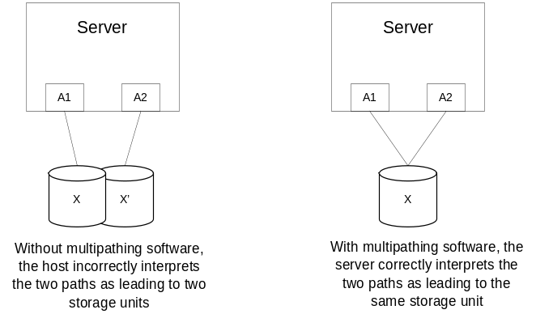
Figure 1: What the operating system “sees” with and without MPIO
The following are the sequence of steps that the device driver stack walks through in discovering, enumerating and grouping the physical devices, device paths into a logical set. (Assuming a scenario where a new device is being presented to the server)
- New device arrives.
- PnP manager detects the arrival of this device.
- MPIO driver stack is notified of this device arrival (it will take further action if it is a supported MPIO device).
- MPIO driver stack creates a pseudo device for this physical device.
- MPIO driver walks through all the available DSM’s to find out which vendor specific DSM can claim this device. After a DSM claims a device it is associated only with the DSM that claimed it.
- The MPIO driver, along with the DSM, makes sure the path to this device is connected, active, and ready for IO.
If a new path for this same device arrives, MPIO then works with the DSM to determine whether this device is the same as any other claimed device. It then groups this physical path for the same device into a logical set called multipath group.

Unique Storage Device Identifier
For dynamic discovery to work correctly, some form of identifier must be identified and obtainable regardless of the path from the host to the storage device. Each logical unit must have a unique hardware identifier. The MPIO driver package does not use disk signatures placed in the data area of a disk for identification purposes by software. Instead, the Microsoft provided generic DSM manufactures a unique serial number from the hardware data reported by standard SCSI INQUIRY commands. MPIO also provides for optionally using device manufacturer assigned unique serial numbers.
Since not all storage IHV’s assign their devices a unique hardware serial number, Microsoft includes in its sample generic DSM source code a means of deriving one, using other SCSI INQUIRY data. Alternatively, vendor-specific mechanisms can be implemented in IHV’s DSM.

Dynamic Load Balancing
Load balancing, the redistribution of read/write requests for the purpose of maximizing throughput between server and storage device, is especially important in high workload settings or other settings where consistent service levels are critical. Without Multi Path I/O software, a server sending I/O requests down several paths may operate with very heavy workloads on some paths while others are underutilized.
The Microsoft MPIO software supports the ability to balance I/O workload, without administrator intervention. MPIO determines which paths to a device are in an active state and can be used for load balancing. Each vendor’s load balancing policy (which may use any of several algorithms, such as round robin, the path with the fewest outstanding commands, or a vendor unique algorithm) is set in the DSM. This policy determines how the I/O requests are actually routed.
Note: In addition to the support for load balancing provided by MPIO, the hardware used must support the ability to use multiple paths at the same time rather than just fault tolerance.

Error Handling, Failover and Recovery
The MPIO driver, in combination with the DSM, supports end-to-end path failover. The process of detecting failed paths and recovering from the failure, like load balancing, is automatic, usually fast, and completely transparent to the IT organization. The data ideally remains available at all times.
Not all errors result in failover to a new path. Some errors are temporary and can be recovered using a recovery routine in the DSM; if recovery is successful, MPIO is notified and path validity checked to verify that it can be used again to transmit I/O requests.
When a fatal error occurs, the path is invalidated and a new path is selected. The I/O is resubmitted on this new path without requiring the Application layer to resubmit the data.

Differences in load balancing terminology:
There are 2 primary types of load balancing technology referred to within Microsoft Windows. This whitepaper discusses the use of the first only.
- MPIO Load Balancing – This type of load balancing supported by MPIO is the use of multiple data paths between server and storage to provide greater throughput of data then could be achieved with only one connection.
- Network Load Balancing (NLB) – This is a Microsoft Windows Cluster technology that provides load balancing of network interfaces to provided greater throughput across a network to the server, and is most typically used with Internet Information Server (IIS).

Differences in failover technology:
When speaking about data path failover, such as the failover of HBA or iSCSI connections to storage, the following main types of failover are available:
- MPIO based Fault Tolerant (FT) failover – In this scenario, multiple data paths to the storage are configured, and in the event that one path fails, the HBA or NIC is able to failover to the other path, and re-send any outstanding IO.
  - For a server that has one or more HBA or NIC, MPIO offers support for redundant switch fabrics or connections from the switch to the storage array.
  - For a server that has more than one HBA or NIC, MPIO also offers protection against the failure of one of those adapters within the server directly.
- MPIO based Load Balancing – In this scenario, multiple paths to storage are also defined, however the DSM is able to balance the data load to maximize throughput. This configuration can also employ FT behavior so that if one path fails, all data would go over an alternate path.
In some hardware configurations you may have the ability to perform dynamic firmware updates on the storage controller, such that a complete outage is not required for firmware updates. This capability is hardware dependant and requires (at a minimum) that more than one Storage Controller be present on the storage so that data paths can be moved off of a storage controller for upgrades.
- The third type of failover, such as Windows Server Failover Clustering (WSFC). This type of configuration offers resource failover at the application level from one cluster server node to another. This type of failover is more invasive than storage path failover in that it will require client applications to reconnect after failover, and resend data from the application layer. This method can be combined with scenarios 1 and/or 2 above to further mitigate risk exposure to different types of hardware failures.
Different behaviors are available depending on the type of failover technology used, and whether it is combined with a different type of failover or redundancy. Consider the following scenarios:
Scenario 1: Using MPIO without clustering:
This scenario provides for either a fault tolerant connection to data, or a load balanced connection to storage. Since this layer of FT operation protects only the connectivity between the server and storage, it does not provide protection against server failure.

Scenario 2: Combining the use of MPIO in fault tolerant mode with WSFC:
This configuration provides the following advantages:
- If a path to the storage fails, MPIO can use an alternate path without requiring client application reconnection.
- If an individual server experiences a critical event such as hardware failure, the application managed by WSFC is failed over to another cluster node. While this does require client reconnection, the time to restoration of service may be much shorter than that required for replacing the failed hardware.
Scenario 3: Combining the use of MPIO in load balancing mode with WSFC:
This scenario provides the same benefits as scenario 2 plus:
- During normal operation, multiple data paths may be employed to provide greater aggregate throughput than one path could provide.
Scenarios 2 and 3 may also be used as an aid to software update management to reduce total downtime perceived by clients by making the managed application available again on a different server while one is updated.

The Windows Storage Stack and Drivers
For the operating system to correctly perform operations that relate to hardware, such as addition or removal of devices or transferring I/O requests from an application to a storage device, the correct device drivers must be associated with the device. All device-related functionality is initiated by the operating system, but under direct control of subroutines contained within each driver. These processes are considerably complicated when there are multiple paths to a device. The MPIO software prevents data corruption by ensuring correct handling of the driver associated with a single device that is visible to the operating system through multiple paths. Data corruption is likely to occur because when an operating system believes two separate paths lead to two separate storage volumes, it does not enforce any serialization or prevent any cache conflicts. Consider what would happen if NTFS tries to initialize its journal log twice on a single volume.

Storage Stack and Device Drivers
Storage architecture in Windows consists of a series of layered drivers, as shown in Figure 2. (Note that the application and the disk subsystem are not part of the storage layers.) When a device such as a storage disk is first added in, each layer of the hierarchy is responsible for making the disk functional (such as by adding partitions, volumes and the file system (FS)). The stack layers below the broken line are collectively known as the device stack and deal directly with managing storage devices.
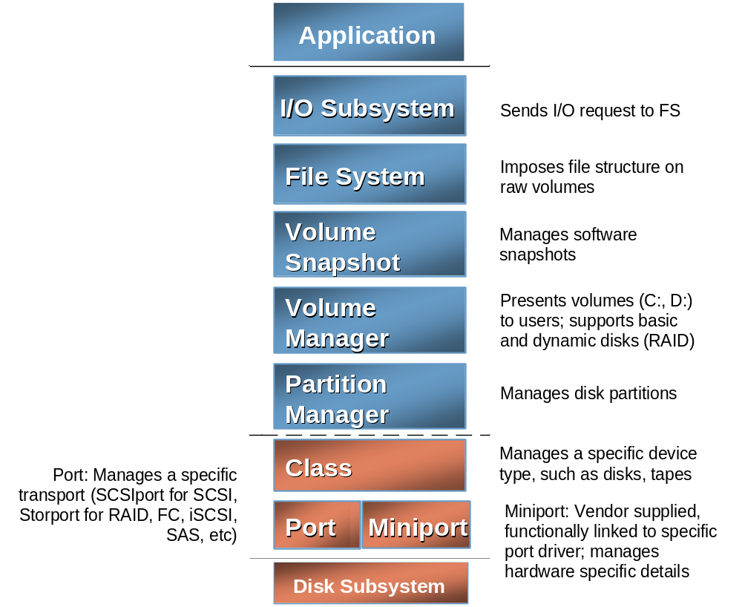
Figure 2. The Windows Storage Stack
Device Drivers
Device drivers manage specific hardware devices, such as a disks or tapes, on behalf of the operating system.

Port Drivers
Port drivers manage different types of transport, depending on the type of adapter (USB, iSCSI or Fibre Channel (FC), for example) in use. Historically, one of the most common port drivers in the Windows system was the SCSIport driver. In conjunction with the class driver, the port driver handles PnP and power functionality. Port drivers manage the connection between the device and the bus. Windows Server 2003 introduced a new port driver, Storport, which is better suited to high-performance, high-reliability environments and is typically much more commonly used than SCSIport today.

Miniport Drivers
Each storage adapter has an associated device driver known as a “miniport.” This driver implements only those routines necessary to interface with the storage adapter’s hardware. A miniport partners with a port driver to implement a complete layer in the storage stack, as shown in Figure 2.
Class Driver
Class drivers manage a specific device type. Class drivers are responsible for presenting a unified disk interface to the layers above (for example, to control read/write behavior for a disk). The class driver manages the functionality of the device. Class drivers (like port and miniport drivers) are not a part of the MPIO driver package per se; however, the Plug and Play disk class driver, disk.sys, is used as part of the Multipathing solution, since the class driver controls the disk add/removal process and I/O requests pass through this driver to the MPIO bus driver (see “MPIO Drivers,” the following section).
The MPIO driver package consists of three multipath drivers: the port filter driver, the disk-driver replacement, and the bus driver; all are implemented in the kernel mode of the operating system. The MPIO driver package works in combination with the PnP Manager, the disk class driver, the port driver, the miniport driver, and a device-specific module (DSM) to provide full Multipath functionality.
Multipath Port Filter Driver (mpsfltr)
The multipath port filter driver loads between the port driver and the class driver, and manages information passed up the stack by the port drivers. The filter changes the default ID for disk devices from the generic one of “GenDisk” to the MPIO specific “MPIODisk”.

Multipath Disk Driver (mpdev.sys)
The multipath disk driver works as a parallel implementation to the existing class driver. Once a device is identified and the DSM of a specific vendor is associated with it, mpdev.sys claims ownership of the disk device object (the PDO) and prevents any other driver from being associated with it. This directly prevents another driver from creating another device stack on the same LUN and mounting a new file system—a process that would destroy the original file system and any data on the LUN. Without this driver, this disk class driver would claim each instance of the disk devices, creating multiple active paths to the device. This driver also notifies the MPIO bus driver of new device arrivals.

Multipath Bus Driver (mpio.sys)
Bus drivers are responsible for managing the connection between the device and the host computer. The multipath bus driver provides a “software bus (also technically termed a “root bus”)”—the conceptual analog to an actual bus slot into which a device plugs. It acts as the parent bus for the multipath children (disk PDOs). As a root bus, mpio.sys can create new device objects that are not created by new hardware being added into the configuration. The MPIO bus driver also communicates with the other multipath drivers ( the MPIO port filter and MPIO class driver), manages the PnP connection and power control between the hardware devices and the host computer, and uses WMI to allow storage array partners to monitor and manage their storage and associated DSMs.

DSM Management
Management and monitoring of the DSM can be done through WMI. On Windows Server 2008, MPIO may be configured using the mpclaim.exe tool and additionally does include the needed WMI code within the MPIO drivers.

MPIO Drivers in Windows Server 2008
On Windows Server 2008, some of these MPIO drivers have been integrated into the storage stack. In particular
- The MPIO port filter driver mpspfltr.sys has been integrated into Storport.
- The Mpdev disk class driver functionality has been integrated into classpnp .
Note: In order to receive a Windows Logo, multipath solutions need meet the requirements of the MPIO Framework. Storage partners that implement their own class driver (legacy multipath) are not supported in Windows Server 2008

MPIO DSM
As explained earlier, a storage IHV’s DSM incorporate knowledge of the IHV’s hardware. A DSM interacts with the MPIO driver. The MPIO DDK available from Microsoft includes source for a generic DSM that Storage partners can modify. A DSM plays a crucial role in device initialization, I/O request handling including I/O request error handling. These DSM actions are described further in the following sections.

Device Initialization
Recall that MPIO allows for devices from different storage vendors to coexist, and be connected to the same Windows Server 2008 based or Windows Server 2003 based system. This means a single Windows server may have multiple DSM’s installed. When a new eligible device is detected via PnP, MPIO attempts to determine which DSM is appropriate to handle this particular device. MPIO contacts each DSM, one device at a time. The first DSM to claim ownership of the device is associated with that device and the remaining DSMs are not allowed a chance to press claims for that already claimed device. There is no particular order in which the DSMs are contacted, one at a time. The only guarantee is that the Microsoft generic DSM is always contacted last. If the DSM does support the device, it then indicates whether the device is a new installation, or the same device previously installed but which is now visible through a new path.

MPIO device discovery
Figure 2 showed the hierarchy of layered Windows drivers. Figure 3 on the following page illustrates how devices and path discovery works with MPIO.
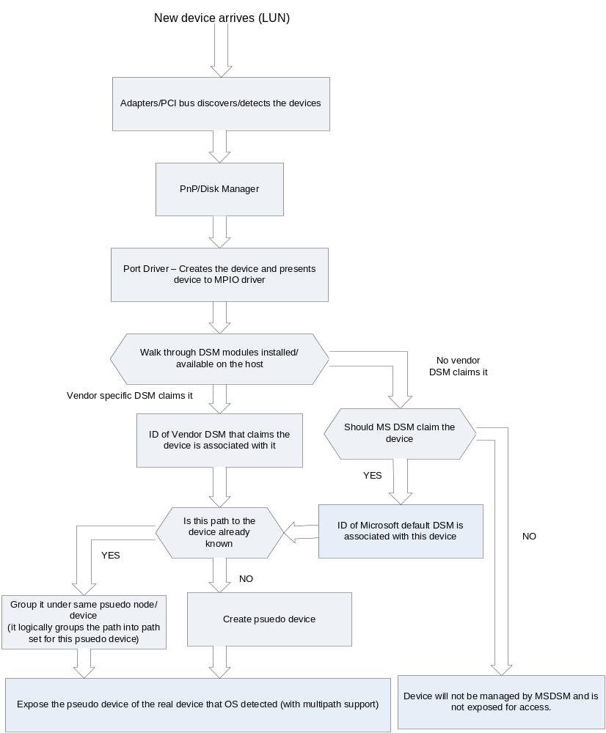
Figure 3. MPIO device discovery flowchart

Request Handling
When an application makes an I/O request to a specific device, the DSM that claimed the device makes a determination, based on its internal load balancing algorithms, as to which path the request should be sent.

Error Handling
If the I/O request fails, the DSM responsibilities include analyzing the failure to determine whether to simply retry the I/O or to cause a failover to a new path or to return the error to the requesting application. In case of a failover, the DSM determines what new path should be used. The actual rebuild of the I/O and resubmission of the I/O is done by the Microsoft MPIO framework and is not the responsibility of the DSM. The details of the DSM/MPIO interaction to make all of this happen are beyond the scope of this document, and are given in the MPIO Driver Development Kit (DDK) material available from Microsoft.

Details of the Windows Server 2008 Microsoft DSM
The Microsoft DSM provided as part of the complete solution in Windows Server 2008 includes support for the following policies:
- Failover, where no load balancing is performed. The DSM will specify a primary path and a set of standby paths. Primary path is used for processing device requests. If the primary path fails, one of the standby paths will be used.. Any one of the available paths could be used as primary path, and the remaining paths will be used as standby paths.
Note: With an array that supports ALUA, paths will typically be referred to as Active / Optimized and Active Unoptimized rather than only as a Primary path.
Failback is the ability to dedicate I/O to a designated preferred path whenever it is operational. If the preferred path fails, I/O will be directed to an alternate path, but will automatically switch back to the preferred path, with some DSM assistance when it becomes operational again.
- Round Robin Load balancing where the DSM will use all available paths for I/O in a balanced, round robin fashion. This is the default policy chosen when the storage controller follows the true Active-Active model and the management application does not explicitly choose a load balancing policy.
- Round Robin with subset of paths is load balancing wherein the application will specify a set of paths to be use in Round Robin fashion, and a set of standby paths. The DSM will use paths from primary pool of paths for processing requests as long as at least one of the paths is available. The DSM will use a standby path only when all the primary paths fail. For example, given 4 paths – A, B, C, and D, A, B, and C are listed as primary paths and D is standby path. The DSM will choose a path from A, B, and C in round robin fashion as long as at least one of them is available. If all three fail, the DSM will start using D, the standby path. If A, B, or C become available, DSM will stop using D and switch to the available paths among A, B, and C.
- Dynamic Least Queue Depth Load Balancing where the DSM will route I/O to the path with the least number of outstanding requests.
- Weighted Path load balancing where a weight is assigned to each path; the weight indicates the relative priority of a given path. The larger the number the lower the priority. The DSM will choose a path, among the available paths, with least weight.

Using MPIO on Windows Server 2008
This section is focused on the Storage Administrator and explains how to install, administer and troubleshoot MPIO on Windows Server 2008.

Adding MPIO Support on Windows Server 2008
MPIO is an Optional Component (OC) in Windows Server 2008 and is not installed by default. To install MPIO support on a Windows Server 2008 server, perform the following steps:
- From Server Manager, select “Add Features” as shown in Figure 4.

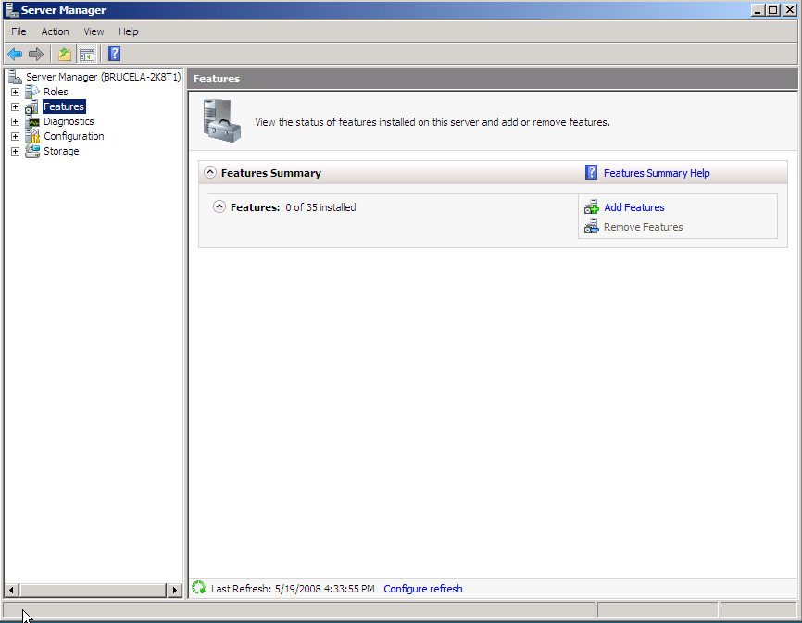
Figure 4. Windows Server 2008 Add Features GUI
- Select Multipath I/O as shown in Figure 5.

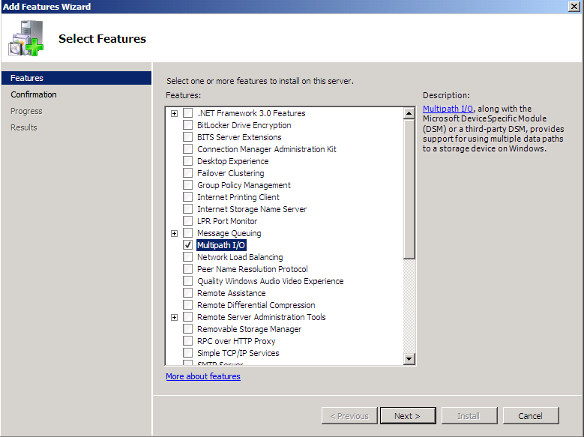
Figure 5 - Windows Server 2008 Features Selection for Installation GUI
- Click Next.

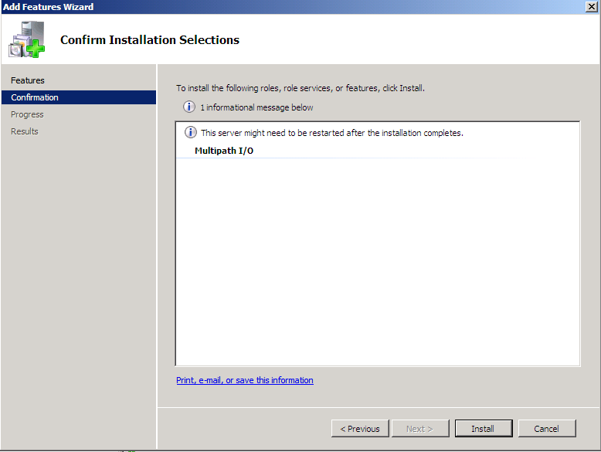
Figure 6. Windows Server 2008 MPIO Feature Installation Confirmation GUI
- Click Install as shown in Figure 6.
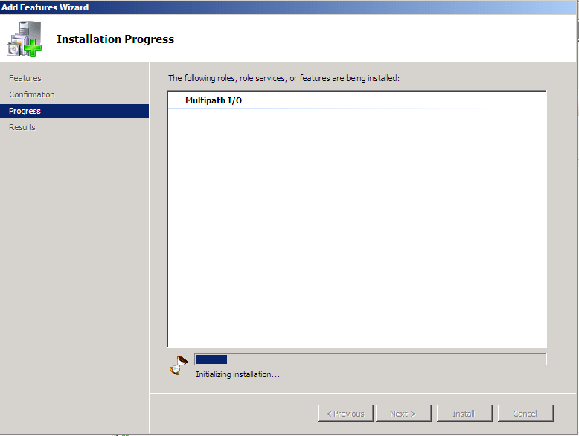
Figure 7. Windows Server 2008 MPIO Installation Progress GUI
- Allow MPIO Installation to complete.
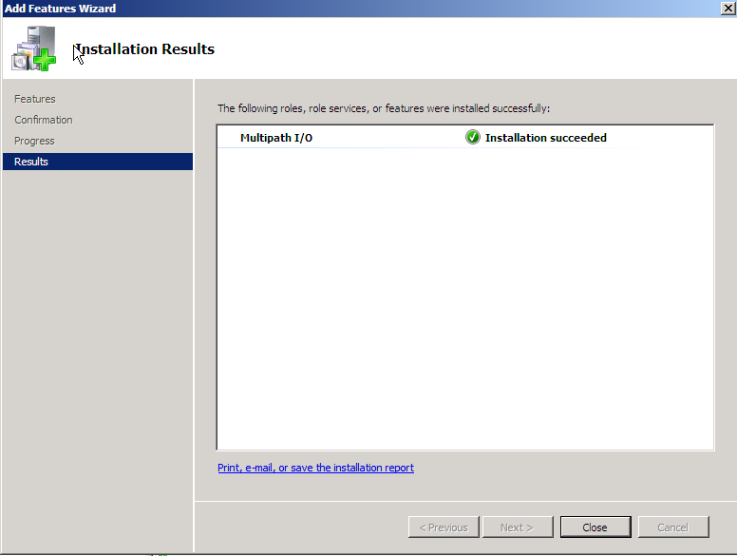
Figure 8. Windows Server 2008 MPIO Installation Results GUI
- Click “Close” to finish the MPIO installation

MPIO Configuration and DSM installation

When MPIO is installed, the Microsoft provided DSM is also installed. An MPIO control panel is also installed. This MPIO control panel can be used to:
- Configure MPIO functionality
- Install additional storage DSMs
The MPIO control panel is accessed from the classic view of the Control Panel as shown in Figure 9 on the next page.
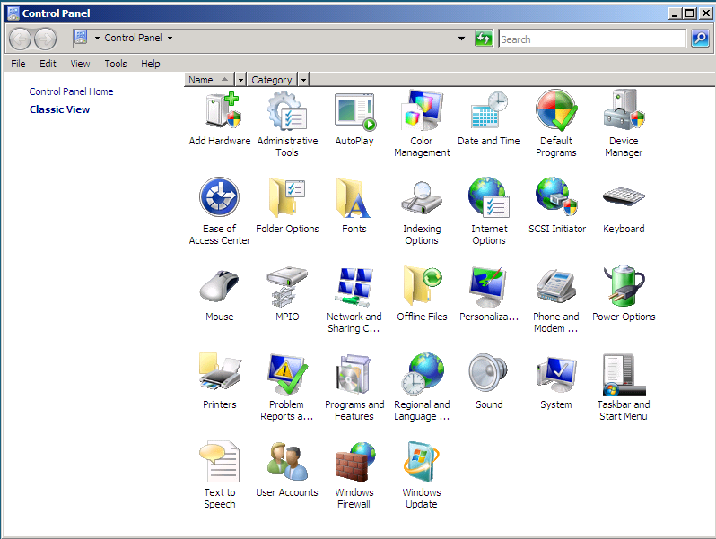
Figure 9. Windows Server 2008 Control Panel Classic View showing MPIO Control Panel Applet
MPIO Configuration can also be launched from Administrative Tools as shown in Figure 10.
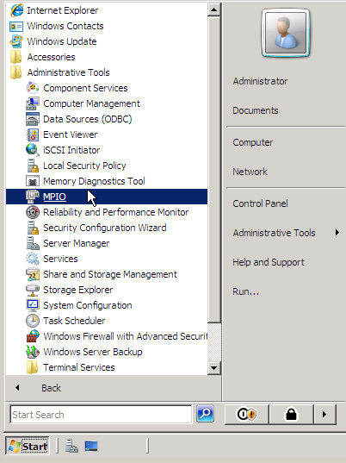
Figure 10. Windows Server 2008 Administrative tools showing MPIO administration applet
When the MPIO Control Panel applet is launched as shown in either Figure 9 or Figure 10, the applet generates an MPIO Properties page as shown in Figure 11

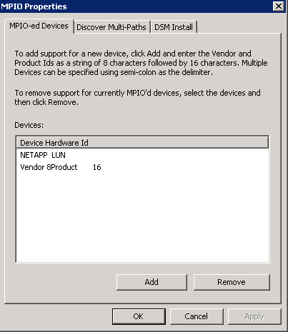
Figure 11. MPIO Properties GUI
The MPIO Properties page has 3 tabs and by default, the MPIO-ed Devices Tab is selected.
The “MPIO-ed Devices” tab shows the hardware ID’s of devices that will currently be managed by MPIO whenever they are present. The decision is based on their hardware id (ie. Vendor+Product string) matching one that is maintained by MPIO in its MPIOSupportedDeviceList (this is something that every DSM specifies in its INF at the time of installation).
Figure 11 shows an example of a device is MPIO-ed.
The Add Button in Figure 11 allows for the administrator to specify another MPIO-ed device. Figure 12 shows the GUI generated when the Add tab in Figure 11 is clicked.
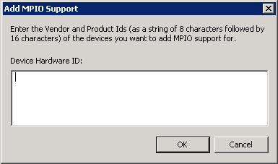
Figure 12 Specifying MPIO-ed devices GUI

Note: The Vendor and Product ID’s needed in the “Add MPIO Support” dialog box shown above will be provided by the Storage provider, and are specific to each type of hardware.

Referring back to Figure 11, recall that there are 3 tabs in the GUI. The first tab “MPIO-ed devices” Is explained in previous sections.
The “Discover Multi-Paths” tab runs an algorithm for every device instance that is present on the system and determines if multiple instances actually represent the same LUN (through different paths). For such devices found, their hardware ids are presented for the Admin for MPIO’ing (they’ll get MSDSM support though).
Again, referring back to Figure 11, the “DSM Install” tab can be used to install DSMs provided by the storage IHV.

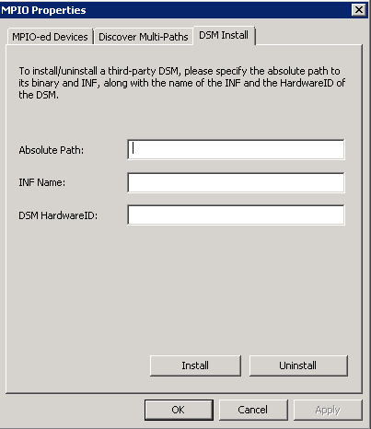
Figure 13 DSM Install Tab
Many storage arrays which are active/active and SPC-3 compliant will work using the Microsoft MPIO DSM. Some storage array partners also provide their own DSMs to use with the Microsoft MPIO architecture. These DSMs may be installed using the DSM Install tab in the MPIO properties Control Panel configuration utility:
IHV’s are expected to build their package using the MPIO Development Kit version 1.21 or higher from Microsoft. Many storage array partners provide their own installation package for their DSM. For Windows Server 2003, this installation package includes the MPIO core binaries signed by Microsoft. When such a package is run on Windows Server 2008, the operating system allows the vendor DSM to be installed, but prevents the MPIO binaries already present in Windows Server 2008 from being updated by the package. Thus the end result of running the vendor installation package is to preserve the core MPIO binaries already present in Windows Server 2008, but the 3rd party provided DSM is added.

How to configure the Load Balance policy for a LUN:
MPIO LUN load balancing is integrated with Disk Management. To configure MPIO LUN load balancing, start the Disk Management GUI

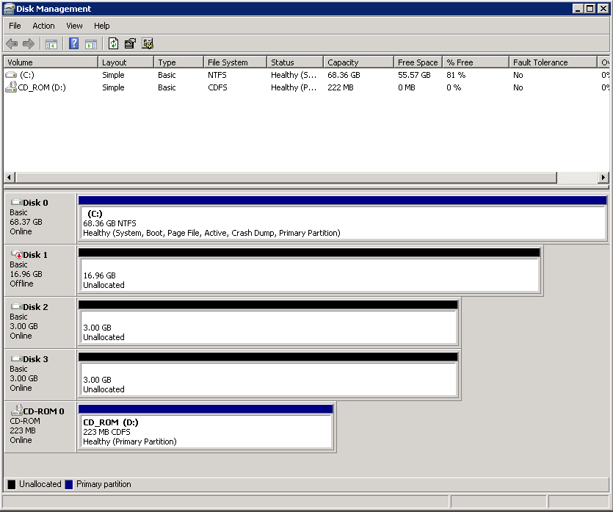
Figure 14 Disk Management
Figure 14 shows the Disk Management GUI. Right-Click the Desired disk (in this case C: ) to change the policy for, and choose properties:
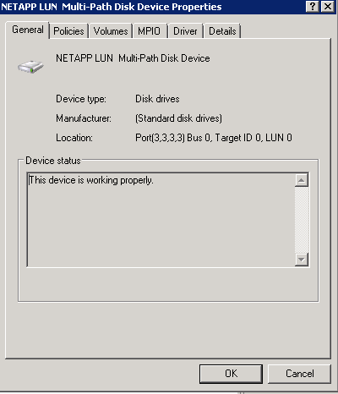
Figure 15 Device Properties Page
Click the MPIO tab in the Device Properties Page shown in Figure 15.
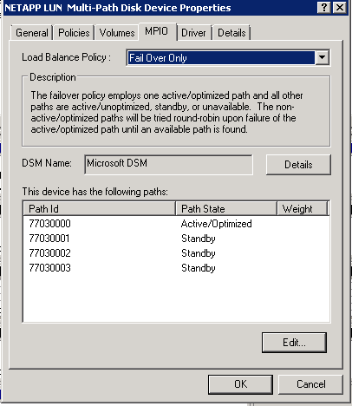
Figure 16 MPIO Device Properties Page
Figure 16 shows the resulting GUI. The Desired Load Balance Policy can be configured by selecting the drop-down menu for Load Balancing Policy in Figure 16.
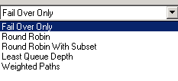
Figure 17 Load Balancing Drop Down dialog box
Figure 17 shows just the resulting drop down menu choices for Load Balancing. In this example, “Fail Over Only” is selected.
Additional details about the currently configured DSM can be displayed by clicking the Details button in Figure 16.
Note: When using a DSM other than MSDSM, the DSM vendor may use their own interface to manage these policies.

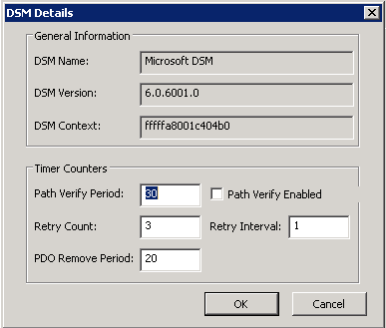
Figure 18 DSM Details
Figure 18 shows the resulting DSM Details dialog
Note: For additional information on DSM Timer Counters please refer to appendix D.

Troubleshooting Examples:
In the example below, we use IBM 1742 storage

Verify whether the storage is correctly setup with MPIO
- Click Start, in the search box, type “devmgmt.msc” (without quotes) and press ENTER.
- Click the View menu, and choose “Devices by connection”
  - Do you see the node: “Microsoft Multi-Path Bus Driver”?
  - Do you see the node: “Microsoft Multi-Path Device Specific Module”?
- Expand each of the FC adapters that the IBM storage is connected through
  - Do you see the IBM device(s) show up under the HBA?
- Click Start, point to Run, type “regedit” (without quotes) and press ENTER.
- Expand HKLM\System\CurrentControlSet\Control and go to the MPDEV key
  - Do you see “IBM 1742 ” listed in the MPIOSupportedDeviceList value?
- Expand HKLM\System\CurrentControlSet\Services\msdsm\Parameters
  - Do you see “IBM 1742 ” listed in the DsmSupportedDeviceList value?

If answers to #5 and #6 are both YES, is the storage SPC-3 compliant? Specifically, does it support the ALUA semantics?
If answer to #3 is NO, try uninstalling the MPIO Optional Component (OC) and after rebooting, perform step #3 (bypassing steps #1 and #2) and see if the devices show up under the adapters.

Using mpclaim.exe to configure MPIO on Windows Server 2008
With Windows Server 2008, MPIO can be configured from the command line tool MPCLAIM. This capability is also available when using Windows Server 2008 “Server Core”.
USAGE:
Installs MPIO OC and then ensures MSDSM claims passed in device.
Usage: mpclaim reboot_option install_switch device_switch device_hwid(s)
reboot_option Whether to automatically reboot or not
-r automatically reboot without prompting
-n suppress reboot request (CALLER IS EXPECTED TO REBOOT)
install_switch Whether to multipath or remove MPIO support
-i install MPIO OC and add multipath support for device
-u remove multipath support for device and uninstall MPIO
OC if no remaning devices are multipath'd

device_switch Whether to apply above options to all devices or passed in devices
-d following parameters indicate hardware ids of devices
-a work on all applicable devices
device_hwid HardwareIDs of Devices to be MPIO'd, as strings of vendor8product16,
delimited by a space (Note: Use empty string with '-a' option)

Add MPIO support for FC device(s):
mpclaim.exe -r -i -d <device#1_hardwareID> <device#2_hardwareID>
NOTE: if the MPIO optional component is not installed, the tool will install it first.
eg. To add MPIO support for a device with Vendor=ABC and Product=WXYZ
mpclaim -r -i -d "ABC WXYZ "
(notice that the vendor string length is made 8 chars and the product string length is made 16 chars and both fields are padded with spaces as needed.)
For example, to add MPIO support for devices with Vendor==ABC, Product==WXYZ and Vendor==DE, Product==JKLMN
mpclaim -r -i -d "ABC WXYZ " "DE JKLMN "

Add MPIO support for iSCSI devices:
mpclaim -r -i -d "MSFT2005iSCSIBusType_0x9"
NOTE: if the MPIO optional component is not installed, the tool will install it first.

Add MPIO support for all devices that are multipathed:
mpclaim.exe -r -i -a ""
NOTE: If the MPIO optional component is not installed, the tool will install it first. Also, the tool will go through all devices seen by the system, determine if there are multiple paths to the device, and if yes, add MPIO support for it. If any iSCSI disk device is found, MPIO support will be added for all iSCSI disk devices.

Remove MPIO support for FC device(s):
mpclaim.exe -r -u -d <device#1_hardwareID> <device#2_hardwareID>

NOTE: if the MPIO optional component is installed, the tool will also uninstall it.

eg. To remove MPIO support for a device with Vendor==ABC and Product==WXYZ

mpclaim -r -u -d "ABC WXYZ "
(notice that the vendor string length is made 8 chars and the product string length is made 16 chars)

eg. To remove MPIO support for devices with Vendor==ABC, Product==WXYZ and Vendor==DE, Prouct==JKLMN

mpclaim -r -u -d "ABC WXYZ " "DE JKLMN "

Remove MPIO support for iSCSI devices:
mpclaim.exe -r -u -d "MSFT2005iSCSIBusType_0x9"

NOTE: if the MPIO optional component is installed, the tool will also uninstall it.

Remove MPIO support for all devices on the system:
mpclaim.exe -r -u -a ""
NOTE: if the MPIO optional component is installed, the tool will also uninstall it. Also, the tool will remove MPIO support for all devices on the system, even if multiple paths do NOT exist to the array. Use caution when removing MPIO optional component from the system.

Installation of MPIO on Server Core installations of Windows Server
2008
Since a Server Core installation of Windows Server 2008 does not contain a Graphical User Interface (GUI), installation of the MPIO feature is done from the CMD prompt.
Note: the commands listed in this section are only available on server core versions of Windows Server 2008.
In order to list the Roles and Features currently installed, type “oclist” (without quotes) at the CMD prompt. This will list all of the roles and features and their current installation state.
Example oclist output showing the MPIO feature installed:
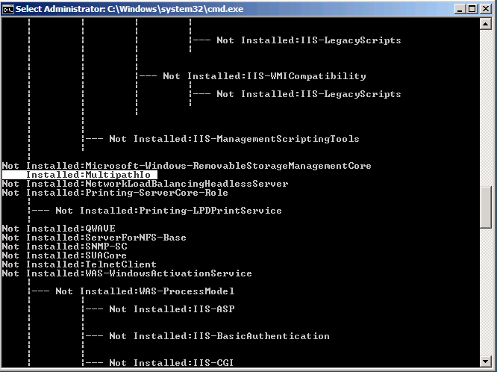

The MPIO feature may then be installed or removed using the ocsetup.exe tool.
Note: When adding and removing roles and features using the ocsetup tool, the name of the component is case sensitive based on the name listed in the oclist tool.

To install MPIO on server core:
- At the command prompt, type “start ocsetup MultipathIo” (without quotes).

To remove the MPIO feature on server core:
- At the command prompt type “start ocsetup MultipathIo /uninstall” (without quotes).
After the uninstall is complete, the following message will be displayed:
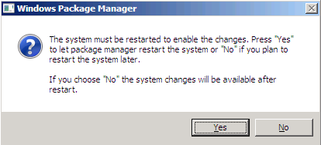
- To restart the system and enable the change, click Yes, otherwise click No to postpone the restart until later.

Access the MPIO control panel on server core:
- To access the MPIO control panel on a server core installation, type “mpiocpl.exe” (without quotes) at the CMD prompt, and press ENTER.
MPCLAIM.exe may also be used on server core to configure MPIO support after the feature is installed. For more information on MPCLAIM usage see the section on MPCLAIM earlier in this document.

Appendix A – Script Example : Query the MPIO Policy for a device
Please note, the use of included script samples are subject to the terms specified at http://www.microsoft.com/info/cpyright.htm
The following script example shows how to query the current load balancing policy for MPIO devices.
Once it successfully runs, it will print out integer values. i.e.) 1, 2, 3, 4, 5, 6, and 7
These values represent the following MPIO policies:
1 "Fail Over Only"
2 "Round Robin",
3 "Round Robin with Subset"
4 "Dynamic Least Queue Depth"
5 "Weighted Paths"

NOTE: The script uses DSM_QueryLBPolicy_V2 class to query the current LB policy setting. The class works on W2K8+ , but it won’t work on W2K3. For W2K3, DSM_QueryLBPolicy has to be used instead.

On Error Resume Next

Const wbemFlagReturnImmediately = &h10
Const wbemFlagForwardOnly = &h20

strComputer = "."

WScript.Echo

Set objWMIService = GetObject("winmgmts:\\" & strComputer & "\root\WMI")
Set colItems = objWMIService.ExecQuery("SELECT * FROM DSM_QueryLBPolicy_V2", "WQL", _
wbemFlagReturnImmediately + wbemFlagForwardOnly)

For Each objItem In colItems
WScript.Echo "Active: " & objItem.Active
WScript.Echo "InstanceName: " & objItem.InstanceName
WScript.Echo "LoadBalancePolicy: " & objItem.LoadBalancePolicy.LoadBalancePolicy
WScript.Echo
Next

Appendix B – MPIO & DSM Configuration and best practices
When configuring a disk device to be managed by MPIO for multipath access, the hardware ID for the disk device is required to be present in two different locations in registry in order to be claimed by MPIO and the DSM managing connection to the device. These two locations are:
HKLM\System\CurrentControlSet\Control\MPDEV\MPIOSupportedDeviceList
AND
HKLM\System\CurrentControlSet\Services\<DSMNAME>\Parameters\DsmSupportedDeviceList

Note: For both registry keys listed in this section, they are REG_MULTI_SZ data values, so if a number of devices are configured, it may be necessary to actually open this key with REGEDIT in order to view all of the hardware ID’s.
By default, the only value listed in this key will be “Vendor 8Product 16” (without quotes) will be listed for a hardware ID associated with MPIO. This entry is intended as an example only to show the correct hardware ID format which is made up of an 8 byte vendor ID followed by a 16 byte product ID.
If the device will be associated with the Microsoft DSM (MSDSM), then the <DSM NAME> will be MSDSM. If the device connection will be handled by a vendor provided DSM, then the name of this key will be dependent on the service name associated with the DSM in the HKLM\System\CurrentControlSet\Services registry hive.

It is strongly recommended that the hardware ID for a specific disk device should be configured such that it is only associated with one DSM in the services key. This will help ensure that the device is only available to be claimed by the desired DSM, and will help avoid a situation where a disk is not claimed by the desired DSM, when multiple DSM’s have the ability to support a given device. This process may also be used to determine which DSM a disk drive could be associated with for troubleshooting purposes.
Warning: Removing hardware ID’s from DSM’s that are not required should be performed by editing the registry keys directly, as removing a device from the MPIO GUI will result in the hardware ID being removed in both registry locations above and prevent the device from being claimed by the desired DSM.

When a hardware ID is listed in both locations detailed above, it does not indicate that the hardware ID will be actually claimed by the given DSM, it is just an indication that it would be possible for the devices to be claimed by the DSM. The DSM that is actually used for a given device is randomly selected from all DSM’s that the hardware ID is registered with.
Note: If the hardware ID is listed with the MSDSM, that DSM will be selected only if no other DSM’s claim the device.
The DSMSupportedDeviceList key contains the hardware ID’s of all devices that are capable of being associated with the selected DSM.

To search for hardware ID’s registered with more than one DSM:
In order to determine which DSM’s a hardware ID are associated with, perform the following steps.
- Using Regedit, open the following registry key:
HKLM\System\CurrentControlSet\Control\MPDEV\MPIOSupportedDeviceList
- The list of current hardware ID’s will be displayed such as the example from regedit.exe below:
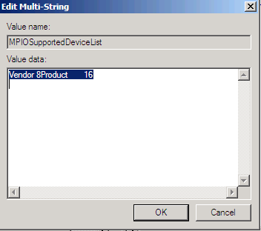
- Select one line from the Value Data filed, and Right-Click and choose copy.
Such as “Vendor 8Product 16”.
- From the Edit menu in Regedit.exe, choose Find.
- In the Find What box, right-click, and choose Paste.
- Click the Find Next button. This will jump to the first DSM that this hardware ID is associated with. Make a note of the registry path listed at the bottom of the Registry Editor window such as the path to the MSDSM entry listed below.
HKLM\System\CurrentControlSet\Services\msdsm\Parameters
In order to check for registration with other DSM’s, repeat step 6 until the Registry Editor finishes searching the registry:
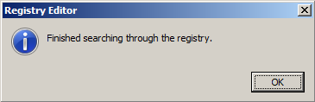
- In order to disassociate the hardware ID with a DSM to prevent it from being claimed by a particular DSM, remove the hardware ID from only the entry under the DSM’s entry in the Services registry hive leaving only the hardware ID’s that you wish to have claimed by the DSM.
A reboot is required after this step for the changes to take effect.

To add a hardware ID to be used with MPIO:

- Open the MPIO control panel.
On the Mpio’d devices tab, click the Add button.
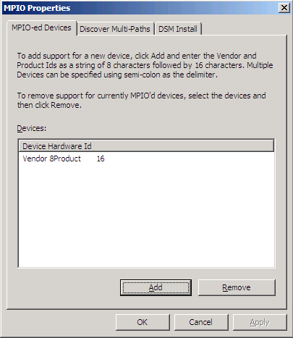
- In the Add MPIO Support dialog box, paste in the hardware ID for the device to be managed by MPIO and then click OK.
For information on determining the hardware ID of a device to be used with MPIO, see Appendix C : Determining the hardware ID to be used with MPIO.
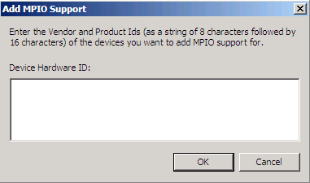
After the device is claimed by MPIO, the device originally shown in Device Manager will be hidden, and a pseudo-LUN device will be shown in device manager.
For example, the single path disk device listed in device manager which is named “emBoot sanFly SCSI Disk device” will become a hidden device, and will be replaced with a new device named “emBoot sanFly Multi-Path Disk Device”.
The exact name will depend on a number of items, such as the type of device and the DSM being used.
The original disk device is still viewable in Device Manager by choosing “Show Hidden Devices” from the Action menu.

Appendix C – Determining the Hardware ID to be used with MPIO

In order to add the hardware ID for a device to MPIO to allow the device to be managed by MPIO, it is first necessary to obtain the hardware ID from the device, and then format the hardware ID differently so that it can be recognized by MPIO.
To determine the hardware ID for a disk device to use with MPIO, perform the following steps:
Note: These steps assume that the device is already configured and presented to the system.

- Click Start, type “Devmgmt.msc” (without quotes), and press ENTER.
- In Device manager, click the plus symbol next to Disk Drives to expand the category.
- Right-Click the desired disk device, and choose properties.
- Click the Details Tab.
- In the Property drop down list, select Hardware ID.
- A list such as the example below will be displayed:
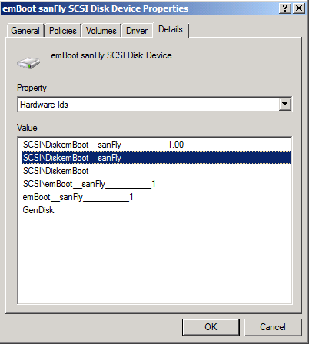
- The hardware ID is in the format of TYPE\Vendor_Product/model. The vendor field is 8 bytes, followed by a 16 byte field to describe the product type or model, such as:
“SCSI\DiskemBoot__sanFly__________” (Not including quotes).
Right-Click the hardware ID, and choose Copy.
- Open Notepad, and paste this string into Notepad.
- Next we must convert the string to the format that is used with MPIO. The first step will be to remove the device type (In this case “SCSI\” (without quotes) from the string. This would leave the resulting string:
“emBoot__sanFly__________” (Not including quotes).
- Next, we must convert the number of underline characters to an equal number of spaces.
In this example, there are 2 underlines in the middle, and 10 trailing underline characters. The resulting string is:
“emBoot sanFly “ (Not including quotes).
- The resulting string listed in step 10 above is the value that will be listed in the MPDEV and DSM registry keys that are detailed in Appendix B in order to allow the device to be claimed by MPIO.

Appendix D – Enabling software tracing for MPIO
This section describes how to enable software trace logging for troubleshooting MPIO Issues.
Note: Software trace logs are binary files that will typically only be used by Microsoft Product Support in the course of troubleshooting an issue, and are not directly viewable.
Creating GUID file to enable tracing

First a <GUID File> needs to be created using notepad.exe and contain the GUID of the provider that corresponds to the driver that we want trace for. For this example we will use MPIOGUID.CTL as the file name.
The file will contain the first line if we want it for MPIO and the second line if we want it for MSDSM.

{8E9AC05F-13FD-4507-85CD-B47ADC105FF6} 0x0000FFFF 0xF
{DEDADFF5-F99F-4600-B8C9-2D4D9B806B5B} 0x0000FFFF 0xF

The format of these files is as follows:

<GUID of provider to trace> <Trace Flags> <Trace Level>

Note: The Trace Flag and Trace Level values will typically be specified by product support depending on the type of troubleshooting being performed.

Start Trace
To start tracing, do the following from a CMD Prompt:
logman.exe create trace <Name> -ets -nb 16 256 -bs 64 -o <LogFile> -pf <GUID File>
logman.exe is present in %windir%\system32 directory. The above command starts a trace session. The name <Name> is assigned to that session. The trace level is controlled by the value of the flag in the GUID File. <Guid File> contains the trace GUID and trace flag. The trace messages are written to <Log File>.

For example, to start a trace session by named MPIOTrace and log file named MPIOTrace.Log, do the following:

logman.exe create trace MPIOTrace -ets -nb 16 256 -bs 64 -o MPIOTRACE.log -pf MPIOGUID.CTL

Stop Tracing
To stop tracing do the following from CMD prompt:

logman.exe stop <Name> -ets

For example, to stop the trace session with name MPIOTrace, do

logman stop MPIOTrace -ets

The log file is a binary file. If you are troubleshooting an MPIO issue via Microsoft Product support services, please send the log file to them to assist in analyzing the failure.

Query Trace Status
To verify that tracing is running properly, do the following from a CMD prompt.
logman.exe query -ets

To return extended information about the tracing status, do the following from the CMD prompt:

logman query MPIOTrace -ets

Appendix E - MPIO timers
- PathVerifyEnabled: This flag enables path verification by MPIO on all paths every N seconds (where N depends on the value set in PathVerificationPeriod).
Type is boolean and must be filled with either 0 (disbale) or 1 (enable). By default, it is disabled.
- PathVerificationPeriod: This setting is used to indicate the periodicity (in seconds) with which MPIO has been requested to perform path verification. This field is only honored if PathVerifyEnabled is TRUE.
This timer is specified in seconds. The default is 30 seconds. The max allowed is MAXULONG.
- PDORemovePeriod: This setting controls the amount of time (in seconds) that the multipath pseudo-LUN will continue to remain in system memory, even after losing all paths to the device.
This timer is specified in seconds. The default is 20 seconds. The max allowed is MAXULONG.
- RetryCount: This setting specifies the number of times a failed IO if the DSM determines that a failing request must be retried. This is invoked when DsmInterpretError() returns Retry = TRUE.
The default setting is 3.
- RetryInterval: This setting specifies the interval of time (in seconds) after which a failed request is retried (after the DSM has decided so, and assuming that the IO has been retried lesser number of times than RetryCount).
This value is specified in seconds. The default is 1 second

Appendix F – Acronyms:

ALUA |  | Asymmetric Logical Unit Access
DDK |  | Driver Development Kit
DSM |  | Device Specific Module
FC |  | Fibre Channel
FS |  | File System
FT |  | Fault Tolerant
GUI |  | Graphical User Interface
HBA |  | Host Bus Adapters
I/O |  | Input / Output
IHV |  | Independent Hardware Vendor
IIS |  | Internet Information Server
iSCSI |  | Internet SCSI
ISV |  | Independent Software Vendor
IT |  | Information Technology
LUN |  | Logical Unit Number
MPIO |  | Multi-path I/O
MSCS |  | Microsoft Cluster
MSDSM |  | Microsoft DSM
NAS |  | Network Attached Storage
NIC |  | Network Interface Card
NLB |  | Network Load Balancing
OC |  | Optional Component
NTFS |  | New Technology File System
PDO |  | Physical Device Object
PnP |  | Plug and Play
RAID |  | Redundant Array of Independent Disks
SAN |  | Storage Area Network
SAS |  | Serial Attached SCSI
SCSI |  | Small Computer System Interface
SPC-3 |  | SCSI Primary Commands – 3
USB |  | Universal Serial Bus
WMI WSFC |  | Windows Management Interface  Windows Failover Clustering

Conclusion
The Microsoft MPIO framework provides hardware and software vendors with a means of creating Microsoft MPIO solutions that work effectively with the Windows Server operating system to provide organizations with reliable multiple path support on Windows Server 2008 and Windows Server 2003, The Microsoft MPIO solution provides support for Fibre Channel, parallel SCSI, Serial Attached SCSI and iSCSI storage and also ensures that MPIO based storage solutions from different storage partners can coexist on the same Windows Server host.

Resources
Information about the Windows Hardware Quality Labs is available at
http://www.microsoft.com/whdc/winlogo/default.mspx
Products designed for use with Windows are listed at http://www.microsoft.com/whdc/hcl/default.mspx
Information about Windows Management Instrumentation (WMI) is available at
http://msdn2.microsoft.com/en-us/library/aa394582(VS.85).aspx.

More information on the Microsoft iSCSI Software initiator is listed at
http://www.microsoft.com/iSCSI

More information on the Microsoft Storport driver is available at:
www.microsoft.com/storport

Failover Clustering in Windows Server 2008 does not support the use of parallel SCSI storage
On Microsoft Windows Server 2003, the storage provider will redistribute the MPIO framework with the storage provider’s DSM.

