Get Started, Part 2: Containers
过去如果你要运行一个app.py，你需要安装python并且搭建环境。使用docker你仅仅只需要通过一个镜像就能实现，不需要安装python环境。镜像用Dockerfile文件来定义，Dockerfile定义了一个容器运行时的环境，例如网络接口访问，存储驱动，资源隔离，映射端口等。

创建Dockerfile
创建一个空目录，cd进去，然后创建一个Dockerfile文件内容为：
# Use an official Python runtime as a parent image
FROM python:2.7-slim
# Set the working directory to /app
WORKDIR /app
# Copy the current directory contents into the container at /app
COPY . /app
# Install any needed packages specified in requirements.txt
RUN pip install --trusted-host pypi.python.org -r requirements.txt
# Make port 80 available to the world outside this container
EXPOSE 80
# Define environment variable
ENV NAME World
# Run app.py when the container launches
CMD ["python", "app.py"]
创建requirements.tx
Flask
Redis
app.py

from flask import Flask
from redis import Redis, RedisError
import os
import socket
# Connect to Redisredis = Redis(host="redis", db=0, socket_connect_timeout=2, socket_timeout=2)
app = Flask(__name__)
@app.route("/")def hello():
try:
visits = redis.incr("counter")
except RedisError:
visits = "<i>cannot connect to Redis, counter disabled</i>"

html = "<h3>Hello {name}!</h3>" \
"<b>Hostname:</b> {hostname}<br/>" \
"<b>Visits:</b> {visits}"
return html.format(name=os.getenv("NAME", "world"), hostname=socket.gethostname(), visits=visits)
if __name__ == "__main__":
app.run(host='0.0.0.0', port=80)

执行命令

docker build --tag=friendlyhello .
--tag或-t
访问宿主机4000端口
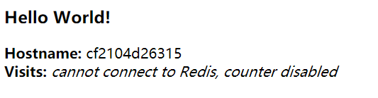
Get Started, Part 3: Services
Services称之为“生产中的多个容器”。一个service只运行一个image，但它定义了image如何运行：应该暴露什么端口，多少个容器副本。可以很简单的通过写docker-compose.yml文件来升级你的service规模。
docker-compose.yml
version: "3"services:
web:
# replace username/repo:tag with your name and image details
image: annor/yyh:latest
deploy:
replicas: 5
resources:
limits:
cpus: "0.1"
memory: 50M
restart_policy:
condition: on-failure
ports:
- "4000:80"
networks:
- webnetnetworks:
webnet:
以上文件告诉docker去执行一下几步：
- 拉取镜像
- 创建一个名为web的service，由5个实例组成。每个实例限定10%cpu利用率，50M RAM
- 立即重启如果运行失败
- 指定web访问端口通过负载均衡网络webnet
- 定义webnet默认设置（负载均衡overlay网络）
运行docker stack deploy前执行docker swarm init
给定appname一个名字getstartedlab
docker stack deploy -c docker-compose.yml getstartedlab
访问宿主机4000端口

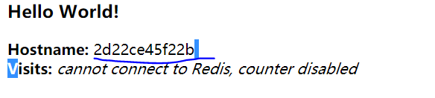
Hostname的id即为5个副本容器id之一，这是一个负载均衡service，刷新页面会发现Hostname的值会变成另一个容器id，说明实现负载均衡。

Get Started, Part 4: Swarms
第二部分是介绍如何构造一个镜像，第三部分介绍如何由一个镜像构造多个容器组成的service。这部分是介绍如何把service部署到不同的主机形成集群。
Swarm是由多个运行docker的主机组成的一个集群，由swarm manager管理。执行一条docker命令将会在不同主机执行。主机可以是虚拟的或者物理的，加入到sarm集群被称为集群的节点。
docker swarm init开启swarm模式并成为swarm manager，别的机器执行docker swarm join加入swarm集群并成为workers。
$ docker-machine ssh myvm1 "docker swarm init --advertise-addr <myvm1 ip>"
Swarm initialized: current node <node ID> is now a manager.
To add a worker to this swarm, run the following command:
docker swarm join \
--token <token> \
<myvm ip>:<port>
To add a manager to this swarm, run 'docker swarm join-token manager' and follow the instructions.

部署swarm集群
安装docker-machine
curl -L https://github.com/docker/machine/releases/download/v0.13.0/docker-machine-`uname -s`-`uname -m` > /usr/local/bin/docker-machine
chmod +x /usr/local/bin/docker-machine
安装VirtualBox:
# yum install VirtualBox-5.2-5.2.24_128163_el7-1.x86_64.rpm
编辑docker-compose.yml

version: "3"services:
web:
# replace username/repo:tag with your name and image details
image: username/repo:tag
deploy:
replicas: 5
restart_policy:
condition: on-failure
resources:
limits:
cpus: "0.1"
memory: 50M
ports:
- "80:80"
networks:
- webnet
visualizer:
image: dockersamples/visualizer:stable
ports:
- "8080:8080"
volumes:
- "/var/run/docker.sock:/var/run/docker.sock"
deploy:
placement:
constraints: [node.role == manager]
networks:
- webnetnetworks:
webnet:

相比之前的配置文件，多了两项，其一增加web可视化服务visualizer，以及设置volumes确保visualizer可以访问本地宿主机的docker.
接着执行
$ docker stack deploy -c docker-compose.yml getstartedlab
Updating service getstartedlab_web (id: angi1bf5e4to03qu9f93trnxm)
Creating service getstartedlab_visualizer (id: l9mnwkeq2jiononb5ihz9u7a4)
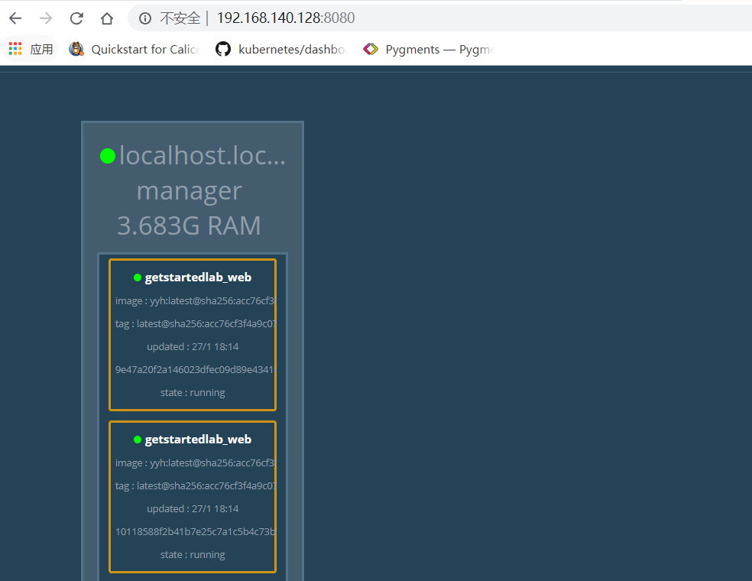

持久化数据
修改docker-compose.yml文件,增加redis
version: "3"services:
web:
# replace username/repo:tag with your name and image details
image: annor/yyh:latest
deploy:
replicas: 3
restart_policy:
condition: on-failure
resources:
limits:
cpus: "0.1"
memory: 50M
ports:
- "80:80"
networks:
- webnet
visualizer:
image: dockersamples/visualizer:stable
ports:
- "8080:8080"
volumes:
- "/var/run/docker.sock:/var/run/docker.sock"
deploy:
placement:
constraints: [node.role == manager]
networks:
- webnet
redis:
image: redis
ports:
- "6379:6379"
volumes:
- "/home/docker/data:/data"
deploy:
placement:
constraints: [node.role == manager]
command: redis-server --appendonly yes
networks:
- webnet
networks:
webnet:
6379为redis暴露的端口供外部访问redis.
Redis数据存储在容器/data目录，如果没有挂载volumes，当sevice重新deploy是/data目录会被清空。
docker stack deploy -c docker-compose.yml getstartedlab
