Graded Lab 1
COMPSCI 2XC3

Tianyan He,
Louis Cao,
Yucheng Wang

Table of Contents
Experiment 1 -------------------------------------------------------------------- P6
Experiment 2 -------------------------------------------------------------------- P8
Experiment 3 ------------------------------------------------------------------- P10
Experiment 4 ------------------------------------------------------------------- P12
Experiment 5 ------------------------------------------------------------------- P14
Experiment 6 ------------------------------------------------------------------- P16
Experiment 7 ------------------------------------------------------------------- P18
Experiment 8 ------------------------------------------------------------------- P20
Appendix ------------------------------------------------------------------------ P22

Table of Figures
Runtime Comparison of Bubble, Insertion, and Selection Sort ---------- P6
Origin vs better bubble sort -----------------------------------------------------P8
Origin vs better selection sort --------------------------------------------------P9
Effect of Near-Sortedness on Bad Sorting Algorithms -------------------P10
Average Runtime vs List Length for good sorts ---------------------------P12
Average Runtime vs Swaps ---------------------------------------------------P14
Traditional vs Dual Pivot Quick Sort ----------------------------------------P16
Traditional vs Bottom-Up Merge Sort ---------------------------------------P18
Insertion Sort vs Quick Sort & MergeSort ----------------------------------P20

Summary
Experiment 1:
Confirmed that all three algorithms exhibit quadratic time complexity (O(N^2)). Selection Sort demonstrated the lowest runtime in Python due to its minimal number of swap operations (O(N)), while Bubble Sort was consistently the slowest.
Experiment 2:
Optimize bubble sort which uses shift instead of swap and add early stop to decrease runtime. Optimize selection sort allows to find both max and min at the same time which half the time for loop and reduces runtime.
Experiment 3:
In case of a near sorted list, better bubble and insertion sort takes nearly no time when no swap, insertion increase stabilizes while the swap increases, better bubbles become the slowest, selection and better selection not affected by much.
Experiment 4:
All three algorithms has O(nlog⁡n) growth. Quick sort has the lowest runtime across the tested input sizes, merge sort shows stable performance, and heap sort has the highest runtime.
Experiment 5:
Quick sort is highly sensitive to input sorted level. It performs significantly worse than the other two on sorted lists but begins to outperform them once the number of swaps reaches around 125.
Experiment 6:
Traditional quick sort and dual-pivot quick sort show similar growth trends. The dual-pivot version has slightly lower runtimes across the tested input sizes.
Experiment 7:
Bottom-up merge sort and traditional merge sort show similar growth trends. The bottom-up version has only a small runtime improvement.
Experiment 8:
Insertion sort has a lower runtime than merge sort and quick sort when input size is below approximately 35, but is outperformed by the other algorithms when the size reaches about 105.

Experiment 1: Runtime Comparison of Bubble, Selection and Insertion Sort
Input Data:
- list lengths : [500, 1000, 1500, 2000, 2500, 3000, 3500, 4000, 4500, 5000]
Selected these large, evenly spaced list lengths show the algorithm's runtime trend and preventing the growth curve from being distorted or obscured by irregular scaling

- max value : 5000
Reduce data duplication by using the maximum value that is the same as the list length.

- runs : 20
reduce noise and random fluctuation by running every same data 20 times and calculate average

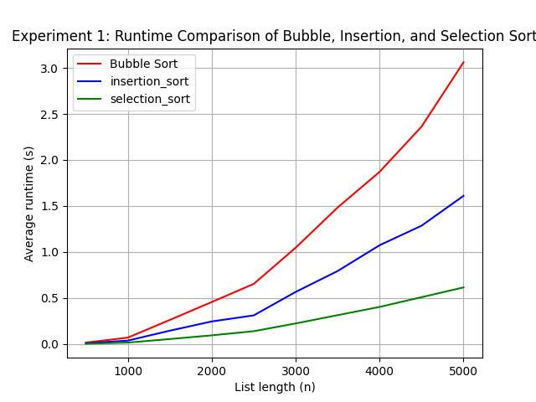
Graph:

Conclusion:
The experiment results demonstrate that all three algorithms (Bubble, Insertion, and Selection Sort) exhibit a quadratic growth trend (O(N^2)) as the list length increases. Selection Sort consistently performed the best (had the lowest runtime) in our experiment, followed by Insertion Sort, while Bubble Sort was the slowest. The reason why this happens is selection sort always does N swaps, because when it’s trying to find min it does not do any swaps, while insertion sort, it could do up to N^2/2 swaps(averagely N^2/4), but it has early stop, so it’s still faster than origin bubble sort. All those sorts have fast grow runtime, that’s why they are called bad sorts.

Experiment 2: Origin vs better bubble sort / selection sort
Input Data:
- list lengths : [500, 1000, 1500, 2000, 2500, 3000, 3500, 4000, 4500, 5000]
Same as experiment1

- max value : 5000
Same as experiment1

- runs : 20
Same as experiment1

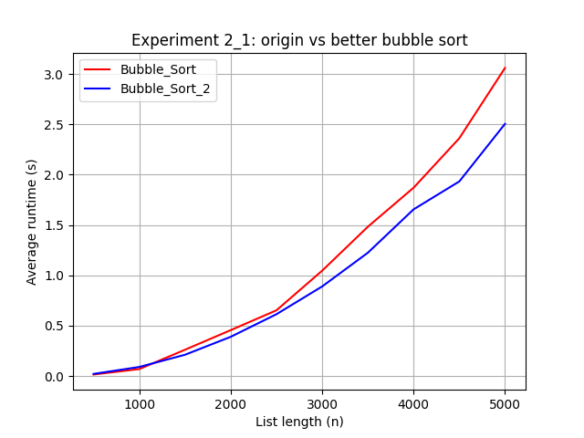
Graph:

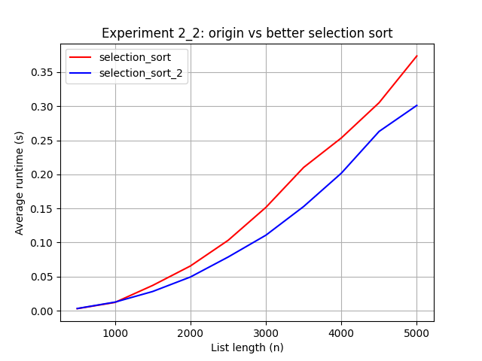

Conclusion:
By using shifts instead of swaps and adding early stop in bubble sort, we can see it’s strictly faster than the origin bubble sort because shift is just one move and swap takes three moves, so shift is faster than swap and the function will exit right after the function is sorted instead of always going through the whole list. For selection sort, although the swap time isn’t changed, the runtime for the loop is halved so the total run time is also reduced.

Experiment 3: Effect of Near-Sortedness on Bad Sorting Algorithms
Input Data:
- fixed list length : 5000
As the lab mentioned

- max value : 5000
Same as experiment1

- runs : 20
Same as experiment1

- swaps : [0, 10, 50, 100, 200, 500, 1000, 2000]
Starting for 0 which is an already sorted list, until swap 2000 time for a somehow messy list

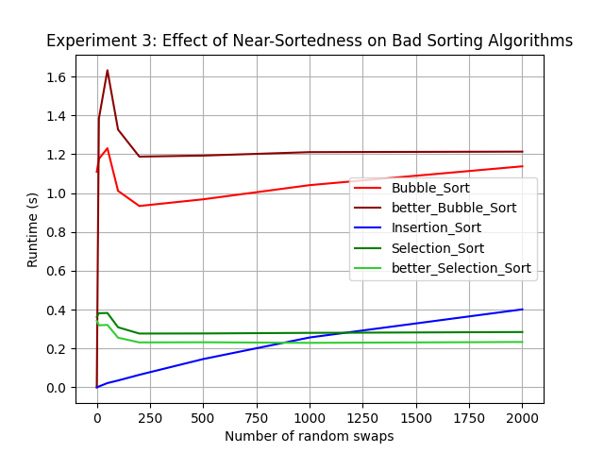
Graph:

Conclusion:
The experiment results reveal distinct behaviors for each algorithm as the list transitions from "perfectly sorted" (swaps=0) to "partially sorted". With the impact of Early Termination, both Insertion Sort and better Bubble Sort exhibit almost 0 runtimes at swaps=0. This confirms that their early exit correctly identifies the sorted state and terminates immediately , unlike the non-adaptive Selection and original Bubble sorts. But for better Bubble Sort, as the number of swaps increases, better Bubble Sort rapidly degrades and eventually becomes the slowest algorithm, performing even worse than the original Bubble Sort. This result is due to the overhead of the Shift operation. While the original Bubble Sort only swaps those ones needed, the better version requires rewriting memory for every element in the unsorted portion during each pass. In Python, this repeated assignment overhead outweighs the benefits of skipping swaps when the list is only partially sorted. For Insertion Sort Consistency, it shows a steady, linear increase in runtime relative to the number of swaps. This aligns with its theoretical property where runtime is proportional to the number of inversions, making it the most robust choice for near-sorted data. While for both versions of Selection Sort remain largely unaffected by the degree of sortedness, appearing as flat lines. This is because Selection Sort blindly performs a fixed number of comparisons (O(N^2)) regardless of the initial order. However, the optimized bidirectional version consistently outperforms the original due to halving the number of loop iterations.

Experiment 4: Runtime Comparison of Heap, Merge and Quick Sort
Input Data:
- list lengths : [2 ** x for x in range(10)]
Using the power of 2s length test better reflects the growth trend of different algorithms.

- max value : 10000
Reduce data duplication by using the maximum value that is significantly larger than the list length.

- runs : 50
The test of each list is repeated 50 times to reduce noise and random fluctuation.

Graph: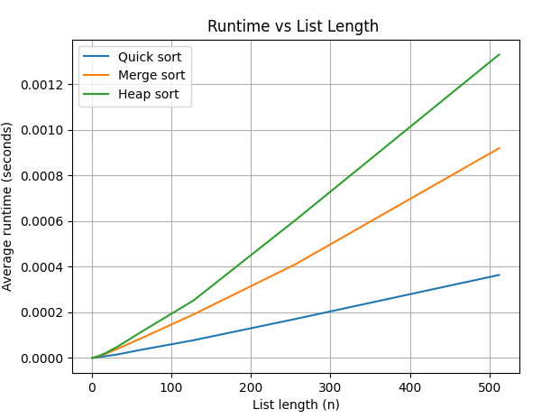
Figure: Average Runtime vs List Length for good sorts

Conclusion:
All three algorithms exhibit an approximate performance of O(n log⁡n). The results show that quick sort has a smaller average runtime than the other two algorithms across the tested input list sizes. The merge sort curve is flatter than the other two, illustrating its stable performance. Heap sort has the highest runtime among the three. As a result, quick sort demonstrates the best overall performance among the three algorithms.

Experiment 5: Runtime Comparison of Heap, Merge and Quick Sort in different unsorted levels

Input Data:
- list lengths : 2000
The length is fixed at 2000 to serve as a control variable.

- max value : 20000
Using a larger maximum value that is significantly larger than the list length to reduce data duplication.

- runs : 50
The test of each list is repeated 50 times to reduce noise and random fluctuation.

- swap_values = [2 ** x for x in range(10)]
This range can be used to observe the overall change in quick sort runtime.

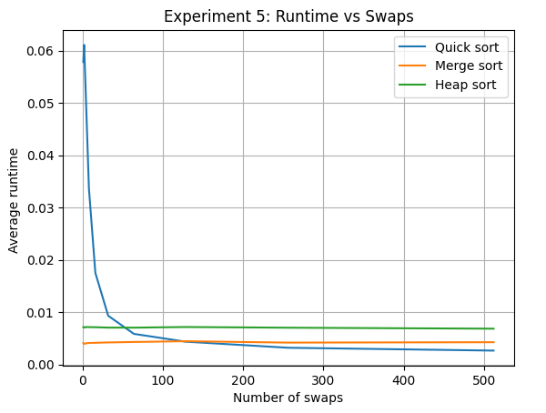
Graph:
Figure: Average Runtime vs Swaps

Conclusion:
The graph shows that quick sort is highly sensitive to the sorted level of lists. When the number of swaps is small, quick sort performs significantly worse than the other two. However, as the number of swaps increases around 125 swaps, it outperforms the other algorithms. In contrast, the runtimes of merge sort and heap sort remain stable across different swaps.

Experiment 6: Traditional Quick sort vs Dual Pivot Quick sort
Input Data:
- list lengths : [2 ** x for x in range(20)]
Using power of 2s includes a wide range of lengths, better reflects the growth trend of the two algorithms.

- max value : 100000
Using a larger maximum value that is significantly larger than the list length to reduce data duplication.

- runs : 20
The test of each list is repeated 20 times to reduce noise and random fluctuation

Graph: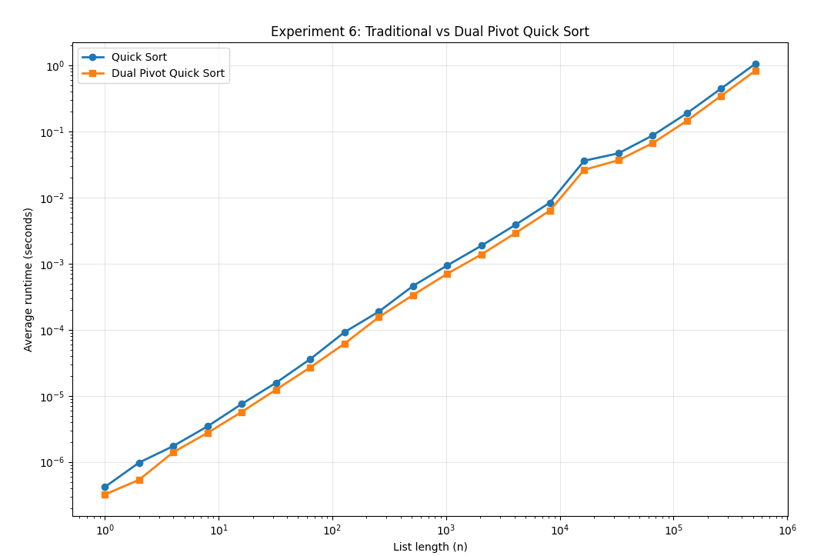
Figure: Traditional vs Dual Pivot Quick Sort

Conclusion:
The graph shows that traditional quick sort and dual-pivot quick sort demonstrates similar growth trends across all tested input sizes. However, the dual-pivot implementation has a slightly lower runtime than the traditional version. The speed up is possibly due to the dual-pivot version having a relatively more balanced partition and reduced recursion depth.

Experiment 7: Traditional Quick sort vs Dual Pivot Quick sort
Input Data:
- list lengths : [2 ** x for x in range(20)]
Using power of 2s includes a wide range of lengths, better reflects the growth trend of the two algorithms.

- max value : 200000
Using a larger maximum value that is significantly larger than the list length to reduce data duplication.

- runs : 20
The test of each list is repeated 20 times to reduce noise and random fluctuation

Graph: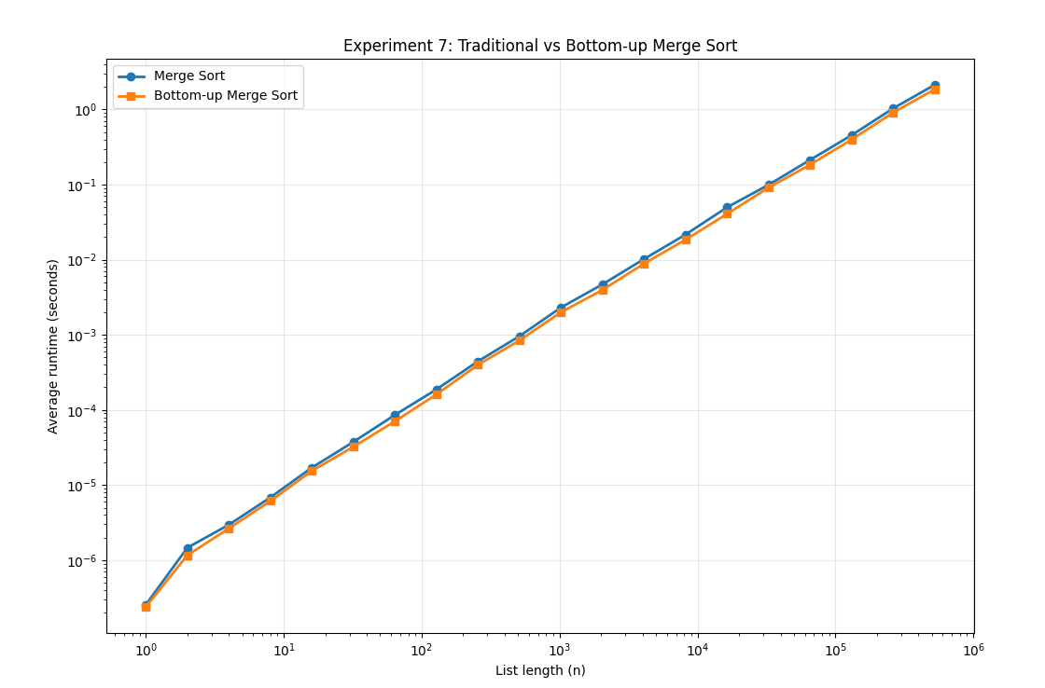
Figure: Traditional vs Bottom-Up Merge Sort

Conclusion:
The graph shows that traditional merge sort and bottom-up merge sort have very similar performance trends across all tested input sizes. The bottom-up version exhibits only a very limited runtime improvement, possibly because the main cost of merge sort lies in the linear merge operations rather than recursion itself.

Experiment 8: Insertion sort vs Merge and Quick sort for small lists
Input Data:
- list lengths : [x for x in range(140)]
This tested range is sufficient to capture the transition where insertion sort goes from being faster than the two good sorting algorithms to outperform by them.

- max value : 10000
Using a larger maximum value that is significantly larger than the list length to reduce data duplication.

- runs : 400
The test of each list is repeated 400 times to reduce noise and fluctuations.

Graph: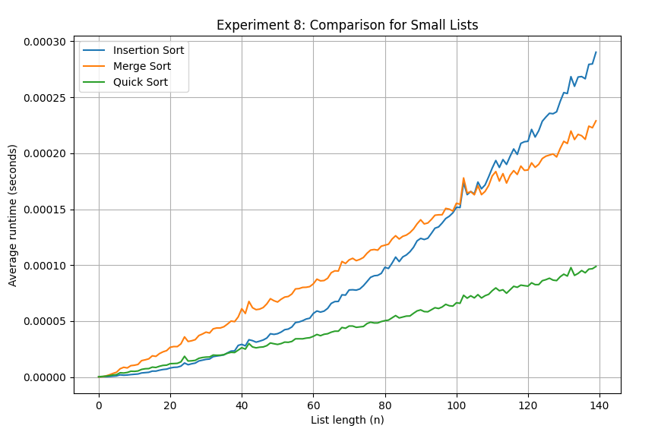
Figure: Insertion Sort vs Quick Sort & MergeSort

Conclusion:
According to the graph, when the list size is below approximately 35, insertion sort performs better than merge sort and quick sort. However, once the list size reaches around 105, insertion sort is outperformed by the other two algorithms. This demonstrates the different growth behaviors of good and bad sorting algorithms: as the list size becomes sufficiently large, good sorting algorithms eventually outperform bad ones.

Appedix
Experiment 1: bad_sorts_experiments.py
Experiment 2: bad_sorts_experiments.py
Experiment 3: bad_sorts_experiments.py
Experiment 4: Experiment4.py
Experiment 5: Experiment5.py
Experiment 6: experience_6.py
Experiment 7: experience_7.py
Experiment 8: experience_8.py

