# Work Breakdown Structure (WBS)

|  |  |  |
| --- | --- | --- |
| WBS ID | Phase / Task | Description |
| 1 | Project Planning | Initial preparation and planning for the project |
| 1.1 | Write the project plan | Define goals, scope, requirements, WBS, and schedule |
| 1.2 | Set up GitHub repository | Initialize repository, branches, README, and .gitignore |
| 1.3 | Set up Scrum methodology | Prepare product backlog, assign roles |
| 1.4 | Task and role assignment | Distribute responsibilities among team members |
| 2 | Hardware Setup | Assemble the robot car and connect hardware components |
| 2.1 | Hardware testing | Check if motors, sensors, and power supply work properly |
| 3 | Software Development | Develop control logic and functionality for the robot |
| 3.1 | Basic movement control code | Code for moving forward, backward, left, right |
| 3.2 | Implement obstacle avoidance | Use sensor data to avoid obstacles while navigating |
| 3.3 | Path planning and navigation | Navigate from origin to destination in the maze |
| 3.4 | Route recording and communication | Record the path taken and transmit data to a computer |
| 4 | Testing and Optimization | Test the integrated system and improve performance |
| 4.1 | Unit testing of functions | Test each module separately |
| 4.2 | Full maze traversal test | Run the car in an actual maze and evaluate performance |
| 4.3 | Optimize route and performance | Refine navigation strategy based on previous runs |
| 5 | Documentation | Prepare all required project documents |
| 5.1 | Project plan document | Document the full project scope and schedule |
| 5.2 | Design report | Describe hardware setup, architecture, and software design |
| 5.3 | Testing report | Summarize testing process, results, and bug fixes |
| 6 | Final Presentation | Prepare for final project showcase |
| 6.1 | Create presentation slides | Highlight goals, methods, results, and lessons learned |
| 6.2 | Set up live robot demonstration | Prepare robot run-through, battery, maze layout |
| 6.3 | Team reflection and project review | Discuss lessons learned, challenges, and team feedback |

Sprint1

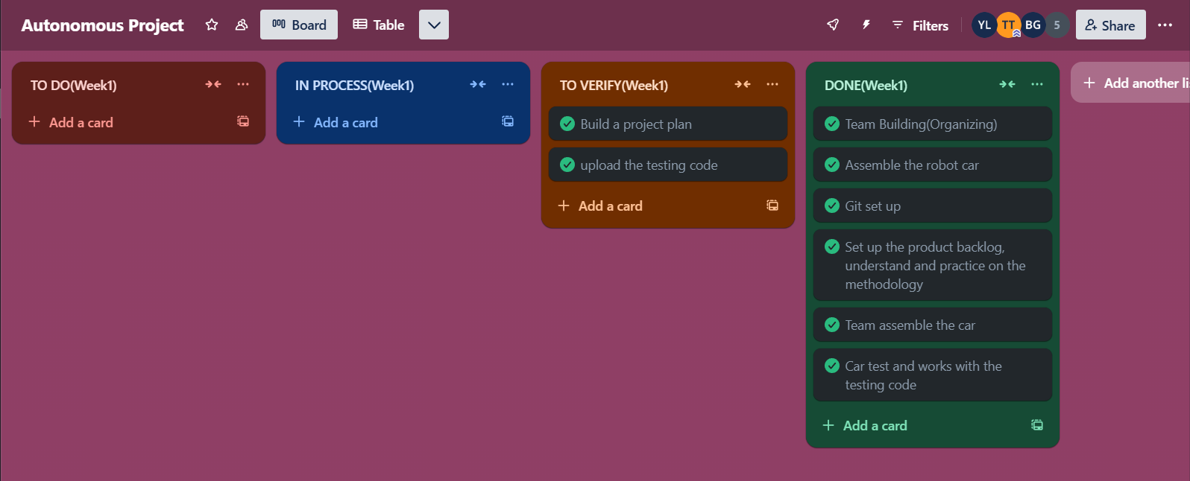

Team building: most of the group member come and get to know each other

Assemble the robot car: all members assemble the robot car as the given guide. Marius and Bogdan do the further changes to make the car meet require.

Git set up: Yiyang Li build a reposotory and invite other people.

Car test and works with the testing code: Marius and Bogdan do the test

Project plan: all of the group member together fill in the project plan.

Product backlog: Yiyang Li make the product backlog