此处具体算一下欧拉伽马常数是怎么得到的。
在，
$$ξ(1)=\sum_{n=1}^{i^{2}+1}{\frac{1}{n}}$$
中，$n$和$n+1$之间的1个单位，被平分成$i^{2}$份，如果周期是$i^{2}+1$，但这个平分的每一份都取边界值的倒数为结果。而在，
$$\int_{1}^{∞}{\frac{1}{x}}dx=\int_{1}^{i^{2}+1}{\frac{1}{x}}dx={\left(\ln{x}\right)}_{1→i^{2}+1}$$
过程中，每一个单位也被平分成$i^{2}$份，周期也是$i^{2}+1$，但是这平分的每一份则取对应数值的倒数为结果。所以，对于积分形式，
$$\int_{1}^{i^{2}+1}{\frac{1}{x}}dx$$
来说，整个区间被分成，
$$\left(i^{2}+1-1\right)∙i^{2}=i^{2}∙i^{2}=i^{4}$$
份，每一份的单位是$\frac{1}{i^{4}}$。
$$\int_{1}^{i^{2}+1}{\frac{1}{x}}dx=\sum_{n=1}^{i^{4}+1}{\frac{1}{n}}\frac{1}{i^{4}}$$

而对于求和形式，
$$ξ\left(1\right)=\sum_{n=1}^{i^{2}+1}{\frac{1}{n}}$$
来说，整个区间被分成，
$$\left(i^{2}+1-1\right)∙1=i^{2}∙1=i^{2}$$
份，每一份的单位都是1。相比较而言，积分形式的对应的求和份数更多，细节更细，
$$\int_{1}^{i^{2}+1}{\frac{1}{x}}dx=\sum_{n=1}^{i^{4}+1,1}{\frac{1}{n}\frac{1}{i^{4}}}$$
$$ξ\left(1\right)=\sum_{n=1}^{i^{4}+1,i^{2}}{\frac{1}{n}\frac{1}{i^{2}}}$$
在每个$n$到$n+1$的区间，积分形式为，
$$S_{2}=\frac{1}{i^{4}}\left(\frac{1}{n}+\frac{1}{n+\frac{1}{i^{2}}\left(n+1-n\right)}+\frac{1}{n+\frac{2}{i^{2}}\left(n+1-n\right)}+…+\frac{1}{n+\frac{i^{2}}{i^{2}}\left(n+1-n\right)}\right)=\left(\frac{1}{n}\frac{1}{i^{4}}+\frac{1}{n+\frac{1}{i^{2}}\left(n+1-n\right)}\frac{1}{i^{4}}+\frac{1}{n+\frac{2}{i^{2}}\left(n+1-n\right)}\frac{1}{i^{4}}+…+\frac{1}{n+\frac{i^{2}}{i^{2}}\left(n+1-n\right)}\frac{1}{i^{4}}\right)$$
将内部精度提升到$\frac{1}{i^{4}}$
$$S_{2}=\frac{1}{i^{4}}\left(\frac{1}{n}+\frac{1}{n+\frac{1}{i^{4}}\left(n+1-n\right)}+\frac{1}{n+\frac{2}{i^{4}}\left(n+1-n\right)}+…+\frac{1}{n+\frac{i^{4}}{i^{4}}\left(n+1-n\right)}\right)=\left(\frac{1}{n}\frac{1}{i^{4}}+\frac{1}{n+\frac{1}{i^{4}}\left(n+1-n\right)}\frac{1}{i^{4}}+\frac{1}{n+\frac{2}{i^{4}}\left(n+1-n\right)}\frac{1}{i^{4}}+…+\frac{1}{n+\frac{i^{4}}{i^{4}}\left(n+1-n\right)}\frac{1}{i^{4}}\right)$$

求和形式为，
$$S_{1}=\left(\frac{1}{n}\frac{1}{i^{2}}+\frac{1}{n}\frac{1}{i^{2}}+…+\frac{1}{n}\frac{1}{i^{2}}\right)=\left(\frac{1}{n}\frac{1}{i^{2}}i^{2}\right)=\frac{1}{i^{2}}\frac{1}{n}i^{2}$$
将$S_{1}$的每个部分都提升精度到$\frac{1}{i^{4}}$
$$S_{1}=\left(\frac{1}{n}\frac{1}{i^{4}}+\frac{1}{n}\frac{1}{i^{4}}+…+\frac{1}{n}\frac{1}{i^{4}}\right)=\left(\frac{1}{n}\frac{1}{i^{4}}i^{4}\right)=\frac{1}{i^{4}}\frac{1}{n}i^{4}$$
以最高精度计算面积的差值是，
$$S_{d}=S_{1}-S_{2}=\left(\frac{1}{i^{4}}\frac{1}{n}i^{4}\right)-\left(\frac{1}{n}\frac{1}{i^{4}}+\frac{1}{n+\frac{1}{i^{2}}\left(n+1-n\right)}\frac{1}{i^{4}}+\frac{1}{n+\frac{2}{i^{2}}\left(n+1-n\right)}\frac{1}{i^{4}}+…+\frac{1}{n+\frac{i^{2}}{i^{2}}\left(n+1-n\right)}\frac{1}{i^{4}}\right)=i^{2}\left(\frac{1}{n+\frac{1}{i^{4}}}+\frac{1}{n+\frac{2}{i^{4}}}+…+\frac{1}{n+\frac{i^{4}-2}{i^{4}}}+\frac{1}{n+\frac{i^{4}-1}{i^{4}}}+\frac{1}{n+\frac{i^{4}}{i^{4}}}\right)=i^{2}\left(\frac{1}{n-1}+\frac{1}{n-2}+…+\frac{1}{n+1}\right)$$
每一个微小面积，
$$S_{k}=\frac{1}{n}\frac{1}{i^{4}}-\frac{1}{n+\frac{k}{i^{4}}\left(n+1-n\right)}\frac{1}{i^{4}}=\left(\frac{1}{n}-\frac{1}{n+\frac{k}{i^{4}}\left(n+1-n\right)}\right)\frac{1}{i^{4}}=\left(\frac{1}{n}-\frac{1}{n+\frac{k}{i^{4}}×1}\right)\frac{1}{i^{4}}=\left(\frac{1}{n}-\frac{1}{n+\frac{k}{1}×1}\right)\frac{1}{i^{4}}=\left(\frac{1}{n}-\frac{1}{n+k}\right)\frac{1}{i^{4}}=\left[\frac{n+k-n}{n\left(n+k\right)}\right]\frac{1}{i^{4}}=\left[\frac{k}{n(n+k)}\right]\frac{1}{i^{4}}$$
$$S_{d}=\sum{S_{k}}=\sum_{k=1}^{i^{4}}{\frac{k}{n(n+k)}}\frac{1}{i^{4}}$$
以最高精度计算的总面积差为，
$$∆S=\sum{S_{d}}=\sum_{n=1}^{i^{2}}{\sum_{k=1}^{i^{4}}{\frac{k}{n\left(n+k\right)}}\frac{1}{i^{4}}}=\sum_{n=1}^{i^{2}}{\sum_{k=1}^{i^{4}}{\frac{k}{n\left(n+k\right)}}}$$
这里的内层分的更细，外层没有那么细。回到微小面积，
$$S_{n,k}=\frac{1}{n}\frac{1}{i^{4}}-\frac{1}{n+\frac{k}{i^{4}}\left(n+1-n\right)}\frac{1}{i^{4}}=\left(\frac{1}{n}-\frac{1}{n+\frac{k}{i^{4}}\left(n+1-n\right)}\right)\frac{1}{i^{4}}=\left(\frac{1}{n}-\frac{1}{n+\frac{k}{i^{4}}×1}\right)\frac{1}{i^{4}}$$
$$i^{4}+1=N$$
$$i^{4}=N-1$$
$$S_{n,k}=\left(\frac{1}{n}-\frac{1}{n+\frac{k}{i^{4}}×1}\right)\frac{1}{i^{4}}=\left(\frac{1}{n}-\frac{1}{n+\frac{k}{N-1}}\right)\frac{1}{N-1}=\left(\frac{1}{n}-\frac{1}{\frac{n(N-1)+k}{N-1}}\right)\frac{1}{N-1}=\left(\frac{1}{n}-\frac{N-1}{n(N-1)+k}\right)\frac{1}{N-1}=\frac{1}{n(N-1)}-\frac{1}{n\left(N-1\right)+k}=\frac{n\left(N-1\right)+k-n\left(N-1\right)}{\left[n\left(N-1\right)+k\right]n\left(N-1\right)}=\frac{k}{[n\left(N-1\right)+k]n\left(N-1\right)}$$
$$S_{d}=\sum{S_{k}}=\sum_{k=1}^{i^{4}}{\frac{k}{\left(N-1\right)[n\left(N-1\right)+k]n}}=\sum_{k=1}^{N-1}{\frac{k}{\left(N-1\right)\left[n\left(N-1\right)+k\right]n}}$$
以最高精度计算的总面积差为，
$$∆S=\sum{S_{d}}=\sum_{n=1}^{\sqrt{N-1}}{\sum_{k=1}^{N-1}{\frac{k}{\left(N-1\right)\left[n\left(N-1\right)+k\right]n}}}=\frac{1}{\left(N-1\right)}\sum_{n=1}^{\sqrt{N-1}}{\sum_{k=1}^{N-1}{\frac{k}{n^{2}\left(N-1\right)+nk}}}$$
$$i^{2}=\sqrt{N-1}=S$$
$$i^{4}=N-1=S^{2}$$
$$∆S=\sum{S_{d}}=\frac{1}{S^{2}}\sum_{n=1}^{S}{\sum_{k=1}^{S^{2}}{\frac{k}{n^{2}S^{2}+nk}}}$$
这个公式用程序验证，得到很好的结果。
static double GetGamma(long S = 10000)
{
var q = S * S;
var s = 0.0;
for (var n = 1L; n <= S; n++)
{
for (var k = 1L; k <= q; k++)
{
s += k / (1.0 * n * n * q + 1.0 * n * k);
}
}
return s / q;
}
$$r=0.5771647389914232$$
$$γ=0.5772156649015329$$
$$\frac{γ-r}{γ}=\frac{0.5772156649015329-0.5771647389914232}{0.5772156649015329}=8.82268×{10}^{-5}$$

在程序运行中观察到外层循环是否为$S^{2}$对精度的影响有限。
下面用求和公式，反推积分公式，
$$∆S=\sum{S_{d}}=\frac{1}{S^{2}}\sum_{n=1}^{S}{\sum_{k=1}^{S^{2}}{\frac{k}{n^{2}S^{2}+nk}}}$$
$$γ=\frac{1}{i^{4}}\int_{1}^{i^{2}+1}{\int_{1}^{i^{4}+1}{\frac{k}{n^{2}i^{4}+nk}dn}}dk=\frac{1}{i^{4}}\int_{1}^{i^{2}+1}{{\left[\ln{n}-\ln\left(k+ni^{4}\right)\right]}_{1→i^{4}}}dk=\frac{1}{i^{4}}\int_{1}^{i^{2}+1}{\left[\ln{i^{4}}-\ln\left(k+i^{4}i^{4}\right)+\ln{1}-\ln\left(k+i^{4}\right)\right]}dk=\frac{1}{i^{4}}{\left[2k+k\ln{i^{4}}-\left(k+i^{4}\right)\ln\left(k+i^{4}\right)-\left(k+i^{8}\right)\ln\left(k+i^{8}\right)\right]}_{1→i^{2}+1}$$
$$γ=\frac{1}{i^{4}}\int_{1}^{i^{2}+1}{\int_{1}^{i^{4}+1}{\frac{k}{n^{2}i^{4}+nk}dn}}dk=\frac{1}{i^{4}}\int_{1}^{i^{2}+1}{{\left[\ln{n}-\ln\left(k+ni^{4}\right)\right]}_{1→i^{4}+1}}dk=\frac{1}{i^{4}}\int_{1}^{i^{2}+1}{\left[\ln{(i^{4}+1)}-\ln\left(k+(i^{4}+1)i^{4}\right)+\ln{1}-\ln\left(k+i^{4}\right)\right]}dk=\frac{1}{i^{4}}{\left[2k+k\ln{i^{4}}-\left(k+i^{4}\right)\ln\left(k+i^{4}\right)-\left(k+i^{8}\right)\ln\left(k+i^{8}\right)\right]}_{1→i^{2}+1}$$
$$γ=\frac{1}{i^{4}}\left\{\left[2\left(i^{2}+1\right)+\left(i^{2}+1\right)\ln{i^{4}}-\left(i^{2}+1+i^{4}\right)\ln\left(i^{2}+1+i^{4}\right)-\left(i^{2}+1+i^{8}\right)\ln\left(i^{2}+1+i^{8}\right)\right]-\left[2+\ln{i^{4}}-\left(1+i^{4}\right)\ln\left(1+i^{4}\right)-\left(1+i^{8}\right)\ln\left(1+i^{8}\right)\right]\right\}=\frac{1}{1}\left\{\left[2\left(-1+1\right)+\left(-1+1\right)\ln{1}-\left(-1+1+1\right)\ln\left(-1+1+1\right)-\left(-1+1+1\right)\ln\left(-1+1+1\right)\right]-\left[2+\ln{1}-\left(1+1\right)\ln\left(1+1\right)-\left(1+1\right)\ln\left(1+1\right)\right]\right\}=\left[0+\left(0\right)\ln{1}-\left(1\right)\ln\left(1\right)-\left(1\right)\ln\left(1\right)\right]-\left[2+\ln{1}-\left(2\right)\ln\left(2\right)-\left(2\right)\ln\left(2\right)\right]=4\ln{2}-2=2\left(\ln{2}-1\right)=-0.6137056388801094$$
按照同样的步骤计算，如果积分上限减小1，则结果增大为2倍，
$$\frac{1}{i^{4}}\int_{1}^{i^{2}+1}{\int_{1}^{i^{4}+1}{\frac{k}{n^{2}i^{4}+nk}dn}}dk=\frac{1}{2}\left[\frac{1}{i^{4}}\int_{1}^{i^{2}}{\int_{1}^{i^{4}}{\frac{k}{n^{2}i^{4}+nk}dn}}dk\right]=\frac{1}{2}\left[4\left(\ln{2}-1\right)\right]$$
观察完全不替换虚数单位的情况，
$$\frac{1}{i^{4}}{\left[2k+k\ln{i^{4}}-\left(k+i^{4}\right)\ln\left(k+i^{4}\right)-\left(k+i^{8}\right)\ln\left(k+i^{8}\right)\right]}_{1→i^{2}+1}=\frac{1}{i^{4}}\left\{\left[2\left(i^{2}+1\right)+\left(i^{2}+1\right)\ln{i^{4}}-\left(i^{2}+1+i^{4}\right)\ln\left(i^{2}+1+i^{4}\right)-\left(i^{2}+1+i^{8}\right)\ln\left(i^{2}+1+i^{8}\right)\right]-\left[2+\ln{i^{4}}-\left(1+i^{4}\right)\ln\left(1+i^{4}\right)-\left(1+i^{8}\right)\ln\left(1+i^{8}\right)\right]\right\}$$
这里出现不可消去的$i^{8}$，这说明这个运算过程是不可能在一个虚数单位周期中闭合完成的。也就是说这个运算的结果不唯一，而且受到相邻周期的虚数单位的实际数值大小的影响。如果一定解出来，这个数值就是，
$$2\left(\ln{2}-1\right)=-0.6137056388801094$$
为了进一步提高精度，且兼容符号运算和数值运算，把积分中的虚数单位相关的项替换成指数形式，
$$γ=\frac{1}{i^{4}}\int_{1}^{i^{2}+1}{\int_{1}^{i^{4}+1}{\frac{k}{n^{2}i^{4}+nk}dn}}dk$$
替换为，
$$γ=\frac{1}{e^{2x}}\int_{1}^{e^{x}+1}{\int_{1}^{e^{2x}+1}{\frac{k}{n^{2}e^{2x}+nk}dn}}dk$$
可以看出，若要实现积分和求和的对齐，需要
$$i^{4}=e^{2x}$$
也就是说，获得结果的点的横坐标为，
$$x=0$$
具体计算，
$$γ=\frac{1}{e^{2x}}\int_{1}^{e^{x}+1}{\int_{1}^{e^{2x}+1}{\frac{k}{n^{2}e^{2x}+nk}dn}}dk=\frac{1}{e^{2x}}\int_{1}^{e^{x}+1}{{\left[\ln{n}-\ln\left(k+ne^{x}\right)\right]}_{1→e^{2x}+1}}dk=\frac{1}{e^{2x}}\int_{1}^{e^{x}+1}{{\left[\ln{\frac{n}{\left(k+ne^{x}\right)}}\right]}_{1→e^{2x}+1}}dk=\frac{1}{e^{2x}}\int_{1}^{e^{x}+1}{\left[\ln{\frac{e^{2x}+1}{\left(k+(e^{2x}+1)e^{x}\right)}}-\ln{\frac{1}{\left(k+e^{x}\right)}}\right]}dk=\frac{1}{e^{2x}}\int_{1}^{e^{x}+1}{\left[\ln{\frac{(e^{2x}+1)\left(k+e^{x}\right)}{\left(k+e^{3x}+e^{x}\right)}}\right]}dk=\frac{1}{e^{2x}}{\left[\ln{\frac{\left(e^{2x}+1\right)\left(k+e^{x}\right)}{\left(k+e^{3x}+e^{x}\right)}}\right]}_{1→e^{x}+1}=\frac{1}{e^{2x}}\left[\ln{\frac{\left(e^{2x}+1\right)\left(e^{x}+1+e^{x}\right)}{\left(e^{x}+1+e^{3x}+e^{x}\right)}}-\ln{\frac{\left(e^{2x}+1\right)\left(1+e^{x}\right)}{\left(1+e^{3x}+e^{x}\right)}}\right]=\frac{1}{e^{2x}}\left[\ln{\frac{\left(e^{2x}+1\right)\left(e^{x}+1+e^{x}\right)\left(1+e^{3x}+e^{x}\right)}{\left(e^{x}+1+e^{3x}+e^{x}\right)\left(e^{2x}+1\right)\left(1+e^{x}\right)}}\right]=\frac{1}{e^{2x}}\left[\ln{\frac{\left(e^{x}+1+e^{x}\right)\left(1+e^{3x}+e^{x}\right)}{\left(e^{x}+1+e^{3x}+e^{x}\right)\left(1+e^{x}\right)}}\right]=\frac{1}{e^{2x}}\ln{\frac{1+3e^{x}+2e^{2x}+e^{3x}+2e^{4x}}{1+3e^{x}+2e^{2x}+e^{3x}+1e^{4x}}}=\frac{1}{e^{2x}}\ln{(1+\frac{e^{4x}}{1+3e^{x}+2e^{2x}+e^{3x}+e^{4x}})}$$
它的图像为，
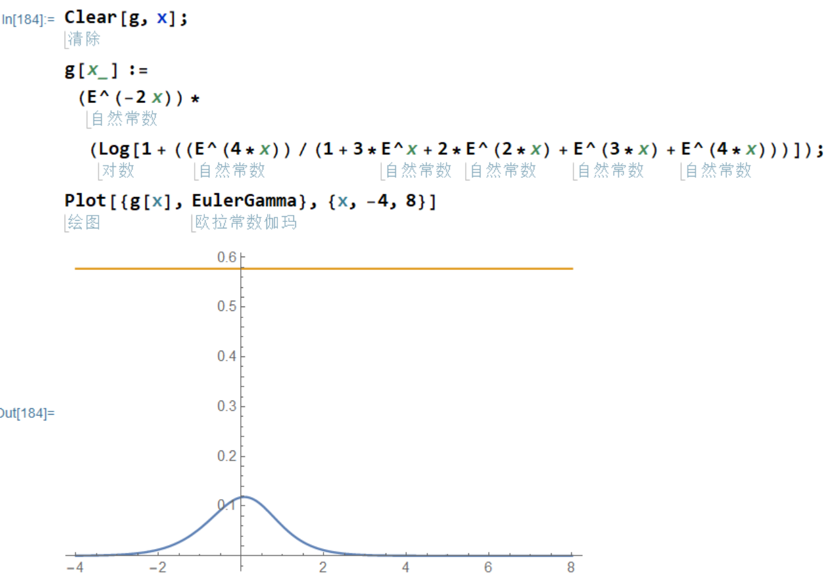
它的最高点以及其数值在，
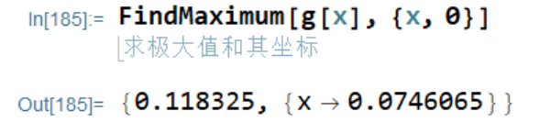
当$x=0$,
$$γ\left(0\right)=\frac{1}{e^{2x}}\ln\left(1+\frac{e^{4x}}{1+3e^{x}+2e^{2x}+1e^{3x}+e^{4x}}\right)=\frac{1}{e^{2∙0}}\ln\left(1+\frac{e^{4∙0}}{1+3e^{0}+2e^{2∙0}+1e^{3∙0}+e^{4∙0}}\right)=\frac{1}{1}\ln\left(1+\frac{1}{1+3+2+1+1}\right)=\ln\left(1+\frac{1}{8}\right)=\ln{\frac{9}{8}}$$
做数值计算和对比，得到，
$$γ=\frac{7^{2}}{10} γ\left(0\right)=\frac{7^{2}}{10}\ln{\frac{9}{8}}$$
对于原方程，和0相等价的还有，
$$x=kπi$$
如果，
$$x=πi$$
$$γ\left(πi\right)=\frac{1}{e^{2x}}\ln\left(1+\frac{e^{4x}}{1+3e^{x}+2e^{2x}+1e^{3x}+e^{4x}}\right)=\frac{1}{e^{2πi}}\ln\left(1+\frac{e^{4πi}}{1+3e^{πi}+2e^{2πi}+1e^{3πi}+e^{4πi}}\right)=\frac{1}{1}\ln\left(1+\frac{1^{2}}{1-3+2-1+1^{2}}\right)=\frac{1}{1}\ln\left(1+\frac{1}{0}\right)=\ln\left(\frac{0+1}{0}\right)=\ln{\frac{1}{0}}$$
可见此时函数具有无法解出的值，考虑到涉及虚数单位的8次幂，我们开始观察第二个周期，如果，
$$x=2πi$$
$$γ\left(2πi\right)=\frac{1}{e^{2x}}\ln\left(1+\frac{e^{4x}}{1+3e^{x}+2e^{2x}+1e^{3x}+e^{4x}}\right)=\frac{1}{e^{2∙2πi}}\ln\left(1+\frac{e^{4∙2πi}}{1+3e^{1∙2πi}+2e^{2∙2πi}+1e^{3∙2πi}+e^{4∙2πi}}\right)=\frac{1}{e^{4πi}}\ln\left(1+\frac{e^{8πi}}{1+3e^{2πi}+2e^{4πi}+1e^{6πi}+e^{8πi}}\right)=\frac{1}{1^{2}}\ln\left(1+\frac{1^{2}}{1+3∙1+2∙1^{2}+1∙1^{3}+1^{4}}\right)=\frac{1}{1^{2}}\ln\left(1+\frac{1}{8}\right)=\ln{\frac{9}{8}}$$
如果返回到前一个周期，
$$x=-πi$$
$$γ\left(-πi\right)=\frac{1}{e^{2x}}\ln\left(1+\frac{e^{4x}}{1+3e^{x}+2e^{2x}+1e^{3x}+e^{4x}}\right)=\frac{1}{e^{-2πi}}\ln\left(1+\frac{e^{-4πi}}{1+3e^{-πi}+2e^{-2πi}+1e^{-3πi}+e^{-4πi}}\right)=\frac{1}{\frac{1}{1}}\ln\left(1+\frac{\frac{1}{1^{2}}}{1-\frac{3}{1}+\frac{2}{1}-\frac{1}{1}+\frac{1^{2}}{1}}\right)=\frac{1}{1}\ln\left(1+\frac{1}{0}\right)=\ln\left(\frac{0+1}{0}\right)=\ln{\frac{1}{0}}$$
结果和$γ\left(πi\right)$相同。如果代入虚数单位，
$$x=\frac{πi}{2}$$
$$γ\left(\frac{πi}{2}\right)=\frac{1}{e^{2x}}\ln\left(1+\frac{e^{4x}}{1+3e^{x}+2e^{2x}+1e^{3x}+e^{4x}}\right)=\frac{1}{e^{2\frac{πi}{2}}}\ln\left(1+\frac{e^{4\frac{πi}{2}}}{1+3e^{\frac{πi}{2}}+2e^{2\frac{πi}{2}}+1e^{3\frac{πi}{2}}+e^{4\frac{πi}{2}}}\right)=\frac{1}{-1}\ln\left(1+\frac{1}{1+3i-2-i+1}\right)=-\ln\left(1+\frac{1}{2i}\right)=-\ln\left(1-\frac{i}{2}\right)=-0.11157177565710485 +0.4636476090008061i$$
考虑半个周期的情况，如果，
$$x=-\frac{πi}{2}$$
$$γ\left(-\frac{πi}{2}\right)=\frac{1}{e^{2x}}\ln\left(1+\frac{e^{4x}}{1+3e^{x}+2e^{2x}+1e^{3x}+e^{4x}}\right)=\frac{1}{e^{-2\frac{πi}{2}}}\ln\left(1+\frac{e^{-4\frac{πi}{2}}}{1+3e^{-\frac{πi}{2}}+2e^{-2\frac{πi}{2}}+1e^{-3\frac{πi}{2}}+e^{-4\frac{πi}{2}}}\right)=\frac{1}{\frac{1}{-1}}\ln\left(1+\frac{1}{1+\frac{3}{i}-\frac{2}{1}-\frac{1}{i}+\frac{1}{1}}\right)=-1\ln\left(1+\frac{i}{2}\right)=-0.11157177565710485 -0.4636476090008061ⅈ$$
$$γ\left(±\frac{πi}{2}\right)=-0.11157177565710485 ±0.4636476090008061ⅈ$$
这些结果为复数。分析了几种特殊情况，可以认为，解都在，
$$x=2kπi,k∈N$$
也就是对于原方程来说的，
$$x=4kπi,k∈N$$
换句话说，这个函数的结果，在奇数周期（包括自身）发散（结果为$\ln{\frac{1}{0}}$），在（相对于当前周期的）偶数周期收敛到定值，且$\ln{\frac{9}{8}}$意味着若要计算精确的结果，需要穿出这个偶数周期，到达邻接的奇数周期，也就是说，完成这个精确值的计算，需要跨越三个周期，
$$γ\left(2kπi\right)=\ln{\frac{9}{8}},k∈N$$
所以，
$$γ=\frac{7^{2}}{10} γ\left(2kπi\right)=\frac{7^{2}}{10}\ln{\frac{9}{8}},k∈N$$
实际上就是欧拉伽马常数的真实值。在数值计算过程中，发现小数点后3位之后的变化非常缓慢，而数值计算的结果，
$$r=0.5771647389914232$$
更接近我们给出的，
$$γ=0.577136874716279$$
而不是Mathematica给出的，
$$γ=0.5772156649015329$$
可见，完全有可能真实的值比已知的伽马常数要小。
将这个数还原，
$$γ=\frac{7^{2}}{10}\ln{\frac{9}{8}}=\frac{7^{2}}{10}\left(\ln{9}-\ln{8}\right)=\ln{\sqrt[10]{9^{7^{2}}}}-\ln{\sqrt[10]{8^{7^{2}}}}$$
可见这个数的精确形式不是轻易可以想到的。考虑外层积分上限为虚数单位的平方的情况，
$$γ=\frac{1}{e^{2x}}\int_{1}^{e^{x}}{\int_{1}^{e^{2x}+1}{\frac{k}{n^{2}e^{2x}+nk}dn}}dk=\frac{1}{e^{2x}}\int_{1}^{e^{x}}{{\left[\ln{n}-\ln\left(k+ne^{x}\right)\right]}_{1→e^{2x}+1}}dk=\frac{1}{e^{2x}}\int_{1}^{e^{x}}{{\left[\ln{\frac{n}{\left(k+ne^{x}\right)}}\right]}_{1→e^{2x}+1}}dk=\frac{1}{e^{2x}}\int_{1}^{e^{x}}{\left[\ln{\frac{e^{2x}+1}{\left(k+(e^{2x}+1)e^{x}\right)}}-\ln{\frac{1}{\left(k+e^{x}\right)}}\right]}dk=\frac{1}{e^{2x}}\int_{1}^{e^{x}}{\left[\ln{\frac{(e^{2x}+1)\left(k+e^{x}\right)}{\left(k+e^{3x}+e^{x}\right)}}\right]}dk=\frac{1}{e^{2x}}{\left[\ln{\frac{\left(e^{2x}+1\right)\left(k+e^{x}\right)}{\left(k+e^{3x}+e^{x}\right)}}\right]}_{1→e^{x}}=\frac{1}{e^{2x}}\left[\ln{\frac{\left(e^{2x}+1\right)\left(e^{x}+e^{x}\right)}{\left(e^{x}+e^{3x}+e^{x}\right)}}-\ln{\frac{\left(e^{2x}+1\right)\left(1+e^{x}\right)}{\left(1+e^{3x}+e^{x}\right)}}\right]=\frac{1}{e^{2x}}\left[\ln{\frac{\left(e^{2x}+1\right)\left(e^{x}+e^{x}\right)\left(1+e^{3x}+e^{x}\right)}{\left(e^{x}+e^{3x}+e^{x}\right)\left(e^{2x}+1\right)\left(1+e^{x}\right)}}\right]=\frac{1}{e^{2x}}\left[\ln{\frac{\left(e^{x}+e^{x}\right)\left(1+e^{3x}+e^{x}\right)}{\left(e^{x}+e^{3x}+e^{x}\right)\left(1+e^{x}\right)}}\right]=\frac{1}{e^{2x}}\left[\ln{\frac{2e^{x}+2e^{2x}+2e^{4x}}{2e^{x}+2e^{2x}+e^{3x}+e^{4x}}}\right]$$

考虑完全用两个周期的情况，也就是积分上限都为$e^{2x}+1$，
$$γ=\frac{1}{e^{2x}}\int_{1}^{e^{2x}+1}{\int_{1}^{e^{2x}+1}{\frac{k}{n^{2}e^{2x}+nk}dn}}dk=\frac{1}{e^{2x}}\int_{1}^{e^{2x}+1}{{\left[\ln{n}-\ln\left(k+ne^{x}\right)\right]}_{1→e^{2x}+1}}dk=\frac{1}{e^{2x}}\int_{1}^{e^{2x}+1}{{\left[\ln{\frac{n}{k+ne^{x}}}\right]}_{1→e^{2x}+1}}dk=\frac{1}{e^{2x}}\int_{1}^{e^{2x}+1}{\left[\ln{\frac{e^{2x}+1}{k+(e^{2x}+1)e^{x}}}-\ln{\frac{1}{k+e^{x}}}\right]}dk=\frac{1}{e^{2x}}\int_{1}^{e^{2x}+1}{\left[\ln{\frac{(e^{2x}+1)(k+e^{x})}{(k+e^{3x}+e^{x})}}\right]}dk=\frac{1}{e^{2x}}{\left[\ln{\frac{\left(e^{2x}+1\right)\left(k+e^{x}\right)}{\left(k+e^{3x}+e^{x}\right)}}\right]}_{1→e^{2x}+1}=\frac{1}{e^{2x}}\left[\ln{\frac{\left(e^{2x}+1\right)\left(e^{2x}+1+e^{x}\right)}{\left(e^{2x}+1+e^{3x}+e^{x}\right)}}-\ln{\frac{\left(e^{2x}+1\right)\left(1+e^{x}\right)}{\left(1+e^{3x}+e^{x}\right)}}\right]=\frac{1}{e^{2x}}\left[\ln{\frac{\left(e^{2x}+1\right)\left(e^{2x}+1+e^{x}\right)\left(1+e^{3x}+e^{x}\right)}{\left(e^{2x}+1+e^{3x}+e^{x}\right)\left(e^{2x}+1\right)\left(1+e^{x}\right)}}\right]=\frac{1}{e^{2x}}\left[\ln{\frac{\left(e^{2x}+1+e^{x}\right)\left(1+e^{3x}+e^{x}\right)}{\left(e^{2x}+1+e^{3x}+e^{x}\right)\left(1+e^{x}\right)}}\right]=\frac{1}{e^{2x}}\left[\ln{\frac{1+2e^{x}+2e^{2x}+2e^{3x}+e^{4x}+e^{5x}}{1+2e^{x}+2e^{2x}+2e^{3x}+e^{4x}}}\right]=\frac{1}{e^{2x}}\ln{(1+\frac{1e^{5x}}{1+2e^{x}+2e^{2x}+2e^{3x}+1e^{4x}})}$$
当$x=0$的时候，
$$γ\left(x\right)=\frac{1}{e^{2x}}\ln\left(1+\frac{1e^{5x}}{1+2e^{x}+2e^{2x}+2e^{3x}+1e^{4x}}\right)=\frac{1}{e^{2∙0}}\ln\left(1+\frac{1e^{5∙0}}{1+2e^{0}+2e^{2∙0}+2e^{3∙0}+1e^{4∙0}}\right)=\frac{1}{1}\ln\left(1+\frac{1}{1+2+2+2+1}\right)=\ln\left(1+\frac{1}{8}\right)=\ln{\frac{9}{8}}$$
从函数图像，
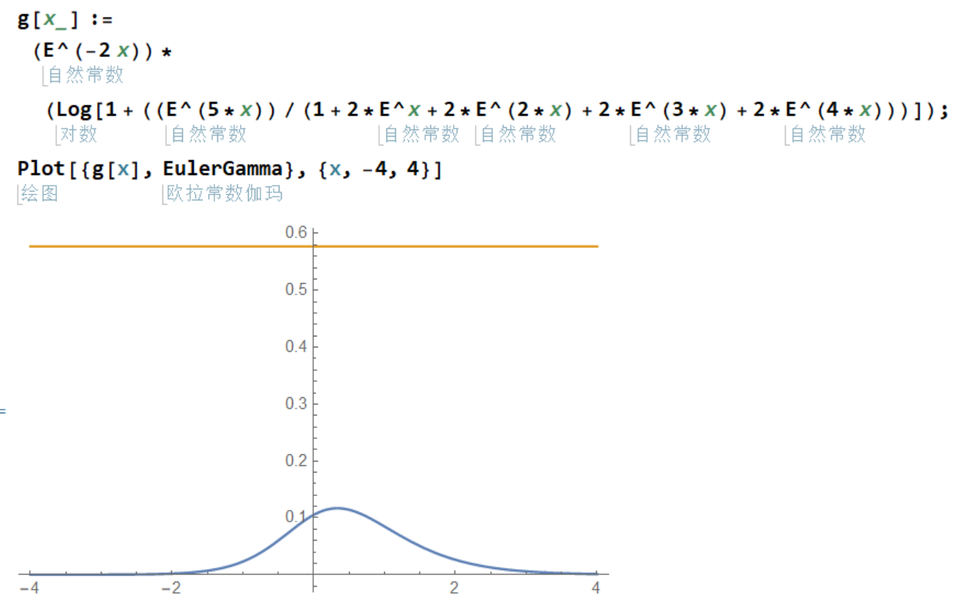
可以看出，这个形式比先前的形式更好，其最大值，
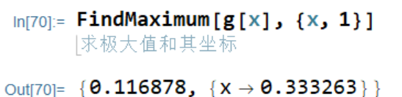
在，
$$x=\frac{1}{3}$$
处，
$$γ\left(\frac{1}{3}\right)=\frac{1}{e^{2x}}\ln\left(1+\frac{1e^{5x}}{1+2e^{x}+2e^{2x}+2e^{3x}+1e^{4x}}\right)=\frac{1}{e^{\frac{2}{3}}}\ln\left(1+\frac{1e^{\frac{5}{3}}}{1+2e^{\frac{1}{3}}+2e^{\frac{2}{3}}+2e^{\frac{3}{3}}+1e^{\frac{4}{3}}}\right)$$
得到，
$$γ=\frac{7^{2}}{10} γ\left(2kπi+\frac{1}{3}\right)$$
积分上限增加1，相当于极限点平移了$\frac{1}{3}$，另外这个数值的精度不如先前的好。
考虑两个都是不完全周期，
$$γ=\frac{1}{e^{2x}}\int_{1}^{e^{2x}}{\int_{1}^{e^{2x}}{\frac{k}{n^{2}e^{2x}+nk}dn}}dk=\frac{1}{e^{2x}}\int_{1}^{e^{2x}}{{\left[\ln{n}-\ln\left(k+ne^{x}\right)\right]}_{1→e^{2x}}}dk=\frac{1}{e^{2x}}\int_{1}^{e^{2x}}{{\left[\ln{\frac{n}{k+ne^{x}}}\right]}_{1→e^{2x}}}dk=\frac{1}{e^{2x}}\int_{1}^{e^{2x}}{\left[\ln{\frac{e^{2x}}{k+e^{2x}e^{x}}}-\ln{\frac{1}{k+e^{x}}}\right]}dk=\frac{1}{e^{2x}}\int_{1}^{e^{2x}}{\left[\ln{\frac{e^{2x}(k+e^{x})}{k+e^{3x}}}\right]}dk=\frac{1}{e^{2x}}{\left[\ln{\frac{e^{2x}\left(k+e^{x}\right)}{k+e^{3x}}}\right]}_{1→e^{2x}}=\frac{1}{e^{2x}}\left[\ln{\frac{e^{2x}\left(e^{2x}+e^{x}\right)}{e^{2x}+e^{3x}}}-\ln{\frac{e^{2x}\left(1+e^{x}\right)}{1+e^{3x}}}\right]=\frac{1}{e^{2x}}\left[\ln{\frac{e^{2x}\left(e^{2x}+e^{x}\right)(1+e^{3x})}{(e^{2x}+e^{3x})e^{2x}\left(1+e^{x}\right)}}\right]=\frac{1}{e^{2x}}\left[\ln{\frac{\left(e^{2x}+e^{x}\right)(1+e^{3x})}{(e^{2x}+e^{3x})\left(1+e^{x}\right)}}\right]=\frac{1}{e^{2x}}\left[\ln{\frac{e^{x}+e^{2x}+e^{4x}+e^{5x}}{e^{2x}+2e^{3x}+e^{4x}}}\right]$$
当$x=0$，
$$γ\left(0\right)=\frac{1}{e^{2x}}\left[\ln{\frac{e^{x}+e^{2x}+e^{4x}+e^{5x}}{e^{2x}+2e^{3x}+e^{4x}}}\right]=\frac{1}{e^{2∙0}}\left[\ln{\frac{e^{0}+e^{2∙0}+e^{4∙0}+e^{5∙0}}{e^{2∙0}+2e^{3∙0}+e^{4∙0}}}\right]=\frac{1}{1}\left[\ln{\frac{1+1+1+1}{1+2+1}}\right]=\ln{\frac{1}{1}}=\ln{1}=0$$
$$γ=\frac{7×8}{10} γ\left(2kπi+\frac{4}{5}\right)=0.5831011136793175$$
再考虑内小外大的情况，
$$γ=\frac{1}{e^{2x}}\int_{1}^{e^{2x}+1}{\int_{1}^{e^{2x}}{\frac{k}{n^{2}e^{2x}+nk}dn}}dk=\frac{1}{e^{2x}}\int_{1}^{e^{2x}}{{\left[\ln{n}-\ln\left(k+ne^{x}\right)\right]}_{1→e^{2x}}}dk=\frac{1}{e^{2x}}\int_{1}^{e^{2x}+1}{{\left[\ln{\frac{n}{k+ne^{x}}}\right]}_{1→e^{2x}}}dk=\frac{1}{e^{2x}}\int_{1}^{e^{2x}+1}{\left[\ln{\frac{e^{2x}}{k+e^{2x}e^{x}}}-\ln{\frac{1}{k+e^{x}}}\right]}dk=\frac{1}{e^{2x}}\int_{1}^{e^{2x}+1}{\left[\ln{\frac{e^{2x}(k+e^{x})}{k+e^{3x}}}\right]}dk=\frac{1}{e^{2x}}{\left[\ln{\frac{e^{2x}\left(k+e^{x}\right)}{k+e^{3x}}}\right]}_{1→e^{2x}+1}=\frac{1}{e^{2x}}\left[\ln{\frac{e^{2x}\left(e^{2x}+1+e^{x}\right)}{e^{2x}+1+e^{3x}}}-\ln{\frac{e^{2x}\left(1+e^{x}\right)}{1+e^{3x}}}\right]=\frac{1}{e^{2x}}\left[\ln{\frac{e^{2x}\left(e^{2x}+1+e^{x}\right)(1+e^{3x})}{(e^{2x}+1+e^{3x})e^{2x}\left(1+e^{x}\right)}}\right]=\frac{1}{e^{2x}}\left[\ln{\frac{\left(e^{2x}+1+e^{x}\right)(1+e^{3x})}{(e^{2x}+1+e^{3x})\left(1+e^{x}\right)}}\right]=\frac{1}{e^{2x}}\left[\ln{\frac{1+e^{x}+e^{2x}+e^{3x}+e^{4x}+e^{5x}}{1+e^{x}+e^{2x}+2e^{3x}+e^{4x}}}\right]$$
当$x=0$，
$$γ\left(0\right)=\frac{1}{e^{2x}}\left[\ln{\frac{1+e^{x}+e^{2x}+e^{3x}+e^{4x}+e^{5x}}{1+e^{x}+e^{2x}+2e^{3x}+e^{4x}}}\right]=\frac{1}{e^{2∙0}}\left[\ln{\frac{1+e^{0}+e^{2∙0}+e^{3∙0}+e^{4∙0}+e^{5∙0}}{1+e^{0}+e^{2∙0}+2e^{3∙0}+e^{4∙0}}}\right]=\frac{1}{1}\left[\ln{\frac{1+1+1+1+1+1}{1+1+1+2+1}}\right]=\ln{\frac{6}{6}}=\ln{1}=0$$
$$γ=\frac{1}{e^{2x}}\int_{1}^{e^{x}+1}{\int_{1}^{e^{2x}}{\frac{k}{n^{2}e^{2x}+nk}dn}}dk=\frac{1}{e^{2x}}\int_{1}^{e^{x}+1}{{\left[\ln{n}-\ln\left(k+ne^{x}\right)\right]}_{1→e^{2x}}}dk=\frac{1}{e^{2x}}\int_{1}^{e^{x}+1}{{\left[\ln{\frac{n}{k+ne^{x}}}\right]}_{1→e^{2x}}}dk=\frac{1}{e^{2x}}\int_{1}^{e^{x}+1}{\left[\ln{\frac{e^{2x}}{k+e^{2x}e^{x}}}-\ln{\frac{1}{k+e^{x}}}\right]}dk=\frac{1}{e^{2x}}\int_{1}^{e^{x}+1}{\left[\ln{\frac{e^{2x}(k+e^{x})}{(k+e^{3x})}}\right]}dk=\frac{1}{e^{2x}}{\left[\ln{\frac{e^{2x}\left(k+e^{x}\right)}{\left(k+e^{3x}\right)}}\right]}_{1→e^{x}+1}=\frac{1}{e^{2x}}\left[\ln{\frac{e^{2x}\left(e^{x}+1+e^{x}\right)}{\left(e^{x}+1+e^{3x}\right)}}-\ln{\frac{e^{2x}\left(1+e^{x}\right)}{\left(1+e^{3x}\right)}}\right]=\frac{1}{e^{2x}}\left[\ln{\frac{e^{2x}\left(e^{x}+1+e^{x}\right)\left(1+e^{3x}\right)}{\left(e^{x}+1+e^{3x}\right)e^{2x}\left(1+e^{x}\right)}}\right]=\frac{1}{e^{2x}}\left[\ln{\frac{\left(e^{x}+1+e^{x}\right)\left(1+e^{3x}\right)}{\left(e^{x}+1+e^{3x}\right)\left(1+e^{x}\right)}}\right]=\frac{1}{e^{2x}}\left[\ln{\frac{1+2e^{x}+e^{3x}+2e^{4x}}{1+2e^{x}+e^{2x}+e^{3x}+e^{4x}}}\right]$$
$$γ\left(0\right)=0$$
$$γ=5^{2}γ\left(\frac{1}{3}\right)=0.5658084199661618$$
在考虑过各种情况之后，可以认识到，欧拉常数存在的意义，在于方程的虚数单位周期和数量本身的无限可分之间的矛盾的体现。微分的本质要求数量无限可分，无限可分也是实际的情况，但是方程能够写出，则自动产生了数量层级之间的差异以及因为虚数单位的存在而造成的周期性。整数和有理数都是这种周期性存在的体现，对于整数来说，$i_{1}=-1$作为虚数单位，即可处理大多数整数之间的运算问题，而涉及到质数，则需要$i_{2}=\sqrt{-1}$来处理。在讨论哥德巴赫猜想的时候，这一点已经明确了。用于计算质数或者其倒数全乘积的黎曼泽塔函数，用复数可以处理它的大多数性质，但是，$ξ\left(1\right)$和它对应的连续形式$\ln{x}$之间的差异，就使得用复数处理失去了精度，哪怕是用，$e^{2x}$作为虚数单位，也不能得到足够精度的结果。这说明，充分连续的数学对象，和用来度量的数字系统之间总是存在微小的差异。数学对象用以描述真实世界，而这种真实在于其无限的精度，但是数字总是有最小间隔，以至于数字系统总是基于有限精度，即便增加了周期性的复数，仍然不能保证两个系统之间具有相同的精度，也就是说，两位多分复数并不能处理这种精度差异，而是需要两个多分复数，它们之间的最小单位之间的比率可能仍然是一个复数，这个比率的变化将会决定最终计算的精度。从上面的分析不难看出，强制要求两种系统都以虚数单位的四次幂的倒数为共同最小单位，能够获得的十进制精度至多只有5位。所以我们需要的是两个不同的虚数单位，才能获得无限精度的表述方式。换句话说，就是自然中任何两个系统之间的精度都可能是完全不同的，就像不同的惯性系有着不同的虚数单位。而试着统一虚数单位的做法本质上是不成立的。那么，一个基于连续性的数学对象，其实就是一个虚数单位自身可变的数学对象，或者说，完全不受到虚数单位大小束缚的数学对象，比如对倒数积分之后的对数函数。换句话说，以上尝试必然都是失败的，唯一能成功的做法，就是像处理相对论问题那样，使用两个不同的虚数单位，并且通过调节两个不同的虚数单位的比值，决定最终的精度的数字位数。
再来一遍！
在，
$$ξ(1)=\sum_{n=1}^{i_{1}^{2}+1}{\frac{1}{n}}$$
中，$n$和$n+1$之间的1个单位，被平分成$i_{1}^{2}$份，如果周期是$i_{1}^{2}+1=0$，但这个平分的每一份都取边界值的倒数为结果。而在，
$$\int_{1}^{∞}{\frac{1}{x}}dx=\int_{1}^{i_{2}^{2}+1}{\frac{1}{x}}dx={\left(\ln{x}\right)}_{1→i_{2}^{2}+1}$$
过程中，每一个单位被平分成$i_{2}^{2}$份，周期是$i_{2}^{2}+1=0$，但是这平分的每一份则取对应数值的倒数为结果。所以，对于积分形式，
$$\int_{1}^{i_{2}^{2}+1}{\frac{1}{x}}dx$$
来说，整个区间被分成，
$$\left(i_{2}^{2}+1-1\right)∙i_{2}^{2}=i_{2}^{2}∙i_{2}^{2}=i_{2}^{4}$$
份，每一份的单位是$\frac{1}{i_{2}^{4}}$。
$$\int_{1}^{i_{2}^{2}+1}{\frac{1}{x}}dx=\sum_{n=1}^{i_{2}^{4}+1}{\frac{1}{n}}\frac{1}{i_{2}^{4}}$$

而对于求和形式，
$$ξ\left(1\right)=\sum_{n=1}^{i_{1}^{2}+1}{\frac{1}{n}}$$
来说，整个区间被分成，
$$\left(i_{1}^{2}+1-1\right)∙1=i_{1}^{2}∙1=i_{1}^{2}$$
份，每一份的单位都是1。相比较而言，积分形式的对应的求和份数更多，细节更细，
$$S_{2}=\int_{1}^{i_{2}^{2}+1}{\frac{1}{x}}dx=\sum_{n=1}^{i_{2}^{4}+1,1}{\frac{1}{n}\frac{1}{i_{2}^{4}}}$$
$$S_{1}=ξ\left(1\right)=\sum_{n=1}^{i_{1}^{4}+1,i_{1}^{2}}{\frac{1}{n}\frac{1}{i_{1}^{2}}}$$
在每个$n$到$n+1$的区间，积分形式为，
$$S_{2}=i_{2}^{4}\frac{1}{i_{2}^{4}}\left(\frac{1}{n}+\frac{1}{n+\frac{1}{i_{2}^{2}}\left(n+1-n\right)}+\frac{1}{n+\frac{2}{i_{2}^{2}}\left(n+1-n\right)}+…+\frac{1}{n+\frac{i_{2}^{2}}{i_{2}^{2}}\left(n+1-n\right)}\right)=\left(\frac{1}{n}\frac{1}{i_{2}^{4}}+\frac{1}{n+\frac{1}{i_{2}^{2}}\left(n+1-n\right)}\frac{1}{i^{4}}+\frac{1}{n+\frac{2}{i_{2}^{2}}\left(n+1-n\right)}\frac{1}{i_{2}^{4}}+…+\frac{1}{n+\frac{i_{2}^{2}}{i_{2}^{2}}\left(n+1-n\right)}\frac{1}{i_{2}^{4}}\right)$$
将内部精度提升到$\frac{1}{i_{2}^{4}}$
$$S_{2}=i_{2}^{4}\frac{1}{i_{2}^{4}}\left(\frac{1}{n}+\frac{1}{n+\frac{1}{i_{2}^{4}}\left(n+1-n\right)}+\frac{1}{n+\frac{1}{i_{2}^{4}}\left(n+1-n\right)}+…+\frac{1}{n+\frac{i_{2}^{4}}{i_{2}^{4}}\left(n+1-n\right)}\right)=\left(\frac{1}{n}\frac{1}{i_{2}^{4}}+\frac{1}{n+\frac{1}{i^{4}}\left(n+1-n\right)}\frac{1}{i_{2}^{4}}+\frac{1}{n+\frac{2}{i^{4}}\left(n+1-n\right)}\frac{1}{i_{2}^{4}}+…+\frac{1}{n+\frac{i_{2}^{4}}{i_{2}^{4}}\left(n+1-n\right)}\frac{1}{i_{2}^{4}}\right)$$

求和形式为，
$$S_{1}=\left(\frac{1}{n}\frac{1}{i_{1}^{2}}+\frac{1}{n}\frac{1}{i_{1}^{2}}+…+\frac{1}{n}\frac{1}{i_{1}^{2}}\right)=\left(\frac{1}{n}\frac{1}{i_{1}^{2}}i_{1}^{2}\right)=\frac{1}{i_{1}^{2}}\frac{1}{n}i_{1}^{2}$$
将$S_{1}$的每个部分都提升精度到$\frac{1}{i_{1}^{4}}$
$$S_{1}=\left(\frac{1}{n}\frac{1}{i_{1}^{4}}+\frac{1}{n}\frac{1}{i_{1}^{4}}+…+\frac{1}{n}\frac{1}{i_{1}^{4}}\right)=\left(\frac{1}{n}\frac{1}{i_{1}^{4}}i_{1}^{4}\right)=\frac{1}{i_{1}^{4}}\frac{1}{n}i_{1}^{4}$$

以最高精度计算面积的差值是，
$$S_{d}=S_{1}-S_{2}=\left(\frac{1}{i_{1}^{4}}\frac{1}{n}i_{1}^{4}\right)-i_{2}^{4}\left(\frac{1}{n}\frac{1}{i_{2}^{4}}+\frac{1}{n+\frac{1}{i_{2}^{4}}\left(n+1-n\right)}\frac{1}{i_{2}^{4}}+\frac{1}{n+\frac{2}{i_{2}^{4}}\left(n+1-n\right)}\frac{1}{i_{2}^{4}}+…+\frac{1}{n+\frac{i_{2}^{4}}{i_{2}^{4}}\left(n+1-n\right)}\frac{1}{i_{2}^{4}}\right)$$
在此处给出比例关系，
$$i_{1}=ki_{2}=ki,i_{2}=i$$

$$S_{d}=\left(\frac{1}{i_{1}^{4}}\frac{1}{n}i_{1}^{4}-\frac{1}{n}\frac{1}{i_{2}^{4}}i_{2}^{4}\right)-i_{2}^{4}\frac{1}{i_{2}^{4}}\left(\frac{1}{n+\frac{1}{i_{2}^{4}}}+\frac{1}{n+\frac{2}{i_{2}^{4}}}+…+\frac{1}{n+\frac{i_{2}^{4}-2}{i_{2}^{4}}}+\frac{1}{n+\frac{i_{2}^{4}-1}{i_{2}^{4}}}+\frac{1}{n+\frac{i_{2}^{4}}{i_{2}^{4}}}\right)$$
$$S_{d}=\left(\frac{1}{k^{4}}\frac{1}{i^{4}}\frac{1}{n}k^{4}i^{4}-\frac{1}{n}\frac{1}{i^{4}}i^{4}\right)-i^{4}\frac{1}{i^{4}}\left(\frac{1}{n+\frac{1}{i^{4}}}+\frac{1}{n+\frac{2}{i^{4}}}+…+\frac{1}{n+\frac{i^{4}-2}{i^{4}}}+\frac{1}{n+\frac{i^{4}-1}{i^{4}}}+\frac{1}{n+\frac{i^{4}}{i^{4}}}\right)=i^{4}\left(\frac{k^{4}}{k^{4}}\frac{1}{n}\frac{1}{i^{4}}-\frac{1}{n}\frac{1}{i^{4}}\right)-i^{4}\frac{1}{i^{4}}\left(\frac{1}{n+\frac{1}{i^{4}}}+\frac{1}{n+\frac{2}{i^{4}}}+…+\frac{1}{n+\frac{i^{4}-2}{i^{4}}}+\frac{1}{n+\frac{i^{4}-1}{i^{4}}}+\frac{1}{n+\frac{i^{4}}{i^{4}}}\right)$$
这里出现了，$\frac{k^{4}}{k^{4}}$，由于虚数单位自身的可变性，$k^{4}$和$k^{4}$可能完全不相等，正如，
$$\left|e^{2kπi}\right|=\left|e^{2(k+d)πi}\right|$$
但是作为实际的数值，
$$e^{2kπi}≠e^{2(k+d)πi}$$
两者相差$2πd$的相位，或者说，不在同一个周期，所以，令，
$$t^{4}=\frac{k^{4}}{k^{4}}=\frac{k^{2}}{k^{2}}=\frac{1}{1}=\frac{-1}{-1}$$
代入每一个微小面积，
$$S_{k}=\frac{1}{n}\frac{k^{4}}{k^{4}}\frac{1}{i^{4}}-\frac{1}{n+\frac{k}{i^{4}}}\frac{1}{i^{4}}=\frac{1}{n}t^{4}\frac{1}{i^{4}}-\frac{1}{n+\frac{k}{i^{4}}}\frac{1}{i^{4}}=\left(\frac{t^{4}}{n}-\frac{1}{n+\frac{k}{i^{4}}}\right)\frac{1}{i^{4}}=\left(\frac{t^{4}}{n}-\frac{1}{n+\frac{1}{i^{4}}k}\right)\frac{1}{i^{4}}=\left(\frac{t^{4}}{n}-\frac{1}{\frac{ni^{4}+k}{i^{4}}}\right)\frac{1}{i^{4}}=\left(\frac{t^{4}}{n}-\frac{i^{4}}{ni^{4}+k}\right)\frac{1}{i^{4}}=\left[\frac{nt^{4}+kt^{4}-n}{n\left(ni^{4}+k\right)}\right]\frac{1}{i^{4}}=\left[\frac{nt^{4}+kt^{4}-n}{n^{2}i^{4}+nk}\right]\frac{1}{i^{4}}$$
$$S_{d}=\sum_{k=1}^{i^{4}}{\frac{1}{i^{4}}\frac{n(t^{4}-1)+kt^{4}}{n^{2}i^{4}+nk}}$$
以最高精度计算的总面积差为，
$$∆S=\sum{S_{d}}=\sum_{n=1}^{i^{2}}{\sum_{k=1}^{i^{4}}{\frac{1}{i^{4}}\frac{n(t^{4}-1)+kt^{4}}{n^{2}i^{4}+nk}}}=\frac{1}{i^{4}}\sum_{n=1}^{i^{2}}{\sum_{k=1}^{i^{4}}{\frac{n(t^{4}-1)+kt^{4}}{n^{2}i^{4}+nk}}}$$
原来的求和公式，
$$∆S=\frac{1}{S^{2}}\sum_{n=1}^{S}{\sum_{k=1}^{S^{2}}{\frac{k}{n^{2}S^{2}+nk}}}$$
导出积分公式，
$$γ(x)=\frac{1}{e^{2x}}\int_{1}^{e^{x}+1}{\int_{1}^{e^{2x}+1}{\frac{k}{n^{2}e^{2x}+nk}dn}}dk$$
现在的求和公式，
$$∆S=\frac{1}{i^{4}}\sum_{n=1}^{i^{2}}{\sum_{k=1}^{i^{4}}{\frac{n(t^{4}-1)+kt^{4}}{n\left(ni^{4}+k\right)}}}$$
$$γ(x,t)=\frac{1}{e^{2x}}\int_{1}^{e^{x}+1}{\int_{1}^{e^{2x}+1}{\frac{n(t^{4}-1)+kt^{4}}{n^{2}e^{2x}+nk}dn}}dk$$
根据的$k$取值，判断，
$$t^{4}=\frac{k^{4}}{k^{4}}={\left[\frac{e^{2\left(x+d\right)}}{e^{2x}}\right]}^{4}={\left[e^{2\left(x+d\right)-2x}\right]}^{4}={\left(e^{2d}\right)}^{4}=e^{8d}$$
$$\left|t^{4}\right|={\left|t\right|}^{4}={\left|e^{8y}\right|}^{4}=1$$
方程变为，
$$γ(x,y)=\frac{1}{e^{2x}}\int_{1}^{e^{x}+1}{\int_{1}^{e^{2x}+1}{\frac{n\left(e^{8y}-1\right)+ke^{8y}}{n^{2}e^{2x}+nk}dn}}dk$$
可见$x$为实数，$y$为复数。整数系统和实数系统的单位的关系可以由，
$$z=x+yi=x+\left(a+bi\right)$$
$$y=a+bi$$
表示。其中$x$确定大致的比例关系，$y$用于调整和确定关系的精度。有黎曼泽塔函数可以直到，整数系统的最大值（周期）由其中所有的质数决定，而实数系统则是完全连续的，所以这里用于调整精度的$y$就对应了整数系统中的质数分布。这也是黎曼泽塔函数体现质数分布的原因。
$$γ(x,a,b)=\frac{1}{e^{2x}}\int_{1}^{e^{x}+1}{\int_{1}^{e^{2x}+1}{\frac{n\left[e^{8(a+bi)}-1\right]+ke^{8(a+bi)}}{n^{2}e^{2x}+nk}dn}}dk$$
从先前的分析可以看出，如果没有
$$d=a+bi$$
的参与，函数的极值达不到伽马的数值，而且经常是倾斜的，极值最高点并不落在0点上，有微小但难于计算的偏移，所以引入复数$y$来纠正这种旋转是必须的。但是作为初步极限，我们还是保留$t^{4}$在最后再考虑$y$的调整。
设，
$$T(d)=t^{4}=e^{8(a+bi)}=e^{8d}$$
原函数变成，
$$γ(x,T)=\frac{1}{e^{2x}}\int_{1}^{e^{x}+1}{\int_{1}^{e^{2x}+1}{\frac{n(T-1)+kT}{n^{2}e^{2x}+nk}dn}}dk$$
计算，
$$γ\left(x,T\right)=\frac{1}{e^{2x}}\int_{1}^{e^{x}+1}{\int_{1}^{e^{2x}+1}{\frac{n(T-1)+kT}{n^{2}e^{2x}+nk}dn}}dk\frac{1}{e^{2x}}=\frac{1}{e^{2x}}\int_{1}^{e^{x}+1}{{\left[T\ln{n}-ⅇ^{-2x}\left(1+\left(-1+ⅇ^{2x}\right)T\right)\ln{(k+ⅇ^{2x}n)}\right]}_{1→e^{2x}+1}}dk=\frac{1}{e^{2x}}\int_{1}^{e^{x}+1}{{\left[\ln{n^{T}}-\ln{{\left(k+ⅇ^{2x}n\right)}^{ⅇ^{-2x}\left(1+\left(-1+ⅇ^{2x}\right)T\right)}}\right]}_{1→e^{2x}+1}}dk=\frac{1}{e^{2x}}\int_{1}^{e^{x}+1}{[\ln{\frac{{(e^{2x}+1)}^{T}}{{\left(k+ⅇ^{2x}(e^{2x}+1)\right)}^{ⅇ^{-2x}\left(1+\left(-1+ⅇ^{2x}\right)T\right)}}}-\ln{\frac{1^{T}}{{\left(k+ⅇ^{2x}\right)}^{ⅇ^{-2x}\left(1+\left(-1+ⅇ^{2x}\right)T\right)}}}]}dk=\frac{1}{e^{2x}}\int_{1}^{e^{x}+1}{\ln{\frac{{(e^{2x}+1)}^{T}{\left(k+ⅇ^{2x}\right)}^{ⅇ^{-2x}\left(1+\left(-1+ⅇ^{2x}\right)T\right)}}{{\left(k+ⅇ^{4x}+e^{2x}\right)}^{ⅇ^{-2x}\left(1+\left(-1+ⅇ^{2x}\right)T\right)}}}}dk=\frac{1}{e^{2x}}\int_{1}^{e^{x}+1}{\ln\left\{{(e^{2x}+1)}^{T}{\left[\frac{\left(k+ⅇ^{2x}\right)}{\left(k+ⅇ^{4x}+e^{2x}\right)}\right]}^{ⅇ^{-2x}\left(1+\left(-1+ⅇ^{2x}\right)T\right)}\right\}}dk=\frac{1}{e^{2x}}{\left[\ln\left\{{\left(e^{2x}+1\right)}^{T}{\left[\frac{\left(k+ⅇ^{2x}\right)}{\left(k+ⅇ^{4x}+e^{2x}\right)}\right]}^{ⅇ^{-2x}\left(1+\left(-1+ⅇ^{2x}\right)T\right)}\right\}\right]}_{1→e^{x}+1}=\frac{1}{e^{2x}}\left[\ln\left\{{\left(e^{2x}+1\right)}^{T}{\left[\frac{\left(e^{x}+1+ⅇ^{2x}\right)}{\left(e^{x}+1+ⅇ^{4x}+e^{2x}\right)}\right]}^{ⅇ^{-2x}\left(1+\left(-1+ⅇ^{2x}\right)T\right)}\right\}-\ln\left\{{\left(e^{2x}+1\right)}^{T}{\left[\frac{\left(1+ⅇ^{2x}\right)}{\left(1+ⅇ^{4x}+e^{2x}\right)}\right]}^{ⅇ^{-2x}\left(1+\left(-1+ⅇ^{2x}\right)T\right)}\right\}\right]=\frac{1}{e^{2x}}\ln{\frac{{\left(e^{2x}+1\right)}^{T}{\left[\frac{\left(e^{x}+1+ⅇ^{2x}\right)}{\left(e^{x}+1+ⅇ^{4x}+e^{2x}\right)}\right]}^{ⅇ^{-2x}\left(1+\left(-1+ⅇ^{2x}\right)T\right)}}{{\left(e^{2x}+1\right)}^{T}{\left[\frac{\left(1+ⅇ^{2x}\right)}{\left(1+ⅇ^{4x}+e^{2x}\right)}\right]}^{ⅇ^{-2x}\left(1+\left(-1+ⅇ^{2x}\right)T\right)}}}=\frac{1}{e^{2x}}\ln{{\left[\frac{\left(e^{x}+1+ⅇ^{2x}\right)\left(1+ⅇ^{4x}+e^{2x}\right)}{\left(e^{x}+1+ⅇ^{4x}+e^{2x}\right)\left(1+ⅇ^{2x}\right)}\right]}^{ⅇ^{-2x}\left(1+\left(-1+ⅇ^{2x}\right)T\right)}}=\frac{1}{e^{2x}}ⅇ^{-2x}\left(1+\left(-1+ⅇ^{2x}\right)T\right)\ln{\frac{\left(e^{x}+1+ⅇ^{2x}\right)\left(1+ⅇ^{4x}+e^{2x}\right)}{\left(e^{x}+1+ⅇ^{4x}+e^{2x}\right)\left(1+ⅇ^{2x}\right)}}=ⅇ^{-4x}\left(1+\left(ⅇ^{2x}-1\right)T\right)\ln{\frac{\left(e^{x}+1+ⅇ^{2x}\right)\left(1+ⅇ^{4x}+e^{2x}\right)}{\left(e^{x}+1+ⅇ^{4x}+e^{2x}\right)\left(1+ⅇ^{2x}\right)}}$$

$$γ\left(x,T\right)=ⅇ^{-4x}\left(1+\left(ⅇ^{2x}-1\right)T\right)\ln{\frac{1+e^{x}+2e^{2x}+e^{3x}+2ⅇ^{4x}+ⅇ^{5x}+ⅇ^{6x}}{1+e^{x}+2ⅇ^{2x}+ⅇ^{3x}+2ⅇ^{4x}+ⅇ^{6x}}}=\left(ⅇ^{-4x}+\left(ⅇ^{-2x}-ⅇ^{-4x}\right)T\right)\ln{(1-\frac{ⅇ^{5x}}{1+e^{x}+2ⅇ^{2x}+ⅇ^{3x}+2ⅇ^{4x}+ⅇ^{6x}})}$$
$$c(x)=1-\frac{ⅇ^{5x}}{1+e^{x}+2ⅇ^{2x}+ⅇ^{3x}+2ⅇ^{4x}+ⅇ^{6x}}$$
$$γ\left(x,T\right)=\left(ⅇ^{-4x}+\left(ⅇ^{-2x}-ⅇ^{-4x}\right)T\right)\ln{c(x)}$$
$$T(d)=e^{8d}$$
$$γ\left(x,d\right)=\left(ⅇ^{-4x}+\left(ⅇ^{-2x}-ⅇ^{-4x}\right)T\right)\ln{c(x)}=\left(ⅇ^{-4x}+\left(ⅇ^{-2x}-ⅇ^{-4x}\right)e^{8d}\right)\ln{c(x)}=\left(ⅇ^{-4x}+ⅇ^{-2x+8d}-ⅇ^{-4x+8d}\right)\ln{c(x)}$$

$$γ\left(x,a,b\right)=\left[ⅇ^{-4x}+ⅇ^{-2x+8\left(a+bi\right)}-ⅇ^{-4x+8\left(a+bi\right)}\right]\ln{c\left(x\right)}=\left[ⅇ^{-4x}+ⅇ^{\left(-2x+8a\right)+8bi}-ⅇ^{\left(-4x+8a\right)+8bi}\right]\ln{c\left(x\right)}=\left[\left(ⅇ^{-10a}\right){\left(ⅇ^{-4}\right)}^{\frac{-2x+4a}{-2}+2a}+e^{4-2a}({ⅇ^{-2})}^{\frac{\left(-2x+4a\right)}{-2}+2a-4bi}-e^{-2a}{\left(ⅇ^{-4}\right)}^{\frac{\left(-2x+4a\right)}{-2}+2a-2bi}\right]∙\ln{c\left(\frac{-2x+4a}{-2}+2a\right)}$$
$$x=\frac{-2x+4a}{-2}+2a$$
这说明，如果用这种算法，$a$必须分成两个部分，一部分被包含在$x$里面，另一部被包含在$y$里面。为了避免这种情况，我们对内外两层循环都做完整周期的累积。

$$γ\left(x,T\right)=\frac{1}{e^{2x}}\int_{1}^{e^{2x}+1}{\int_{1}^{e^{2x}+1}{\frac{n(T-1)+kT}{n^{2}e^{2x}+nk}dn}}dk\frac{1}{e^{2x}}=\frac{1}{e^{2x}}\int_{1}^{e^{2x}+1}{{\left[T\ln{n}-ⅇ^{-2x}\left(1+\left(-1+ⅇ^{2x}\right)T\right)\ln{(k+ⅇ^{2x}n)}\right]}_{1→e^{2x}+1}}dk=\frac{1}{e^{2x}}\int_{1}^{e^{2x}+1}{{\left[\ln{n^{T}}-\ln{{\left(k+ⅇ^{2x}n\right)}^{ⅇ^{-2x}\left(1+\left(-1+ⅇ^{2x}\right)T\right)}}\right]}_{1→e^{2x}+1}}dk=\frac{1}{e^{2x}}\int_{1}^{e^{2x}+1}{[\ln{\frac{{(e^{2x}+1)}^{T}}{{\left(k+ⅇ^{2x}(e^{2x}+1)\right)}^{ⅇ^{-2x}\left(1+\left(-1+ⅇ^{2x}\right)T\right)}}}-\ln{\frac{1^{T}}{{\left(k+ⅇ^{2x}\right)}^{ⅇ^{-2x}\left(1+\left(-1+ⅇ^{2x}\right)T\right)}}}]}dk=\frac{1}{e^{2x}}\int_{1}^{e^{2x}+1}{\ln{\frac{{(e^{2x}+1)}^{T}{\left(k+ⅇ^{2x}\right)}^{ⅇ^{-2x}\left(1+\left(-1+ⅇ^{2x}\right)T\right)}}{{\left(k+ⅇ^{4x}+e^{2x}\right)}^{ⅇ^{-2x}\left(1+\left(-1+ⅇ^{2x}\right)T\right)}}}}dk=\frac{1}{e^{2x}}\int_{1}^{e^{2x}+1}{\ln\left\{{(e^{2x}+1)}^{T}{\left[\frac{\left(k+ⅇ^{2x}\right)}{\left(k+ⅇ^{4x}+e^{2x}\right)}\right]}^{ⅇ^{-2x}\left(1+\left(-1+ⅇ^{2x}\right)T\right)}\right\}}dk=\frac{1}{e^{2x}}{\left[\ln\left\{{\left(e^{2x}+1\right)}^{T}{\left[\frac{\left(k+ⅇ^{2x}\right)}{\left(k+ⅇ^{4x}+e^{2x}\right)}\right]}^{ⅇ^{-2x}\left(1+\left(-1+ⅇ^{2x}\right)T\right)}\right\}\right]}_{1→e^{2x}+1}=\frac{1}{e^{2x}}\left[\ln\left\{{\left(e^{2x}+1\right)}^{T}{\left[\frac{\left(e^{2x}+1+ⅇ^{2x}\right)}{\left(e^{2x}+1+ⅇ^{4x}+e^{2x}\right)}\right]}^{ⅇ^{-2x}\left(1+\left(-1+ⅇ^{2x}\right)T\right)}\right\}-\ln\left\{{\left(e^{2x}+1\right)}^{T}{\left[\frac{\left(1+ⅇ^{2x}\right)}{\left(1+ⅇ^{4x}+e^{2x}\right)}\right]}^{ⅇ^{-2x}\left(1+\left(-1+ⅇ^{2x}\right)T\right)}\right\}\right]=\frac{1}{e^{2x}}\ln{\frac{{\left(e^{2x}+1\right)}^{T}{\left[\frac{\left(e^{2x}+1+ⅇ^{2x}\right)}{\left(e^{2x}+1+ⅇ^{4x}+e^{2x}\right)}\right]}^{ⅇ^{-2x}\left(1+\left(-1+ⅇ^{2x}\right)T\right)}}{{\left(e^{2x}+1\right)}^{T}{\left[\frac{\left(1+ⅇ^{2x}\right)}{\left(1+ⅇ^{4x}+e^{2x}\right)}\right]}^{ⅇ^{-2x}\left(1+\left(-1+ⅇ^{2x}\right)T\right)}}}=\frac{1}{e^{2x}}\ln{{\left[\frac{\left(e^{2x}+1+ⅇ^{2x}\right)\left(1+ⅇ^{4x}+e^{2x}\right)}{\left(e^{2x}+1+ⅇ^{4x}+e^{2x}\right)\left(1+ⅇ^{2x}\right)}\right]}^{ⅇ^{-2x}\left(1+\left(-1+ⅇ^{2x}\right)T\right)}}=\frac{1}{e^{2x}}ⅇ^{-2x}\left(1+\left(-1+ⅇ^{2x}\right)T\right)\ln{\frac{\left(e^{2x}+1+ⅇ^{2x}\right)\left(1+ⅇ^{4x}+e^{2x}\right)}{\left(e^{2x}+1+ⅇ^{4x}+e^{2x}\right)\left(1+ⅇ^{2x}\right)}}=ⅇ^{-4x}\left(1+\left(ⅇ^{2x}-1\right)T\right)\ln{\frac{\left(e^{2x}+1+ⅇ^{2x}\right)\left(1+ⅇ^{4x}+e^{2x}\right)}{\left(e^{2x}+1+ⅇ^{4x}+e^{2x}\right)\left(1+ⅇ^{2x}\right)}}$$

$$γ\left(x,T\right)=ⅇ^{-4x}\left(1+\left(ⅇ^{2x}-1\right)T\right)\ln{\frac{1+3e^{2x}+3ⅇ^{4x}+2ⅇ^{6x}}{1+3e^{2x}+3ⅇ^{4x}+1ⅇ^{6x}}}=\left(ⅇ^{-4x}+\left(ⅇ^{-2x}-ⅇ^{-4x}\right)T\right)\ln{(1+\frac{ⅇ^{6x}}{1+3e^{2x}+3ⅇ^{4x}+1ⅇ^{6x}})}$$
$$c\left(x\right)=1+\frac{ⅇ^{6x}}{1+3e^{2x}+3ⅇ^{4x}+1ⅇ^{6x}}$$
$$γ\left(x,T\right)=\left(ⅇ^{-4x}+\left(ⅇ^{-2x}-ⅇ^{-4x}\right)T\right)\ln{c(x)}$$
重新定义关于$x$的函数，
$$A\left(x\right)=ⅇ^{2x}$$
$$C\left(x\right)=1-\frac{A{\left(x\right)}^{3}}{1+3A\left(x\right)+3A{\left(x\right)}^{2}+A{\left(x\right)}^{3}}$$
代换得到，
$$γ\left(x,d\right)=\left[ⅇ^{-4x}+\left(ⅇ^{-2x}-ⅇ^{-4x}\right)T\left(d\right)\right]∙\ln{c\left(x\right)}=\left[{A\left(x\right)}^{-2}+\left({A\left(x\right)}^{-1}-{A\left(x\right)}^{-2}\right)T\left(d\right)\right]∙\ln{C\left(x\right)}=\frac{\ln{C\left(x\right)}}{A{\left(x\right)}^{2}}+T\left(d\right)\left[\frac{A{\left(x\right)}^{2}-A\left(x\right)}{A{\left(x\right)}^{3}}\right]\ln{C(x)}$$
观察这个函数颠倒的图像，
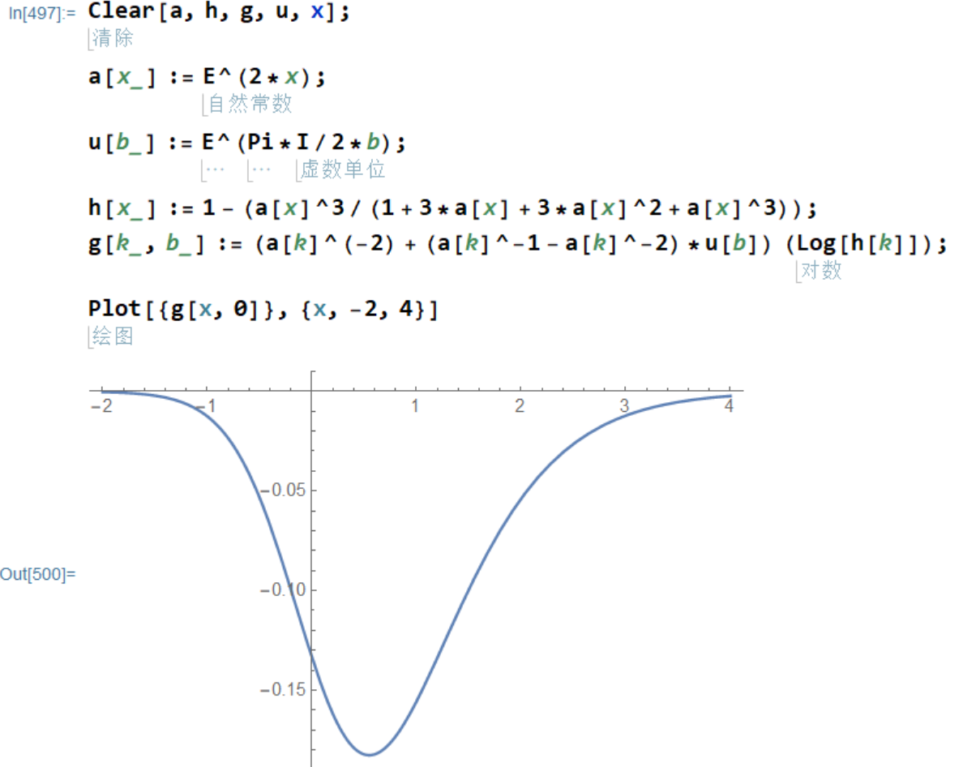
图像基本上是对称的，但也是倾斜的。
因为当前求出的极值对应的对称轴是倾斜的，所以只能旋转整个函数的图像，而且在旋转之前不知道旋转中心在哪里，所以只能基于原点做全局旋转。观察方程，
$$γ\left(x,d\right)=\left[ⅇ^{-4x}+\left(ⅇ^{-2x}-ⅇ^{-4x}\right)T\left(d\right)\right]∙\ln{c\left(x\right)}=\left[{A\left(x\right)}^{-2}+\left({A\left(x\right)}^{-1}-{A\left(x\right)}^{-2}\right)T\left(d\right)\right]∙\ln{C\left(x\right)}=T\left(d\right)\left[\frac{A{\left(x\right)}^{2}-A\left(x\right)}{A{\left(x\right)}^{3}}\right]\ln{C\left(x\right)}+\frac{\ln{C\left(x\right)}}{A{\left(x\right)}^{2}}$$
它在最宏观的层面上，具有，
$$y=sx+b$$
的形式，因为具体大小未知，所以暂时不考虑$T\left(d\right)$，曲线的斜率为，
$$s=\left[\frac{A{\left(x\right)}^{2}-A\left(x\right)}{A{\left(x\right)}^{3}}\right]\ln{C\left(x\right)}$$
观察向着正无穷方向的斜率，
$$s=\lim_{x→∞}{\frac{ⅇ^{4x}-ⅇ^{2x}}{ⅇ^{6x}}\ln\left(1+\frac{ⅇ^{6x}}{1+3e^{2x}+3ⅇ^{4x}+ⅇ^{6x}}\right)}=\lim_{x→∞}{\frac{1}{ⅇ^{2x}}\ln\left(1+\frac{ⅇ^{6x}}{ⅇ^{6x}}\right)}=\lim_{x→∞}{\frac{1}{ⅇ^{2x}}\ln\left(1+1\right)}=\lim_{x→∞}{\frac{1}{ⅇ^{2x}}\ln{2}}=\ln{2}\lim_{x→∞}{\frac{1}{ⅇ^{2x}}}$$
向着负无穷方向的斜率为，
$$s=\lim_{x→-∞}{\frac{ⅇ^{4x}-ⅇ^{2x}}{ⅇ^{6x}}\ln\left(1+\frac{ⅇ^{6x}}{1+3e^{2x}+3ⅇ^{4x}+ⅇ^{6x}}\right)}=\lim_{x→∞}{\frac{1}{ⅇ^{2x}}\ln\left(1+\frac{ⅇ^{6x}}{ⅇ^{6x}}\right)}=\lim_{x→-∞}{\frac{1}{ⅇ^{\frac{3}{2}x}}\ln\left(1\right)}=\lim_{x→∞}{ⅇ^{\frac{3}{2}x}\ln\left(1\right)}=0$$
其中，
$$\lim_{x→∞}{\frac{1}{ⅇ^{2x}}}$$
使得曲线被拉平，所以不是宏观上的斜率，宏观上的斜率为，
$$s=\ln{2}$$
这个斜率对应的角度为，
$$a=arc\tan{\ln{2}}=0.606111934732855=34.7276557727014°$$
大约34°。由于负向的斜率为0，正负无穷两端造成的角度增量是一样的。因为函数图像是一个中心对称图形，所以角度要减小一半，
$$\frac{1}{2}a=\frac{1}{2}arc\tan{\ln{2}}$$
对应的正切值为，
$$s=\tan{\frac{1}{2}a}=\tan\left(\frac{1}{2}arc\tan{\ln{2}}\right)$$
为了平衡这个斜率，需要这个正切值的倒数。这是因为这个系数是对数函数的系数，相当于对数函数自变量的指数，这个自变量的指数为1，则可以保持这个自变量本身不变，以及其对数不变，也就是使得函数值始终保持一致，函数上各点斜率为0。
在一个周期里面，$T\left(d\right)$作为这个数值的倒数，就可以用于实现斜率趋向于0的平衡，
$$T\left(d\right)=e^{8d}=\cot\left(\frac{1}{2}arc\tan{\ln{2}}\right)$$
$$\ln{e^{8d}}=\ln{ \cot\left(\frac{1}{2}arc\tan{\ln{2}}\right)}$$
$$8d=\ln{\cot\left(\frac{1}{2}arc\tan{\ln{2}}\right)}$$
$$d=\frac{1}{8}\ln{\cot\left(\frac{1}{2}arc\tan{\ln{2}}\right)}$$
虚数单位平方之间的比率，也就是它和自身的比率为，
$$k^{2}=\frac{i_{1}^{2}}{i_{2}^{2}}=\frac{k^{2}}{k^{2}}=e^{2d}=\tan\left(\frac{1}{2}arc\tan{\ln{2}}\right)=\frac{1}{3.1980778996994306}$$
意思是，整数系统的虚数单位的平方的大小约为实数系统的虚数单位平方的大小的
$$k^{2}=\tan\left(\frac{1}{2}arc\tan{\ln{2}}\right)=\frac{1}{3.1980778996994306}=0.3126878179215035$$
整数系统的虚数单位的大小约为实数系统的虚数单位的大小的。
$$k=\sqrt{k^{2}}=\sqrt{\tan\left(\frac{1}{2}arc\tan{\ln{2}}\right)}=\sqrt{\frac{1}{3.1980778996994306}}=0.5591849585973352$$
整数系统的单位1的大小约为实数系统的单位1的大小的。
$$k^{4}={\left(k^{2}\right)}^{2}={\left[\tan\left(\frac{1}{2}arc\tan{\ln{2}}\right)\right]}^{2}={\left(\frac{1}{3.1980778996994306}\right)}^{2}=\frac{1}{10.227702252545921}=0.09777367147651134$$
也就是说，整数系统的单位1不足实数系统单位1的十分之一。
由此，原函数化为，
$$γ\left(x\right)=\cot\left(\frac{1}{2}arc\tan{\ln{2}}\right)\left[\frac{A{\left(x\right)}^{2}-A\left(x\right)}{A{\left(x\right)}^{3}}\right]\ln{C\left(x\right)}+\frac{\ln{C\left(x\right)}}{A{\left(x\right)}^{2}}$$
修正之后的图像为，
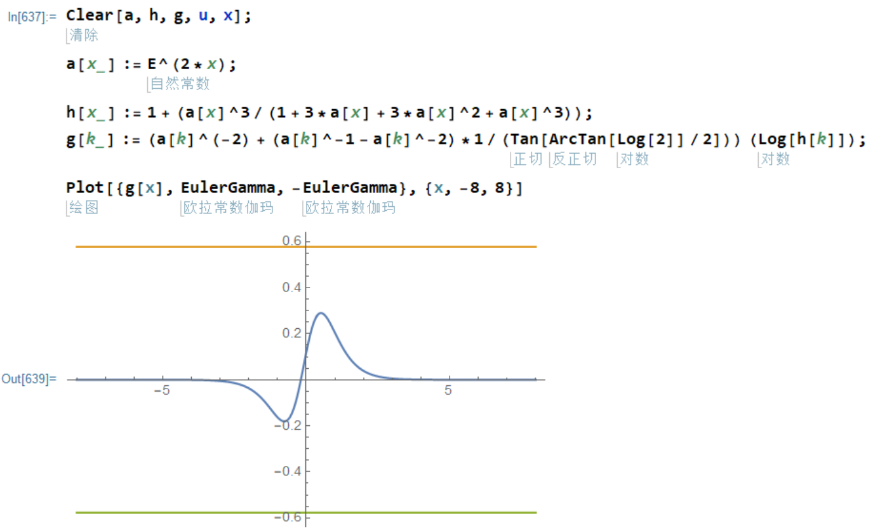
仔细考虑，我们用的积分方法，来自于二重求和，自然数倒数的无限项和，正如自然数的无限项和，应为一个负数（虚数单位的平方），所以这个结果，应开看曲线的最小值，这个值约为，
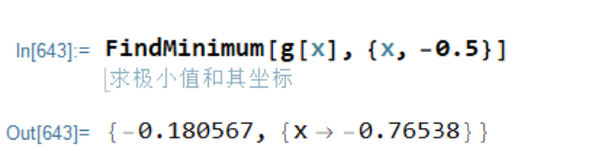
但是这个值的绝对值却小于欧拉常数的绝对值。考虑各种可能的原因，最有可能的原因就是整数系统的单位和实数系统的单位的比率不为1，而这个比率我们已经算出来了，它就是用于补偿斜率的，
$$\frac{i_{1}^{2}}{i_{2}^{2}}=\frac{k^{2}}{k^{2}}=\tan\left(\frac{1}{2}arc\tan{\ln{2}}\right)$$
它的倒数位，
$$k_{c}=\frac{i_{2}^{2}}{i_{1}^{2}}=\cot{\tan\left(\frac{1}{2}arc\tan{\ln{2}}\right)}$$
所以原函数整体上乘以这个比率的倒数$k_{c}$，
$$γ\left(x\right)=\cot\left(\frac{1}{2}arc\tan{\ln{2}}\right)\left\{\cot\left(\frac{1}{2}arc\tan{\ln{2}}\right)\left[\frac{A{\left(x\right)}^{2}-A\left(x\right)}{A{\left(x\right)}^{3}}\right]\ln{C\left(x\right)}+\frac{\ln{C\left(x\right)}}{A{\left(x\right)}^{2}}\right\}={\left[\cot\left(\frac{1}{2}arc\tan{\ln{2}}\right)\right]}^{2}\frac{A{\left(x\right)}^{2}-A\left(x\right)}{A{\left(x\right)}^{3}}\ln{C\left(x\right)}+\cot\left(\frac{1}{2}arc\tan{\ln{2}}\right)\frac{\ln{C\left(x\right)}}{A{\left(x\right)}^{2}}$$
抽出常数，
$$γ\left(x\right)=k_{c}^{4}\frac{A{\left(x\right)}^{2}-A\left(x\right)}{A{\left(x\right)}^{3}}\ln{C\left(x\right)}+k_{c}^{2}\frac{\ln{C\left(x\right)}}{A{\left(x\right)}^{2}},k_{c}^{2}=\cot\left(\frac{1}{2}arc\tan{\ln{2}}\right)$$
然后再求0点附近的最小值，就是欧拉伽马常数的数值的相反数，
$$γ=-γ\left(x_{p}\right),γ\left(x_{p}\right)=min⁡[γ\left(x_{p}\right)]$$
也就是方程，
$$\frac{dγ\left(x\right)}{dx}=0,x<0$$
的时候函数值的相反数，
$$γ=-γ\left(x\right)$$
具体情况如图所示，
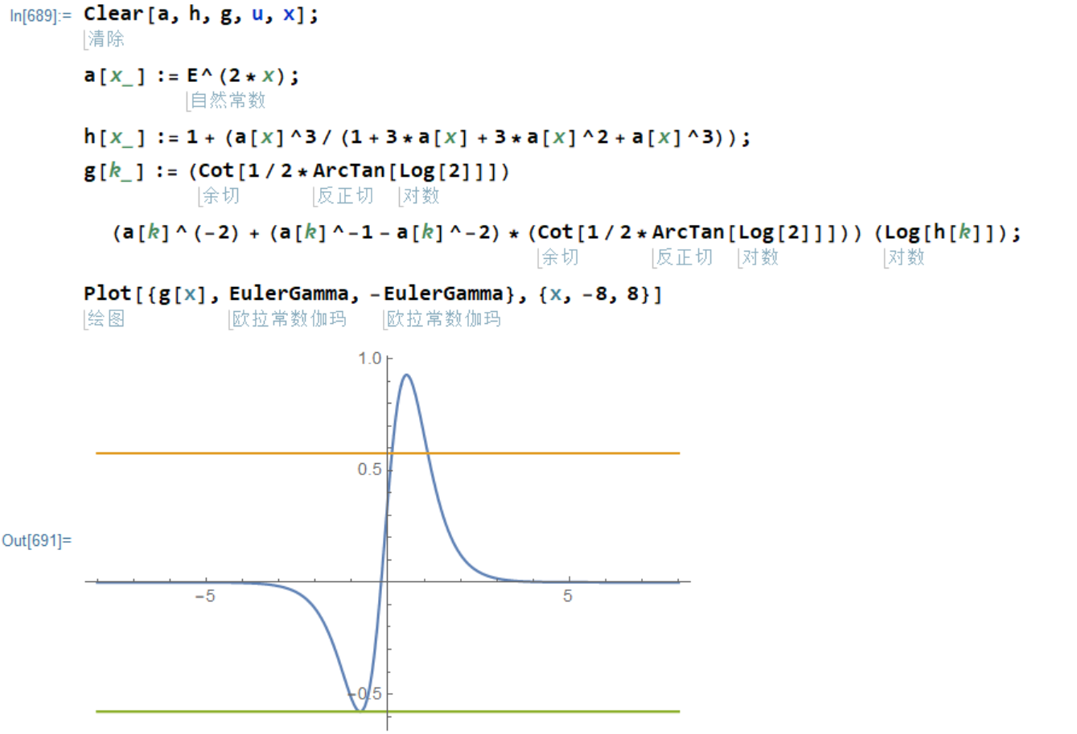
从图中可以看出，
$$ξ\left(1\right)=\sum_{n=1}^{∞}{\frac{1}{n}}=\frac{1}{1}+\frac{1}{2}+\frac{1}{3}+\frac{1}{4}+⋯$$
也是有周期的（体现为从负无穷趋向于0），它在无穷大和无穷小两端都和实数域的周期对齐，但如果选择某些特殊的虚数单位比值，则结果会比实数域的周期要小，整数虚数单位的数值越大，也就是单位之间的间距越稀疏，倒数全加和相比较于实数倒数全加和就小得更多，由于累加的顺序是从较大的数到较小的数，微小差异的顺序也是如此，所以结果为正数，但实际上应当反向比较，此时结果为负数，也就是图像上所指出的。这个差值，其实就是整数前提下，
$$i_{n}^{2}+1=0$$
中的1，也就是比周期小1的“负一”。同理，
$$i_{r}^{4}+γ=0$$
可见，$γ$就是实数系统的“负一”。由于相对于完全连续的实数来说，整数系统的连续性是不充分的，所以要用基于整数系统的数字来表达这个“负一”，就必定会出现无限精度的问题，也就是无限不循环小数的问题。因为一旦可以写成有限或者循环小数，它就是可以用有限精度表示的，它的本质就是某种单位更小的整数。所以所谓的无理数，才是理想世界，也包括未能感知的现实世界的等价物，才能够正确描述真实世界。而整数只是基于某些有限大小的质数而构造的粗糙计数系统。但正如我们需要数字和进制，不适用这种系统我们就无法清晰理解数值的大小。所以就像是圆周率，它是真实和精确的，但是若不以某些小数位表示，就没法知道它的数值范围。所以那些真正的数学对象，是表达式和方程指出的关系，而不是用来计算的数字。相比较于关系，即便是有充分多的位数，也无法精确的描述关系本身。
有了以上的关于欧拉伽马常数的认识，我们就可以推导出计算数值的离散算法，对任何给定整数或者实数范围，计算它对应的伽马常数，然后再把这个具体的数值代入质数的计数函数$π(x)$就能得到非常精确的结果。关于离散算法，这里就不作推导了。
但是，初步计算的结果，只有5位十进制精度，这一点也是可以理解的，因为我们在考虑虚数单位平方的比率的时候，已经考虑过精度的问题，但是在一个实数周期里面，并未应用。也就是说，在计算虚数单位平方的比率的时候，假定，
$$d=1+bi$$
是因为，
$$d^{'}=a+bi$$
$$d^{'}=\frac{d}{a}=\frac{a+bi}{a}=1+\frac{b}{a}i=1+b^{'}i$$
也就是，
$$d=1+bi$$
代入虚数单位的平方的比率，
$$\frac{i_{1}^{2}}{i_{2}^{2}}=\frac{k^{2}}{k^{2}}=\frac{1}{T\left(d\right)}=\left|e^{-8d}\right|=\left|e^{-8(1+bi)}\right|=\tan\left(\frac{1}{2}arc\tan{\ln{2}}\right)+r$$
其中的$r$就是单一周期中的余量。我们知道单一周期里面一定不可能对齐，所以这个余量必定是存在的。函数$dγ\left(x\right)$在单一周期中的极值较小，是一个绝对值比欧拉伽马常数更大的负数，正好说明了余量$r$必然存在。继续计算，已知，
$$k_{c}^{2}=\frac{1}{k^{2}}=T(d)=e^{8d}=\cot\left(\frac{1}{2}arc\tan{\ln{2}}\right)$$
$$d=\ln{\cot\left(\frac{1}{2}arc\tan{\ln{2}}\right)}$$
把原来的$d$代入复数形式，
$$k^{2}=\frac{1}{T\left(d\right)}=e^{-8d}=e^{-8(a+bi)}=e^{-8(d+bi)}=e^{-8\left[(\ln{\cot\left(\frac{1}{2}arc\tan{\ln{2}}\right)}+bi)\right]}=e^{8\ln{\tan\left(\frac{1}{2}arc\tan{\ln{2}}\right)}-bi}=\tan\left(\frac{1}{2}arc\tan{\ln{2}}\right)+r$$
$$e^{-8d}=e^{\ln{{\left[\tan\left(\frac{1}{2}arc\tan{\ln{2}}\right)\right]}^{8}}+\frac{b}{i}}=\tan\left(\frac{1}{2}arc\tan{\ln{2}}\right)+r$$
$$e^{-8d}=e^{\ln{{\left[\tan\left(\frac{1}{2}arc\tan{\ln{2}}\right)\right]}^{8}}}∙e^{\frac{b}{i}}=\tan\left(\frac{1}{2}arc\tan{\ln{2}}\right)+r$$
$$r=e^{\ln{{\left[\tan\left(\frac{1}{2}arc\tan{\ln{2}}\right)\right]}^{8}}}∙e^{\frac{b}{i}}-\tan\left(\frac{1}{2}arc\tan{\ln{2}}\right)$$
这里的虚数单位，指的是以整数的虚数单位为单位1，实数的虚数单位相较于整数虚数单位的倍数，也就是，
$$i_{r}=i_{n}\sqrt{\tan\left(\frac{1}{2}arc\tan{\ln{2}}\right)}$$
$$r=e^{\ln{{\left[\tan\left(\frac{1}{2}arc\tan{\ln{2}}\right)\right]}^{8}}}∙e^{\frac{b}{i}}=e^{\ln{{\left[\tan\left(\frac{1}{2}arc\tan{\ln{2}}\right)\right]}^{8}}}∙e^{\frac{b}{i\sqrt{\tan\left(\frac{1}{2}arc\tan{\ln{2}}\right)}}}-\tan\left(\frac{1}{2}arc\tan{\ln{2}}\right)={\left[\tan\left(\frac{1}{2}arc\tan{\ln{2}}\right)\right]}^{8}∙e^{\frac{b}{i\sqrt{\tan\left(\frac{1}{2}arc\tan{\ln{2}}\right)}}}-\tan\left(\frac{1}{2}arc\tan{\ln{2}}\right)$$
此时将b的作用转移给虚数单位，
$$i_{n}=\frac{i}{b}$$
$$e^{-8d}=\tan\left(\frac{1}{2}arc\tan{\ln{2}}\right)+r=\tan\left(\frac{1}{2}arc\tan{\ln{2}}\right)+{\left[\tan\left(\frac{1}{2}arc\tan{\ln{2}}\right)\right]}^{8}∙e^{\frac{1}{i_{n}\sqrt{\tan\left(\frac{1}{2}arc\tan{\ln{2}}\right)}}}-\tan\left(\frac{1}{2}arc\tan{\ln{2}}\right)={\left[\tan\left(\frac{1}{2}arc\tan{\ln{2}}\right)\right]}^{8}∙e^{\frac{1}{i_{n}\sqrt{\tan\left(\frac{1}{2}arc\tan{\ln{2}}\right)}}}$$
在第一个周期中，$i_{n}=1$，但随着周期的增加，整数系统和实数系统互相纠缠迭代，这个数值也会变化。此时，
$$T\left(d\right)=e^{8d}=\cot\left(\frac{1}{2}arc\tan{\ln{2}}\right)$$
就要替换为，
$$T\left(d\right)=\frac{1}{{\left[\tan\left(\frac{1}{2}arc\tan{\ln{2}}\right)\right]}^{8}∙e^{\frac{b}{i_{n}\sqrt{\tan\left(\frac{1}{2}arc\tan{\ln{2}}\right)}}}}$$
$$T\left(i_{n}\right)={\left[\tan\left(\frac{1}{2}arc\tan{\ln{2}}\right)\right]}^{-8}∙e^{-\frac{1}{i_{n}\sqrt{\tan\left(\frac{1}{2}arc\tan{\ln{2}}\right)}}}$$
回到，
$$γ\left(x\right)=k_{c}^{4}\frac{A{\left(x\right)}^{2}-A\left(x\right)}{A{\left(x\right)}^{3}}\ln{C\left(x\right)}+k_{c}^{2}\frac{\ln{C\left(x\right)}}{A{\left(x\right)}^{2}},k_{c}^{2}=\cot\left(\frac{1}{2}arc\tan{\ln{2}}\right)$$
其中，把其中静态的$k_{c}^{2}$替换为和整数的虚数单位对应的$T\left(i_{n}\right)$，
$$γ\left(x\right)=T{\left(i_{n}\right)}^{2}\frac{A{\left(x\right)}^{2}-A\left(x\right)}{A{\left(x\right)}^{3}}\ln{C\left(x\right)}+T\left(i_{n}\right)\frac{\ln{C\left(x\right)}}{A{\left(x\right)}^{2}}$$
$$T\left(i_{n}\right)={\left[\tan\left(\frac{1}{2}arc\tan{\ln{2}}\right)\right]}^{-8}∙e^{-\frac{1}{i_{n}\sqrt{\tan\left(\frac{1}{2}arc\tan{\ln{2}}\right)}}}$$
此时求出的结果，就是当前周期中，实数虚数单位的平方和整数虚数单位的平方的比率，也就是欧拉伽马常数的当前值，也就是$T\left(i_{n+1}\right)$的倒数，
$$k^{2}=\frac{1}{T\left(i_{n+1}\right)}=\lim_{f\left(x\right)→f_{min}(x)}\left[T{\left(i_{n}\right)}^{2}\frac{A{\left(x\right)}^{2}-A\left(x\right)}{A{\left(x\right)}^{3}}\ln{C\left(x\right)}+T\left(i_{n}\right)\frac{\ln{C\left(x\right)}}{A{\left(x\right)}^{2}}\right]$$
其中，
$$A\left(x\right)=ⅇ^{2x}$$
$$C\left(x\right)=1-\frac{A{\left(x\right)}^{3}}{1+3A\left(x\right)+3A{\left(x\right)}^{2}+A{\left(x\right)}^{3}}$$
$$T\left(i_{n}\right)={\left[\tan\left(\frac{1}{2}arc\tan{\ln{2}}\right)\right]}^{-8}∙e^{-\frac{1}{i_{n}\sqrt{\tan\left(\frac{1}{2}arc\tan{\ln{2}}\right)}}},i_{n_{0}}=1$$
这个方程左边为原来的$γ\left(x\right)$它的数值小于-1，又被作为倒数迭代回方程，所以绝对值是不断减小并趋于不动点的，而且反复的颠倒迭代将导致数值呈现反复起伏的周期性变化。这一点对于质数分布规律函数$π(x)$的周期性起伏可能具有调节和抑制作用。
计算这个函数最小值的极限，取向无穷次的结果，就是欧拉伽马常数，
$$γ=-\lim_{n→∞}{γ\left(x\right)}=-\lim_{n→∞}{\frac{1}{T\left(i_{n+1}\right)}}=-\lim_{n→∞}\left\{\lim_{f\left(x\right)→f_{min}(x)}\left[T{\left(i_{n}\right)}^{2}\frac{A{\left(x\right)}^{2}-A\left(x\right)}{A{\left(x\right)}^{3}}\ln{C\left(x\right)}+T\left(i_{n}\right)\frac{\ln{C\left(x\right)}}{A{\left(x\right)}^{2}}\right]\right\}$$
用这个迭代过程即可跨越周期，求出$γ$的无限精度。由于这个迭代过程涉及到每一个周期中寻求最小值的运算，所以无限精度的$γ$不可能通过公式的综合而一次性获得，只能以单周期数值运算的方式获得更多的精度，这一点和圆周率以及根号二都是一样的。所以这个数必然是无理数。也就是说，它也是超越有限精度的度量系统的真实数量的体现。换句话说，真实世界是可以理解，但无法预先精确计算的。这一点不只是物理上的，同样是数学上的。若要计算，只能计算，而无法预先，也就是说，只能让计算的过程发生，无论是数学上的还是现实中的，但发生了就是发生了，没发生就是没发生，通过计算来预言发生的结果，是不成立的。因为某些基本的数量，哪怕无限精度可以计算，也不能省略任何计算的步骤，就像求最小值的过程在每个周期之中都必须再做一次一样。
我们知道这些超越数，比如$ⅇ,π,γ$等这些自然常数，都可以用离散的计算来逼近。这是因为，通过有限或者无限次的迭代过程，算法可以趋向于这个数值本身，或者叫做不动点。虽然数值的精度不断提高，但是无论如何也达不到这个不动点本身。这是因为我们使用的度量系统是不精确的，有颗粒度的。但是这些超越数所表达的不动点本身，却不受到度量系统的颗粒度的影响。也就是说，这些数值是纯粹真实的。比如整数1，它的颗粒度虽然也是任选的，但是颗粒度小于某个数值之后，其精度就不可能增加了，所以它实际上表达了一种有层次的相对关系。但是自然对数底$ⅇ$却不是这样，无论怎么增加度量的精度，结果都不会停止在同一个数值上。所以，并不是$ⅇ$不精确，它是无限精确的，是我们的度量系统不精确，而这种不精确是必然的，这是由于度量系统必须有刻度而导致的。所以说，经历过各种尺度的刻度之后，观察者才能发现一个数值是否是完全真实的。
然而，这通常来说也是非常难于做到的。更精细的系统总是可以体现出更多的有效数字，用无限次的测试去探查一个系统的精度，通常也是不现实的。所以相对于某些数量的绝对真实，大多数数量都是相对的和不稳定的（不构成不动点）。就像我们观测量子系统，出现不确定性，不是量子系统本身不确定，而是观察者本身不确定，但量子系统在更高的频率下完全可以也是不确定的。但观察者总是得到相反的认知，因为观察者总是认为自己是确定的，所观之物才是不确定的。至于究竟谁是确定的，探查是必要的，但过度的探查，也是一种时间上的消耗。最终，追求完全真实，可能在物理世界中是无法成立的。但根据有限性和无限性本无差异的本质，可知，若不追求它，它也必定就在那里。
回到数学，所谓收敛性，指的是通过有限次或者无限次的迭代或者递归运算，计算的结果可以趋向于某个不动点。具有真实收敛性的序列或者函数，通常来说都意味着某种真实，因为它可以超越度量系统的有限精度而存在。检验这种收敛性需要实际的运算过程，只是这个过程并不总是必须发生的：大多时候都没有发生的必要。
回到物理学，正如我们度量一个系统，或者得到确定性的结果，说明系统的精度有限，或者得到不确定的结果，说明系统的精度超过观察者的度量能力。后者则意味着，若被度量系统显示出充分的不确定性，则被度量系统就具有极高的确定性，而不确定的反而是观察者本身。观察者通过对极度确定的系统的观测，进而获得了自身不确定性带来的相对运动，以及对应的动能。所以，越是在度量中体现出不确定性的系统，对于观察者来说，其产生的能量效果越明显，也就是说，观察者可以由此获得自身的能量，而不损耗其它能源。这就使得观察者自己成为了自己给自己提供能量且可以给环境提供能量的能源本身。所以，一个确定性系统的价值，不在于自身是否提供能量，而在于其它观察者在观察这个确定性系统的过程中，获得了对自身能量的认识。但这种能量不应当轻易输出，否则会导致观察者自身出现难以弥补的匮乏。但此时的观察者可以成为其它观察者的被观察者，通过被观察者输出能量而获得能量补给。这就构成了能量上抽的逻辑链条。然而，确定性系统本身并不缺少能量，缺少能量的反而是不确定的度量系统。所以这种能量转移的模式，是应当慎用的。若是不得不用，应当在合适的时候给以归还。
确定性较低的系统，对确定性较高的系统评价为不确定度较高，这种认知正是导致能量分层，各个层次上的能量水平被锁死的原因。确定性具有差异的系统之间无法正确的判断确定性的确定程度，以及必须实际探查才能认知确定性的成本本身不确定，则是谎言和欺骗可以存在的原因。

