<http://www.codeproject.com/Articles/330184/How-does-it-work-in-Mono-s-C-compiler>

Jay

Jay is an Open Source Compiler-Compiler tool derived from Berkeley Yacc. It is used in the Mono project as a Compiler-Compiler tool to generate the parser of the Mono C# compiler. Jay reads the grammar specification from a grammar file and generates an LR parser for it. This *cs-parser.jay* file is used by Jay to turn into *cs-parser.cs* file which will be consumed by the Mono C# compiler as the parser.

cs-parser.jay to cs-parser.cs conversion

Cygwin is a set of Open Source tools which provide a Linux like environment for Windows where Linux applications, for example, Shell can be used in Windows. So now we assume we have a working Cygwin environment in our desktop. We will open the Cygwin terminal by clicking on *Start > Program Files > Cygwin > Cygwin Terminal*. When we open the Cygwin terminal, it will be like Figure 1.

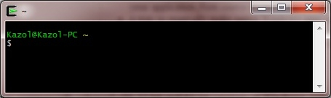

Figure 1: Cygwin Open mode

Please copy the Mono source code inside the */usr/src* directory of the Cygwin installation directory. And now open the Cygwin terminal and write the following command listed in Code-Listing 1.

Code-Listing 1: Bash Command to convert cs-parser.jay to cs-parser.cs

$cd /usr/src/Mono/mcs

$cd jay

$make

$cd ..

$cd mcs

$../jay/jay.exe -ctv < ../jay/skeleton.cs cs-parser.jay > cs-parser.cs

Please see the following figure:

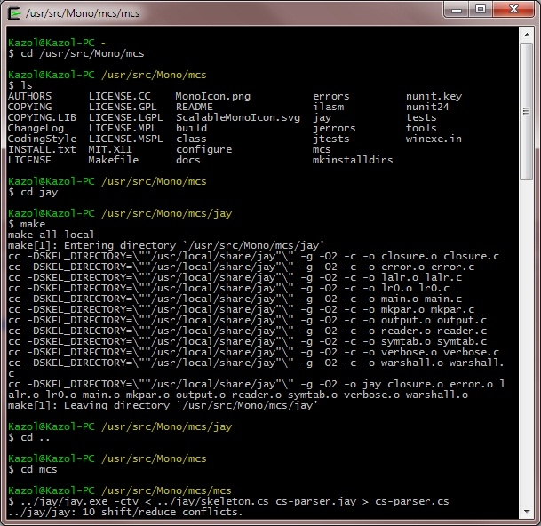

Figure 2: Bash Command output

So after executing *Jay.exe* with the appropriate argument, it will convert the *cs-parser.jay* file into *cs-parser.cs* which is the parser for Mono.