**Homework Set 10**

# Problem1

P(Purchase) = 9/14

P(not Purchase) = 5/14

P(Purchase | Age <= 30, Income = medium, Student = yes, Credit rating = Fair) =

P(Purchase) P(Age <= 30 | Purchase) P(Income = medium | Purchase) P(Student = yes | Purchase) P(Credit rating = Fair | Purchase) =

**9/14 * 2/9 * 4/9 * 6/9 * 6/9 = 0.0282186949**

P(not Purchase | Age <= 30, Income = medium, Student = yes, Credit rating = Fair) =

P(not Purchase) P(Age <= 30 | not Purchase) P(Income = medium | not Purchase) P(Student = yes | not Purchase) P(Credit rating = Fair | not Purchase) =

**5/14 * 3/5 * 2/5 * 1/5 * 2/5 = 0.0068571429**

P(Purchase)= **0.0282186949/(0.0068571429 + 0.0282186949) = 0.804505228382599**

P(not Purchase) = **0.0068571429/(0.0068571429 + 0.0282186949)** = **0.19549477161740095**

**Since P(Purchase) > P(not Purchase), the person will but a computer.**

# Problem 2

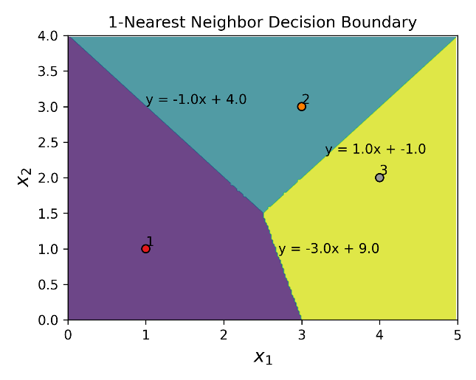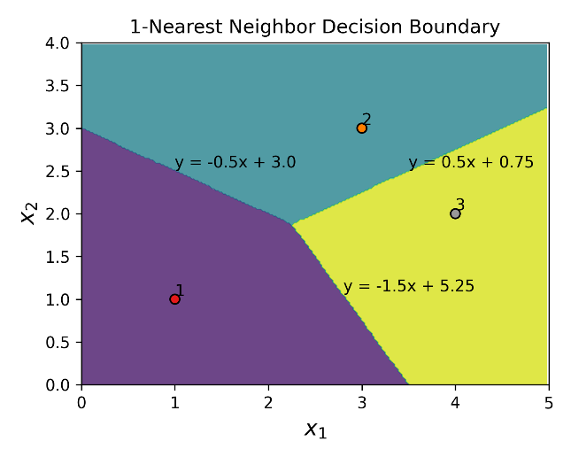

1NN with custom distance

1NN with Euclidean distance

# Problem 3

(a)

The error values are:

|  |  |  |
| --- | --- | --- |
| k | Training Error | Validation Error |
| 1 | 0.0 | 0.127 |
| 3 | 0.068 | 0.143 |
| 5 | 0.084 | 0.13 |
| 11 | 0.118 | 0.173 |
| 16 | 0.139 | 0.197 |
| 21 | 0.155 | 0.203 |

The best k for validation data is 1 and validation error is 0.127

The test error of this classifier is 0.083

(b)

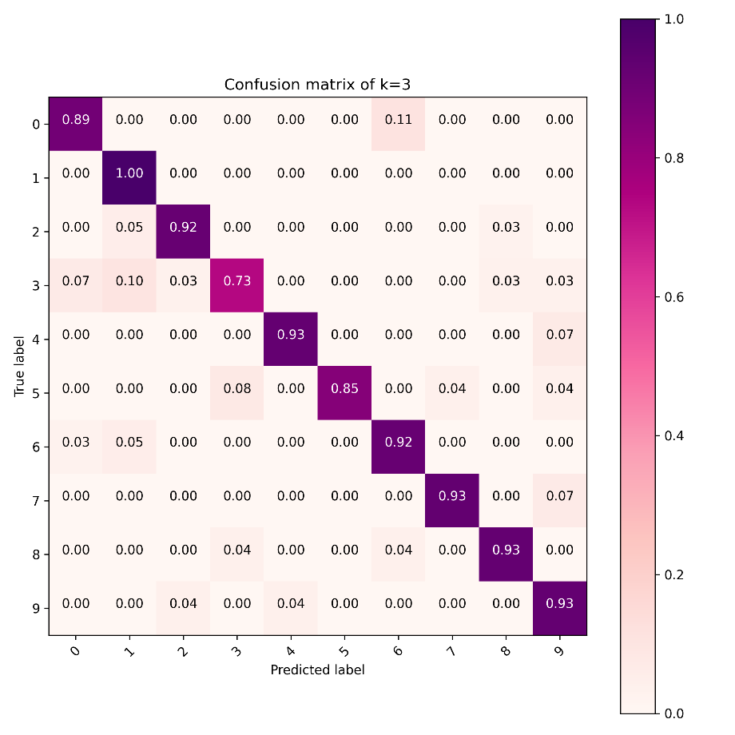

The easiest to classify is 1

The hardest to classify is 3

(c)

One image from class 2 was classified as class 8.

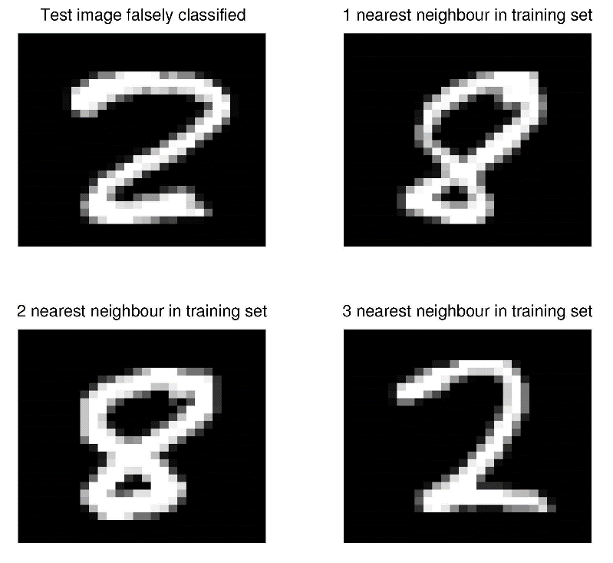1