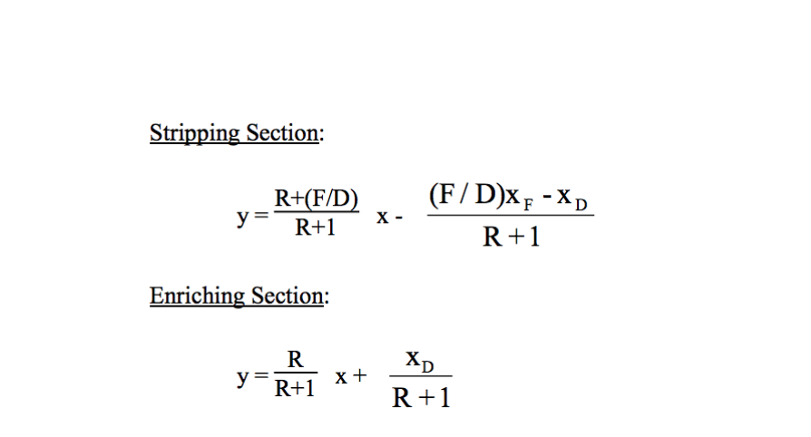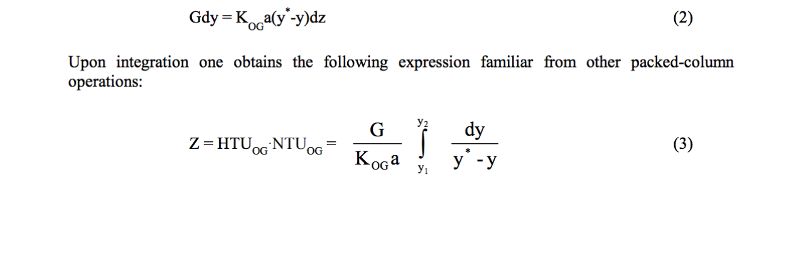

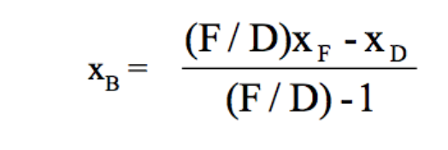

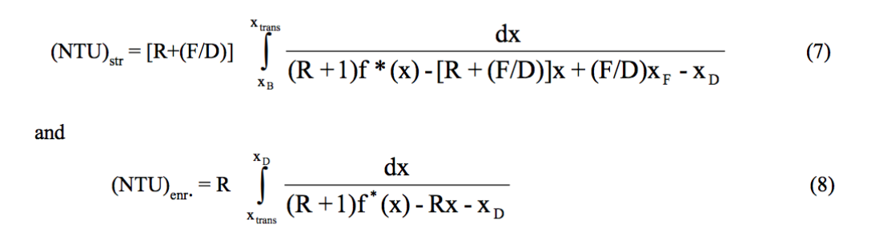

stripping:

Dy/dx = (R+F/D)/(R+1)

Int = dx[(R+F/D)/(R+1) / [y\* -



xb(F/D) – xb = F/D\*xf – xd

xbF – xbD = xfF – xdD

F = B + D

B = F-D

xfF = xbB + xdD

xb = (xfF – xdD)/B

xb = (xfF – xdD)/(F-D)

xb = (xfF/D – xd)/(F/D-1)