**Project Plan**

**Chatbot Web App**

**IT Clan Consulting Services**

|  |  |
| --- | --- |
| Industry Partner | Vimal |
| Primary Instructor | Anjana Shah |
| Team Member | Young Pyung Yoo |
| Team Member | Mark Romel Trespeces |
| Team Member | Kent Pedrocha |
| Team Member | Viet Long Cao |
| Team Member | John Jademar Lopez |

Document Revision History

|  |  |
| --- | --- |
| Revision # | Date |
| 1.1 | January 26th 2022 |

**1. Executive Summary**

The following describes the project to be executed.

|  |  |
| --- | --- |
| Objective | * To provide first line communication to the users. * To establish real-time engagement with the users. * Process large volume of queries from users. * Saves time by answering users FAQs. |
| Corporate Goals Addressed | * Increase corporate sales by attaining the proper information and present to their potential customers at the right time. * Saves more funds by reducing number of works with AI Chatbots when customers are in need to be helped. * Create conversational forms and saving all the data on spreadsheets. * Setting the essence for the companies' conversational marketing approach. |
| Planned Start Date | September 20, 2021 |
| Planned End Date | April 1, 2022 |

**2. Project Approvers, Reviews and Distribution List**

Approvers, reviewers,

and distribution list

|  |  |  |  |
| --- | --- | --- | --- |
| Project Role | Name | E-mail | Date |
| Project Manager | Young Pyung Yoo | youngpyung.yoo@georgebrown.ca | 10/08/2021 |
| Full-Stack Developer | Mark Romel Trespeces | markromel.trespeces@georgebrown.ca | 10/08/2021 |
| Full-Stack Developer | Kent Pedrocha | kent.pedrocha@georgebrown.ca | 10/08/2021 |
| Front-end Developer | Viet Long Cao | vietlong.cao@georgebrown.ca | 10/08/2021 |
| Back-end Developer | John Jademar Lopez | johnjademar.lopez@georgebrown.ca | 10/08/2021 |
| Stakeholder | Vimal | Vimal.talk@gmail.com | 10/08/2021 |

**3. Scope**

Features:

|  |  |
| --- | --- |
| In Scope | Out of Scope |
| Visual Flow Builder | Chatbot Marketing |
| Omnichannel Messaging Support | Chatbot Analytics |
| Sentiment Analysis | Chatbot Widget Customization |
| AI Chatbots | Live Chat Handover |
| Chatbot API | Data Security |
|  |  |
|  |  |

**4. Deliverables**

This project will deliver the following:

|  |  |
| --- | --- |
| Deliverable | Description |
| Faster response time to customers | Chatbot replies to queries quicker to customers than agents. |
| Improved productivity and efficiency | Create greater output with the same amount of input. |
| Service prototype | Testing the interactions between chatbot and beta users. |
|  |  |
|  |  |

**5. Assumptions**

This project makes the following assumptions:

* The project commissions and intents will be guaranteed when project team members are needed at anytime to finalize.
* Training will be conducted internally with no additional training costs incurred.
* Shareholder will provide necessary support for successful project completion.
* All the team members can complete their respective tasks within the schedule planned efficiently.
* All relevant stakeholders will come to the next meeting as scheduled. However, there might be instances at which the stakeholders are unavailable to attend, and unanimous vote should be made if rescheduling is needed.
* Project postponement will happen if supervision fails to recognize different instances to the draft deliverables on time in the project timeline.

**6. Dependencies**

The following are the internal and external dependencies that will have to be acknowledged and addressed.

* Stakeholder must give approval of the prototype before developing the project.
* System requirements should be disclosed to the team so designers can make the appropriate design that can meet the requirements.
* Training and research must be done in order to proceed to development of the project.
* Before starting development, database design and chatbot architecture should be done.
* Coding and developing of the chatbot must be done in order to do testing. If an issue was found, it must be corrected.
* Implementation of the chatbot to stakeholder's website can only be done if the testing was successful.
* The more the chatbot is used, the more it gets better. Therefore, the only way the chatbot gets better is by analyzing conversation with the user.

**7. Risk Management**

|  |  |  |  |
| --- | --- | --- | --- |
| Potential Risk | Severity (H/M/L) | Likelihood (H/M/L) | Management Strategy |
| Lack of knowledge | H | M | Getting trained by the experts and practicing to a great extent. |
| Natural disaster | H | L | Pushing the team’s work to the cloud or repository. |
| Unclear project timeline | H | M | Generate a concise project schedule periodic report. |
| Member availability | M | M | Have different member to cover the work of the absent one and make a report about it. |
| Potential lack of responsibility | M | L | Constantly asking for feedback and reports to ensure members’ attitude and work progress. |

**8. Communication**

**Reporting**

The following reports will be produced.

|  |  |  |
| --- | --- | --- |
| Report | Audience | Frequency |
| Weekly Status Report   * Review of tasks completed in previous week. * Review of tasks scheduled for completion in the next week * Review of problem condition and solution | Team members with Project Manager | Weekly |
|  |  |  |

**Meetings**

The following meetings/communication will be established;

|  |  |  |  |
| --- | --- | --- | --- |
| Meeting | Purpose | Attendees | Frequency |
| Weekly Project Status Meeting | To review assignments that were finished in previous week.  To discuss on tasks that should be done next week.  To review any issues that are needed to be resolved, if necessary. | Team members with Project Manager | Weekly |
| Bi-weekly Project Meeting with Stakeholder | To review the progress and the status of the project with the stakeholder | Team members, Project Manager, and Stakeholder | Bi-weekly |

**9. Task Listing (WBS- Work Breakdown Structure)**

The following resource proposal template summarizes the resource hours committed to this project, upon final approval of this document.

|  |  |  |  |
| --- | --- | --- | --- |
| Reference | Tasks | Duration | Dependency |
| A | Planning | September 24th 2021 – December 7th 2021 |  |
| B | Research & Discoveries | December 13th 2021 – January 31st 2022 | A |
| C | Design | February 1st 2022 – February 13th 2022 | B |
| D | Coding & Development | February 14th 2022 – March 6th 2022 | C |
| E | Testing | March 7th 2022 –  March 15th 2022 | D |
| F | Implementation | March 16th 2022 –  April 1st 2022 | E |

**10. Gantt Chart**

Create a detailed Gantt Chart from your Task Listing(Use any software tool and paste the image or upload as a separate file that can be opened as pdf/doc/xls)

Gantt chart is provided through separate file.

**11. Milestones**

|  |  |  |
| --- | --- | --- |
| Major Activity or Milestone | Estimated Milestone Target date | Owner/Reviewer Team Members |
| Presentation I | October 19th 2021 | Team |
| Presentation II | December 7th 2021 | Team |
| Achieve Training and Discovery | January 31st 2022 | Team |
| Design Work Template | February 13th 2022 | Team |
| Chatbot Development Completion | March 6th 2022 | Team |
| Chatbot Testing Completion | March 15th 2022 | Team |
| Achieve Chatbot Integration | April 1st 2022 | Team |
| Project Completion |  | Team |

**12. RAM – Responsibility Assignment Matrix**

Create a RAM from your Task Listing. A sample is shown below:

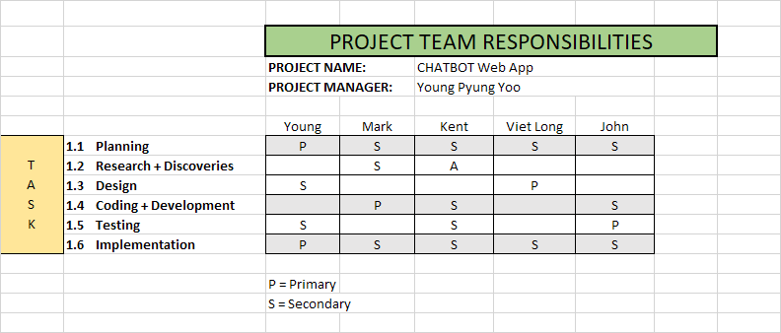

**13. Approval**

The signatures below indicate their approval of the contents of this document.

|  |  |  |  |
| --- | --- | --- | --- |
| Project Role | Name | Signature | Date |
| Client | Vimal |  |  |
|  |  |  |  |