Project Identification

Project: | Chatbot Web App
Prepared By: | Group T10
Document Version: | Version 1.0
Published Date: | 10/03/21

Contributors

Name | Title
John Jademar Lopez | Team Member
Kent Pedrocha | Team Member
Mark Romel Trespeces | Team Member
Viet Long Cao | Team Member
Young Pyung Yoo | Team Member

Distribution

Name | Title
Anjana Shah | Professor
Vimal | Stakeholder

Referenced Documents

Version number | Title | Author | Date | Source / Location
1 | What is Chatbot : Design Process & Its Architecture |  |  | https://www.elprocus.com/chatbot-design-process-and-its-architecture/

Revision History

Version Number | Revision Date | Summary of Changes | Modified by

TABLE OF CONTENTS
1. Business Context Diagram 3
2. REquirements Scope Statements 4
3. High Level Business Requirements (HLR) Traceability 4
4. High Level Business Requirements Sign-Off 5

- Business Context Diagram
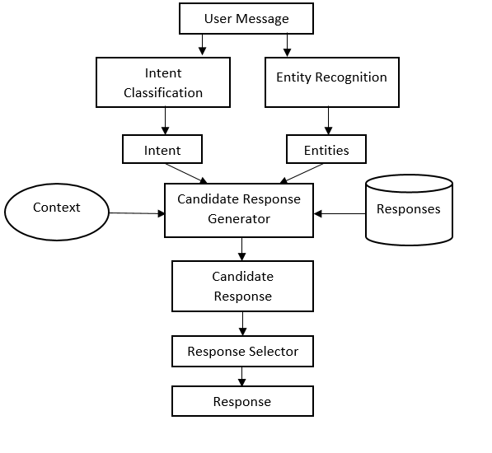
<Reference: https://www.elprocus.com/chatbot-design-process-and-its-architecture/>

Requirement Scope Area | Description
Chatbot | A software that interacts though instant messaging, replicating human conversations. A well-built chatbot can address users’ questions, as a result, the business can save expenses by cutting out the need of human.

External Entity | Description
User | User starts conversation, give all his/her information needed to the chatbot for verification purposes.
Agent | Agent can view user’s information such as name, email, and phone number for verification purposes. Agent can also have access of the entire conversation if the user asked for a human takeover.

Information Flows | Description
User info | Information needed to verify identity such as name, email and address.
Query | User’s question to be solved by the chatbot.
Response | Chatbot’s solution to the query or agent’s depending on if the user requested a takeover.
Request for takeover | Live agent can take over if the question is more complex.
History / Context | Recorded conversation between the User and chatbot (or Agent in some case).
- Requirements Scope Statements
HLR# | Description | Priority  (H, M, L)
 | Human-like approach  - The chatbot should be capable of understanding the context of the conversation and understand the goal of the customer. | M
 | High level Security  - User should feel secured when sharing information such as payment methods and addresses. | H
 | Extended Support  - Chatbot should be available 24/7. If agent is needed the chatbot should be able to transfer the user to and agent, | L
HLR04 | Easy to use  - The UI/UX should be straight forward to accommodate more users that are not tech savvy. | H
HLR05 | Interactive media  - The Chatbot should be able to send images and emojis in the conversation as it brings out more personality and it can boost the conversation rates. | H

- High Level Business Requirements Sign-Off
The undersigned acknowledge their agreement with the contents of Version <1.0> of the High-Level Requirements document for <Chatbot Web App>.

Following approval of this document, requirements changes will be governed by the project’s change management process, including impact analysis and appropriate reviews and approvals, under the general control of the Project Plan and according to company policy. Approved Change Request Documents, if present, will be attached to this Requirements Document as updates.

Name | Project Role and  Functional Area | Date Signed
Young Pyung Yoo | Project Manager | 10/09/2021
Mark Romel Trespeces | Full-stack Developer | 10/09/2021
Kent Pedrocha | Full-stack Developer | 10/09/2021
Viet Long Cao | Front-end Developer | 10/09/2021
John Jademar Lopez | Back-end Developer | 10/09/2021
Vimal | Stakeholder

* Note: physical signatures are not required. Email approvals are acceptable and should be appended to project documents.

