VAPOR User Interface Reference Manual

April, 2007

Version 1.1

Table of Contents

1 Introduction 3
1.1 Terminology and symbols. 3
2 VAPOR Main Menu capabilities 5
2.1 VAPOR main window layout 5
2.2 Main Menu bar 6
2.2.1 File Menu and the VAPOR session 6
2.2.2 Edit Menu 7
2.2.3 Data Menu 9
2.2.4 View Menu 12
2.2.4 Help Menu 12
3 Visualizers 14
3.1 Toolbars 14
3.1.1 Mouse Modes and the Mouse Mode Toolbar. 14
3.1.2 The VizTools toolbar 16
3.2 Visualizer features panel 17
4 Tabbed Parameter Panels 19
4.1 General settings of the tabbed panels 19
4.1.1 Scope 19
4.1.2 VAPOR Renderers and Renderer Control 19
4.1.3 Refinement 20
4.2 Viewpoint and Lights panel 21
4.3 Animation panel 23
4.4 Region panel 24
4.4.1 Settings in the region panel. 25
4.4.2 Region description 26
4.5 DVR panel 26
4.5.1 General DVR Settings 27
4.5.2 Transfer Function Editor 28
4.5.3 Additional DVR settings 30
4.6 Flow panel 31
4.6.1 Basic Flow Parameters 32
4.6.2 Advanced Flow Parameters 35
4.6.3 Flow Seeding Parameters 37
4.6.4 Shape Parameters 38
4.6.5 Color/Opacity map editing 39
4.7 Probe panel 42
4.7.1 General probe settings 43
4.7.2 Probe cross-section 44
4.7.3 Probe transfer function editor 46

Introduction

This VAPOR User Interface Reference Manual provides a technical specification of the capabilities of the VAPOR User Interface, version 1.1. It is meant to be used in conjunction with other documentation, such as the VAPOR Quick Start Guide and the VAPOR Data Collection Overview. This manual specifies all the capabilities of the VAPOR user interface; however it does not describe how these capabilities are used. Read the VAPOR Quick Start Guide to understand the process of using the VAPOR User Interface in scientific analysis.

Terminology and symbols.
Underlining is used in this document to identify text that is a literal copy of the text in the user interface. Italics are used to identify terms that are being defined.

The user interface includes many editable text boxes. If the value can be edited the box is recessed, as in the following:
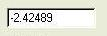

Text that is not editable is not recessed, as in:
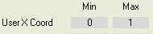

Combo boxes provide a means of selecting from a list of choices in a dropdown menu:
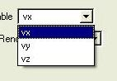

Buttons are used to trigger an action, and are also used to toggle an on/off state:
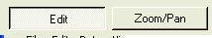

Often sliders are combined with text boxes, providing multiple means of controlling a single variable:

Check boxes are useful for controlling binary (on/off) state:
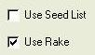

VAPOR Main Menu capabilities

VAPOR main window layout

When VAPOR is launched, the user interface appears as in Figure 2.1. Across the top of the window is the main menu bar, including the File, Edit, Data, View, Script, Animation, and Help menus. These menus enable the user to perform high level capabilities, such as reading files or controlling options in a VAPOR session. These menus are described in section 2.2.

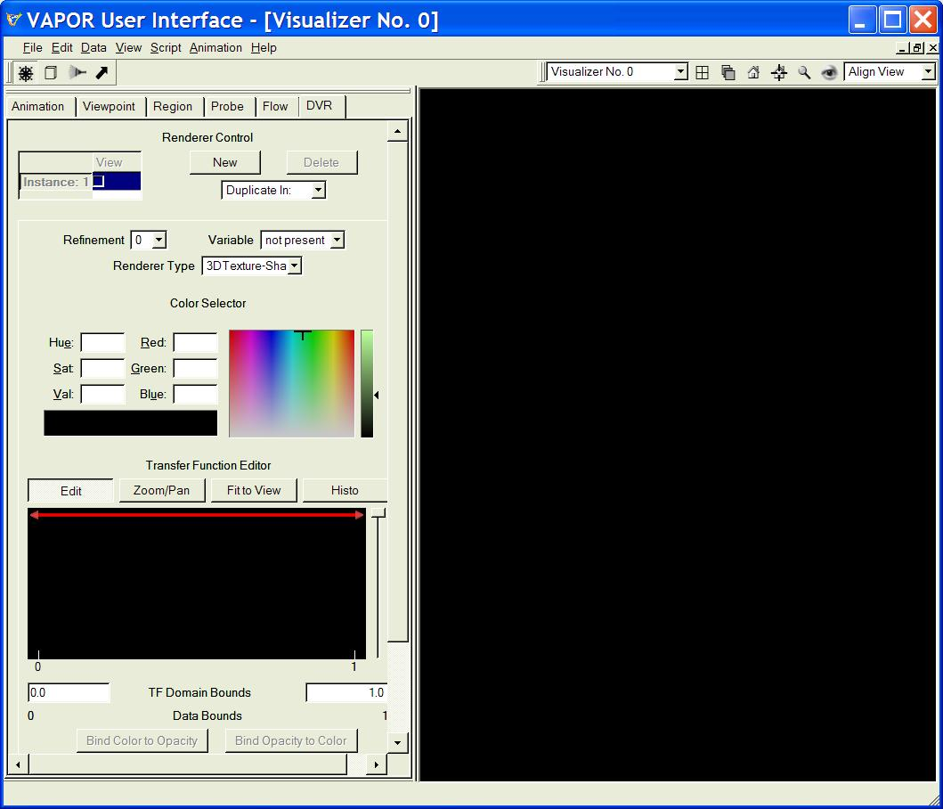
Figure 2.1: Vapor User Interface at start-up

Below the main menu bar are two toolbars, the Mouse Mode toolbar on the left, and the visualizer toolbar on the right. These toolbars are described in Section 3.1.
The rest of the VAPOR main window is divided into two (left and right) halves. On the right side are visualizer(s), wherein VAPOR visualization is performed. The right side can be subdivided into many different visualizer windows, although initially (by default) it contains only one visualizer. The operation of the visualizers is described in Section 3.

On the left side of the main window are the tabbed parameter panels. These panels allow the users to specify all the various settings needed for controlling the visualizers. There are several different tabs at the top of the tabbed parameter panels, which can be used to select a set of parameters. These tabs (from left to right) are Animation, Viewpoint, Region, Probe, Flow, and DVR. The tabbed parameter panels are described in Section 4.

Main Menu bar

The main menu bar has seven dropdown menus, however, currently only five are implemented: (File, Edit, Data, View, and Help).

File Menu and the VAPOR session
The VAPOR File menu appears as follows:
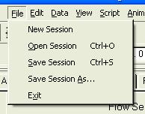
File Menu

The five entries in the file menu relate to controlling the VAPOR session. The session is the totality of settings established by the user during the VAPOR application. The session includes all of the current state of the VAPOR application, except for the following:

- Window size and layout
- Visualizer contents (rendered images), discussed in section 3
- Mouse mode (discussed in section 3.1.1)
- Tabbed panel enabled/disabled state (discussed in section 4.1)
- History (queue) of commands executed (see 2.2.2)

The following are the five choices in the File menu:

- New Session: This resets VAPOR to an initial default session, such as the session that results when you launch VAPOR.
- Open Session: This enables you to read a “Vapor Saved Session” (*.vss) file, and sets VAPOR to the settings in that session.
- Save Session: This saves the current session state in the current default session file. The session cannot be saved until a dataset has been loaded (see the Data menu, Section 3.2.3). Initially the session file is “/tmp/VaporSavedSession.vss”; however the default session file always refers to the most recent file name that was specified by either of the File menu options: Open Session or Save Session As.
- Save Session As: This requests the user to specify a file (name and path) and saves the current session state in the named file. The session cannot be saved until after a dataset has been loaded (see the Data menu, Section 2.2.3). On completion, the specified file becomes the default session file.
- Exit: This ends the current session, exiting the VAPOR application.

Edit Menu
This menu has four entries: Undo .., Redo.., Edit Session Parameters, and Edit Visualizer Features:
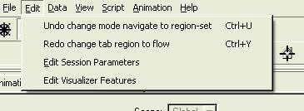
Edit Menu

- Undo… and Redo…: These control the session command queue. VAPOR maintains a history of the most recent 100 changes to the session state. Undo enables the user to move to the previous state. After clicking Undo one or more times, the user can return the session to following states by clicking Redo. The Undo option is disabled until an actual change has been made, and then a short descriptive phrase is provided after the word “Undo”, specifying the action that will be undone. The Redo option is only enabled after an Undo.

- Edit Session Parameters. This launches the Set Session Parameters Panel, shown below:

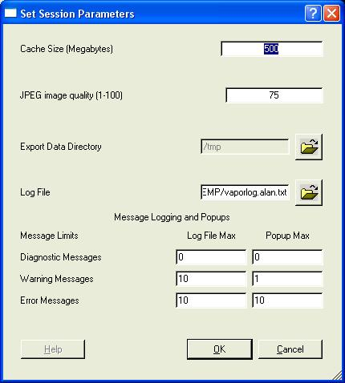
Figure 2.1: Session Parameters Panel

The entries in the Session Parameters Panel are global parameters that affect the general operation during a VAPOR session. These include the following:
- Cache Size (Megabytes) : This specifies the amount of memory that will be used to store the most recent volume data that is being used by VAPOR, at the next Load Data operation. This should be set to a value near the amount of physical memory available for your use in your system.
- JPEG image quality (1-100): is a value between 1 and 100 specifying the level of quality in visualizer images saved (see the View menu, Section 2.2.4, below). Default value is 100.
- Export Data Directory: specifies the directory that is used for exporting data to IDL (Section 2.2.3). Currently this directory cannot be changed.
- Log File: Specifies the name of a file that will contain any log messages (specified in the Message Logging and Popups)
- Message Logging and Popups. During the operation of VAPOR, the messages can result are of the following types:
    - Diagnostic Messages are indications of actions performed. These are primarily for debugging. Hundreds or thousands of these are posted during a typical session.
    - Warning Messages indicate unusual conditions that ordinarily do not interfere with completion of the current VAPOR operation.
    - Error Messages indicate more serious problems that may interfere with completion of the current VAPOR operation.
The Log File Max values in the Message Logging specify how many times a given message will be output to the log file. If this value is 0, the message will not be output. If this value is N, a given message will appear at most N times in the log file. Note that if the text of the message is only slightly changed (e.g. a numerical value in the message is different), then the changed message is considered different for the purposes of this count.
The Popup Max values in the Message Logging specify how many times a given message will be presented to the user as a Pop-Up dialog. If this value is 0, the message will not be shown. If this value is N, a given message will appear at most N times in a Pop-Up. Note that if the text of the message is only slightly changed, the message is considered different for the purposes of this count. To avoid annoying repetitive messages, no message will be presented twice in succession; i.e., a popup message will not be repeated until after a different message appears.
Changing any of the max values in this panel, or changing the log file name, resets all the counts to zero.

- Edit Visualizer Features: This launches a panel allowing the user to set various features of the visualizer windows. These will be discussed later (in section 3.2).

Data Menu
The Data Menu has seven options:
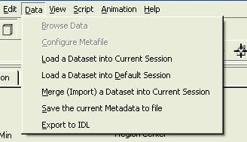
Data Menu

The first two entries in this menu, Browse Data and Configure Metafile, are not yet implemented. The remaining entries refer to various operations involved in specifying the data (Vapor Data Collection, or VDC) that VAPOR will be visualizing, and enabling the VAPOR user interface to communicate with an IDL analysis session.
The VAPOR Data Collection Overview provides more information about VAPOR metadata and about interaction with IDL. We provide some basic terminology here: A VDC contains one or more named variables. A variable can be regarded as a function of space and time. Each variable has one or more time-steps. For each time-step, there is a 3-dimensional volume of data values, such as a 3-dimensional array, specifying the value of the variable at a spatial coordinate and at the associated time-step.
A VAPOR session involves performing visualization and other operations on data in a VDC. Only one dataset is used in the current session. The dataset that is being examined is described by a VAPOR metadata file (an xml file, of type *.vdf). The metadata specifies information about the dataset, enabling applications to access the data. The actual data that is read is contained in numerous files specified in the metadata. The data is not read from disk until it is required for a specified user operation.

The following actions may be selected in the Data menu:

- Load a Dataset into Current Session. This launches a file-open dialog, enabling the user to specify a metadata file (i.e. file of type *.vdf) to be read. The current session settings are not changed (unless there is an inconsistency between the session settings and the metadata). After the user has restored a previously saved session, this option should be used to re-load the data prior to continuing the session. This option should not be used to load a dataset that is inconsistent with the current session settings (e.g. with different region settings) because the previous session settings may be inappropriate for examining such a dataset.

- Load a Dataset into Default Session. This launches a file-open dialog enabling the user to specify a metadata file to be loaded. The current session state is reset to default (as in the New Session option of the File menu), and then the data is loaded into that session. The session is set to appropriate values for visualizing the specified metadata. Because the previous session parameters are lost, any important session state should be saved prior to choosing this option.

- Merge (Import) a Dataset into Current Session. This launches a file-open dialog enabling the user to specify a metadata file to be loaded. If successful, this results in a merged metadata that includes the previous metadata in the session as well as the newly specified metadata. The operation will fail if the newly specified metadata does not have the same physical extents or grid dimensions as the previous metadata. The resulting VDC will include all of the variable names that appear in either metadata. If a variable name exists in both the former and the newly specified metadata, then the variable is replaced (i.e. the variable data in the former metadata will not be referenced in the merged metadata). Prior to performing the merge, the user is prompted to provide a time-step offset. The time steps in the new data will begin at the offset specified in the new, merged metadata.
The merge operation is intended to be used when new data is created that should be examined alongside the previous data. For example, the new data may result from performing operations in IDL. The result of these operations may be a newly derived dataset that can then be adjoined to (merged with) the previous data.
VDC metadata contains references to the locations of VDC field data (variables). In general, these references are file path names relative to the location of the metafile. When a merge operation is performed the newly created metadata will use absolute path names to reference the newly merged field variables.

With a few minor exceptions, the contents of the metafile to be merged with the current metadata will replace the current metadata in the session.

- Save the current Metadata to file. This option is useful after performing a merge operation. This is useful, for example, whenever the user needs to save the session containing the merged metadata. Note that a merge will result in new metadata in the VAPOR session; however, there may not exist a metadata file (*.vdf file) that describes the merged data. It can be difficult to restore the session if the merged metadata is not available in one file.
When the Save the current Metadata to file option is chosen, the user is presented with a file-open dialog, allowing the specification of a *.vdf file, in the same directory where the previously-read *.vdf file resides. The user is required to save the metadata in that same directory. The current metadata is written to the specified file.

- Export to IDL. This option saves a file (of type .xml) in a location that is known to the user’s current IDL session, specifying the current metadata location and the current region settings. This file is in the /tmp directory on Unix systems, and in C:\TEMP on Windows. The file contains sufficient information so that the IDL session can locate the specified data and perform operations on that data. The options Export to IDL and Merge (import) a dataset into current session are intended to be used in tandem, enabling the user to repeatedly do the following:
    - Identify regions of interest, using the VAPOR user interface
    - Perform IDL analysis on the region of interest in the dataset.
    - Visualize new variables resulting from the IDL analysis

View Menu
The View menu has four options:
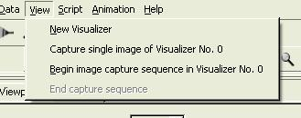
View Menu

- New Visualizer: This creates a new visualizer window, sharing the space in the right-hand side of the screen
- Capture single image in Visualizer…: This results in a file-open dialog, enabling the user to specify a jpeg file name. Then an image is written to the jpeg file, based on the contents of the specified visualizer. The specified visualizer is the currently active visualizer, and can be changed by clicking in a visualizer. Note: The user should make sure the file selection dialog is not over the specified visualizer in order to get a clean image capture.
- Begin image capture sequence in Visualizer…: This action results in a file-open dialog, enabling the user to specify a jpeg file name. Then jpeg images are successively written using the specified file name, appended by a 4-digit integer. Additional JPEG Images are written each time the specified visualizer is redrawn. Note: The user should move the file selection dialog away from the specified visualizer to get a clean image capture. This image capture operation continues until End Capture Sequence is clicked.
- End capture sequence. This option is only available during an image capture sequence. It results in termination of the current image-capturing operation.

Help Menu
The Help menu appears as follows:
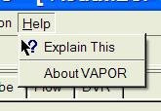

The two options are:
- ? Explain This provides access to context-sensitive technical help. Many of the capabilities of the VAPOR user interface are more fully described by this feature. To access this, first click on ? Explain This, and then click on the GUI element of interest. A one-paragraph explanation is provided.
- About Vapor provides top-level information about the version of VAPOR you are using.

Visualizers

The right side of the VAPOR main window is used for data visualization. Up to 16 separate windows can be created in this space. Each window can be maximized to fill the space, or minimized, leaving an icon in the space. By default the visualizers are named “Visualizer No. n” where n is the order of creation of the visualizer; however users can give the visualizers more meaningful names by using the Visualizer features panel in Section 3.2.
All of the visualizers can simultaneously display images; however exactly one of the visualizers is the active visualizer. When parameter values are specified in the user interface, those values apply to the visualization in the active visualizer. The settings may apply also to other visualizers when using Global Scope (see section 4.1.1) Users can specify the active visualizer by clicking the mouse in that visualizer, or by selecting that visualizer in the VizTools toolbar (Section 3.1.2).

Toolbars
There are two toolbars on the VAPOR main menu, both initially located immediately below the main menu bar. The toolbars can be grabbed with the left mouse button and moved elsewhere on the screen. Both are used in conjunction with visualizers.

Mouse Modes and the Mouse Mode Toolbar.
The Mouse Mode toolbar contains four buttons, as shown below:

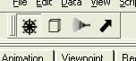
Mouse Mode Toolbar

The mouse mode toolbar determines the function of mouse- clicks and drags in the visualizer windows.

The leftmost button, with a wheel icon, specifies the default mode, navigation mode. When in navigation mode, you can drag with the left, middle, or right mouse. Left mouse drags result in a rotation in the scene about the current rotation center (as specified in the viewpoints menu). Middle mouse drags perform a (vertical and/or horizontal) translation of the scene in the plane orthogonal to the view direction. Right mouse drags (vertical only) result in a zoom-in or zoom-out toward or away from the rotation center.
The other three buttons, from left to right, using cube, rake, and arrow icons, enable Region Select mode, Rake mode, and Data Probe mode respectively. Clicking one of these mode buttons results in a red wire-frame outline of the volume associated with the mode, and also causes the appropriate tab (region, flow, probe) to show up at the front of the tabbed panels. Each of these wire-frames has 6 red cube-shaped handles, one on each face of the wire-frame, connected by a straight line to the center of the volume. A handle is highlighted with yellow when it is grabbed by clicking and holding the mouse button down over the handle. A typical region-select frame (with a grabbed handle) is pictured below:

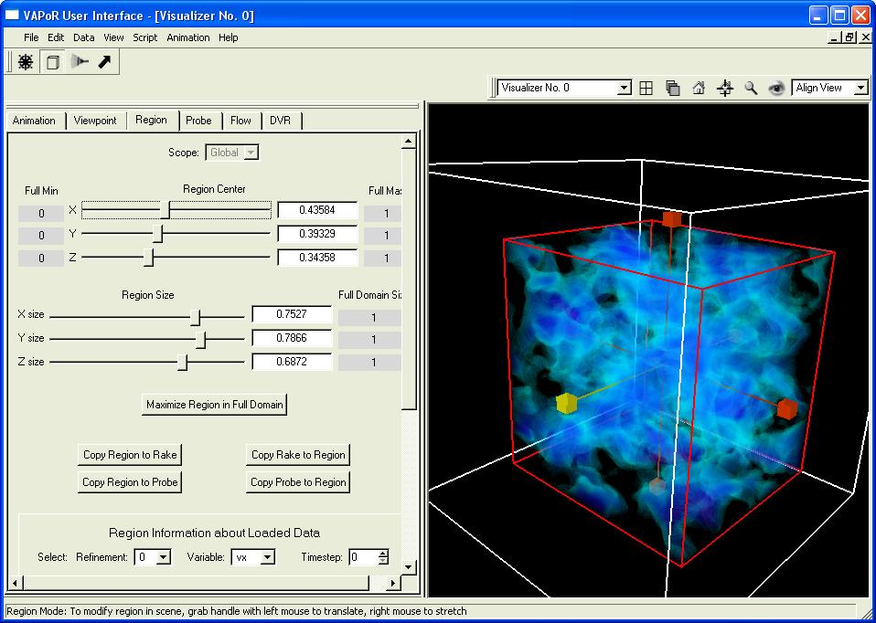
Figure 3.1 A typical region select frame

In Region, Rake, or Probe mode, mouse clicks and drags can be used to manipulate the size and position of the associated volume. A click/drag with the left mouse button over a handle is used to slide the volume in the direction of that handle. A click/drag with the right mouse button slides the edge of the volume closest to the handle. A click/drag elsewhere in the scene (not over any handle) performs navigation (as in the navigation mode described above).
While in Probe mode, if the probe is rotated to be non-axis-aligned (i.e. if there is a rotation angle that is not a multiple of 90 degrees) then the right mouse can no longer be used to adjust the probe volume size. In that situation, the sliders in the data probe tabbed panel can still be used to change the size.

The VizTools toolbar
The VizTools toolbar provides several capabilities that are useful in manipulating visualizers. This toolbar appears as follows:

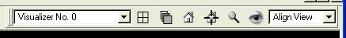
The VizTools toolbar

From left to right, the elements of this toolbar include:
- The “Visualizer combo”: This provides a dropdown menu, enabling the user to select one of the existing visualizers by name, or to create a new visualizer. The current active visualizer is shown in the combo box. When an existing visualizer is selected, it becomes the active visualizer.
- The “Tile Window” button (icon is a 2x2 array of squares) is useful in arranging more than one visualizer. It automatically arranges the visualizers to cover the available area, so they can all be seen at once.
- The “Cascade Windows” button (icon shows three overlapping squares) arranges the visualizer in a cascade so that you can see the front one with others partially hidden behind it.
- The “Home” button (icon is a house) resets the viewpoint in the current active visualizer to the home viewpoint. This is a reference viewpoint that can be defined and reset by the user. The home viewpoint is initially the default viewpoint, looking at the center of the full data array, with the camera/eye positioned in the negative Z direction from that center. Users can change the home viewpoint by clicking on the set-home button (discussed next).
- The “set-home” button (icon is a house with cross-hairs) is used to establish a home viewpoint. When this is clicked, the current viewpoint in the active visualizer becomes the home viewpoint in that visualizer.
- The “Zoom to Region” button (icon is a magnifying glass) is used to get a close look at the current region. (Current region is discussed in section 4.4). Clicking this button changes the viewpoint to be centered at the center of the current region and at a distance so that the current region almost fills the visualizer. The viewer direction remains the same as before the button was pressed.
- The “View All” button (icon is an eye) positions the viewpoint to see the entire data volume. The view center becomes the center of that volume and the distance is adjusted to make the data volume almost fill the visualizer. The viewer direction remains the same as before the button was pressed.
- The “Align View” combo box provides a dropdown menu with positive or negative X, Y, or Z values. This is used to provide an axis-aligned viewpoint, looking in the specified direction. The view rotation center is not changed.

Visualizer features panel
Several infrequently changed properties of the visualizers can be set in the Visualizer features menu, by selecting Edit Visualizer Features from the main window edit menu, as shown below:
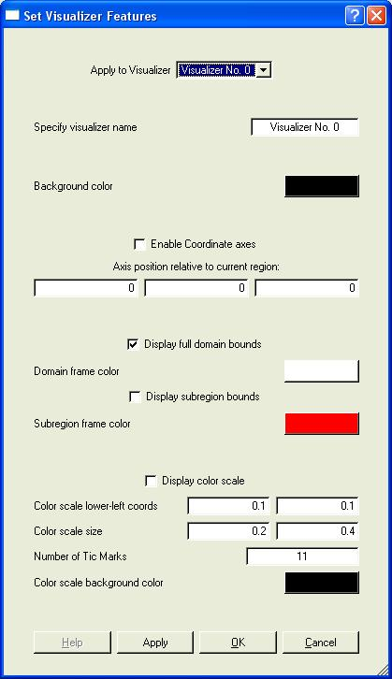
The visualizer features panel

The visualizer features panel contains the following (listed from top to bottom):
- The Apply to Visualizer combo box specifies the visualizer to which the other settings will apply.
- Specify Visualizer name: Used to rename a visualizer.
- Background color button: Click on this button to specify the color that will appear behind the image in the visualizer.
- Enable Coordinate Axes check-box: When this is checked, the coordinate axes are displayed in the visualizer. These are represented as three orthogonal arrows pointing in the positive X, Y, and Z directions. The X-axis is shown as a red arrow, Y is green, Z is blue.
- Axis position relative to current region edit boxes: These three boxes specify where the coordinate axes will be displayed, relative to the smallest (x,y,z) corner of the current region, in user coordinates.
- Display full domain bounds check-box: When checked, the extents of the full domain are framed with lines. Click on the Domain frame color button to select a color for this frame.
- Display subregion bounds check-box: When checked, the extents of the current region are framed with lines. Click on the Subregion frame color button to select a color for this frame.
- Display color scale checkbox: When checked, the current color mapping of the DVR transfer function (see section 4.5.2) in the selected window is shown as a color scale in the visualizer. The color scale can be used to calibrate the numerical values associated with colors. Several additional settings enable customization of the color scale:
    - Color scale lower-left coordinates: These specify the lower-left corner of the color scale relative to the visualizer window, where (0,0) is the lower left corner of the visualizer and (1,1) is the upper-right corner.
    - Color scale size specifies the horizontal and vertical size of the color scale relative to the visualizer dimensions.
    - Number of Tic Marks: Specifies how many uniformly spaced tic marks will be placed in the color scale.
    - Color scale background color: Click on this button to pick a background color for the color scale.

Tabbed Parameter Panels
The left side of the VAPOR main window is used to specify the parameters that control the visualizations. The parameters are grouped into tabbed panels, each tab controlling a collection of related capabilities. Three of the tabbed panels, DVR, Flow, and Probe, control a specific rendering (3D drawing) functionality in the visualizers. The other three (viewpoint, region, and animation) control sets of parameters that must be readily accessed during a visualization session.
Each tabbed parameter panel should be regarded as a collection of panels, one for each visualizer. When you click with the left mouse in a visualizer (i.e., make that visualizer active), the parameter values associated with that visualizer are displayed in the front tabbed parameter panel.
Most panels contain lots of edit boxes in which values are displayed. To change these values, type in the new value, and then press <enter> while the cursor is still over the edit box. If you do not press <enter>, and do not click on another widget in that panel, your changes may be lost. You can avoid unnecessary data access delays by typing in multiple changes, and then verifying that the values are correct, before pressing <enter>.

General settings of the tabbed panels

Scope
The Region, Animation, and Viewpoint parameter tabs have at the top a Scope selector. It can be set either to Local or Global. The scope selectors are only available when there is more than one visualizer, because they would have no effect when there is just one visualizer.
The scope provides a means of sharing parameter settings between different visualizers. If a particular tabbed panel is set to Local scope, then the settings in that panel apply only to the one (current active) visualizer. If the scope is set to Global, then the current active visualizer will use a unique shared set of parameters associated with Global scope. All visualizers that have scope set to Global on that tabbed panel will share that same parameter set. For example, to share region settings between two visualizers, select the Region tab and select Global scope for each of the two visualizers. By default, the region, animation, and viewpoint parameters have Global scope.

VAPOR Renderers and Renderer Control

The DVR, Flow, and Probe tabs control the rendering of images in the visualizers. Each of these tabs has a Renderer Control section near the top, appearing as follows:

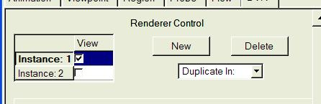
Renderer Control

Using the Renderer Control, you can control any number of renderers in the current visualizer. The different renderers are identified as “Instance: 1”, “Instance: 2”, etc. When you click in the check-box, the specified renderer is enabled; i.e. the renderer will start drawing in the current visualizer. One of the renderers is active, in the sense that the parameters displayed in the tab apply to that renderer. You can change the active renderer by clicking over the instance name. Additional renderers can be created by using the “New” button or the “Duplicate In” selector. The “Duplicate In” selector constructs a duplicate of the renderer in the current visualizer, or in any other visualizer (when multiple visualizers are available). Multiple Flow and Probe renderers can be enabled at the same time in the same visualizer. However, only one DVR renderer can be enabled at one time, because of limitations in hardware support for volume rendering.

Users must always enable rendering before performing visualization, because rendering may result in time-consuming access to data if it is not properly initialized. After loading a new dataset, all the renderers will be disabled.

Refinement
The three rendering tabs, DVR, Flow, and Probe, also have a Refinement selector:
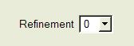
This specifies the resolution of the data that is used for rendering. By default the Refinement is set to 0, meaning that the lowest available resolution of the data will be accessed. Increases in the refinement by 1 will double the volume resolution in each dimension, thereby resulting in an 8-fold increase in the data size.

Viewpoint and Lights panel
The Viewpoint panel controls the position and orientation of a virtual camera, as well as the position and attributes of up to three light sources. It is pictured below:
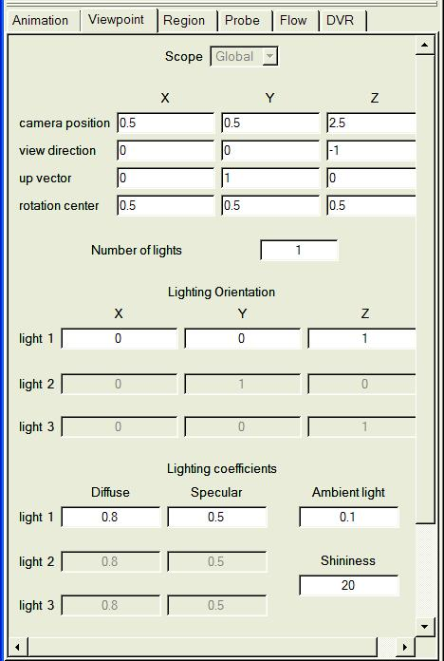
Figure 4.1: The Viewpoint and Lights Panel

The camera can also be positioned by mouse navigation (described in section 3.1.1). The viewpoint panel will display the result of any camera positioning in the appropriate edit boxes. The VAPOR camera subtends a horizontal field of view of 45 degrees. The following are the settings in the viewpoint panel:
- Camera position: Specifies the camera location in world coordinates
- View direction. Specifies a direction vector, pointing in the direction the camera is pointed. This vector should be nonzero.
- Up vector. Determines how the camera is rotated. The actual upward direction of the camera is the projection of this vector into the plane orthogonal to the view direction. This vector should be nonzero.
- Rotation center. This vector should ordinarily be set to the center of the data being examined. This vector does not affect the camera position but does affect the navigation. During navigation, rotations are about the rotation center position, and zooming is performed into or away from this location.
- Lighting orientation. The direction of up to three different directional white light sources can be specified in this panel. These lights are used for rendering flow lines, and the first of these lights is used for volume rendering (when dvr lighting is enabled). The value in the Number of Lights edit box determines how many directional lights are used, and a nonzero direction vector should be specified for each enabled light. These directions specify the light direction relative to the viewer direction, so the default (z-axis aligned) first light source is pointed in the same direction as the viewer.
- Lighting coefficients. Each light source has a diffuse and specular coefficient (between 0 and 1), determining the amount of diffuse and specular reflection is associated with each light. The ambient coefficient (again between 0 and 1) determines the amount of ambient (nondirectional) light in the scene. The shininess coefficient, between 1 and 128, affects the specular illumination, regulating the sharpness of the specular reflection.

Animation panel
VAPOR data collections are indexed by an integral time step, starting at a nonnegative integer. The current setting of the time step, as well as the timing of changes to that time step, are controlled in the animation panel, pictured below:

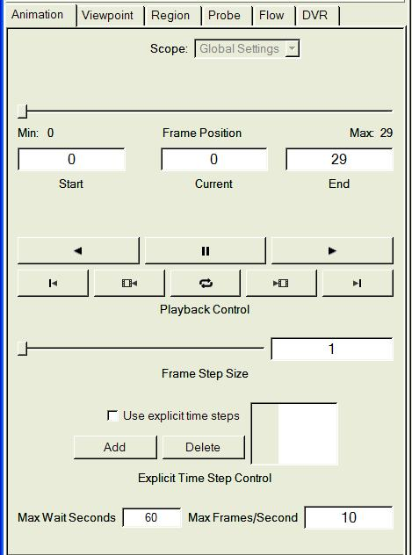
Figure 4.2: The Animation Panel

By default, the animation panel has global scope, so that one animation panel will control the time-stepping of all visualizers. The animation panel has the following settings:

- The current time step is specified by the frame position slider, as well as by the Current text box. Below the frame position slider are the Min and Max time steps, indicating the range of actual time steps that are specified in the metadata.
- The Start and End time steps default to the Min and Max, but can be specified to be a sub-interval of [Min,Max]. These determine the range of time steps that will be used during animation.
- There are two rows of buttons provided for animation control. The top row contains buttons for backward and forward play (icons are left and right-pointing triangles), as well as a pause button (icon is a pair of vertical lines) in the middle.
The buttons on the second row, from left to right, specify:
  - Jump to start (icon is vertical line with left-pointer)
  - Single frame step back (icon is film clip with left-pointer)
  - Continuous play on/off (icon is rotating arrows)
  - Single frame step forward (icon is film clip with right-pointer)
  - Jump to end. (icon is vertical line with right-pointer)

The single-step buttons are disabled when the forward or reverse play buttons are pressed.

- The Frame Step Size (slider and text box) enables users to skip multiple timesteps.
- The check box labeled “Use explicit time steps” is useful when the time steps to be animated are not evenly spaced. When this box is checked, the Add and Delete buttons become active, and the list of time steps (at the right) becomes editable. To specify a list of time steps, repeatedly click the “Add” button, and then edit the time step number that results. This list is always in ascending order.
- The Max Wait Seconds text box specifies the maximum number of seconds that will be waited for rendering completion(as well as any data loading required for rendering) before starting a new rendering. If a rendering takes longer than this, it is likely that a renderer is not available (e.g. the window may not be visible on the screen) so that other renderers that are synchronized with it will go ahead.
- The Max Frames/Second text box sets a limit on how fast the animation is allowed to proceed. Rendering rate is always limited by the software and hardware, so users may not obtain the specified rendering rate. Often a slower animation rate is useful for better data understanding.

Region panel
The region panel is used to specify a region of interest within the full data extents. The region of interest is a 3D box, bounded by 6 axis-aligned planes within the full data extents. The Region panel is used to position those planes and also to see the current positions of the planes. The bounds of the region can be visualized and manipulated in region mode; see Figure 3.1 and the accompanying discussion in Section 3.1.1. The region panel also provides a means of determining the resolution and other properties of the data that is available in the current Vapor Data Collection. The Region panel is shown below:
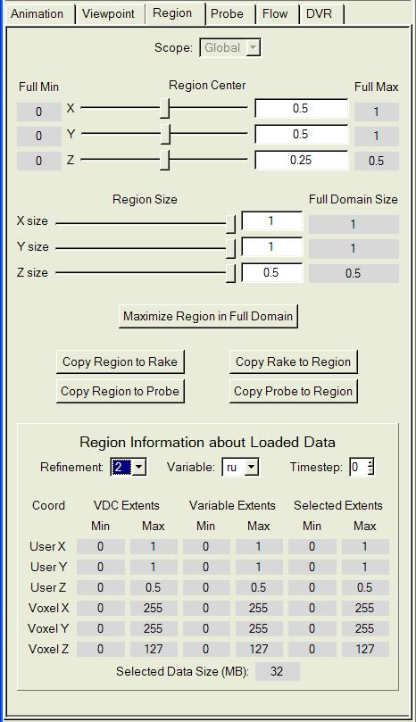
Figure 4.3: The Region Panel

Settings in the region panel.
The region panel contains the following settings:
- The Region Center (sliders and text boxes) specify the center of the region in user coordinates. These values are further restricted by the requirement that the entire region must lie within the extents specified by Full Min and Full Max. It may be necessary to first reduce the Region Size to meet this requirement.
- The Region Size (sliders and text boxes) specify values between 0 and the full domain size. The Full Domain Size, indicated on the right, is obtained from the domain extents in the metadata.

Note that the region center and size can also be controlled interactively in the visualizer, by using Region mode (Section 3.1.1 above).

Several useful buttons are provided below the region size sliders:

- Maximize Region in Full Domain: This button resets the region to use the full extents of the data.
- The four copy buttons enable the region center and size in the current active visualizer to be copied to, or from, the rake bounds (in the current instance in the Flow panel) and the probe bounds (in the current instance in the Probe panel). Note however that this copying ignores any rotation associated with the probe.

Region description
At the bottom of the Region panel is a section entitled Region Information about Loaded Data. This section enables the user to determine dimensions of the VDC, plus exactly what data is available in the current VDC. Three selectors (Refinement, Variable, Timestep) control the information that is displayed. Note that this section is purely informative: Setting the values of the three selectors will not have any effect on the data that is accessed by VAPOR.
The information about the data is displayed in a 6x6 array of values.
The first two columns provide user and voxel (grid) coordinate extents as specified in the metadata. The next two columns provide user and voxel coordinate extents for the actual data that is available on disk. The last two columns provide user and voxel extents for the current region (as specified at the top of this Region panel). Whenever the data is not available (i.e. does not exist in the VDC) the corresponding values in the Variable Extents are left blank.
Finally, the Selected Data Extents field shows the amount of data in megabytes that is associated with the specified refinement, variable, and timestep and for the current region. This value is useful in determining data cache size and estimating memory requirements.

DVR panel
The term “DVR” refers to Direct Volume Rendering. The DVR panel specifies the settings for volume rendering, as shown below:

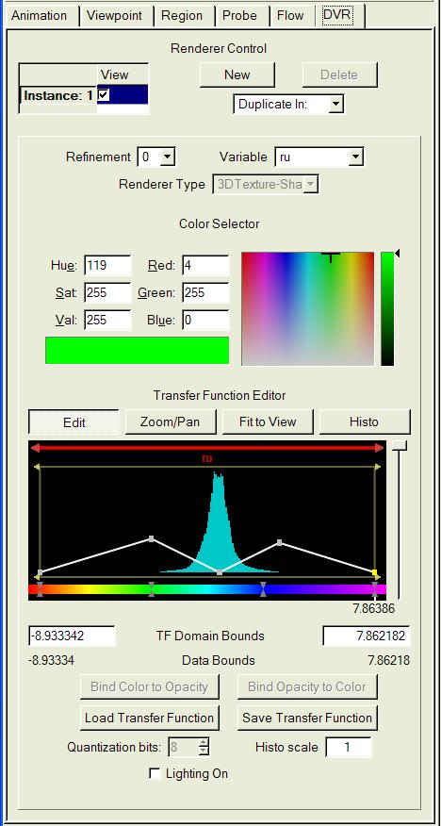
Figure 4.4: The DVR panel

General DVR Settings
From top to bottom, these are the settings in the DVR panel:

- Renderer control: This is described in Section 4.1.2.
- Refinement: This is described in Section 4.1.3.
- The Variable combo specifies the variable (named in the metadata) that will be volume-rendered.
- Renderer Type combo is only active when the renderer is disabled. It includes a choice of renderers, based on what graphics hardware is currently available in the system.

Transfer Function Editor
A transfer function is a mapping from data values to color and transparency. This is very important for volume rendering because it specifies the appearance of the variable being rendered. The Transfer Function Editor is a tool for defining the transfer function. There is a transfer function editor in the DVR panel and another one in the Probe panel.

The VAPOR transfer function is, by default, defined by a set of color control points and a set of opacity control points. Using the transfer function editor, the user specifies the location (a floating point value) for each of the control points, plus a color value at each color control point and an opacity value at each opacity control point. The resulting transfer function is obtained by linearly interpolating the color (in HSV coordinates) and opacity between the control points.
Optionally, the user may specify one or more “opacity widgets” to control the opacity. Each opacity widget determines a function defined in an interval of the variable with values in the interval [0,1]. The opacity can be either a piecewise-linear mapping or a Gaussian curve. Multiple opacity widgets are either added or multiplied to determine the total opacity at each variable value. This functionality is described more fully below.

The elements of the transfer function editor are the following:
    - The Color Selector is located above the Transfer Function Editor. This is a tool for specifying a color, using RGB or HSV coordinates, or by picking it from a palette. The palette selection specifies the hue and saturation of the color, and the slider on the right specifies the value (intensity).
- Next is a row of four buttons:
- Edit and Zoom/Pan determine the function of the left mouse. In Edit mode the mouse is used to select and drag control points (discussed below). In Zoom/Pan mode the left-mouse drags result in translation or stretching of the transfer function position in the editor window. Zooming and panning do not change the transfer function; they only affect its appearance in the editing window.
- The Fit to View button resets the edit window so that the transfer function domain uses the full window (from left to right). It does not change the transfer function.
- The Histo button rebuilds and redraws the histogram that appears in the opacity graph (discussed below).
- Below the buttons is a dark red horizontal bar (the domain bar) with red triangles at each end. Click/drag the bar to the left or right to translate the domain interval on which the transfer function is defined. Click/drag either triangle to translate one or the other end-point of the transfer function domain interval. The name of the variable being mapped is printed in red below the domain bar.
- Below the domain bar is a rectangular region (opacity edit region) with a black background, on which both a histogram and the opacity curve are drawn, as in the following:
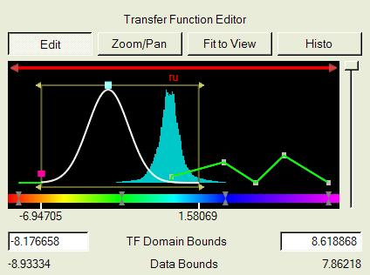
Opacity widgets in the opacity edit region

The opacity edit region displays the following:
    - Bounds of an opacity widget are shown, when that widget is selected. The opacity widget is shown as a dark gold rectangle with outward-pointing arrowheads at the top and bottom of both ends. Click and drag an arrowhead to change the bounds of that widget.
    - The curve associated with an opacity widget is shown in white when that widget is selected. The overall opacity curve associated with all combined opacity widgets is shown in green when no opacity widget is selected.
    - The individual control points of a piecewise-linear opacity widget are shown in grey, or, when a point is selected, in yellow.
    - A selected Gaussian opacity widget is controlled by a red control point (on the left edge of the widget) and a green control point (on the top of the widget). The red control point controls the horizontal scale (standard deviation) of the Gaussian, and the green control point, located at the mean, translates the Gaussian along the x-axis.
    - A histogram of data values in the transfer function domain is displayed in blue-green, behind the opacity curve. This is a histogram of the values of the specified variable in the current region at the specified refinement level. The histogram is normalized to use the top of the opacity edit region for the maximum value of the histogram.

- Right-mouse menus are available by clicking in the opacity edit region, to control the following:
    - Creation and deletion of opacity widgets
    - Creation and deletion of opacity and color control points
    - Boolean, linear, or logarithmic scaling of the histogram.
    - Addition or multiplication for combining of multiple opacity widgets
    - Enabling or disabling the contribution of any individual opacity widget to the overall opacity curve.
- Values of the transfer function and histogram are displayed (as a tool-tip) when the cursor hesitates for a few seconds in the opacity edit region.
- Below the opacity edit region is the color bar, a horizontal strip on which hourglass shapes (pairs of triangles) specify the location of color control points.
- Control point editing functionality: The control points and the values they are mapped to can be edited as follows:
    - New control points are created by clicking with the right mouse in the opacity edit region or color bar at the desired location.
    - A right-click near an existing control point provides the option of deleting or adjusting the position/value at that control point.
    - Control points are highlighted (in yellow) when selected. Control points can be selected by clicking with the left mouse button. Multiple points can be selected by selecting with the control key. An interval of control points can be selected using the shift key. The x-coordinate of selected points is shown below the transfer function editor. Note that selection only occurs in Edit mode.
    - Selected points can be dragged together by sliding the mouse, or deleted by pressing the delete key. Dragged control points are not allowed to slide past unselected control points.
- Immediately below the color bar are displayed the coordinates of the selected control points as well as the coordinates at the left and right endpoints of the editing interval. Each coordinate is associated with a tic mark at that coordinate.
- At the right side of the transfer function editor is the opacity scale slider. This slider provides an immediate means of scaling all the opacity values of the transfer function. It is useful when the transfer function needs to be quickly made more or less transparent. The scaling factor is 1 at the top and 0 at the bottom, varying quadratically over that interval. The scale factor is displayed in a tool-tip when the cursor hesitates over the slider.

Additional DVR settings
Below the transfer function editor are several additional text boxes and buttons.
- TF Domain Bounds identifies two text boxes (left and right) indicating left and right endpoints of the transfer function domain. These values can also be modified by sliding the domain bar or its endpoints (see above)
- Left and right limits in the current variable are indicated below the domain bounds by Actual Data Bounds.
- Two buttons (labeled Bind Color to Opacity and Bind Opacity to Color) are enabled whenever exactly one color control point and one opacity control point are simultaneously selected. Clicking the Bind Color to Opacity button moves the selected color control point to the same location as the opacity control point. Similarly the Bind Opacity to Color button moves the selected opacity control point to the same location as the color control point.
- Load Transfer Function and Save Transfer Function buttons provide the capability of loading and saving transfer functions, either from/to files, or from/to a set of transfer functions that are named and kept in the current session. Saving transfer functions in the current session provides a means of sharing transfer functions between different contexts, such as between different variables in a DVR, between the DVR’s associated with different visualizers, or between the DVR and other panels with transfer functions (such as the probe panel). Clicking on one of these buttons launches a dialog that enables the user to choose the file name or to choose the name of the transfer function in the session.
- Quantization bits is currently always 8, cannot be changed.
- Histo Scale is a text box that specifies a value that scales the height of the histogram in the transfer function editor.
- The Lighting On checkbox is currently only available when the Renderer Type is “3D Texture-Shader”. When lighting is enabled, the volume is shaded in accordance with properties of the first light source in the Viewpoint and Lights panel.

Flow panel
The Flow panel specifies the parameters controlling the integration and display of flow lines associated with a 3-dimensional vector field. There are three different types of flow advection: Steady flow, Unsteady flow, and Field Line Advection, selected from the flow Type selector at the top of the Basic Flow Parameters. In order to not present irrelevant options to the user, the Flow panel appears quite different, depending on the flow Type selected. The Basic Flow Parameters for each of these Types are displayed below the Renderer Control, as shown below:

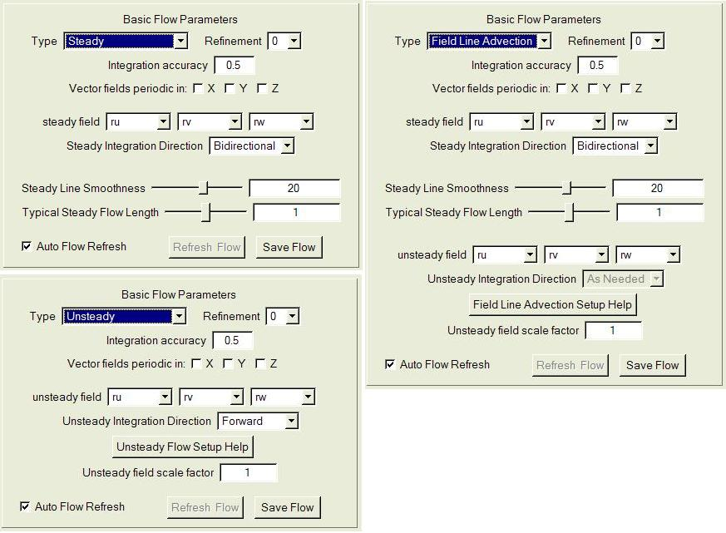
Figure 4.5: Basic Flow Parameters for Steady, Unsteady, and Field Line Advection flow types.

Basic Flow Parameters
The Basic Flow Parameters are as follows:
- The flow Type and Refinement selectors are at the top of the Basic Flow Parameters. The Refinement selector is described in Section 4.1.3. The Type selector supports the following choices:
    - When Steady flow is selected, the integration of flow lines is performed using the field values at a single time step (using the current time step from the animation panel). Steady flow results in a different set of flow lines for each time step, each flow line based on the current seeding parameters.
    - When Unsteady is selected, the flow integration is across multiple time steps, using vector field values at all time steps, and interpolating between the vector field values at adjacent time steps.
    - Field Line Advection combines steady and unsteady flow to enable animation of steady field lines subject to a time-varying velocity field. The result of Field Line Advection is a set of different steady flow lines at each time step, each field line determined from the corresponding field line at the previous time step.
- The Integration accuracy specifies a number between 0 and 1 that adjusts the integration feedback loop. The flow integration is performed using order 4 Runge-Kutta integration. The vector field is sampled by performing tri-linear interpolation within the grid cells determined by the Refinement level within the data region associated with the visualizer. The step size (distance between successive sample points) is adapted (repeatedly doubled or halved) to ensure that the change in angle between successive samples is between 3 and 15 degrees. The Integration accuracy parameter affects both the maximum and the minimum step size relative to the grid spacing. When the accuracy parameter is 0, the minimum step size is 0.01, and the maximum step size is 4.0. When the accuracy parameter is 1, the minimum step size is 0.25 and the maximum is 10. Values between 0 and 1 use a linear interpolation of both the minimum and maximum step sizes between their limiting values.
- There are three (X, Y, Z) checkboxes labeled “Vector fields periodic in:” . When checked, all variables are assumed to be periodic in the indicated dimension with period equal to the full size of the data extents in that dimension. Flow lines that exit on one end of the domain resume at the opposite end.
- For Steady flow and Field Line Advection, three text boxes, labeled steady field (x-, y-, and z- variables) specify the variables that comprise the vector field that is integrated in the flow line calculation. For Unsteady flow and Field Line Advection, three similar text boxes are provided to specify the unsteady field.
- The panel includes integration direction selectors for both steady and unsteady flow, that have different choices for each flow type:
    - For Steady flow, and for Field Line Advection, the Steady Integration Direction is either backward, forward, or bidirectional, indicating the integration direction along each field line from the seed point.
    - For Unsteady flow the Unsteady Integration Direction is either backward or forward, indicating that all integration goes either backwards or forwards in time.
    - For Field Line Advection, the Unsteady Integration Direction is always “As Needed”, indicating that the integration is either backwards or forwards in time, going from the Seed Time Start (described below) to the current time, as specified in the Animation panel.

- In the Steady and Field Line Advection parameters, there are sliders and text boxes labeled Steady Line Smoothness and Typical Steady Flow Length. These are to provide easy control of the appearance of the steady field lines. The integration length and the sampling frequency is determined by these values. This is based on the average value of the steady field magnitude over the current region: If the field magnitude were constant, equal to its average, then the field lines would have length equal to the value of Typical Steady Flow Length times the diameter of the full data extents. The value of Steady Line Smoothness indicates the number of distinct line segments used to represent a field line of length equal to the domain diameter. In general, the field magnitudes will usually not be constant, so these values provide only a coarse estimate of line length and smoothness. More direct control over integration length and resampling can be obtained by turning off the automatic scaling of the steady field, an option in the Advanced Flow Parameters discussed below.
- The help buttons, “Unsteady Flow Setup Help” and “Field Line Advection Setup Help” provide detailed instructions for setting up either unsteady advection or field line advection, because that setup requires several technical issues to be considered.
- In the Basic Flow Parameters for both the Unsteady flow and Field Line Advection, there is an Unsteady Field Scale Factor. The unsteady field is multiplied by this factor during unsteady integration. It is often necessary to use this factor to correct for inconsistencies in the time step size and the domain size, to make the parameters in the flow integration match those of the simulation that produced the data. This factor should be set to the reciprocal of the number of time steps per second (assuming the vector data has seconds as time units). It should then be divided by a spatial correction factor if the domain size is not the size of the simulated domain in the units in which the vector fields are specified.
- The Auto Flow Refresh checkbox determines whether or not the flow will be recalculated whenever a parameter that affects it is changed. When this is un-checked, the Refresh Flow button becomes enabled whenever the flow needs to be recalculated, and then clicking the Refresh Flow results in immediate flow recalculation.
- The Save Flow button launches a file-chooser dialog, to specify the name of a text file that will contain the current flow. In the output file, one line is written for each point of each flow line. Each line of the output file contains four floating point values, corresponding to the 3 spatial coordinates and the time step associated with the point. For a steady flow, the time coordinate is the current time step. For an unsteady flow, the time coordinate is the time step or fraction thereof at the current temporal position along the length of the flow. For steady flow, the number of points that are output for each flow line is equal to the number of samples per flow line, as determined by Steady Line Smoothness and Typical Steady Flow Length described above. If the field line is not being automatically scaled (see the Advanced Flow Parameters, below), then the value of Steady samples per flow line is used for the number of points. For unsteady flow, the number of points output per flow line is the number of time steps (in the Animation panel) multiplied by the value of Unsteady samples per time step in the Shape Parameters (below).
Frequently, when a flow line is output, the number of valid points in the flow is less than the specified number of samples. In that situation, missing values are padded with flags so that all flow lines in the file have the same number of points. When a flow line exits the current region, the value 1.e+30 is written as the x, y, and z-coordinates of all the subsequent points in the flow. This flag can occur at either the start or the end of the flow line or both, depending on whether the flow line is bidirectional, forward, or backward.
A steady flow line can become stationary; i.e. the value of the vector field can become so small that further integration will not exit the current grid cell. In that case the stationary point and subsequent points are coded as -1.e+30. The value -1.e+30 can be written to either the start or the end of a flow, or both, depending on whether the stationary point results from integration in the negative or positive direction. Unsteady flows do not identify stationary points because it is always possible that a change in the field value will start a flow moving again.

Advanced Flow Parameters
Several infrequently used parameters can be set by clicking the button “Show Advanced Flow Parameters”. These parameters are different, depending on whether the flow Type is Steady, Unsteady, or Field Line Advection. One of the following three panels is displayed:

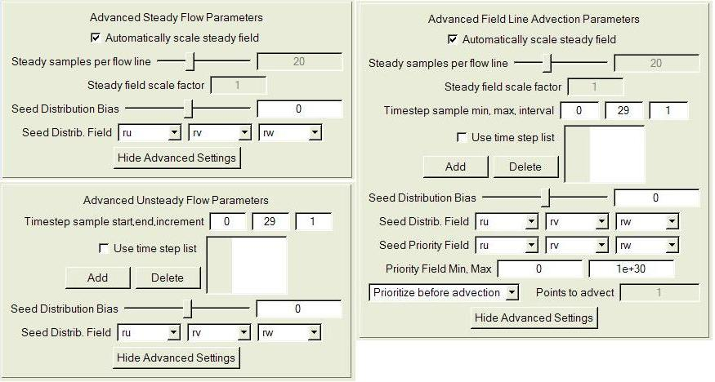

Figure 4.6: The three Advanced Flow Parameters panels for steady flow, unsteady flow, and field line advection.

The advanced flow parameters include the following:
- The checkbox labeled “Automatically scale steady field” is available for both steady flow and field line advection. When checked, the Steady Line Smoothness and Typical Steady Flow Length settings of the Basic Flow Parameters are used to control the integration length and resampling. When un-checked, the sampling and field length are controlled directly by the Steady Samples per Flow Line (slider and text box) and by the Steady field scale factor in the advanced flow parameters.
- Timestep sample start, end, increment identifies three text boxes that are available with both unsteady flow integration and field line advection. These text boxes specify a first and last time step that will be used in the flow integration, and an interval (increment) between successive time step samples. The sequence of time steps is always increasing, independent of whether the integration proceeds in the forward or backward direction. By default the values are the starting and ending time steps in the data, with an increment of 1, so that the unsteady flow integration will use the vector field data at all time steps. Unsteady flow integration calculates the field values at a time by linearly interpolating the field between the nearest sampled time steps.
- Also with both unsteady flow and field line advection, there is a check box “use time step list”, to handle situations where the time steps are not equally spaced. When this box is checked, the Timestep sample start, end, increment text boxes become disabled, the Add and Delete buttons become active, and the list of time steps (at the right) becomes editable. To specify a list of time steps to be sampled, repeatedly click the “Add” button, and then edit the time step integer that results. This list is always kept in ascending order.
- The Save Flow button provides a means of saving the current flow lines to a file. Clicking on this button launches a file-open dialog, where the user specifies a text file (*.txt) where the flow will be written. The flow panel must be enabled in order to write this output file.
- The Seed Distribution Bias (slider and textbox) is used when the flow seed points use a Random Rake but a nonuniform distribution is desired. Whenever this value is nonzero, the random seed distribution is biased, based on the magnitude of the Seed Distrib. Field, specified in this panel. Larger values of b result in seeds with higher magnitude of the Seed Distrib. Field. If b is the value of the bias (between -15 and 15) then (m/M)^{b} is the probability that a random point having seed distribution field magnitude of m is chosen, where M is the maximum magnitude of points in the rake.
- The Seed Distrib. Field combo boxes enable the selection of the field that is used for biased seed distribution. By default this is the steady field.
- The Seed Priority Field is only used with Field Line Advection. This field is used to determine how to select seed points when a field line is being advected to another time step. By default (when Prioritize before advection is selected), the point along a steady field having the largest magnitude of the Seed Priority Field is selection for advection to the next time step.
- Priority Field Min, Max specifies two textboxes that are used only with Field Line Advection. These values influence the choice of seed points when Prioritize before advection is selected. The search for the point having the largest Seed Priority Field magnitude is terminated if a point is found that is not between the Priority Field Min and Max values. This search starts at the seed point and goes first forward, then backward, along the field line.
- The last line of the Advanced Field Line Advection Parameters allows the selection of either Prioritize before advection, or Prioritize after advection. When Prioritize after advection is selected, the text box “Points to Advect” is enabled. When Prioritize before advection is selected, the seeds at the next time step are determined by maximizing the Seed Priority Field along each field line, as described in the previous two bullets. If Prioritize after advection is selected, with Points to Advect equal to a positive integer N>1, then N (evenly spaced) points are selected along the field line for advection to the next time step. The seed point for the advected field line is chosen to be the advected point having the largest magnitude of the Seed Priority Field.

Flow Seeding Parameters

Below the Advanced Flow Parameters is located the section of the flow panel entitled Flow Seeding Parameters. These parameters are described in the order they appear from top to bottom in this section of the panel:

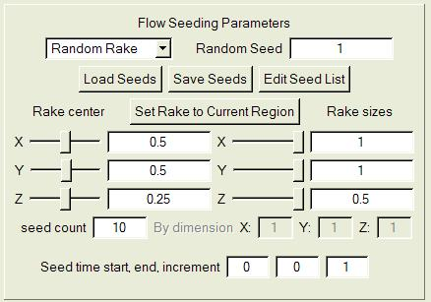
Figure 4.5: Flow seeding parameters

- The top line of the Flow Seeding Parameters contains a selector with the options “Random Rake”, “Nonrandom Rake” and “Seed List”. These options work as follows:
- When Random Rake is selected, the seed points are chosen randomly from within the bounds of the current Rake (as established by the values of Rake center and Rake sizes in this panel section). The number of seed points is the value of “seed count” below. This distribution is uniform unless the Seed Distrib. Bias in the Advanced Flow Parameters is nonzero. The Random Seed textbox determines the pseudorandom seed used for point generation.
- When Nonrandom Rake is selected, a 1-, 2-, or 3-dimensional grid of seed points is obtained by evenly subdividing the seed rake in each dimension, with the grid size in each dimension determined by the three integers specified next to the labels: By dimension X: …Y:… Z:….
- When Seed List is specified, the points that are contained in the current seed list (in the current flow instance) are used as seeds. A point from the seed list is only used if the time step in the seed list agrees with the time step being used for flow seeding. The seed list contents can be edited or read from a file, using buttons described in the next section.

- Next are three push buttons:
- The Load Seed List button results in a file-open dialog, whereby the user specifies a text (*.txt) file that contains a list of seeds. The format of the seed list file is the same as the format of the save flow file (described above): Each line has four floating point values, 3 spatial coordinates and one time step coordinate. If the time step is negative, the seed point is valid for all time steps. Otherwise, the seed point is only valid for the integer time step nearest the nonnegative time step coordinate.
- Click Save Seeds to specify a file to write the current seeds. If the seeds are using Random Rake or Nonrandom Rake, the seeds from the rake are generated and written to file (formatted as in Load Seeds above). If a Seed List is currently specified, then the seeds in the seed list are output.
- Click Edit Seed List to launch a table containing the current list of seeds. Buttons enable the user to Add Seed or Delete Seed, and the currently selected seed can be edited by typing in a new value and then pressing the <enter> key.
- The button labeled Set Rake to Current Region causes the rake to be immediately set to have the same extents as the current region in the current active visualizer.
- The Rake center and Rake sizes (sliders and text boxes) specify the X, Y, and Z extents of the rake. These are similar to the region extents that are specified in the region panel in Section 4.4.1 above. The rake is not required to lie within the current region; however, if the rake is outside the current region, the flow seeds that like outside the region will not be integrated. The rake extents can also be specified interactively in the scene in Rake Mode (see section 3.1.1).
- The seed count text box indicates the total number of seeds being used. It is only editable with a Random Rake.
- The three text boxes labeled Seed time start, end, and increment are only available with unsteady flow and with seed line advection.
- With unsteady flow, a seed point can be repeated; that is, the seed point can be injected into the flow at multiple times. These three values specify the first and last time steps for injection, and the interval between injections. Note that the increment is always positive, whether the flow is forward or backward. If a seed list is specified in an unsteady flow, a seed with a nonnegative time step will be only injected once at that time step. A seed with a negative time step will be repeatedly injected at all values specified by the values of Seed time start, end, and increment.
- When using field line advection, only the first value (Seed time start) is used. This is the time step when the field line advection begins. Field lines at other times are determined by advecting field lines (either forwards or backwards) from that time step.

Shape Parameters
Below the Flow Seeding Parameters is a section labeled Shape parameters. This section of the flow panel is shown in Figure 4.6, below. These settings are generally related to how the flow will be displayed and (with unsteady flow) how the display changes over time.

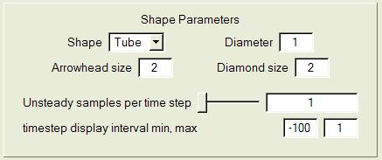
Figure 4.6: Shape Parameters

- Shape specifies whether the flow lines will be represented as Tubes, Arrows or Points. One geometric shape is associated with each geometric sample.
- Diameter specifies the diameter of the geometric shape (relative to the size of a voxel at full data resolution). If the diameter of a tube is 0, it is drawn with lines.
- Arrowhead size is only used when the Geometric Shape is set to Arrows. This specifies the diameter of an arrowhead as a multiple of the shape diameter.
- Unsteady samples per time step (slider and text box) is used only with unsteady flow. This quantity determines how many points are used to track flow lines between successive time steps. Minimum value is 1, resulting in a time sample at each time step.
- timestep display interval min/max is followed by two text boxes. These values are only available with unsteady flow. These (min and max) values define the portion of the flow that will be displayed at a given time. If the current time step (in the Animation panel) is T, the portion of the flow from (T+min) to (T+max) will be displayed. These values can be used to track particle motion along an unsteady flow line, by animating the time step and showing the changing segment of the field line as it moves along the full flow path resulting from integration.

Color/Opacity map editing
Below the Shape Parameters is a section labeled Color/Opacity mapping. This section of the flow panel is similar to the transfer function editors in the DVR and Probe panels. These mappings specify how color and opacity will be applied to the flow lines. Unlike the transfer function editor, there are two separate editors here, one for opacity and one for color. Also there is no histogram in the opacity editor. The Color/Opacity mapping section is shown below:

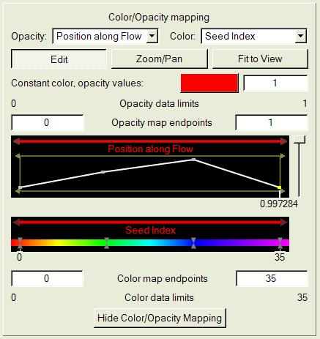

The parameters in this section include:
- At the top of the Color/Opacity mapping section are two combo boxes containing lists of entities that are mapped to color and opacity, identified with the labels Opacity: and Color: The available entities include:
- Constant: (i.e. there is just one opacity or color). This is the default.
- Position along flow: This entity is available for either steady flow or field line advection. The value is the relative position along a steady flow line, between 0 and 1. In bidirectional flow, the seed point is at 0.5.
- Timestep (available only with unsteady flow) is the time step along the flow line starting at 0.
- Field Magnitude: This setting uses as mapping entity the magnitude of the vector field defining the flow, at each point along the flow.
- Seed Index: The seed points are numbered with nonnegative integers. With a seed list the index is the position of the seed in the list. With nonrandom rake, the index increases first in x, then y, then z. With a random rake, the index is the order that the seed point was generated. When Seed Index is specified, each flow line has a constant color and opacity along its full length. The color and opacity of the flow line depend only upon the index of its seed point.
- Variable: Any of the variables in the current metadata can also be used as the mapped entity for color and opacity mapping. The value of the variable at each point along the flow is used for the mapping.
- Below the opacity and color combo boxes are three buttons that control the flow map editor. These are similar to the buttons above the transfer function editor (although there is no “Histo” button here):
  - Edit: When clicked, the left mouse performs editing functions such as selecting and moving control points
  - Zoom/Pan: When clicked, the left mouse button enables zooming (magnification) and panning (translation), in either the opacity map or in the color map, not changing the color/opacity mapping.
  - Fit to View: When clicked, the opacity and color editors are reset to use the full window width.
- Constant color/opacity values: This button and textbox control the color and the opacity that are used when the Opacity map combo box and/or the Color map combo box are set to Constant. Click the colored button to launch a color selector.
- The flow map editor permits separate control of color and opacity bounds. The opacity bounds are shown above the editing region:
  - The Opacity data limits (left and right labels) indicate the lower and upper bounds of the entity that is currently mapped to opacity.
  - The Opacity map endpoints (left and right text boxes) specify the lower and upper limits of the domain of the opacity mapping. Values to the left of the lower limit are mapped to the same value as the lower limit. Values to the right of the upper limit are mapped to the same value as the upper limit.
- The top part of the flow map editor controls the opacity map, by the positioning of opacity domain endpoints and the placement of opacity control points. The bottom part similarly controls the color map. These are edited in the same manner as the opacity is edited in the transfer function editor (above, section 4.5.2). However there are separate domain bars for opacity (above the opacity editing region) and color (immediately above the color bar), enabling separate control of the opacity and color mapping domains by dragging the left mouse over either of these bars.
- Below the opacity editor are displayed the coordinates of any selected opacity control points, with tic marks at the horizontal position, as well as the left and right bounds.
- Below the color bar are displayed the coordinates of any selected color control points, with tic marks at the horizontal position, as well as the left and right bounds.
- The color mapping bounds are shown below the color editing region:
  - The Color map endpoints (left and right text boxes) specify the lower and upper limits of the domain of the color mapping. Values to the left of the lower limit are mapped to the same color as the lower limit. Values to the right of the upper limit are mapped to the same color as the upper limit.
  - The Color data limits (left and right labels) indicate the lower and upper bounds of the entity that is currently mapped to color.

Probe panel
The probe panel controls the location of a 3-dimensional box-shaped volume that can be positioned and rotated anywhere in the current region. The probe can be used to interrogate data values (visually and numerically) within its volume. The probe can also be used to interactively place seed points for flow calculations.
The probe can be regarded as a 2- or 3- dimensional box that is linearly mapped into the data volume. The x,y,z coordinates of the probe box are initially aligned with the x,y,z coordinates in the data volume, but a rotation of the box will change this alignment.
The center plane of the probe box (the rectangle inside the probe, defined by z = 0) is displayed as a texture in the probe panel when the probe is enabled. This textured rectangle is also displayed in the associated visualizer, in the location defined by the probe mapping, when the probe is enabled. When the probe is planar, it provides a contour plane in the scene with the ability to interrogate values on the probe panel. When the mouse mode is data probe mode (Section 3.1.1), the extents of the probe in the 3D scene are outlined by a red frame with handles. The probe center plane is also used for positioning a cursor that is displayed as two-dimensional cross-hairs in the probe panel, and as three-dimensional cross-hairs in the visualizer (in data probe mode).
The entire contents of the probe box are used to calculate a histogram of data values. The histogram appears in a transfer function editor near the bottom of the probe panel.

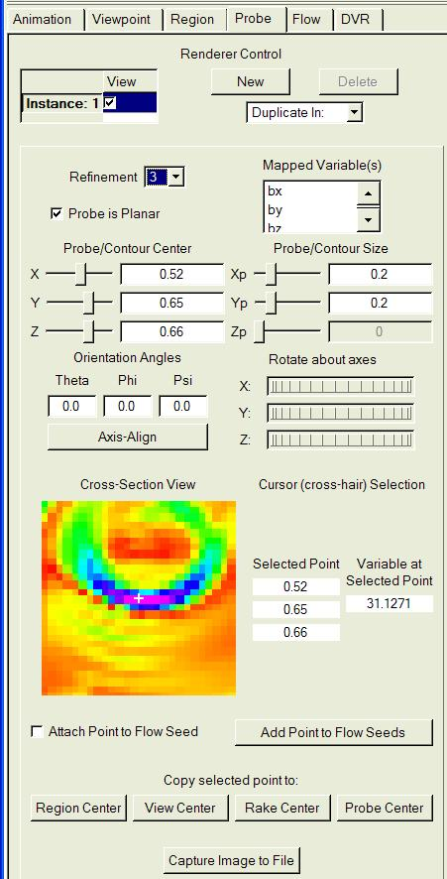
Figure 4.7: Top of the probe panel

General probe settings

The top of the probe panel is shown in figure 4.7, above. The elements in the probe panel are described from top to bottom:

- The Renderer Control section has the same functionality as described in section 4.1.2, as in DVR and Flow panels, enabling multiple probes to be defined in each visualizer.
- The Refinement combo box specifies the resolution of the data that is used by the probe.
- The Mapped Variable(s) list-box enables the user to select any subset of the variables in the current metadata. Multiple variables are selected by holding down the <Ctrl>-key while clicking with the left mouse button. If only one variable is selected, then the probe displays and uses the values of that variable. If multiple variables are selected, then the probe displays and uses the length of the vector defined by the multiple variables; i.e, the square root of the sum of the squares of the selected variables.
- The Probe is Planar checkbox, when checked, locks the z-size of the probe to zero. This is the default, enabling the probe to be used to position a contour plane slicing through the data volume.
- The Probe Center and Probe Size sliders and text boxes control the positioning and size of the probe in X, Y, and Z dimensions. Note that, when in data probe mode (Section 3.1.1), the probe positioning and size can also be controlled by left- and right-mouse drags in the visualizer scene. The probe is permitted to overlap the full extents of the data domain.
- The Orientation Angles text boxes allow the user to rotate the probe relative to the coordinate axes in user space. The Theta text box specifies the horizontal angle between the positive X-axis in user space and the positive X-axis of the probe. The Phi text box specifies an angle of rotation between the positive Z-axis of the probe and the positive Z-axis in user space. The Psi text box specifies an angle of rotation about the axis determined by the values of theta and phi. The orientation of the probe in the 3D scene is determined by first applying the psi angle (in the X-Y plane), then applying the vertical (phi) rotation, rotating the probe in the X-Z plane, finally applying the horizontal (theta) rotation, rotating the probe in the X-Y plane.
- To facilitate interactive orientation of the probe, there are thumbwheels labeled “Rotate about axes”, one for each of the three coordinate axes. Rotating a thumbwheel causes the probe to rotate about its center in the plane orthogonal to the indicated axis.
- Under the Orientation Angles is the Axis-Align button. Clicking on this button causes the probe to rotate to the nearest axis-aligned orientation.

Probe cross-section
- When the probe is enabled, the Cross-Section View displays a two-dimensional texture. This texture is the result of applying the mapping of the center (X-Y) plane (i.e. the plane defined by Z=0 in probe coordinates) from probe space into user space, as determined by the probe/contour center, size, and orientation. The points in the Cross-Section View are colored by applying a transfer function (described below) to the values of the Mapped Variable(s) in the probe center plane. The color (but not the opacity) of that transfer function is displayed in this texture. In the cross-section view are also displayed white cross-hairs. The cross-hairs track the location of the most recent click or drag of the left mouse in the Cross-Section View.
- If the probe is enabled, the probe cross-section view is displayed in the visualizer at the position determined by the mapping. In probe mode, the currently active probe instance is outlined with a red frame. In addition, the cross-hair position in the scene is shown in the visualizer as 3-dimensional white cross-hairs, aligned with the coordinate axes.
- To the right of the Cross-Section View are shown four numerical values. The Selected Point indicates the three coordinates in user space that the current cross-hairs are mapped to. The Variable at Selected Point specifies the value of the single variable (if only one is selected in the Mapped Variable(s) combo) or the length of the vector of variables (if more than one is selected in the Mapped Variable(s) combo).
- Below the Cross-Section View are a check box and several buttons that copy or use the coordinates of the selected point in various parameter panels. These set values in the parameter panels that are associated with the current active visualizer.
    - When checked, Attach Selected Point to Flow Seed inserts a seed point as the last seed in the flow panel’s seed list, at the position of the selected point. As long as this remains checked, changes to the selected point position result in changes to the position of the last seed point in the list. Note that, in order for this check-box to have a visible effect, the active flow instance must be enabled, and the Use Seed List checkbox must be checked in that flow instance.
    - When clicked, the button labeled Add Selected Point to Flow Seeds causes the current selected point to be added to the end of the list of flow seeds in the current flow instance. If Attach Selected Point to Flow Seed is checked, then the current point will appear twice in the list until the selected point is moved. This will have no visible effect unless the current instance in the flow panel is enabled and Use Seed List is checked in the current instance in that panel.
    - Four buttons, below the label Copy selected point to:, can be used to make the selected point the center of the extents defined in the region panel (region center), viewpoint panel (center of rotation), flow panel (rake center) and the center of the current probe instance. These buttons are respectively labeled Region Center, View Center, Rake Center, and Probe Center.
    - The button labeled “Capture Image to File” launches a file-selection dialog, enabling the user to choose a jpeg image file, to which the current probe/contour plane is written. The image will be of resolution at least as fine as the probe data at its current resolution.

The remaining (bottom) part of the Probe panel is shown below:

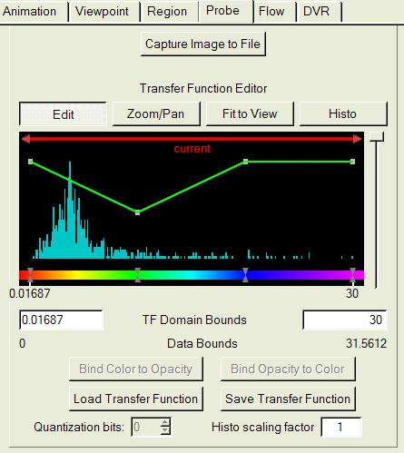
Figure 4.8: Bottom of the probe panel

Probe transfer function editor

The bottom of the probe panel contains a transfer function editor. The functionality of this transfer function editor is identical to the transfer function editor in the DVR panel described in section 4.5.2, with the following minor differences:
- The transfer function is applied either to a single variable or to the length of the vector determined by multiple selected variables.
- The histogram displays the values of the selected variable (or the values of the vector length, if multiple variables are selected) within the current extents of the probe. If multiple variables are selected, only the name of the first of those variables is displayed in the editor.
- In data probe mode, if the probe is enabled, both the color and opacity of the transfer function are applied to a rectangular texture in the visualizer, along the center plane of the probe region, determined by the extents and orientation of the probe.
- Only the color (not the opacity) determined by this transfer function is applied to the texture in the Cross-Section View of the probe panel.
- There is no color selector associated with the transfer function editor in the probe. Colors can be identified and specified by clicking on color control points with the right mouse button.

