VAPOR Quick Start Guide

March, 2006

Version 1.0

Introduction

This guide is intended to provide the new user with a quick introduction to the use of VAPOR. Just work through the instructions below to get a basic understanding of the tool.
The VAPOR user interface is intended to enable scientists to readily visualize and analyze time-varying datasets that result from numerical simulation. These datasets can be extremely large: Often many terabytes of data result from months of supercomputer calculations. Simply reading and writing such data can take weeks, so visualization and analysis of this data would ordinarily involve enormous batch runs, with little hope for scientists to interactively work with their data. Using VAPOR, much of this work can now be performed interactively!

This guide provides a few examples to illustrate that such massive datasets do not need to be impenetrable. VAPOR permits users to interactively visualize large- and small-scale features of massive time varying datasets, without needing to process the entire dataset.

This guide is only an introduction to the basic features of VAPOR. Once you have worked through these examples, you will want to try VAPOR on your own data. Additional and advanced features are documented in the Users’ Guide. Many of the capabilities of the user interface are described in “tool-tips”; i.e. when you hold the mouse for a second or two over a text input field or a slider, a description of the functionality will appear.

Prior to working through this guide, you will need to download and install the two example datasets from http://www.vapor.ucar.edu/download/. There are both high-resolution and low resolution versions of these datasets. The guide assumes you are using the low-resolution data, however the instructions will not change much if you use the high-resolution data.

If you encounter problems following all the steps in this guide, you can quickly advance to any of the tasks below. For most of the illustrations in this guide, there is a VAPOR session file named “guideFigureN.vss”, that can be used to put VAPOR into the same state as was used to generate Figure ‘N’ below. The session files are found in the VAPOR examples directory, which is the subdirectory $(VAPOR_HOME)/examples/ of the VAPOR install directory. To use such a session file, you need to do the following:

- From the VAPOR file menu, click on “Open Session” and select the desired session file associate with one of the figures below. (Note: If you are on Windows, you may get a warning message that the log file cannot be opened. That’s because the session file was created on a Unix platform where the path names do not have a drive letter. If you would like to have a log file, you can click on Edit→Edit Session Parameters, and specify a log file on your Windows system).
- From the VAPOR data menu, click on “Load Data into current Session” and select the metadata (vdf file) associated with that figure.
- Click on each of the renderer tab(s) used in the illustration (DVR, Flow, or Probe). Select Rendering “Enabled” for each renderer that is active.
- If there is a mouse mode that is used in the illustration, (e.g. Region Select, Navigation, Data Probe, or Rake) you should select the appropriate mode by clicking on one of the mode select buttons below the VAPOR main menu bar.

You should see a similar image on your screen as is shown in the corresponding figure.

Prerequisites

Before you begin this guide, you need to have access to a (Linux, Windows, or Irix) workstation on which VAPOR has been installed. Follow the installation instructions provided on the VAPOR website (http://www.vapor.ucar.edu). When you run VAPOR, you need to be directly connected to the graphics console of the system. You cannot run VAPOR via a remote shell, however you can remotely connect to a graphics system via SGI Vizserver or via HPRGS.

You will also need to download and install the two example datasets from http://www.vapor.ucar.edu/download/. At that site there are both high-resolution and low resolution versions of these datasets. The guide assumes you are using the low-resolution data; however the instructions do not change very much if you use the high-resolution data.

You will need to prepare your execution environment before running VAPOR. For Unix users, there are shell scripts in the bin subdirectory of the VAPOR installation directory. You will need to initialize your shell by running vapor-setup.csh (in a c shell) or vapor-setup.sh (in a Bourne shell). Remember to re-source these whenever you change your shell. Windows users need to follow the installation instructions to set up the execution path.

Section 1: Volume visualization

  - Launching VAPOR

From the command line issue the command “vaporgui”. (In Windows, you can double-click on the file “vaporgui.exe” in the bin subdirectory of the VAPOR install directory, or type “vaporgui” from a dos window.) You should see a screen like the following:

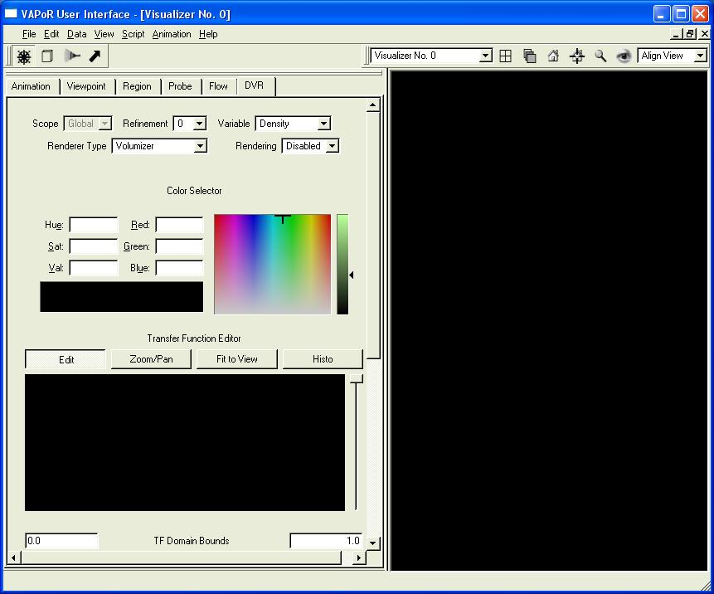
Figure 1.1: Initial VAPOR GUI window

The right side of this screen (mostly black) is where the 3D graphics images are displayed. The left side of the screen has a set of tabs across the top, labeled “animation”, “viewpoint”, “region”, “probe”, “flow” and “DVR”. We shall initially work with the DVR panel (this stands for “direct volume rendering”, referring to the fact that this panel controls the direct conversion of data to a volumetric representation.)

  - Specifying a volume dataset

Click the Data menu (at the top of the screen) and you will see a list of various commands that can be applied to datasets. Click “Load a Dataset into current session”. (You can alternatively load a dataset into default session, at this point). You will see a file selection dialog, asking you to “Choose the metadata file to load into current session”:

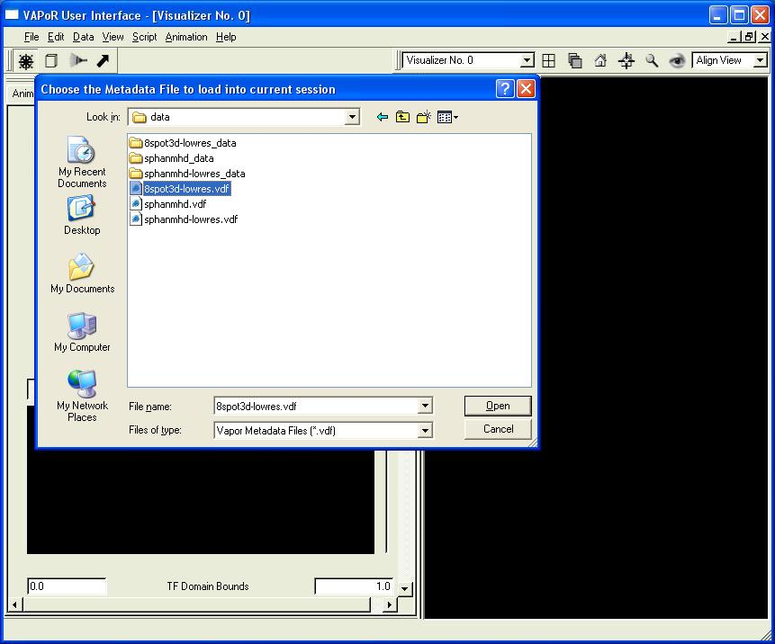
Figure 1.2: Loading a metadata file

This file selection dialog enables you to read a file of type “.vdf”, which stands for “Vapor Data Format”. These are Metadata files, not data files: .vdf files contain descriptions of data. Typically the referenced data is in many different files.

Choose the file “8spot3d-lowres.vdf” and click “Open”. This is a time-varying data set. It contains a vector field consisting of the three components (ru, rv, and rw) of the cartesian momentum, resulting from simulation of flow in the interior of the Sun (work by Mark Rast at NCAR and Univ. of Colorado). Using the Rendering selector near the top-right corner of the DVR panel, choose “Enabled”, to enable a volume rendering of this data. Your display will appear as follows:

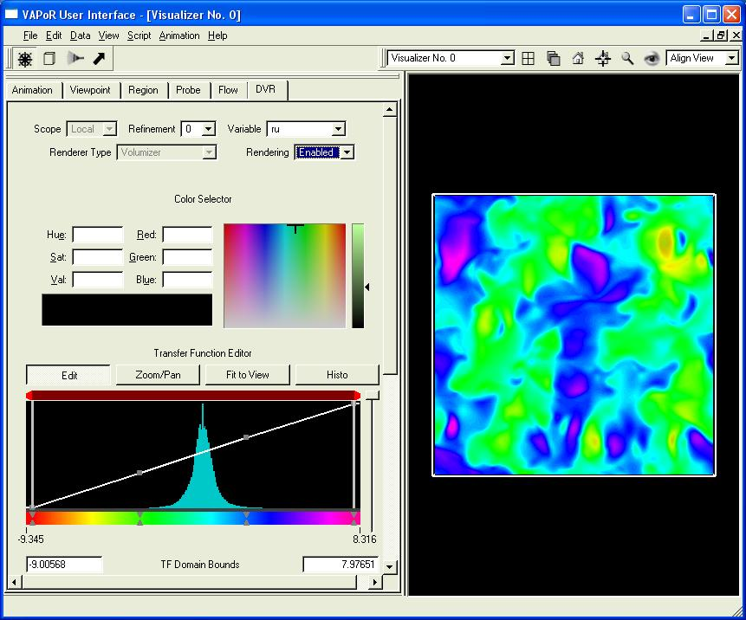
Figure 1.3: Volume rendering a variable

The image on the right is a 3D volume rendering of the variable ‘ru’ from the data set. Click and drag your left mouse in the right window and you can rotate the image. When you click and drag the right mouse button vertically, you zoom into or out of the scene. If you click and drag the middle mouse button, you translate the image vertically or horizontally. Return to the initial viewpoint by clicking the “home” button above the visualizer. Change the variable you are visualizing by selecting the variable name ‘rw’

  - Designing a transfer function

The appearance (i.e. color and transparency) of the volume rendering is controlled by the Transfer Function Editor in the middle of the DVR panel, as seen below:

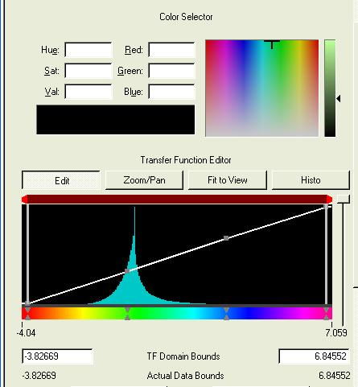
Figure 1.4: The VAPOR Transfer Function Editor

In the center of the transfer function editor window you see a blue-green histogram, indicating the values of the variable ‘rw’. We shall use this histogram to construct a transfer function to visualize ‘rw’.
The transfer function editor enables you to define a mapping from data values (in this case values of the variable “rw”) to both color and opacity. The color is controlled by a horizontal bar of colors at the bottom of the editor. Opacity is controlled by the white line in the center region. You initially will see four color control points (grey triangle pairs) on the color bar, and four opacity control points (grey squares) on a diagonal white line. Colors and opacity in the scene are interpolated between the control points.
First we make some changes in the Opacity curve, to show some important features of the variable ‘rw’. We will make the opacity curve in the transfer function editor look like the curve you see in Figure 1.5, below.
You move control points by clicking on them with the left mouse button and dragging them to their new locations. You create new control points by clicking with the right mouse at the desired location.
First drag the rightmost (fourth) opacity control point down to the bottom of the opacity graph. Drag the second and third opacity control points down to about 1/10 of the distance from the bottom to top of the opacity window, on either side of the peak in the histogram. If you make mistakes, you can undo (or redo) your latest changes by selecting “Edit” from the main menu, and clicking to undo (or redo) the specified actions.
After you move these opacity control points, introduce two new opacity control points, slightly to the left and right of the peak in the histogram. This choice of opacity helps identify the data that is associated with either upward or downward flow, making the other data transparent. Your editor and your visualizer window should now have two bumps, one on either side of the histogram peak like the following:

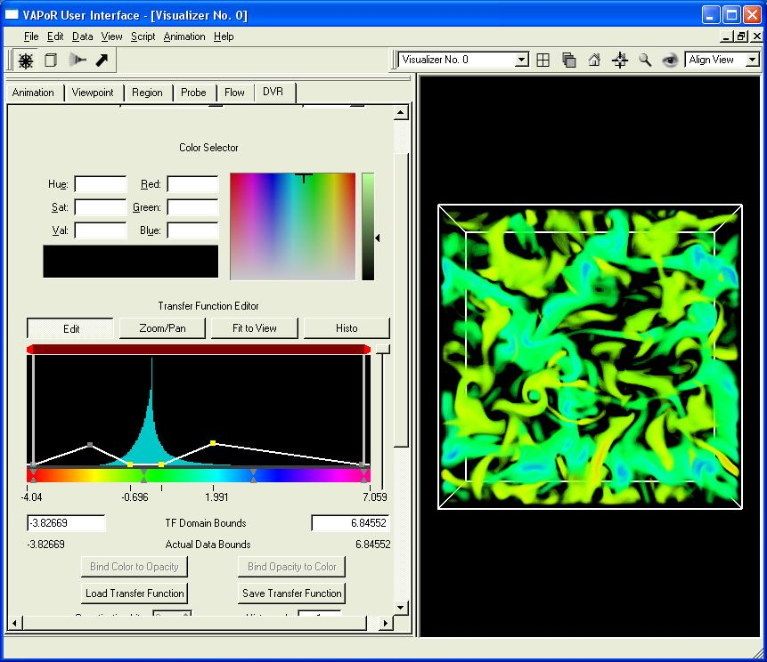
Figure 1.5: Using the transfer function opacity to emphasize positive and negative values

Now, introduce a new color control point by right-clicking slightly to the right of the histogram peak, and selecting “New Color Control Point”. This new color control point should be slightly to the right of the existing (second from left) color control point. Select the new color control point, by clicking on that point with the left mouse button. Then change the color by dragging the cross-hairs in the Color Selector to a sky-blue color. Then select the second color control point, and change the color of that color control point to orange. The resulting image should look like the following:

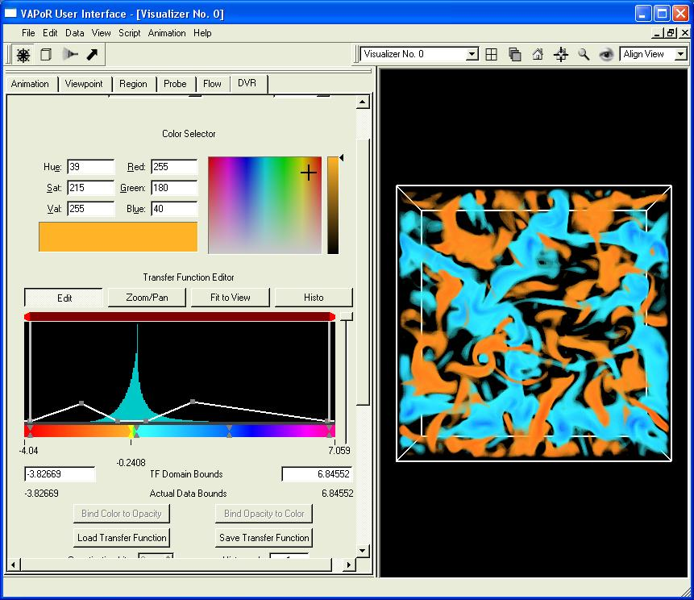
Figure 1.6: Editing the color map in the transfer function
With this choice of transfer function we have colored the vertical component of flow momenta so that upward (blue) and downward (orange) flow can be distinguished. Now is a good time to save the current setup. Click on “File→.
Save Session As”, and specify the file “saved8spot.vss”. Later on, if you want to visualize this data again, you can use “Open Session” from the file menu to return VAPOR to this current state.

  - Animating the data.

This data set has 30 timesteps. To control the time-stepping, click on the “Animation” tab, revealing a set of buttons similar to a VCR controller, as shown below:

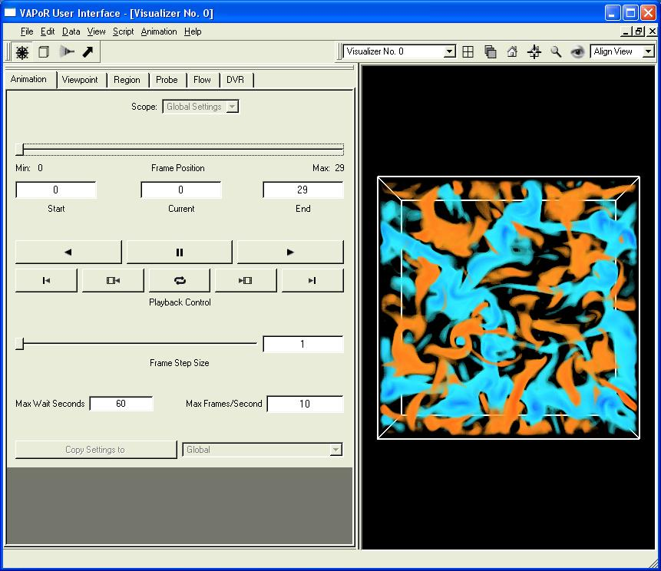
Figure 1.7: Animating the changing volume

Click on the button labeled by a right-pointing triangle. You will see the images slowly evolve from frame to frame, finally stopping at frame 29. You can click the left-pointing triangle to play backwards in time. You will note that the animation is faster the second time because the data is cached the first time it is read from disk. You can make it play slower or faster by setting the value of Max Frames/Second. Reset the current frame to “0” by sliding the frame position slider (at the top of the animation panel) to the far left.

1.6 Taking a closer look at the data.

So far we have been looking at this data at low-resolution (64x64x32) so that we can interact easily with the data. The data is available at the higher resolution 256x256x128 (and even at 512x512x256, if you have downloaded the high-resolution version of the sample datasets). If we were to load all the full resolution data into VAPOR, it would run much slower. However we can quickly examine small spatial regions of the higher-resolution data. We shall select a region containing a vortex and zoom into that region.
Return to the original viewpoint by clicking on the “Home” button above the visualizer. You will note that there is a swirl with a blue center to the left and below the center of the visualizer. We shall isolate that swirl using interactive region selection. Click on the cube at the top left of your screen, identified as “Region Select Mode”. You will see that the volume in the scene is enclosed by red lines, with cube-shaped handles on each side. These handles can be used to manipulate the bounds of the region that we visualize. If you ‘grab’ a handle by clicking on it with the left mouse, you can slide the whole region in the direction of the handle. If you ‘grab’ with the right mouse, you will slide just the side of the region closest to the handle. You are initially prevented from sliding with the left mouse because the region is the entire domain and you cannot move the region bounds outside of the full data domain.
Click with your right mouse button on the handle at the top of the cube. It will change color to yellow. Drag it downward until the top of the region is just above the swirl. Then release the mouse. Similarly, drag the bottom, left, and right handles to narrow the region down to a small rectangular volume enclosing the vortex, as shown below:

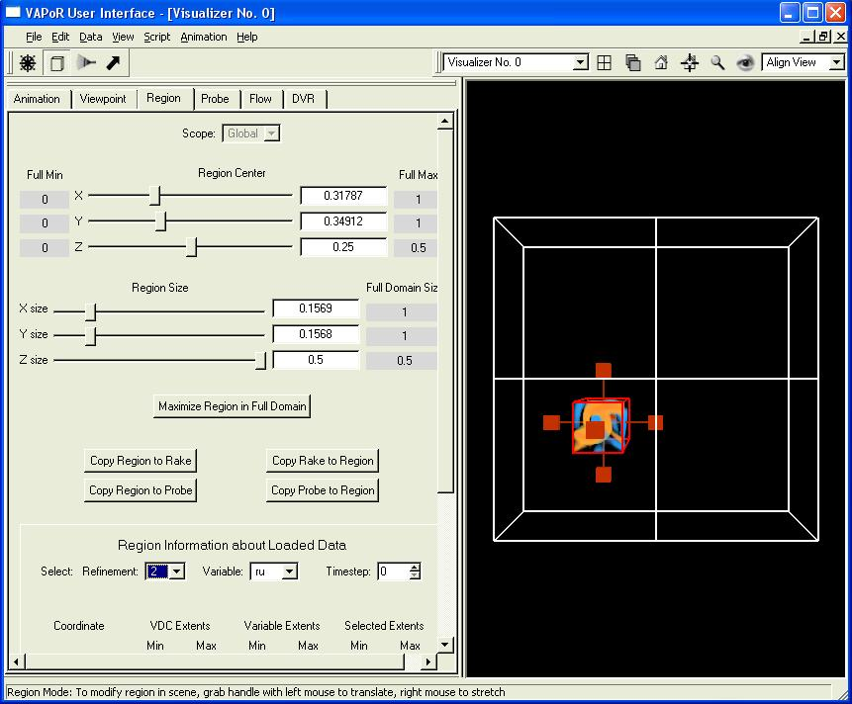
Figure 1.8: Using the region selection tool to specify a vortex

Return to “navigation” mode by clicking on the wheel button at the upper left of your screen. Zoom into this region by clicking on the magnifying-glass at the top of your screen. Note that this vortex is quite fuzzy because the resolution is so low. To increase the resolution, first click on the DVR tab. At the top of the DVR panel, there is a “Refinement” selector currently set to “0”. The value of 0 is the base (lowest resolution) resolution of this data. Select refinement level “2”. It may take a few seconds to retrieve the higher resolution data, but then you will see a sharper image. You can zoom further into the volume by dragging the right mouse in the scene, obtaining a closer view of this vortex, like the following:

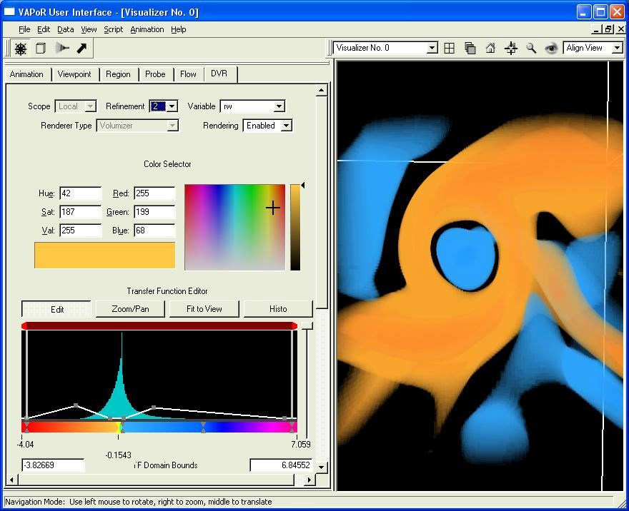
Figure 1.9: Zooming into the selected vortex

Save this session as “8spothighres.vss”. We will find this useful in the next section.

Section 2: Flow visualization

In this section we shall construct flow visualization based on the same dataset that we volume rendered in Section 1. VAPOR visualizes flow by performing a numerical integration along a vector field through a volume of data. The integration starts at user-specified starting points, called “seed points”, and tracks the successive positions in the volume that result from the integration. This process, of following points subjected to a vector field, is called “advection”. The successive advected positions can be visualized with various geometric entities.
Let’s take advantage of what we already know about this volume by opening the session file saved8spot.vss, saved in section 1.4. Click on File→Open Session and specify the saved8spot.vss file. Then, as in Section 1.2, load the 8spot3d-lowres.vdf data set into this session. This time, don’t enable the flow visualization (yet). Instead, click on the “Flow” tab, and then select “Enabled” in the Rendering selector at the top of the flow panel. You will see something like the following:

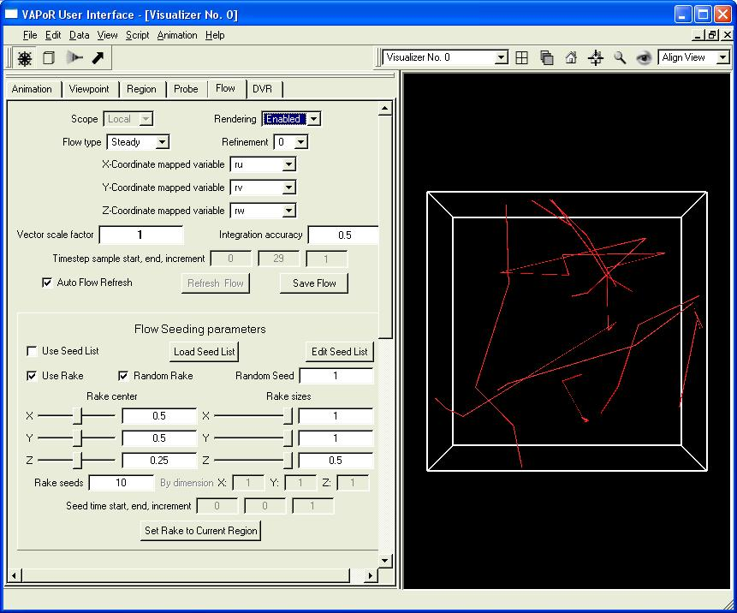
Figure 2.1: Random flow lines in a momentum field

2.1 Initial Parameters

Before we can make a meaningful flow visualization, we need to establish some parameters. First, you must specify three variables that define the x, y, and z-components of the vector field that will be visualized. The current dataset happens to have four variables, ro, ru, rv, and rw. The field we shall visualize has (x, y, z) components specified by (ru,rv,rw), so set the X, Y, and Z-coordinate selectors to ru, rv, rw (if they are not already set that way).
Second, it is important to specify a “Vector Scale Factor” that magnifies or shrinks the vector magnitudes. If the scale factor is too small, the flow lines will go nowhere, and will be displayed as grey diamonds. Try setting the scale factor to 0.001 (type it in, then press enter) and you will see the flow seed points as diamonds. On the other hand, if the scale factor is too large, the flow lines immediately exit the scene and will be seen as straight lines to the volume boundary. Set the scale to 100 and notice the resulting lines. For the current data set, a scale factor of 0.05 works well. In general, to pick a meaningful scale factor, compare the magnitudes in the vector field with the region size (in the region panel). You can estimate the vector field magnitudes by looking at the histograms of the variables in the DVR panel. A vector magnitude of M integrates a distance of M in one time step, so you will want to scale the vector magnitude so as to make M smaller than the region size. Then you can track the vector field as it passes through the region.
Third, you need to select the flow type. By default, the flow type is steady. By steady we mean that the vector field does not change during the flow integration. The successive positions of a flow line in a steady flow depend only on the coordinates along the flow line, not on the elapsed time.
You may also want to make the flow lines a bit thicker, or change their color. Scroll the flow panel down to the Graphic Parameters, and you can set the constant color of these lines by clicking on the red “Constant color” button. Select a light maroon shade. After making the above settings, you should see the following:

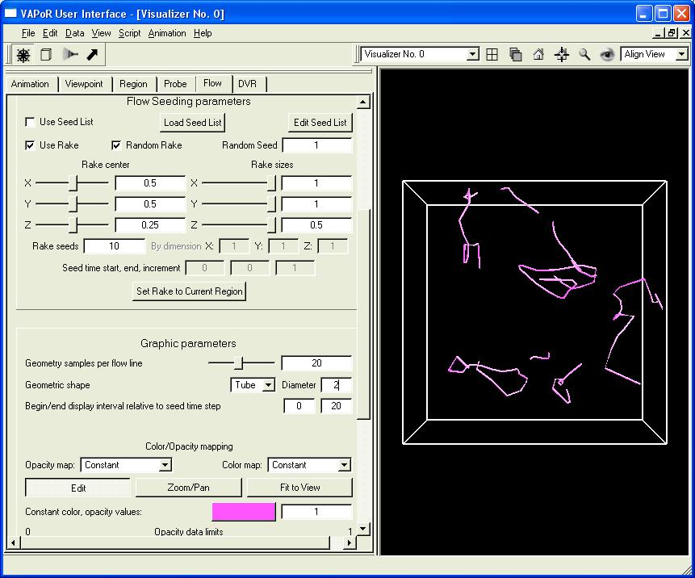
Figure 2.2: Setting the color and other properties of the flow visualization

2.2 Placing seeds with a rake

The problem with the above flow visualization is that it doesn’t enable us to put the flow lines where we want them. To easily position lots of seed points, VAPOR provides a device called a “rake”, by analogy with rake-shaped devices that are used to inject smoke into wind tunnels. The default rake is random, providing a randomly generated set of 10 seed points, distributed over the full data volume. To manipulate the position and size of this rake, click on the rake icon near the top of your window. You will see red lines and red handles in the visualizer, similar to the region tool discussed in Section 1.6. You stretch or shrink the rake by dragging with the right mouse button. You translate the rake by dragging with the left mouse button. You can also manipulate the rake by using the sliders and text boxes in the Flow panel. Whenever you release the rake, the flow lines will be recalculated based on the new rake. After you reduce the rake size and position the rake in the center of the volume you should see something like the following:

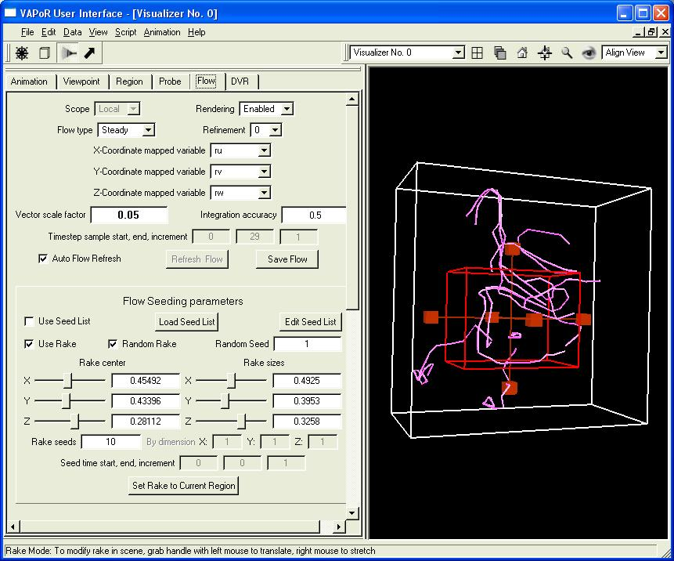
Figure 2.3: Using the rake tool to specify random seed points

We would like to position the rake over the vortex that was explored in Section 1.6. To locate that vortex it will be useful to restore the session file where we found a high-resolution visualization of the vortex. From the main menu, click on File→Open, select and open the session file “8spothires.vss”, and then load the “8spot3d-lowres.vdf” metadata file.
Click on the DVR tab, and, from the Rendering selector at the top of the DVR tab, select “Enable”. Now you should see the volume rendering of the vortex from section 1.6. We would like to visualize the flow around this vortex. To do so, we will put the flow rake over the region we have selected. Click on the flow tab and then click the button at the bottom of the flow seeding parameters, entitled “Set Rake to Current Region”. Also, from the flow panel apply the same flow settings that we set in section 2.1 (set the vector scale factor to 0.05; set the vector variables to ru,rv,rw; and set the constant color to maroon. When you click “Enabled” in the flow panel, you should see something like the following:

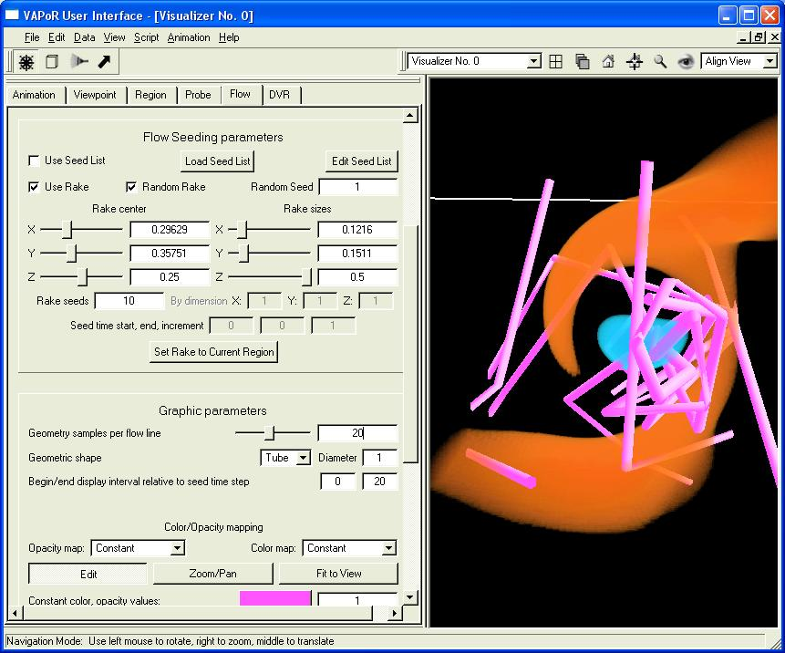
Figure 2.4: Inserting the rake into the vortex.

Don’t be surprised if your flow lines look quite different than the lines illustrated above. The flow lines will vary quite a bit depending on your environment (e.g. random placement of flow seeds, data resolution, etc.)

2.3 Setting geometric parameters.

We are beginning to see the vortex in the flow, but we need to tweak the geometric parameters to really visualize what is going on. First, let’s make the flow lines track the flow more closely. In the “Graphic Parameters” there is a slider labeled “Geometric samples per flow line”. This determines how many points along the flow are used in rendering each flow tube. Slide it up to about 200, to get smooth, curvy tubes.
We can use color to show the direction of flow in the vortex. From the “Color Map” selector, select “Timestep”. This causes the flow to be colored according to the time units that are used in the flow integration. The default mapping colors the seed points red, and the color changes to green, blue, and violet as the flow advances, to a maximum of 20 time units.
The flow lines are somewhat obscured by the volume rendering in the visualizer. Click on the “DVR” tab. Note the vertical slider to the right of the transfer function editor. This slider scales the opacity, making the volume more or less transparent. Slide it about half-way down, so you can see the flow lines better.
To make sure your rake is concentrated on the most interesting part of the vortex, you can narrow it in the X- and Y- directions. Click on the flow tab, and set the X-size and Y-size of the rake to 0.05. Increase the number of rake seeds to 30.
You can visualize this vortex better from a side view. In navigation mode (click on the wheel near the top left of your screen), drag the left mouse upward in your screen to make the vortex point up and down. Drag downward with the middle-mouse button, to center the vortex in your visualizer. You should see something like the following:

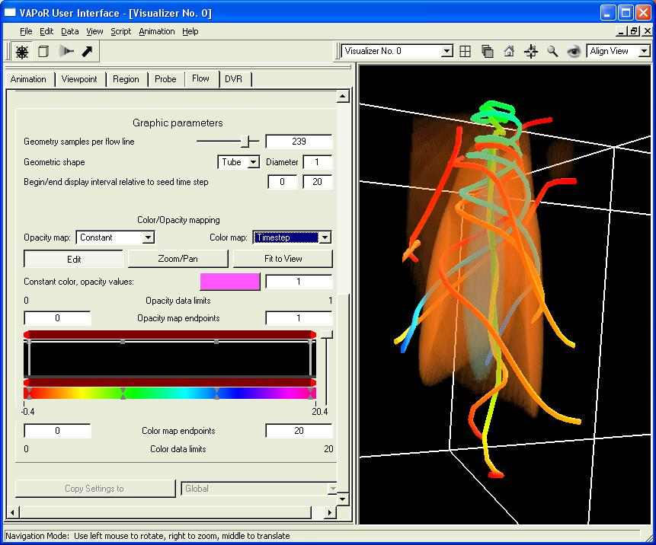
Figure 2.5: Flow in the vortex

Note that now you can see that the flow pulls the points upward (in the +Z direction) in the center of the vortex, while points on the outside of the vortex rotate outward and downward.
You may find it interesting to explore this vortex further. For example, in rake mode, you can position the flow rake in the interior of this vortex, or you can add more seeds to the rake. From the animation panel you can see how this flow evolves over time. Note: Before you click “play” in the animation panel, you may need to lower the Refinement levels in both the Flow panel and in the DVR panel to 0. This example data set has only the lowest resolution data (Refinement 0) for timesteps larger than 0. In general you can find out what refinement levels are available by checking the information at the bottom of the Region panel. The first time you try to render a refinement level that is not available, you will get a popup warning message.

2.4 Unsteady flow visualization

The steady flow visualization above captures the flow at various instants over time, but it does not show how particles in the flow would actually move as the flow changes. With unsteady flow, we integrate over changing time steps, simulating the result of releasing a particle in the evolving flow.
We begin again with the 8spot3d-lowres data set. Load the session file “saved8spot.vss” and load the 8spot3d-lowres.vdf data into the current session. It will be helpful to see the coordinate axes in the scene, so click Edit→”Edit Visualizer Features”, and click “Enable coordinate axes”. Enable rendering in the DVR panel, and rotate the scene to give a side view (with +Z, the blue-colored axis, pointing up). The resulting scene should look like the following:

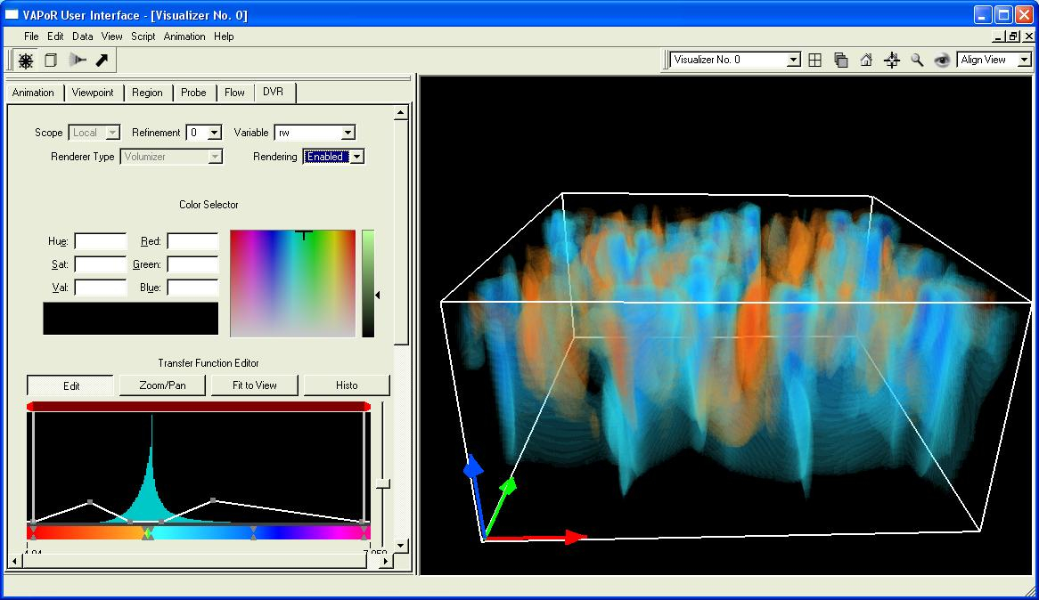
Figure 2.6: A side view of upward and downward flow

Note that we have stretched the screen horizontally, lowered the opacity scale, and zoomed in, to make a better image.

Click on the flow tab. As before, set the vector scale factor to 0.05. This time set the Flow type selector to “unsteady”. Make sure the field coordinates are (ru, rv, rw). Then select Rendering “Enabled” at the top of the flow panel. You will have a few seconds to wait. Unsteady flow visualization can be slow because you need to access all the different time steps in the data whenever you make a change in the flow settings. To avoid these annoying delays, you may want to un-check the “Auto Flow Refresh” checkbox. With it un-checked, you can make several changes to the flow panel without delays, and then, when you are finished with your changes, you can click “Refresh Flow” to rebuild the flow lines. We will want to make a number of changes to the flow settings to get a good unsteady flow visualization. When you make a change in the flow panel and press enter, the flow visualization will disappear until you click “Refresh Flow”.
Instead of a random cube of seed points, this time we will use a regular 2D grid of seed points, positioned near the bottom of the volume. In the Flow Seeding parameters, un-check the “Random Rake” checkbox, and specify X,Y,Z dimensions of the rake (next to “By Dimensions”) as 6, 6, and 1. Click on the rake icon (above the flow tab), and then, dragging the top rake handle with the right mouse button, pull the top of the rake down nearly (but not all the way) to the bottom of the scene. After you refresh the flow, you will see a visualization similar to the following:

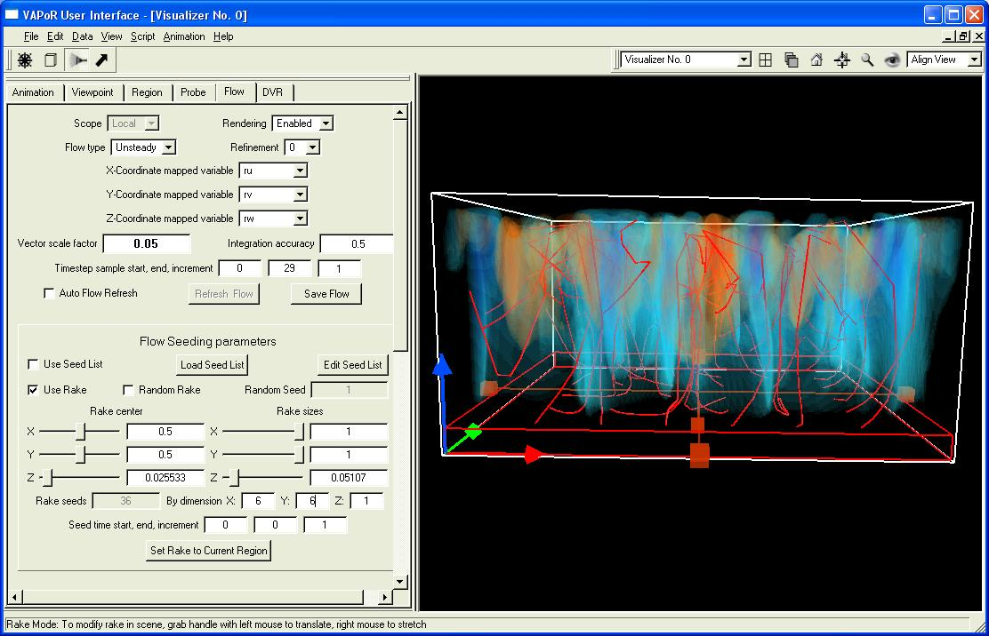
Figure 2.7: Unsteady flow lines

Let’s color-code the unsteady flow lines. Click on the color map selector, set it to “Timestep”. Near the bottom of the graphic parameters, there are (left and right) textboxes labeled “Color Map Endpoints”. Set them to 0 and 29, because this is the time step interval for our data. Also, to make the successive positions along the flow more obvious, set the geometry samples per flow line to 29, i.e. one time sample per time step. Be sure to press the <enter> key after you make your editing changes, or they will not be saved. After you click the “Refresh Flow” button, you will be able to see how the seed points start to move up from the bottom of the scene, as the color changes from red to green to blue and violet. Click the rake button to return to navigate mode and you will see the following:

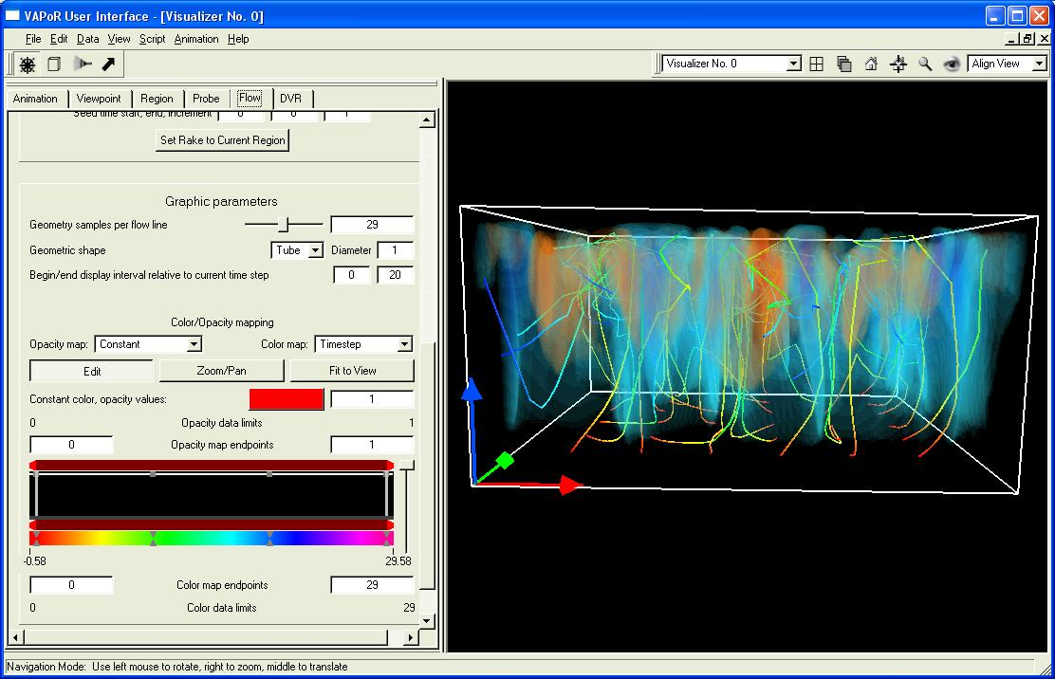
Figure 2.8: Color-mapped unsteady flow

We can animate this scene and see how the particles move over time. Note in the graphic parameters the item labeled “Begin/end display interval relative to current time step”. We shall set these values so that, for each time step, you only see the portion of the flow near that time step. Set the begin value to “-1” and the end value to “1”. With this setting, at each animation time step we shall just see the portion of a flow line from one time step before to one time step after the current time step. Set the “Geometric Shape” to “Arrow”, so that each arrow will represent the motion of a particle in one time step. Click “Refresh Flow” and you should see a 6x6 array of red-orange arrows, starting near the bottom of your data cube, like the following:
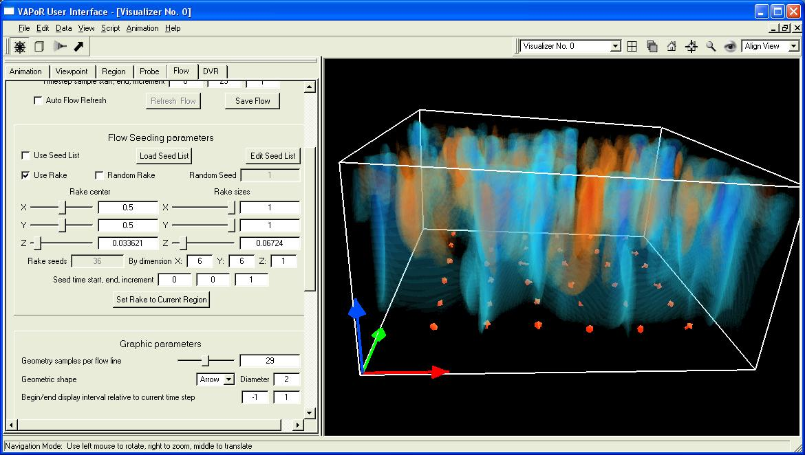
Figure 2.9: Using arrows to track particles in an unsteady flow

Now go to the animation tab. Click on the “play” button and you will be able to follow the seed points as they are moved through the flow. You may want to slow down the max frame rate to 1 second or so, so that you can track the motion.
Return to the flow panel; we can improve this visualization a bit. Note that we are only seeding this flow at the very first time-step. We can inject new particles into the flow as it proceeds. At the bottom of the flow seeding parameters are three text boxes labeled “Seed time start, end, increment.” Set these values to 0, 28, and 4. This will result in additional flow lines starting every four time steps for the duration of the simulation. After you click “Refresh Flow”, return to the animation panel and click the play button. Now you will see arrows starting near the bottom of the volume, with a new particle starting every four time steps. You can rotate or zoom into the scene to get a better understanding of the particle motion. The image below shows this animation at time step 8, just as the third particle injection is starting:
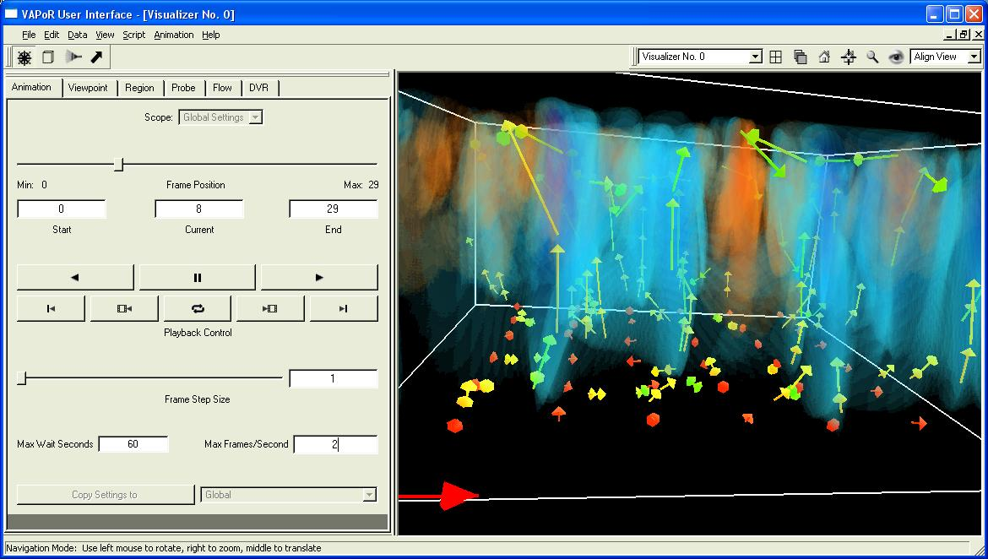
Figure 2.10: One time-step of an animating steady flow, using arrows.

Section 3: Probing the data

So far we have been investigating the vector field using a rake to position seed points. The rake tool is sometimes not precise enough, especially if there are fine details in the flow that need to be understood. VAPOR provides another tool, a “Data Probe” that allows you to specify exactly where a point is situated, and you can place the flow seeds individually based on field values at their position.

3.1: Visualizing a magnetic field

We shall illustrate this with another dataset. From the Data menu select “Load a data set into default session” and specify the metadata file “sphanmhd-lowres.vdf”. From the Edit→”Edit Visualizer Features” panel, enable the coordinate axes. From the DVR panel, set the variable to “bc” and, click “Enabled”. You will see the following visualization:

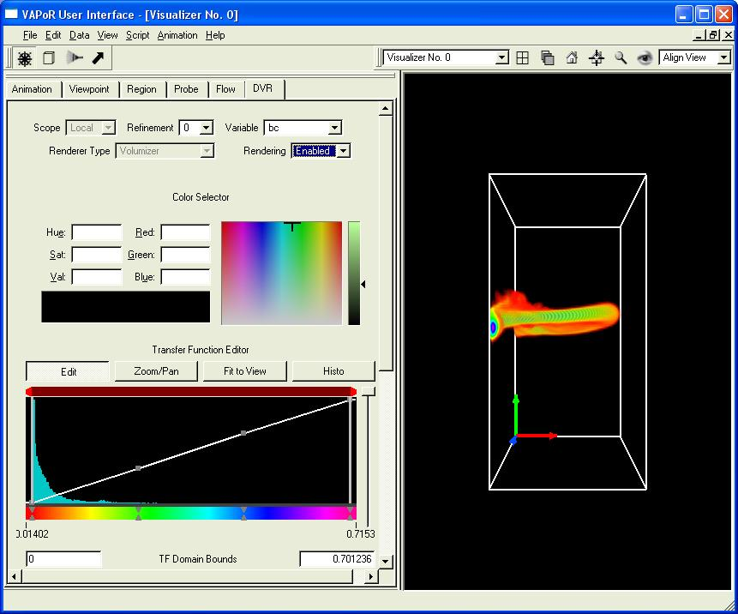
Figure 3.1: Volume visualization of the absolute field strength (bc) of a rising magnetic flux tube

This field is a magnetic field with components b1c, b2c, and b3c. It results from a simulation (by Y. Fan of HAO/NCAR) of the buoyant rise of a twisted magnetic flux tube through the solar convective envelope towards the solar surface. The volume rendering shown in the domain corresponds to the absolute magnetic field strength (bc) of the rising flux tube.
In the Flow panel, set (b1c, b2c, b3c) to be the x, y, and z-mapped variables. Select Rendering “Enabled” at the top of the flow visualization panel. You will probably not see much of interest except for a few grey diamonds in the scene. That is because all of the interesting magnetic field values are concentrated along the tubular structure in the center of your visualization. Using the rake tool, you can situate the rake around the flux tube, but it will be very difficult to see the actual field lines inside the flux tube. Dragging upward in the scene with the left mouse button, rotate the coordinate axes to the left front corner. You will obtain a side-view of the flux tube inside the rake, as follows:
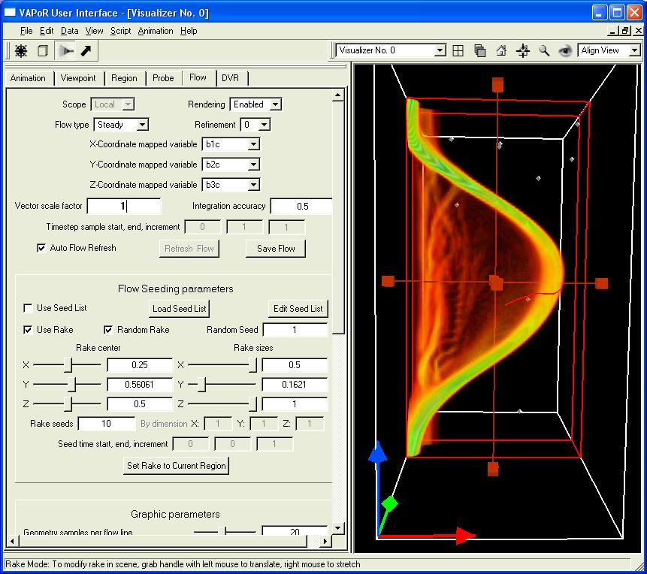
Figure 3.2: Using the rake to place seed points near a flux tube.

3.2 Positioning the probe tool

Click on the bold arrow next to the rake icon near the top left of your screen. You will see a small red rectangle in the scene, with six handles attached. The “Probe” tab will also be visible on the left side of your screen. In the left side of the probe tab, there is a list of “Mapped Variables”. With the left mouse, click on “b1c”. Then, holding the control key down, click also on “b2c” and “b3c”, so that all three variables are selected. The result of selecting multiple variables is that the probe uses the root-mean square of the selected variables, i.e. the norm of the vector (b1c,b2c,b3c). Click Rendering “Enabled” at the top of the probe tab, rotate the visualization downward, and you will see an image like the following:

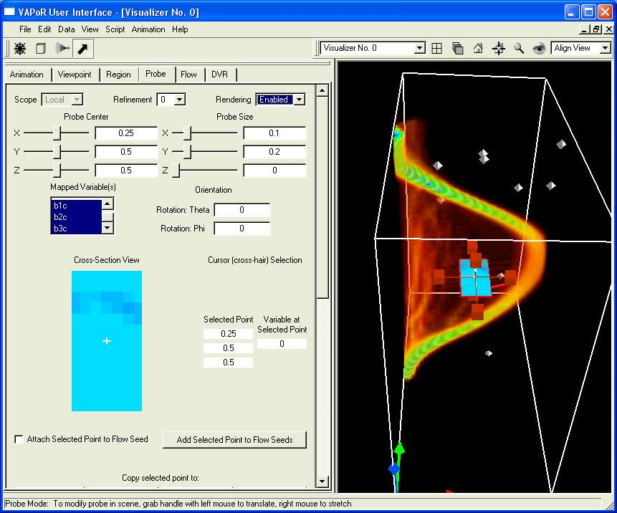
Figure 3.3: Placing a probe tool in the scene

The probe, shown as a blue rectangle in the probe panel, has been inserted in the scene, and has handles attached so you can move it around. Drag the handles with left mouse to position the probe where it cuts through the flux tube. You can alternatively position the probe by using the text boxes or sliders at the top of the probe panel. A good starting position for the probe is at x=0.45, y= 0.56, z= 0.5, with x-size = 0.1, y-size = 0.1, z-size = 0, as shown below:

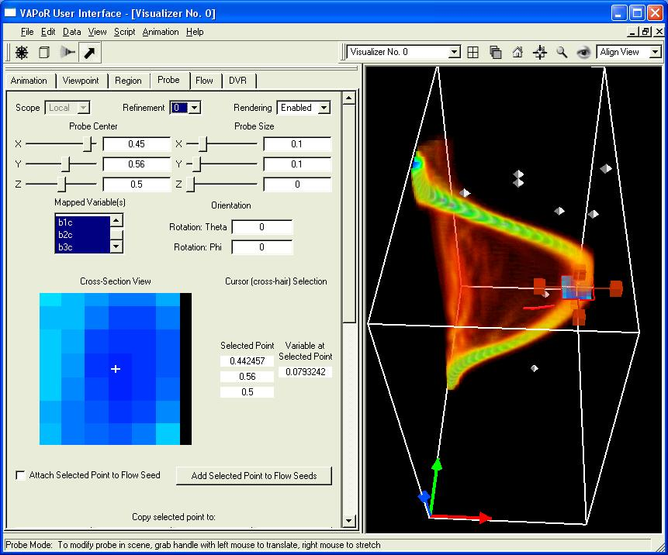
Figure 3.4: Inserting the probe in the flux tube

3.3 Color mapping the probe

The probe cross-section looks pretty coarse, because we are using the lowest resolution data. Select refinement 2 to get a better image.
If you scroll down to the bottom of the probe panel, you will see a transfer function editor, just like the transfer function editor you used with the volume renderer in section 1. This transfer function controls the colors displayed in the plane of the probe, mapping the magnitude of the field (bc1, bc2, bc3) to a color and opacity. The transfer function editor also displays a histogram of the values in the probe.
For the purpose of understanding the magnetic field in the flux tube we are mostly interested in the large values of the field intensity. You can see what the values are in the probe by clicking the “Histo” button; they are mostly between 0 an 0.10. To show the larger values, type 0.05 as the left TF domain bound and 0.10 as the right domain bound. Click “Fit to View” and then click “Histo” to see the histogram over this range of values. You should see the following:

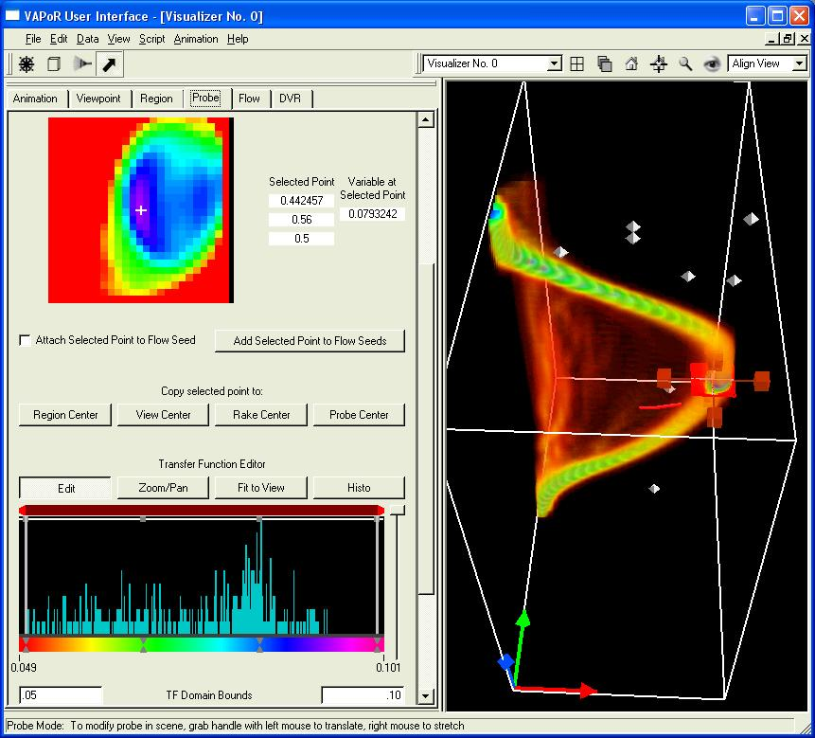
Figure 3.5: color-mapping the probe to look at the flux tube cross-section

It will make it easier to navigate in this scene if the probe is the center of rotation. Click on the button labelled “Copy selected point to: View Center”. Then drag the right-mouse button upward in the scene to zoom in, closer to the probe. So that the volume visualization does not interfere with your view, click on the DVR tab, and slide the opacity scale in the DVR about halfway down. After you make these changes, the resulting image should be similar to the following:

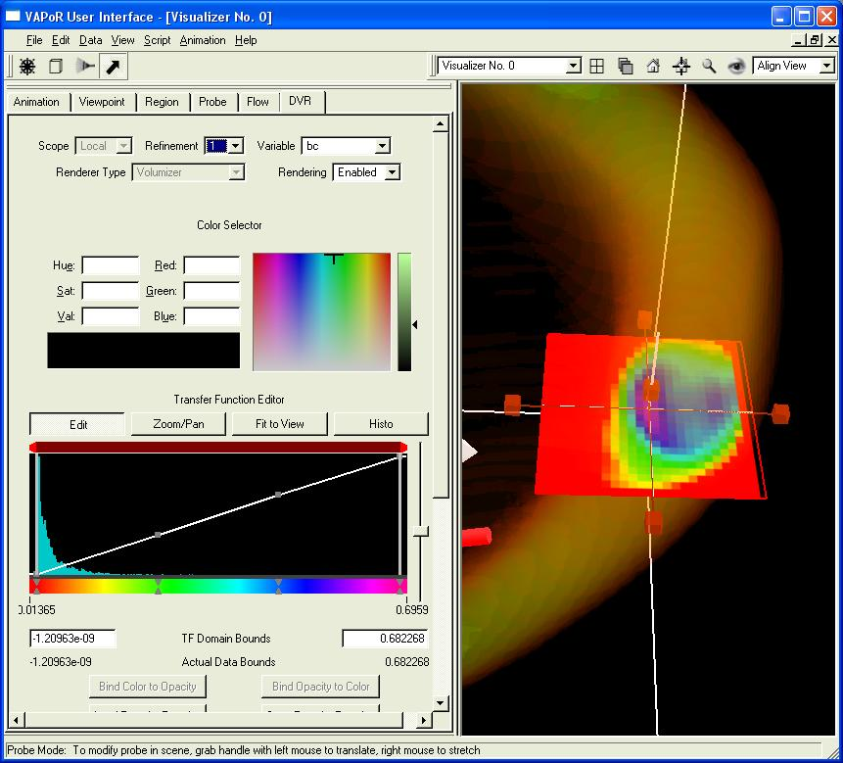
Figure 3.6: A good view of the probe in the flux tube

Now you can understand why it was so difficult to obtain useful flow seeds: The large values of the field are limited to the very small volume in the flux tube.

3.4 Using the probe to select flow seed points.

The probe tool can now be used to specify the location of seed points for field visualization. Before doing this, however, we need to prepare the flow panel to visualize the field lines that come from the probe. Click on the flow tab. It should already be set to visualize the vector with components (b1c, b2c, b3c). Set the Vector scale factor to 0.1. Un-check the “Use Rake” checkbox, and check the “Use seed list” checkbox. Select refinement level 2 (so we will get more accurate tracking of field lines. Click Rendering “Enabled” (if it is not already enabled). You are now prepared to visualize field lines associated with a list of seed points. However, there are currently no seed points in that list so you won’t see any field lines yet.

Scroll down to the Graphic Parameters, and, in the space labeled “Begin/End display interval, specify -20 and 20. This will enable us to integrate the field lines 20 steps forward and backward from the seed point. (Bidirectional flow lines are appropriate for looking at magnetic field lines). Set the geometric shape diameter to 0.5. Your flow panel should look like the following:

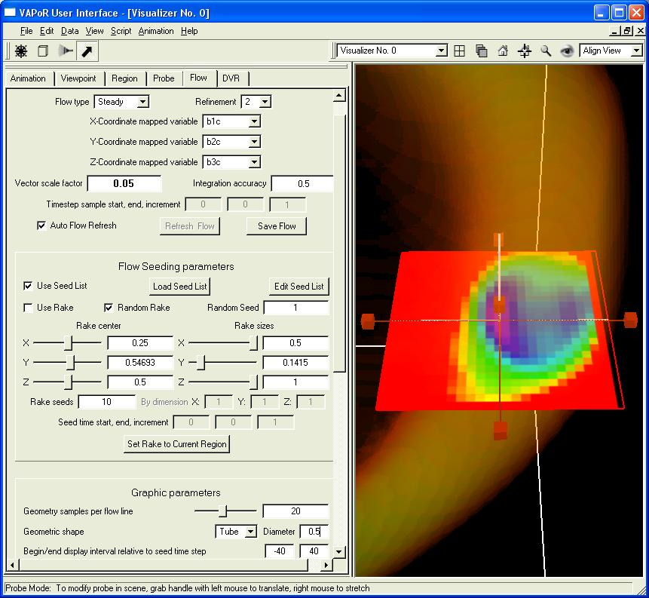
Figure 3.7: Flow settings for using a list of seeds from the probe

Next, return to the probe panel. We shall specify field lines by moving the cross-hairs in the image in the probe tab. Click the check-box labeled “Attach selected point to flow seeds”. After waiting a few seconds for the necessary data to be retrieved, you will see a red field line that passes through the current cross-hair location in the visualization window. You can click various locations in the probe image and see the field line that results. When you are satisfied with the resulting field line, click “Add Selected Point to Flow Seeds”. After you have selected several points from the probe, your flow visualization will look something like the following:

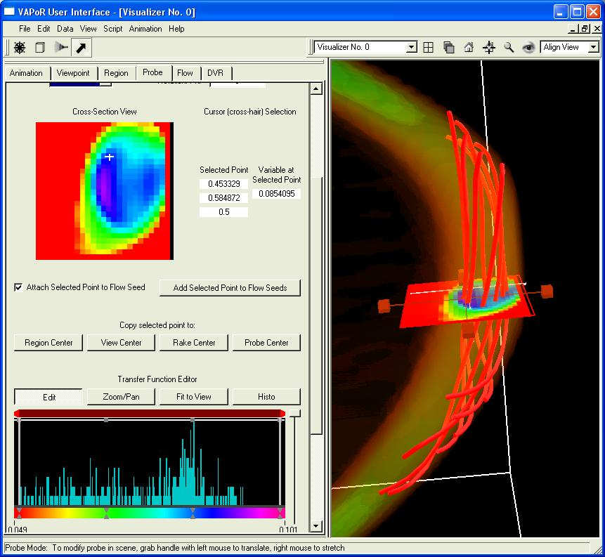
Figure 3.8: Magnetic field lines resulting from seeds selected in the probe

To make it easier to distinguish the various field lines, return to the flow tab, and scroll down to the bottom. In the Graphic Parameters, select the color map to be “Seed Index”. This way each seed point determines a color based on its index. If you have a list of N seeds, the seeds in the seed list have indices 0,1,2,…, N-1. Seeds in the rake are indexed with negative integers.
Below the color mapping window you will see “Color Data Limits”. The left limit is 0, and the right limit is N-1, where N is the number of flow seeds you have selected in the probe panel. Set the color map endpoints to be 0 and N-1, so that we map the integers 0,…, N-1, to evenly spaced colors. In the example we are displaying, there are N=9 seed points in the list. You can look at (or modify) the values of these seed points by clicking on “Edit Seed List”, resulting in a screen like the following:

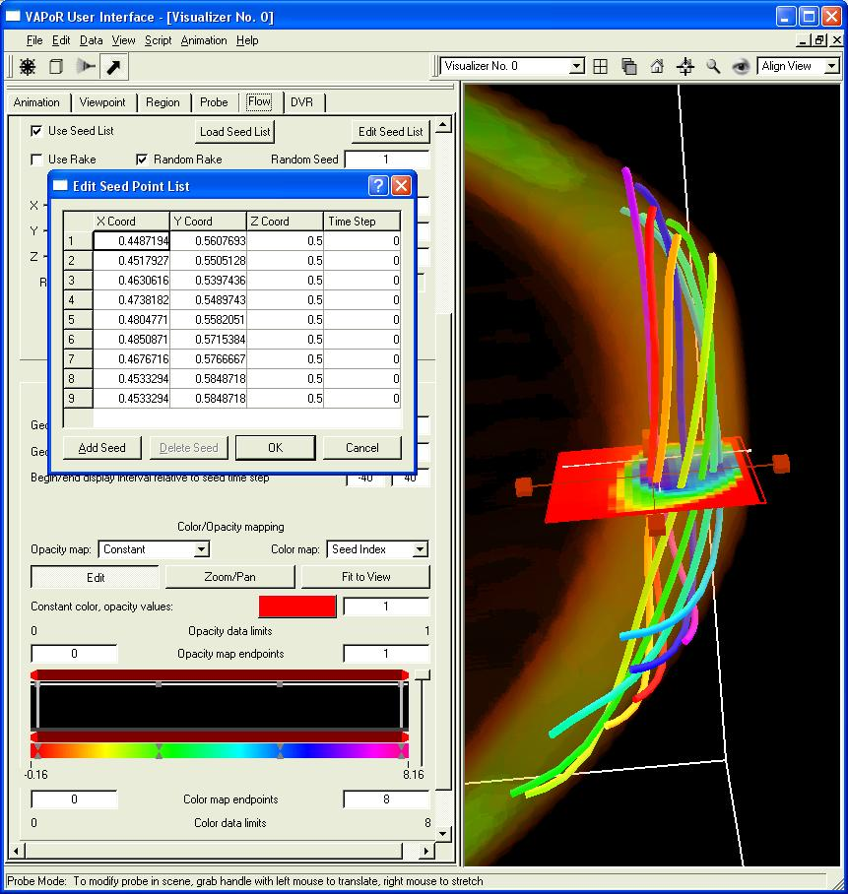
Figure 3.9: Color mapping and editing the list of seed points

In the above screen shot, each of the 9 field lines is colored differently. Note that each seed has four coordinates. The third (Z) coordinate is always 0.5 because we chose the probe to be parallel to the X-Y plane. The fourth coordinate is 0 corresponding to the time step we are currently visualizing. To make seed points that are valid for all time steps, set the time step to “*” or “-1”.

Section 4: Advanced topics

4.1 IDL Import and Export
An important feature of VAPOR is the ability to perform analysis concurrently with visualization of data. Currently VAPOR supports analysis using the IDL language, from RSI. Information about IDL is available on their website, at http://www.rsinc.com. In this guide we shall show how a VAPOR session can interact with an IDL session by importing and exporting data. Several examples of applying IDL code to VAPOR data sets are provided in the VAPOR VDC document, http://www.vapor.ucar.edu/doc/VDCIntro.pdf . Here we shall show how those IDL routines can be used in combination with a VAPOR visualization session. You do not need to know IDL in order to run this example.
The IDL import and export features provide a means of communicating data between an IDL session and a VAPOR visualization session. From the VAPOR user interface, when you export data, you provide a description of the current data volume that can be read by the IDL session. From IDL, you can perform numerical operations on the data, resulting in new VAPOR data sets (described by .vdf files). Then, using the VAPOR user interface, you can import the data into your VAPOR visualization session, adding the new data to the previously existing session.

Set up for IDL analysis: These instructions are a bit different depending on whether you are using Windows or a Unix platform. In either platform you need to write to the IDL examples directory (It’s the examples/idl subdirectory of the VAPOR install directory). Copy the contents of examples/idl to a writable directory if you do not have write-access to it. Follow the setup instructions below, depending on whether you are using Unix or Windows:

On Unix: To run this example you will need to run an IDL session in a shell window separate from the window in which you will run the VAPOR user interface. Initialize that shell by running vapor-setup.csh (in a c shell) or vapor-setup.sh (in a Bourne shell) then cd to your idl examples directory. Type “idl” and press enter to start running idl in that shell.

Set up for IDL analysis on Windows: In Windows you run IDL from the IDL IDE (I.e. the IDL desktop application). To initialize your environment, click File->Preferences, and select the “startup” tab. Specify the Working Directory as the (writeable) directory where you have put the VAPOR idl examples. Under the “path” tab add the VAPOR bin subdirectory (in addition to the <IDL_DEFAULT> directory).

Start the VAPOR visualization in its own window, and open the session file you created in section 2.3, “8spothires.vss”. If you did not save that file, you can use the session file for figure 2.5, “guideFigure2.5.vss”. Then load the data “8spot3d-lowres.vdf” into the current session.

Exporting the data: From the VAPOR DVR tab, click Rendering “Enabled” to see the volume visualization of the vortex that we isolated in section 2.3. Click on the cube button near the top-left of your window, to enter region select mode. You will see a wireframe that identifies the boundary of the current region. We would like to perform analysis of the data in that region, to better understand the flow in the vortex. From the Data menu, Click on Data->Export to IDL. This operation identifies the region around the vortex so that the IDL session can use it, as shown below:
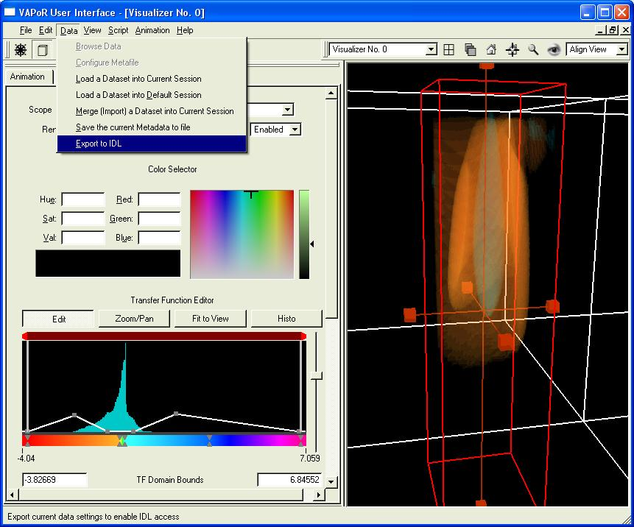
Figure 4.1: Specifying a region to export

Importing the data into the IDL session: There is an IDL script, “QuickStartEx1.pro” provided in the VAPOR examples directory. When executed, this script will calculate the z-component of vorticity of the flow in the specified region. From the IDL command line, type
“ .RUN QuickStartEx1.pro” and press enter. You will get several lines indicating the progress of the idl, such as:

% Compiled module: $MAIN$
% Compiled module: IMPREGION (This reads the region you exported)
% Loaded DLM: LIBIDL_VDFMODULE (This loads the VAPOR library)
% Compiled module: MYDERIV (This calculates the vorticity of the flow)
% Compiled module: EXPREGION (This outputs the results as a .vdf file)

You may also see a message about an arithmetic error. You can ignore this. Note how long it took to execute this script. It would have taken much longer if you had calculated the vorticity for the full volume!

Merging the resulting data back into your VAPOR visualization session: From the Data menu, click “Merge (Import) a Dataset into Current Session”. Then select the file “QuickStartEx1.vdf”, which will be located in your idl examples directory. A dialog will pop up, asking you to select a timestep offset. This specifies the difference in timestep numbering between your original data (8spot3dlowres.vdf) and the new data that you created in IDL. In this case, the data was exported from timestep 0 of the original data, so the correct offset to use is 0. Click “OK”. VAPOR will then augment the current session by loading the new volume into the current session.
It would be a good idea to now save the new (merged) metadata in one metadata file. This will make it easier if, for instance, you would like to restore this session in the future. Click on “Data->Save the Current Metadata to File” and specify a vdf filename (different from 8spot3dlowres.vdf) associated with the merged data.
To visualize the new data, click on the DVR tab, and then select the variable “omz”. This is the new variable you have just loaded. Click Rendering “Enabled” at the top of the DVR panel and you will see the data, but with a transfer function that isn’t very useful. You can edit the transfer function as we did in section 1.4 above, to create a transfer function that highlights the positive and negative values of omz:

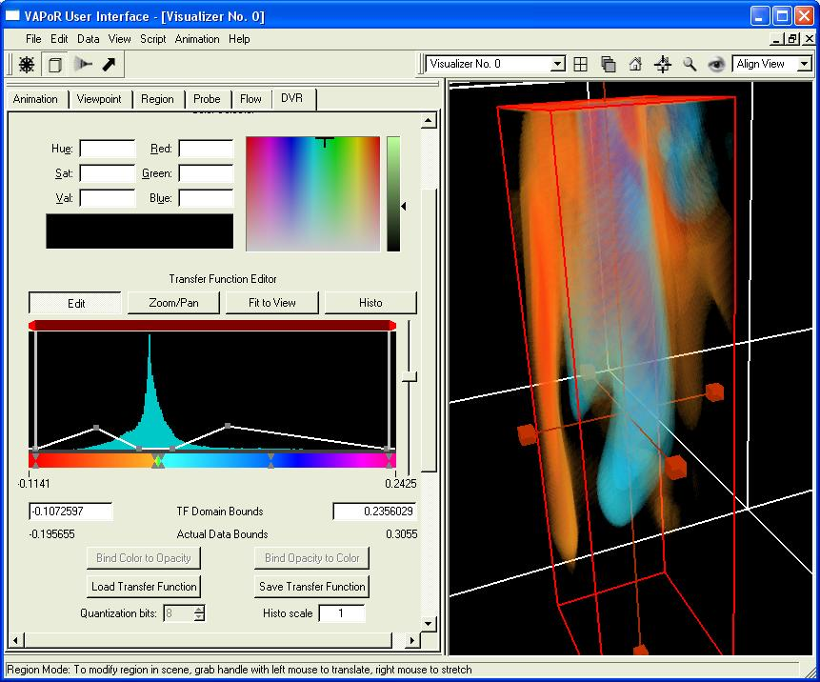
Figure 4.2: A visualization of omz with a transfer function similar to the one in section 1.

You can now use the new data (the omz variable) to position seed points in the flow. We leave as an exercise for the user to inject seed points into the flow at the points of maximal value of omz. This is just like we showed in section 3.4 above. You will find that, when you insert seeds at a large value of omz, the resulting flow lines move upward, eventually twisting and turning back down, such as illustrated below:
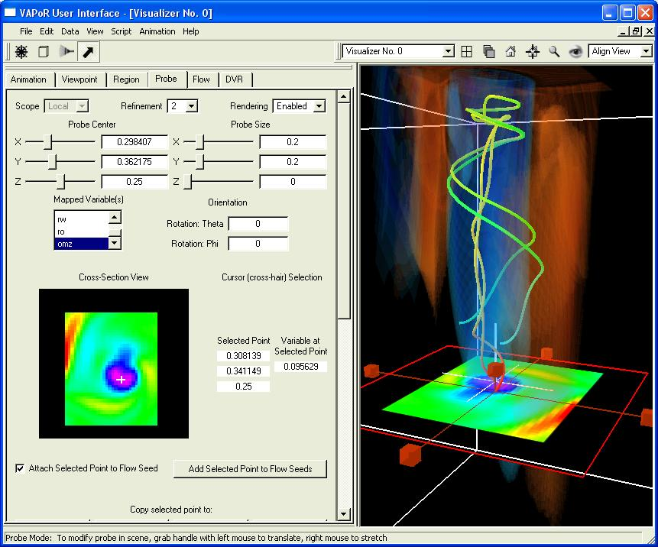
Figure 4.3: Stream lines resulting from injecting seeds at large values of omz

4.2 Using Multiple Visualizers

So far all of the visualization we have made were performed in one window. However it is often useful to do a side-by-side comparison of different visualizations. For an example we show how to perform a comparison of the vorticity variable “omz” we just created with the “rw” variable that was visualized in section 1.
Make your VAPOR window wider by grabbing the right edge with the left mouse and dragging it to the right. This will give us more room for the visualizers. Then at the top-middle of your window, where you see the text “Visualizer No. 0”, select “Create new visualizer”. You will see a black window on the right, labeled “Visualizer No. 1”. Select the DVR tab and then click the top of a visualizer. You will see that the parameters in the DVR tab change, depending on which visualizer you click. Click on Visualizer No. 1, and then, in the DVR tab, select the variable “rw”, select refinement 2, and click Rendering “Enabled”. You will see the variable rw, but with the default transfer function.
You can repeat the steps in section 1.4 to create a transfer function here. But an easier way to fix the transfer function is copy the transfer function we previously made (in section 1.4) from the DVR renderer in Visualizer 0 over to the DVR renderer in Visualizer No. 1. Click on Visualizer No. 0, and select the variable “rw”. In the DVR panel you will see the transfer function for the variable “rw”. Click on the “Save Transfer Function” button below the transfer function editor. You will see a dialog box enabling you to save to file or to save in the current session. Type in the transfer function name “rwTransferFunction” and then click the button “Save Transfer Function in this Session”.
Now, to copy that transfer function into the DVR in Visualizer 1, select visualizer No. 1, and select the DVR tab. In the Load Transfer Function dialog, select the name “rwTransferFunction” and click “Load Selected Transfer Function in this Session”. Then click back on Visualizer 0, and select the variable “omz” that we previously visualized. Your VAPOR window will now show a side-by-side comparison of these two volume-rendered variables. Click on the Navigation mode button (removing the probe from the scene) and you will see the following:

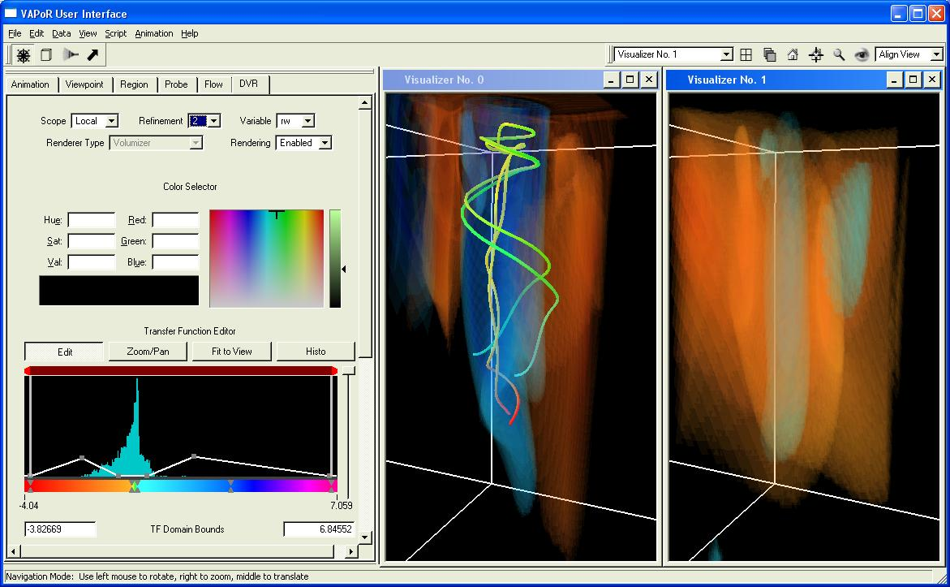
Figure 4.4: Side-by-side comparison of volume renderings of omz and rw

4.3 Local and Global parameters

In the side-by-side visualization of the previous section, some of the parameters in the tabbed panels are shared between the visualizer, and some are not. Each parameter panel has a selector indicating either “Global” or “Local” scope. By default, the viewpoint, animation and region tabs are Global, and the probe, dvr and flow tabs are Local. If you click and drag the left mouse button in one of the visualizers, both scenes will rotate because both are using the Global viewpoint parameters. We saw different volume renderings in the two visualizers because the DVR parameters were Local to each visualizer.
If we want to see the flow streamlines in both visualizers, we need to make them Global. Click on visualizer 0, and on the flow tab. Select Global scope in the flow tab. The flow lines will disappear because the global flow renderer is not enabled. Set up the Global parameter the same as we used above: Set the scale factor to 0.05. Set the refinement level to 2. Check “Use Seed List” and un-check “Use Rake”. Set the geometry samples per flow line to 200 or so. Set the tube diameter to 0.5, and set the color map to “Timestep”. Then click Rendering “Enabled” at the top of the flow panel. (You won’t see any flow lines because we haven’t added any seed points to the seed point list). Click on visualizer No. 1 and select “Global” for the scope in its flow tab. You will see the same settings in this tab, as you just set, because they are Global.
To add seed points, click on Visualizer 0 (where we previously set up the probe) and click on the probe arrow (at the top of your screen) to enable data probe mode. Select Rendering “Enabled” at the top of the Probe panel if the data probe is not already enabled. Select a few seed points with large values of omz, by repeatedly clicking purple or blue points in the probe cross section, and then clicking “Add selected point to flow seeds”. You will see several flow lines, appearing in both visualizers as in the following:

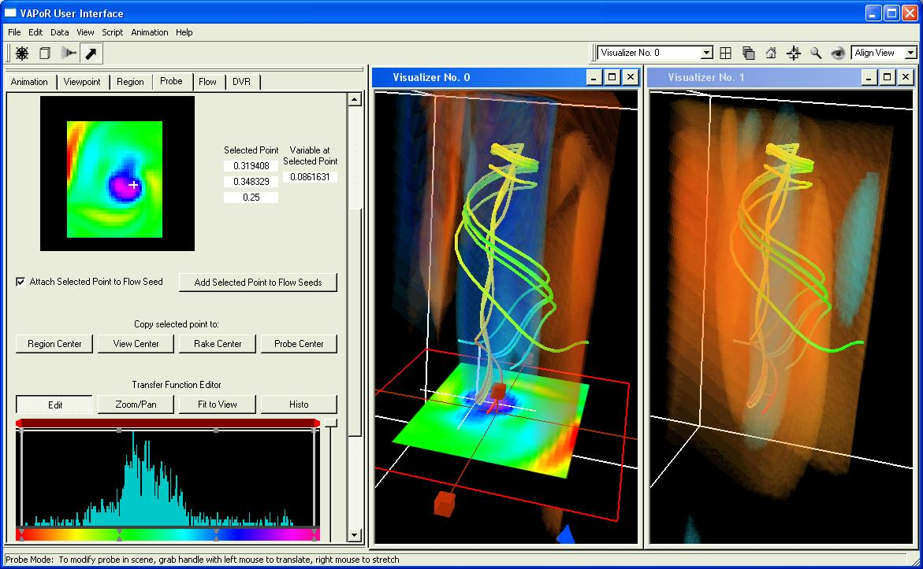
Figure 4.5: Global flow lines with local DVR renderers.

It is often useful to use Local animation control, region, or viewpoint panels, for example to view a volume from different perspectives, or to compare different time-steps side-by-side. You can always revert to the Shared parameters when needed.

