Introduction
This project explores how serious games and gamification can improve focus, motivation, and task completion, especially for individuals with executive function challenges. The idea is to design an adaptive gamified productivity system that helps users manage tasks effectively while maintaining motivation through game-based reward mechanics. This project will investigate how gacha mechanics, a randomized reward system popular in games, can be effectively used to improve engagement and sustain productivity habits.
Many productivity tools fail to sustain engagement among neurodiverse users who struggle with organisation and self-regulation. Most of these tools are abandoned after only a few days as they fail to maintain motivation. Gamification offers a promising approach, particularly when integrated with gacha-style reward systems that introduce anticipation. Research by Nikola Lakić. (2023) found that “Most (91.7%) participants did not think they had any gambling problems, 57.2% participants regularly received money (work or other sources), and most participants (80.2%) spent the money on Gacha games.” This shows how unpredictable yet steady rewards used in gacha systems can strongly reinforce user engagement, often leading to compulsive and addictive behaviours. The variable-ratio reward schedule behind gacha design is a well-known psychological mechanism for sustaining attention and emotional investment, which if applied ethically, could be redirected towards maintaining focus and task persistence.
Furthermore, in their study of gacha game spending habits, Nikola Lakić. (2023) also highlighted that player motivation often comes from the desire to collect exclusive cosmetic items or rare characters rather than from the gameplay progression. They found that “To unlock a character/weapon – 476 answers (77.7%)” and “More than half of the participants (53.8%) spent money because they wanted a character or weapon that was available for a limited time.” showing how anticipation and perceived scarcity drive repeated engagement. This reinforces the psychological power of randomised rewards, which leverage curiosity and collection instincts to sustain player attention. While this mechanism can contribute to addictive behaviours in entertainment games, it also demonstrates the potential of reward-based anticipation to maintain motivation. If used ethically, without financial transactions or manipulative scarcity, such collectible elements could be repurposed to reward productivity milestones, transforming task completion into a more engaging and emotionally rewarding experience.
However, a review published in the Journal of Medical Internet Research Games (2024) concluded that serious games can improve attention, working memory and cognitive flexibility. These cognitive improvements align directly with the challenges faced by neurodiverse users, suggesting that game-based mechanics can provide measurable functional benefits beyond entertainment.
Similarly, Habeeb Ur Rahiman (2023) reported that “82% of the respondents are aware of gamification and are working in the private sector with minimum graduation as their qualification and in team personnel.” which indicates a growing familiarity with gamification in professional environments. Their findings suggest that when properly implemented, gamification can improve motivation and engagement, leading to enhanced productivity outcomes.
Building on these findings, this project investigates how gacha-style rewards can be applied responsibly, reinforcing motivation and progress while ensuring ethical safeguards that prevent unhealthy addiction patterns. By incorporating adaptive difficulty, time-based limitations and transparent reward structures the Adaptive Gamified Productivity System will reinforce focus, motivation and progress without encouraging unhealthy engagement patterns. This work contributes to ongoing research in serious games, user experience and adaptive learning systems, with potential implications for developing more inclusive and sustainable productivity tools for neurodiverse users.
Project Scope
The project scope is Adaptive Gamified Productivity System that integrates Pomodoro-style focus sessions and task completion tracking with a gacha reward mechanic. The system aims to enhance motivation and focus, particularly for neurodiverse users, by rewarding consistent productivity with collectible digital items. The core scope includes designing and implement a task dashboard, a focus time, and a gacha reward interface, each supported by adaptive feedback.
Key Screens
Dashboard and Focus mode
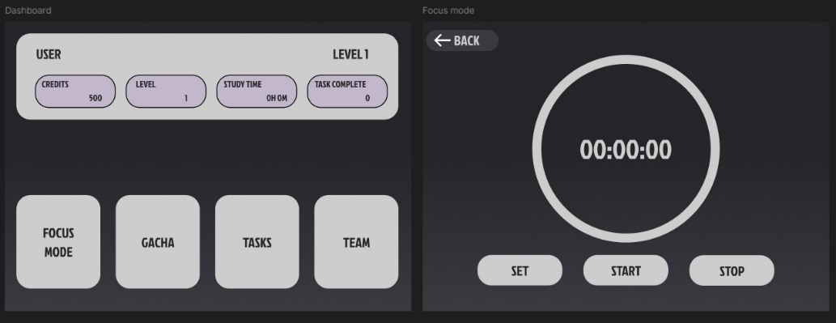
Gacha interface and Task manager
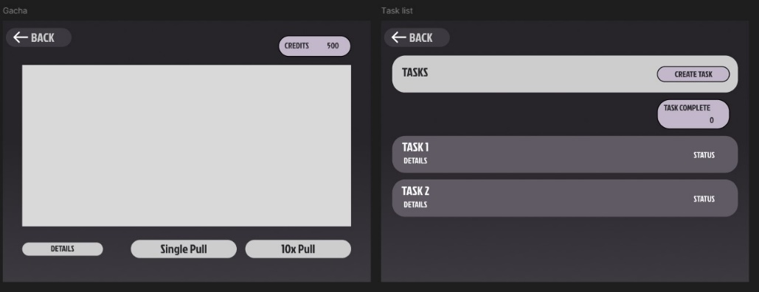
Team editing (character collectible or items, the illustrations are not final product)


Aim and Objectives
Project Aim
To develop an adaptive gamified productivity system that supports neurodiverse users in improving focus and motivation while evaluating the effectiveness of gacha-based reward mechanisms in sustaining long-term productivity and engagement.
Objectives
- Develop and deploy the core productivity tracking feature by Week 7. Allowing users to create, manage and complete daily tasks and complete pomodoro rounds within an adaptive gamified interface that visually rewards progress through gacha-style collectibles.
- Implement adaptive gacha-based reward mechanics by Week 8, ensuring that rewards unlock only after measurable task milestones, with randomized but balanced item distribution to prevent exploitative behavior.
- Achieve an engagement rate of at least 75% by Week 10, verified through prototype testing logs that record user session frequency and task completion consistency over a two-week period.
- Conduct usability testing with a minimum of 10 neurodiverse participants by week 12, gathering both qualitative and quantitative feedback on motivation, focus and enjoyment using online surveys aiming for a satisfaction rating.
- Evaluate and document the ethical and motivational impact of gacha mechanics by Week 13, using observation notes and participant feedback to determine whether adaptive random rewards encourage sustained productivity without compulsive engagement.
- Complete final testing, documentation and demo preparation by Week 14, demonstrating system stability, adaptive response accuracy, and ethical application of reward mechanisms suitable for productivity environments.

Tasks and Deliverables
Task | Description | Deliverable | Milestone
Background Research | Investigate gamification, serious games and executive dysfunction | Literature Review | Week 4
Requirements Gather | Identify user needs and accessibility requirements | Requirements Report | Week 5
System Design | Develop wireframes and architecture | Design Documentation | Week 5
Prototype Development | Build interactive system with core function  - Design basic collectibles | Prototype v1 | Week 8
Prototype Development 2 | Build interactive system with more functions. Polish it.  - Implement collectibles into the interactive system | Prototype v2 | Week 10
Testing and Feedback | Conduct usability testing | Test Report | Week 12
Evaluation | Analyze data and refine prototype | Evaluation summary | Week 13
Final Documentation | Write report and prepare demo | Final Report and Demo | Week 14

Gantt Chart
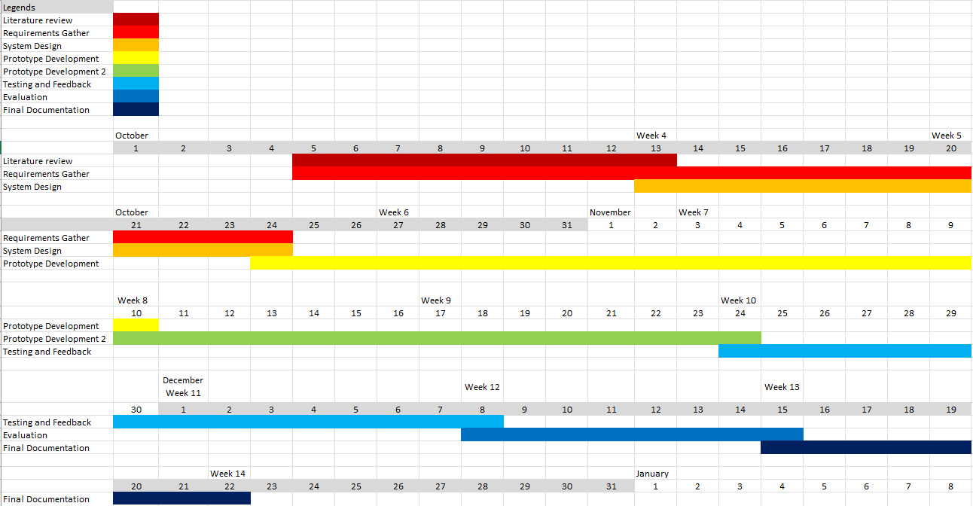

Resources
Hardware:
- Personal Laptop
- Internet Connection
Software and Development tools:
- Figma: for wireframe design
- Unity: for development and prototype
- Clip Studio: for producing custom graphics and elements
- GitHub: for version control and project backup
- Google Forms: feedback and survey
- Excel: Project planning, tracking tasks and Gantt chart

Risks
Risk | Cause | Mitigation | Severity | Risk Impact | Likeli-hood
Project Scope Creep | Too many features planned | Prioritize core mechanics | Unacceptable | Low | Unlikely
Technical Challenges | Bugs of integration issues in Unity | Test iteratively and use GitHub for version control | Unacceptable | High | Possible
Limited Backend Skills | Inexperience with data handling | Use Firebase templates and online documentation | Unacceptable | Medium | Possible
Ethical issues | Gacha mechanics could encourage addictive behavior | Implement responsible reward pacing | Unacceptable | Low | Possible
Time Management | Overlapping deadlines with other modules | Use Gantt chart and Agile sprint planning | Unacceptable | Medium | Unlikely
Participant Recruitment | Difficulty finding testers | Recruit peers and online volunteers early | Tolerable | Low | Unlikely
Design Complexity | Interface may overwhelm users | Keep UI simple, accessible and consistent | Tolerable | Medium | Possible
Data Loss | File corruption or sync issues | Regular Git commits and backup on cloud | Unacceptable | High | Possible
Hardware/  Software Failure | Laptop or tool malfunction | Use on campus device and have a backup plan. | Unacceptable | High | Possible

Legal, Social, Ethical and Professional Issues (LSEPIs)
Legal Issues
This project will comply with all relevant data protection and privacy laws, including the UK Data Protection Act (2018) and GDPR. Any user data collected through feedback or surveys will remain anonymous and stored securely. No personally identifiable information will be shared publicly. The software and assets used will be properly licensed or self-created to avoid any copyright infringement.
Social Issues
The project aims to create a positive social impact by supporting neurodiverse users who face challenges with focus, organization and executive function. By improving motivation and productivity through gamified systems, the project promotes accessibility and inclusion. However, the design will also consider social responsibility, ensuring that game mechanics do not exploit users’ attention or encourage unhealthy habits.
Ethical Issues
Ethical considerations are central to this project due to the inclusion of gacha-style reward systems, which can be a form of gambling mechanics. To address this, all the rewards will be non-monetary and earned through productivity. Reward pacing will be designed to encourage consistent effort rather than compulsive behavior.
During user testing, participants will be fully informed of the study’s purpose and must provide informed consent before taking part. No sensitive data will be collected, only relevant information on the project will be collected and participants can withdraw at any time.
Professional Issues
Throughout the project, professional conduct will be maintained by adhering to the BCS (British Computer Society) Code of Conduct. The project will also follow the University’s Ethical Guidelines for Student Research and complete the required Ethical Declaration Form at Review Point.

Career Aspirations
In short term, my goal is to pursue a career in UX/UI design or game development which focus on creating interactive and inclusive digital experiences. This project directly supports the goal by allowing me to design and build an adaptive system that involves the productivity with gamification.
In the long term, I aim to work in the game design or digital media production which contribute to projects that combine aesthetics, technology and narrative to create immersive experiences. I also aim to work in educational technology sector, developing tools for education and inclusion for users.

Skill Development
Through this project, I aim to strengthen both my creative and technical skills,
- UI/UX Design: Creating wireframes using Figma.
- Game Development: Prototyping in Unity to implement gamified and interactive elements
- Visual Design: Using Clip Studio Paint and other tools for illustration
- Project Management: Organising milestones, testing phases and feedback collecting through structured planning

Industry Relevance
The game technology and digital experience industries are increasingly focused on interactivity, immersion and adaptive feedback systems. Gamification, data-driven design and responsive systems are not central to maintaining user engagement and motivation.
This project aligns closely with these trends by combining UX design, gamified systems and adaptive feedback mechanics to enhance user motivation and productivity. Developing the Adaptive Gamified Productivity System allows me to apply technical and design principles ethically and creatively, preparing me for careers where technology and engagement design intersect
Impact on Professional Growth
Completing this project will improve my professional portfolio with a working prototype that demonstrates a full production pipeline, from concept and interface design to development and evaluation. It highlights my ability to manage both technical implementation and user-centred design, reflecting real world workflows in game and interactive system development. This experience will help me pursue roles such as Game Developer, Technical Designer or UX Engineer where in a studio environment or as part of indie creative team.
Networking and Professional Relationships
Through this project, I will collaborate with supervisor, peers and participants. This will enhance my ability to communicate professionally. These relationships may open opportunities for future collaborations or research in inclusive technology design. These collaborations will mirror industry-style teamwork.

Personal Fulfilment and Motivation
This project reflects my passion for interactive design and game technology, where creativity meets functionality. I find it rewarding to develop systems that not only work effectively but also motivate and engage users. Building this project provides personal satisfaction through both problem-solving and creative expression, reinforcing my motivation to design technology that improves digital experiences.
Educational or Certification Opportunities
I plan to pursue certifications or workshops in advanced Unity development, game UX or interactive system design to expand my technical expertise. This project serves as a practical foundation for those goals. It not only supports my career progression but also demonstrates my commitment to continuous professional and creative growth.

References
- Lakić, N., Bernik, A. and Čep, A. (2023). Addiction and Spending in Gacha Games. Information, 14(7) [online] Available at: https://doi.org/10.3390/info14070399. [Accessed: 17 October]
- Games Journal of Medical Internet Research (2024) Use of Serious Games in Interventions of Executive Functions in Neurodevelopmental Conditions [online] Available at: https://games.jmir.org/2024/1/e59053/ [Accessed: 17 October]
- Rahiman, H.U., Kodikal, R. and Suresh, S. (2023). Game on: Can gamification enhance productivity? F1000Research, 12. [online] Available at: https://doi.org/10.12688/f1000research.131579.2. [Accessed: 17 October]
- The illustrations are self-created

