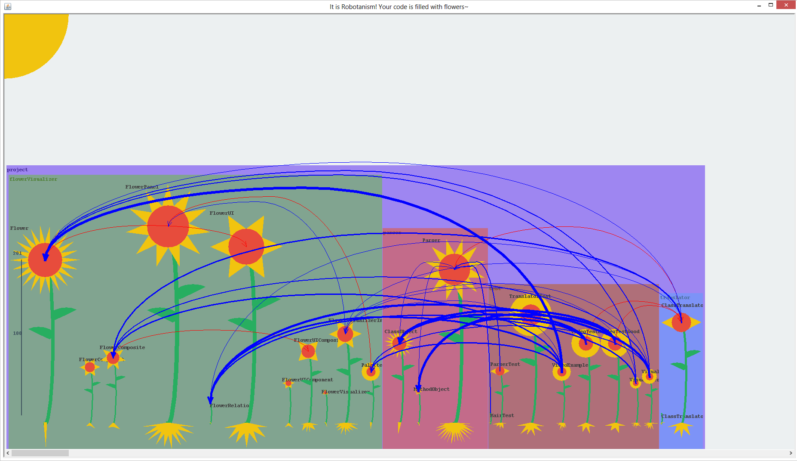

a.png

This is how our project looks with all the test classes.

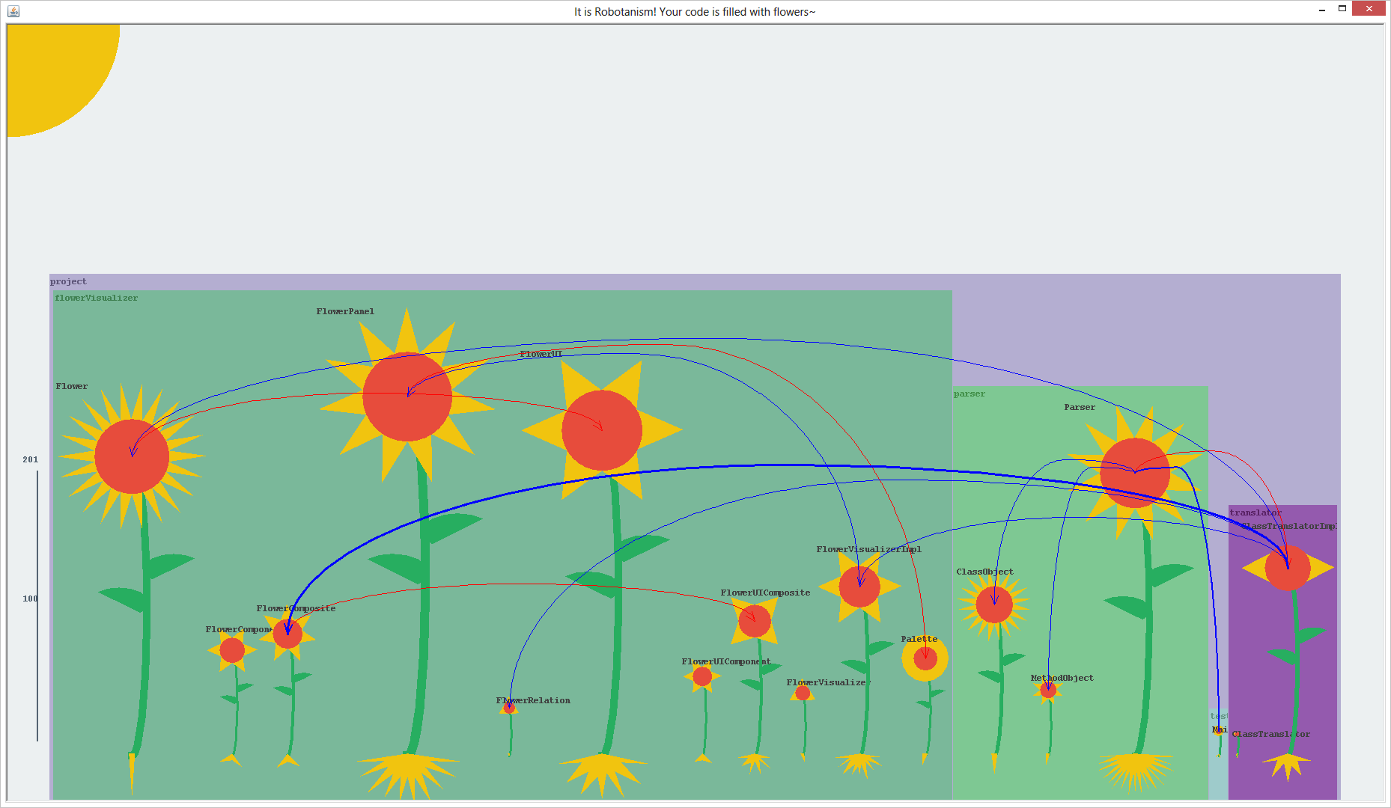

b.png

And this is it with only one test class (main.java). Can you see the difference? =)

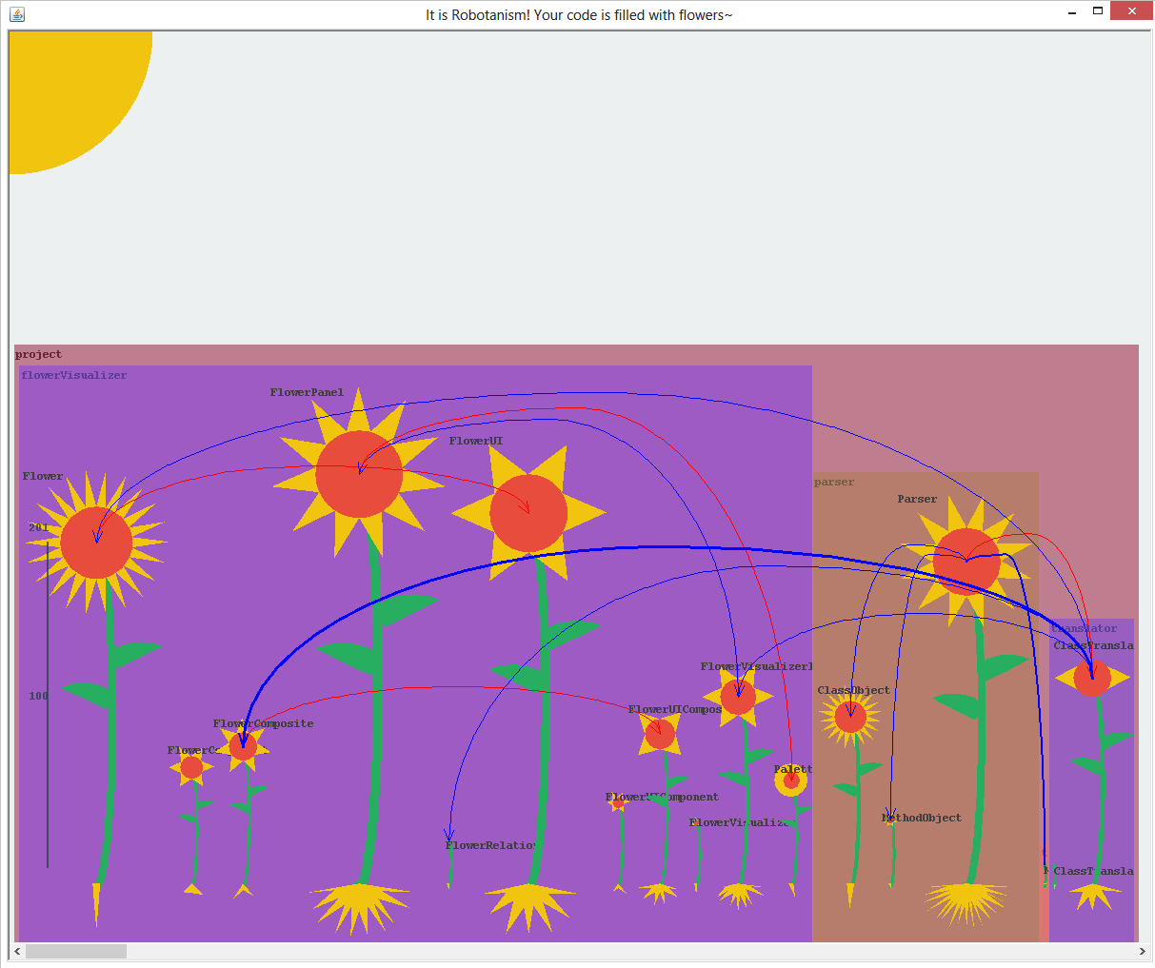

c.pdf

This is just a version of b.png with bigger class names (taken at lower resolution).

Hope that you enjoyed the pictures! =)