# Machine Learning: Assignment #4

## Spectral Clustering

(a)

I have finish the knn_graph.m, spectral.m and spectral.exp1.m.

The spectral clustering is as follow :

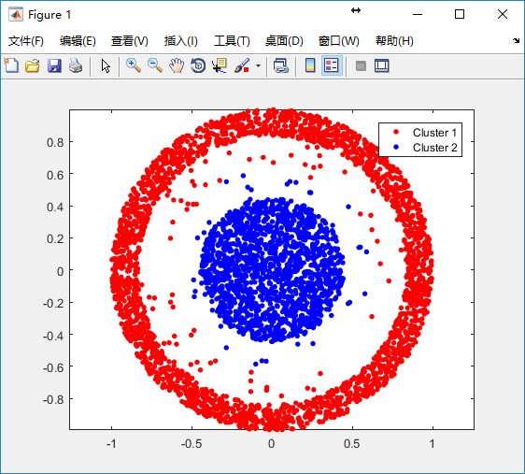

The k-means clustering is as follow:

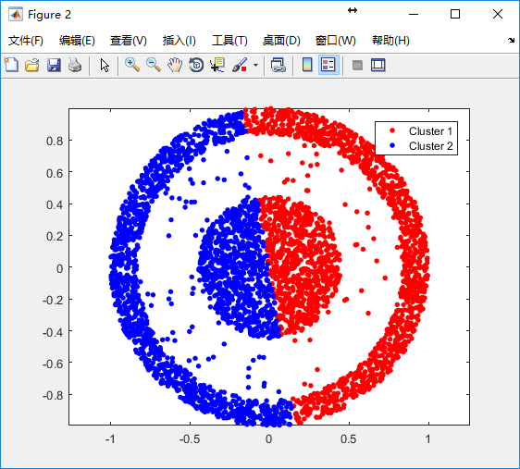

(b)

I have finished spectral_exp2.m using constructW.m and MutualInfo.m.

The average MIhat of spectral clustering is 0.6584.

The average MIhat of spectral clustering is 0.3011.

## Principal Component Analysis

(a)

I have write the pca.m and the hack_pca.m, the picture is as follow:

(1)

1

01

(2)

2

02

(3)

3

03

(4)

4

04

(5)

5

05

(b)

(i)

The eigenface is as follow:

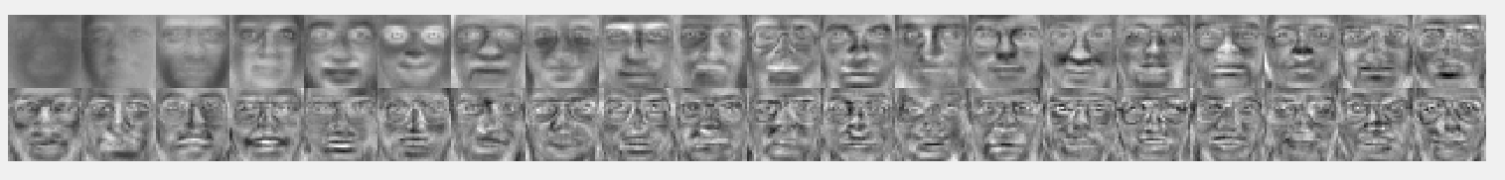

(ii)

The testing error rate 26.00% is with number of reduced dimensionality being 8.

The testing error rate 18.50% is with number of reduced dimensionality being 16.

The testing error rate 14.50% is with number of reduced dimensionality being 32.

The testing error rate 12.00% is with number of reduced dimensionality being 64.

The testing error rate 12.50% is with number of reduced dimensionality being 128.

(iii)

I have finished the pca_exp2.m.

The picture when k=8 is as follow:

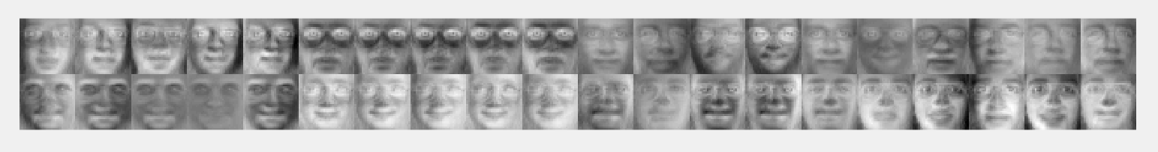

The picture when k=16 is as follow:

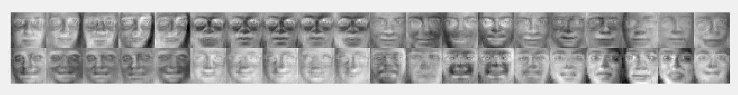

The picture when k=32 is as follow:

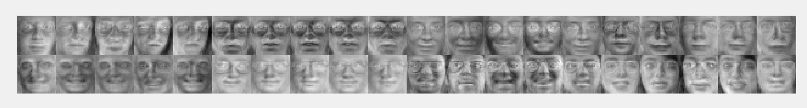

The picture when k=64 is as follow:

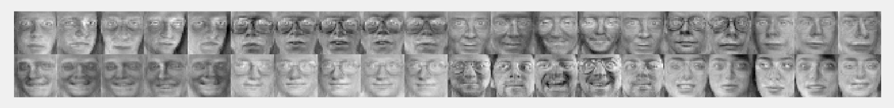

The picture when k=128 is as follow:

