Draft:

Step 1:

At first, we plot the whole dataset and have a look.

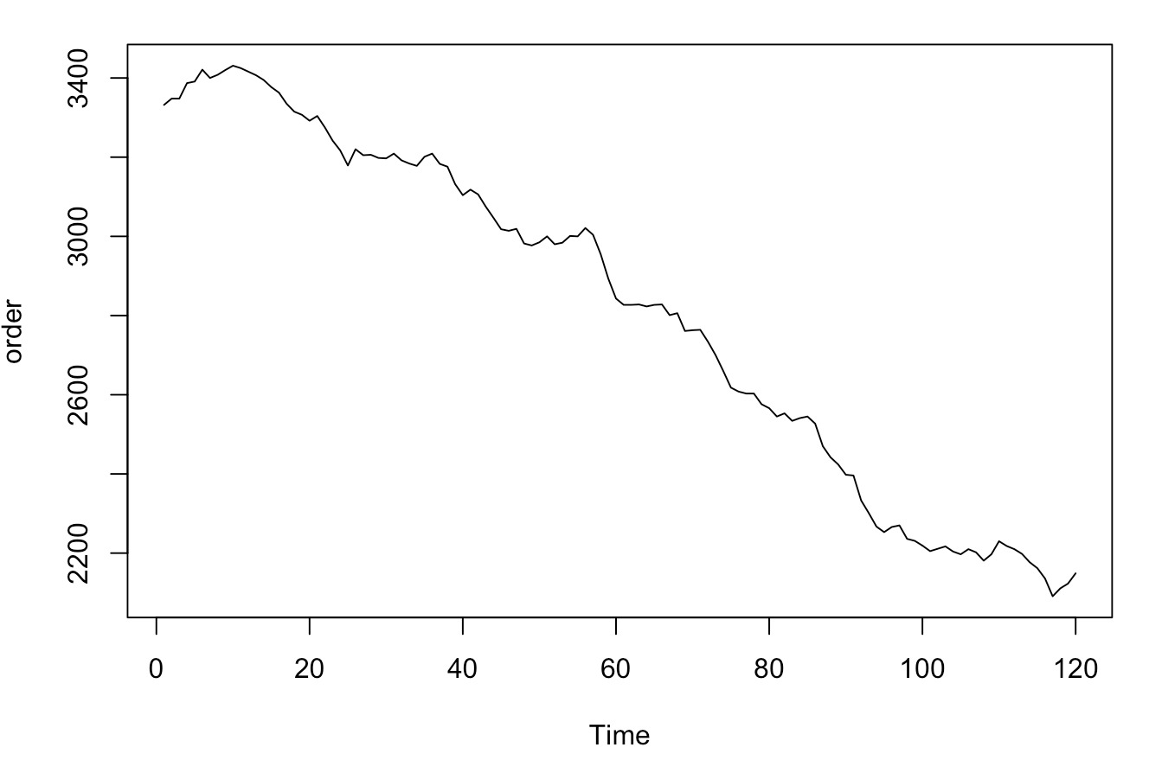

Step 2:

Split the dataset into two parts, the train and the test. We use 90%of the whole dataset to build the train dataset, which contains 108 data. The remain data belong to the test dataset.

Step 3:

We firstly fit Linear Trend Regression model, .

K = 1,

The fitted model is:

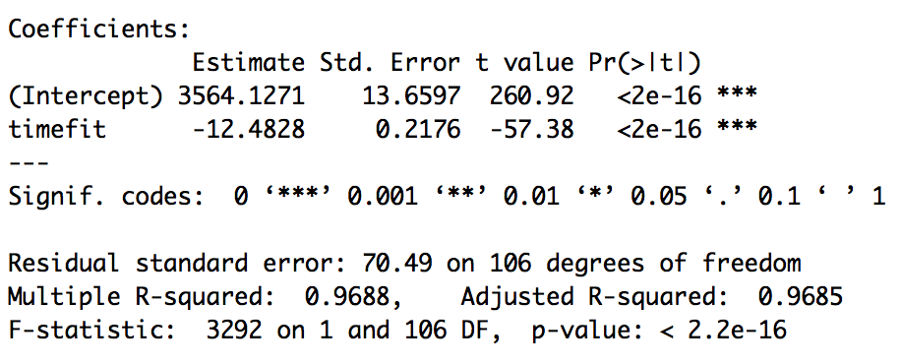 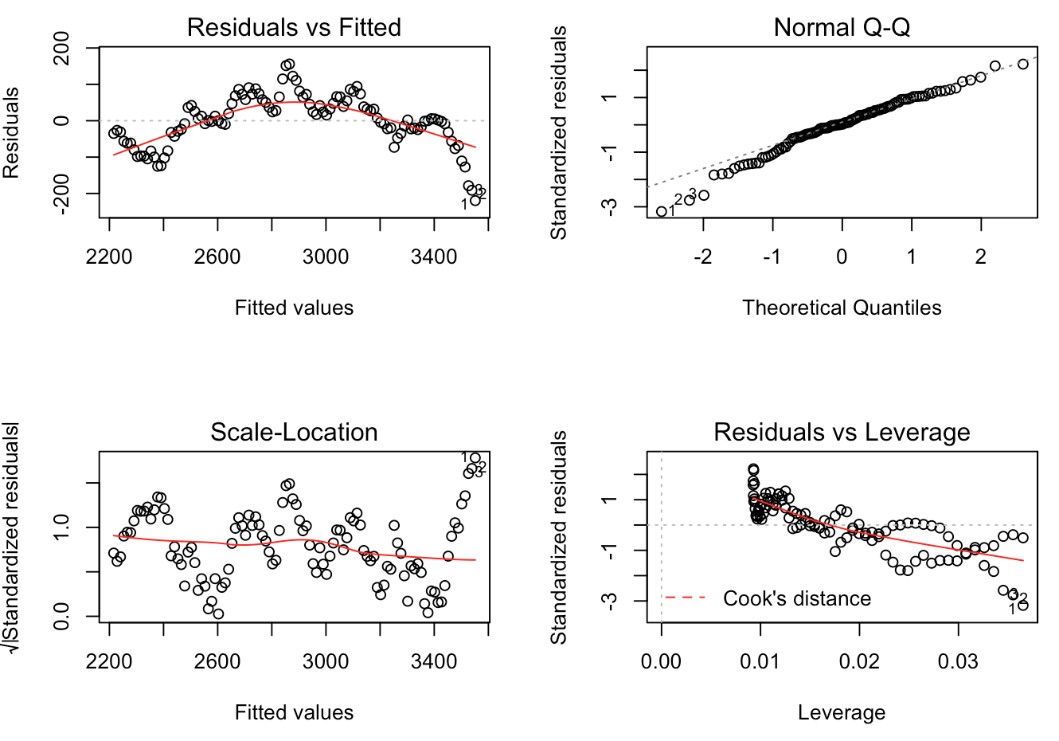

K = 2,

The fitted model is:

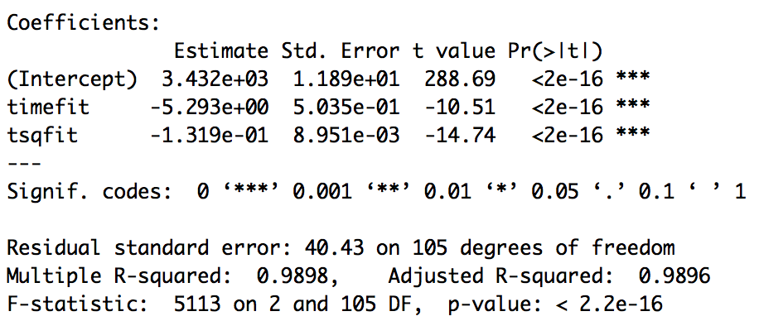 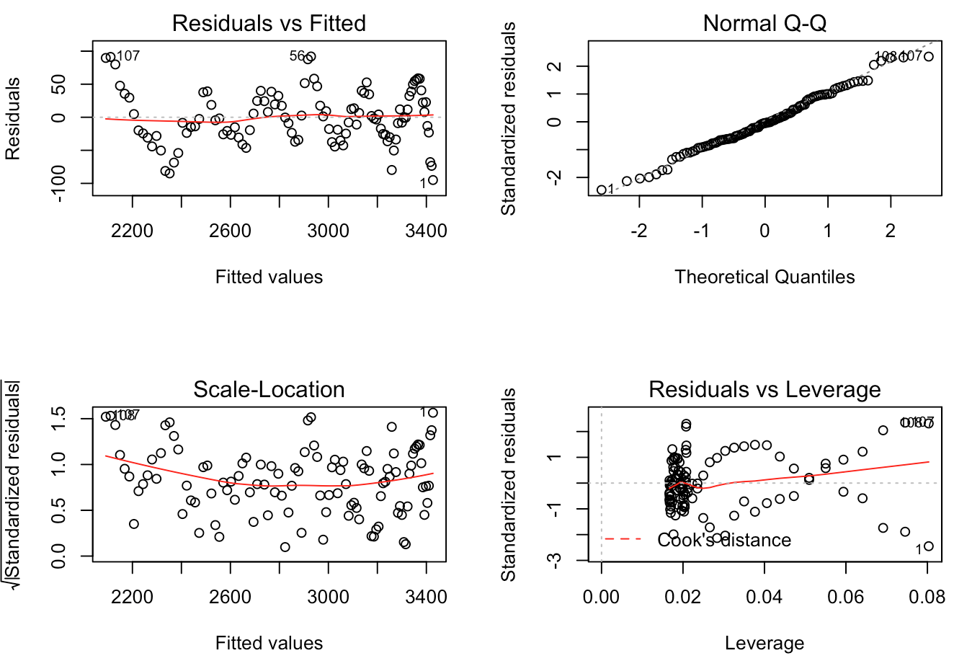

K = 3,

The fitted model is:

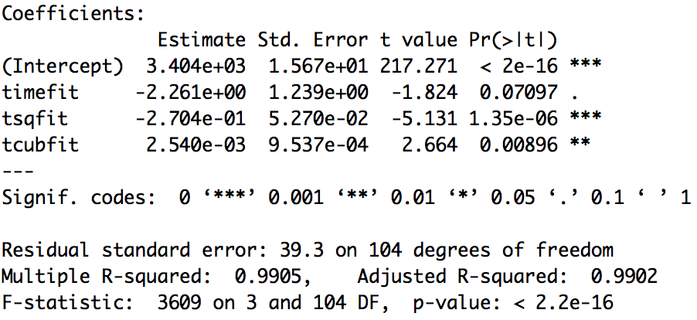 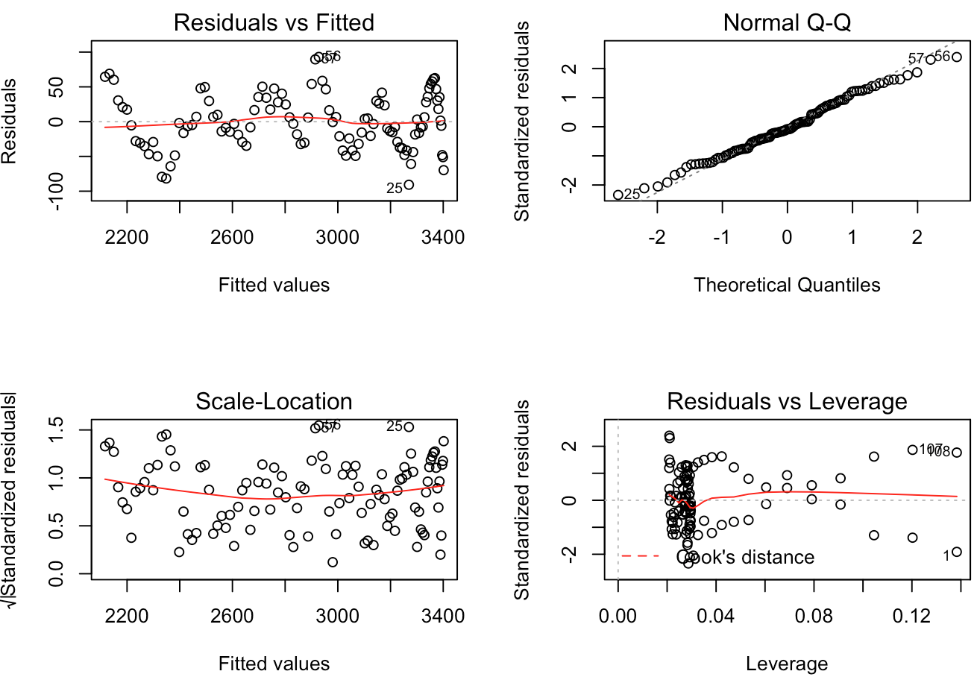

Plot time series with Fits from k=1,2,3 Models

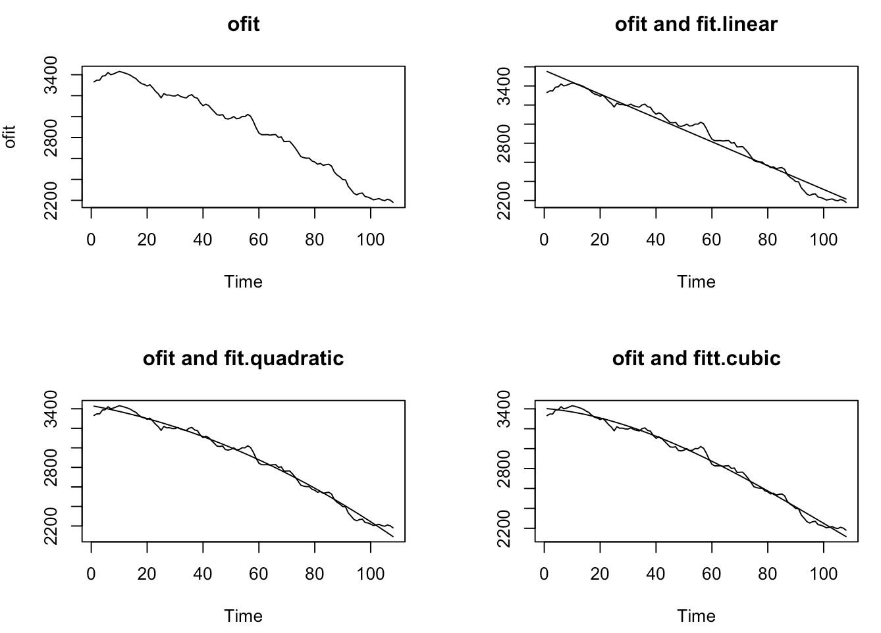

Compare these three models(Linear Trend Model, Quadratic Trend Model, Cubic Trend Model)

(1) **Compare models using the** R2 **criterion**

0.9688, 0.9898,0.9905

The R2criterion prefers the Cubic Trend model.

(2) Compare models using Significance Tests

we use the Extra Sum of Squares F-test.

Cubic Trend Model or the Linear Trend Model ?

Extra SS F-test= 118.4447, qf(0.95,2,104)= 3.083706, so reject H0.

Compare the Quadratic Trend Model to the Cubic Trend Model, ,

Extra SS F-test= 7.0938, qf(0.95,1,104)=3.932438, so reject H0.

The significance tests prefer the Cubic Trend model.

(3) AIC

11.38555, 10.2827, 10.23522. The AIC prefer the Cubic Trend model.

(4) BIC

11.46006, 10.38204, 10.35939. The BIC prefer the Cubic Trend model.

(5) AICc

9.548908, 8.456612, 8.420159. The AICc prefer the Cubic Trend model.

(6)ME

31.98648, 206.1312, 158.2064. Linear Trend Model

(7)MPE

1.470221, 9.531554, 7.308646. Linear Trend Model

(8)MSE

1599.984, 44171.91, 25983.9. Linear Trend Model

(9)MAE

35.17683, 206.1312, 158.2064. Linear Trend Model

(10)MAPE

1.620296, 9.531554, 7.308646. Linear Trend Model

Finally, we choose the Linear Trend Model.85: 1005.153268,86: 992.670468

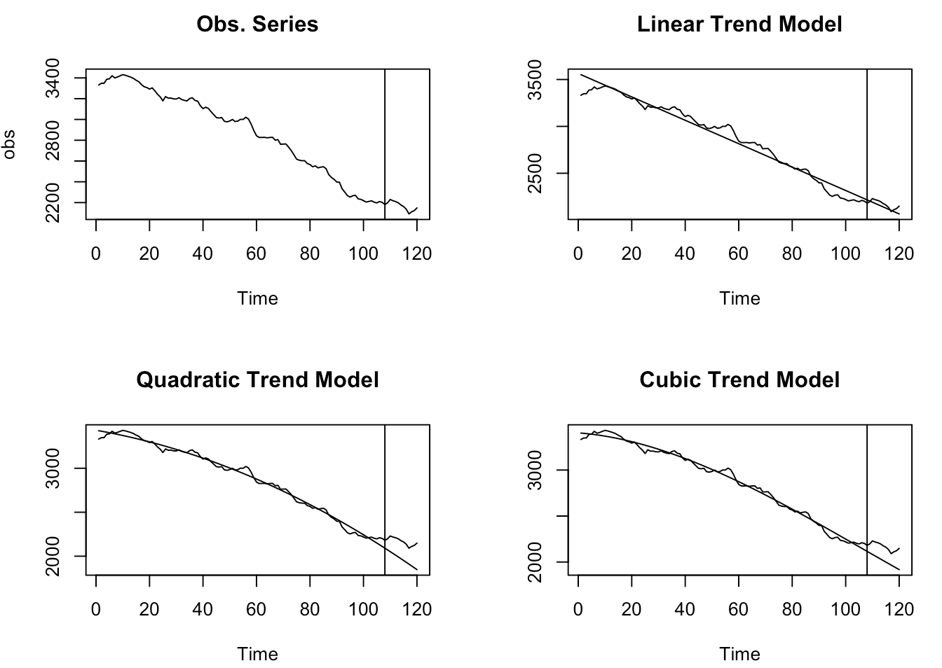

Step 4: Fit a time series model.

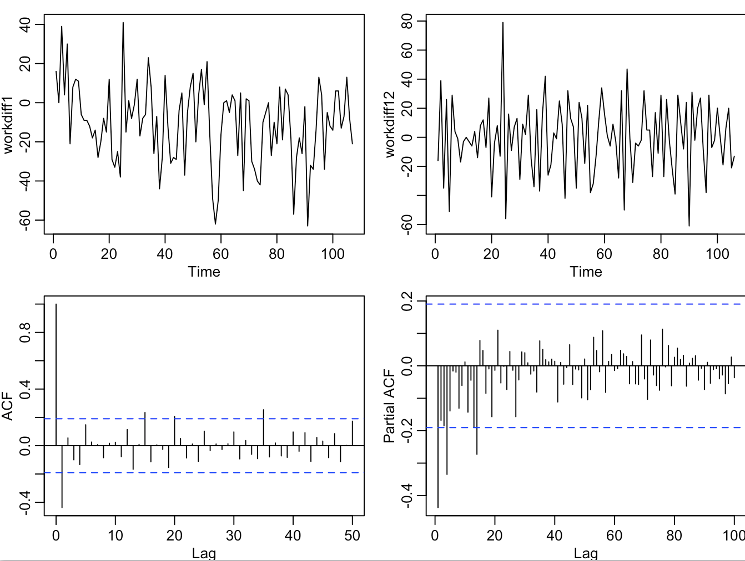

ARIMA(0,1,1): fitted model

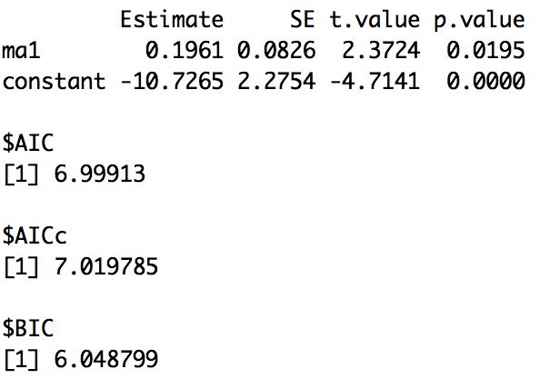 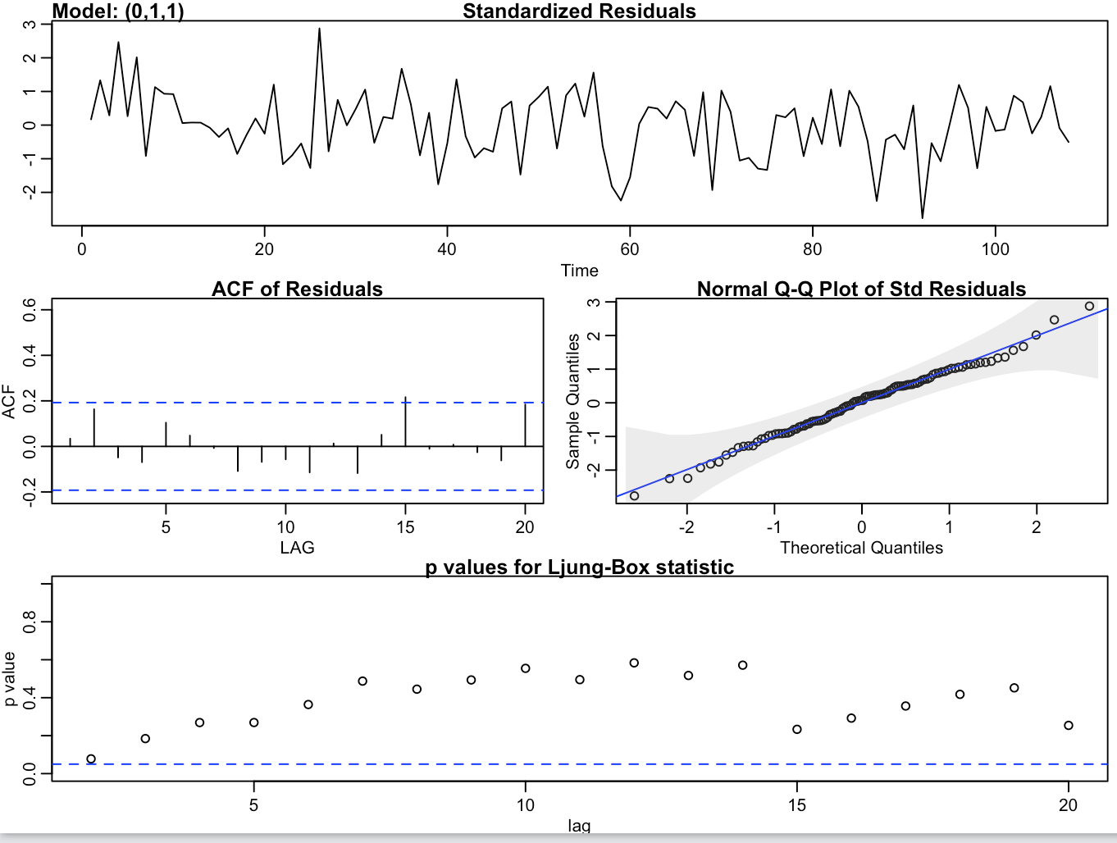

109: 1009.8641, 110: 999.1376

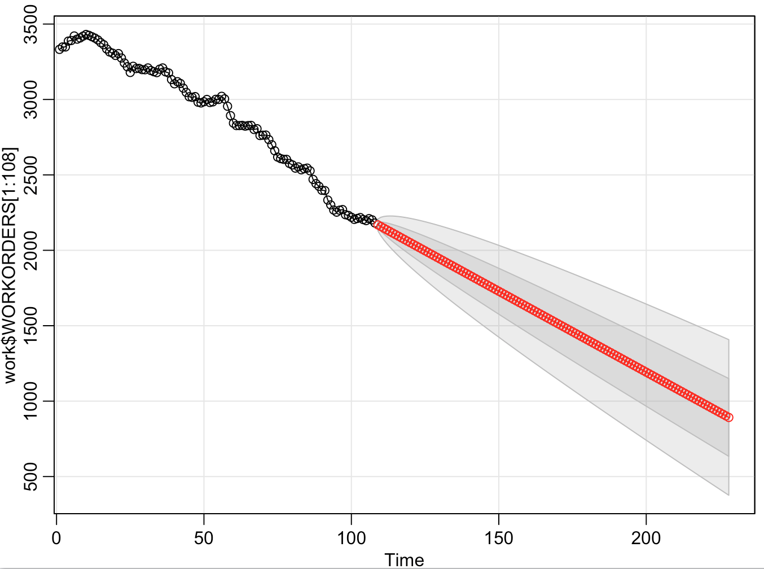

Final model : ARIMA(1,2,1)

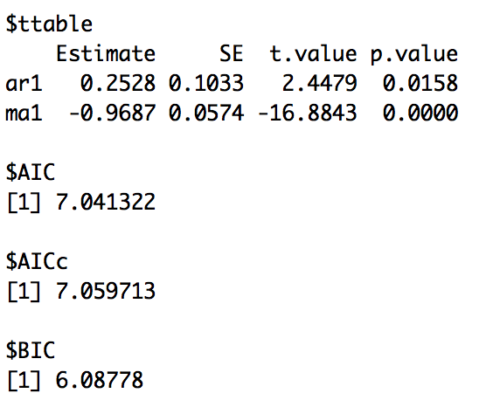 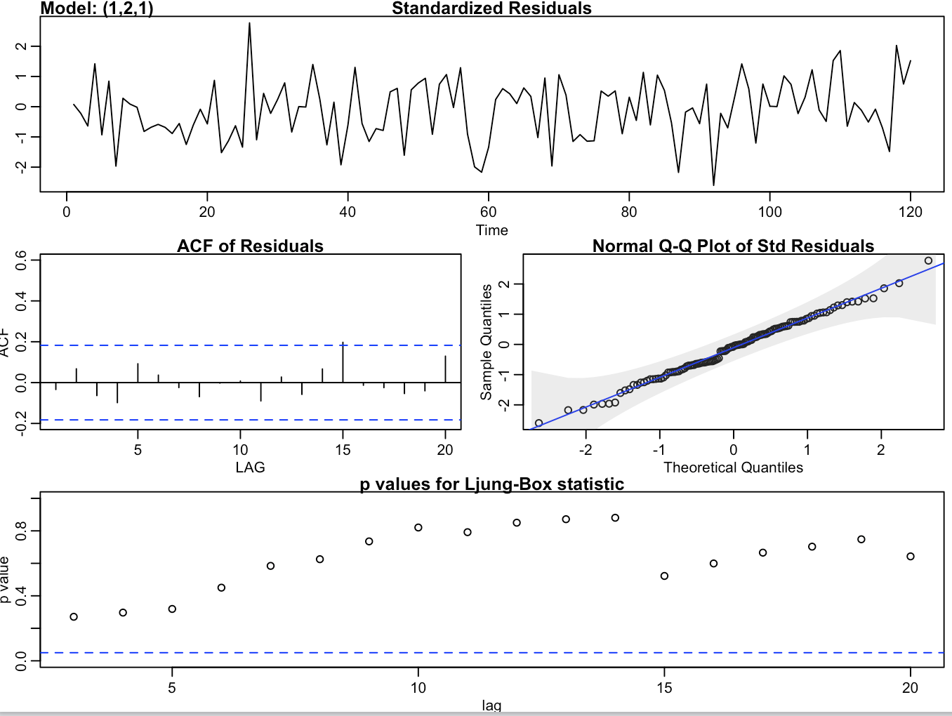

128:1003.6528 129: 994.6121

