Accessibility Report — availFlightSearchModal
Tarih: 01.04.2026 11:16 | Platform: ANDROID

Element ID | Page | Type | Label / Text | Value | Resource ID | Status | New Status
availFlightSearchModal_element_1 | MainActivity | EditText | khi | khi |  | ID Yok | ID Eklenecek (Waiting Dev)
availFlightSearchModal_element_2 | MainActivity | ViewGroup |  |  | port_picker_dep_header | ID Var
availFlightSearchModal_element_3 | MainActivity | ViewGroup | Karachi, KHI - Karachi Jinnah International Airport |  | port_picker_dep_port_item_KHI | ID Var

📸 Ekran Görüntüsü
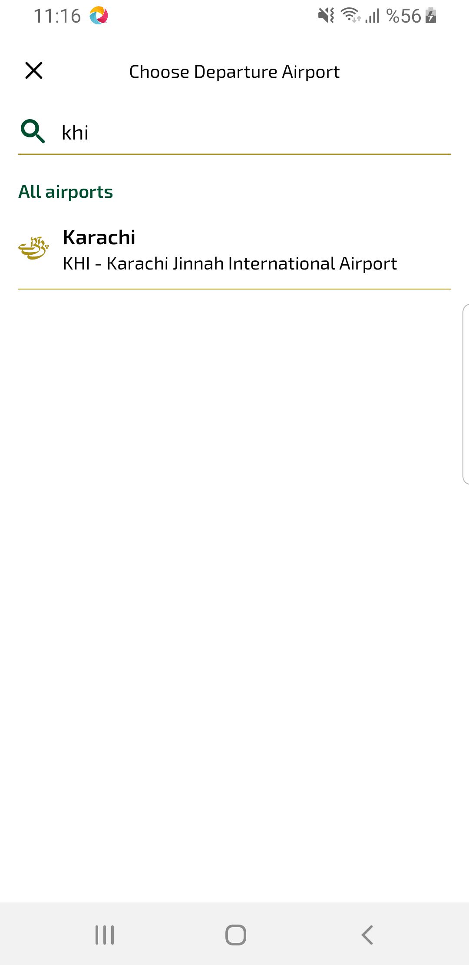
availFlightSearchModal sayfası ekran görüntüsü

