Accessibility Report — availMCSearchModal
Tarih: 01.04.2026 11:19 | Platform: ANDROID

Element ID | Page | Type | Label / Text | Value | Resource ID | Status | New Status
availMCSearchModal_element_1 | MainActivity | View | Home |  |  | ID Yok | ID Eklenecek (Waiting Dev)
availMCSearchModal_element_2 | MainActivity | View | Book |  |  | ID Yok | ID Eklenecek (Waiting Dev)
availMCSearchModal_element_3 | MainActivity | View | Manage |  |  | ID Yok | ID Eklenecek (Waiting Dev)
availMCSearchModal_element_4 | MainActivity | View | Check-in |  |  | ID Yok | ID Eklenecek (Waiting Dev)
availMCSearchModal_element_5 | MainActivity | View | Profile |  |  | ID Yok | ID Eklenecek (Waiting Dev)
availMCSearchModal_element_6 | MainActivity | ViewGroup | Add Flight |  |  | ID Yok | ID Eklenecek (Waiting Dev)
availMCSearchModal_element_7 | MainActivity | ViewGroup | Departure, Select |  | avail_search_dep_port_card | Duplicate | ID Eklenecek (Waiting Dev)
availMCSearchModal_element_8 | MainActivity | ViewGroup | Arrival, Select |  | avail_search_arr_port_card | Duplicate | ID Eklenecek (Waiting Dev)
availMCSearchModal_element_9 | MainActivity | ViewGroup | Departure Date, Select |  | avail_search_dep_date_card | Duplicate | ID Eklenecek (Waiting Dev)
availMCSearchModal_element_10 | MainActivity | ViewGroup | Departure, Karachi - Karachi Jinnah International Airport(KHI) |  | avail_search_dep_port_card | Duplicate | ID Eklenecek (Waiting Dev)
availMCSearchModal_element_11 | MainActivity | ViewGroup | Arrival, Faisalabad - Faisalabad International Airport(LYP) |  | avail_search_arr_port_card | Duplicate | ID Eklenecek (Waiting Dev)
availMCSearchModal_element_12 | MainActivity | ViewGroup | Departure Date, Fri, 17 Apr |  | avail_search_dep_date_card | Duplicate | ID Eklenecek (Waiting Dev)
availMCSearchModal_element_13 | MainActivity | ViewGroup |  |  | avail_search_header | ID Var
availMCSearchModal_element_14 | MainActivity | ViewGroup | Passengers, 2 Adult, , 1 Child, , 1 Infant |  | avail_search_pax_count_card | ID Var

📸 Ekran Görüntüsü
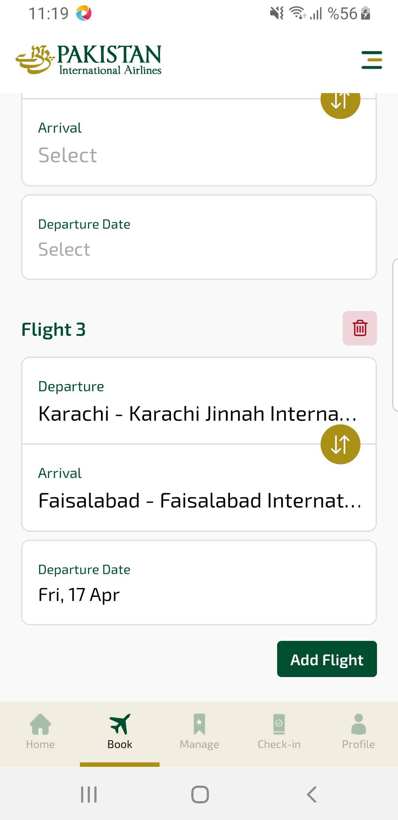
availMCSearchModal sayfası ekran görüntüsü

