Accessibility Report — availPassengerSelectModal
Tarih: 01.04.2026 11:17 | Platform: ANDROID

Element ID | Page | Type | Label / Text | Value | Resource ID | Status | New Status
availPassengerSelectModal_element_1 | MainActivity | View | Home |  |  | ID Yok | ID Eklenecek (Waiting Dev)
availPassengerSelectModal_element_2 | MainActivity | View | Book |  |  | ID Yok | ID Eklenecek (Waiting Dev)
availPassengerSelectModal_element_3 | MainActivity | View | Manage |  |  | ID Yok | ID Eklenecek (Waiting Dev)
availPassengerSelectModal_element_4 | MainActivity | View | Check-in |  |  | ID Yok | ID Eklenecek (Waiting Dev)
availPassengerSelectModal_element_5 | MainActivity | View | Profile |  |  | ID Yok | ID Eklenecek (Waiting Dev)
availPassengerSelectModal_element_6 | MainActivity | ViewGroup | One Way |  | avail_selection_switch_item | Duplicate | ID Eklenecek (Waiting Dev)
availPassengerSelectModal_element_7 | MainActivity | ViewGroup | Round Trip |  | avail_selection_switch_item | Duplicate | ID Eklenecek (Waiting Dev)
availPassengerSelectModal_element_8 | MainActivity | ViewGroup | Multi City |  | avail_selection_switch_item | Duplicate | ID Eklenecek (Waiting Dev)
availPassengerSelectModal_element_9 | MainActivity | ViewGroup | Passengers, 2 Adult, , 1 Child, , 1 Infant |  | avail_search_pax_count_card | Duplicate | ID Eklenecek (Waiting Dev)
availPassengerSelectModal_element_10 | MainActivity | ViewGroup | Class, Economy |  | avail_search_pax_count_card | Duplicate | ID Eklenecek (Waiting Dev)
availPassengerSelectModal_element_11 | MainActivity | ViewGroup |  |  | avail_search_header | ID Var
availPassengerSelectModal_element_12 | MainActivity | ViewGroup | Departure, Karachi - Karachi Jinnah International Airport(KHI) |  | avail_search_dep_port_card | ID Var
availPassengerSelectModal_element_13 | MainActivity | ViewGroup | Arrival, Faisalabad - Faisalabad International Airport(LYP) |  | avail_search_arr_port_card | ID Var
availPassengerSelectModal_element_14 | MainActivity | ViewGroup | Departure Date, Fri, 15 May |  | avail_search_dep_date_card | ID Var
availPassengerSelectModal_element_15 | MainActivity | ViewGroup | Return Date, Sun, 17 May |  | avail_search_ret_date_card | ID Var
availPassengerSelectModal_element_16 | MainActivity | ViewGroup | Search |  | avail_search_search_flight_button | ID Var
availPassengerSelectModal_element_17 | MainActivity | ViewGroup |  |  | pax_count_picker_header | ID Var
availPassengerSelectModal_element_18 | MainActivity | ViewGroup |  |  | pax_count_picker_dec_button_ADLT | ID Var
availPassengerSelectModal_element_19 | MainActivity | ViewGroup |  |  | pax_count_picker_inc_button_ADLT | ID Var
availPassengerSelectModal_element_20 | MainActivity | ViewGroup |  |  | pax_count_picker_dec_button_CHLD | ID Var
availPassengerSelectModal_element_21 | MainActivity | ViewGroup |  |  | pax_count_picker_inc_button_CHLD | ID Var
availPassengerSelectModal_element_22 | MainActivity | ViewGroup |  |  | pax_count_picker_dec_button_INFT | ID Var
availPassengerSelectModal_element_23 | MainActivity | ViewGroup |  |  | pax_count_picker_inc_button_INFT | ID Var
availPassengerSelectModal_element_24 | MainActivity | ViewGroup | Done |  | pax_count_picker_done_button | ID Var

📸 Ekran Görüntüsü
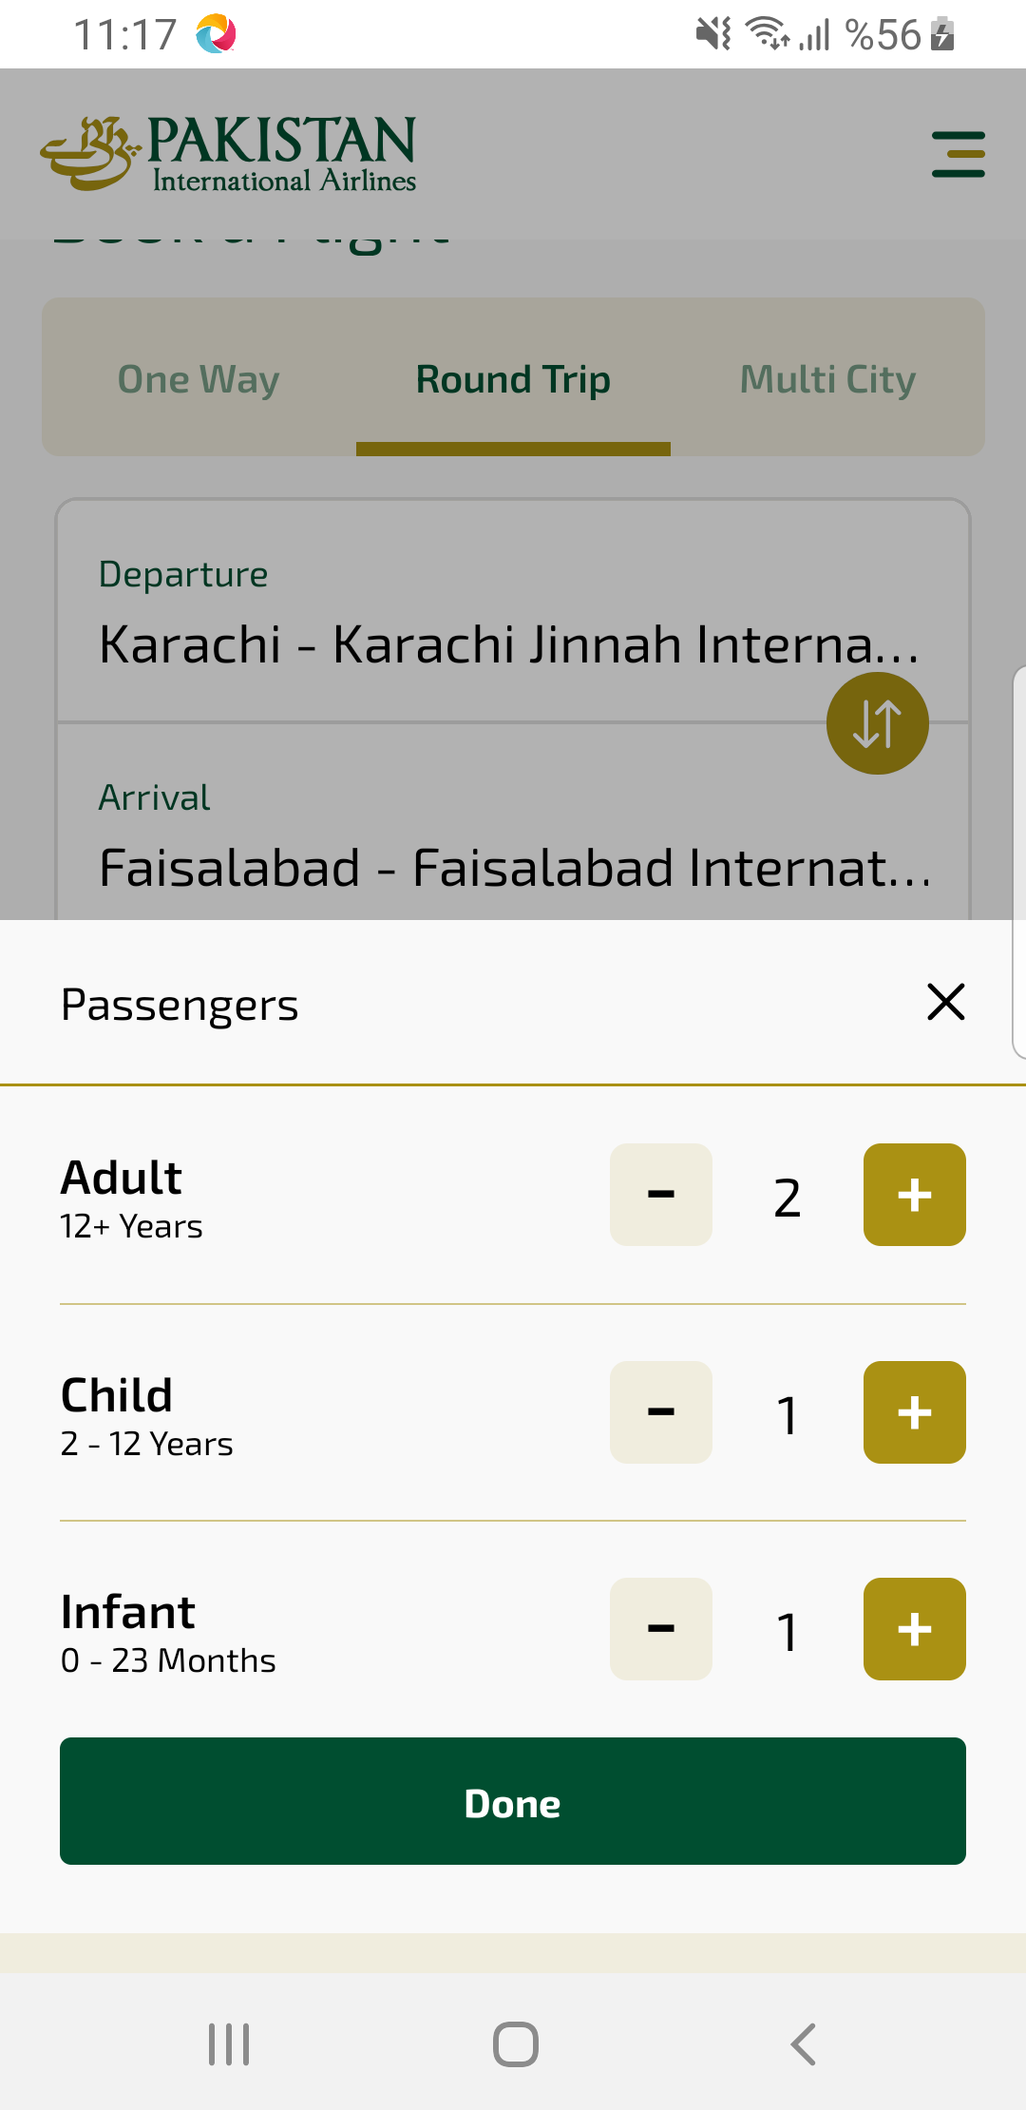
availPassengerSelectModal sayfası ekran görüntüsü

