Accessibility Report — availSearchUseMiles
Tarih: 01.04.2026 13:46 | Platform: ANDROID

Element ID | Page | Type | Label / Text | Value | Resource ID | Status | New Status
availSearchUseMiles_element_1 | MainActivity | View | Home |  |  | ID Yok | ID Eklenecek (Waiting Dev)
availSearchUseMiles_element_2 | MainActivity | View | Book |  |  | ID Yok | ID Eklenecek (Waiting Dev)
availSearchUseMiles_element_3 | MainActivity | View | Manage |  |  | ID Yok | ID Eklenecek (Waiting Dev)
availSearchUseMiles_element_4 | MainActivity | View | Check-in |  |  | ID Yok | ID Eklenecek (Waiting Dev)
availSearchUseMiles_element_5 | MainActivity | View | Profile |  |  | ID Yok | ID Eklenecek (Waiting Dev)
availSearchUseMiles_element_6 | MainActivity | ViewGroup | One Way |  | avail_selection_switch_item | Duplicate | ID Eklenecek (Waiting Dev)
availSearchUseMiles_element_7 | MainActivity | ViewGroup | Round Trip |  | avail_selection_switch_item | Duplicate | ID Eklenecek (Waiting Dev)
availSearchUseMiles_element_8 | MainActivity | ViewGroup | Multi City |  | avail_selection_switch_item | Duplicate | ID Eklenecek (Waiting Dev)
availSearchUseMiles_element_9 | MainActivity | ViewGroup | Passengers, 1 Adult |  | avail_search_pax_count_card | Duplicate | ID Eklenecek (Waiting Dev)
availSearchUseMiles_element_10 | MainActivity | ViewGroup | Class, Economy |  | avail_search_pax_count_card | Duplicate | ID Eklenecek (Waiting Dev)
availSearchUseMiles_element_11 | MainActivity | ViewGroup |  |  | avail_search_header | ID Var
availSearchUseMiles_element_12 | MainActivity | ViewGroup | Departure, Karachi - Karachi Jinnah International Airport(KHI) |  | avail_search_dep_port_card | ID Var
availSearchUseMiles_element_13 | MainActivity | ViewGroup | Arrival, Faisalabad - Faisalabad International Airport(LYP) |  | avail_search_arr_port_card | ID Var
availSearchUseMiles_element_14 | MainActivity | ViewGroup | Departure Date, Fri, 10 Apr |  | avail_search_dep_date_card | ID Var
availSearchUseMiles_element_15 | MainActivity | ViewGroup | Search |  | avail_search_search_flight_button | ID Var

📸 Ekran Görüntüsü
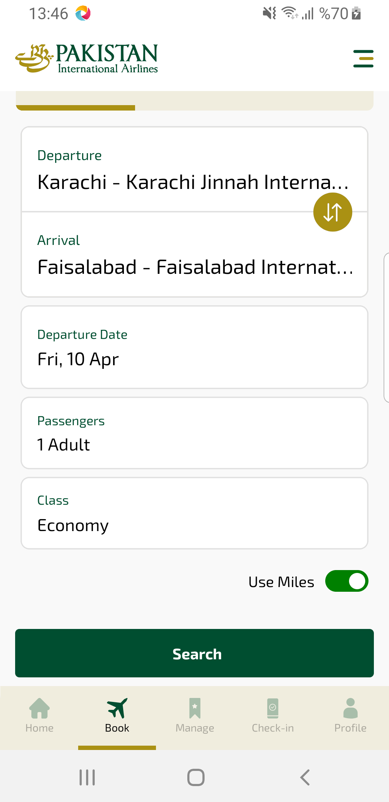
availSearchUseMiles sayfası ekran görüntüsü

