Accessibility Report — availSelectDates
Tarih: 01.04.2026 11:14 | Platform: ANDROID

Element ID | Page | Type | Label / Text | Value | Resource ID | Status | New Status
availSelectDates_element_1 | MainActivity | ViewGroup | Departure Date, Fri, 15 May |  |  | ID Yok | ID Eklenecek (Waiting Dev)
availSelectDates_element_2 | MainActivity | ViewGroup | Return Date, Sun, 17 May |  |  | ID Yok | ID Eklenecek (Waiting Dev)
availSelectDates_element_3 | MainActivity | ViewGroup |  |  | native.calendar.DAY_NAMES-undefined_Fri, 01 May 2026 00:00:00 GMT | Undefined ID | ID Eklenecek (Waiting Dev)
availSelectDates_element_4 | MainActivity | TextView | May 2026 | May 2026 | HEADER_MONTH_NAME-undefined_Fri, 01 May 2026 00:00:00 GMT | Undefined ID | ID Eklenecek (Waiting Dev)
availSelectDates_element_5 | MainActivity | Button | Monday 6 April 2026 |  | calendar_picker_day_item | Duplicate | ID Eklenecek (Waiting Dev)
availSelectDates_element_6 | MainActivity | Button | Tuesday 7 April 2026 |  | calendar_picker_day_item | Duplicate | ID Eklenecek (Waiting Dev)
availSelectDates_element_7 | MainActivity | Button | Wednesday 8 April 2026 disabled |  | calendar_picker_day_item | Duplicate | ID Eklenecek (Waiting Dev)
availSelectDates_element_8 | MainActivity | Button | Thursday 9 April 2026 disabled |  | calendar_picker_day_item | Duplicate | ID Eklenecek (Waiting Dev)
availSelectDates_element_9 | MainActivity | Button | Friday 10 April 2026 |  | calendar_picker_day_item | Duplicate | ID Eklenecek (Waiting Dev)
availSelectDates_element_10 | MainActivity | Button | Saturday 11 April 2026 disabled |  | calendar_picker_day_item | Duplicate | ID Eklenecek (Waiting Dev)
availSelectDates_element_11 | MainActivity | Button | Sunday 12 April 2026 |  | calendar_picker_day_item | Duplicate | ID Eklenecek (Waiting Dev)
availSelectDates_element_12 | MainActivity | Button | Monday 13 April 2026 |  | calendar_picker_day_item | Duplicate | ID Eklenecek (Waiting Dev)
availSelectDates_element_13 | MainActivity | Button | Tuesday 14 April 2026 |  | calendar_picker_day_item | Duplicate | ID Eklenecek (Waiting Dev)
availSelectDates_element_14 | MainActivity | Button | Wednesday 15 April 2026 disabled |  | calendar_picker_day_item | Duplicate | ID Eklenecek (Waiting Dev)
availSelectDates_element_15 | MainActivity | Button | Thursday 16 April 2026 disabled |  | calendar_picker_day_item | Duplicate | ID Eklenecek (Waiting Dev)
availSelectDates_element_16 | MainActivity | Button | Friday 17 April 2026 |  | calendar_picker_day_item | Duplicate | ID Eklenecek (Waiting Dev)
availSelectDates_element_17 | MainActivity | Button | Saturday 18 April 2026 disabled |  | calendar_picker_day_item | Duplicate | ID Eklenecek (Waiting Dev)
availSelectDates_element_18 | MainActivity | Button | Sunday 19 April 2026 |  | calendar_picker_day_item | Duplicate | ID Eklenecek (Waiting Dev)
availSelectDates_element_19 | MainActivity | Button | Monday 20 April 2026 disabled |  | calendar_picker_day_item | Duplicate | ID Eklenecek (Waiting Dev)
availSelectDates_element_20 | MainActivity | Button | Tuesday 21 April 2026 |  | calendar_picker_day_item | Duplicate | ID Eklenecek (Waiting Dev)
availSelectDates_element_21 | MainActivity | Button | Wednesday 22 April 2026 disabled |  | calendar_picker_day_item | Duplicate | ID Eklenecek (Waiting Dev)
availSelectDates_element_22 | MainActivity | Button | Thursday 23 April 2026 disabled |  | calendar_picker_day_item | Duplicate | ID Eklenecek (Waiting Dev)
availSelectDates_element_23 | MainActivity | Button | Friday 24 April 2026 |  | calendar_picker_day_item | Duplicate | ID Eklenecek (Waiting Dev)
availSelectDates_element_24 | MainActivity | Button | Saturday 25 April 2026 disabled |  | calendar_picker_day_item | Duplicate | ID Eklenecek (Waiting Dev)
availSelectDates_element_25 | MainActivity | Button | Sunday 26 April 2026 |  | calendar_picker_day_item | Duplicate | ID Eklenecek (Waiting Dev)
availSelectDates_element_26 | MainActivity | Button | Monday 27 April 2026 disabled |  | calendar_picker_day_item | Duplicate | ID Eklenecek (Waiting Dev)
availSelectDates_element_27 | MainActivity | Button | Tuesday 28 April 2026 |  | calendar_picker_day_item | Duplicate | ID Eklenecek (Waiting Dev)
availSelectDates_element_28 | MainActivity | Button | Wednesday 29 April 2026 disabled |  | calendar_picker_day_item | Duplicate | ID Eklenecek (Waiting Dev)
availSelectDates_element_29 | MainActivity | Button | Thursday 30 April 2026 |  | calendar_picker_day_item | Duplicate | ID Eklenecek (Waiting Dev)
availSelectDates_element_30 | MainActivity | Button | Friday 1 May 2026 |  | calendar_picker_day_item | Duplicate | ID Eklenecek (Waiting Dev)
availSelectDates_element_31 | MainActivity | Button | Saturday 2 May 2026 disabled |  | calendar_picker_day_item | Duplicate | ID Eklenecek (Waiting Dev)
availSelectDates_element_32 | MainActivity | Button | Sunday 3 May 2026 |  | calendar_picker_day_item | Duplicate | ID Eklenecek (Waiting Dev)
availSelectDates_element_33 | MainActivity | Button | Monday 4 May 2026 disabled |  | calendar_picker_day_item | Duplicate | ID Eklenecek (Waiting Dev)
availSelectDates_element_34 | MainActivity | Button | Tuesday 5 May 2026 |  | calendar_picker_day_item | Duplicate | ID Eklenecek (Waiting Dev)
availSelectDates_element_35 | MainActivity | Button | Wednesday 6 May 2026 disabled |  | calendar_picker_day_item | Duplicate | ID Eklenecek (Waiting Dev)
availSelectDates_element_36 | MainActivity | Button | Thursday 7 May 2026 disabled |  | calendar_picker_day_item | Duplicate | ID Eklenecek (Waiting Dev)
availSelectDates_element_37 | MainActivity | Button | Friday 8 May 2026 disabled |  | calendar_picker_day_item | Duplicate | ID Eklenecek (Waiting Dev)
availSelectDates_element_38 | MainActivity | Button | Saturday 9 May 2026 |  | calendar_picker_day_item | Duplicate | ID Eklenecek (Waiting Dev)
availSelectDates_element_39 | MainActivity | Button | Sunday 10 May 2026 |  | calendar_picker_day_item | Duplicate | ID Eklenecek (Waiting Dev)
availSelectDates_element_40 | MainActivity | Button | Monday 11 May 2026 disabled |  | calendar_picker_day_item | Duplicate | ID Eklenecek (Waiting Dev)
availSelectDates_element_41 | MainActivity | Button | Tuesday 12 May 2026 |  | calendar_picker_day_item | Duplicate | ID Eklenecek (Waiting Dev)
availSelectDates_element_42 | MainActivity | Button | Wednesday 13 May 2026 disabled |  | calendar_picker_day_item | Duplicate | ID Eklenecek (Waiting Dev)
availSelectDates_element_43 | MainActivity | Button | Thursday 14 May 2026 disabled |  | calendar_picker_day_item | Duplicate | ID Eklenecek (Waiting Dev)
availSelectDates_element_44 | MainActivity | Button | Friday 15 May 2026 period start |  | calendar_picker_day_item | Duplicate | ID Eklenecek (Waiting Dev)
availSelectDates_element_45 | MainActivity | Button | Saturday 16 May 2026 |  | calendar_picker_day_item | Duplicate | ID Eklenecek (Waiting Dev)
availSelectDates_element_46 | MainActivity | Button | Sunday 17 May 2026 period end |  | calendar_picker_day_item | Duplicate | ID Eklenecek (Waiting Dev)
availSelectDates_element_47 | MainActivity | Button | Monday 18 May 2026 disabled |  | calendar_picker_day_item | Duplicate | ID Eklenecek (Waiting Dev)
availSelectDates_element_48 | MainActivity | Button | Tuesday 19 May 2026 |  | calendar_picker_day_item | Duplicate | ID Eklenecek (Waiting Dev)
availSelectDates_element_49 | MainActivity | Button | Wednesday 20 May 2026 disabled |  | calendar_picker_day_item | Duplicate | ID Eklenecek (Waiting Dev)
availSelectDates_element_50 | MainActivity | Button | Thursday 21 May 2026 disabled |  | calendar_picker_day_item | Duplicate | ID Eklenecek (Waiting Dev)
availSelectDates_element_51 | MainActivity | Button | Friday 22 May 2026 |  | calendar_picker_day_item | Duplicate | ID Eklenecek (Waiting Dev)
availSelectDates_element_52 | MainActivity | Button | Saturday 23 May 2026 disabled |  | calendar_picker_day_item | Duplicate | ID Eklenecek (Waiting Dev)
availSelectDates_element_53 | MainActivity | Button | Sunday 24 May 2026 |  | calendar_picker_day_item | Duplicate | ID Eklenecek (Waiting Dev)
availSelectDates_element_54 | MainActivity | ViewGroup |  |  | calendar_picker_header | ID Var
availSelectDates_element_55 | MainActivity | ViewGroup | Done |  | calendar_picker_done_button | ID Var

📸 Ekran Görüntüsü
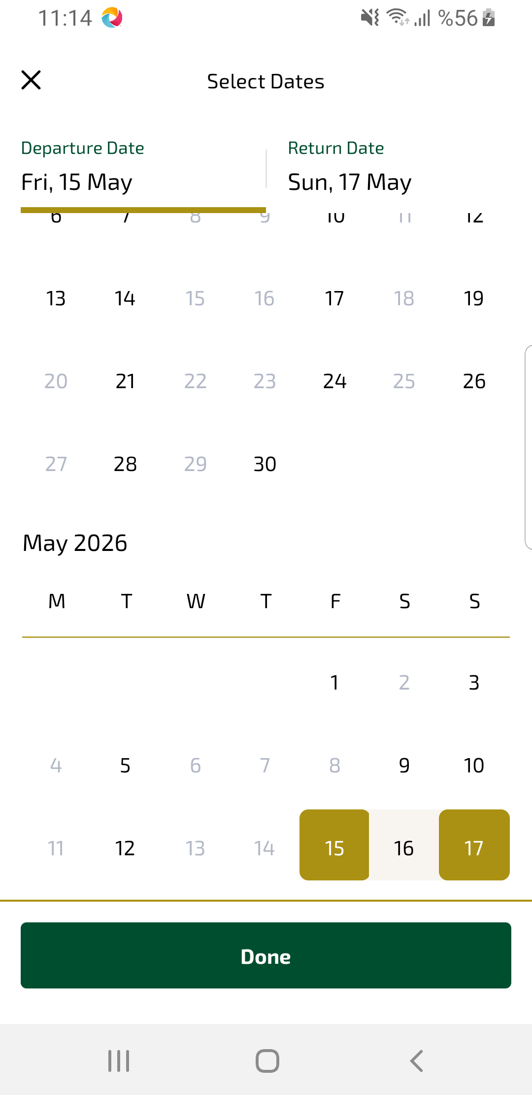
availSelectDates sayfası ekran görüntüsü

