Accessibility Report — boardingpass
Tarih: 01.04.2026 12:33 | Platform: ANDROID

Element ID | Page | Type | Label / Text | Value | Resource ID | Status | New Status
boardingpass_element_1 | MainActivity | ViewGroup |  |  | check_in_success_pass_header | ID Var
boardingpass_element_2 | MainActivity | ViewGroup |  |  | check_in_success_pass_back_button | ID Var
boardingpass_element_3 | MainActivity | ImageView |  |  | check_in_success_pass_qr_code | ID Var

📸 Ekran Görüntüsü
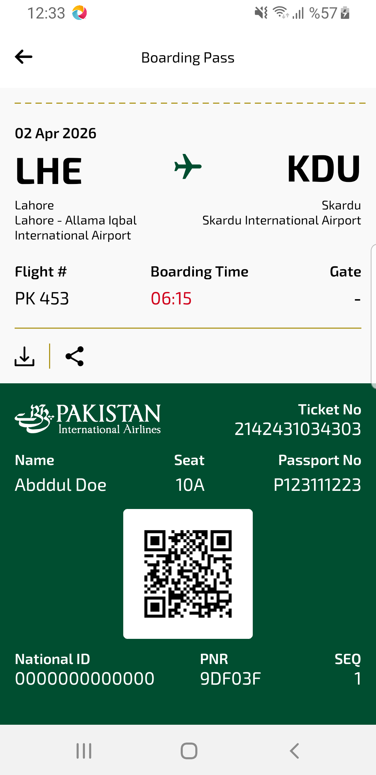
boardingpass sayfası ekran görüntüsü

