Accessibility Report — bookingSuccess
Tarih: 01.04.2026 12:01 | Platform: ANDROID

Element ID | Page | Type | Label / Text | Value | Resource ID | Status | New Status
bookingSuccess_element_1 | MainActivity | ViewGroup | PNR No, 9DRQ4B |  |  | ID Yok | ID Eklenecek (Waiting Dev)
bookingSuccess_element_2 | MainActivity | ViewGroup | Karachi (KHI) to Faisalabad (LYP), Fri, 15 May - 21:00, 1h 45min - PK 340, ECONOMY |  |  | ID Yok | ID Eklenecek (Waiting Dev)
bookingSuccess_element_3 | MainActivity | ViewGroup | Direct |  |  | ID Yok | ID Eklenecek (Waiting Dev)
bookingSuccess_element_4 | MainActivity | ViewGroup | Faisalabad (LYP) to Karachi (KHI), Sun, 17 May - 17:30, 1h 45min - PK 341, ECONOMY |  |  | ID Yok | ID Eklenecek (Waiting Dev)
bookingSuccess_element_5 | MainActivity | ViewGroup | Direct |  |  | ID Yok | ID Eklenecek (Waiting Dev)
bookingSuccess_element_6 | MainActivity | ViewGroup | Karachi - , Faisalabad, Included In Your Package, WCHR Support , Flight Extras, 4A, 5 KG, Faisalabad - , Karachi, Included In Your Package, WCHR Support , 20 KG |  |  | ID Yok | ID Eklenecek (Waiting Dev)
bookingSuccess_element_7 | MainActivity | ViewGroup | Adult One Automation, E-Ticket Number:, 2142431221178 |  |  | ID Yok | ID Eklenecek (Waiting Dev)
bookingSuccess_element_8 | MainActivity | ViewGroup | Go to Manage Booking |  | payment_success_mbk_button | ID Var

📸 Ekran Görüntüsü
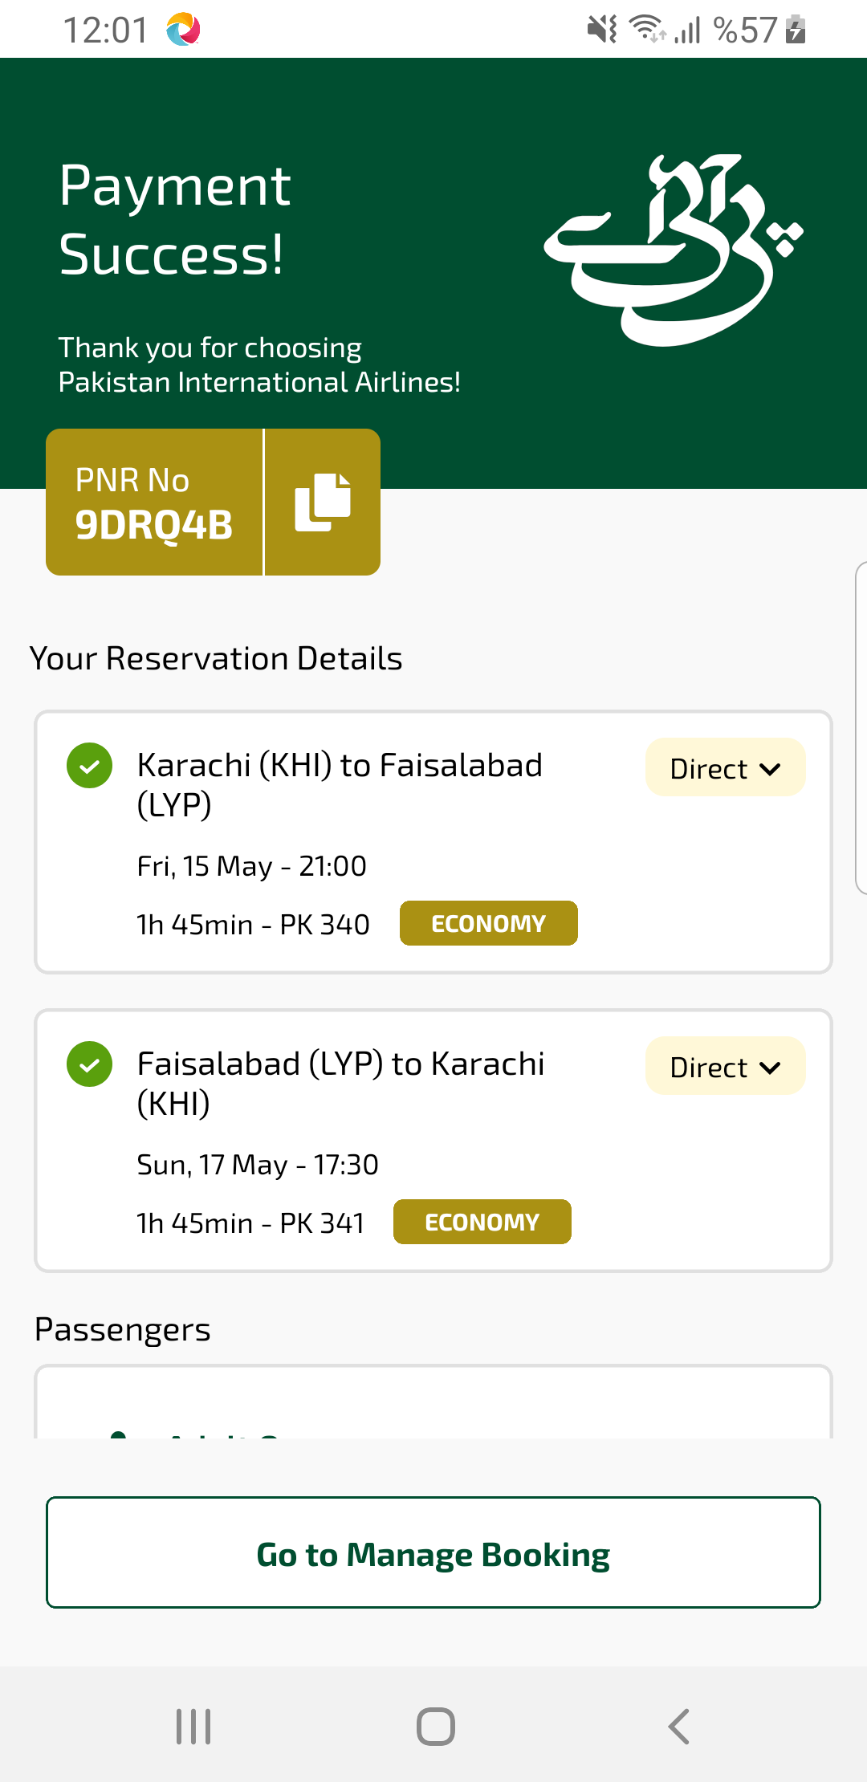
bookingSuccess sayfası ekran görüntüsü

