Accessibility Report — bundleSelectUseMiles
Tarih: 01.04.2026 13:48 | Platform: ANDROID

Element ID | Page | Type | Label / Text | Value | Resource ID | Status | New Status
bundleSelectUseMiles_element_1 | MainActivity | ViewGroup | ECONOMY, Lowest Price, Free Carry-On Baggage, Free Checked Baggage, Seat Selection (*charges apply), Free Meal/Beverages, Booking Change (*charges apply), Cancellation/Refund (*charges apply), Check-in Baggage 40 KG, last 5 seats! |  |  | ID Yok | ID Eklenecek (Waiting Dev)
bundleSelectUseMiles_element_2 | MainActivity | ViewGroup | 11,000￼Miles, and 9.00￼EUR |  |  | ID Yok | ID Eklenecek (Waiting Dev)

📸 Ekran Görüntüsü
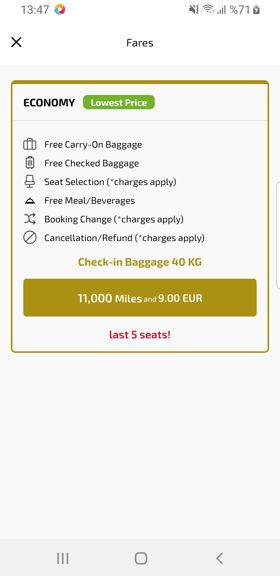
bundleSelectUseMiles sayfası ekran görüntüsü

