Accessibility Report — changeContact
Tarih: 01.04.2026 12:05 | Platform: ANDROID

Element ID | Page | Type | Label / Text | Value | Resource ID | Status | New Status
changeContact_element_1 | MainActivity | EditText | +92 | +92 |  | ID Yok | ID Eklenecek (Waiting Dev)
changeContact_element_2 | MainActivity | EditText | ADULT ONE | ADULT ONE | change_contact_text_field_givenName | ID Var
changeContact_element_3 | MainActivity | EditText | AUTOMATION | AUTOMATION | change_contact_text_field_surname | ID Var
changeContact_element_4 | MainActivity | EditText | 56 55555555 | 56 55555555 | change_contact_phone_input_value_phoneNumber | ID Var
changeContact_element_5 | MainActivity | EditText | yunus.sahin@testinium.com | yunus.sahin@testinium.com | change_contact_text_field_email | ID Var
changeContact_element_6 | MainActivity | ViewGroup |  |  | change_contact_header | ID Var
changeContact_element_7 | MainActivity | ViewGroup |  |  | change_contact_phone_dial_code_phoneNumber | ID Var
changeContact_element_8 | MainActivity | ViewGroup | Continue |  | change_contact_change_button | ID Var

📸 Ekran Görüntüsü
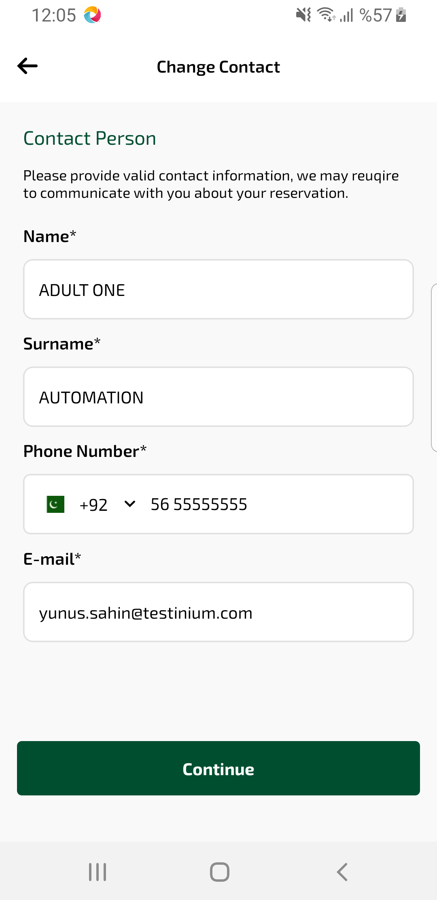
changeContact sayfası ekran görüntüsü

