Accessibility Report — checkinApisNationalId
Tarih: 01.04.2026 12:21 | Platform: ANDROID

Element ID | Page | Type | Label / Text | Value | Resource ID | Status | New Status
checkinApisNationalId_element_1 | MainActivity | EditText | Select | Select |  | ID Yok | ID Eklenecek (Waiting Dev)
checkinApisNationalId_element_2 | MainActivity | EditText | Pakistan | Pakistan |  | ID Yok | ID Eklenecek (Waiting Dev)
checkinApisNationalId_element_3 | MainActivity | EditText | 01/04/2029 | 01/04/2029 |  | ID Yok | ID Eklenecek (Waiting Dev)
checkinApisNationalId_element_4 | MainActivity | EditText | DOE | DOE | check_in_apis_form_text_field_PAX_INFO.surname | ID Var
checkinApisNationalId_element_5 | MainActivity | EditText | asd | asd | check_in_apis_form_text_field_NATIONAL_ID.docHolderName | ID Var
checkinApisNationalId_element_6 | MainActivity | EditText | 123 | 123 | check_in_apis_form_text_field_NATIONAL_ID.docId | ID Var
checkinApisNationalId_element_7 | MainActivity | ViewGroup |  |  | check_in_apis_form_header | ID Var
checkinApisNationalId_element_8 | MainActivity | ViewGroup | Date of Birth* |  | check_in_apis_form_date_card_PAX_INFO.birthDate | ID Var
checkinApisNationalId_element_9 | MainActivity | ViewGroup | Nationality* |  | check_in_apis_form_country_card_PAX_INFO.nationality | ID Var
checkinApisNationalId_element_10 | MainActivity | ViewGroup | Document Expire Date* |  | check_in_apis_form_date_card_NATIONAL_ID.docExpireDate | ID Var
checkinApisNationalId_element_11 | MainActivity | ViewGroup | Continue |  | check_in_apis_form_continue_button | ID Var

📸 Ekran Görüntüsü
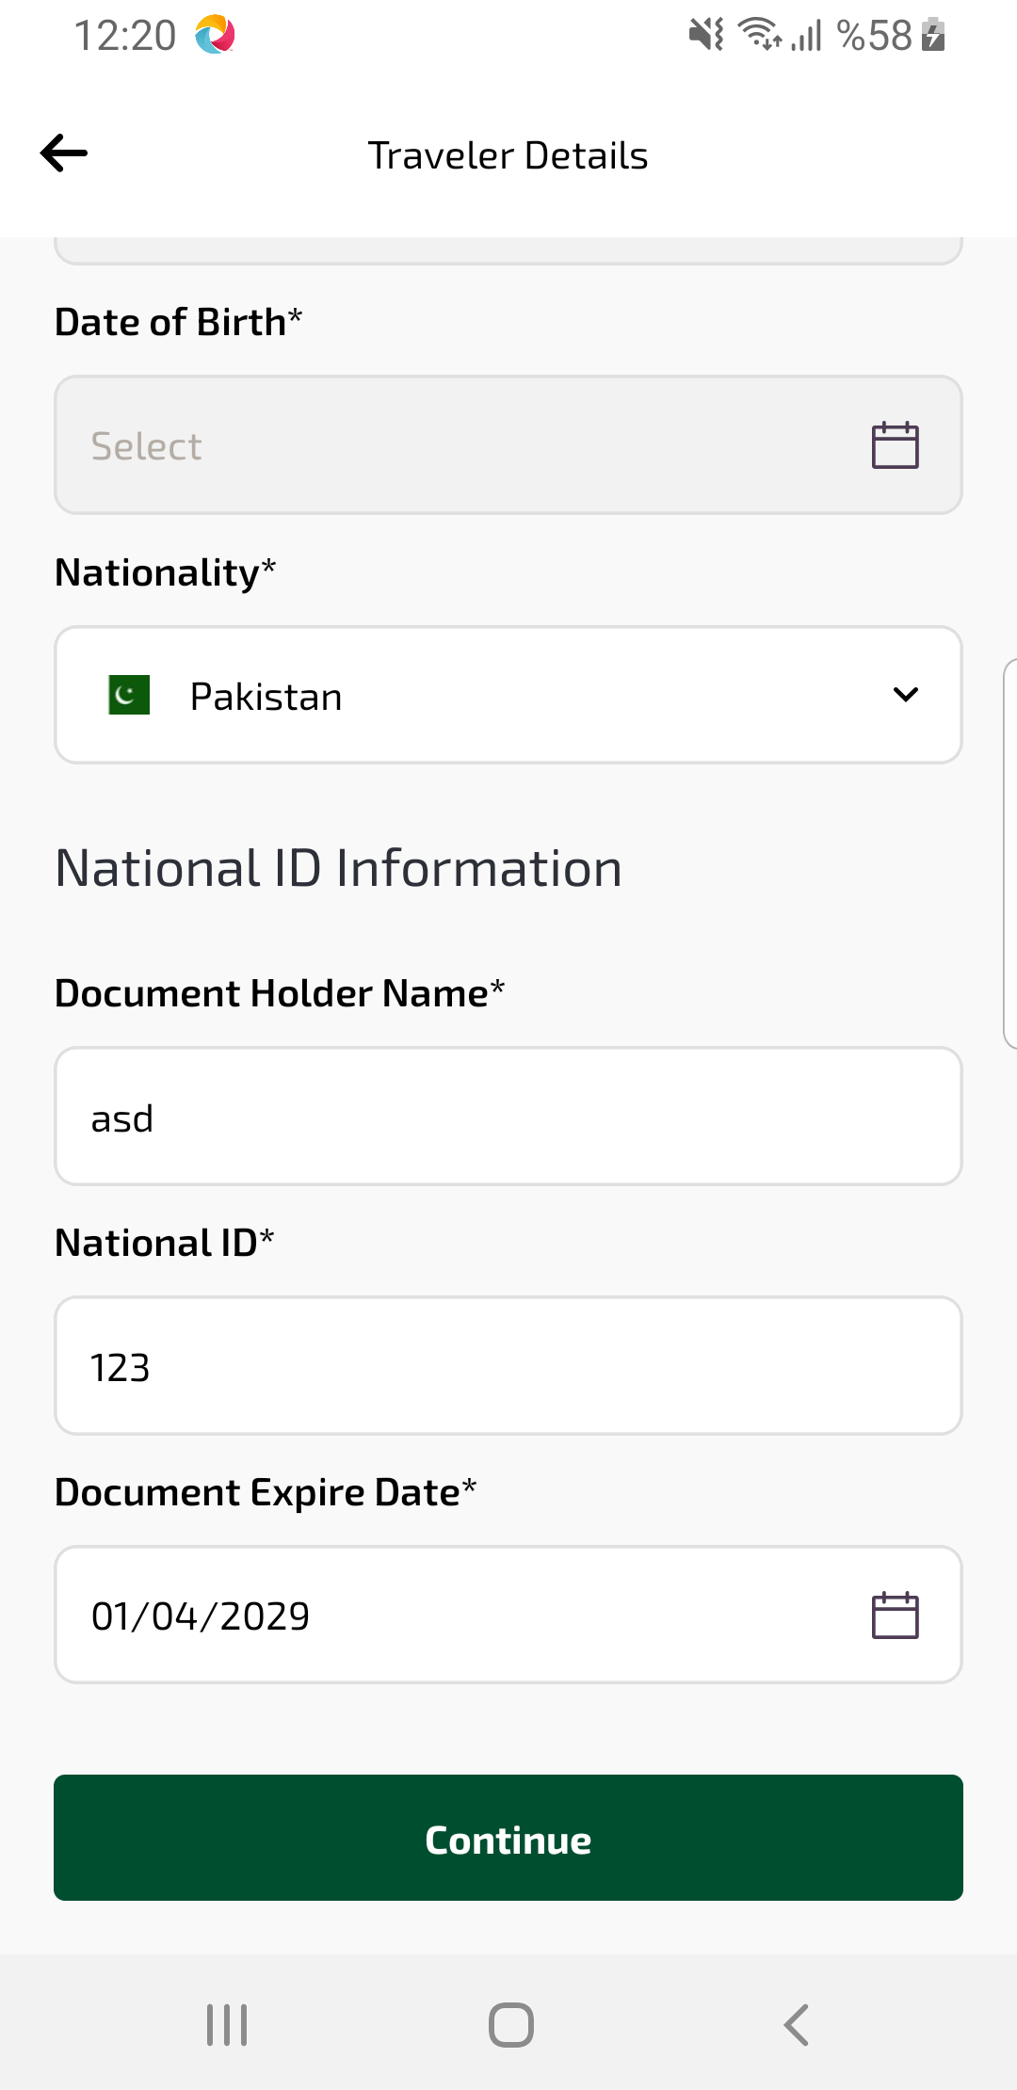
checkinApisNationalId sayfası ekran görüntüsü

