Accessibility Report — checkinApisPassport
Tarih: 01.04.2026 12:21 | Platform: ANDROID

Element ID | Page | Type | Label / Text | Value | Resource ID | Status | New Status
checkinApisPassport_element_1 | MainActivity | EditText | Select | Select |  | ID Yok | ID Eklenecek (Waiting Dev)
checkinApisPassport_element_2 | MainActivity | EditText | Afghanistan | Afghanistan |  | ID Yok | ID Eklenecek (Waiting Dev)
checkinApisPassport_element_3 | MainActivity | EditText | 01/04/2027 | 01/04/2027 |  | ID Yok | ID Eklenecek (Waiting Dev)
checkinApisPassport_element_4 | MainActivity | EditText | Andorra | Andorra |  | ID Yok | ID Eklenecek (Waiting Dev)
checkinApisPassport_element_5 | MainActivity | EditText | Angola | Angola |  | ID Yok | ID Eklenecek (Waiting Dev)
checkinApisPassport_element_6 | MainActivity | EditText | 123 | 123 | check_in_apis_form_text_field_PASSPORT.docId | ID Var
checkinApisPassport_element_7 | MainActivity | ViewGroup |  |  | check_in_apis_form_header | ID Var
checkinApisPassport_element_8 | MainActivity | ViewGroup | Date of Birth* |  | check_in_apis_form_date_card_PAX_INFO.birthDate | ID Var
checkinApisPassport_element_9 | MainActivity | ViewGroup | Nationality* |  | check_in_apis_form_country_card_PAX_INFO.nationality | ID Var
checkinApisPassport_element_10 | MainActivity | ViewGroup | Expire Date* |  | check_in_apis_form_date_card_PASSPORT.docExpireDate | ID Var
checkinApisPassport_element_11 | MainActivity | ViewGroup | Issue Location* |  | check_in_apis_form_country_card_PASSPORT.docIssueLocation | ID Var
checkinApisPassport_element_12 | MainActivity | ViewGroup | Document Holder Nationality* |  | check_in_apis_form_country_card_PASSPORT.docHolderNationality | ID Var
checkinApisPassport_element_13 | MainActivity | ViewGroup | Continue |  | check_in_apis_form_continue_button | ID Var

📸 Ekran Görüntüsü
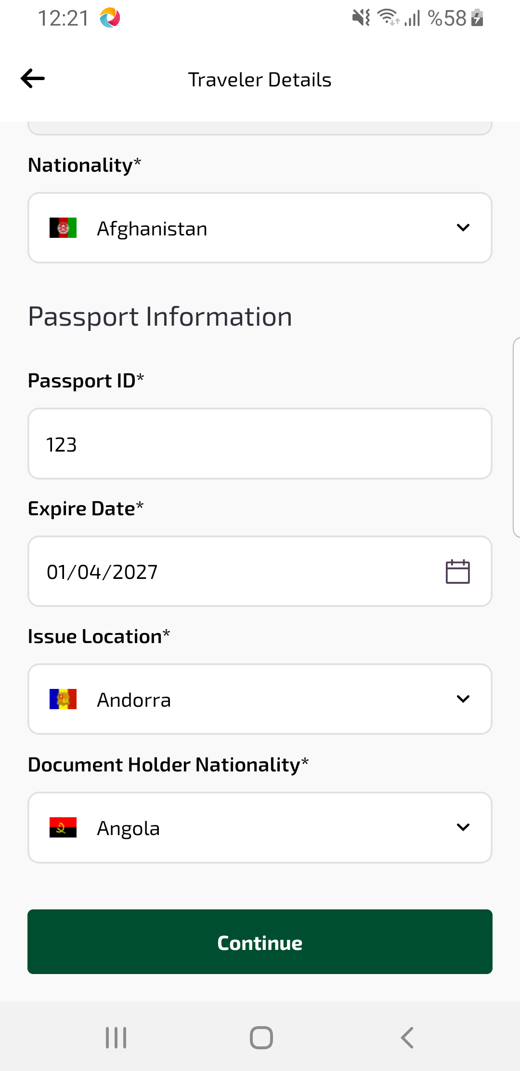
checkinApisPassport sayfası ekran görüntüsü

