Accessibility Report — checkinDisclaimer
Tarih: 01.04.2026 12:27 | Platform: ANDROID

Element ID | Page | Type | Label / Text | Value | Resource ID | Status | New Status
checkinDisclaimer_element_1 | MainActivity | ViewGroup | Online Check-In Disclaimer |  |  | ID Yok | ID Eklenecek (Waiting Dev)
checkinDisclaimer_element_2 | MainActivity | ViewGroup | Baggage Prohibit and Restrictions of Dangerous Goods. |  |  | ID Yok | ID Eklenecek (Waiting Dev)
checkinDisclaimer_element_3 | MainActivity | ViewGroup |  |  | check_in_dangerous_header | ID Var
checkinDisclaimer_element_4 | MainActivity | ViewGroup |  |  | check_in_dangerous_check_box | ID Var
checkinDisclaimer_element_5 | MainActivity | ViewGroup | Continue |  | check_in_dangerous_continue_button | ID Var

📸 Ekran Görüntüsü
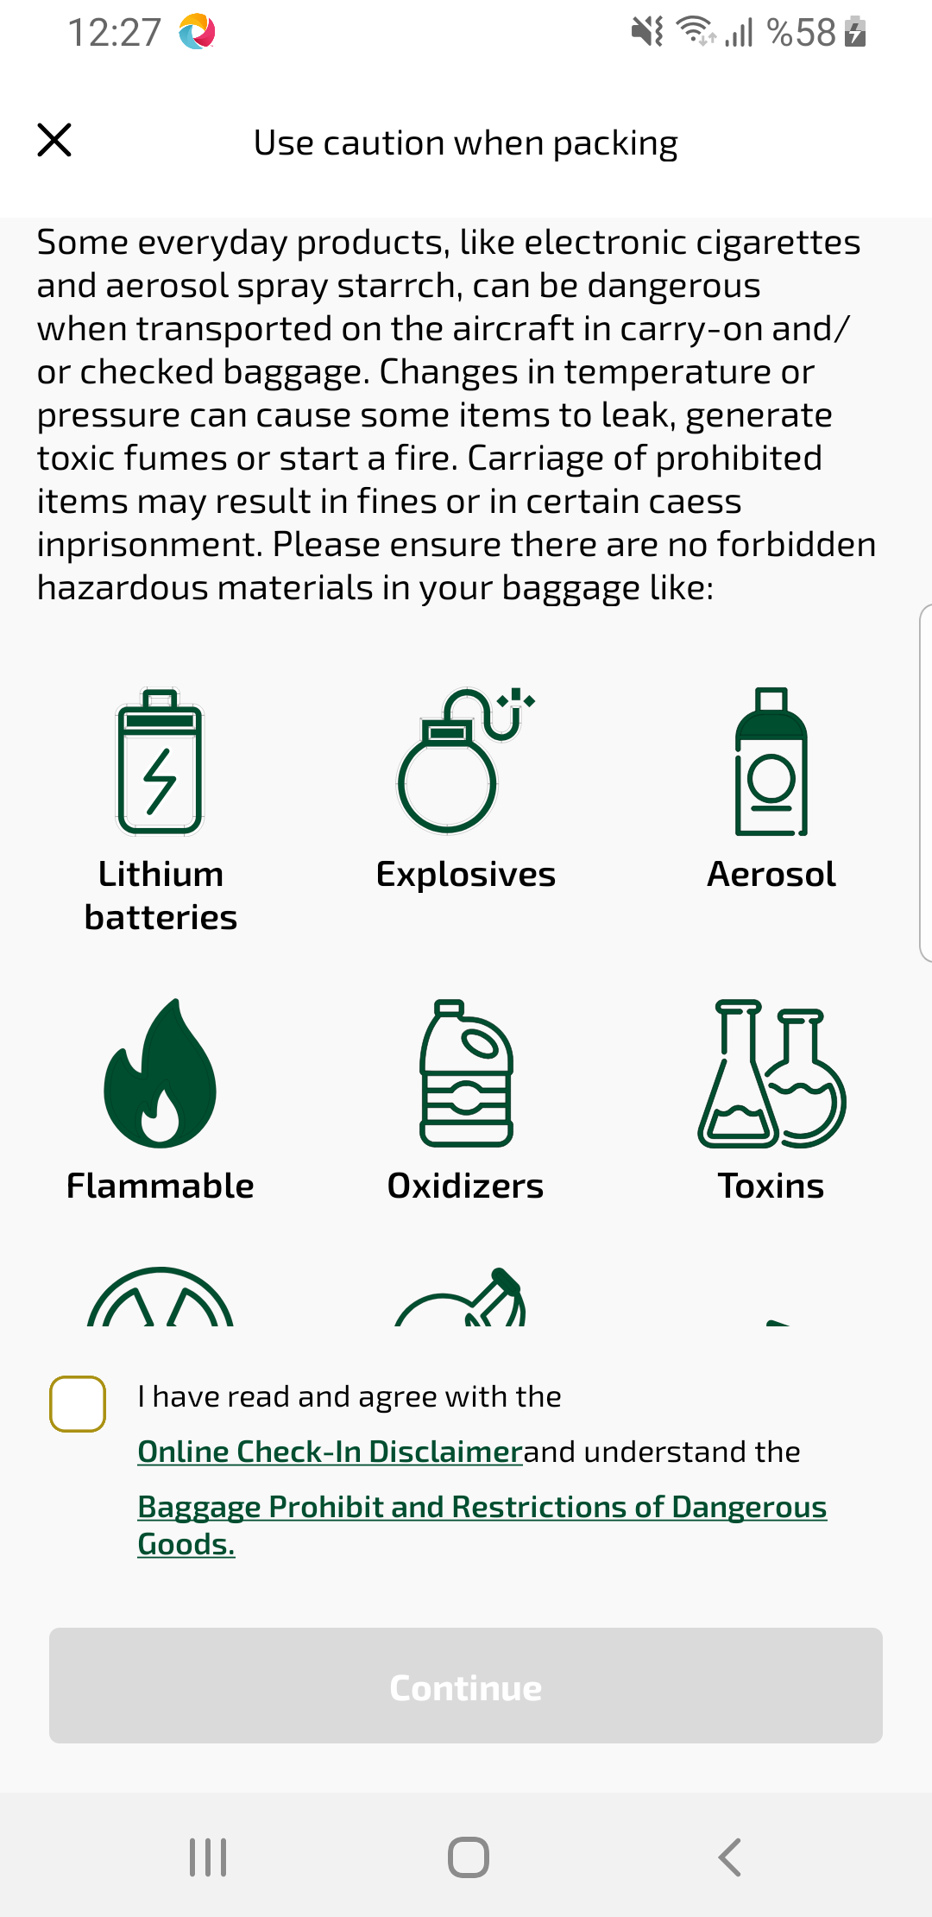
checkinDisclaimer sayfası ekran görüntüsü

