Accessibility Report — checkinExpectedSeatPopup
Tarih: 01.04.2026 12:27 | Platform: ANDROID

Element ID | Page | Type | Label / Text | Value | Resource ID | Status | New Status
checkinExpectedSeatPopup_element_1 | MainActivity | ViewGroup | Allocated Seats, Your seat for Online Check-in has been assigned without a fee. You can change your seat for a fee. |  |  | ID Yok | ID Eklenecek (Waiting Dev)
checkinExpectedSeatPopup_element_2 | MainActivity | ViewGroup | ABDDUL DOE, 10A |  |  | ID Yok | ID Eklenecek (Waiting Dev)
checkinExpectedSeatPopup_element_3 | MainActivity | ViewGroup |  |  | seat_selection_alloc_modal_close_button | ID Var

📸 Ekran Görüntüsü
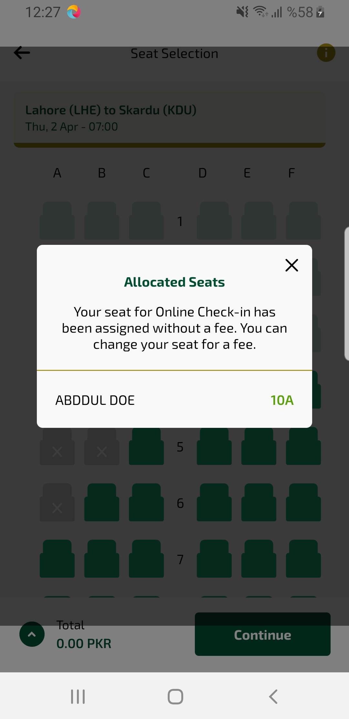
checkinExpectedSeatPopup sayfası ekran görüntüsü

