Accessibility Report — checkinFlightSelect
Tarih: 01.04.2026 12:20 | Platform: ANDROID

Element ID | Page | Type | Label / Text | Value | Resource ID | Status | New Status
checkinFlightSelect_element_1 | MainActivity | ViewGroup | Direct |  |  | ID Yok | ID Eklenecek (Waiting Dev)
checkinFlightSelect_element_2 | MainActivity | ViewGroup |  |  | check_in_trip_card | Duplicate | ID Eklenecek (Waiting Dev)
checkinFlightSelect_element_3 | MainActivity | ViewGroup | Lahore (LHE) to Skardu (KDU), Thu, 02 Apr - 07:00, 1h 20min - PK 453, ECONOMY |  | check_in_trip_card | Duplicate | ID Eklenecek (Waiting Dev)
checkinFlightSelect_element_4 | MainActivity | ViewGroup |  |  | check_in_trip_card | Duplicate | ID Eklenecek (Waiting Dev)
checkinFlightSelect_element_5 | MainActivity | ViewGroup |  |  | check_in_trip_header | ID Var
checkinFlightSelect_element_6 | MainActivity | ViewGroup | Continue |  | check_in_trip_continue_button | ID Var

📸 Ekran Görüntüsü
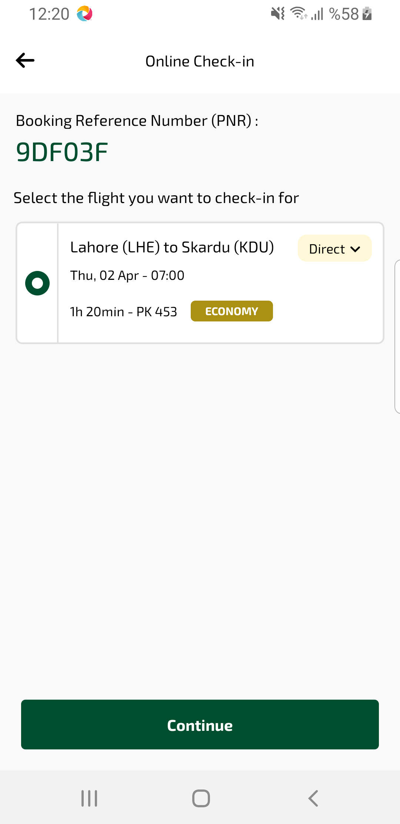
checkinFlightSelect sayfası ekran görüntüsü

