Accessibility Report — checkinPassengersSelect
Tarih: 01.04.2026 12:26 | Platform: ANDROID

Element ID | Page | Type | Label / Text | Value | Resource ID | Status | New Status
checkinPassengersSelect_element_1 | MainActivity | ViewGroup | Lahore (LHE) to Skardu (KDU), Thu, 02 Apr - 07:00, 1h 20min - PK 453, ECONOMY |  |  | ID Yok | ID Eklenecek (Waiting Dev)
checkinPassengersSelect_element_2 | MainActivity | ViewGroup | Direct |  |  | ID Yok | ID Eklenecek (Waiting Dev)
checkinPassengersSelect_element_3 | MainActivity | ViewGroup | I have read and accepted |  |  | ID Yok | ID Eklenecek (Waiting Dev)
checkinPassengersSelect_element_4 | MainActivity | ViewGroup | Online Check-in Rules |  |  | ID Yok | ID Eklenecek (Waiting Dev)
checkinPassengersSelect_element_5 | MainActivity | ViewGroup | Abddul Doe |  | check_in_pax_card_abddul_doe | Duplicate | ID Eklenecek (Waiting Dev)
checkinPassengersSelect_element_6 | MainActivity | ViewGroup |  |  | check_in_pax_card_abddul_doe | Duplicate | ID Eklenecek (Waiting Dev)
checkinPassengersSelect_element_7 | MainActivity | ViewGroup | Jamila Doe |  | check_in_pax_card_jamila_doe | Duplicate | ID Eklenecek (Waiting Dev)
checkinPassengersSelect_element_8 | MainActivity | ViewGroup |  |  | check_in_pax_card_jamila_doe | Duplicate | ID Eklenecek (Waiting Dev)
checkinPassengersSelect_element_9 | MainActivity | ViewGroup | Fiza Doe |  | check_in_pax_card_fiza_doe | Duplicate | ID Eklenecek (Waiting Dev)
checkinPassengersSelect_element_10 | MainActivity | ViewGroup |  |  | check_in_pax_card_fiza_doe | Duplicate | ID Eklenecek (Waiting Dev)
checkinPassengersSelect_element_11 | MainActivity | ViewGroup |  |  | check_in_pax_header | ID Var
checkinPassengersSelect_element_12 | MainActivity | ViewGroup | Continue |  | check_in_pax_continue_button | ID Var

📸 Ekran Görüntüsü
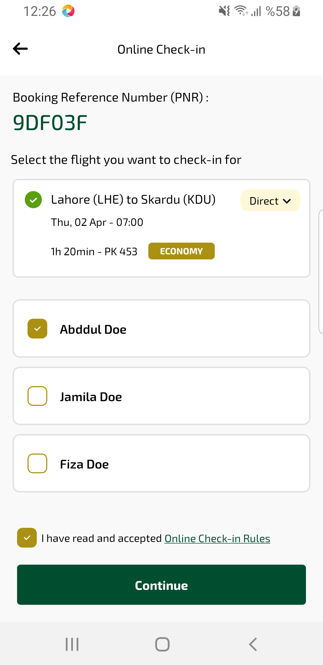
checkinPassengersSelect sayfası ekran görüntüsü

