Accessibility Report — checkinSearch
Tarih: 01.04.2026 13:54 | Platform: ANDROID

Element ID | Page | Type | Label / Text | Value | Resource ID | Status | New Status
checkinSearch_element_1 | MainActivity | View | Home |  |  | ID Yok | ID Eklenecek (Waiting Dev)
checkinSearch_element_2 | MainActivity | View | Book |  |  | ID Yok | ID Eklenecek (Waiting Dev)
checkinSearch_element_3 | MainActivity | View | Manage |  |  | ID Yok | ID Eklenecek (Waiting Dev)
checkinSearch_element_4 | MainActivity | View | Check-in |  |  | ID Yok | ID Eklenecek (Waiting Dev)
checkinSearch_element_5 | MainActivity | View | Profile |  |  | ID Yok | ID Eklenecek (Waiting Dev)
checkinSearch_element_6 | MainActivity | ViewGroup | Information for Credit Card Holders |  |  | ID Yok | ID Eklenecek (Waiting Dev)
checkinSearch_element_7 | MainActivity | ViewGroup | Test Operational Notice For Testing In UAT1 Test Operational Notice For Testing In UAT2 |  |  | ID Yok | ID Eklenecek (Waiting Dev)
checkinSearch_element_8 | MainActivity | ViewGroup | Long Lon Long Operational Notice One Two |  |  | ID Yok | ID Eklenecek (Waiting Dev)
checkinSearch_element_9 | MainActivity | EditText | Surname | Surname | check_in_search_text_field_surname | ID Var
checkinSearch_element_10 | MainActivity | EditText | Enter | Enter | check_in_search_text_field_bookingId | ID Var
checkinSearch_element_11 | MainActivity | ViewGroup |  |  | check_in_search_header | ID Var
checkinSearch_element_12 | MainActivity | ViewGroup | Find My Flight |  | check_in_search_find_button | ID Var

📸 Ekran Görüntüsü
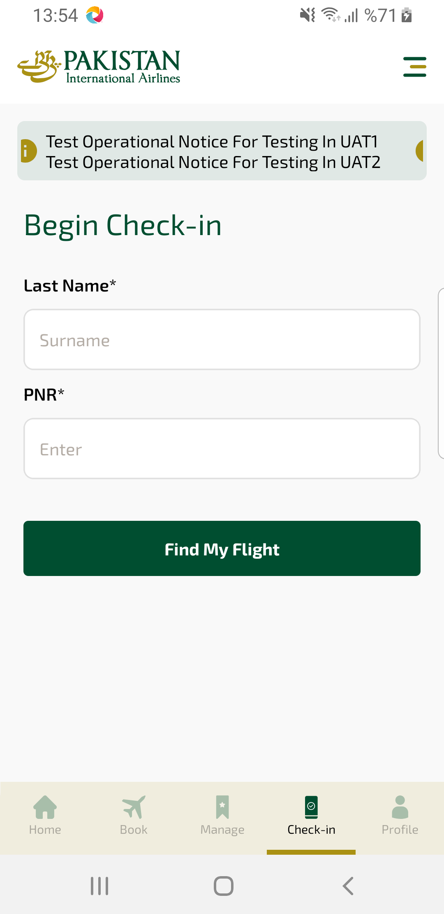
checkinSearch sayfası ekran görüntüsü

