Accessibility Report — checkinSuccess
Tarih: 01.04.2026 12:29 | Platform: ANDROID

Element ID | Page | Type | Label / Text | Value | Resource ID | Status | New Status
checkinSuccess_element_1 | MainActivity | ViewGroup | See Important Notice |  |  | ID Yok | ID Eklenecek (Waiting Dev)
checkinSuccess_element_2 | MainActivity | ViewGroup | Abddul Doe |  | check_in_success_pax_card | ID Var
checkinSuccess_element_3 | MainActivity | ViewGroup | Go to Manage Booking |  | check_in_success_mbk_button | ID Var

📸 Ekran Görüntüsü
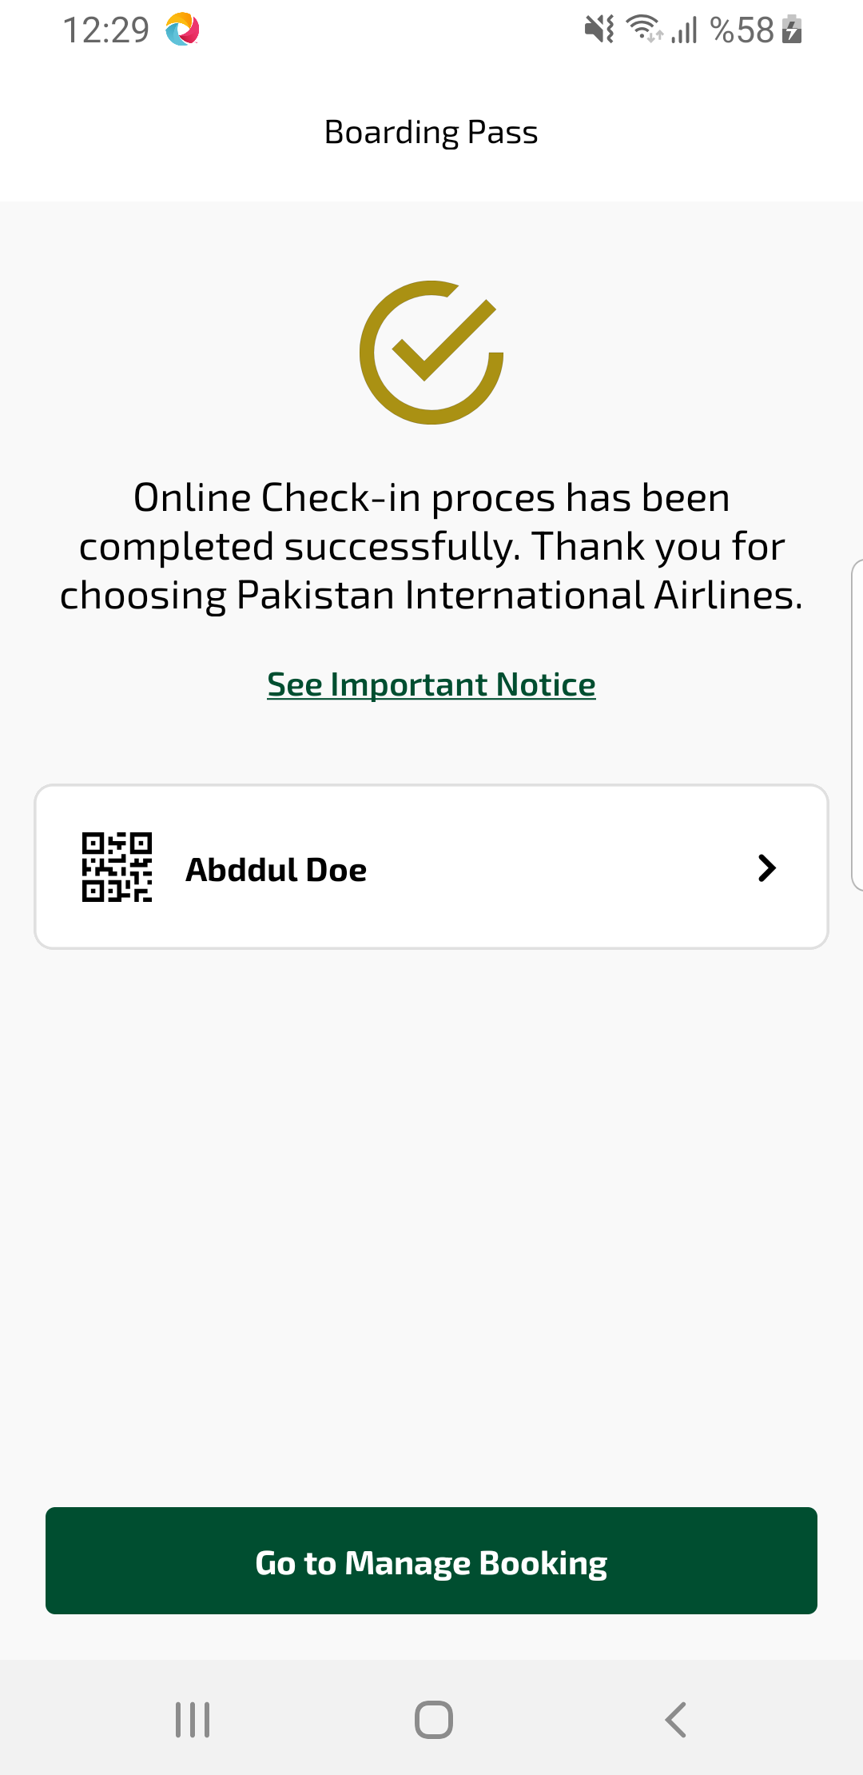
checkinSuccess sayfası ekran görüntüsü

