Accessibility Report — contactInfo
Tarih: 01.04.2026 11:33 | Platform: ANDROID

Element ID | Page | Type | Label / Text | Value | Resource ID | Status | New Status
contactInfo_element_1 | MainActivity | EditText | +92 | +92 |  | ID Yok | ID Eklenecek (Waiting Dev)
contactInfo_element_2 | MainActivity | ViewGroup | Total , 123,582.00￼PKR |  |  | ID Yok | ID Eklenecek (Waiting Dev)
contactInfo_element_3 | MainActivity | ViewGroup | Child 1 |  | pax_form_tab_bar_item | Duplicate | ID Eklenecek (Waiting Dev)
contactInfo_element_4 | MainActivity | ViewGroup | Infant 1 |  | pax_form_tab_bar_item | Duplicate | ID Eklenecek (Waiting Dev)
contactInfo_element_5 | MainActivity | ViewGroup | Contact Person |  | pax_form_tab_bar_item | Duplicate | ID Eklenecek (Waiting Dev)
contactInfo_element_6 | MainActivity | EditText | Adult one | Adult one | pax_form_text_field_givenName | ID Var
contactInfo_element_7 | MainActivity | EditText | Automation | Automation | pax_form_text_field_surname | ID Var
contactInfo_element_8 | MainActivity | EditText | 56 55555555 | 56 55555555 | pax_form_phone_input_value_phoneNumber | ID Var
contactInfo_element_9 | MainActivity | EditText | yunus.sahin@testinium.com | yunus.sahin@testinium.com | pax_form_text_field_email | ID Var
contactInfo_element_10 | MainActivity | ViewGroup |  |  | pax_form_header | ID Var
contactInfo_element_11 | MainActivity | ViewGroup |  |  | pax_form_back_button | ID Var
contactInfo_element_12 | MainActivity | ViewGroup |  |  | pax_form_phone_dial_code_phoneNumber | ID Var
contactInfo_element_13 | MainActivity | ViewGroup | Continue |  | pax_form_continue_button | ID Var

📸 Ekran Görüntüsü
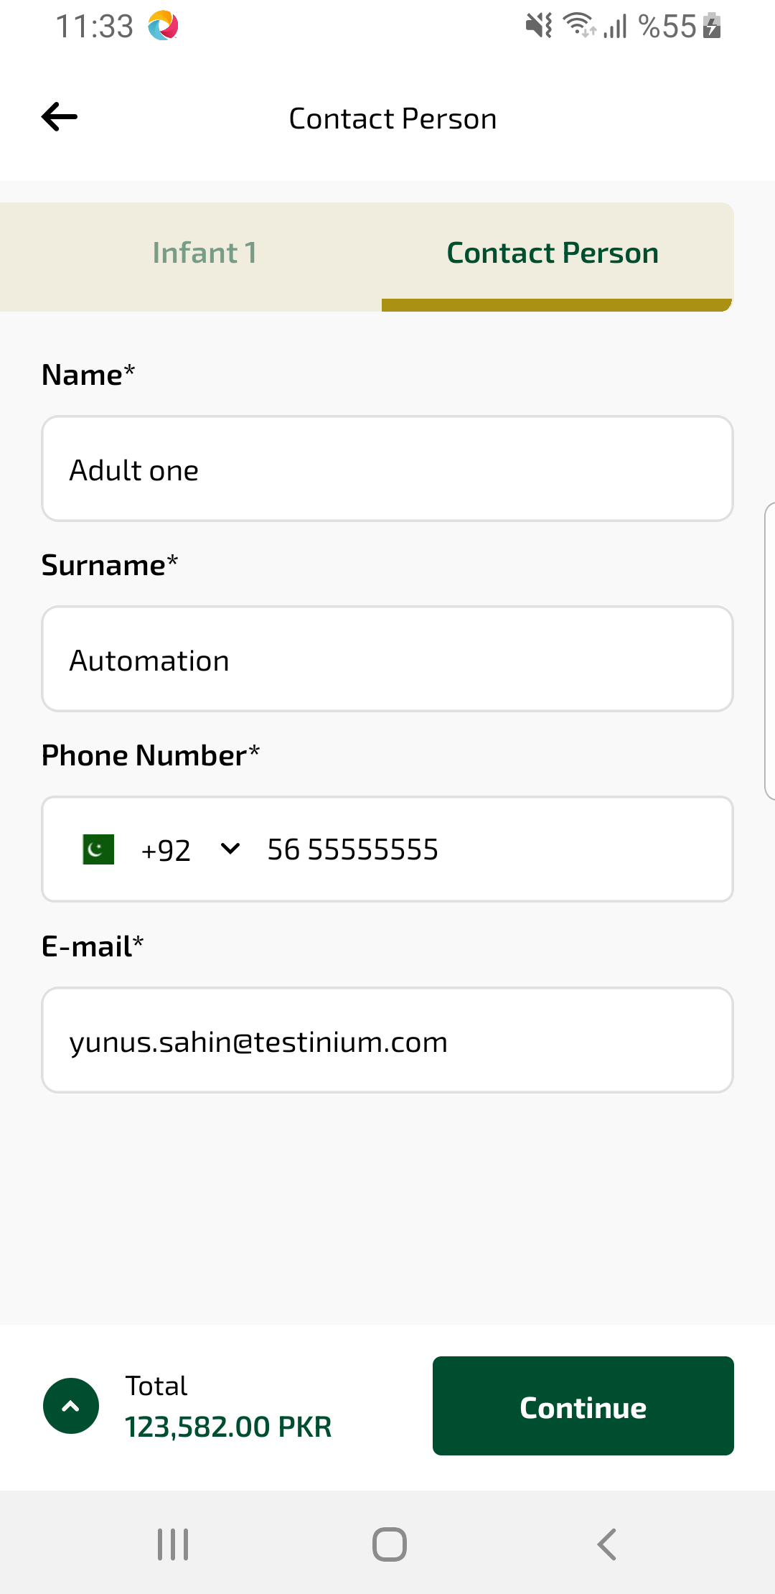
contactInfo sayfası ekran görüntüsü

