Accessibility Report — flightCancelSuccess
Tarih: 01.04.2026 12:12 | Platform: ANDROID

Element ID | Page | Type | Label / Text | Value | Resource ID | Status | New Status
flightCancelSuccess_element_1 | MainActivity | ViewGroup | Faisalabad (LYP) to Karachi (KHI), Sun, 17 May - 17:30, 1h 45min - PK 341, ECONOMY |  |  | ID Yok | ID Eklenecek (Waiting Dev)
flightCancelSuccess_element_2 | MainActivity | ViewGroup | Direct |  |  | ID Yok | ID Eklenecek (Waiting Dev)
flightCancelSuccess_element_3 | MainActivity | ViewGroup | Manage My Booking |  | cancel_flight_success_mbk_button | ID Var

📸 Ekran Görüntüsü
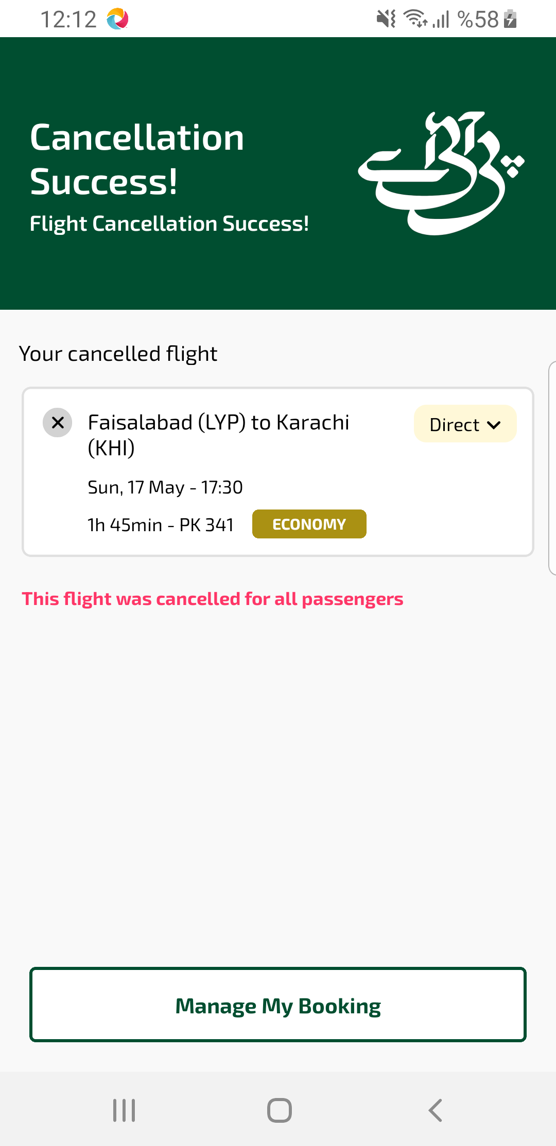
flightCancelSuccess sayfası ekran görüntüsü

