Accessibility Report — flightCancelYesNoModal
Tarih: 01.04.2026 12:12 | Platform: ANDROID

Element ID | Page | Type | Label / Text | Value | Resource ID | Status | New Status
flightCancelYesNoModal_element_1 | MainActivity | ViewGroup | Dasd Dsad, E-Ticket Number:, 2142431221180 |  |  | ID Yok | ID Eklenecek (Waiting Dev)
flightCancelYesNoModal_element_2 | MainActivity | ViewGroup | Infant Deneme, E-Ticket Number:, 2142431221181 |  |  | ID Yok | ID Eklenecek (Waiting Dev)
flightCancelYesNoModal_element_3 | MainActivity | ViewGroup | Amount to be returned, 2,264.00￼PKR |  |  | ID Yok | ID Eklenecek (Waiting Dev)
flightCancelYesNoModal_element_4 | MainActivity | ViewGroup | Cancellation Rules |  |  | ID Yok | ID Eklenecek (Waiting Dev)
flightCancelYesNoModal_element_5 | MainActivity | ViewGroup | No |  | cancel_flight_summary_modal_neg_button | ID Var
flightCancelYesNoModal_element_6 | MainActivity | ViewGroup | Yes |  | cancel_flight_summary_modal_pos_button | ID Var
flightCancelYesNoModal_element_7 | MainActivity | ViewGroup |  |  | cancel_flight_summary_terms_check_box | ID Var
flightCancelYesNoModal_element_8 | MainActivity | ViewGroup | Cancel Flight |  | cancel_flight_summary_continue_button | ID Var

📸 Ekran Görüntüsü
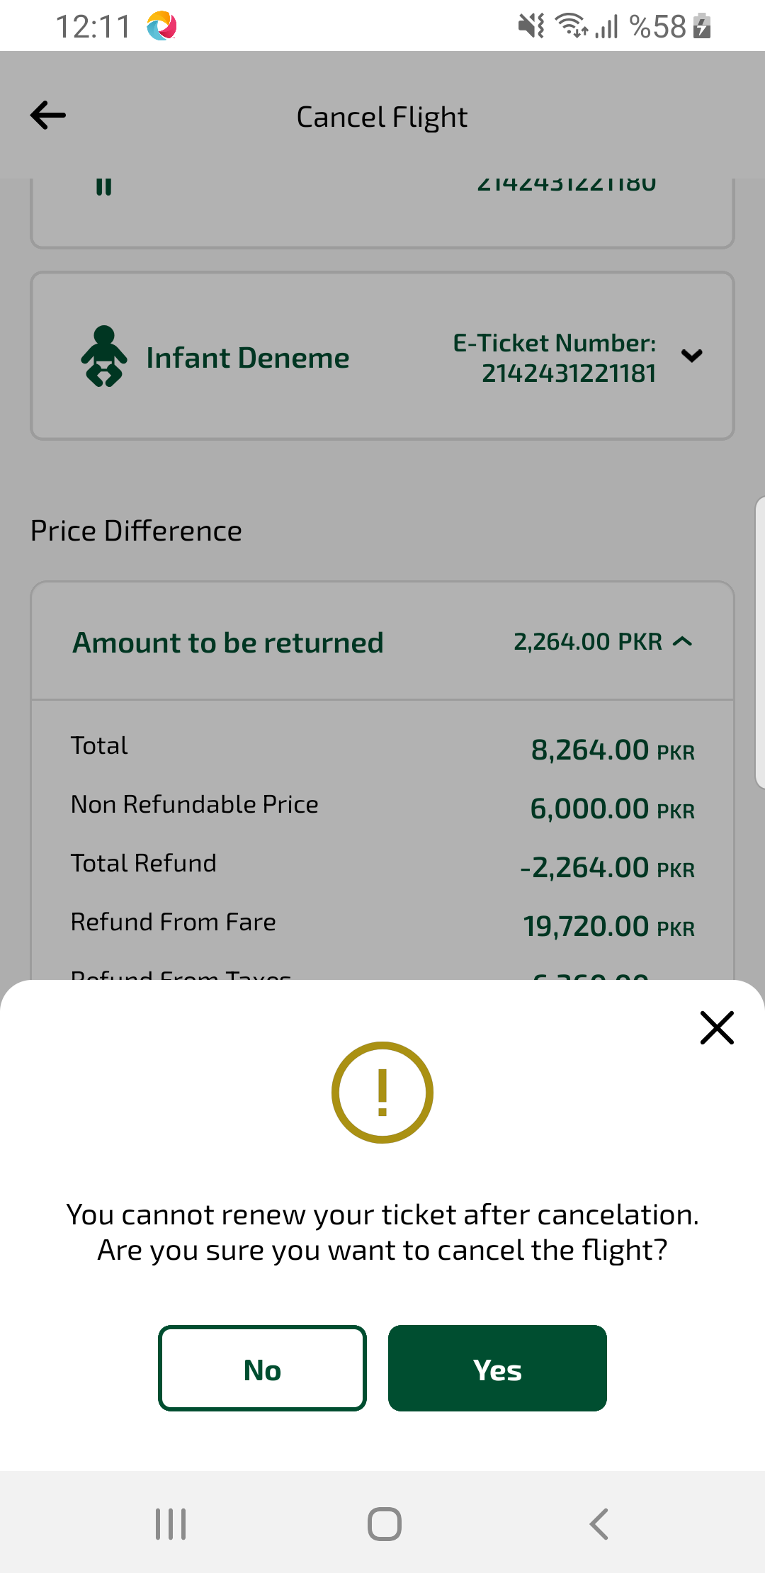
flightCancelYesNoModal sayfası ekran görüntüsü

