Accessibility Report — flightChangeSearchFlight
Tarih: 01.04.2026 12:07 | Platform: ANDROID

Element ID | Page | Type | Label / Text | Value | Resource ID | Status | New Status
flightChangeSearchFlight_element_1 | MainActivity | ViewGroup | Departure, Karachi - Karachi Jinnah International Airport(KHI) |  |  | ID Yok | ID Eklenecek (Waiting Dev)
flightChangeSearchFlight_element_2 | MainActivity | ViewGroup | Arrival, Faisalabad - Faisalabad International Airport(LYP) |  |  | ID Yok | ID Eklenecek (Waiting Dev)
flightChangeSearchFlight_element_3 | MainActivity | ViewGroup | Passengers, 2 Adult, , 1 Child, , 1 Infant |  |  | ID Yok | ID Eklenecek (Waiting Dev)
flightChangeSearchFlight_element_4 | MainActivity | ViewGroup | Departure Date, Fri, 01 May |  | change_flight_search_dep_date_card | ID Var
flightChangeSearchFlight_element_5 | MainActivity | ViewGroup | Return Date, Sun, 03 May |  | change_flight_search_ret_date_card | ID Var
flightChangeSearchFlight_element_6 | MainActivity | ViewGroup | Class, Economy |  | change_flight_search_cabin_class_card | ID Var
flightChangeSearchFlight_element_7 | MainActivity | ViewGroup | Find a Flight |  | change_flight_search_find_flight_button | ID Var

📸 Ekran Görüntüsü
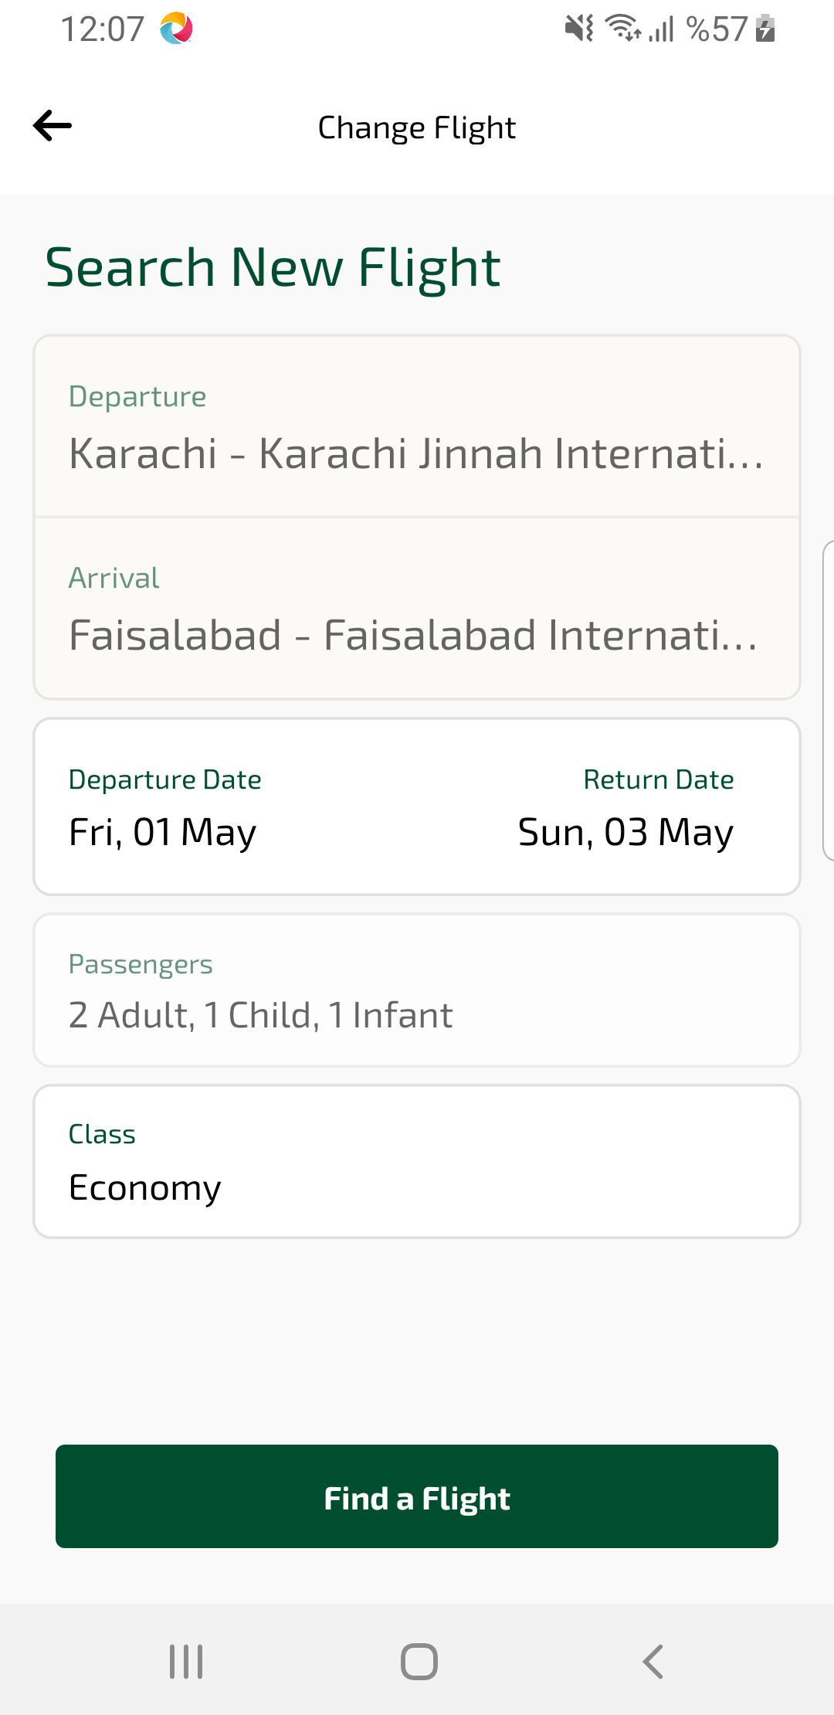
flightChangeSearchFlight sayfası ekran görüntüsü

