Accessibility Report — flightChangeSelectBundle
Tarih: 01.04.2026 12:08 | Platform: ANDROID

Element ID | Page | Type | Label / Text | Value | Resource ID | Status | New Status
flightChangeSelectBundle_element_1 | MainActivity | ViewGroup | LIGHT, Lowest Price, Free Carry-On Baggage, Free Meal/Beverages, Seat Selection (*charges apply), Booking Change (*charges apply), Cancellation/Refund (*charges apply), No Check-in Baggage |  |  | ID Yok | ID Eklenecek (Waiting Dev)
flightChangeSelectBundle_element_2 | MainActivity | ViewGroup | 19,207.00￼PKR |  |  | ID Yok | ID Eklenecek (Waiting Dev)
flightChangeSelectBundle_element_3 | MainActivity | ViewGroup | STANDARD, Free Carry-On Baggage, Free Meal/Beverages, Seat Selection (*charges apply), One change free either side (Bef. 72 hrs), next with a fee, Cancellation/Refund (*charges apply), Check-in Baggage 20 KG |  |  | ID Yok | ID Eklenecek (Waiting Dev)
flightChangeSelectBundle_element_4 | MainActivity | ViewGroup | 20,327.00￼PKR |  |  | ID Yok | ID Eklenecek (Waiting Dev)

📸 Ekran Görüntüsü
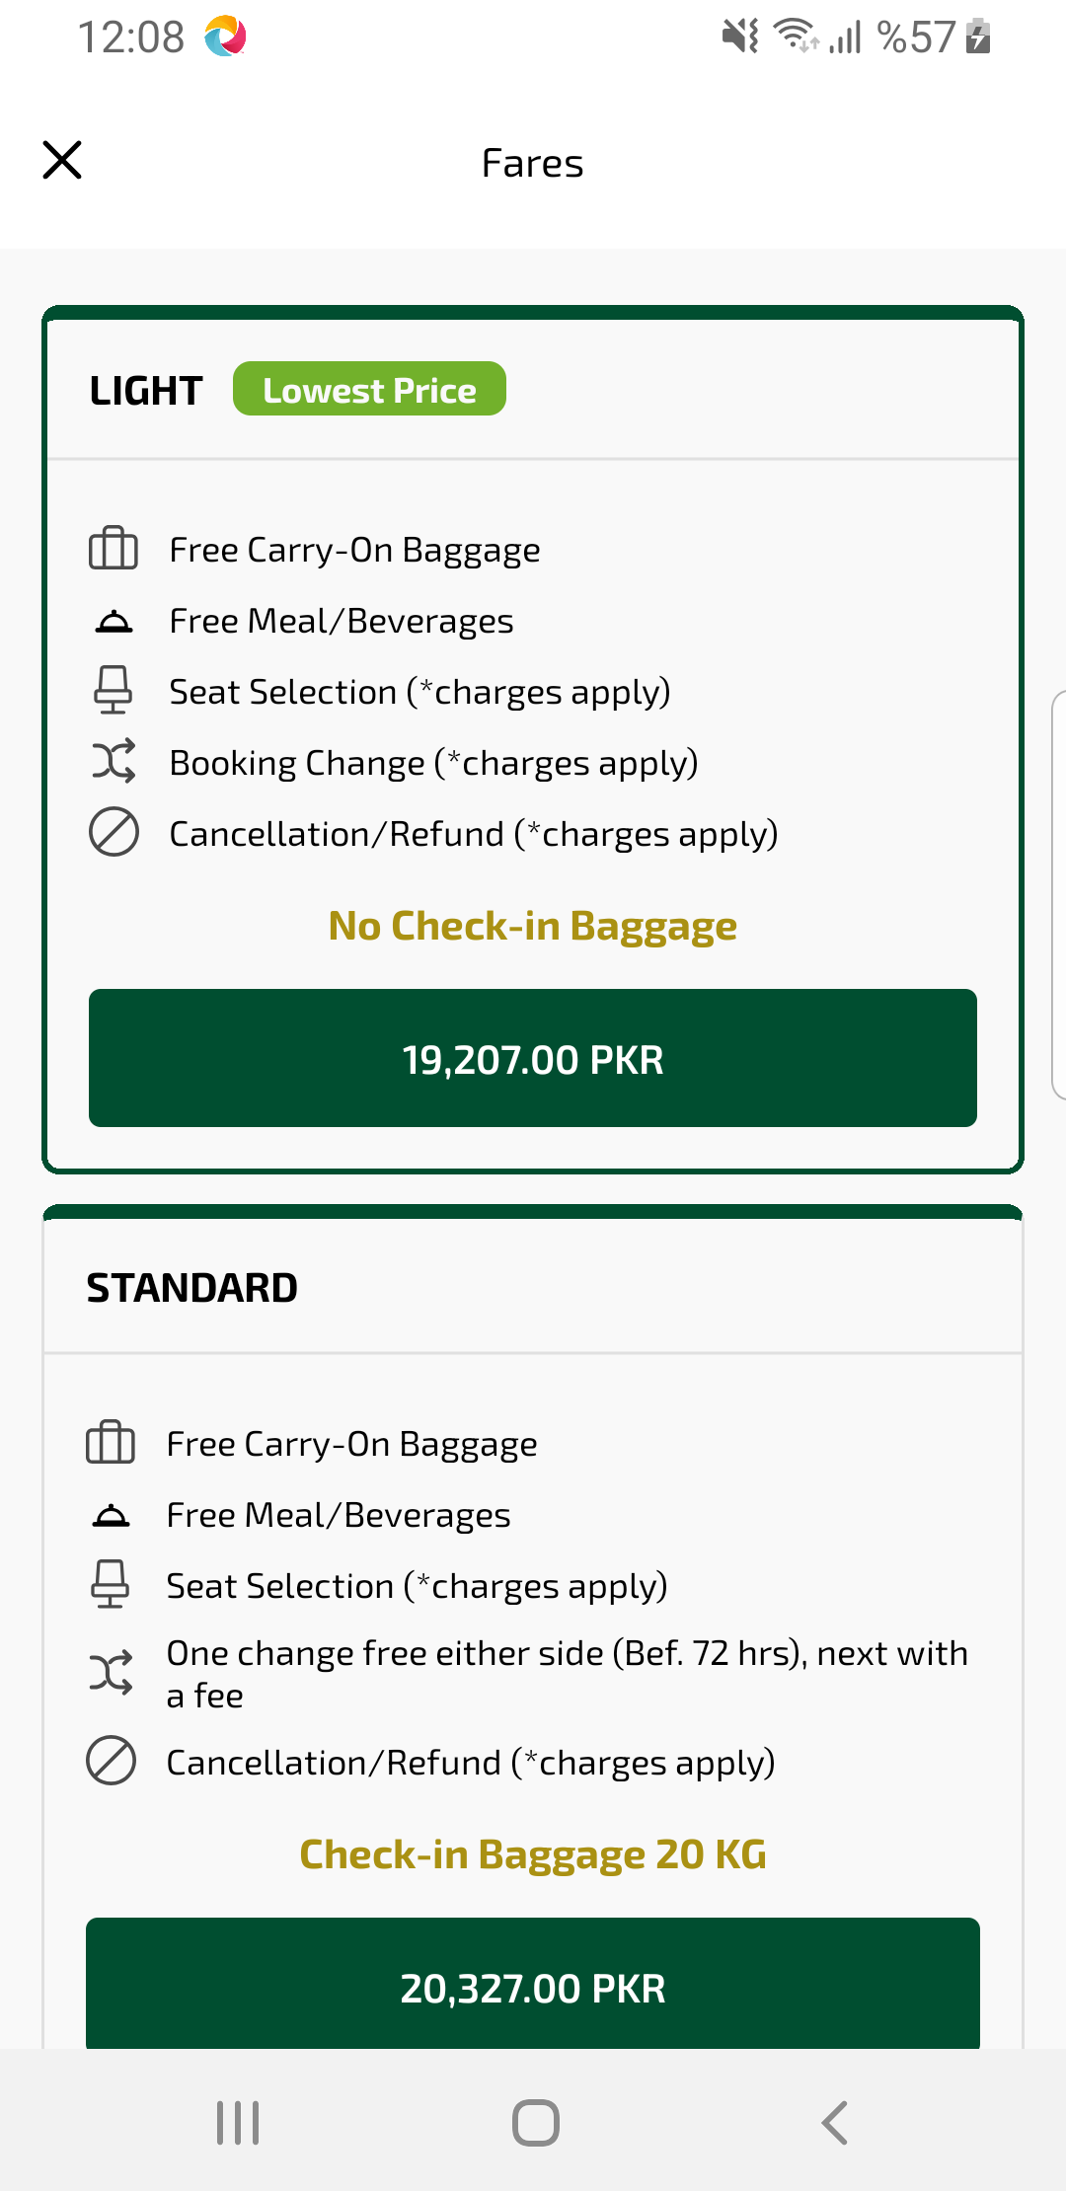
flightChangeSelectBundle sayfası ekran görüntüsü

