Accessibility Report — flightChangeSelectFlight
Tarih: 01.04.2026 12:06 | Platform: ANDROID

Element ID | Page | Type | Label / Text | Value | Resource ID | Status | New Status
flightChangeSelectFlight_element_1 | MainActivity | ViewGroup | Direct |  |  | ID Yok | ID Eklenecek (Waiting Dev)
flightChangeSelectFlight_element_2 | MainActivity | ViewGroup | Direct |  |  | ID Yok | ID Eklenecek (Waiting Dev)
flightChangeSelectFlight_element_3 | MainActivity | ViewGroup |  |  | change_flight_trip_card | Duplicate | ID Eklenecek (Waiting Dev)
flightChangeSelectFlight_element_4 | MainActivity | ViewGroup | Karachi (KHI) to Faisalabad (LYP), Fri, 15 May - 21:00, 1h 45min - PK 340, ECONOMY |  | change_flight_trip_card | Duplicate | ID Eklenecek (Waiting Dev)
flightChangeSelectFlight_element_5 | MainActivity | ViewGroup |  |  | change_flight_trip_card | Duplicate | ID Eklenecek (Waiting Dev)
flightChangeSelectFlight_element_6 | MainActivity | ViewGroup | Faisalabad (LYP) to Karachi (KHI), Sun, 17 May - 17:30, 1h 45min - PK 341, ECONOMY |  | change_flight_trip_card | Duplicate | ID Eklenecek (Waiting Dev)
flightChangeSelectFlight_element_7 | MainActivity | ViewGroup |  |  | change_flight_trip_card | Duplicate | ID Eklenecek (Waiting Dev)
flightChangeSelectFlight_element_8 | MainActivity | ViewGroup |  |  | change_flight_header | ID Var
flightChangeSelectFlight_element_9 | MainActivity | ViewGroup | Continue |  | change_flight_continue_button | ID Var

📸 Ekran Görüntüsü
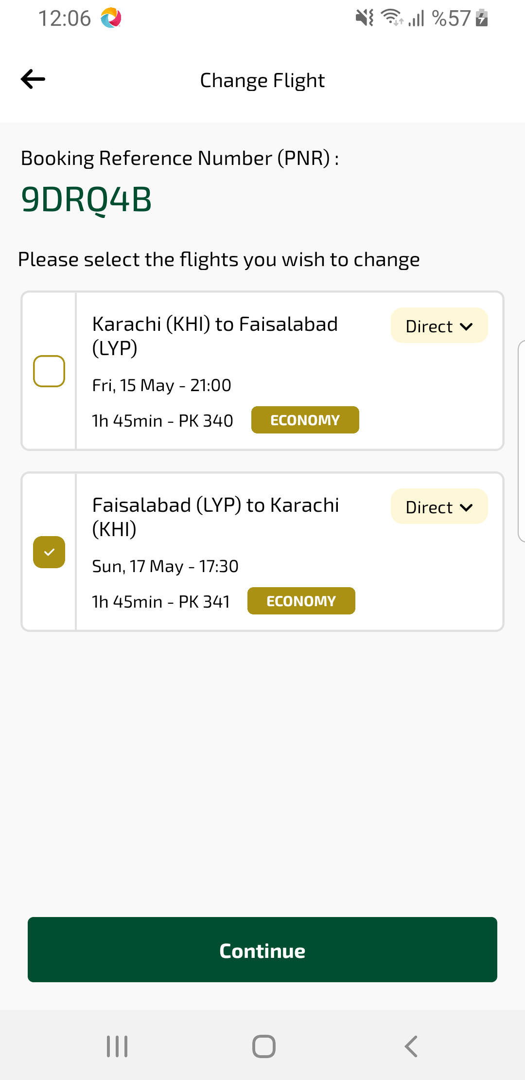
flightChangeSelectFlight sayfası ekran görüntüsü

