Accessibility Report — flightChangeSuccess
Tarih: 01.04.2026 13:43 | Platform: ANDROID

Element ID | Page | Type | Label / Text | Value | Resource ID | Status | New Status
flightChangeSuccess_element_1 | MainActivity | ViewGroup | Karachi (KHI) to Faisalabad (LYP), Fri, 10 Apr - 21:00, 1h 45min - PK 340, ECONOMY |  |  | ID Yok | ID Eklenecek (Waiting Dev)
flightChangeSuccess_element_2 | MainActivity | ViewGroup | Direct |  |  | ID Yok | ID Eklenecek (Waiting Dev)
flightChangeSuccess_element_3 | MainActivity | ViewGroup | Manage My Booking |  | change_flight_success_home_button | ID Var

📸 Ekran Görüntüsü
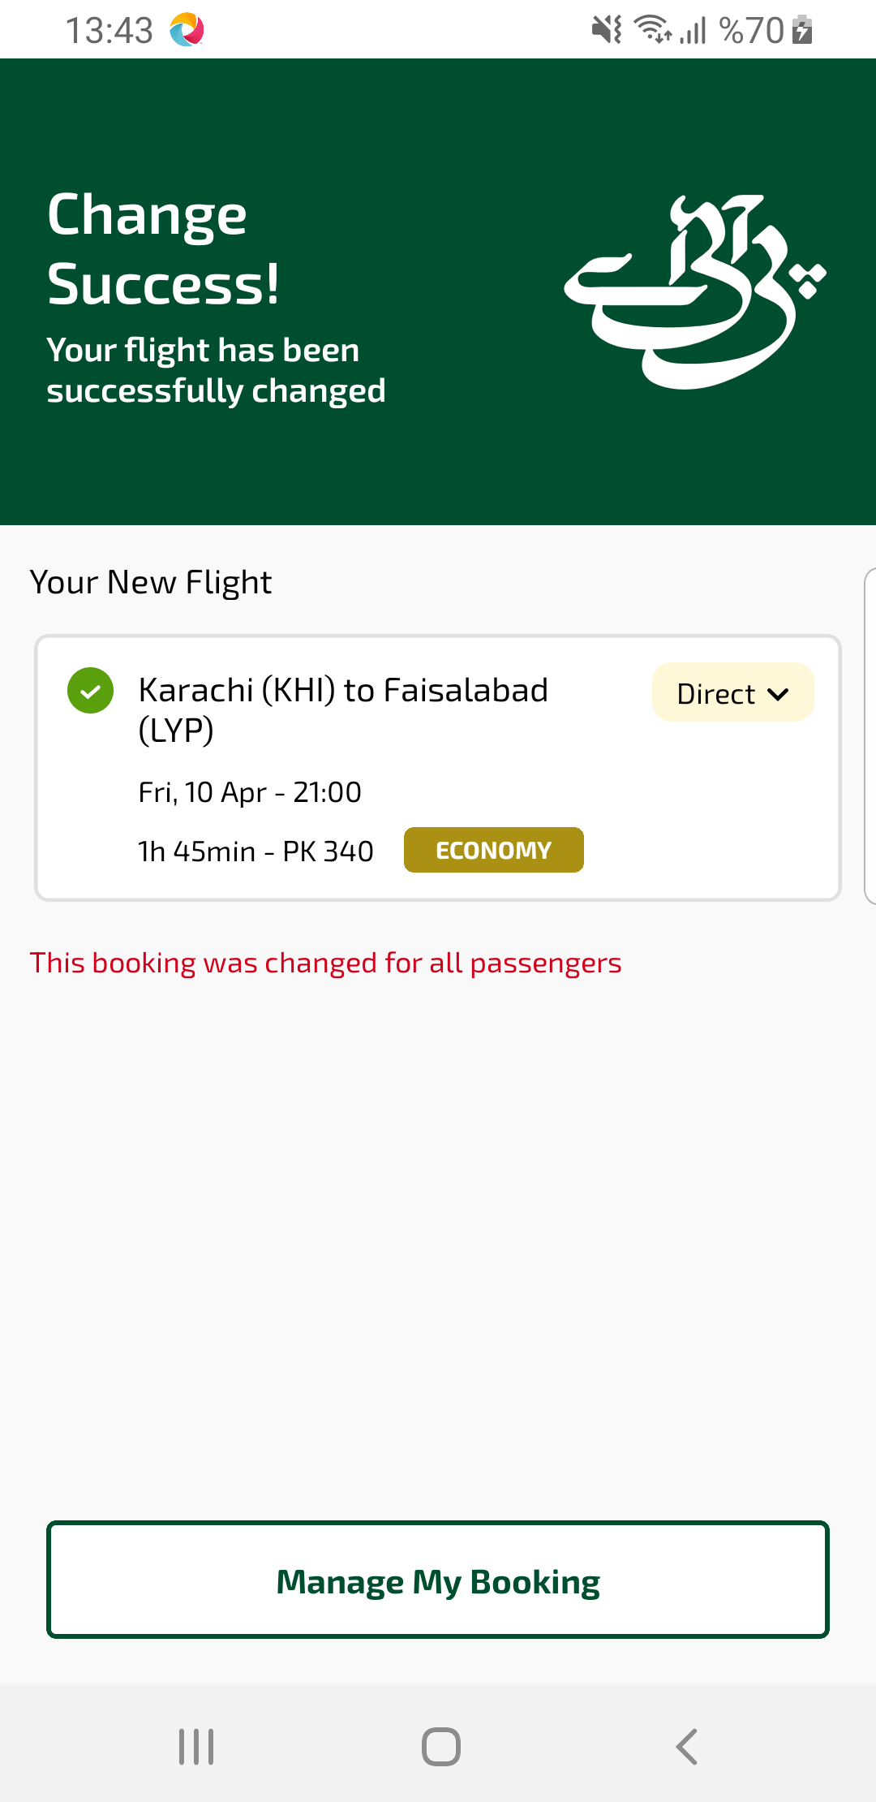
flightChangeSuccess sayfası ekran görüntüsü

