Accessibility Report — flightChangeSummary
Tarih: 01.04.2026 13:42 | Platform: ANDROID

Element ID | Page | Type | Label / Text | Value | Resource ID | Status | New Status
flightChangeSummary_element_1 | MainActivity | ViewGroup | Karachi (KHI) to Faisalabad (LYP), Fri, 03 Apr - 21:00, 1h 45min - PK 340, ECONOMY |  |  | ID Yok | ID Eklenecek (Waiting Dev)
flightChangeSummary_element_2 | MainActivity | ViewGroup | Direct |  |  | ID Yok | ID Eklenecek (Waiting Dev)
flightChangeSummary_element_3 | MainActivity | ViewGroup | Karachi (KHI) to Faisalabad (LYP), Fri, 10 Apr - 21:00, 1h 45min - PK 340, ECONOMY |  |  | ID Yok | ID Eklenecek (Waiting Dev)
flightChangeSummary_element_4 | MainActivity | ViewGroup | Direct |  |  | ID Yok | ID Eklenecek (Waiting Dev)
flightChangeSummary_element_5 | MainActivity | ViewGroup | Amount to be paid , 1,000￼Miles |  |  | ID Yok | ID Eklenecek (Waiting Dev)
flightChangeSummary_element_6 | MainActivity | ViewGroup | Continue |  | change_flight_summary_continue_button | ID Var

📸 Ekran Görüntüsü
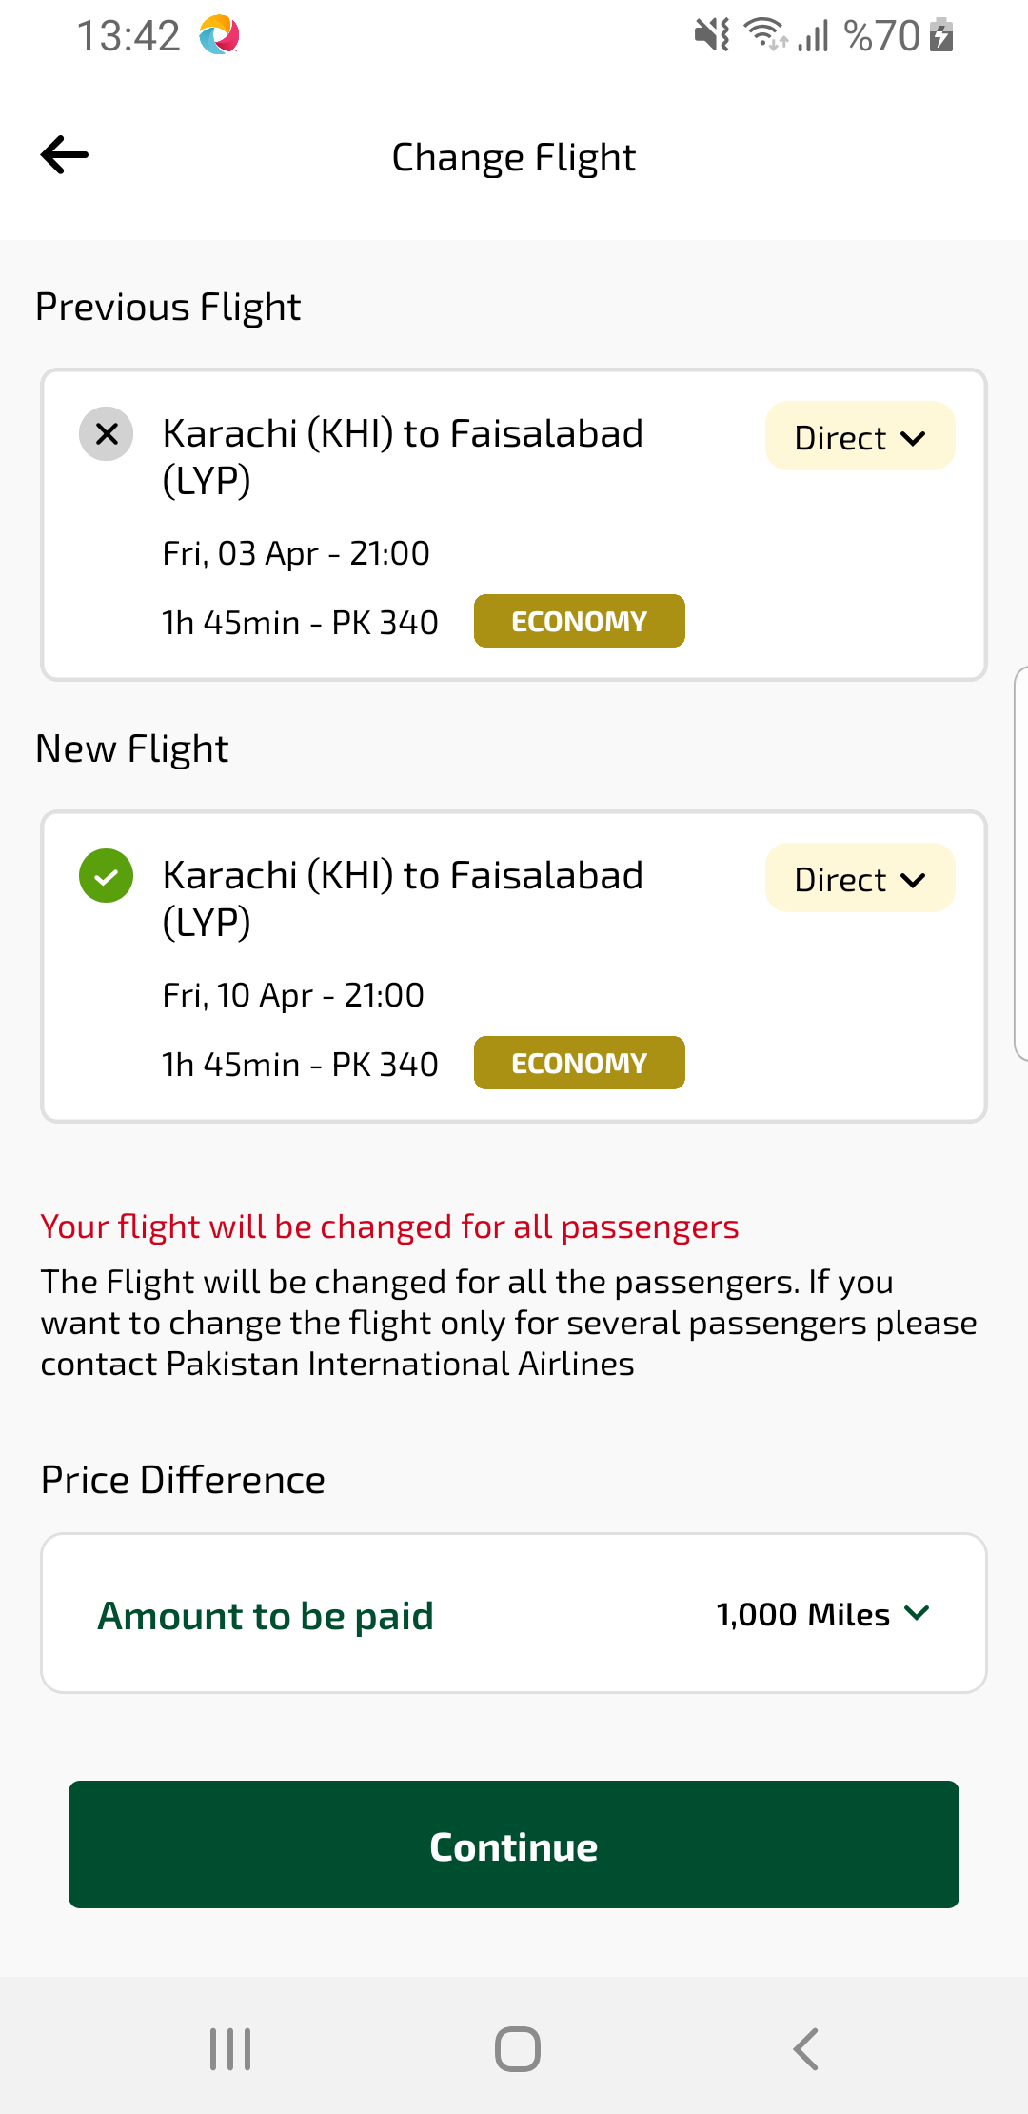
flightChangeSummary sayfası ekran görüntüsü

