Accessibility Report — flightSchedule
Tarih: 01.04.2026 10:29 | Platform: ANDROID

Element ID | Page | Type | Label / Text | Value | Resource ID | Status | New Status
flightSchedule_element_1 | MainActivity | ViewGroup | Information for Credit Card Holders |  |  | ID Yok | ID Eklenecek (Waiting Dev)
flightSchedule_element_2 | MainActivity | ViewGroup | Departure, Aalborg - Aalborg Lufthavn Airport(AAL) |  |  | ID Yok | ID Eklenecek (Waiting Dev)
flightSchedule_element_3 | MainActivity | ViewGroup | Arrival, Islamabad - Islamabad International Airport(ISB) |  |  | ID Yok | ID Eklenecek (Waiting Dev)
flightSchedule_element_4 | MainActivity | ViewGroup | Departure Date, Thu, 09 Apr |  |  | ID Yok | ID Eklenecek (Waiting Dev)
flightSchedule_element_5 | MainActivity | ViewGroup | Return Date, Sat, 11 Apr |  |  | ID Yok | ID Eklenecek (Waiting Dev)
flightSchedule_element_6 | MainActivity | ViewGroup | Search Now |  |  | ID Yok | ID Eklenecek (Waiting Dev)
flightSchedule_element_7 | MainActivity | View |  |  | statusBarBackground | ID Var
flightSchedule_element_8 | MainActivity | View |  |  | navigationBarBackground | ID Var
flightSchedule_element_9 | MainActivity | ViewGroup |  |  | __CAROUSEL_ITEM_2__ | ID Var
flightSchedule_element_10 | MainActivity | FrameLayout |  |  | content | ID Var
flightSchedule_element_11 | MainActivity | LinearLayout |  |  | action_bar_root | ID Var

📸 Ekran Görüntüsü
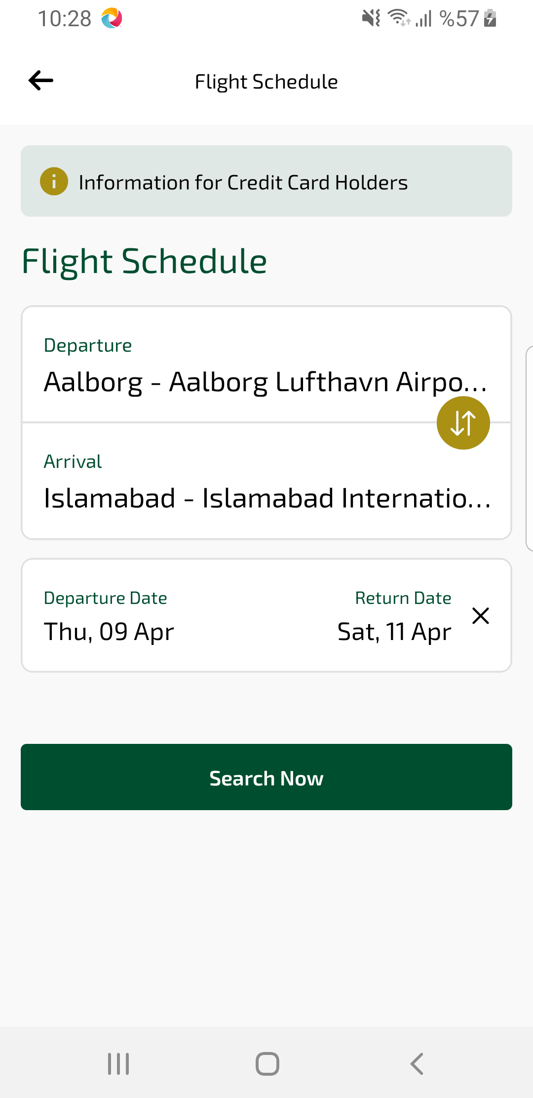
flightSchedule sayfası ekran görüntüsü

