Accessibility Report — flightSelectUseMiles
Tarih: 01.04.2026 13:47 | Platform: ANDROID

Element ID | Page | Type | Label / Text | Value | Resource ID | Status | New Status
flightSelectUseMiles_element_1 | MainActivity | ViewGroup | 08 , Apr, Wed |  |  | ID Yok | ID Eklenecek (Waiting Dev)
flightSelectUseMiles_element_2 | MainActivity | ViewGroup | 09 , Apr, Thu, NO FLIGHT |  |  | ID Yok | ID Eklenecek (Waiting Dev)
flightSelectUseMiles_element_3 | MainActivity | ViewGroup | 10 , Apr, Fri, 11,000￼Miles +, 9￼EUR |  |  | ID Yok | ID Eklenecek (Waiting Dev)
flightSelectUseMiles_element_4 | MainActivity | ViewGroup | 11 , Apr, Sat, NO FLIGHT |  |  | ID Yok | ID Eklenecek (Waiting Dev)
flightSelectUseMiles_element_5 | MainActivity | ViewGroup | 12 , Apr, Sun, 11,000￼Miles +, 9￼EUR |  |  | ID Yok | ID Eklenecek (Waiting Dev)
flightSelectUseMiles_element_6 | MainActivity | ViewGroup | Direct |  |  | ID Yok | ID Eklenecek (Waiting Dev)
flightSelectUseMiles_element_7 | MainActivity | ViewGroup | 11,000￼Miles + , 9.00￼EUR |  |  | ID Yok | ID Eklenecek (Waiting Dev)
flightSelectUseMiles_element_8 | MainActivity | ViewGroup | Economy |  | avail_selection_switch_item | Duplicate | ID Eklenecek (Waiting Dev)
flightSelectUseMiles_element_9 | MainActivity | ViewGroup | Executive Economy |  | avail_selection_switch_item | Duplicate | ID Eklenecek (Waiting Dev)
flightSelectUseMiles_element_10 | MainActivity | ViewGroup | Business |  | avail_selection_switch_item | Duplicate | ID Eklenecek (Waiting Dev)
flightSelectUseMiles_element_11 | MainActivity | ViewGroup |  |  | avail_selection_header | ID Var
flightSelectUseMiles_element_12 | MainActivity | ViewGroup | EUR |  | avail_selection_currency_picker | ID Var
flightSelectUseMiles_element_13 | MainActivity | ViewGroup | 21:00, 22:45, 1h 45min, PK 340 |  | avail_selection_flight_item_direct | ID Var

📸 Ekran Görüntüsü
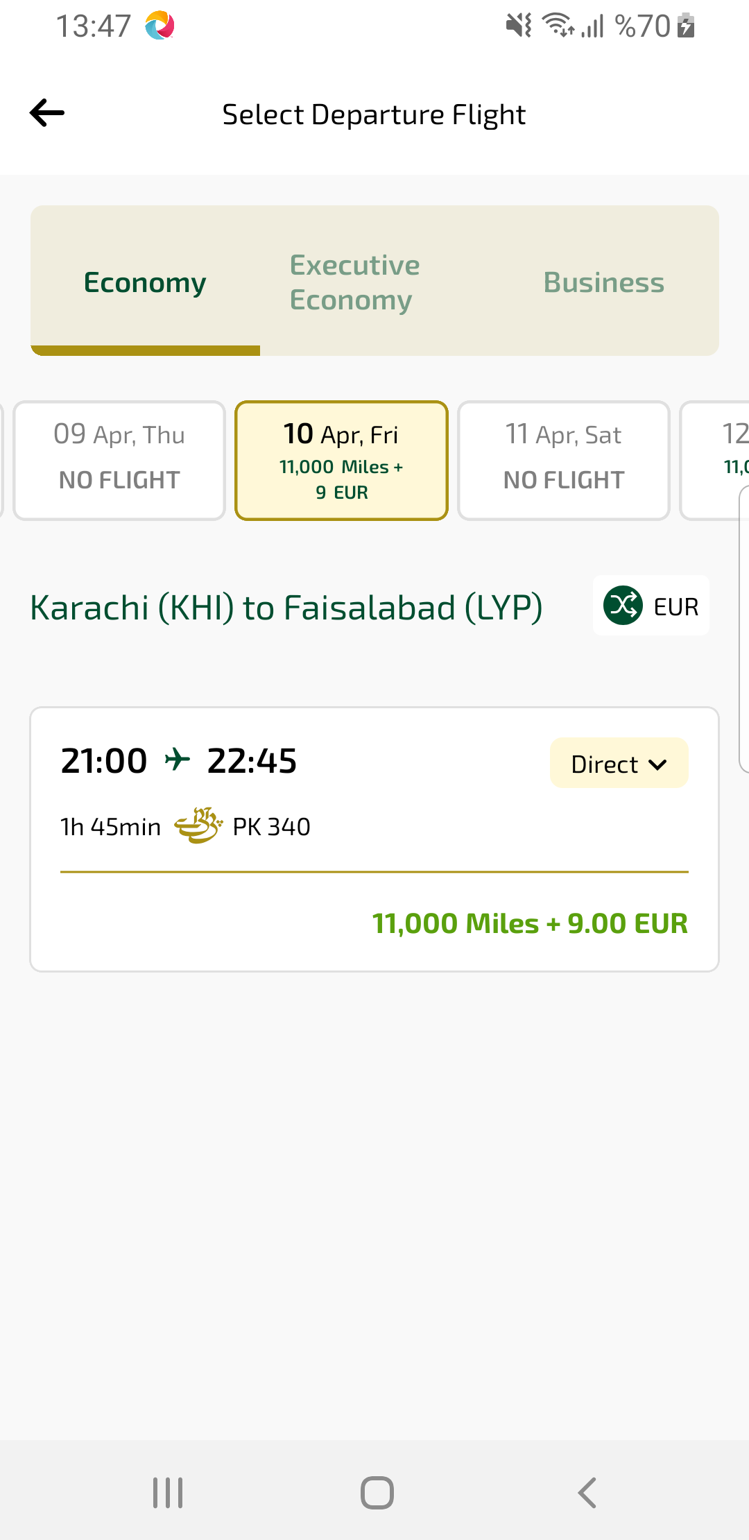
flightSelectUseMiles sayfası ekran görüntüsü

