Accessibility Report — flightStatus
Tarih: 01.04.2026 10:29 | Platform: ANDROID

Element ID | Page | Type | Label / Text | Value | Resource ID | Status | New Status
flightStatus_element_1 | MainActivity | ViewGroup | Test Operational Notice For Testing In UAT1 Test Operational Notice For Testing In UAT2 |  |  | ID Yok | ID Eklenecek (Waiting Dev)
flightStatus_element_2 | MainActivity | ViewGroup | Departure, Aalborg - Aalborg Lufthavn Airport(AAL) |  |  | ID Yok | ID Eklenecek (Waiting Dev)
flightStatus_element_3 | MainActivity | ViewGroup | Arrival, Lahore - LHE - Lahore - Allama Iqbal International Airport(LHE) |  |  | ID Yok | ID Eklenecek (Waiting Dev)
flightStatus_element_4 | MainActivity | ViewGroup | Departure Date, Fri, 17 Apr |  |  | ID Yok | ID Eklenecek (Waiting Dev)
flightStatus_element_5 | MainActivity | ViewGroup | Proceed |  |  | ID Yok | ID Eklenecek (Waiting Dev)
flightStatus_element_6 | MainActivity | View |  |  | statusBarBackground | ID Var
flightStatus_element_7 | MainActivity | ViewGroup |  |  | __CAROUSEL_ITEM_1__ | ID Var
flightStatus_element_8 | MainActivity | FrameLayout |  |  | content | ID Var
flightStatus_element_9 | MainActivity | LinearLayout |  |  | action_bar_root | ID Var

📸 Ekran Görüntüsü
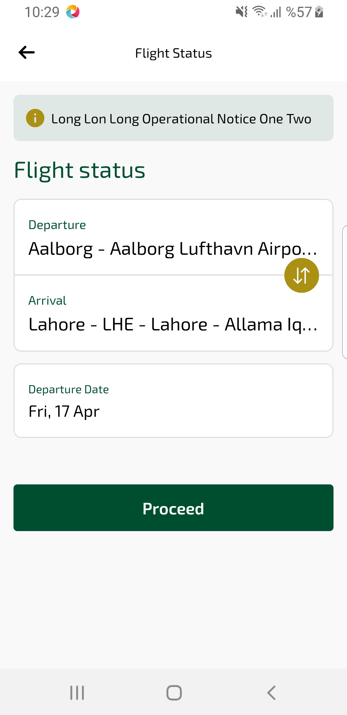
flightStatus sayfası ekran görüntüsü

