Accessibility Report — giftCardContactInfo1
Tarih: 01.04.2026 10:36 | Platform: ANDROID

Element ID | Page | Type | Label / Text | Value | Resource ID | Status | New Status
giftCardContactInfo1_element_1 | MainActivity | EditText | +92 | +92 |  | ID Yok | ID Eklenecek (Waiting Dev)
giftCardContactInfo1_element_2 | MainActivity | ViewGroup | Male |  |  | ID Yok | ID Eklenecek (Waiting Dev)
giftCardContactInfo1_element_3 | MainActivity | ViewGroup | Female |  |  | ID Yok | ID Eklenecek (Waiting Dev)
giftCardContactInfo1_element_4 | MainActivity | ViewGroup | Purchase gift card for self |  |  | ID Yok | ID Eklenecek (Waiting Dev)
giftCardContactInfo1_element_5 | MainActivity | ViewGroup | Purchase gift card for Family & Friends |  |  | ID Yok | ID Eklenecek (Waiting Dev)
giftCardContactInfo1_element_6 | MainActivity | ViewGroup | Preview and Payment |  |  | ID Yok | ID Eklenecek (Waiting Dev)
giftCardContactInfo1_element_7 | MainActivity | EditText | adult one | adult one | undefinedsenderName | Undefined ID | ID Eklenecek (Waiting Dev)
giftCardContactInfo1_element_8 | MainActivity | EditText | automation | automation | undefinedsenderSurname | Undefined ID | ID Eklenecek (Waiting Dev)
giftCardContactInfo1_element_9 | MainActivity | EditText | 56 6666666 | 56 6666666 | undefinedsenderPhoneNumber | Undefined ID | ID Eklenecek (Waiting Dev)
giftCardContactInfo1_element_10 | MainActivity | EditText | aa@aa.com | aa@aa.com | undefinedsenderEmail | Undefined ID | ID Eklenecek (Waiting Dev)
giftCardContactInfo1_element_11 | MainActivity | ViewGroup |  |  | undefinedsenderPhoneNumber | Undefined ID | ID Eklenecek (Waiting Dev)
giftCardContactInfo1_element_12 | MainActivity | View |  |  | statusBarBackground | ID Var
giftCardContactInfo1_element_13 | MainActivity | View |  |  | navigationBarBackground | ID Var
giftCardContactInfo1_element_14 | MainActivity | FrameLayout |  |  | content | ID Var
giftCardContactInfo1_element_15 | MainActivity | LinearLayout |  |  | action_bar_root | ID Var

📸 Ekran Görüntüsü
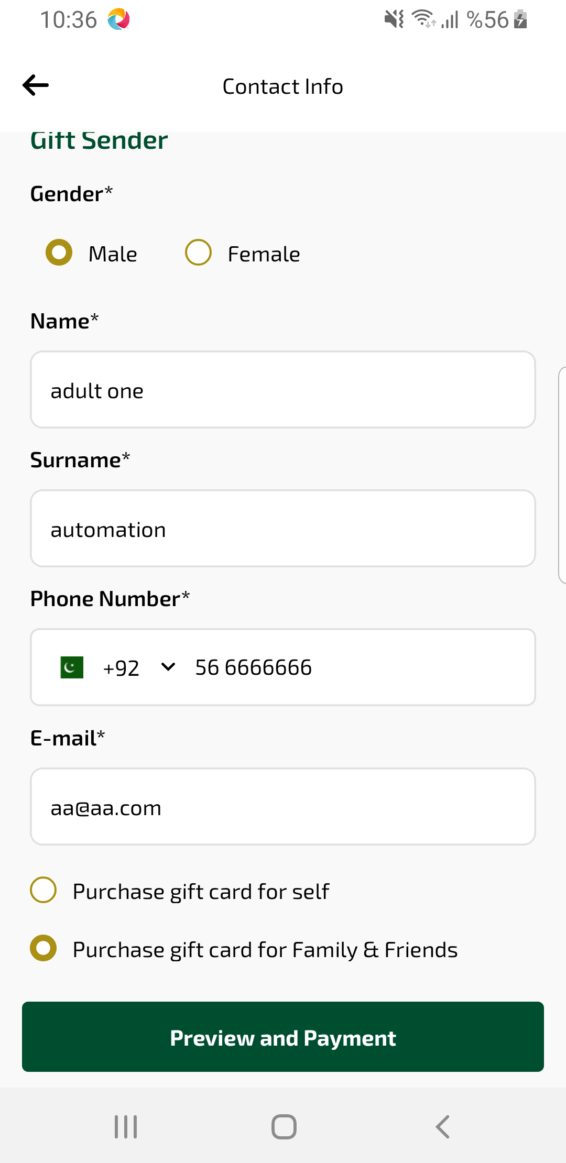
giftCardContactInfo1 sayfası ekran görüntüsü

