Accessibility Report — giftCardContactInfo2
Tarih: 01.04.2026 10:37 | Platform: ANDROID

Element ID | Page | Type | Label / Text | Value | Resource ID | Status | New Status
giftCardContactInfo2_element_1 | MainActivity | EditText | +92 | +92 |  | ID Yok | ID Eklenecek (Waiting Dev)
giftCardContactInfo2_element_2 | MainActivity | ViewGroup | Male |  |  | ID Yok | ID Eklenecek (Waiting Dev)
giftCardContactInfo2_element_3 | MainActivity | ViewGroup | Female |  |  | ID Yok | ID Eklenecek (Waiting Dev)
giftCardContactInfo2_element_4 | MainActivity | ViewGroup | Preview and Payment |  |  | ID Yok | ID Eklenecek (Waiting Dev)
giftCardContactInfo2_element_5 | MainActivity | EditText | adult two | adult two | undefinedrecipientName | Undefined ID | ID Eklenecek (Waiting Dev)
giftCardContactInfo2_element_6 | MainActivity | EditText | test | test | undefinedrecipientSurname | Undefined ID | ID Eklenecek (Waiting Dev)
giftCardContactInfo2_element_7 | MainActivity | EditText | 56 111 222 332 | 56 111 222 332 | undefinedrecipientPhoneNumber | Undefined ID | ID Eklenecek (Waiting Dev)
giftCardContactInfo2_element_8 | MainActivity | EditText | qwe@qwe.com | qwe@qwe.com | undefinedrecipientEmail | Undefined ID | ID Eklenecek (Waiting Dev)
giftCardContactInfo2_element_9 | MainActivity | ViewGroup |  |  | undefinedrecipientPhoneNumber | Undefined ID | ID Eklenecek (Waiting Dev)
giftCardContactInfo2_element_10 | MainActivity | View |  |  | statusBarBackground | ID Var
giftCardContactInfo2_element_11 | MainActivity | View |  |  | navigationBarBackground | ID Var
giftCardContactInfo2_element_12 | MainActivity | FrameLayout |  |  | content | ID Var
giftCardContactInfo2_element_13 | MainActivity | LinearLayout |  |  | action_bar_root | ID Var

📸 Ekran Görüntüsü
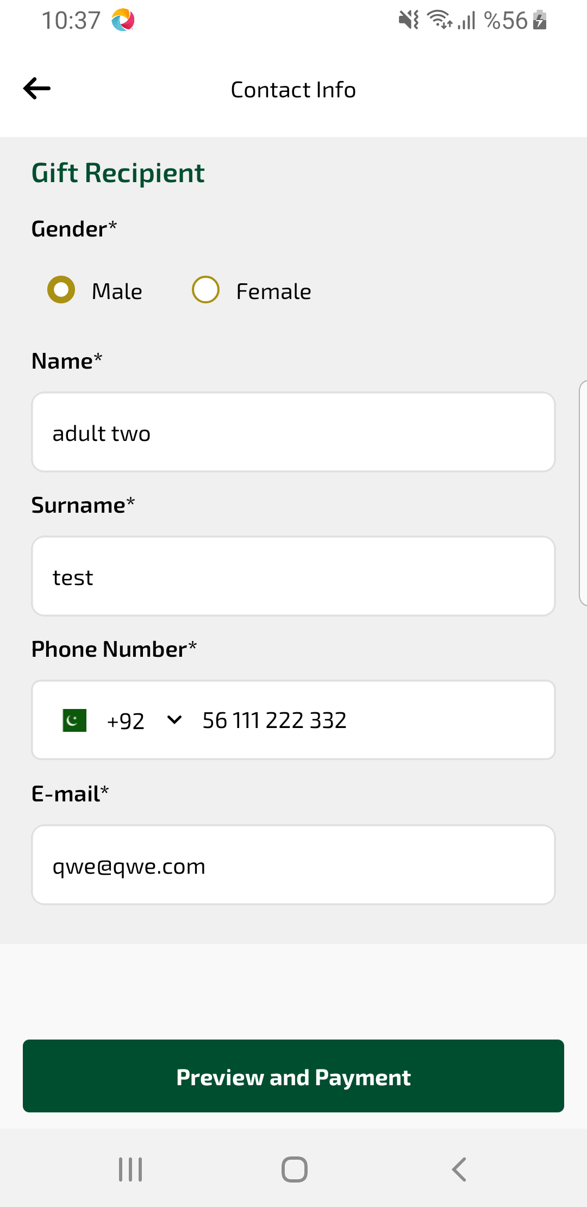
giftCardContactInfo2 sayfası ekran görüntüsü

